**PHASE - IV**

**OOP Project documentation**

**Group 12**

**Yaswanth (AM.EN.U4CSE19229)**

**Pavan (AM.EN.U4CSE19214)**

**Shravanth (AM.EN.U4CSE19250)**

**Sumanth (AM.EN.U4CSE19259)**

**ABSTRACT**

## **ICTS Staff management System**

ICTS department provides various type of hardware, software, network, multimedia services to the people of our college. It has various service staff for this purpose. Each person (student or staff) can place the request for the service such as installation of a particular software, keyboard repair, network not available etc. after approval from the HoD of the respective department. However certain people do not require the approval. Based on the type of service requested, the ICTS staff is allotted the job. The personal details of the requester as well as the ICTS staff is maintained such as id, name,phone no. and department to know which person reqeusted the service and who addressed the issue. A person can place one or more requests at a time.



**Use case diagram**

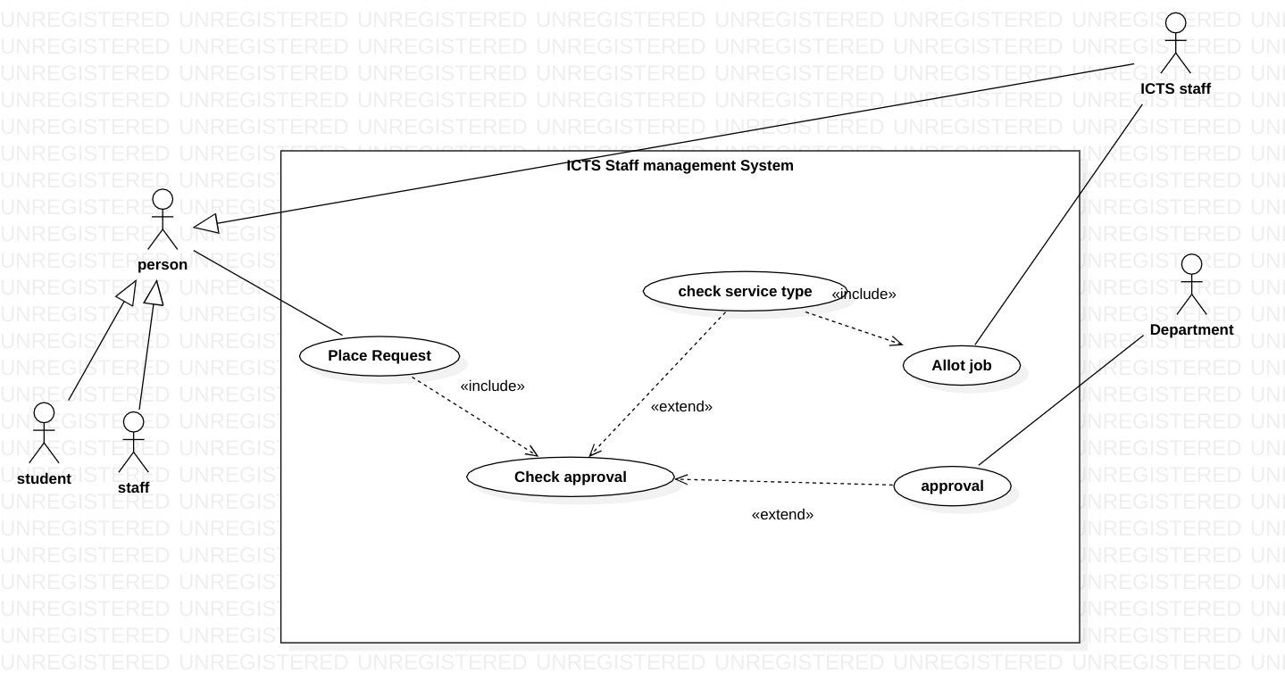

First of all, a person ( belongs to Amrita University) places a request and based on who placed the request we have to determine whether approval is required or not. If it is the staff who placed the request then approval is not required but for a normal person, approval is required. If approval is required the request will be handed over to the department HOD who will either approve or deny the request. If the request is approved then the job will be allotted to ICTS staff based on the requesting department and the availability of the staff. When the request is allotted to an ICTS staff then it will be handed over to the respective staff and he/she will start processing the request. After the completion of processing, the request will move to completed status where the person who placed the request will be informed. If approval is not required (staff placed the request) then the request will be alloted to any ICTS staff on spot and goes to processing state.

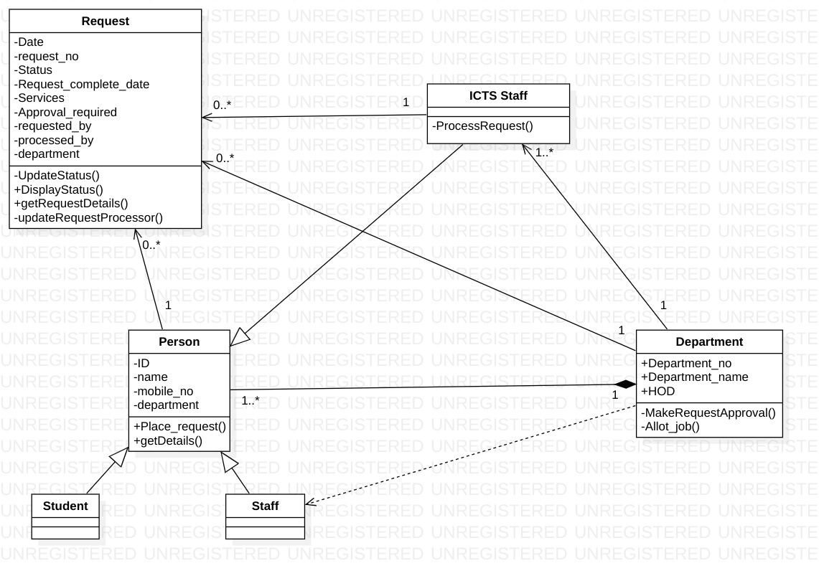**Class diagram**

The relation between persons is a composition because without a department a person cannot exist and the department is a collection of persons ( students and staff). Students, Staff, ICTS are children of the person class as they inherit many properties from person class like place request, ID, department, mobile number which all we are supposed to maintain. UpdateStatus() method in the request can be accessed by department and ICTS staff when they are approving, processing, denying a request. GetRequestDetails() can be accessed by any person who is interested. When MakeRequest() method invokes the AllotJob() method which invokes the updateRequestProcessor() in the request class and allots the request to ICTS staff. ProcessRequest() is invoked by ICTS staff when they completed the processing of a request. When a request is placed by staff then directly allotJob() method is invoked. The relation between Department class and staff class is dependent as many functionalities of the department is done by HOD who is a staff and department class uses staff class in methods and attributes.

**Object Oriented features in our project**

**Inheritance** – The entire project class implements the ActionListener interface and implements the actionPerformed method which determines the functionality of our project. A Person can be a staff, student, HOD who maintains the department, ICTS staff who processes the requests so we made use of inheritance by extending person class into staff, student, ICTSStaff classes, and each of them will be having different functionalities and also common properties which are inherited from person class.

**Polymorphism** – We used polymorphism in many ways for our project. There is a JButton “goBackToHomePage” which will be present on every page except the home page but its position will be different for every page based on the requirement of the user. The login method we used is there in the ICTS login page as well as the HOD login page, but the functionality will be different for both. many Jbutton’s we used is the same but the functionality is entirely determined at runtime. Almost every page is entirely contained in a single JFrame for our project but the visibility is determined at runtime based on the requirement of the user.

We tried to use encapsulation but it was not possible as one method of a class is needed to be used by other classes and also outside the class

We used an array of JButton’s, JScrollPanel’s, JtextFields, person class, department class, and many classes. We also used the vector of request class as the number of requests will not be constant and each time a new request is created it will be added to the vector. We used try-catch numerous times while executing the queries and updates on the database as it throws SQLException.

**User manuel**

*Starting page*

**Stages :**

**WA** – waiting for approval

when a request is placed by a student then the request will move to this stage.

**AD** – access denied

when a request is denied by the HOD then the request will move to this stage.

**P** – Processing

A request will move to this stage when

1. A request is placed by a staff/ICTS staff.

2. A request is approved by HOD.

in this stage request will be automatically(by algorithm) alloted to ICTS staff.

**C** – completed

A request moves to completed stage when processing is completed by ICTS staff.

denied

By student

approved

buy staff

processed

*Home page*

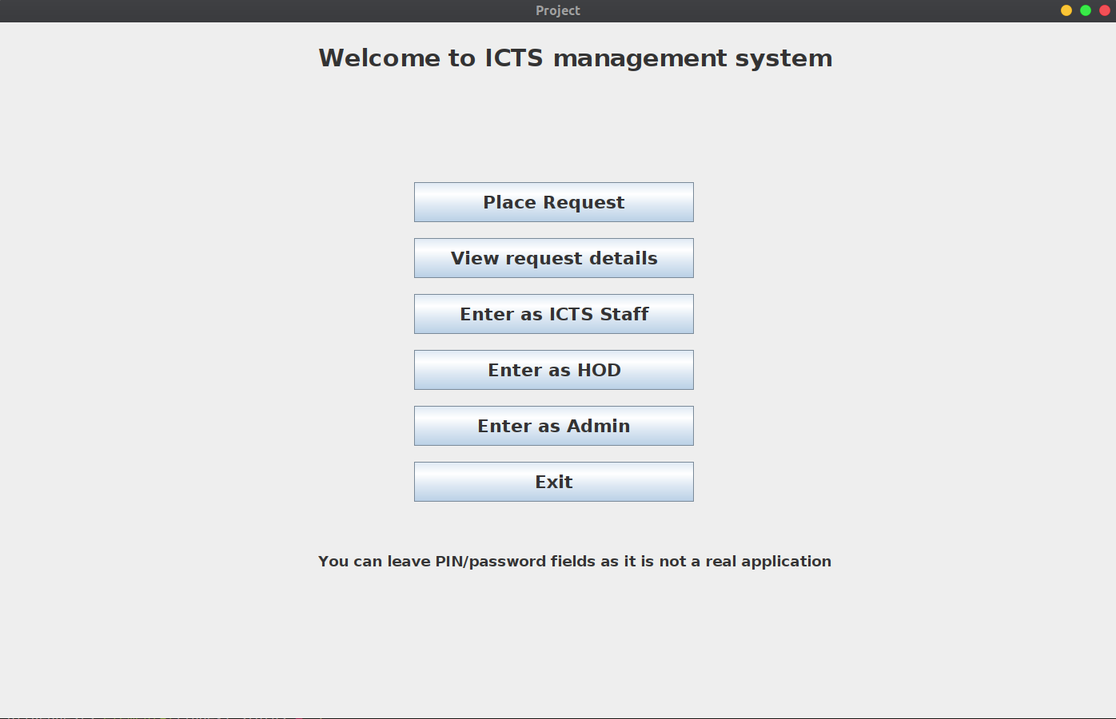

**To place request**

To place request, click on the place request button on the intro page then you will be directed to request placing p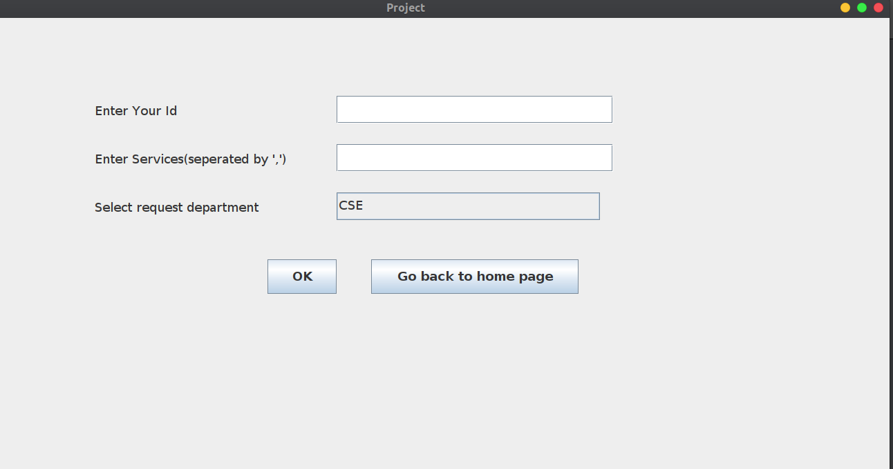age. In the request placing page there will be input fields for id and services.

User should enter their id and services that are seperated by ‘,’ and select the department that request belongs to.

After entering valid id and services if your request is placed, a request number will be generated. Request number should be noted by the user inorder to know details about the request. 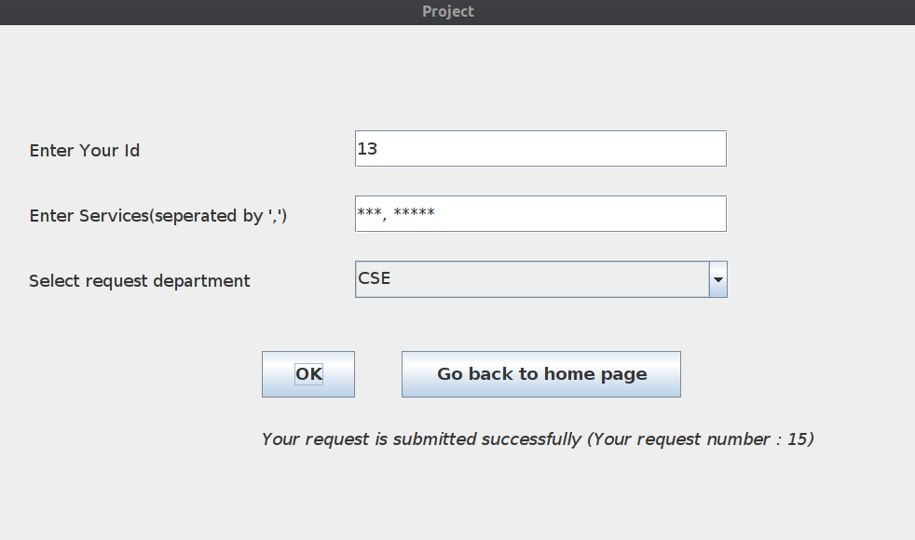If the request id belongs belongs to staff then request will directly move to processing stage else it will move to approval stage.

**To view Request details**

In order to view the request details user can click on the button “view request details” which will direct application to request details page. In the request details page there is a single input field “Enter request number” , In this field user is allowed to enter the request number that is given when request is placed. If the request does not exist then it will give a error message “ Id you provided does not match our database “. If request exists then the request details will be displayed.

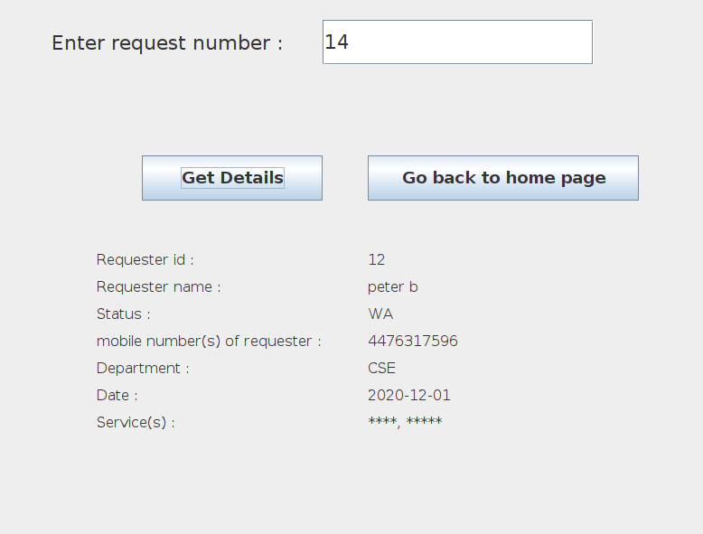

**Requester id** : id of user who placed that request

**Requester name** : name of user that id belongs to

**Status** : status of the request

**Date** : date on which request is placed(automatically generated)

**Department** : department that request belongs to

**Service(s)** : services that are along with request

**Requestee id** (visible if alloted) : id of ICTS staff who is processing this request

**Requestee name** : name of ICTS staff

**mobile no**(s) of requestee and requester : respective mobile no(s) fetched from database

**Completed Date** (visible if completed) : completed date for the request (automatically generated)

**Approval (For HOD’s)**

Approval page can only be accessed by HOD’s. When a request is placed by a student then it will go to department HOD for approval. HOD has to enter id and pin inorder to access the approval page..

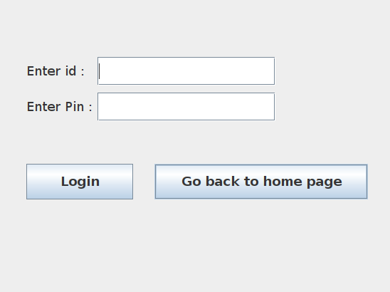

If the id and pin matches then the user will be directed to approval page where approval of requests made.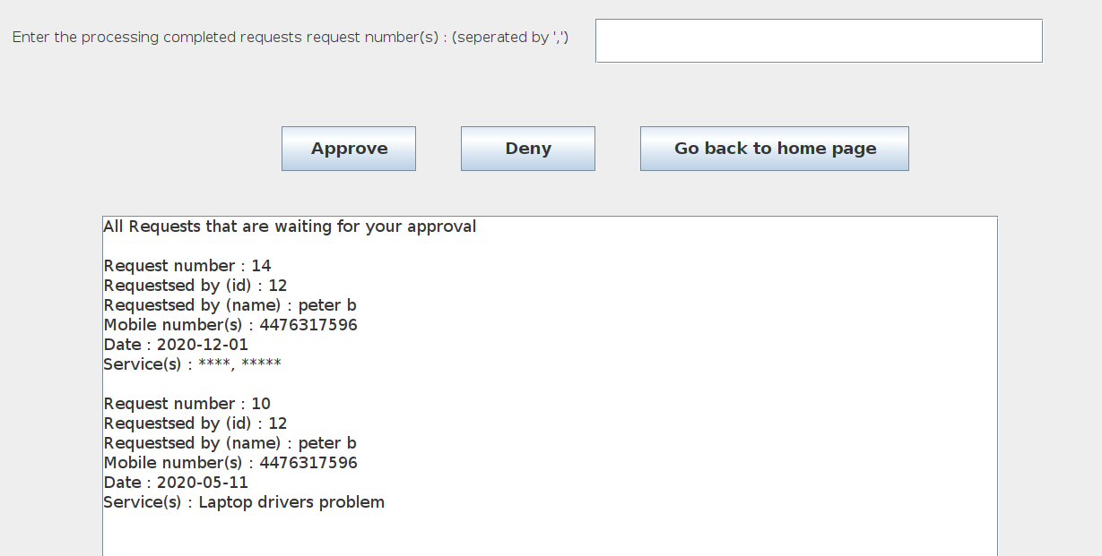

If user want to approve/deny requests then he/she can enter the request number(s) that belong to requests that are seperated by ‘,’ ( If multiple). If the entered requests are valid and belongs to department of the user then they will be approved/denied by clickin on approve/deny buttons.

**Processing(For ICTS Staff)**

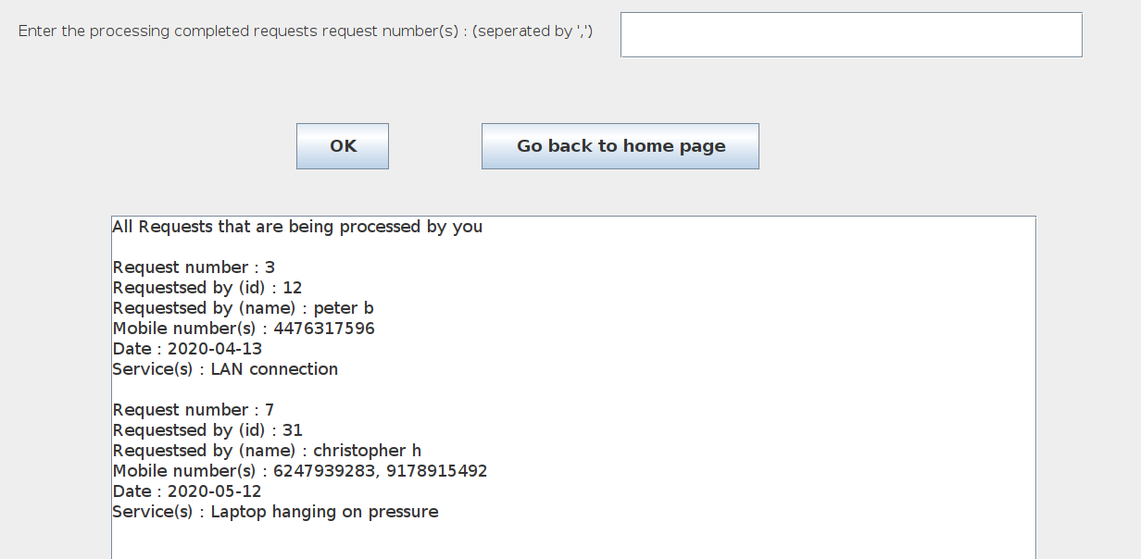

After login, user will be directed to processing page where requests moves from ‘P’ state to ‘C’ state. If a request is processed then user can enter the request number(s) in the field provided(seperated by ’,’ if there are multiple) and click ‘OK’. If the entered request number(s) are valid then the request(s) status will be moved to completed.

**“Go back to home page” button** - this button is present in every page except home page. When user clicks on it, the application will be directed to home page.

**Admin page –** on entering the correct password, user will be directed to admin page where entire database is visible.

**Exit -** By clicking on it the application will be closed.