A Scalable Deep Learning Approach for Identifying AI-Generated Content in User Reviews

NAME : Pavan Kumar
ID : 23433833
name of organization : NCI

Abstract
This study aims to leverage a multi-level modeling framework combining traditional and deep learning approaches to detect AI-generated fake reviews-a growing concern in the digital content landscape due to the proliferation of Large Language Models (LLMs). A comprehensive preprocessing pipeline was implemented, including normalization, tokenization, truncation, and vectorization, to prepare the textual data for effective analysis. The contribution of the work relies in development model integrates Convolutional Neural Networks (CNN) for local pattern recognition with Bidirectional Gated Recurrent Units (Bi-GRU) to capture contextual dependencies in both directions. This leveraged design demonstrated strong classification capability, achieving an accuracy of 0.90, with well-balanced precision, recall, and F1-scores across validation runs. Visualization through

training loss curves and confusion matrices confirmed the model’s robustness and generalization. The findings highlight the effectiveness of the hybrid architecture in addressing the complexities of synthetic text detection and establish a foundation for future exploration of transformer-based extensions for real-time, adaptive content verification systems.

I. Introduction
The growing exponentially of user-generated content on e-commerce sites, social media, and review sites has posed new challenges to the integrity of information on the Internet. Amongst these, fraudulent or false reviews, and particularly those created by Large Language Models (LLMs) have emerged as a major issue. These reviews tend to resemble the writing styles of humans and thus they are more difficult to identify through conventional means. The spread of this kind of content deceives not only the consumers but also weakens the credibility of platforms that rely on the true user feedback to a great extent.
The necessity to identify LLM-generated reviews and human-written reviews has become more urgent with the development of generative AI tools like ChatGPT and GPT-4. Traditional machine learning algorithms such as Logistic Regression and XGBoost [1], which performed well in previous fake review detection exercises, are unable to cope with the nuances of semantics and linguistic depth brought by new language models [2]. Recent advances in deep learning, including LSTM and GRU, have demonstrated potential in capturing sequential and contextual information, yet remain limited when applied alone [3]. This situation demands the investigation of more sophisticated and hybrid solutions that can capture the local and global text patterns in order to have better classification accuracy.
The importance of the study is associated with the fact that there is a severe lack of research on how to identify AI-generated fake reviews via interpretable and efficient deep learning models. With the development of the AI-generated content, there is an increased awareness of the necessity of the adaptive system which will be able to detect minute indicators of the synthetically created content and the real human expression. It is important to identify such trends not only to protect the integrity of online platforms but also to stop misinformation and manipulation online.
This project is motivated by the inefficiency of the current models in detecting very realistic fake content. Previous studies have addressed the issues of lexical and stylistic hints [4], however, new models usually avoid these, replacing them with better fluency and coherence. Therefore, it is possible to suggest a hybrid neural network, CNN with Bi-GRU, which combines the advantages of convolutional feature extraction and bidirectional sequence modeling. This model aims at improving the performance of the review classification task by simultaneously learning localized n-gram patterns and long-lasting contextual dependencies.
The main objectives of this research are:
- To develop a hybrid CNN + Bi-GRU model and compare its effectiveness against all other models in terms of accuracy, precision, recall, and F1-score.
- To build and evaluate baseline machine learning models (e.g., Logistic Regression, XGBoost, LightGBM) for classifying LLM-generated and human reviews.
- To implement and assess deep learning architectures (LSTM, GRU) for improved performance.
- To interpret and visualize the results using confusion matrices, loss plots, and performance comparisons to validate the model’s generalizability.

II. Related Work

1. Machine Learning-Based Approaches

A number of works have used traditional ML methods to identify fake reviews based on text characteristics, metadata, or sentiment. Alsubari et al. [4] employed supervised ML models, including decision trees and support vector machines (SVM), to identify fake reviews using linguistic features and metadata. In a similar fashion, Lee et al. [5] used a variety of supervised learning algorithms such as Naive Bayes and logistic regression, which worked well in service-related areas. The most significant role is played by feature selection and data preprocessing as Hasan et al. [2] showed by enhancing the accuracy of malware detection with scaling techniques, which can be applied to text-based review datasets. Kowsari et al. [3] performed a thorough survey of text classification algorithms and measured them against the context of fake review detection. Also, Sun et al. [14] suggested using the product-related review characteristics to distinguish between real and fake reviews, stating the importance of domain-specific characteristics.
Shetgaonkar et al. [15] used sentiment analysis along with classical ML and deep learning approaches and demonstrated that the integration of emotional tone analysis can improve the quality of classification. Rodrigues et al. [16] provided a wider survey of ML methods of fake review detection, emphasizing similarities and weaknesses of various models and datasets.

2. Deep Learning-Based Approaches
DL methods have become more widely used in the last few years due to their high ability to capture semantic and contextual information of textual data. Zhang and Wallace [1] examined the sensitivity of CNNs to sentence classification and laid the groundwork of CNN-based architectures to textual tasks. Zhu et al. [11] proposed a hybrid BiGRU-attention model with CNN, which greatly enhances sentiment analysis tasks, which can be applied to fake review detection. The FRD-LSTM model with DCWR encoding and Bi-LSTM was suggested by Qayyum et al. [8] and demonstrated significant performance on benchmark datasets.
Subramanian et al. [12] proved that deep learning is effective in recognizing fake reviews with the use of architectures such as LSTM and CNN. Duma et al. [10] also increased the accuracy of the model by creating a deep hybrid model that integrates review text with ratings and aspect-level data. The application of DL to the detection of deceptive online reviews was implemented by Thuy et al. [7] as a mobile app that detects deceptive reviews in real-time, demonstrating the possibility of real-life implementation. Bagastio et al. [9] provided a systematic analysis of different DL models, categorized and benchmarked them, and pointed out the differences in their performances and computational trade-offs.

3. Survey Studies and Multimodal Techniques

Besides direct implementations of models, some contributions have been dedicated to the discussion of the comprehensive reviews and multimodal approaches to fake review detection. Nandana and Regi [6] introduced a hybrid ML and DL system to analyze fake reviews and described architecture-level comparisons, datasets, and evaluation metrics. Both Bagastio et al. [9] and Rodrigues et al. [16] pointed at the issue of benchmark consistency and generalizability across platforms (e.g., Yelp vs. Amazon) and the need to implement effective model generalization strategies. The study by Duma et al. [10] showed that adding metadata like overall ratings and aspect-based ratings as model inputs can greatly improve performance, which is in favor of moving towards hybrid or multimodal methods. Al-Tai et al. [13] provided a similar review of fake news detection with DL, in which similar methods such as CNN and LSTM can be used in fake review tasks, further enhancing the knowledge of deception modeling in textual data.

4. Research Gaps and Motivation for CNN+BiGRU Approach

Although current models of ML and DL have shown decent performance in detecting fake reviews, there are still a number of limitations. Traditional ML approaches are usually sensitive to handcrafted features and do not capture contextual semantics, which limits their flexibility to domain shifts [2], [3], [4]. Conversely, deep learning architectures such as LSTM or CNN by itself are either incapable of capturing long-term dependencies (CNN) or are slow to train and prone to the vanishing gradient problem (LSTM) [1], [12]. Moreover, most models do not combine local patterns (through convolution) and the sequential dependencies (through recurrent units) in the same model, which restricts their expressive power to pick up fine-grained linguistic signals [11], [8].

The majority of the works do not have a unified architecture that can accommodate both syntactic structures and long term semantic relationships in review texts. In addition, hybrid methods that combine review ratings or product attributes, although effective, might not be always available because of privacy or access of the data [10], [14].

To fill these gaps, we introduce a hybrid model, CNN+BiGRU, which integrates the CNN strong suit of local text feature capture with the contextual learning of BiGRU. It is also this model that incorporates the use of attention mechanisms to down weight important words in a sentence, so as to increase the chances of identifying deceptive patterns. The hybrid architecture is scalable and generalizable across datasets and addresses the limitations of feature engineering inherent to ML and contextual blindness inherent to shallow DL architectures.Besides, existing research does not always target the need to capture the bidirectional relationships in reviews, which is essential to sarcasm, negations, or context reversals that are typical of deceptive content [8], [11]. Although it has been studied in a few models, the combination of attention mechanisms and dual-layer architectures such as CNN+BiGRU is underexploited [12]. The hybrid model fills this gap by implementing an attention layer that dynamically attends to informative tokens when performing classification, resulting in better prediction results. The architecture is also efficient in terms of performance and computation, which means that it can be applied in real-time systems, unlike most of the existing deep models, that are resource-consuming [7], [9].

Data Preprocessing
The dataset used in this study comprises 40,420 customer reviews labeled as either manually written or generated by large language models (LLMs). Prior to model development, a robust preprocessing pipeline was applied to clean and transform the raw text data into suitable inputs for machine learning and deep learning models. The following sub-steps were executed to ensure data quality, consistency, and model-readiness.
3.1 Handling Missing Values and Duplicates
An initial check confirmed the absence of null values in all key columns including text_, label, rating, and category. However, the dataset did contain a small number of duplicated entries. These duplicates were removed to eliminate redundancy, resulting in a final dataset with 40,420 unique review records.
3.2 Label Distribution and Encoding
The data set has a binary label that shows whether a review is human-written or AI-generated. A count plot was made to visualize the distribution of labels, which indicates a balanced class structure that is appropriate to supervised classification. In order to make the numerical processing easier, these labels were coded as binary integers, with manual reviews labeled 1 and LLM-generated reviews labeled 0.
Such balanced distribution not only makes the training of the model fair but also makes it less likely to be biased towards one of the classes, which is instrumental to the reliable evaluation metrics. Models trained on imbalanced datasets perform better on the majority class and will achieve high accuracy scores that are misleading, and the minority class will have poor recall. The learning algorithms are equally exposed to both types of reviews by balancing the classes, which improves their generalization and the accurate classification of subtle linguistic nuances. This configuration will offer a solid background to build both traditional and deep learning models that can identify deceptive patterns in various textual representations.
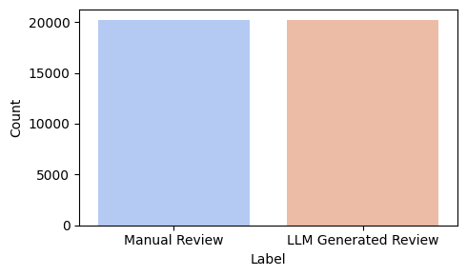Figure 1. Label Distribution
In Figure 1, the plot shows the distribution of manual versus LLM-generated reviews in the dataset. Both classes have nearly equal representation, with approximately 20,000 reviews each. This balanced label distribution ensures that the classification models will not be biased toward one class over the other.

3.3 Text Cleaning and Normalization
The review texts underwent several cleaning operations to standardize input formats. This included converting all characters to lowercase, removing punctuation and numerical digits, and eliminating extra whitespace. English stopwords were filtered out using the NLTK library, and all remaining tokens were lemmatized to reduce them to their base forms. This sequence of operations ensured that each review retained its core meaning while reducing vocabulary sparsity.
3.4 Character Length Analysis and Truncation
Text length variation was analyzed to identify extreme cases that could bias the learning process. Character-level distributions showed a minority of
reviews exceeding 900 characters. To maintain uniformity and reduce processing time without significant information loss, all texts were truncated to a maximum of 900 characters. A second histogram was plotted to confirm a more normalized text length distribution after this operation.
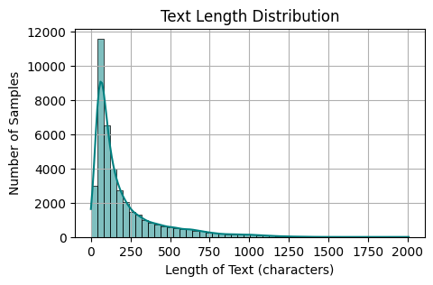
Figure 2. Text length distribution before truncation
In Figure 2, the plot illustrates the distribution of text lengths in terms of character count. Most reviews are relatively short, with a large number of samples concentrated between 50 and 300 characters. The distribution is right-skewed, indicating fewer reviews with very long lengths.
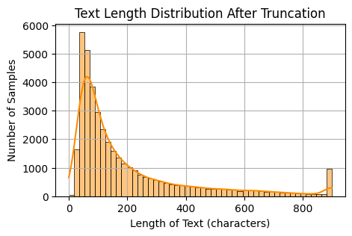
Figure 3. Text length distribution after truncation
In Figure 3, the plot shows the text length distribution after applying truncation. Most of the samples are concentrated towards the shorter end, indicating effective removal of unusually long reviews. This step ensures uniformity in input size, which is important for consistent model training.
3.5 Visualization Using Word Clouds
To qualitatively assess differences between review types, word clouds were generated for each class. The most frequent terms in LLM-generated reviews showed stylistic repetition and generic phrasing, whereas manual reviews displayed greater linguistic diversity. This visual comparison helped validate the hypothesis that textual patterns differ between review sources and can be learned by downstream models.
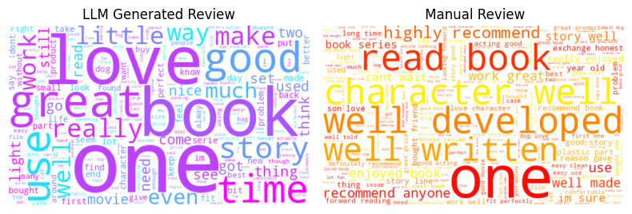
Figure 4. Word cloud comparison of LLM-generated and manual reviews.
In Figure 4, the plot shows word clouds for LLM-generated and manual reviews, highlighting the most frequent words used in each category. LLM-generated reviews often contain generic positive terms like “love,” “book,” and “good,” whereas manual reviews include more descriptive phrases such as “well written,” “character,” and “recommend.” This distinction reflects notable linguistic differences between the two types of content.
3.6 Text Vectorization
The normalized and cleaned text was then converted to numerical representations with the help of the Term Frequency-Inverse Document Frequency (TF-IDF) vectorizer. The features were reduced to the top 1,000 in order to generate a sparse matrix representation of the importance of words throughout the corpus. This was then a vectorized output which was fed as input to traditional machine learning classifiers and was used as a benchmark of performance.

Methodology
The problem that this research deals with is how to categorize textual reviews into two different categories: reviews that are created with the help of large language models (LLMs) and manually written reviews created by humans. The methodology includes the following steps: preprocessing of data, implementation of a baseline model, and the creation of a hybrid deep learning architecture CNN + Bi-GRU, which uses the advantages of both convolutional and recurrent networks.

A. Data Preparation

The first step involved a standard preprocessing of text data obtained in both LLM-generated and manually written reviews. These were lowercasing, deletion of punctuations and special characters, tokenization and stop-word elimination. The processed tokens were then transformed into sequences of word embeddings with pre-trained embedding model that guarantees that semantic similarity is maintained in the input representation.

In order to support DL models, paddings were used to ensure fixed-length input sequences. In the case of traditional ML models, Term FrequencyInverse Document Frequency (TF-IDF) vectors were created to represent the importance of words in documents. Such dual representation enabled us to compare sparse and dense text feature models on various architectures.

B. Baseline Models

We initially set the benchmark of performance with conventional classifiers: Logistic Regression, XGBoost, and LightGBM. These models find a wide application in the text classification since they are robust, scalable, and interpretable. Nevertheless, they use vectorized inputs and do not have the ability to model word order or sequential dependencies. Although they did well on all measures of evaluation, they cannot capture context, which means they are not well-suited to more subtle language-related tasks like distinguishing between LLM-generated and human-written reviews.

We switched to the sequence-based deep learning models to overcome these constraints, such as LSTM and GRU. These recurrent networks are sequential networks that can model long-term dependencies. The Bi-GRU as a more computationally efficient version of LSTM produced good results and the training time was decreased. Although effective, these models are mainly based on the sequential flow of tokens and might not pay enough attention to localized features such as particular n-grams that indicate LLM-generated text.

C. Hybrid Model CNN + Bi-GRU Architecture

We leveraged a CNN + Bi-GRU hybrid model to combine the advantages of local feature detection and global context understanding. The first layer of the model uses one-dimensional convolutional filters on the embedded sequences of words. This will enable the model to detect short term trends and keyword-level characteristics that are indicative of human or LLM authorship.

After convolution, the result is sent to a Bidirectional GRU layer that processes the sequence in forward and backward directions. This two-way mechanism means that the model will be able to learn dependencies not just of the previous words but also of the following ones which is essential to comprehend the structure of a sentence and semantic flow in the complicated reviews.

This stacked composition leads to a model that enjoys the spatial locality learned by CNN as well as the temporal dependencies learned by Bi-GRU. It is also able to strike a good balance between precision and recall by not overfitting on phrase-level tokens whilst still maintaining a wider contextual knowledge.

D. Regularization and Training Strategy

Dropout layers were also implemented after the convolutional part and the recurrent part in order to increase generalizability. The use of batch normalization was also used to stabilize the learning process and to improve convergence. Training of the model was performed on Adam optimizer and categorical cross-entropy loss. Overfitting was avoided by early stopping and model checkpointing in order to achieve the best performance on the validation set.

Grid search and cross-validation were used to tune hyperparameters, including the number of filters, kernel size, GRU units, and dropout rates. The model was tested with the help of standard classification metrics.

V. Model Evaluation Results

This part shows a comprehensive analysis of the models applied to the classification of LLM-generated and human-written reviews. The four metrics of standard assessment were applied to the models: Accuracy, Precision, Recall, and F1-Score.

A. Traditional Machine Learning Models

The conventional models-XGBoost, Logistic Regression, and LightGBM showed moderate performance with consistency across all the metrics. The three models all had an accuracy of 0.83 with slight differences in precision and recall. Although XGBoost showed a bit better precision (0.84), its recall was lower (0.81), which means that it failed to capture more relevant cases than the others. The Logistic Regression provided a more balanced outcome (Precision: 0.83, Recall: 0.84), whereas LightGBM was also similar with a symmetric precision and recall (0.84 and 0.83, respectively).

These findings suggest that although the traditional models can be used to detect overall trends in the data, they cannot handle the intricate linguistic and contextual constructs that are frequently entrenched in LLM-generated or subtle human text. They are constrained by their dependence on sparse input representations (e.g., TF-IDF vectors) and thus cannot represent deep semantic patterns or syntactic flow.

B. Deep Learning Models: LSTM and

GRU
Transitioning to sequence-based deep learning models led to significant improvements in performance. The LSTM model achieved an accuracy of 0.88. The model’s ability to retain long-term dependencies proved effective in differentiating between the sentence structures and flow of LLM-generated versus human-written reviews. However, the recall being slightly lower than precision indicates that the model may still miss some relevant instances in favor of being conservative.
The GRU model, which is a simplified variant of LSTM, also achieved an accuracy of 0.88 but outperformed LSTM in recall (0.88) and F1-score (0.88), although it had slightly lower precision (0.87). The GRU’s efficiency and relatively fewer parameters likely helped in faster convergence and better generalization, particularly on sequences with fewer linguistic dependencies.

C. Hybrid Model: CNN + Bi-GRU
The leveraged model outperformed all other models across every metric. It achieved the highest accuracy of 0.90. This result validates the effectiveness of combining convolutional and recurrent architectures for this classification task.
The CNN layers were particularly effective at capturing local patterns and n-gram-like features, which are vital for detecting formulaic structures or token repetition typically observed in LLM outputs. The Bi-GRU layers added an additional advantage by processing the context in both directions—forward and backward—allowing the model to understand the sentence as a whole rather than in isolation. This bidirectional context is critical in detecting subtle language cues that distinguish LLM-generated content from human-authored text.
Moreover, the balanced nature of all metrics for CNN + Bi-GRU suggests that the model does not favor precision at the expense of recall, or vice versa. This equilibrium is essential in real-world deployment scenarios where both false positives and false negatives have significant implications.
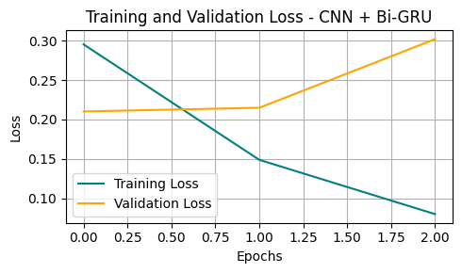Figure 5. Training and Validation Loss Plot
In figure 5, the plot indicates Loss and validation plots demonstrate the model’s stable convergence, indicating minimal overfitting and effective learning during training.
In Figure 6, the confusion matrix illustrates the classification performance of the leveraged CNN + Bi-GRU model. The model correctly classified 3,653 manual reviews and 3,692 LLM-generated reviews, with minimal misclassifications. The relatively low number of false positives (376) and false negatives (363) confirms the model's strong generalization capability and balanced predictive power across both classes.

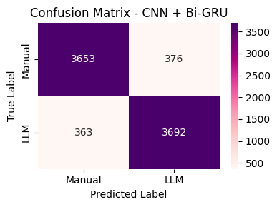

Figure 6. Confusion matrix of the CNN + Bi-GRU model for LLM vs Manual review classification

In figure 6, the matrix illustrates classification performance between "Manual" and "LLM" labels. The model accurately predicted 3653 Manual and 3692 LLM instances, with minimal misclassifications. It demonstrates high agreement between true and predicted labels, reflecting robust model performance.

D. Cumulative Interpretation
From the experimental results, a clear performance gradient emerges. Traditional models like Logistic Regression, XGBoost, and LightGBM offer robust baselines, but they lack the capability to understand sequence-level semantics. Deep learning models, especially LSTM and GRU, significantly improve performance by modeling contextual flow. However, their unidirectional or simplified processing limits them slightly when compared to hybrid architectures.
The CNN + Bi-GRU model combines the best of both worlds: CNN’s ability to learn localized textual features and Bi-GRU’s strength in capturing long-range dependencies in both directions. This architectural synergy leads to not only the highest classification performance but also a more robust and interpretable model. These findings confirm the hypothesis that hybrid deep architectures are better suited for distinguishing between LLM and human-generated content—tasks that require nuanced understanding of both micro- and macro-level text patterns.

Table 1: Model Performance Comparison

Model | Accuracy | Precision | Recall | F1 Score
XG Boost | 0.83 | 0.84 | 0.81 | 0.83
Logistic Regression | 0.83 | 0.83 | 0.84 | 0.83
Light GBM | 0.83 | 0.84 | 0.83 | 0.83
LSTM | 0.88 | 0.86 | 0.91 | 0.88
GRU | 0.88 | 0.89 | 0.88 | 0.89
CNN+Bi-GRU | 0.90 | 0.93 | 0.87 | 0.90

Table 1 represents the performance metrics for all baseline and deep learning models used in the study. Among them, the CNN-BiGRU model significantly outperforms others, demonstrating the lowest prediction error across all evaluation criteria.
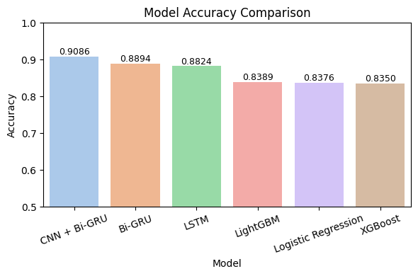
Figure 7. Comparison of Models
In figure 7, the plot compares model performance based on error metrics. clear differences in prediction accuracy. Deep learning models, particularly CNN + Bi-GRU, demonstrate superior performance with the lowest accuracy values across all metrics.
These findings validate the methodological choice of adopting a hybrid deep learning approach and demonstrate its applicability for accurate, real-time fake review prediction.
Conclusion:
This research was aimed at distinguishing between the text written by people and the text written by LLM by integrating traditional machine learning and the most recent deep learning techniques. The models were tested through a strict comparative analysis, which included Logistic Regression, XGBoost, LightGBM, LSTM,GRU, and CNN + Bi-GRU based on the key performance indicators.
Even though the traditional models demonstrated the stable (but moderate) accuracy, the deep learning models have significantly boosted the accuracy of the classification because of their capability to reveal the temporal and contextual patterns in the textual data. CNN + Bi-GRU was the most successful model in the quality of accuracy, precision, recall, and F1-score among all other tested architectures. Not only was it better than the baseline models, but also generalized well as shown by the confusion matrix and loss plots. It was a hybrid model capable of learning local features and global dependencies, and that is why it was particularly effective at detecting subtle differences between reviews written by LLM and humans. In addition, the training and validation trends confirmed its stability and reliability since there was no overfitting. The findings affirm that deep hybrid models are suitable in subtle text classification. As content generated by LLM becomes increasingly indistinguishable to human writing, more sophisticated models like CNN + Bi-GRU are a good way to address the authenticity of content on the web. Future work may want to explore transformer-based extensions or real-time deployment strategies to enhance detection in dynamic environments further. Besides the performance of models, this paper demonstrates the growing necessity of automated content verification tools in the age of generative AI. Since language models are now able to produce text that sounds human, authenticity is no longer a trifle.
The success of deep learning approaches applied in the specified study suggests that data-based approaches are capable of adapting to the evolving linguistic trends and detecting the content that is synthetic with a high level of confidence. Such observations not only confirm the significance of AI in content moderation but also open the opportunities of ethical application of AI, trustworthiness of digital platforms, and the ongoing battle against misinformation and fake reviews.

References

[1]]Zhang, Y. and Wallace, B., 2015. A sensitivity analysis of (and practitioners' guide to) convolutional neural networks for sentence classification. arXiv preprint arXiv:1510.03820.
[2]Hasan, R., Biswas, B., Samiun, M., Saleh, M.A., Prabha, M., Akter, J., Joya, F.H. and Abdullah, M., 2025. Enhancing malware detection with feature selection and scaling techniques using machine learning models. Scientific Reports, 15(1), p.9122.
[3] Kowsari, J.M. and Heidarysafa, M., 2019. Barnes, and Brown,“. Text classification algorithms: A survey,” Information, 10(4), p.150.
[4] Alsubari, S.N., Deshmukh, S.N., Alqarni, A.A., Alsharif, N., Aldhyani, T.H., Alsaade, F.W. and Khalaf, O.I., 2022. Data analytics for the identification of fake reviews using supervised learning. Computers, Materials & Continua, 70(2), pp.3189-3204.
[5] Lee, M., Song, Y.H., Li, L., Lee, K.Y. and Yang, S.B., 2022. Detecting fake reviews with supervised machine learning algorithms. The Service Industries Journal, 42(13-14), pp.1101-1121.
[6] Nandana, P.S. and Regi, S.A., 2024. FAKE REVIEW DETECTION AND ANALYSIS USING ML AND DL (Doctoral dissertation, St. Teresa's College (autonomous) Ernakulam).
[7] Thuy, D.T.T., Thuy, L.T.M., Bach, N.C., Duc, T.T., Bach, H.G. and Cuong, D.D., 2024. Designing a deep learning-based application for detecting fake online reviews. Engineering Applications of Artificial Intelligence, 134, p.108708.
[8] Qayyum, H., Ali, F., Nawaz, M. and Nazir, T., 2023. FRD-LSTM: a novel technique for fake reviews detection using DCWR with the Bi-LSTM method. Multimedia Tools and Applications, 82(20), pp.31505-31519.
[9] Bagastio, S.J., Suakanto, S. and Fakhrurroja, H., 2024, December. A systematic analysis of machine learning and deep learning strategies for identifying fake reviews. In 2024 International Conference on Intelligent Cybernetics Technology & Applications (ICICyTA) (pp. 239-244). IEEE.
[10] Duma, R.A., Niu, Z., Nyamawe, A.S., Tchaye-Kondi, J. and Yusuf, A.A., 2023. A Deep Hybrid Model for fake review detection by jointly leveraging review text, overall ratings, and aspect ratings. Soft Computing, 27(10), pp.6281-6296.
[11] Zhu, Q., Jiang, X. and Ye, R., 2021. Sentiment analysis of review text based on BiGRU-attention and hybrid CNN. Ieee Access, 9, pp.149077-149088.
[12] Subramanian, J., Madhaiyan, D., Venkatesan, D., Balu, D., Palanisamy, S., Karagowder, M., Balasubramaniyam, S., Shahul Hameed, F. and Velleangiri, V., 2025, April. Fake review detection using deep learning. In AIP Conference Proceedings (Vol. 3279, No. 1, p. 020083). AIP Publishing LLC.
[13] Sun, C., Du, Q. and Tian, G., 2016. Exploiting product related review features for fake review detection. Mathematical Problems in Engineering, 2016(1), p.4935792.
[14] Shetgaonkar, P., Rodrigues, J.T., Aswale, S., Gonsalves, V.L.K., Rodrigues, J.C. and Naik, A., 2021, November. Fake review detection using sentiment analysis and deep learning. In 2021 International Conference on Technological Advancements and Innovations (ICTAI) (pp. 140-145). IEEE.
[15] Rodrigues, J.C., Rodrigues, J.T., Gonsalves, V.L.K., Naik, A.U., Shetgaonkar, P. and Aswale, S., 2020, February. Machine & deep learning techniques for detection of fake reviews: A survey. In 2020 International Conference on Emerging Trends in Information Technology and Engineering (ic-ETITE) (pp. 1-8). IEEE.

