**Topics: Descriptive Statistics and Probability**

1. Look at the data given below. Plot the data, find the outliers and find out $μ, σ, σ^{2}$

|  |  |
| --- | --- |
| **Name of company** | **Measure X** |
| Allied Signal | 24.23% |
| Bankers Trust | 25.53% |
| General Mills | 25.41% |
| ITT Industries | 24.14% |
| J.P.Morgan & Co. | 29.62% |
| Lehman Brothers | 28.25% |
| Marriott | 25.81% |
| MCI | 24.39% |
| Merrill Lynch | 40.26% |
| Microsoft | 32.95% |
| Morgan Stanley | 91.36% |
| Sun Microsystems | 25.99% |
| Travelers | 39.42% |
| US Airways | 26.71% |
| Warner-Lambert | 35.00% |

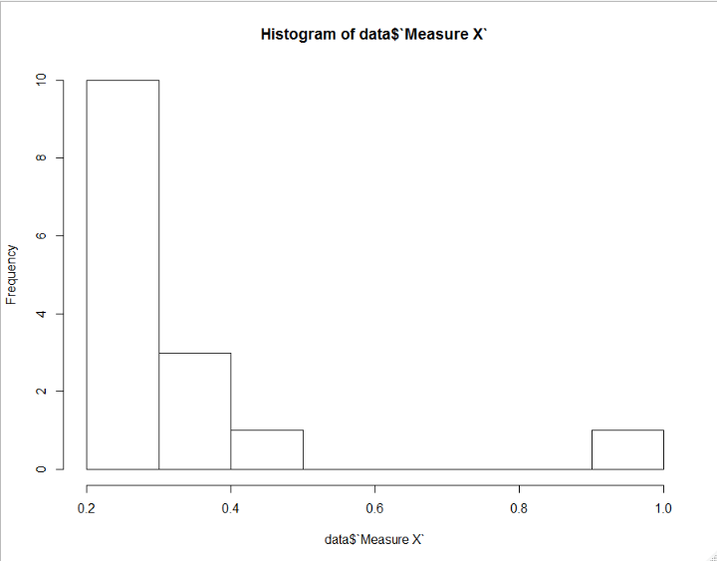

Histogram of the measure x

1)We can get the skewness of the data points it is right skewed because majority of the points lie on right side of the plot.

2)more frequency in 0.2-0.3 bin

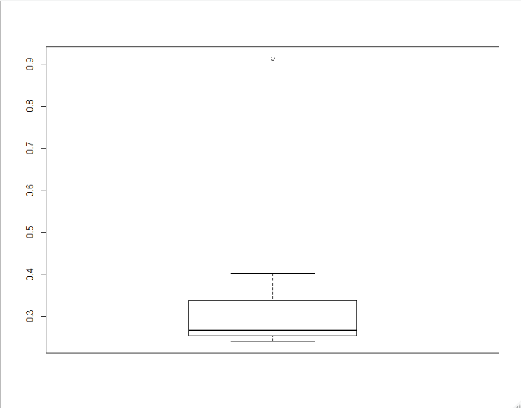

Boxplot

We can find the outlier that is 0.91

$μ$ =0.332

Variance= 0.02871466

S.D=0.169



Answer the following three questions based on the box-plot above.

1. What is inter-quartile range of this dataset? (please approximate the numbers) In one line, explain what this value implies.

Sol:Q3-Q1=12-5=7

1. What can we say about the skewness of this dataset?

Sol: Right skewed

1. If it was found that the data point with the value 25 is actually 2.5, how would the new box-plot be affected?

Sol: outlier will not be reflected



Answer the following three questions based on the histogram above.

1. Where would the mode of this dataset lie?

Sol:4 to 8

1. Comment on the skewness of the dataset.

Sol: Right skewness

1. Suppose that the above histogram and the box-plot in question 2 are plotted for the same dataset. Explain how these graphs complement each other in providing information about any dataset.

Sol: Histogram is use to get mode of the dataset and skewness

Boxplot is used to get the outlier and inter quartile range

Both must be used to get better results

1. AT&T was running commercials in 1990 aimed at luring back customers who had switched to one of the other long-distance phone service providers. One such commercial shows a businessman trying to reach Phoenix and mistakenly getting Fiji, where a half-naked native on a beach responds incomprehensibly in Polynesian. When asked about this advertisement, AT&T admitted that the portrayed incident did not actually take place but added that this was an enactment of something that “could happen.” Suppose that one in 200 long-distance telephone calls is misdirected. What is the probability that at least one in five attempted telephone calls reaches the wrong number? (Assume independence of attempts.)

Sol: Probability of the misdirected call for total 200 calls is=1/200

Probability of the directed call for total 200 calls is=1-1/200=199/200

Probability of that at least one in five attempted telephone calls reaches the wrong number=1-probability of the call reached

=1-(199/200*199/200*199/200*199/200*199/200)

=0.025

1. Returns on a certain business venture, to the nearest $1,000, are known to follow the following probability distribution

|  |  |
| --- | --- |
| x | P(x) |
| -2,000 | 0.1 |
| -1,000 | 0.1 |
| 0 | 0.2 |
| 1000 | 0.2 |
| 2000 | 0.3 |
| 3000 | 0.1 |

1. What is the most likely monetary outcome of the business venture?

Sol:-2000*0.1+-1000*0.1+1000*0.2+2000*0.3+3000*0.1=800

1. Is the venture likely to be successful? Explain

Sol: The probability of the non-negative returns is =0.3+0.1+0.2+0.2=0.8 so the project would be successful but also depends on the income invested.

1. What is the long-term average earning of business ventures of this kind? Explain

Sol: long term average earning of this kind is positive because the probability of the non negative returns is 0.8 and for the given numbers the amount is 800$ and the long term average will be positive.

1. What is the good measure of the risk involved in a venture of this kind? Compute this measure?

Sol: Risk in this concept is negative return and the probability of the negative returns is

0.1+0.1=0.2 20% of risk is involved in this venture.