**Bird Species Identification using Deep Learning**

In this paper author is describing concept to identify species of birds by using python TENSORFLOW and Deep Learning algorithm. Earlier technique were using birds voice or videos to predict it species but this technique will not give accurate result as audio may contains background or other animal voices. So images can be best option to identify species of birds.

To implement this technique we need to train all birds species and generate a model and then by uploading any image deep learning algorithm will convert uploaded image into gray scale format and apply that image on train model to predict best match species name for uploaded image.

To train bird species we are using ‘Caltech-UCSD Birds 200(CUB-200-2011)’ dataset which contains 200 species or categories of birds. Model will be built using that dataset and tensor flow deep learning algorithm.

So the main aim of this project is to identify species of birds.

To test this application i am using below images

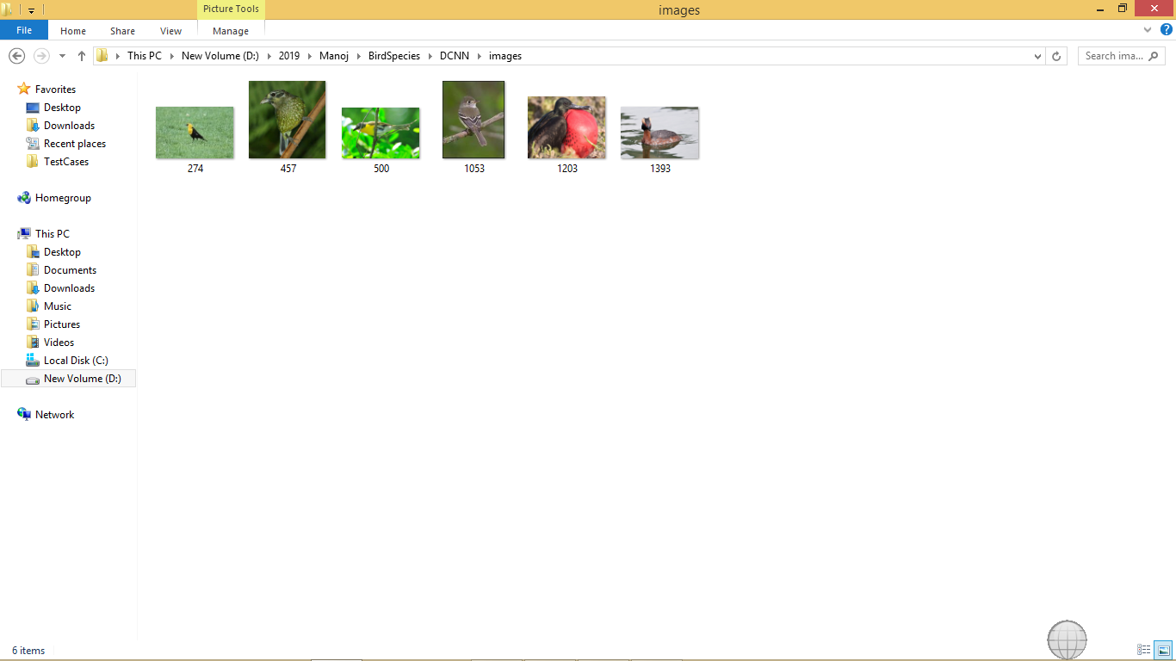

In above screen some bird’s images are there but we don’t know its name or species name. So by uploading this image to application we can get their species name

Screen shots

To run this project double click on ‘run.bat’ file to get below screen

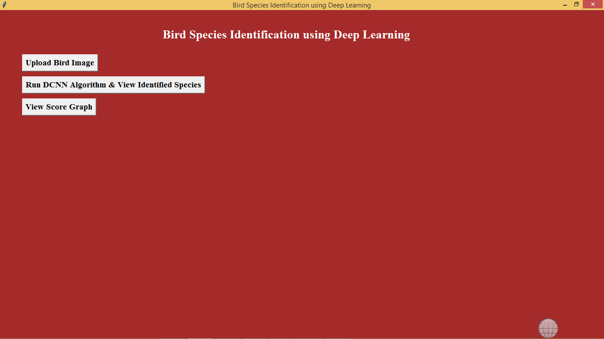

In above screen click on ‘Upload Bird Image’ button to upload bird image

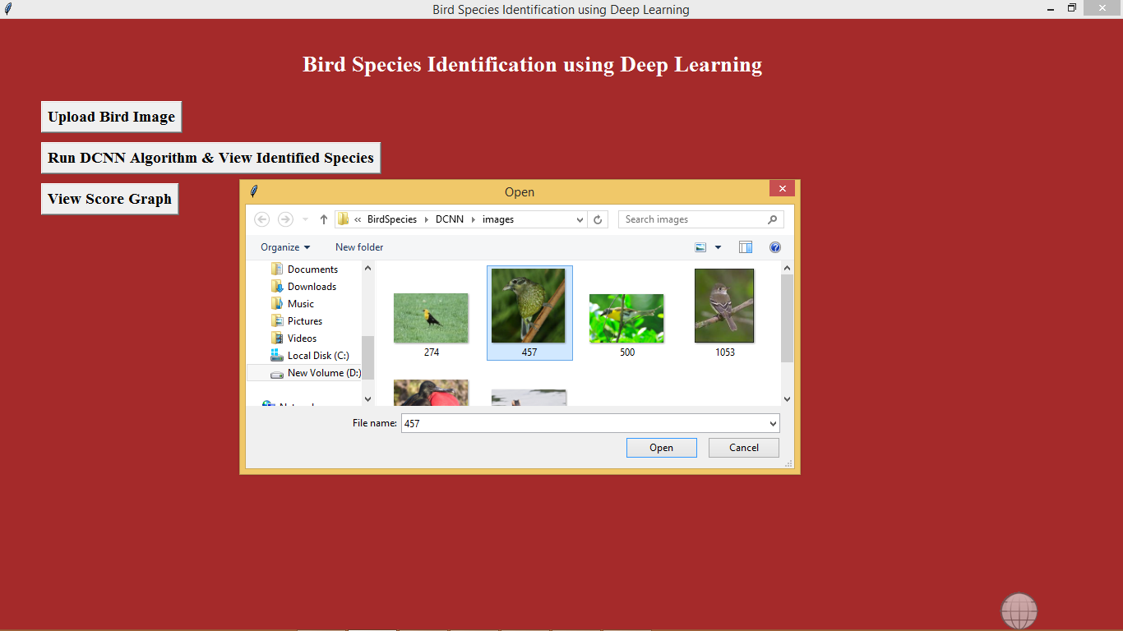

In above screen i am uploading one image of bird called ‘457.jpg’. After upload will get below screen

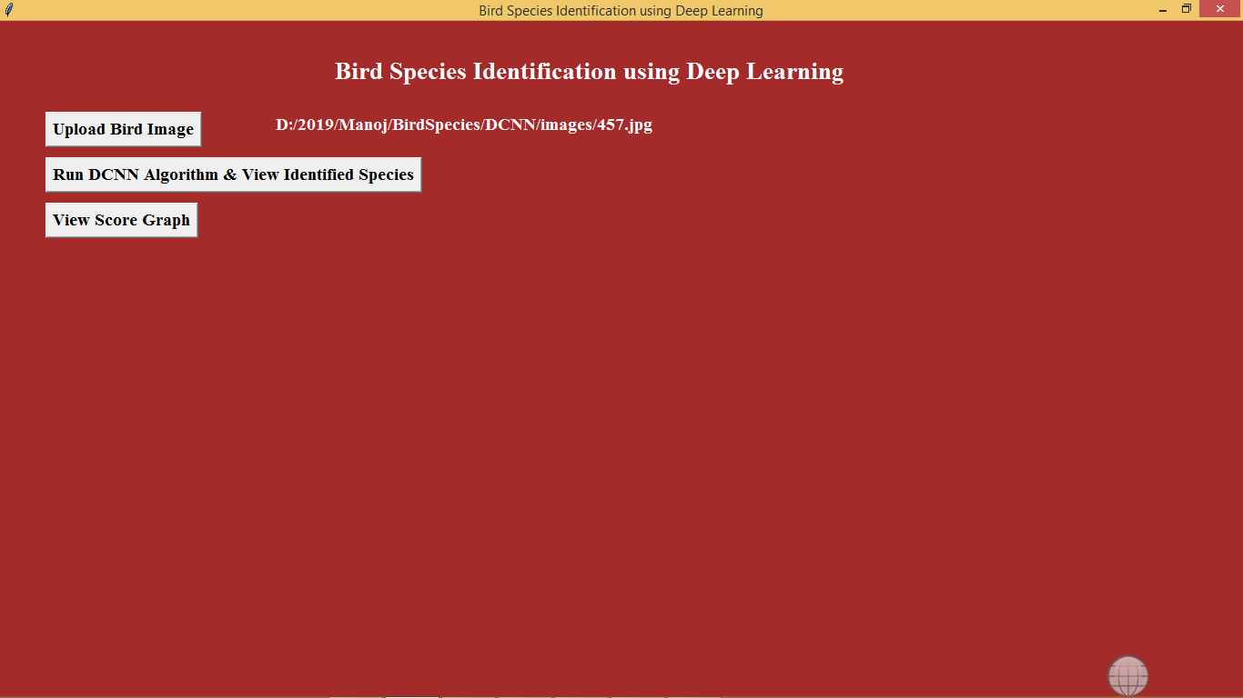

Now click on ‘Run DCNN Algorithm & View Identified Species’ button to know the species name of uploaded bird

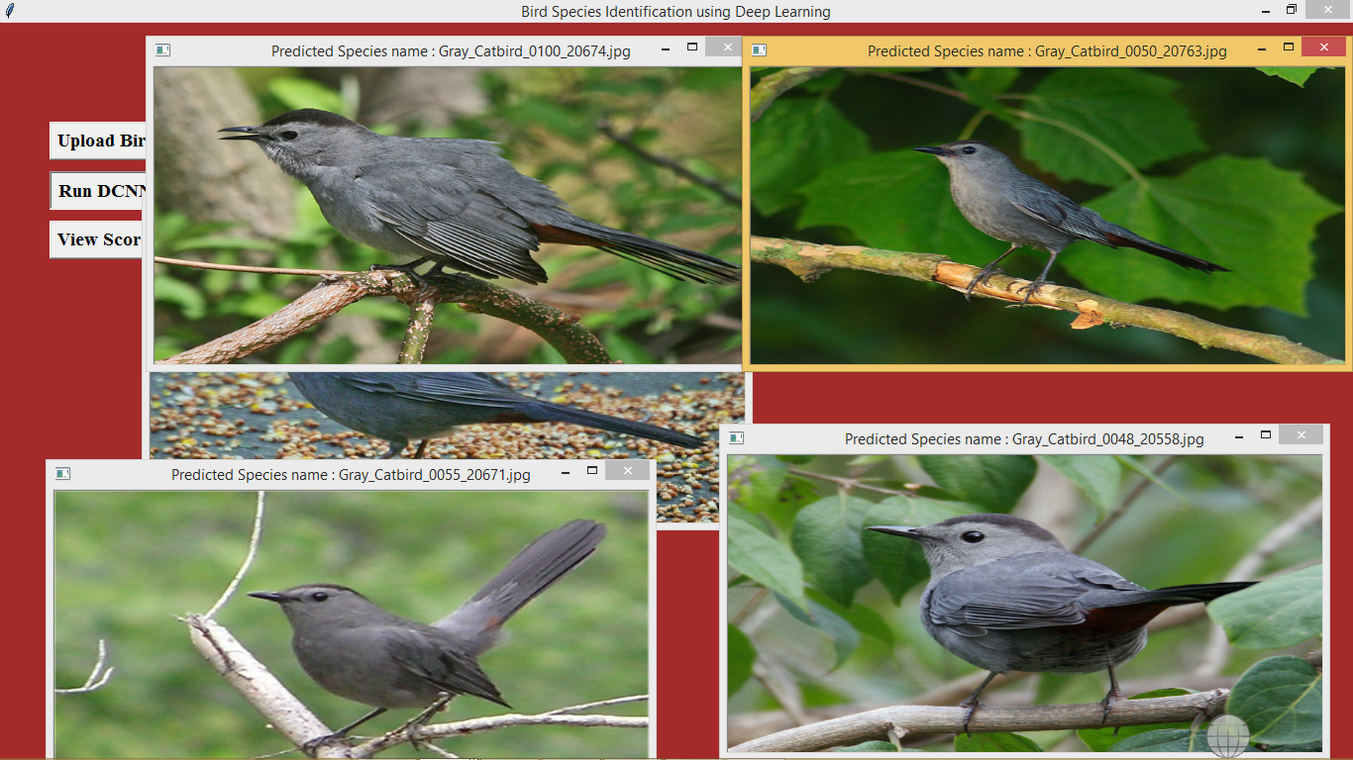

In above screen we got 5 related birds images of uploaded image and we can see the species name of bird on title bar of image. So by uploading any image we can know the name of bird. You can upload any image and get it name and uploading image name should be as integer value.

Now click on ‘View Score Graph’ button to view the graph

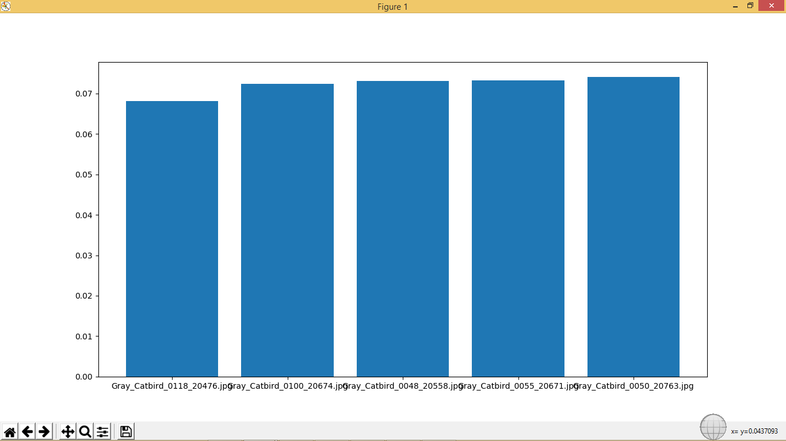

In above graph we got matching score of all 5 related birds and in above graph x-axis represents name of bird and y-axis represents matching score.

Accuracy value of this algorithm you can see in below screen

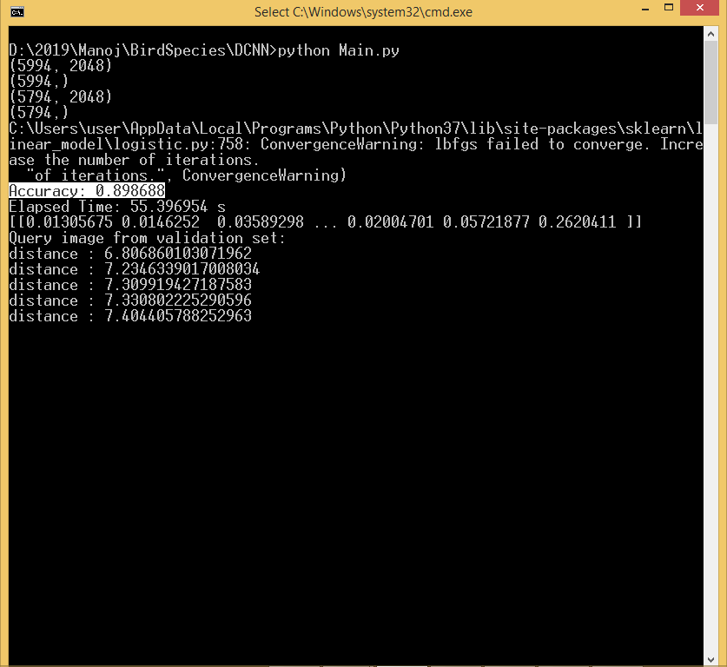

In above screen in selected text you can see Accuracy value.