**1. Write a TCP or UDP client and server program to do the following:**

**-client> java client localhost/IP Port**

**-Enter text: Welcome to Gujarat Technological UNIVERSITY**

**-Response from server: ytisrevinu LACIGOLONHCEt TARAJUg OTEMOCLEw**

**-client> exit**

**Code:**

//server

import java.io.*;

import java.net.*;

public class exam_server

{

public static void main(String[] args)

{

try

{

ServerSocket ss=new ServerSocket(6666);

Socket s=ss.accept();

DataOutputStream dout=new DataOutputStream(s.getOutputStream());

DataInputStream din=new DataInputStream(s.getInputStream());

BufferedReader br=new BufferedReader(new InputStreamReader(System.in));

System.out.println("Ip = "+din.readUTF());

System.out.println("Port = "+din.readInt());

System.out.println("Client Message = "+din.readUTF());

String data=br.readLine();

dout.writeUTF(data);

System.out.println("Client Message = "+din.readUTF());

ss.close();

}

catch(Exception e){System.out.println(e);}

}

}

//client

import java.io.*;

import java.net.*;

public class exam_client

{

public static void main(String[] args)

{

try

{

Socket s=new Socket("localhost",6666);

DataOutputStream dout=new DataOutputStream(s.getOutputStream());

DataInputStream din=new DataInputStream(s.getInputStream());

BufferedReader br=new BufferedReader(new InputStreamReader(System.in));

InetAddress ip=s.getInetAddress();

int port=s.getPort();

dout.writeUTF(ip.toString());

dout.flush();

dout.writeInt(port);

dout.flush();

String data=br.readLine();

dout.writeUTF(data);

dout.flush();

System.out.println("Server Message = "+din.readUTF());

dout.writeUTF("Exit");

dout.flush();

din.close();

dout.close();

s.close();

}

catch(Exception e){System.out.println(e);}

}

}

**Output:**

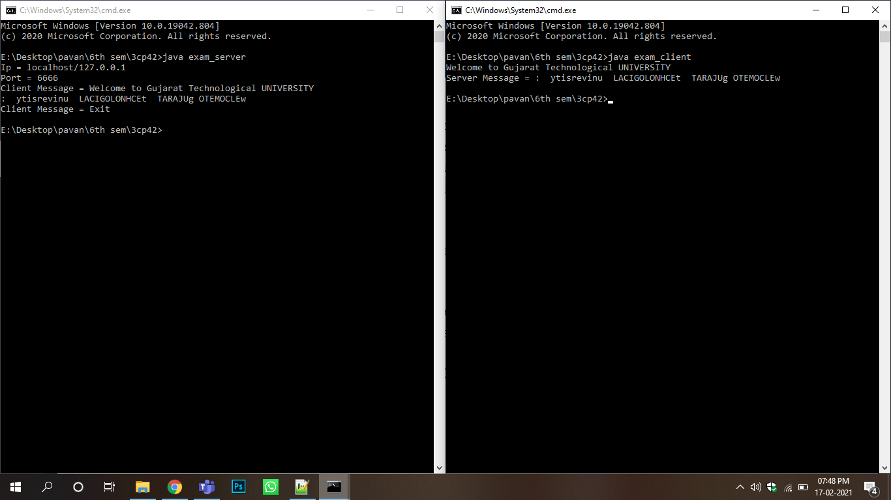

**2. Write a client-server program using TCP sockets to echo the message send by the client.**

**Code:**

//server

import java.io.*;

import java.net.*;

public class Server

{

public static void main(String[] args)

{

try

{

ServerSocket ss=new ServerSocket(6666);

Socket s=ss.accept();//establishes connection

DataInputStream dis=new DataInputStream(s.getInputStream());

String str=(String)dis.readUTF();

System.out.println("message= "+str);

ss.close();

}

catch(Exception e){System.out.println(e);}

}

}

//client

import java.io.*;

import java.net.*;

public class Client

{

public static void main(String[] args)

{

try

{

Socket s=new Socket("localhost",6666);

DataOutputStream dout=new DataOutputStream(s.getOutputStream());

dout.writeUTF("Hello Server");

dout.flush();

dout.close();

s.close();

}

catch(Exception e){System.out.println(e);}

}

}

**Output:**

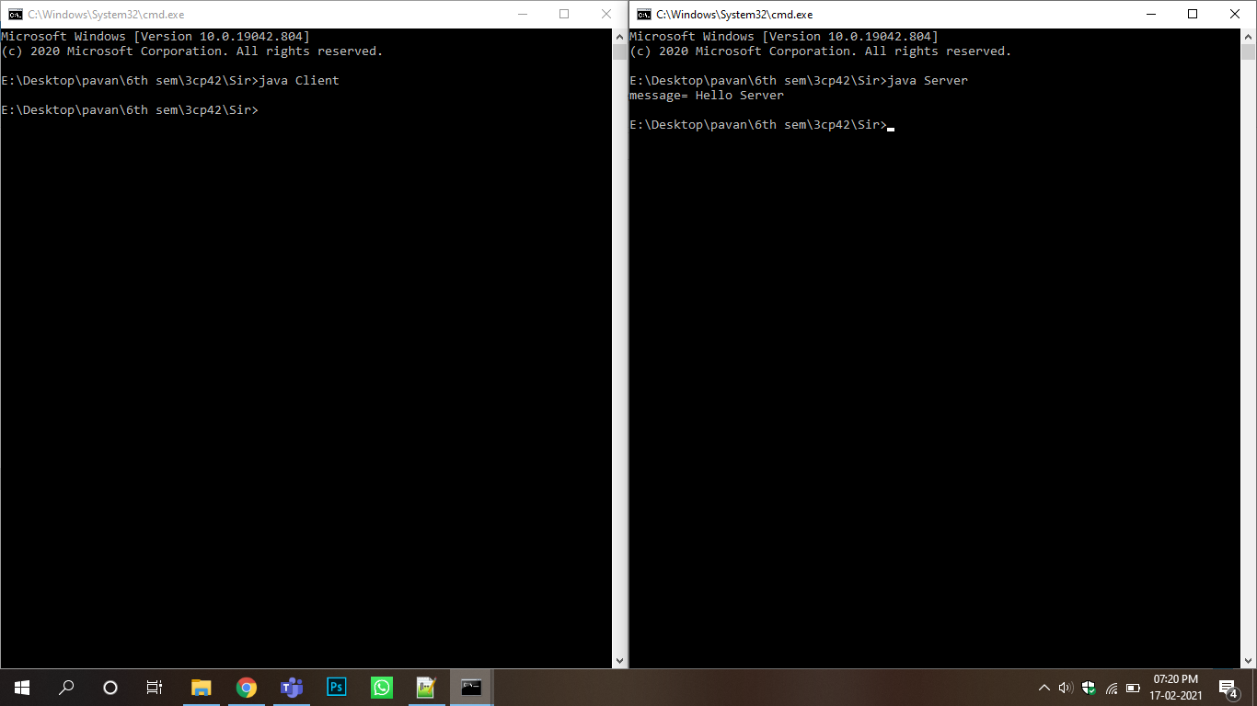

**3. Consider Bank table with attributes AccountNo, CustomerName, Balance, Phone and Address. Write a database application which allows insertion, updation and deletion of records in Bank table. Print values of all customers whose balance is greater than 20,000.(Use PreparedStatement)**

**Code:**

import java.awt.*;

import java.sql.*;

import javax.swing.*;

import java.awt.event.*;

class test extends JFrame implements ActionListener

{

JButton bi,bu,bd,bdis;

JLabel la,ln,lb,lp,ladd,display;

JTextField ta,tn,tb,tp;

JTextArea address;

Connection conn;

Statement st;

PreparedStatement pst;

ResultSet rs;

test()

{

setLayout(new FlowLayout());

bi=new JButton("INSERT");

bu=new JButton("UPDATE");

bd=new JButton("DELETE");

bdis=new JButton("DISPLAY");

la=new JLabel("Enter Your Account No:");

ln=new JLabel("Enter Your Name:");

lb=new JLabel("Enter Balance:");

lp=new JLabel("Enter Your Phone No:");

display=new JLabel("Label");

ladd=new JLabel("Enter Your Address:");

ta=new JTextField(10);

tn=new JTextField(10);

tb=new JTextField(10);

tp=new JTextField(10);

address=new JTextArea(4,20);

add(la);

add(ta);

add(ln);

add(tn);

add(lb);

add(tb);

add(lp);

add(tp);

add(ladd);

add(address);

add(bdis);

add(bi);

add(bu);

add(bd);

add(display);

bi.addActionListener(this);

bu.addActionListener(this);

bd.addActionListener(this);

bdis.addActionListener(this);

setSize(300,300);

setVisible(true);

try{conn=DriverManager.getConnection("jdbc:mysql://localhost:3306/pavan","root","");}

catch(Exception e){System.out.println("NOT CONNECT...pavan!!!");}

}

public void actionPerformed(ActionEvent e)

{

if(e.getSource()==bi)

{

String query="INSERT INTO bank(AccountNo,CustomerName,Balance,Phone,Address) VALUES(?,?,?,?,?)";

try

{

pst=conn.prepareStatement(query);

pst.setInt(1,Integer.parseInt(ta.getText()));

pst.setString(2,tn.getText());

pst.setInt(3,Integer.parseInt(tb.getText()));

pst.setString(4,tp.getText());

pst.setString(5,address.getText());

pst.executeUpdate();

display.setText("DATA INSERTED SUCESSFULLY...");

JOptionPane.showMessageDialog(this,"DATA INSERTEDSUCESSFULLY...");

}

catch(Exception ae){display.setText(ae.getMessage());}

}

if(e.getSource()==bu)

{

String query="UPDATE bank SET CustomerName=?,Balance=?, Phone=?, Address=? WHERE AccountNo=?";

try

{

pst=conn.prepareStatement(query);

pst.setString(1,tn.getText());

pst.setInt(2,Integer.parseInt(tb.getText()));

pst.setString(3,tp.getText());

pst.setString(4,address.getText());

pst.setInt(5,Integer.parseInt(ta.getText()));

pst.executeUpdate();

JOptionPane.showMessageDialog(this,"DATA UPDATED SUCESSFULLY...");

}

catch(Exception oe){display.setText(oe.getMessage());}

}

if(e.getSource()==bd)

{

try

{

st=conn.createStatement();

st.executeUpdate("delete from bank");

JOptionPane.showMessageDialog(this,"DATA DELETED SUCESSFULLY...");

}

catch(Exception oe){display.setText(oe.getMessage());}

}

if(e.getSource()==bdis)

{

try

{

st=conn.createStatement();

rs=st.executeQuery("select * from bank where balance > 20000");

while(rs.next())

{

JOptionPane.showMessageDialog(this,rs.getInt(1)+"\n"+rs.getString(2)+"\n"+rs.getInt(3)+"\n"+rs.getString(4)+"\n"+rs.getString(5)+"\n");

}

}

catch(Exception oe){display.setText(oe.getMessage());}

}

}

}

public class bank

{

public static void main(String args[])

{

test t=new test();

}

}

**Output:**

