**BVM Engineering College**

**Computer Department**

**4CP50: Python Programming**

**Assignment-1**

**1.Python Program to Print Hello world!**

**Code:**

print("Hello World")

**Output:**

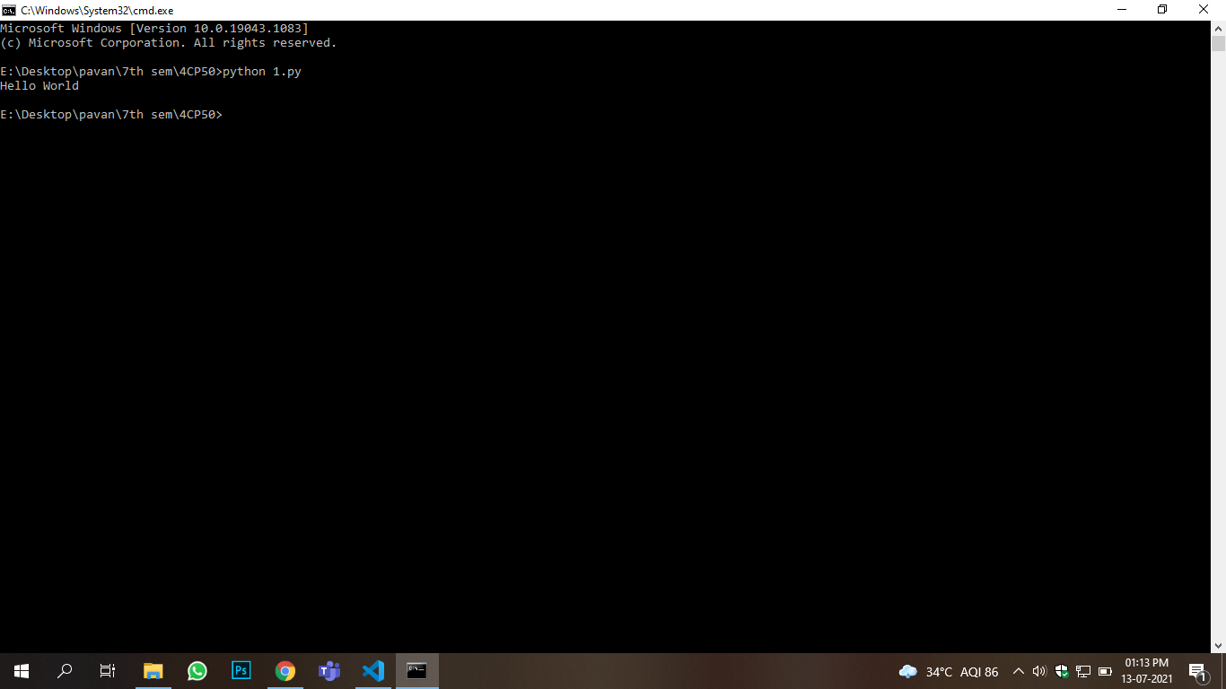

**2.Python Program to Demonstrate the use of list, tuple and dictionary**

**Code:**

list=[1,2,3,4,5,6]

for i in list:

print(i,end=' ')

print(' ')

tuple=(1,2,3,4,5,6)

for i in list:

print(i,end=' ')

print(' ')

dictionary={1:'pavan',2:'avi',3:'mautik'}

for i in dictionary:

print(i,dictionary[i])

**Output:**

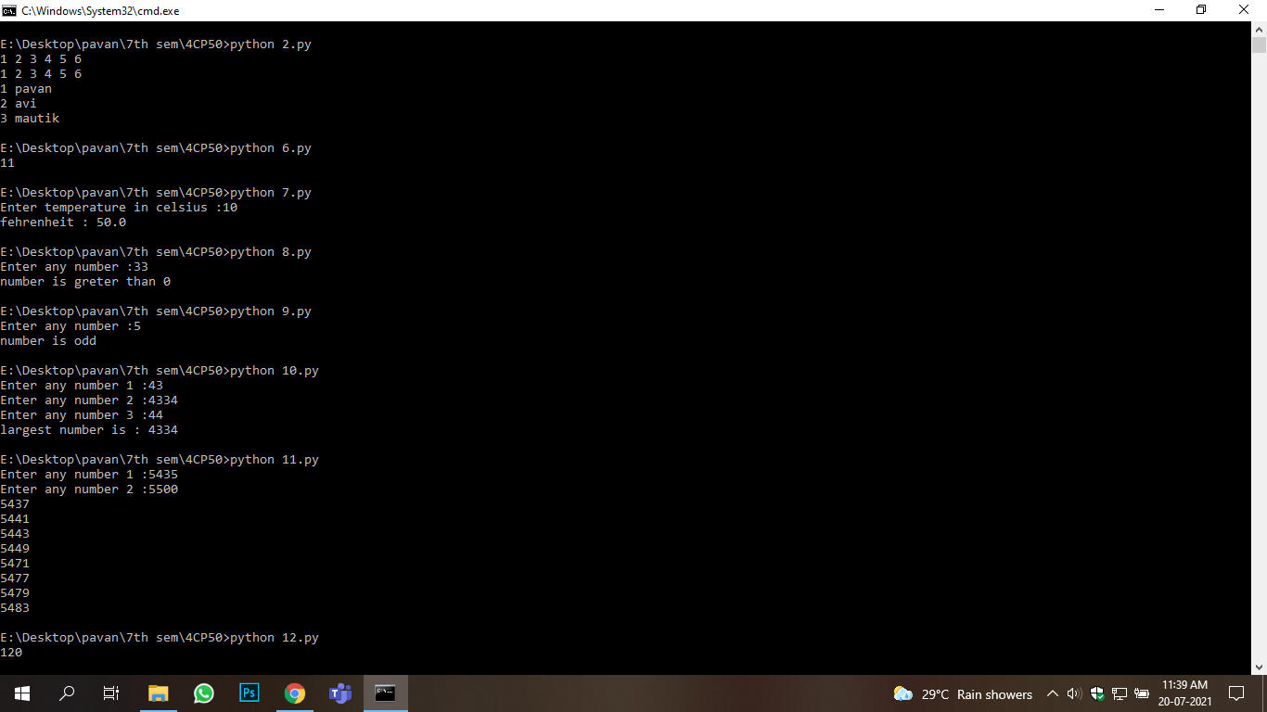

**3.Python Program to Calculate the Area of a Triangle**

**Code:**

a=float(input("Enter Height"))

b=float(input("Enter Base"))

print(0.5*a*b)

**Output:**

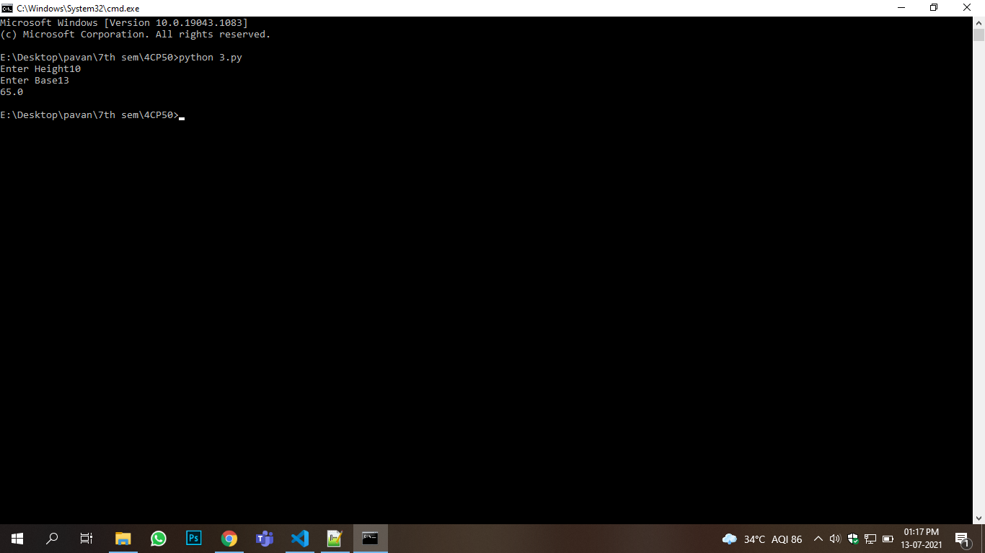

**4.Python Program to Solve Quadratic Equation**

**Code:**

import math

a=float(input("Enter a"))

b=float(input("Enter b"))

c=float(input("Enter c"))

d=b*b-4*a*c

if d<0:

print("No Solution")

else:

d=math.sqrt(d)

print("Solution",(-b+d)/2*a,(-b-d)/2*a)

**Output:**

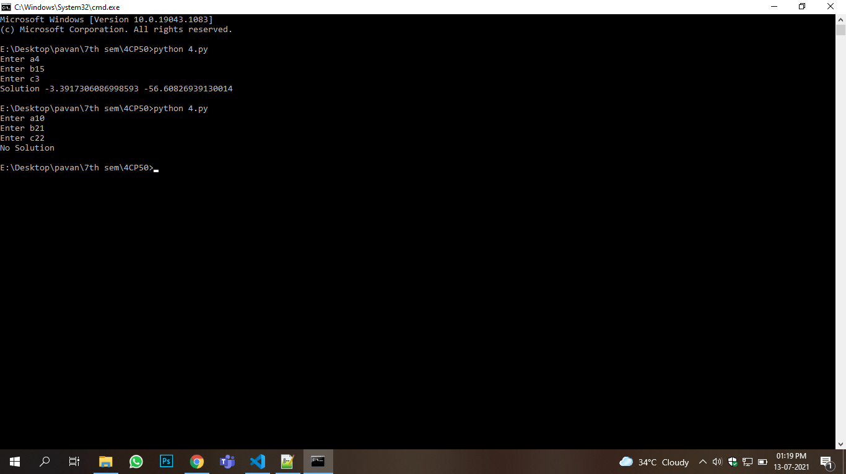

**5.Python Program to Swap Two Variables**

**Code:**

a=float(input("Enter a"))

b=float(input("Enter b"))

a,b=b,a

print("after swap a= ",a,"b= ",b)

**Output:**

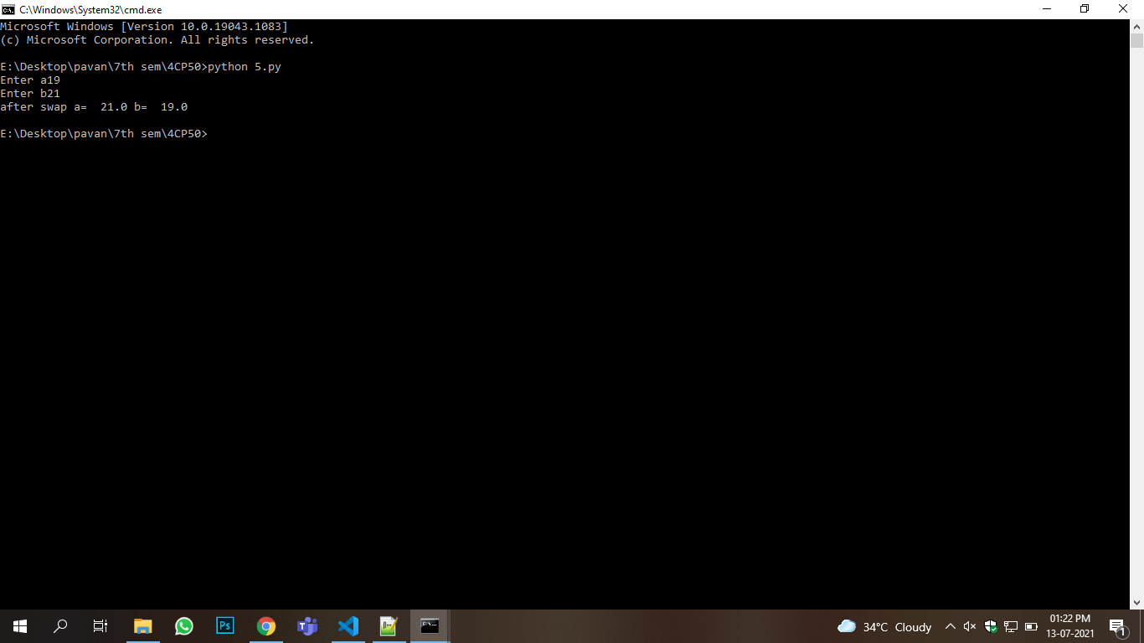

**6.Python Program to Generate a Random Number**

**Code:**

import random

n = random.randint(0,22)

print(n)

**Output:**



**7.Python Program to Convert Celsius To Fahrenheitand vice versa.**

**Code:**

c=float(input("Enter temperature in celsius :"))

f=1.8*c+32

print("fehrenheit :",f)

**Output:**



**8.Python program to check if a number is positive, negative or zero**

**Code:**

a=int(input("Enter any number :"))

if a<0:

print("number is less than 0")

elif a>0:

print("number is greater than 0")

else:

print("number is equal to 0")

**Output:**



**9.Python Program to Check if a Number is Odd or Even**

**Code:**

a=int(input("Enter any number :"))

if a%2==0:

print('number is even')

else:

print('number is odd')

**Output:**



**10.Python Program to Find the Largest Among Three Numbers**

**Code:**

a=int(input("Enter any number 1 :"))

b=int(input("Enter any number 2 :"))

c=int(input("Enter any number 3 :"))

if a>b and a>c:

print("largest number is :",a)

elif b>c:

print("largest number is :",b)

else:

print("largest number is :",c)

**Output:**



**11.Python Program to Print all Prime Numbers in an Interval**

**Code:**

a=int(input("Enter any number 1 :"))

b=int(input("Enter any number 2 :"))

for i in range(a,b+1):

t=0

for j in range(2,i):

if i%j==0:

t=1

break

if t==0:

print(i)

**Output:**



**12.Python program to Find the Factorial of a Numbe**

**Code:**

def factorial(n):

if n==1:

return 1

else:

return n*factorial(n-1)

print(factorial(5))

**Output:**

