**1.Write a program to print Hello World**

print("HelloWorld")

**output:**



**2.Write a program to Print Fibonacci sequence.**

len <- 10

fib<- numeric(len)

fib[1] <- 1

fib[2] <- 1

for (i in 3:len) {

fib[i] <- fib[i-1]+fib[i-2]

}

print(fib)

**output:**



**3a. Write a program to Check weather given year is Leap year or Not.**

print("year is leap or not")

year <- 2020

print(year)

if((year %% 4 == 0 & year %%100 != 0) | year %% 400 == 0) print("YES") else print("NO")

**output:**

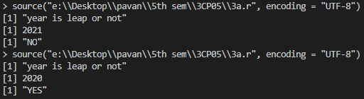

**3b. Write a program to print Multiplication Table of a number and define interval of numbers**

num <-17

for(i in 1:10) {

print(paste(num,'x', i, '=', num*i))

}

**output:**

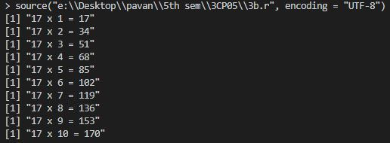

**4.Write a program to print Sum of given Numbers.**

a <- 5

b <- 10

print(a+b)

**output:**



5. WAP to print Armstrong number between given interval

num = as.integer(readline(prompt="Enter a number: "))

sum=0

t=num

while(t > 0) {

r=t%% 10

sum = sum +r*r*r

t =floor(t/10)

}

if(sum==num) print("is armstrong no.") else print("is not armstrong no.")

**output:**

6. WAP to print Prime numbers.

n1 = as.integer(readline(prompt="Enter first number: "))

n2 = as.integer(readline(prompt="Enter second number: "))

for(i in n1:n2 ){

t=0

for(j in 1:i){

if(i %% j == 0) {

t=t+1

}

}

if(t==2){

print(i)}

t=0

}

**output:**

7. WAP to find roots of quadratic equation.

a <- as.integer( readline(prompt="Enter an integer a : "))

b <- as.integer( readline(prompt="Enter an integer b : "))

c <- as.integer( readline(prompt="Enter an integer c : "))

d<- (b^2) - (4*a*c)

if(d < 0) {

print("This quadratic equation has no real numbered roots.")

} else {

r1<- (-b + sqrt(d)) / (2*a)

r2<- (-b - sqrt(d)) / (2*a)

print(paste(r1," ",r2))

}

**output:**

8. WAP to print Factorial of given number.

a <- as.integer( readline(prompt="Enter an integer : "))

f=1

while(a!=0){

f=f*a

a=a-1

}

print(f)

**output:**

9. WAP to print Factors of given numbers

a<- as.integer(readline(prompt="enter a integer :"))

for(i in 1:a)

{

if(a %% i==0) {

print(i)

}

}

**output:**

10. WAP to Convert given number from decimal to binary.

a<- as.integer(readline(prompt="enter a integer :"))

while(a!=0){

b<-0

bit<-1

while (a > 0) {

r<-a %% 2

a<-floor(a / 2)

b<-b + r * bit

bit<-bit * 10

}

print(b)

}

**output:**