//check sir file for number representation

1-// Mautik

2-// Mautik

4 –// Mautik

5.

**Introduction

Predict share value of company in next week using company past data

// add something in it by analyse below

# **Methods & methodologies

# // Multiple Linear Regression - find & write it in brief

**\*\*** Implementation Results & Discussion

# //pavan //I put it in last…… add that

**\*\*** Conclusion

//pavan //I put it in last…. add that

6. //mautik

7. //pavan+ mautik

Pavan:

<https://www.kaggle.com/lesibius/selecting-stocks-from-predicted-p-e-ratio>

<https://datatofish.com/multiple-linear-regression-in-r/>

**\*\*Implementation Results & Discussion**

**Code:**

**library("ggthemes")**

**library(tidyverse)**

**mydata <- read.csv('E:\\Desktop\\pavan\\5th sem\\3CP05\\project.csv', header = TRUE)**

**print(head(mydata))**

**model <- lm( EstimatedSharesOutstanding ~ CashRatio + CurrentRatio + FixedAssets + ForYear + EarningsPerShare +**

**TotalAssets + TotalCurrentAssets + TotalCurrentLiabilities + TotalEquity + Investments + NetCashFlow +**

**ProfitMargin + TotalRevenue , data = mydata )**

**print(summary(model)$coef)**

**newdata <- data.frame(CashRatio=58,CurrentRatio=115,FixedAssets=1156000000,ForYear=2015,EarningsPerShare=4,**

**TotalAssets=8869000000,TotalCurrentAssets=1817000000,TotalCurrentLiabilities=1583000000,**

**TotalEquity=2183000000,Investments=-35000000,NetCashFlow=683000000,ProfitMargin=12,**

**TotalRevenue=6282000000)**

**predicted_Estimated_Shares_Outstanding<-predict(model,newdata)**

**print(predicted_Estimated_Shares_Outstanding<-predict(model,newdata))**

**print("accurecy :")**

**accurecy<-predicted_Estimated_Shares_Outstanding/183255152.7**

**print(accurecy)**

**print(ggplot(mydata, aes(x=EstimatedSharesOutstanding)) + geom_point(aes(y = CashRatio), color = "steelblue")**

**+ geom_point(aes(y = CurrentRatio), color = "darkred")**

**+ geom_point(aes(y = ProfitMargin), color = "black")**

**+ ggtitle("Share market")**

**+ theme_wsj()+ scale_colour_wsj("colors6"))**

**Result:  
data-**

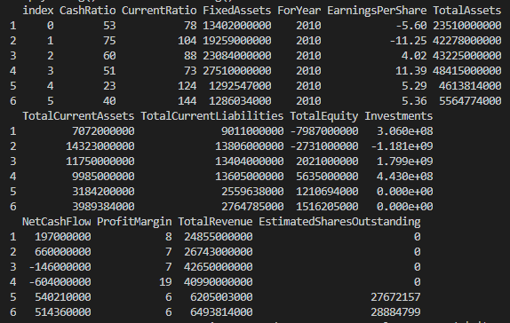

**Coefficient-**

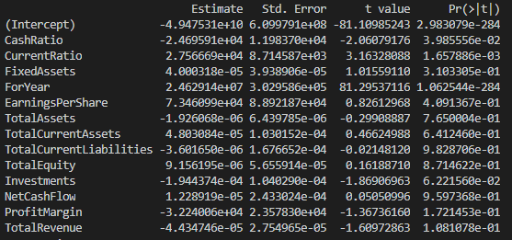

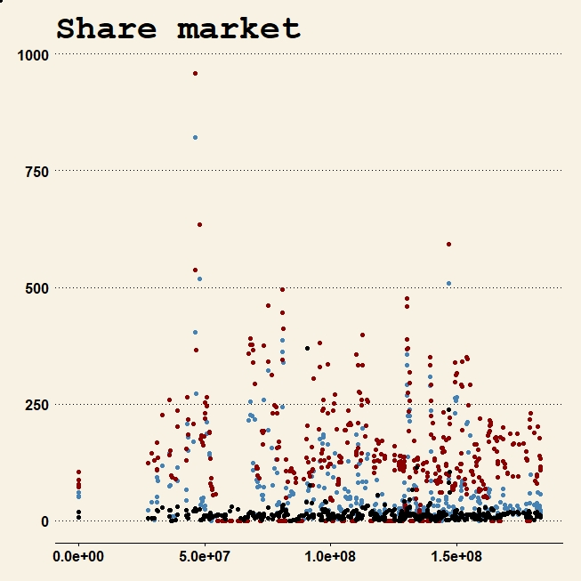

**X = EstimatedSharesOutstanding**

**y = CashRatio , color = "blue"**

**y = CurrentRatio , color = "red"**

**y = ProfitMargin, color = "black"**

**Predicted_value –** **153907699**

**\*\*Conclusion-**

**"accuracy” : 0.8398547**