**Authentication Using Keystroke Dynamics**

**Attendance Management System using Face**

**Recognition**

**DEPRESSION HANDLING SKILL FOR AMAZON ALEXA**

Project team:

* Pavan Gadagi
* Shefali Gaonker
* Shreya Gaunekar

**Authentication Using Keystroke Dynamics**

**Abstract:**

The fact that computers regularly store private, sensitive and classified information makes it very important that we can confidently identify their users. Traditionally, this has been achieved through password authentication systems. However, these systems are far from perfect. For instance, if a password becomes compromised, it is no longer adequate for authenticating its rightful owner. Using Keystroke dynamics authentication technology, system can be secured by password from various attacks. This technique is based on human behaviour to type their password. Here analysis is done using human behaviour with their typing pattern. A Multilayer Perceptron (MLP) neural network is used to train and validate the features. The classifier is used to analyse the features of the user. Authentication of a user is accomplished using a classifier and appropriate adaptation of the user sample is introduced upon successive authentication. As keystroke dynamics does not require any hardware, no extra hardware is used. Only software based technology is required for password protection.

**Introduction:**

Whenever we login onto the computer systems the combination of username & password is required to authenticate the users. This ensures that the users have access to their own data. But there are some weakness of using this scheme like username is not a secret and an imposter who wants to imitate a user can simply guess a password. Also due to simplicity of passwords they are vulnerable to various social engineering attacks like phishing attacks, brute force attack etc. Biometric authentication is the most secure and convenient authentication tool. It can't be borrowed; stolen, forgotten and forging one is practically not easy. Biometrics measure is individual physiological or behavioural characteristics to recognize their identity.

Keystroke dynamics is a behavioural biometrics that captures the typing style of a user. It is a strong behavioural biometric that deals with the unique characteristics present in an individual‘s typing rhythm i.e. when each key was pressed and when it was released as a person types at computer keyboard. How we type on a keyboard is known as keystroke dynamics, which most often use timing information to decide who is typing. By measuring factors such as the amount of time it takes to type the password, how long we depress a key and how long we take to type successive keys.

Traditional Benchmarks or Matrices for Keystroke Dynamics are False Acceptance rate (FAR), False Rejection rate (FRR) and Equal error rate (EER).

1. FAR is the ratio of number of false matches divided by total number of fraud match attempts. Thus FAR gives the number of frauds or imposters who are inaccurately allowed as genuine users.

2. FRR is the ratio of number of false rejections divided by total number of genuine match attempts. Thus FRR gives the number of genuine users who are rejected from using the system. Higher FRR is preferred in high security systems.

3. EER is the ratio of FAR divided by FRR. Lower value of EER signifies a better system

**Method:**

Keystroke dynamics typically includes the analysis of characteristics such as Dwell time – how long a key is pressed, Flight time – how long it takes to move from one key to another, and key code. Usually, each keystroke is represented by two timestamps: the moment that the key was pressed and the moment that it was released. Dwell time refers to a single keystroke and it is defined as the time that passed between the moment the key was pressed and the moment that it was released.

Other timing information like time it takes to write a word, digraph (two letters) or tri-graph (three letters) can also be extracted. Diagraph comes under Press-to-Press category. Digraphs contain two consecutive keystrokes, whereas Tri-graphs contain three; this continues for any number of combinations, which creates n-graphs. Using this terminology, the word ‘search’ would have three digraphs (‘se’, ‘ar’, ‘ch’) and two tri-graphs (‘sea’, ‘rch’). The recorded keystroke timing data is then processed to get the simple patterns derived from statistics of the features such as mean and standard deviations to complex pattern recognition algorithm to classify the typists. All these information can be stored while a user is typing the data.



In this method, as soon as the string is entered the flight time, dwell time and total time are calculated and then final authentication is done depending upon the required credentials and key time interval values. In this case we calculated the timing parameters for each and every character.

The matching between the template stored and sample provided during the session is done in classification phase. There are various methods used for classification such as statistical approach where the computation of mean, standard deviation of the features in the template is done. Another approach is Artificial Neural Network where keystroke features are analysed dynamically. The advantage of this approach is that this approach can handle many parameters and thus giving good results.

**Process:**

Process for user registration:

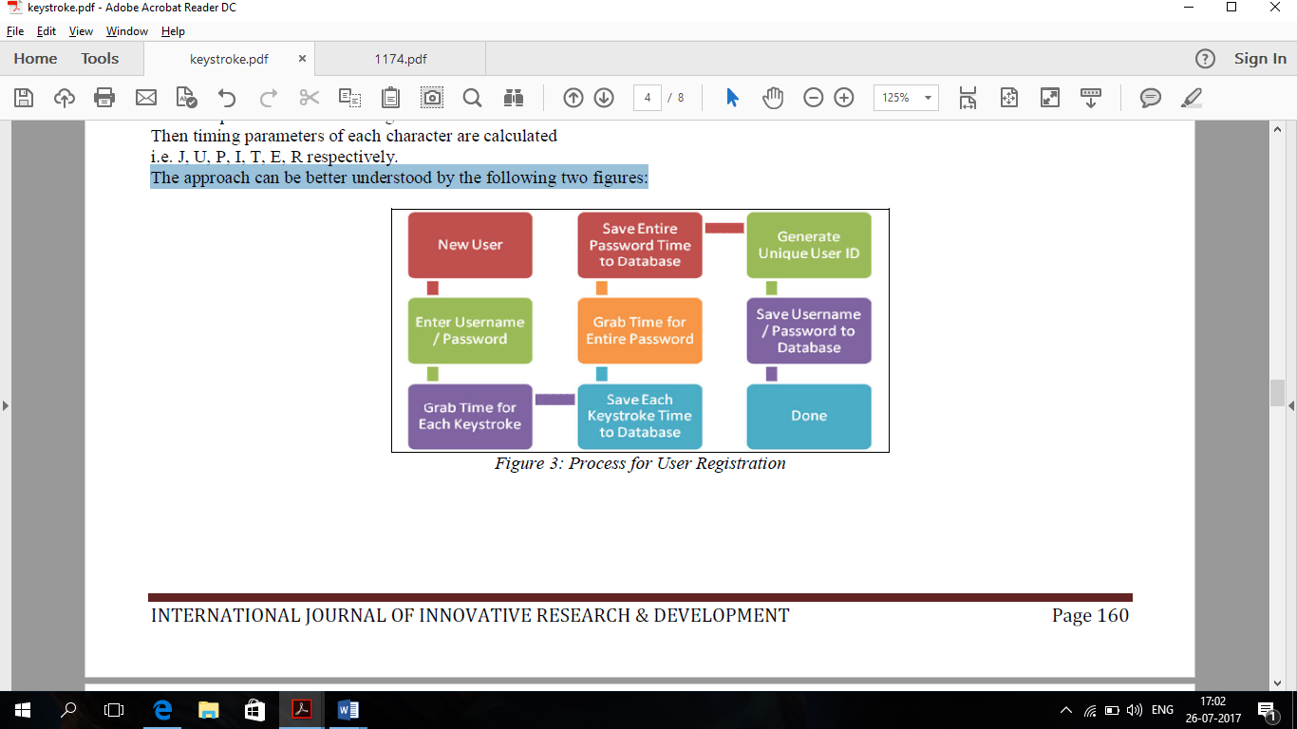

Process for user authentication:

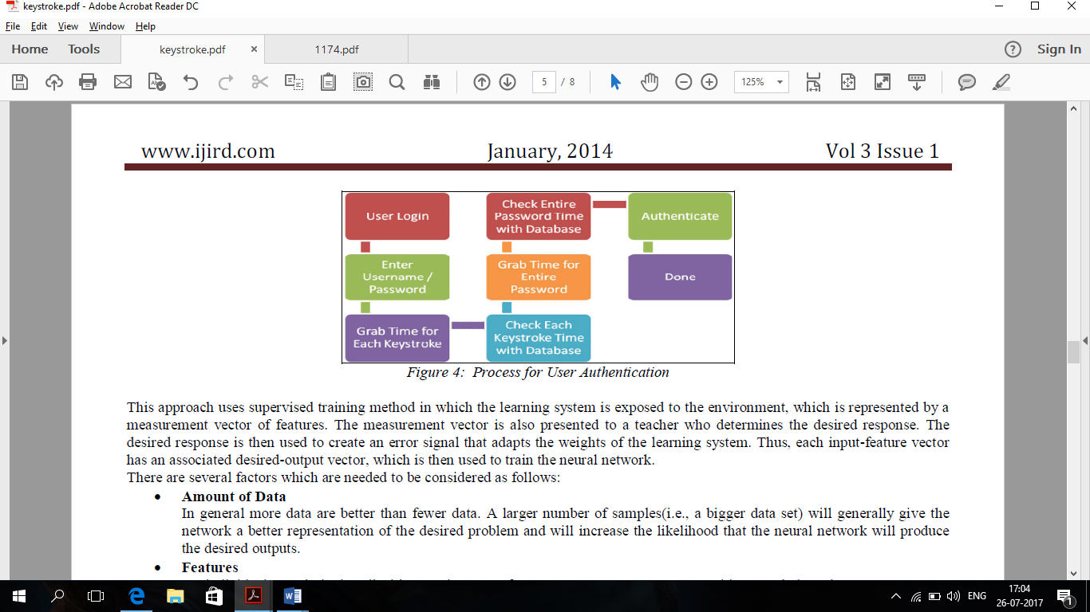

**Advantages:**

* It provide security are cyber security against online attacks, to prevent practice by impostors and to avoid the spyware attacks.
* **It provides multifactor security** that is identification through username/password and authentication through keystroke features.
* The implementation of keystroke dynamics on desktop is cost effective and compatible as integration of external hardware is not required.

**Attendance Management System using Face**

**Recognition**

**Abstract:**

Face recognition is the identification of humans by the unique characteristics of their Faces. Face recognition technology is the least intrusive and fastest bio-metric technology. It works with the most obvious individual identifier the human face. This research aims at providing a system to automatically record the students’ attendance during lecture hours in a hall or room using facial recognition technology instead of the traditional manual methods. The objective behind this research is to thoroughly study the field if pattern recognition (facial recognition) which is very important and is used in various applications like identification and detection.

**Keywords: Image processing, Face recognition, PCA, Eigen Face, Microcontroller**

**Introduction:**

Face Recognition as it is often referred to as, analyses characteristics of a person's face image input through a camera.Verification or identification can be accomplished from two feet away or more, without requiring the user to wait for long periods of time or do anything more than look at the camera. Traditionally student’s attendance is taken manually by using attendance sheet, given by the faculty member in class. The Current attendance marking methods are monotonous & time consuming. Manually recorded attendance can be easily manipulated. Moreover, it is very difficult to verify one by one student in a large classroom environment with distributed branches whether the authenticated students are actually responding or not.

The proposed system consists of a high resolution digital camera put on gate to monitor the classroom or office room. The data or images obtained by the camera are sent to a computer programmed system for further analysis. The obtained images are then compared with a set of reference images of each of the employees or students & mark the corresponding attendance. The system also provides for continuous monitoring of the classroom by an operator if needed. The camera module can be a wireless or wired system.

This face recognition system has the objectives as follows:

* Investigation of unique face features of eye, nose and mouth regions for recognizes individuals. When it comes to separate face regions there are less unique features that help to identify individuals. Identifying unique features of the individuals has being archiving throughout this project.
* Improve capabilities of the detecting features of local segmentations of face It is necessary to find the efficient algorithm to extract features of the face segmentations.
* Implement robust, efferent face recognition system based on facts found in the research.

##### Process:

**1)** Initiate capturing the images through the camera which is able to rotate in all direction in the class room.

**2)** Pre-process the captured images through and extract face image.

**3)** Calculate the eigen value of the captured face image and compared with that of the existing face images.

**4)** If the eigen value does not matches with the existing one,save it as a new face image.

**5)** If the eigen values matches, then the recognition process will start soon.

**6)** Using PCA algorithm the following steps would be followed

**7)** Find the face information of matched face image in the database.

**8)** Update the log table with corresponding face image and system time that makes completion of attendance for an individual students.

|  |
| --- |
| Advantages  * The software can be used for security purposes in organizations and in secured zones. * The software stores the faces that are detected and automatically marks attendance. * The system is convenient and secure for the users. * It saves their time and efforts. |
| Disadvantages  * The system don’t recognize properly in poor light so may give false results. * It can only detect face from a limited distance. |

**Requirements:**

* A standalone computer needs to be installed in the office room where the system is to be deployed.
* Camera must be positioned in the office room to obtain the snapshots. Optimum Resolution: 512 by 512 pixels.
* Secondary memory to store all the images and database

**Conclusion:**

An automatic attendance management system is a necessary tool for any organization. Most of the existing systems are time consuming and require for a semi manual work from the teacher or students. This approach aims to solve the issues by integrating face recognition in the process. Even though this system still lacks the ability to identify each student present on class, there is still much more room for improvement. Since we implement a modular approach we can improve different modules until we reach an acceptable detection and identification rate

**DEPRESSION HANDLING SKILL FOR AMAZON ALEXA**

**Abstract:**

Alexa, the voice service that powers Echo, provides capabilities, or skills, that enable customers to interact with devices in a more intuitive way using voice. Examples of these skills include the ability to play music, answer general questions, set an alarm or timer and more. Alexa is built in the cloud, so it is always getting smarter. The more customers use Alexa, the more she adapts to speech patterns, vocabulary, and personal preferences.

**Keywords: Alexa, Self-learning, Alexa skill, Voice activated**



**Introduction:**

### What Is an Alexa Skill?

Alexa is Amazon’s voice service and the brain behind millions of devices like the Amazon Echo, Echo Dot, and [Echo Show](https://developer.amazon.com/echo-show). Alexa provides capabilities, or skills, that enable customers to create a more personalized experience. There are now [more than 15,000 skills](https://www.amazon.com/alexa-skills/b/ref=skillsrw_surl?ie=UTF8&node=13727921011) from companies like Starbucks, Uber, and Capital One as well as innovative designers and developers.

### What Is the Alexa Skills Kit?

With the Alexa Skills Kit (ASK), designers, developers, and brands can build engaging skills and reach millions of customers. ASK is a collection of self-service APIs, tools, documentation, and code samples that makes it fast and easy for you to add skills to Alexa. With ASK, you can leverage Amazon’s knowledge and pioneering work in the field of voice design.

**Depression handling**

We will be using amazon skill API’s and AWS lambda cloud services to develop the skill. The data to give proper response back will be taken from sites such as helpguide , thiswayup, lifehacks and etc. The language used for the development is Node.js and Python

##### Process:

**1)** Design the ‘Intent of the skill’

**2)** Sign up with amazon web services.

**3)** Load the lambda function.

**4)** Build the code to make multiple https requests to get dynamic data.

**5)** Teach Alexa to improve every time.

**6)** Test the build using Amazon Developer privileges.

**7)** Publish the build if successful.

|  |
| --- |
| Advantages  * Amazon device quickly and accurately provides access to Amazon-hosted music libraries, places items in the Amazon shopping cart associated with the Echo, and helps track shipments. * Alexa is a cloud service, so every time you use her, she learns new things. * Alexa is easy to use and highly adaptable * It saves their time and efforts. |
| Disadvantages  * While using a custom skill, you need to call the skill name also, thus comes a need to keep track of all the skills. * Not very developed in India, making it difficult to access. |

**Requirements:**

* Amazon Echo or Amazon echo dot.
* Amazon web services.

**Conclusion:**

An Alexa skill for depression handling system aims to solve the problem of depression specially among teenagers, who suffer from it almost every day.

As Alexa is a speaking tool, people will find it more relatable and easy to confide with her and solve their problems.

Alexa being a cloud service will learn by continuous usage to give better response each time it is used, thus being more helpful as the time goes by.