[Depression handling](https://www.google.co.in/search?q=depression+handling&spell=1&sa=X&ved=0ahUKEwih2YP2mdnVAhUDOI8KHTX5AjwQvwUIIigA) skill using Amazon Alexa

Group No: 12

1. Pavan Gadagi
2. Shefali Gaonker
3. Shreya Gouneker

Literature Survey:

Amazon’s Alexa-controlled [Echo speaker](https://wclink.co/link/13553/0/1/25449/) is a wireless speaker. But it’s capable of much more. Using nothing but the sound of your voice, you can search the Web, create to-do and shopping lists, shop online, get instant weather reports, and control popular smart-home products—all while your phone stays in your pocket.

[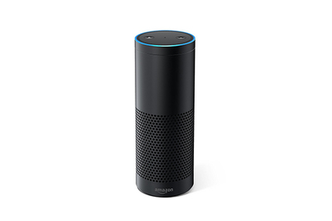](https://wclink.co/link/13553/38695/1/25454)

Echo, always listening via Amazon’s Alexa voice service, lets you play music, order pizza, and get questions answered, and can control popular smart-home devices and 1,000-plus other things.

Alexa (named after the ancient library of Alexandria) is Amazon’s voice control system. It lets you speak your wishes and see them fulfilled—at least simple ones, like dimming your lights or playing music tracks. It turns the Echo, Dot, and Tap streaming audio players into de facto smart-home hubs and Internet assistants. And it’s what turned Echo into not just one of this year’s biggest tech products, but possibly the biggest news so far for those interested in smart-home control.

**How Alexa works**

Amazon built a natural-language processing system that is one of the easiest to interact with we’ve seen. If you ask a question or deliver a command, you usually don’t have to ask twice. Part of Alexa’s success is dependent on the seven very sensitive microphones built into both the Echo and the Dot (a February 2017 update requires Tap owners to turn this feature on in the settings menu). Alexa is always listening, and is quick to respond.

# Alexa Skills Kit

The Alexa Skills Kit is a [software development kit (SDK)](http://whatis.techtarget.com/definition/software-developers-kit-SDK) that enables a developer to build skills, also called conversational applications, on the [Amazon Alexa](http://whatis.techtarget.com/definition/Alexa-Voice-Services-AVS) artificial intelligence assistant.

The Alexa Skills Kit is comprised of tools, [application program interfaces (APIs](http://searchexchange.techtarget.com/definition/application-program-interface)), code samples and documentation that enables a developer to add skills to the 10,000-plus [voice recognition](http://searchcrm.techtarget.com/definition/voice-recognition) capabilities available on Alexa.

Amazon Alexa is based in the [Amazon Web Services (AWS)](http://whatis.techtarget.com/definition/Amazon-Web-Services-AWS) public cloud. A developer can upload Alexa skill code to [AWS Lambda](http://searchaws.techtarget.com/definition/AWS-Lambda-Amazon-Web-Services-Lambda) functions to execute code that is triggered by voice interactions. AWS automatically manages the compute resources for Lambda. A developer can certify, publish and update skills, which are made available through the Alexa Skills Store.

An organization can build an Alexa skill to connect to end users via the conversational Amazon Echo platform. A developer programs the voice user interface to return a variety of voices, accents and responses based on the code for the skill.

Alexa provides a set of built-in capabilities, referred to as *skills*. For example, Alexa’s abilities include playing music from multiple providers, answering questions, providing weather forecasts, and querying Wikipedia.

The Alexa Skills Kit lets you teach Alexa *new skills*. Customers can access these new abilities by asking Alexa questions or making requests. You can build skills that provide users with many different types of abilities.

Detailed Functionality of the System:

Depression handling skill:

We aim on developing a Skill that tries the handle the depression of the user. In which the user will talk with the device and express its feeling, then Alexa will listen to the user and try to give a proper response back to the user.

When designing and building a custom skill, you create the following:

* A set of *intents* that represent actions that users can do with your skill. These intents represent the core functionality for your skill.
* A set of *sample utterances* that specify the words and phrases users can say to invoke those intents. You map these utterances to your intents. This mapping forms the *interaction model* for the skill.
* An *invocation name* that identifies the skill. The user includes this name when initiating a conversation with your skill.
* If applicable, a set of images, audio files, and video files that you want to include in the skill. These must be stored on a publicly accessible site so that each item is accessible by a unique URL.
* A *cloud-based service* that accepts these intents as structured requests and then acts upon them. This service must be accessible over the Internet. You provide an endpoint for your service when configuring the skill.
* A configuration that brings all of the above together so that Alexa can route requests to the service for your skill. You create this configuration in the [developer portal](https://developer.amazon.com/edw/home.html#/).

For Example:

This intent would be mapped to several sample utterances such as:

OneshotTideIntent get high tide

OneshotTideIntent get high tide for {City}

OneshotTideIntent tide information for {City}

OneshotTideIntent when is high tide in {City}

...

(many more sample utterances)

A user would say something like:

User: Alexa, *get high tide for Seattle* from **Tide Pooler**(In this example, the *italicized* words form the sample utterance you have defined, while the invocation name is shown in **bold**).

Speaking this to an Alexa-enabled device does the following:

1. The user’s speech is streamed to the Alexa service in the cloud.
2. Alexa recognizes that this request represents the OneshotTideIntent intent for the “Tide Pooler” skill.
3. Alexa structures this information into a request (specifically an IntentRequest in this example) and sends this request to the service defined for Tide Pooler. The request includes the value “seattle” as the “City”.
4. The Tide Pooler service gets the request and takes an appropriate action (looking up tide information for the current date in Seattle from http://tidesandcurrents.noaa.gov/).
5. Tide Pooler sends the Alexa service a structured response with the text to speak to the user.
6. The Alexa-enabled device speaks the response back to the user:

Block Diagram:

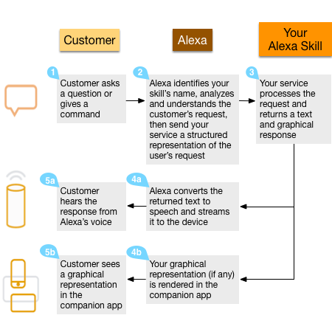

Requirements:

Hardware:

* Amazon echo dot/Amazon Echo;

Software:

* Node.js
* Python
* AWS Lambda
* Html
* Css
* JavaScript

Workable/sellablelity of product:

We aim on making the skill completely workable and also publish the product on Amazon skill store for free for all users around the world to use.

Advantages:

* All users having Amazon devices can access the skill all around the world.
* Easy to use(all you need to do is talk with the device)
* Learns as the users use the skill
* Free to use

Limitations:

* Users need to have Amazon devices.

References:

* <https://developer.amazon.com/public/solutions/alexa/alexa-skills-kit/getting-started-guide>
* <https://developer.amazon.com/public/solutions/alexa/alexa-skills-kit/overviews/understanding-custom-skills>
* <https://www.amazon.com/b?node=13727921011>