Tophat

originall = imread('rice11.png');

original=rgb2gray(originall);

imshow(original)

se = strel('line',12,90);

tophatFiltered = imtophat(original,se);

figure

imshow(tophatFiltered)

contrastAdjusted = imadjust(tophatFiltered);

Figure

imshow(contrastAdjusted)

Output:

Original image:

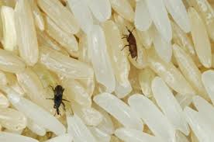

Runned outputs:

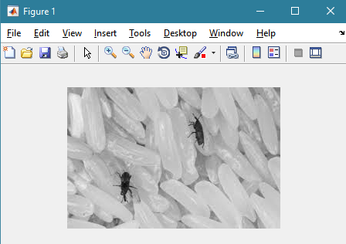

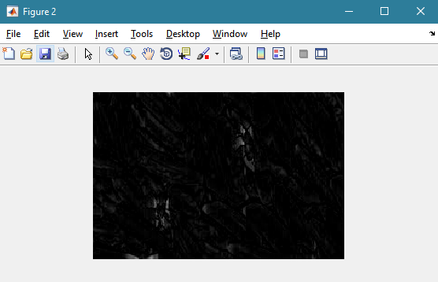

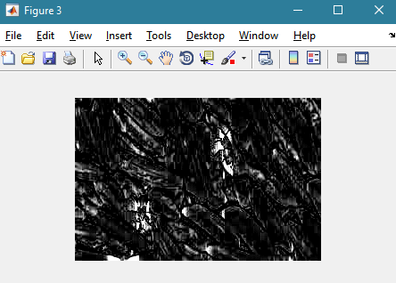

Area Or object detection:

boxImage1 = imread('insects.png');

boxImage=rgb2gray(boxImage1);

figure;

imshow(boxImage);

title('original rice with insects image');

sceneImage1 = imread('crop1.png');

sceneImage=rgb2gray(sceneImage1);

figure;

imshow(sceneImage);

title('insects image');

boxPoints = detectSURFFeatures(boxImage);

scenePoints = detectSURFFeatures(sceneImage);

figure;

imshow(boxImage);

title('100 Strongest Feature Points from Box Image');

hold on;

plot(selectStrongest(boxPoints, 100));

figure;

imshow(sceneImage);

title('300 Strongest Feature Points from Scene Image');

hold on;

plot(selectStrongest(scenePoints, 300));

[boxFeatures, boxPoints] = extractFeatures(boxImage, boxPoints);

[sceneFeatures, scenePoints] = extractFeatures(sceneImage, scenePoints);

boxPairs = matchFeatures(boxFeatures, sceneFeatures);

matchedBoxPoints = boxPoints(boxPairs(:, 1));

matchedScenePoints = scenePoints(boxPairs(:, 2));

figure;

showMatchedFeatures(boxImage, sceneImage, matchedBoxPoints, ...

matchedScenePoints, 'montage');

title('Puritively Matched Points ');

figure;

imshow(sceneImage);

hold on;

title('Detected Box');

Output:

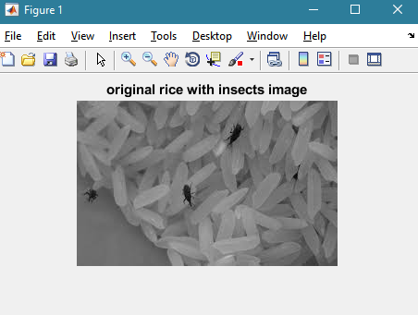

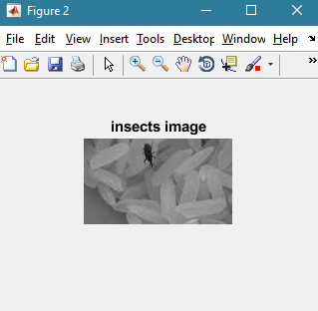

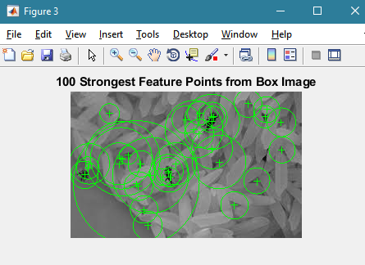

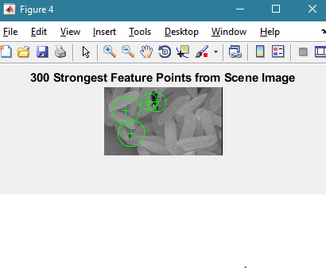

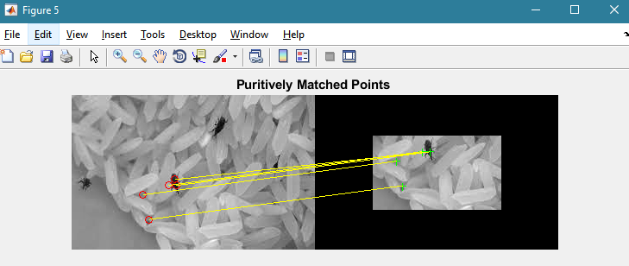

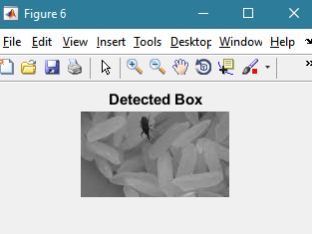

Not found output:



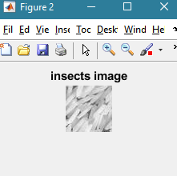



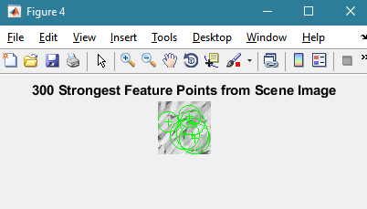

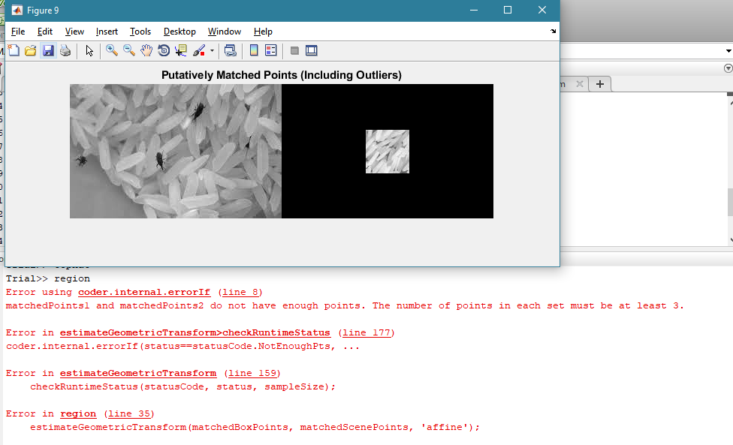

Orginal images

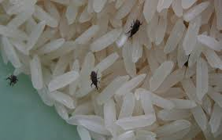

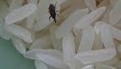

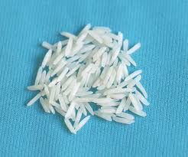

crop3