1.KNIME EXERCISE

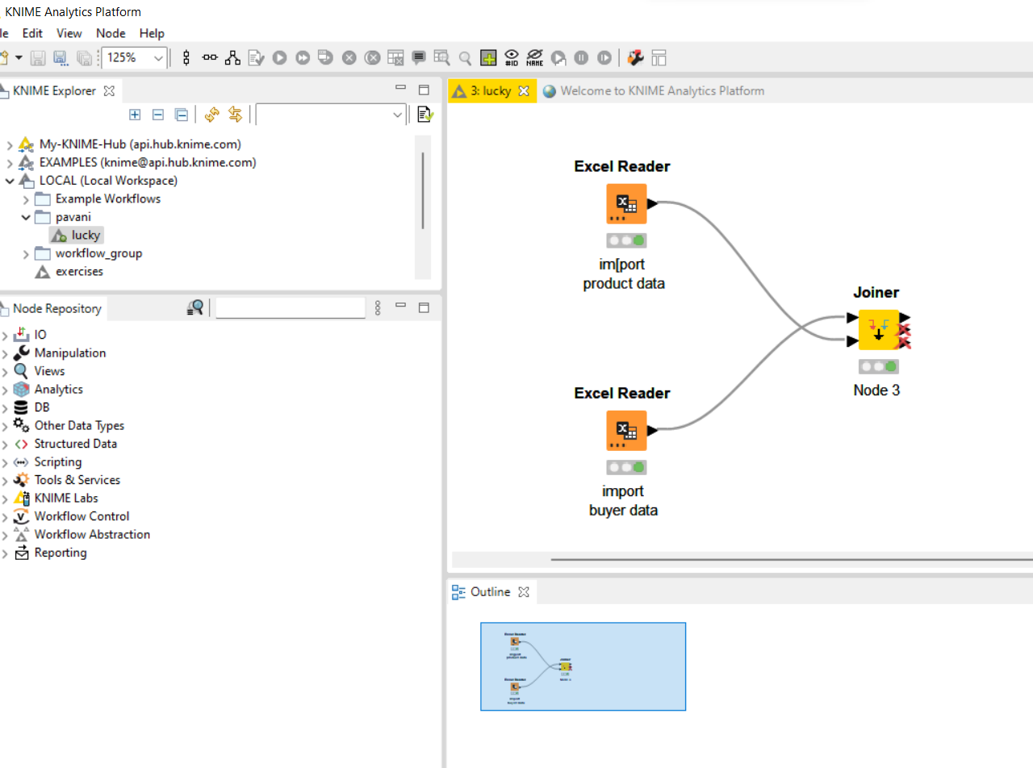

Information of joining of data of product and buyer..

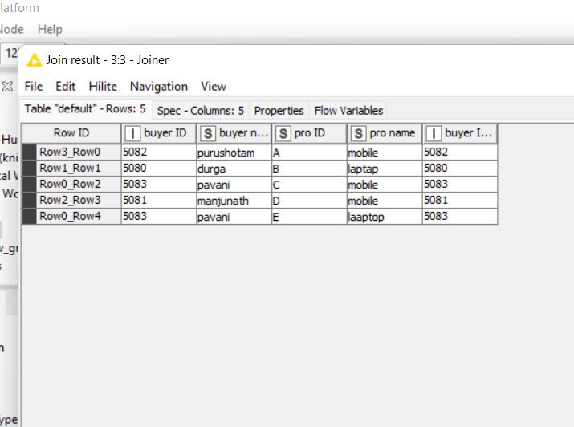

Output of joined information of buyer and product