SAP ABAP Payroll Employee Management System

Project Overview
- The SAP ABAP Payroll Employee Management System is a custom-built application developed using SAP ABAP to manage employee records, salary details, payroll calculations, and payslip generation. This system provides an efficient way to automate employee payroll activities and maintain salary information in a structured format.

The project demonstrates practical implementation of SAP ABAP concepts such as:

- Module Pool Programming
- Screen Programming
- Open SQL Operations
- Database Tables
- CRUD Operations
- Payroll Calculation Logic
- Report Generation
The application is designed with a user-friendly SAP GUI interface for better usability and efficient payroll processing.

Project Objectives
- Maintain employee master records
- Manage employee salary details
- Perform payroll calculations automatically
- Generate employee payslips
- Reduce manual payroll processing errors
- Demonstrate real-time SAP ABAP payroll application development

Technologies Used
- SAP ABAP
- Module Pool Programming
- Screen Painter
- Menu Painter
- Open SQL
- Dictionary Objects
- Internal Tables
- Work Areas
- Selection Screens

- Report Programming
- SAP GUI

Database Tables
1.Employee Master Table (ZPMS_EMP_MST)

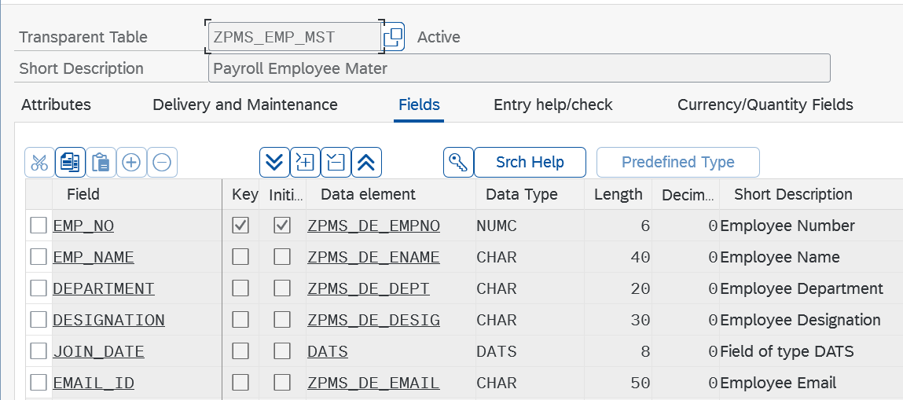

2.Salary Master Table (ZPMS_SAL_MST)

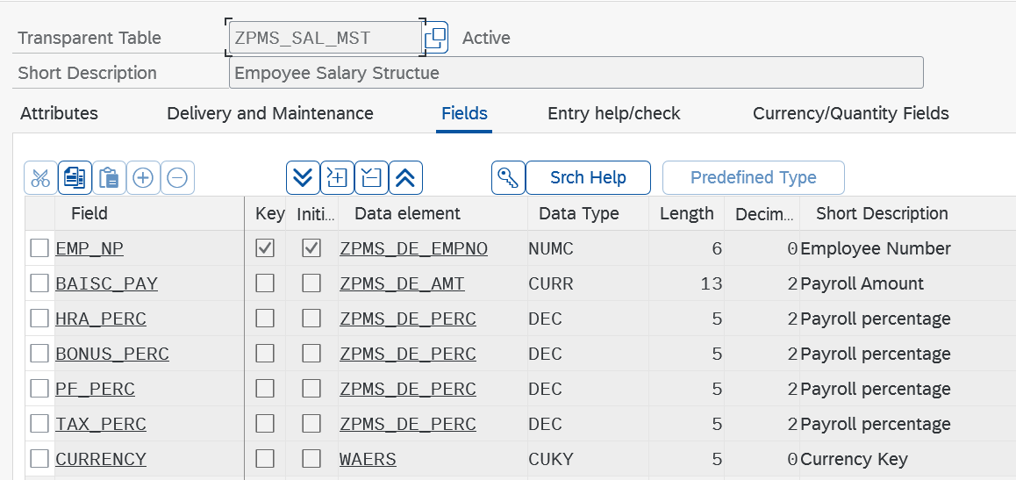

3. Payroll Transaction Table (ZPMS_PAY_TRN)
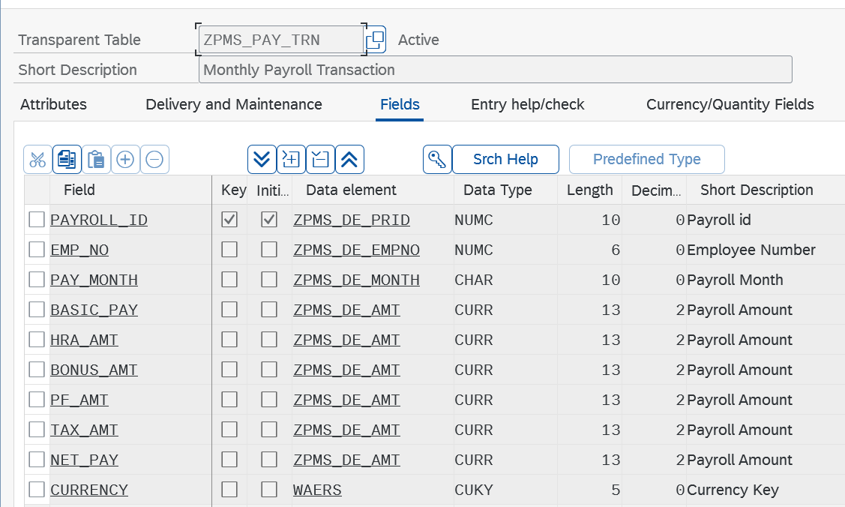

REPORTS
ZPMS_EMPLOYEE_MGMT
REPORT zpms_employee_mgmt.
PARAMETERS:
p_empno TYPE zpms_de_empno,
p_name TYPE zpms_de_ename,
p_dept TYPE zpms_de_dept,
p_desig TYPE zpms_de_desig,
p_email TYPE zpms_de_email.
PARAMETERS:
rb_add RADIOBUTTON GROUP g1 DEFAULT 'X',
rb_disp RADIOBUTTON GROUP g1,
rb_upd RADIOBUTTON GROUP g1,
rb_del RADIOBUTTON GROUP g1.
DATA: ls_emp TYPE zpms_emp_mst.
START-OF-SELECTION.
* Add Employee
IF rb_add = 'X'.
ls_emp-emp_no = p_empno.
ls_emp-emp_name = p_name.
ls_emp-department = p_dept.
ls_emp-designation = p_desig.
ls_emp-email_id = p_email.
INSERT zpms_emp_mst FROM ls_emp.
IF sy-subrc = 0.
WRITE: / 'Employee Added Successfully'.
ELSE.
WRITE: / 'Employee Already Exists'.
ENDIF.
ENDIF.
* Display Employee
IF rb_disp = 'X'.
SELECT SINGLE * FROM zpms_emp_mst
INTO ls_emp
WHERE emp_no = p_empno.
IF sy-subrc = 0.
WRITE: / 'Employee Number :', ls_emp-emp_no,
/ 'Employee Name :', ls_emp-emp_name,
/ 'Department :', ls_emp-department,
/ 'Designation :', ls_emp-designation,
/ 'Email :', ls_emp-email_id.
ELSE.
WRITE: / 'Employee Not Found'.
ENDIF.
ENDIF.
* Update Employee
IF rb_upd = 'X'.
UPDATE zpms_emp_mst
SET emp_name = p_name
department = p_dept
designation = p_desig
email_id = p_email
WHERE emp_no = p_empno.
IF sy-subrc = 0.
WRITE: / 'Employee Updated Successfully'.
ELSE.
WRITE: / 'Employee Not Found for Update'.
ENDIF.
ENDIF.
* Delete Employee
IF rb_del = 'X'.
DELETE FROM zpms_emp_mst
WHERE emp_no = p_empno.
IF sy-subrc = 0.
WRITE: / 'Employee Deleted Successfully'.
ELSE.
WRITE: / 'Employee Not Found for Delete'.
ENDIF.
ENDIF.
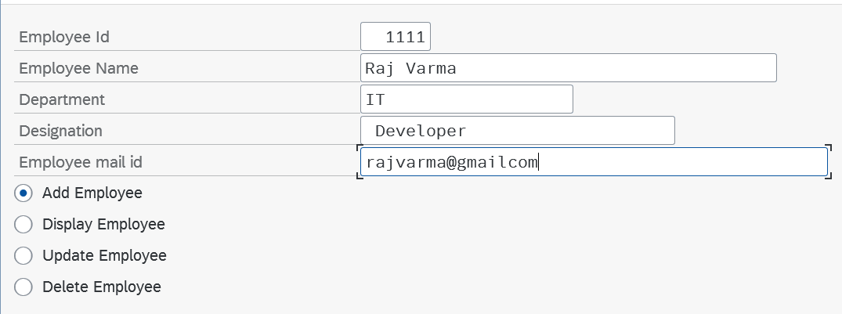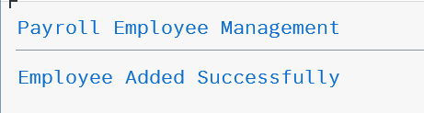

ZPMS_SALARY_MGMT

REPORT zpms_salary_mgmt.
TABLES: zpms_sal_mst.
DATA: ls_sal TYPE zpms_sal_mst.
*--------------------------------------------------
* Selection Screen - Salary Details
*--------------------------------------------------
SELECTION-SCREEN BEGIN OF BLOCK b1 WITH FRAME TITLE text-001.
PARAMETERS:
p_empno TYPE zpms_de_empno,
p_basic TYPE zpms_de_amt,
p_hra TYPE zpms_de_perc,
p_bonus TYPE zpms_de_perc,
p_pf TYPE zpms_de_perc,
p_tax TYPE zpms_de_perc,
p_curr TYPE waers.
SELECTION-SCREEN END OF BLOCK b1.
*--------------------------------------------------
* Selection Screen - Operations
*--------------------------------------------------
SELECTION-SCREEN BEGIN OF BLOCK b2 WITH FRAME TITLE text-002.
PARAMETERS:
rb_add RADIOBUTTON GROUP g1 DEFAULT 'X',
rb_disp RADIOBUTTON GROUP g1,
rb_upd RADIOBUTTON GROUP g1,
rb_del RADIOBUTTON GROUP g1.
SELECTION-SCREEN END OF BLOCK b2.
*--------------------------------------------------
* Main Logic
*--------------------------------------------------
START-OF-SELECTION.
* Add Salary Record
IF rb_add = 'X'.
ls_sal-emp_np = p_empno.
ls_sal-baisc_pay = p_basic.
ls_sal-hra_perc = p_hra.
ls_sal-bonus_perc = p_bonus.
ls_sal-pf_perc = p_pf.
ls_sal-tax_perc = p_tax.
ls_sal-currency = p_curr.
INSERT zpms_sal_mst FROM ls_sal.
IF sy-subrc = 0.
WRITE: / 'Salary Record Added Successfully'.
ELSE.
WRITE: / 'Salary Record Already Exists'.
ENDIF.
ENDIF.
* Display Salary Record
IF rb_disp = 'X'.
SELECT SINGLE * FROM zpms_sal_mst
INTO ls_sal
WHERE emp_np = p_empno.
IF sy-subrc = 0.
WRITE: / 'Employee Number :', ls_sal-emp_np,
/ 'Basic Pay :', ls_sal-baisc_pay,
/ 'HRA % :', ls_sal-hra_perc,
/ 'Bonus % :', ls_sal-bonus_perc,
/ 'PF % :', ls_sal-pf_perc,
/ 'Tax % :', ls_sal-tax_perc,
/ 'Currency :', ls_sal-currency.
ELSE.
WRITE: / 'Salary Record Not Found'.
ENDIF.
ENDIF.
* Update Salary Record
IF rb_upd = 'X'.
UPDATE zpms_sal_mst
SET baisc_pay = p_basic
hra_perc = p_hra
bonus_perc = p_bonus
pf_perc = p_pf
tax_perc = p_tax
currency = p_curr
WHERE emp_np = p_empno.
IF sy-subrc = 0.
WRITE: / 'Salary Record Updated Successfully'.
ELSE.
WRITE: / 'Salary Record Not Found for Update'.
ENDIF.
ENDIF.
* Delete Salary Record
IF rb_del = 'X'.
DELETE FROM zpms_sal_mst
WHERE emp_np = p_empno.
IF sy-subrc = 0.
WRITE: / 'Salary Record Deleted Successfully'.
ELSE.
WRITE: / 'Salary Record Not Found for Delete'.
ENDIF.
ENDIF.
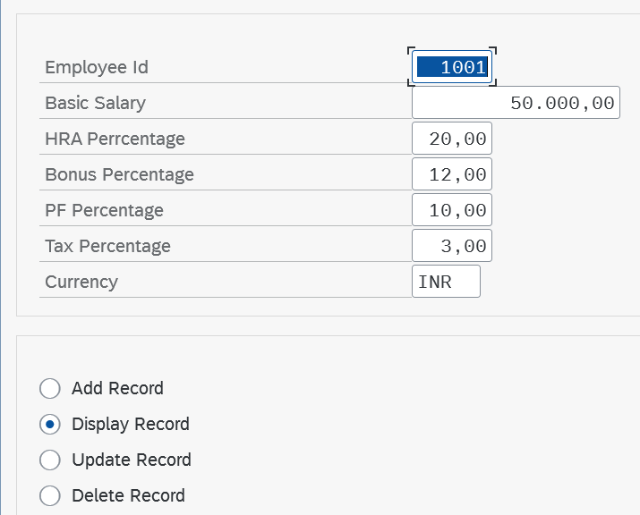
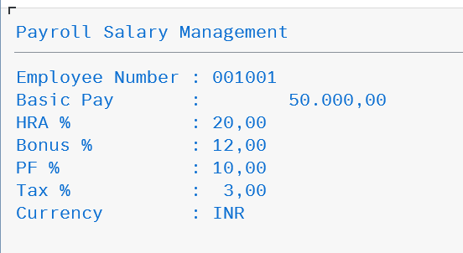

ZPMS_PAYROLL_PROCESS
REPORT zpms_payroll_process.
PARAMETERS:
p_empno TYPE zpms_de_empno,
p_month TYPE zpms_de_month.
DATA:
ls_sal TYPE zpms_sal_mst,
ls_pay TYPE zpms_pay_trn.
DATA:
lv_hra TYPE p DECIMALS 2,
lv_bonus TYPE p DECIMALS 2,
lv_pf TYPE p DECIMALS 2,
lv_tax TYPE p DECIMALS 2,
lv_net TYPE p DECIMALS 2.
START-OF-SELECTION.
SELECT SINGLE * INTO ls_sal
FROM zpms_sal_mst
WHERE emp_np = p_empno.
IF sy-subrc = 0.
lv_hra = ls_sal-baisc_pay * ls_sal-hra_perc / 100.
lv_bonus = ls_sal-baisc_pay * ls_sal-bonus_perc / 100.
lv_pf = ls_sal-baisc_pay * ls_sal-pf_perc / 100.
lv_tax = ls_sal-baisc_pay * ls_sal-tax_perc / 100.
lv_net = ls_sal-baisc_pay + lv_hra + lv_bonus - lv_pf - lv_tax.
ls_pay-payroll_id = sy-datum.
ls_pay-emp_no = p_empno.
ls_pay-pay_month = p_month.
ls_pay-basic_pay = ls_sal-baisc_pay.
ls_pay-hra_amt = lv_hra.
ls_pay-bonus_amt = lv_bonus.
ls_pay-pf_amt = lv_pf.
ls_pay-tax_amt = lv_tax.
ls_pay-net_pay = lv_net.
ls_pay-currency = ls_sal-currency.
INSERT zpms_pay_trn FROM ls_pay.
IF sy-subrc = 0.
WRITE: / 'Payroll Processed Successfully',
/ 'Net Salary:', lv_net.
ELSE.
WRITE: / 'Payroll Already Processed'.
ENDIF.
ELSE.
WRITE: / 'Salary Structure Not Found'.
ENDIF.

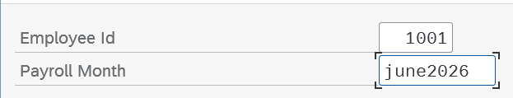



ZPMS_PAYSLIP_RPT
REPORT ZPMS_PAYSLIP_RPT.
PARAMETERS:
p_prid TYPE zpms_de_prid.
DATA: ls_pay TYPE zpms_pay_trn.
START-OF-SELECTION.
SELECT SINGLE * FROM zpms_pay_trn
INTO ls_pay
WHERE payroll_id = p_prid.
IF sy-subrc = 0.
WRITE: / '******** EMPLOYEE PAYSLIP ********'.
SKIP.
WRITE: / 'Payroll ID :', ls_pay-payroll_id.
WRITE: / 'Employee No :', ls_pay-emp_no.
WRITE: / 'Pay Month :', ls_pay-pay_month.
WRITE: / 'Basic Pay :', ls_pay-basic_pay.
WRITE: / 'HRA Amount :', ls_pay-hra_amt.
WRITE: / 'Bonus Amount :', ls_pay-bonus_amt.
WRITE: / 'PF Amount :', ls_pay-pf_amt.
WRITE: / 'Tax Amount :', ls_pay-tax_amt.
WRITE: / 'Net Salary :', ls_pay-net_pay.
WRITE: / 'Currency :', ls_pay-currency.
ELSE.
WRITE: / 'Payslip Record Not Found'.
ENDIF.

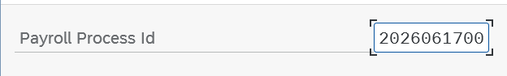
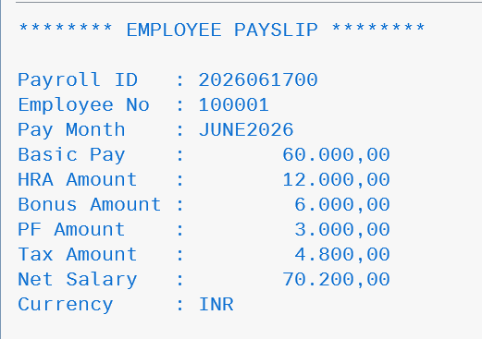

Project Outcome
The SAP ABAP Payroll Employee Management System was successfully developed to automate employee management, salary maintenance, and payroll processing. The system improves payroll accuracy, reduces manual work, and provides a structured way to manage employee payroll data efficiently.

Future Enhancements
- Attendance and Leave Management Integration
- SmartForms for Payslip Generation
- Email Notification for Payslips
- SAP Fiori User Interface

Conclusion
The SAP ABAP Payroll Employee Management System is an effective payroll automation solution developed using SAP ABAP. It demonstrates practical knowledge of module pool programming, report development, database operations, and payroll processing, making it a useful real-time business application.

