1. Write a SQL query to find the actors who were cast in the movie 'Annie Hall'. Return actor first name, last name and role?

Ans: SELECT act_fname,act_lname,role FROM actors

NATURAL JOIN movie_cast

NATURAL JOIN movie

WHERE movie.mov_title ="annie hall";

OR

SELECT act_fname,act_lname,role FROM actors a

JOIN movie_cast mc on a.act_id=mc.act_id

JOIN movie m on m.mov_id=mc.mov_id

WHERE m.mov_title ="annie hall";

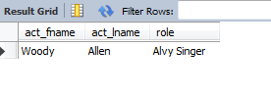

1. From the following tables, write a SQL query to find the director who directed a movie that casted a role for 'Eyes Wide Shut'. Return director first name, last name and movie title?

Ans: SELECT dir_fname,dir_lname,mov_title FROM director

NATURAL JOIN movie_direction

NATURAL JOIN movie_cast

NATURAL JOIN movie

WHERE movie.mov_title ="eyes wide shut";



1. Write a SQL query to find who directed a movie that casted a role as ‘Sean Maguire’. Return director first name, last name and movie title?

Ans: SELECT dir_fname,dir_lname,mov_title FROM movie_cast

NATURAL JOIN movie_direction

NATURAL JOIN movie

NATURAL JOIN director

WHERE movie_cast.role ="sean maguire";



1. Write a SQL query to find the actors who have not acted in any movie between1990 and 2000 (Begin and end values are included.). Return actor first name, last name, movie title and release year?

Ans: SELECT act_fname,act_lname,mov_title,mov_year FROM

actors

JOIN movie_cast

ON actors.act_id=movie_cast.act_id

JOIN movie

ON movie_cast.mov_id=movie.mov_id

WHERE mov_year NOT BETWEEN 1990 AND 2000;

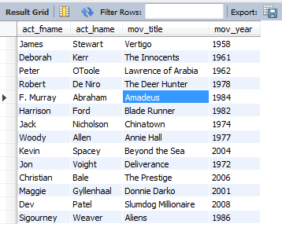

1. Write a SQL query to find the directors with number of genres movies. Group the result set on director first name, last name and generic title. Sort the result-set in ascending order by director first name and last name. Return director first name, last name and number of genres movies?

Ans: SELECT dir_fname,dir_lname,gen_title, count(gen_title)

FROM director

NATURAL JOIN movie_direction

NATURAL JOIN movie_genres

NATURAL JOIN genres

GROUP BY dir_fname,dir_lname,gen_title

ORDER BY dir_fname,dir_lname;



1. Write a SQL query to find the movies with year and genres. Return movie title, movie year and generic title?

Ans: SELECT mov_title,mov_year,gen_title FROM movie

NATURAL JOIN movie_genres

NATURAL JOIN genres ;

1. Write a SQL query to find all the movies with year, genres, and name of the director?

Ans: SELECT mov_title,mov_year,gen_title,dir_fname,dir_lname

FROM movie

NATURAL JOIN movie_genres

NATURAL JOIN genres

NATURAL JOIN movie_direction

NATURAL JOIN director ;

1. Write a SQL query to find the movies released before 1st January 1989. Sort the result-set in descending order by date of release. Return movie title, release year, date of release, duration, and first and last name of the director?

Ans: SELECT

mov_title,mov_year,mov_dt_rel,mov_time,dir_fname,dir_ln

ame FROM movie

JOIN movie_direction on movie.mov_id=movie_direction.mov_id

JOIN director on movie_direction.dir_id=director.dir_id

WHERE mov_dt_rel <'1989/01/01'

ORDER BY mov_dt_rel DESC ;

1. Write a SQL query to compute the average time and count number of movies for each genre. Return genre title, average time and number of movies for each genre?

Ans: SELECT avg(mov_time),count(mov_title),gen_title from

movie

NATURAL JOIN movie_genres

NATURAL JOIN genres

GROUP BY gen_title;

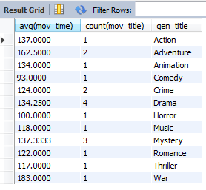

1. Write a SQL query to find movies with the lowest duration. Return movie title, movie year, director first name, last name, actor first name, last name and role?

Ans: SELECT mov_title, mov_year, dir_fname, dir_lname,

act_fname, act_lname, role

FROM movie

NATURAL JOIN movie_direction

NATURAL JOIN movie_cast

NATURAL JOIN director

NATURAL JOIN actors

WHERE mov_time=(SELECT MIN(mov_time) FROM movie);

