1a>

ALL ABOUT THE COLLEGE

St. Ann’s College of Engineering & Technology was established in the year 2001 at Vetapalem Mandal, Chirala, Bapatla District, Andhra Pradesh by The St. Mary Educational Society, pioneered by Educationalists, Industrialists and Philanthropists. The College is housed amidst lush green fields, in serene environment, free from pollution and conductive for the pursuit of education. Bay of Bengal is just two km away from the college.

The Institution is Approved by All India Council for Technical Education (AICTE), New Delhi and is Permanently Affiliated to the Jawaharlal Nehru Technological University, Kakinada.Five Programmes were Accredited by National Board of Accredition(NBA).The Institution is Accredited by NAAC with ‘A’ Grade.The Institution is recognized by UGC under section 2(f) and 12(B).The Institution is awarded ‘A’ grade by Andhra Pradesh State Government Institution is Permanently Accredited by Institution of Engineers(I).Institution is selected for Andhra Pradesh State Technical Skill Development Center(Siemens).The College has a glory of experience in teaching from 2001 onwards. The College is situated along the Bypass Road at 6 KMs distance Chirala town in Chirala-Ongole stretch. The College campus has a sprawling area of around 19.28 1/4 acres, with serene atmosphere, sylvan settings and environs, conductive for academic activities. The college is well connected by rail and road links because of its ideal location.

COURSES OFFERED

B.TECH COMPUTER SCIENCE AND ENGINEERING

B.TECH COMPUTER SCIENCE AND ENGINEERING WITH AIML

B.TECH COMPUTER SCIENCE AND ENGINEERING WITH CS

B.TECH COMPUTER SCIENCE AND ENGINEERING WITH DS

B.TECH COMPUTER SCIENCE AND ENGINEERING WITH IOT

B.TECH ELECTRONICS COMMUNICATION ENGINEERING

B.TECH ELECTRICAL AND ELECTRONICS ENGINEERING

B.TECH CIVIL ENGINEERING

B.TECH MECHANICAL ENGINEERING

AIML

AIML Is the new technology introduced in CSE

DATA SCIENCE

DS Is the new technology introduced in CSE

CYBER SECURITY

CS Is the new technology introduced in CSE

IOT Is the new technology introduced in CSE

Address

chellareddy pallem,

vetapalem,

chirala,

bapatla district,

Andhrapradesh-523157.

**OUTPUT:**

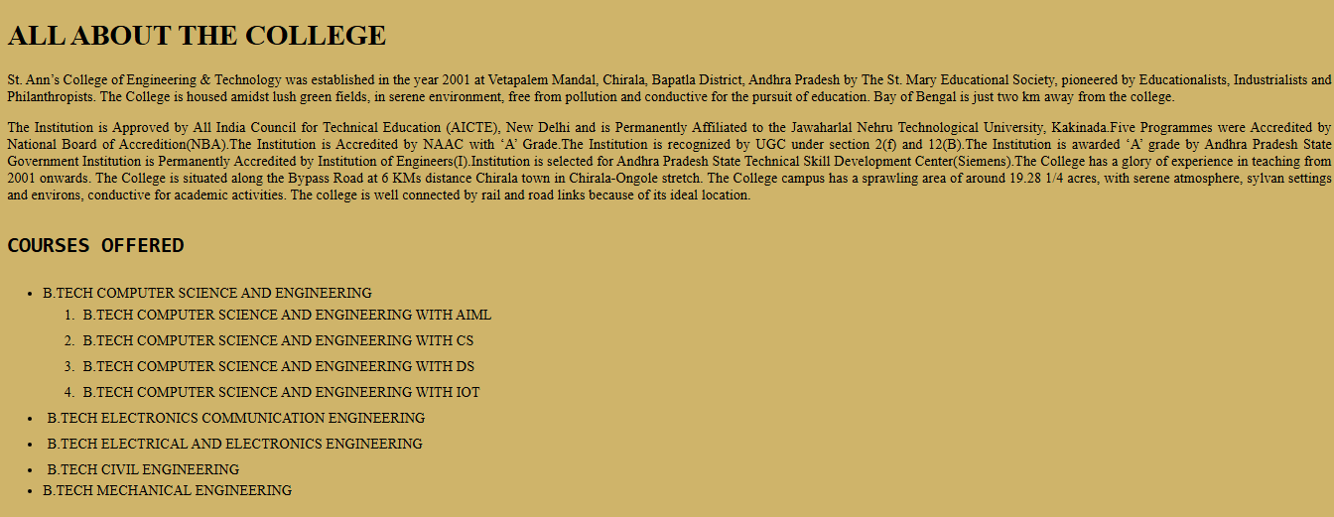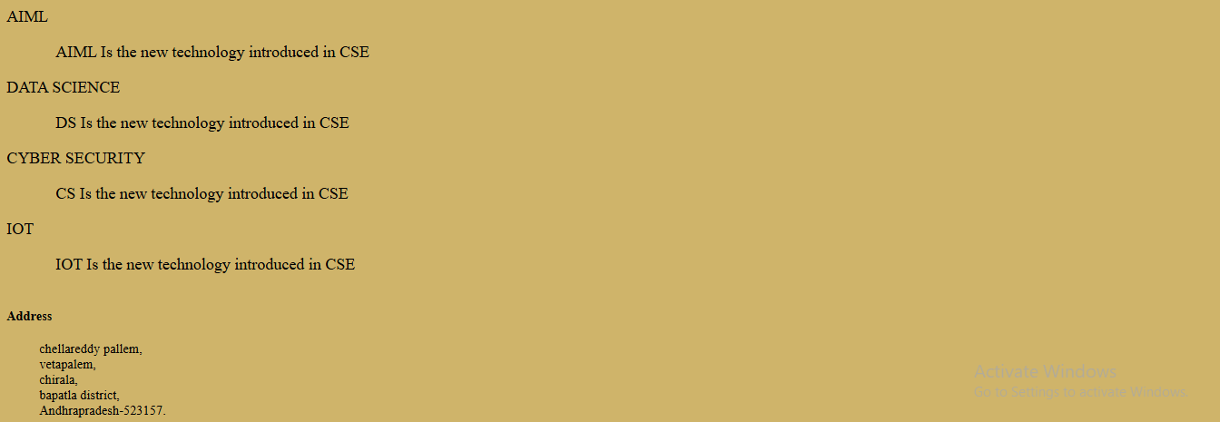

**1b>**

ALL ABOUT THE COLLEGE

St. Ann’s College of Engineering & Technology was established in the year 2001 at Vetapalem Mandal, Chirala, Bapatla District, Andhra Pradesh by The St. Mary Educational Society, pioneered by Educationalists, Industrialists and Philanthropists. The College is housed amidst lush green fields, in serene environment, free from pollution and conductive for the pursuit of education. Bay of Bengal is just two km away from the college.

The Institution is Approved by All India Council for Technical Education (AICTE), New Delhi and is Permanently Affiliated to the Jawaharlal Nehru Technological University, Kakinada.Five Programmes were Accredited by National Board of Accredition(NBA).The Institution is Accredited by NAAC with ‘A’ Grade.The Institution is recognized by UGC under section 2(f) and 12(B).The Institution is awarded ‘A’ grade by Andhra Pradesh State Government Institution is Permanently Accredited by Institution of Engineers(I).Institution is selected for Andhra Pradesh State Technical Skill Development Center(Siemens).The College has a glory of experience in teaching from 2001 onwards. The College is situated along the Bypass Road at 6 KMs distance Chirala town in Chirala-Ongole stretch. The College campus has a sprawling area of around 19.28 1/4 acres, with serene atmosphere, sylvan settings and environs, conductive for academic activities. The college is well connected by rail and road links because of its ideal location.

COURSES OFFERED

B.TECH COMPUTER SCIENCE AND ENGINEERING

B.TECH COMPUTER SCIENCE AND ENGINEERING WITH AIML

B.TECH COMPUTER SCIENCE AND ENGINEERING WITH CS

B.TECH COMPUTER SCIENCE AND ENGINEERING WITH DS

B.TECH COMPUTER SCIENCE AND ENGINEERING WITH IOT

B.TECH ELECTRONICS COMMUNICATION ENGINEERING

B.TECH ELECTRICAL AND ELECTRONICS ENGINEERING

B.TECH CIVIL ENGINEERING

B.TECH MECHANICAL ENGINEERING

AIML

AIML Is the new technology introduced in CSE

DATA SCIENCE

DS Is the new technology introduced in CSE

CYBER SECURITY

CS Is the new technology introduced in CSE

IOT Is the new technology introduced in CSE

Address

chellareddy pallem,

vetapalem,

chirala,

bapatla district,

Andhrapradesh-523157.

OUTPUT: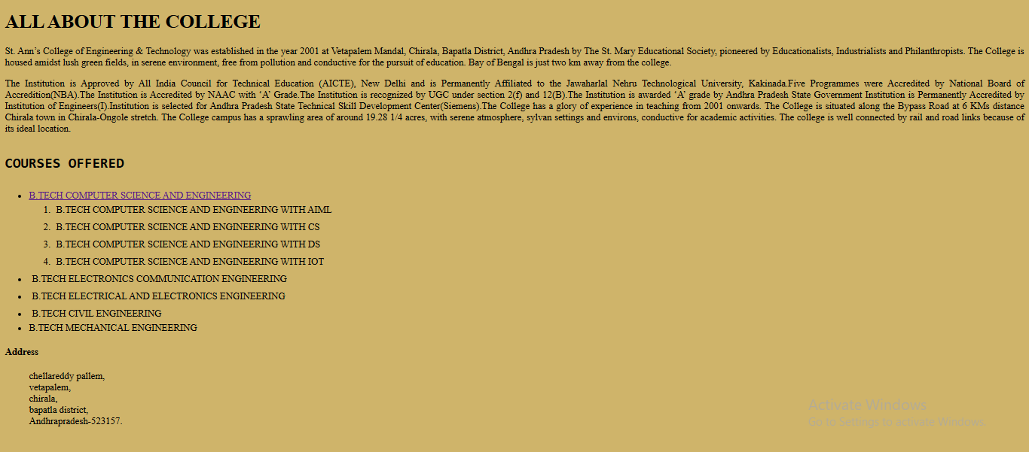

**1c>**

Department Of Computer Science And Engineering

About Principal and HOD

Dr.K.JAGADEESH BABU </strong>has received PhD in 2013 and M.Tech. in 2006 from JNTUH, Hyderabad in the department of ECE. He is a post-doctoral researcher from IIT Kharagpur. He published more than 80 research papers in reputed SCI and Scopus Indexed journals. He executed various research projects worth more than 40 lakhs from various funding agencies like AICTE, New Delhi, DSR, Saudi Arabia etc. He received travel grant from DST to participate in PIERS International conference in Singapore. He received Best Teacher Award in 2012 and Best Researcher Award in 2018 from JNTUK, Kakinada. He is a senior member of IEEE.

Dr.P.HARINI </strong>has received Ph.D in Computer Science and Engineering in 2011 from JNTUA Ananthapur, Andhra Pradesh. She is working as Professor and Head in CSE. she has a total of 27 years of experience in Teaching and Administration.She is ratified by JNTUK, Kakinada.  she recueved BEST TEACHER AWARD FOR THE YEAR 2012 FROM JNTUK.

OUTPUT:

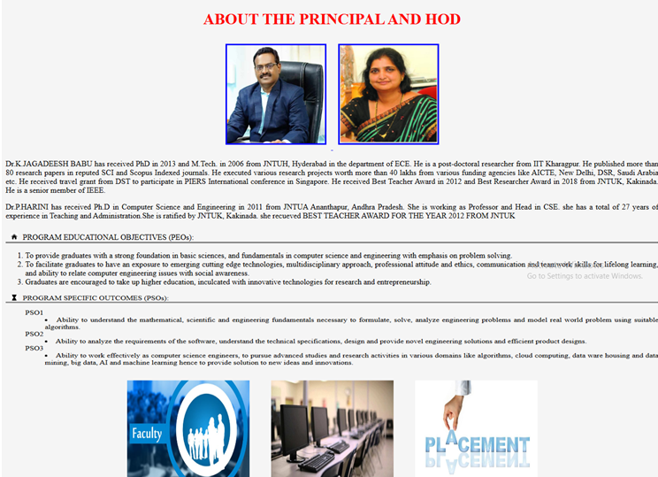

**1d>**

Department Of Computer Science And Engineering

About Principal and HOD

Dr.K.JAGADEESH BABU </strong>has received PhD in 2013 and M.Tech. in 2006 from JNTUH, Hyderabad in the department of ECE. He is a post-doctoral researcher from IIT Kharagpur. He published more than 80 research papers in reputed SCI and Scopus Indexed journals. He executed various research projects worth more than 40 lakhs from various funding agencies like AICTE, New Delhi, DSR, Saudi Arabia etc. He received travel grant from DST to participate in PIERS International conference in Singapore. He received Best Teacher Award in 2012 and Best Researcher Award in 2018 from JNTUK, Kakinada. He is a senior member of IEEE.

Dr.P.HARINI </strong>has received Ph.D in Computer Science and Engineering in 2011 from JNTUA Ananthapur, Andhra Pradesh. She is working as Professor and Head in CSE. she has a total of 27 years of experience in Teaching and Administration.She is ratified by JNTUK, Kakinada.  she recueved BEST TEACHER AWARD FOR THE YEAR 2012 FROM JNTUK

Faculty Gallery

click on the thumbnails below to make image larger

Dr.P.Harini,HOD

Mr.T.Seshasai,M.Tech(Ph.D)

Dr.D.NageshBabu,M.tech.Ph.D

Dr.A.Thirapataiha,M.tech,Ph.D

OUTPUT:



