TO-DO API TESTING USING POSTMAN

TABLE OF CONTENTS
Sr. No | Section | Description
1 | Introduction | Overview of the project and its purpose
2 | Objective | Key goals of the project
3 | Tools & Technologies | Tools used like Postman and JSON Placeholder API
4 | Implementation | Step-by-step process of API testing
5 | Conclusion | Summary of learning outcomes

Objective
The main objectives of this project are:
-To learn how to perform CRUD Operations for API testing.
- To validate API response status codes and JSON data.
- To understand how Postman can be used as a practical API testing tool.
- To create a beginner-friendly project that can be showcased on GitHub.

INTRODUCTION
This project demonstrates API Testing using POSTMAN on “JSON Placeholder-TODO API” It is designed for beginners to understand about HTTPS Requests( GET, PUT,POST..)

LINK : https://jsonplaceholder.typicode.com/

IMPLEMENTATION
Step1:
- Create a workspace
- Name it “project”
// workspace : it is nothing but where we organize all the api work ,it is like project folder.
Step2:
- Create environment
- On top right u can see no environment click on add
- Create a environment
- Name it : to-do-testing
- Now give its variable and value
- Variable : base_url
- Value: https://jsonplaceholder.typicode.com
- Now save it
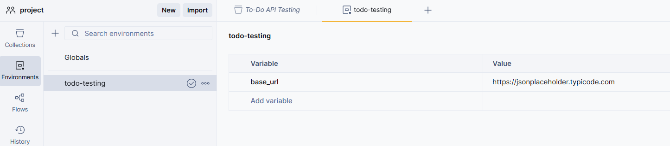

// environment: set of variables you can reuse in requests. Helps switch between different setups, here we have 2 things in this: value, variable
Variable : in simple terms we give a name that can be reused in entire project without giving that URL for example: https://jsonplaceholder.typicode.com (value)we have this URL we can’t copy paste every time so we give me word instead of this “base_url” .
Now every time you going to add a request we can automatically the base_url instead of the link we using , the link will be the value here, we can give multiple environments to the workspace and do testing .

Step3:
- Now add collection to the project
- Name it To-Do API Testing
// Here you can start doing https requests
//collection : a group of api request saved together
Allows you to run multiple requests in order using the Collection Runner.
- You can add tests and documentation for each request in a collection.
• Example:
- Collection: To-Do API Testing
  - GET all To-Dos
  - POST new To-Do
  - PUT update To-Do
  - DELETE To-Do

- We can start giving all the request one by one
- We can also change the order if you want for the request
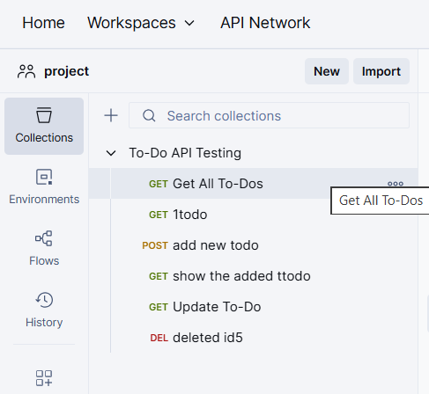

Step4:
HTTPS Requests:
4.1 GET :
1. GET All To-Dos
- URL: {{base_url}}/todos
- Method: GET
- Purpose: Retrieve a list of all To-Do items.
- Save and send you can see the response as 200k(status code)
//status code: it says whether the request is successfully worked or not
// it has 6 status codes:
- 200 ok – success
- 201 created—new data created
- 400 bad request – wrong input
- 401 unauthorized – no access
- 500 internal server error – server problem
You can see the response in below screenshot
- We can use the scripting also to step that :
Script(test):
pm.test("Status code is 200", function () {
pm.response.to.have.status(200);
});

pm.test("Response is an array", function () {
var jsonData = pm.response.json();
pm.expect(jsonData).to.be.an("array");
});

Pm: In Postman, pm is a built-in object used in test scripts and pre-request scripts.
Purpose of pm
- It allows you to write JavaScript tests for your API responses.
- You can access response data, environment variables, request details, and create assertions.
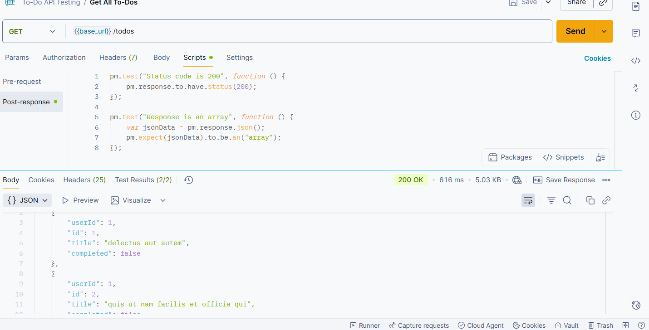

2. GET To-Do by ID
- URL: {{base_url}}/todos/1
- Method: GET
- Purpose: Retrieve a single To-Do item by its ID.
Here we are to fetch a single To-Do item by ID
- Test Script Example: we do here
- pm.test("Status code is 200", function () {
- pm.response.to.have.status(200);
- });

- pm.test("Response has userId, id, title, completed", function () {
- var jsonData = pm.response.json();
- pm.expect(jsonData).to.have.property("userId");
- pm.expect(jsonData).to.have.property("id");
- pm.expect(jsonData).to.have.property("title");
- pm.expect(jsonData).to.have.property("completed");
- });

Save and run it we get response as below
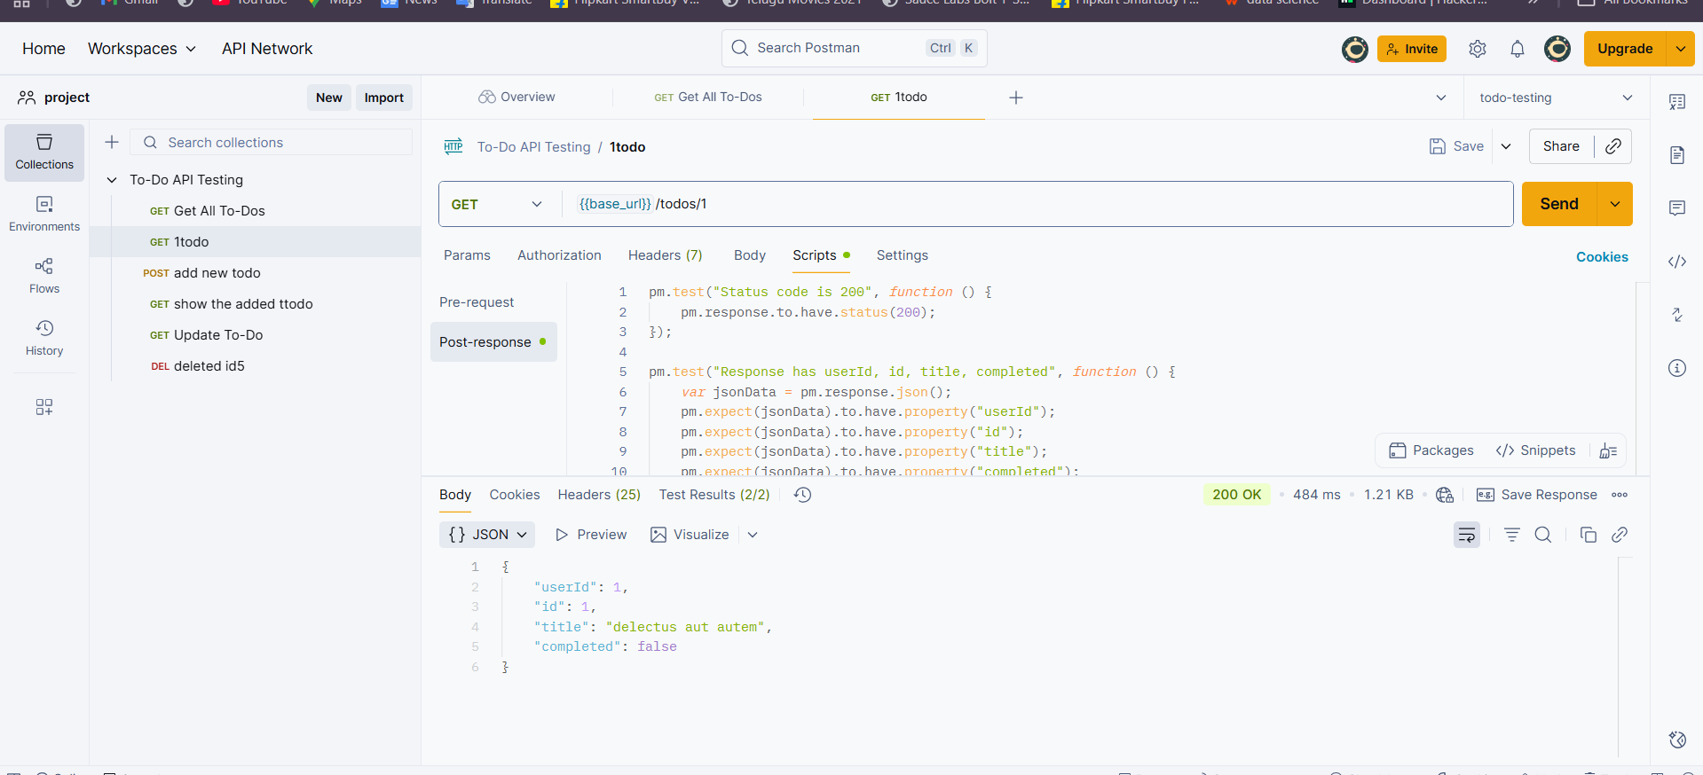

3. POST New To-Do
- URL: {{base_url}}/todos
- Method: POST
Here we are going to create a new book id and post into the data (here it is not real api its just fake api so changes in the data may not be seen )
POST : Send data to create something new on the server. Example: Add a new To-Do item.

- Body (raw JSON):
- {
- "userId": 123,
- "title": "Learn Postman API Testing",
- "completed": false
- }

Here the response for the POST request :
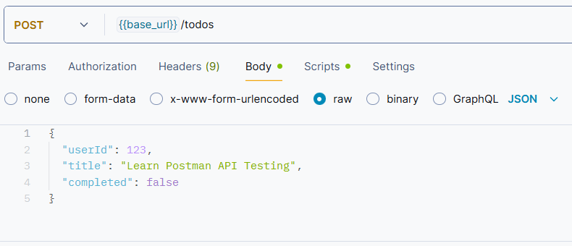

4. PUT Update To-Do
- URL: {{base_url}}/todos/5
- Method: PUT
PUT: Update existing data on the server. Example: Change the title or status of a To-Do item.
Here we are going to update the id: 5 , Update an existing To-Do item.
Body :
{
"userId": 1,
"title": "Updated To-Do with ID 5",
"completed": true
}
Test Script Example:
pm.test("Status code is 200", function () {
pm.response.to.have.status(200);
});
pm.test("Title is updated", function () {
var jsonData = pm.response.json();
pm.expect(jsonData.title).to.eql("Updated Task");
});

Save and run it here the response :
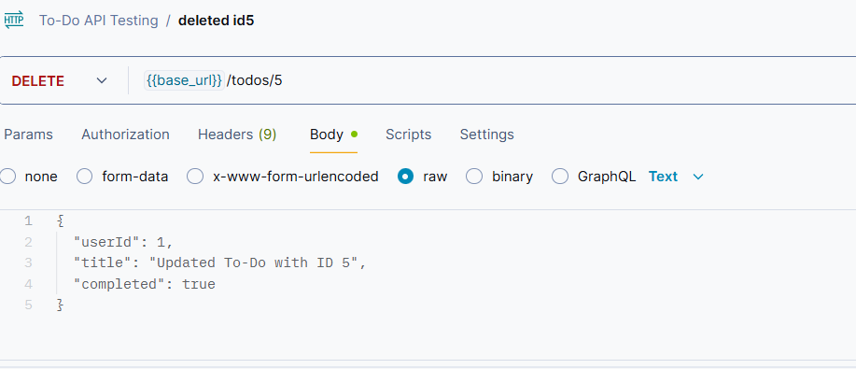

5. DELETE To-Do
- URL: {{base_url}}/todos/5
- Method: DELETE
- Purpose: Delete a To-Do item.
Delete: where we delete particular thing
After sending the delete request that we are going to delete the id: 5 so in the response it gives {} it shows that the id we created is deleted ,Here the response of this:
Methods used for this project :
Method | Endpoint | Purpose | Example Request | Expected Response
GET | /todos | Fetch all To-Do items | GET {{base_url}}/todos | 200 OK, JSON array of To-Do items
GET | /todos/:id | Fetch a single To-Do item by ID | GET {{base_url}}/todos/1 | 200 OK, JSON object of To-Do with ID 1
POST | /todos | Create a new To-Do item | POST {{base_url}}/todos Body (JSON): { "userId": 1, "title": "New Task", "completed": false } | 201 Created, JSON object with new To-Do ID
PUT | /todos/:id | Update an existing To-Do item | PUT {{base_url}}/todos/1 Body (JSON): { "title": "Updated Task", "completed": true } | 200 OK, JSON object of updated To-Do
DELETE | /todos/:id | Delete a To-Do item by ID | DELETE {{base_url}}/todos/1 | 200 OK or 204 No Content, empty response

CONCLUSION
The To-Do API Testing project provides hands-on experience with HTTP requests and demonstrates how APIs work in real-world applications.
Through this project, we:
- Learned how to perform GET, POST, PUT, and DELETE operations.
- Validated response status codes and JSON data using Postman.
- Understood the concept of environment variables, collections, and workspaces in Postman.
- Gained practical skills in API testing, which is an essential part of software development and quality assurance.
This project is a beginner-friendly way to understand APIs, and it serves as a showcase project for GitHub or a portfolio, highlighting the ability to test and interact with web services effective .

