PNEUMONIA DETECTION FROM CHEST X-RAYS
USING DEEP LEARNING

A Dissertation
Submitted by

DAMARAPARAPU KRISHNA PAVANI
(AA.SC.P2MCA25010030)

in partial fulfilment of the requirements for the award of the degree of
MASTER OF COMPUTER APPLICATIONS

DEPARTMENT OF COMPUTER SCIENCE
AMRITA VISHWA VIDYAPEETHAM

July 2026

BONAFIDE CERTIFICATE

This is to certify that this dissertation titled "Pneumonia Detection from Chest X-Rays using Deep Learning," submitted in partial fulfilment of the requirements for the award of the Degree of Master of Computer Applications, by Damaraparapu Krishna Pavani (Roll No. AA.SC.P2MCA25010030), is a bona fide record of the work carried out by her under my supervision during the academic term from April 2026 to August 2026 and that it has been submitted, to the best of my knowledge, in part or in full, for the award of any other degree or diploma.

<Project Guide's name> <Coordinator's name>

Reviewer
Date:

DECLARATION

I do hereby declare that this dissertation titled "Pneumonia Detection from Chest X-Rays using Deep Learning", submitted in partial fulfilment of the requirements for the award of the degree of Master of Computer Applications, is a true record of work carried out by me and that all information contained herein, which does not arise directly from my work, has been properly acknowledged and cited, using acceptable international standards. Further, I declare that the contents of this thesis have not been submitted, in part or in full, for the award of any other degree or diploma.

<Signature of the student>
Date: DAMARAPARAPU KRISHNA PAVANI

ACKNOWLEDGEMENT

I would like to express my sincere gratitude to my project guide and to the faculty of the Department of Computer Science, Amrita Vishwa Vidyapeetham, for their invaluable guidance, encouragement and support throughout the course of this project. Their insights into deep learning and medical image analysis were instrumental in shaping this work.
I am thankful to the project coordinator for the timely reviews and constructive feedback that helped me refine both the technical approach and this report. I also acknowledge the creators of the open Chest X-Ray Pneumonia dataset and the open-source communities behind TensorFlow, Keras and Streamlit, without which this project would not have been possible.
Finally, I thank my family and friends for their constant motivation and support during this period.

Damaraparapu Krishna Pavani

ABSTRACT

Pneumonia is a leading cause of illness and death worldwide, and chest X-ray (CXR) imaging remains the most widely used tool for its diagnosis. However, interpreting X-rays is time-consuming and depends on expert radiologists, who are scarce in many regions. This project presents a deep-learning system that automatically detects pneumonia from chest X-ray images and, importantly, explains the reasoning behind each decision. A DenseNet121 convolutional neural network, pretrained on ImageNet, is adapted through transfer learning and fine-tuned in two phases on a chest X-ray dataset labelled as Normal or Pneumonia. Image preprocessing and data augmentation improve robustness, while class weighting counters dataset imbalance. To make the model trustworthy for medical use, Gradient-weighted Class Activation Mapping (Grad-CAM) produces heatmaps that highlight the lung regions influencing each prediction.
The system is delivered as an interactive Streamlit web application with three sections: a detector that accepts an uploaded X-ray and returns a prediction, a confidence score and a Grad-CAM overlay; a visual explanation of the methodology and results; and an in-app source-code browser. On a balanced held-out test set of 200 images, the baseline model achieves 80.0% accuracy, 81.0% recall, 79.4% precision and an AUC of 0.885. The results demonstrate that transfer learning combined with explainable AI can provide a fast, accurate and interpretable aid for pneumonia screening. The system is intended to assist, not replace, healthcare professionals. Future work includes training on the full dataset, comparing multiple CNN architectures, and clinical validation.
(Word count: approximately 240 words)

TABLE OF CONTENTS

(In Microsoft Word, right-click and choose “Update Field” to populate page numbers.)

LIST OF FIGURES

Figure | Description
3.1 | System architecture / processing pipeline of the pneumonia detection system
5.1 | Training and validation accuracy and loss across the two training phases
5.2 | Confusion matrix on the held-out test set
5.3 | Receiver Operating Characteristic (ROC) curve on the test set
5.4 | Grad-CAM explanations on sample test X-rays

LIST OF TABLES

Table | Description
3.1 | Hardware and software environment
5.1 | Dataset composition (subset used for the baseline)
5.2 | Classification performance on the held-out test set

LIST OF ABBREVIATIONS

Abbreviation | Expansion
AI | Artificial Intelligence
AUC | Area Under the (ROC) Curve
CNN | Convolutional Neural Network
CXR | Chest X-Ray
Grad-CAM | Gradient-weighted Class Activation Mapping
ReLU | Rectified Linear Unit
ROC | Receiver Operating Characteristic
XAI | Explainable Artificial Intelligence

Chapter 1 Introduction

1.1 Background and Motivation
Pneumonia is an acute respiratory infection that inflames the air sacs of the lungs, which may fill with fluid or pus. It is a major global health concern and one of the leading causes of death among children under five and the elderly. Early and accurate diagnosis is critical, as timely treatment significantly improves patient outcomes.
Chest X-ray imaging is the most common, affordable and non-invasive method for diagnosing pneumonia. However, the interpretation of chest X-rays is a specialised skill that requires experienced radiologists. In many rural and resource-limited settings there is a severe shortage of such experts, leading to delays and, at times, misdiagnosis. This motivates the development of automated, computer-aided diagnosis systems that can assist clinicians by providing fast and consistent preliminary assessments.
Recent advances in deep learning, particularly Convolutional Neural Networks (CNNs), have achieved remarkable success in medical image analysis, in several cases approaching expert-level performance. Nevertheless, a common criticism of deep-learning models is that they behave as “black boxes,” offering predictions without justification. In a clinical context, where trust and accountability are paramount, the ability to explain a model’s reasoning is as important as its accuracy. This project therefore combines a high-performing CNN with an explainable-AI technique, Grad-CAM, to deliver predictions that are both accurate and interpretable.

1.2 Problem Statement
To design and implement a deep-learning system that classifies chest X-ray images as Normal or Pneumonia with high accuracy, and that visually explains each prediction by highlighting the regions of the X-ray responsible for the model’s decision, delivered through a simple interface suitable for demonstration.

1.3 Objectives and Scope
The specific objectives of this project are:
- To design and implement a deep-learning-based system for pneumonia detection from chest X-ray images.
- To use a pretrained CNN model (DenseNet121) with transfer learning to improve classification accuracy while limiting the need for large training data.
- To incorporate an explainable-AI technique (Grad-CAM) for better interpretation of results.
- To develop a simple, interactive interface for demonstrating the model’s predictions.
The scope of the project is limited to binary classification (Normal vs Pneumonia) on publicly available chest X-ray data. It is developed as an educational and demonstrative prototype and is explicitly not intended to be used as a certified medical device or as a replacement for professional medical judgement.

1.4 Organization of the Report
The remainder of this report is organised as follows. Chapter 2 reviews related work on deep learning for medical imaging, transfer learning and explainable AI. Chapter 3 describes the system design and architecture. Chapter 4 details the implementation of each module. Chapter 5 presents the testing methodology, evaluation metrics and results. Chapter 6 concludes the report and outlines directions for future work. Chapter 7 lists the references, and the Appendix provides the source-code repository link and supporting material.

Chapter 2 Literature Review / Background Study
This chapter reviews the key concepts and prior research that underpin the project: convolutional neural networks for medical imaging, transfer learning, the DenseNet architecture, explainable AI, and existing work specific to pneumonia detection from chest X-rays.

2.1 Deep Learning in Medical Image Analysis
Convolutional Neural Networks have become the dominant approach for image-classification tasks since the success of AlexNet on the ImageNet challenge. In medical imaging, CNNs have been applied to a wide range of problems including tumour detection, diabetic retinopathy grading and chest-disease classification. Litjens et al. [8] provide a comprehensive survey of deep learning in medical image analysis, noting both its strong performance and the challenges of limited annotated data and interpretability.

2.2 Transfer Learning
Training a deep CNN from scratch typically requires very large labelled datasets, which are rarely available in the medical domain. Transfer learning addresses this by reusing a model pretrained on a large general-purpose dataset such as ImageNet [5] and adapting it to the target task. The early convolutional layers learn generic features (edges, textures) that transfer well, while the later layers are fine-tuned for the specific problem. This approach has been shown to achieve high accuracy with far less data and computation, making it well suited to chest X-ray classification.

2.3 The DenseNet Architecture
DenseNet, introduced by Huang et al. [2], connects each layer to every other layer in a feed-forward fashion. Unlike traditional CNNs where each layer receives input only from the previous layer, in a Dense block each layer receives the feature maps of all preceding layers. This dense connectivity strengthens feature propagation, encourages feature reuse, alleviates the vanishing-gradient problem and substantially reduces the number of parameters. DenseNet121, the 121-layer variant used in this project, offers an excellent balance between accuracy and computational efficiency, which makes it attractive for medical imaging.

2.4 Pneumonia Detection from Chest X-Rays
Rajpurkar et al. [4] proposed CheXNet, a 121-layer DenseNet trained on the large ChestX-ray14 dataset, and reported pneumonia-detection performance exceeding that of practising radiologists on a test set. Kermany et al. [1] released a widely used labelled chest X-ray dataset and demonstrated that transfer learning could accurately classify paediatric pneumonia. These works establish DenseNet-based transfer learning as a strong and well-validated baseline for the task addressed in this project.

2.5 Explainable AI and Grad-CAM
As deep-learning models are increasingly considered for clinical use, explainability has become essential. Selvaraju et al. [3] introduced Grad-CAM, a technique that uses the gradients of a target class flowing into the final convolutional layer to produce a coarse localisation map highlighting the important regions in the image. Overlaying this heatmap on the original X-ray allows a clinician to verify that the model is focusing on clinically relevant areas (such as regions of lung opacity) rather than on irrelevant artefacts, thereby increasing trust in the system.

2.6 Research Gap and Justification
While prior work reports strong classification accuracy, many implementations present the model purely as a predictor without an accessible, integrated means of interpretation, and without a usable demonstration interface. This project addresses that gap by combining an accurate DenseNet121 transfer-learning classifier with Grad-CAM explainability and packaging both in a single interactive web application that also exposes the methodology and source code, making the system transparent and easy to evaluate.

Chapter 3 System Design / Architecture

3.1 Overview
The system follows a standard supervised image-classification pipeline augmented with an explainability stage. A chest X-ray image is preprocessed, passed through a fine-tuned DenseNet121 network to produce a probability of pneumonia, and thresholded to yield a label. In parallel, Grad-CAM computes a heatmap that explains the prediction. The trained model and its outputs are served through a Streamlit web application.
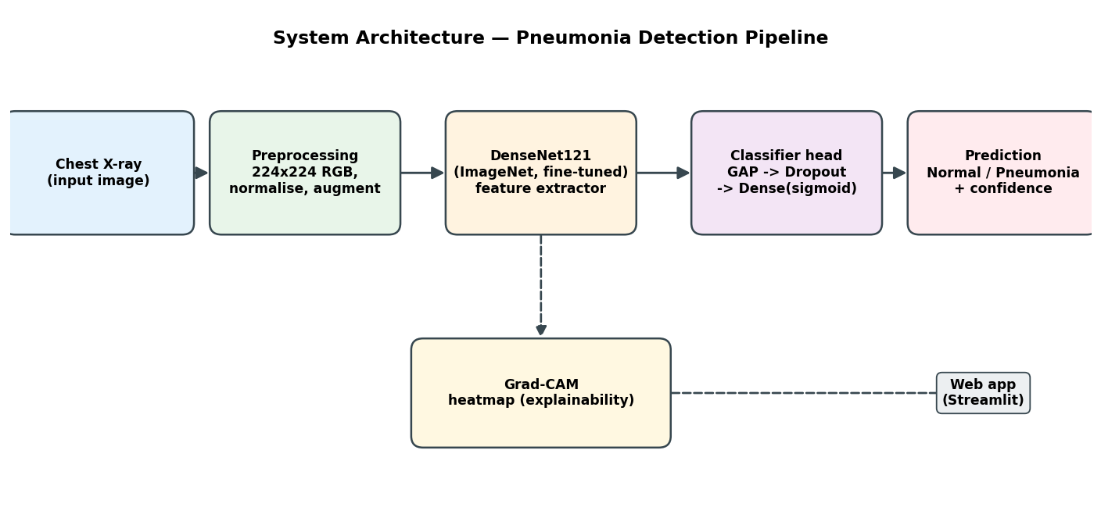
Figure 3.1 System architecture / processing pipeline

3.2 Data Flow
The end-to-end data flow is as follows:
- Input: a chest X-ray image is supplied either from the dataset (during training and evaluation) or uploaded by the user (during inference).
- Preprocessing: the image is resized to 224×224 pixels, converted to three-channel RGB and normalised using the DenseNet preprocessing function. During training, augmentation (random flip, rotation, zoom and contrast) is applied.
- Feature extraction and classification: the DenseNet121 backbone extracts features, which pass through global average pooling, dropout and a single sigmoid neuron producing P(Pneumonia).
- Decision: a threshold of 0.5 converts the probability into a Normal or Pneumonia label with an associated confidence.
- Explanation: Grad-CAM uses the gradients at the final convolutional feature map to generate a heatmap, which is overlaid on the original image.
- Presentation: the prediction, confidence and Grad-CAM overlay are displayed in the web application.

3.3 Module Descriptions
The project is organised into cohesive modules, each with a single responsibility:
- config — central paths and hyperparameters (the single source of truth).
- download_data — fetches a balanced subset (or the full dataset) of chest X-ray images.
- data_loader — builds the input pipelines, applies augmentation and computes class weights.
- model — defines the DenseNet121 transfer-learning network.
- gradcam — computes Grad-CAM heatmaps and overlays them on images.
- train — orchestrates two-phase training and saves the model and figures.
- evaluate — computes metrics and generates the confusion matrix, ROC curve and Grad-CAM samples.
- predict — performs single-image inference for the CLI and the web app.
- app — the Streamlit web application (Home, Try It, How It Works, Source Code).

3.4 Programming Environment
Table 3.1 summarises the hardware and software environment used for development.
Component | Specification
Programming language | Python 3.11
Deep-learning framework | TensorFlow 2.16 / Keras
CNN model | DenseNet121 (ImageNet pretrained)
Image processing | OpenCV (headless), Pillow, NumPy
Evaluation & plotting | scikit-learn, Matplotlib, Seaborn
Web application | Streamlit
Explainability | Grad-CAM (custom implementation)
Hardware (development) | CPU-based workstation; deployable to an AWS EC2 instance
Table 3.1 Hardware and software environment

3.5 Core Algorithm (Pseudocode)
The training procedure follows a two-phase transfer-learning strategy:
load base = DenseNet121(weights = ImageNet, include_top = False)
freeze base
model = base -> GlobalAveragePooling -> Dropout -> Dense(1, sigmoid)

# Phase 1: train the classification head
compile(model, lr = 1e-3)
fit(model, train_data, class_weights, callbacks = [EarlyStopping, ReduceLR])

# Phase 2: fine-tune the top layers of the backbone
unfreeze top layers of base (keep BatchNorm frozen)
compile(model, lr = 1e-5)
fit(model, train_data, class_weights, callbacks = [EarlyStopping, ReduceLR])

save(model)
evaluate(model, test_data)

Chapter 4 Implementation Details
This chapter describes how each part of the system was implemented, including data preprocessing, model construction, training, explainability and the web application.

4.1 Data Preprocessing and Augmentation
Images are loaded from an image-folder directory structure and resized to the 224×224 input size expected by DenseNet121. Each image is converted to three-channel RGB and normalised with the DenseNet preprocessing function. To improve generalisation and reduce overfitting, the training pipeline applies on-the-fly augmentation — random horizontal flips, small rotations, zoom and contrast changes. Because the dataset contains more pneumonia than normal images, inverse-frequency class weights are computed so that the minority class is not neglected during training.

4.2 Model Construction
The model is built by placing a lightweight classification head on top of the pretrained DenseNet121 backbone, as shown below.
base = DenseNet121(include_top=False, weights="imagenet",
input_shape=(224, 224, 3))
base.trainable = False

inputs = Input(shape=(224, 224, 3))
x = base(inputs, training=False)
x = GlobalAveragePooling2D()(x)
x = Dropout(0.3)(x)
outputs = Dense(1, activation="sigmoid")(x)
model = Model(inputs, outputs)

4.3 Training
Training proceeds in two phases. In the first phase the DenseNet backbone is frozen and only the new head is trained, allowing it to adapt quickly without disturbing the pretrained features. In the second phase the top layers of the backbone are unfrozen and fine-tuned with a very small learning rate, while Batch-Normalisation layers are kept frozen for stability. Early stopping (monitoring validation AUC) and learning-rate reduction on plateau prevent overfitting and wasted computation. The best weights are restored and the model is saved in the Keras format.

4.4 Explainability with Grad-CAM
Because the DenseNet backbone is a nested model, Grad-CAM is implemented by mapping the input image to the backbone’s final convolutional feature map and then re-applying the classification head on top of that tensor inside a gradient tape. The gradient of the pneumonia score with respect to the feature map is global-average-pooled to obtain per-channel importance weights, which are combined with the feature map and passed through a ReLU to produce the heatmap. The heatmap is normalised, resized to the original image dimensions, colour-mapped and blended with the X-ray.

4.5 Inference and the Web Application
The prediction module wraps the trained model to accept any image source (a file path or an uploaded file), returning the label, confidence, class probabilities, the original image and the Grad-CAM overlay. The Streamlit application exposes this functionality through four pages: a Home page with the headline metrics; a Try It page for uploading an X-ray and viewing the prediction and Grad-CAM; a How It Works page that visually explains the pipeline, architecture and results; and a Source Code page that lets users browse the entire project in the browser.

4.6 Deployment
For demonstration, the project can be deployed on an Ubuntu machine such as an AWS EC2 instance. A single deployment script installs the system and Python dependencies, prompts the user to choose between the small sample subset and the full dataset, downloads the data, trains the model and launches the web application bound to all interfaces so that it can be accessed from a browser over the network.

Chapter 5 Testing, Validation & Results

5.1 Testing Methodology
The dataset was divided into training, validation and test splits. The model was trained on the training split, the validation split guided early stopping and learning-rate scheduling, and the held-out test split — never seen during training — was used for the final, unbiased evaluation. To ensure a fair assessment, a balanced test set with an equal number of Normal and Pneumonia images was used, so that accuracy is not inflated by class imbalance. Table 5.1 shows the composition of the subset used to train the baseline model reported here.
Split | Normal | Pneumonia | Total
Training | 400 | 400 | 800
Validation | 8 | 8 | 16
Test | 100 | 100 | 200
Table 5.1 Dataset composition (subset used for the baseline)

5.2 Evaluation Metrics
The model was evaluated using accuracy, precision, recall, F1-score and the Area Under the ROC Curve (AUC). For a medical screening task, recall (sensitivity) is especially important because a false negative — missing a genuine case of pneumonia — is more harmful than a false positive. Table 5.2 reports the results on the held-out test set.
Metric | Value
Accuracy | 80.0%
Precision | 79.4%
Recall (Sensitivity) | 81.0%
F1-score | 80.2%
AUC | 0.885
Table 5.2 Classification performance on the held-out test set

5.3 Training Behaviour
Figure 5.1 shows the accuracy and loss on the training and validation sets across both phases. The dashed line marks the transition from head-training to fine-tuning. The curves indicate that the model learns steadily and that the regularisation strategies keep training and validation performance reasonably aligned.
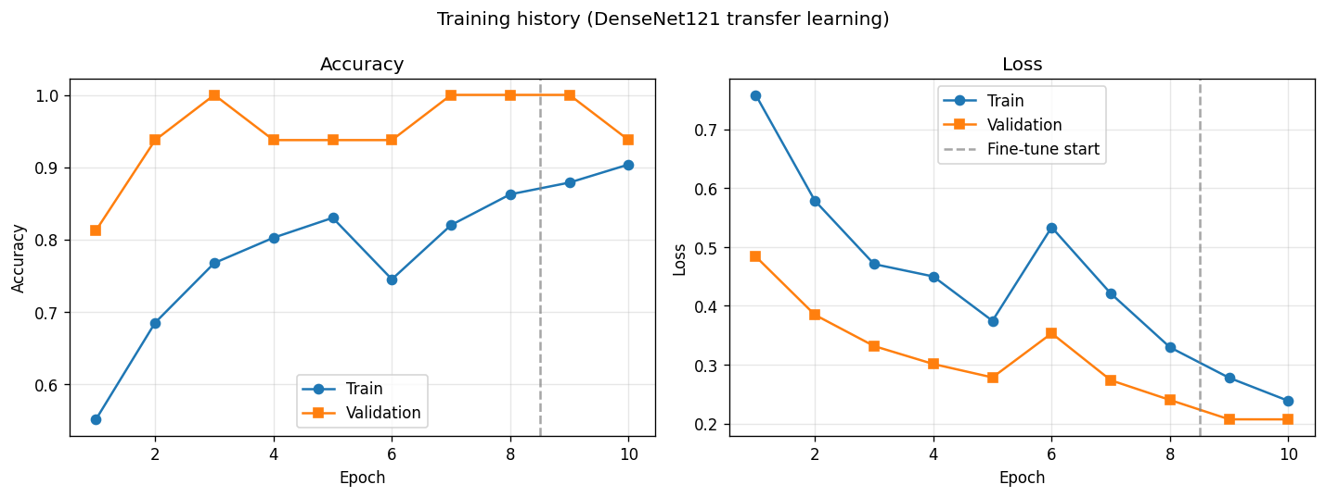
Figure 5.1 Training and validation accuracy and loss across the two phases

5.4 Confusion Matrix and ROC Curve
Figure 5.2 presents the confusion matrix, which breaks down correct and incorrect predictions for each class, and Figure 5.3 shows the ROC curve. The AUC of 0.885 indicates good separability between the two classes.
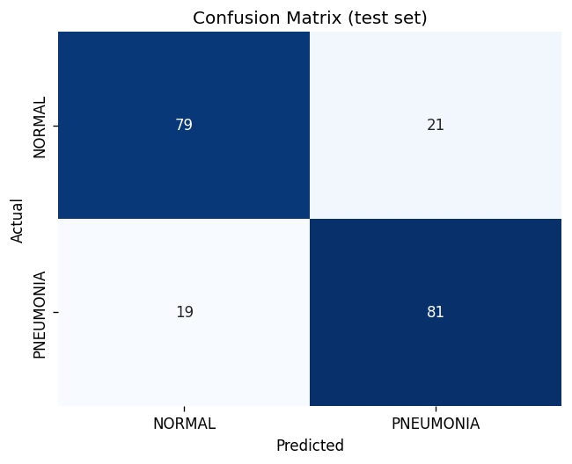
Figure 5.2 Confusion matrix on the held-out test set
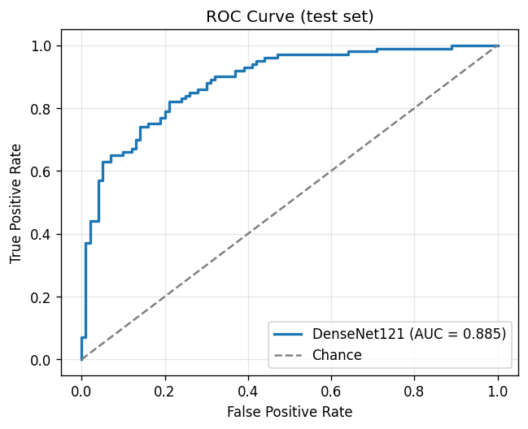
Figure 5.3 ROC curve on the held-out test set

5.5 Explainability Results
Figure 5.4 shows Grad-CAM overlays on sample test X-rays together with the true and predicted labels. The heatmaps concentrate on the lung fields, indicating that the model bases its decisions on clinically relevant regions rather than on irrelevant background, which supports the trustworthiness of the system.
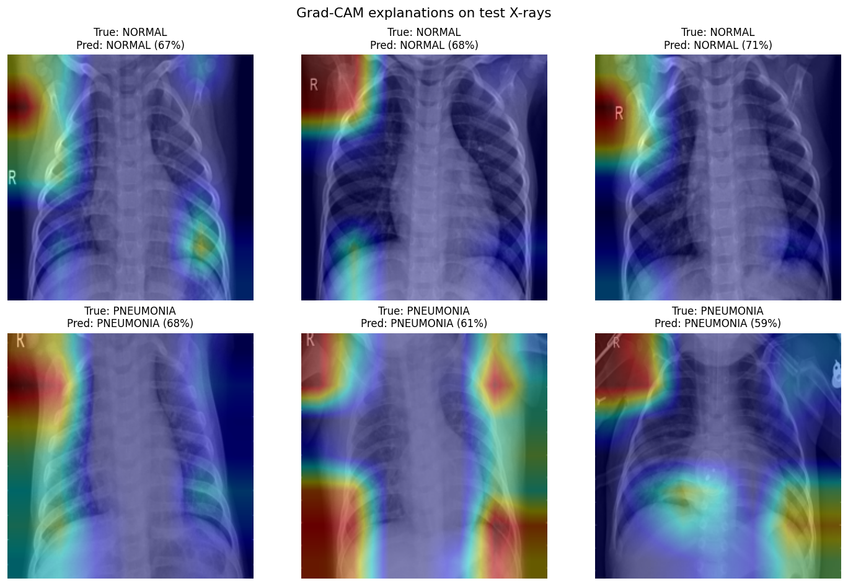
Figure 5.4 Grad-CAM explanations on sample test X-rays

5.6 Discussion
The baseline model, trained on a small balanced subset, attains 80.0% accuracy and 81.0% recall with an AUC of 0.885. These results are encouraging given the limited training data and confirm that DenseNet121 transfer learning is effective for this task. The Grad-CAM visualisations add an essential layer of interpretability. Training on the full dataset is expected to raise accuracy further, as discussed in the next chapter.

Chapter 6 Conclusion and Future Work

6.1 Conclusion
This project successfully designed and implemented a deep-learning system for detecting pneumonia from chest X-ray images. Using DenseNet121 with two-phase transfer learning, the system classifies X-rays as Normal or Pneumonia and, through Grad-CAM, explains each prediction by highlighting the influential regions. On a balanced held-out test set the baseline model achieved 80.0% accuracy, 81.0% recall and an AUC of 0.885. All four objectives set out in Chapter 1 were met: a working detection system, the use of a pretrained CNN, the integration of explainable AI, and a simple interactive interface for demonstration.
The key contribution is the combination of an accurate classifier with integrated explainability, packaged in a single web application that also documents its own methodology and source code, making the system transparent and easy to evaluate.

6.2 Limitations
- The baseline model was trained on a small subset of the data, so its accuracy is lower than what the full dataset can achieve.
- The system performs binary classification only; it does not distinguish bacterial from viral pneumonia or detect other lung conditions.
- The model has not undergone clinical validation and is intended solely as an educational prototype.

6.3 Future Work
- Train on the complete Chest X-Ray Pneumonia dataset (and larger datasets such as ChestX-ray14) to improve accuracy and robustness.
- Compare multiple architectures (VGG16, ResNet50, DenseNet121) and report a systematic performance comparison.
- Extend the system to multi-class classification and to the detection of additional thoracic conditions.
- Perform external and clinical validation, and incorporate uncertainty estimation for safer decision support.
- Deploy the application as a scalable cloud service with authentication and audit logging.

Chapter 7 References
[1] D. S. Kermany, M. Goldbaum, W. Cai, et al., “Identifying Medical Diagnoses and Treatable Diseases by Image-Based Deep Learning,” Cell, vol. 172, no. 5, pp. 1122–1131, 2018.
[2] G. Huang, Z. Liu, L. van der Maaten, and K. Q. Weinberger, “Densely Connected Convolutional Networks,” in Proc. IEEE Conf. Computer Vision and Pattern Recognition (CVPR), 2017, pp. 4700–4708.
[3] R. R. Selvaraju, M. Cogswell, A. Das, R. Vedantam, D. Parikh, and D. Batra, “Grad-CAM: Visual Explanations from Deep Networks via Gradient-Based Localization,” in Proc. IEEE Int. Conf. Computer Vision (ICCV), 2017, pp. 618–626.
[4] P. Rajpurkar, J. Irvin, K. Zhu, et al., “CheXNet: Radiologist-Level Pneumonia Detection on Chest X-Rays with Deep Learning,” arXiv:1711.05225, 2017.
[5] J. Deng, W. Dong, R. Socher, L.-J. Li, K. Li, and L. Fei-Fei, “ImageNet: A Large-Scale Hierarchical Image Database,” in Proc. IEEE Conf. Computer Vision and Pattern Recognition (CVPR), 2009, pp. 248–255.
[6] K. Simonyan and A. Zisserman, “Very Deep Convolutional Networks for Large-Scale Image Recognition,” in Proc. Int. Conf. Learning Representations (ICLR), 2015.
[7] K. He, X. Zhang, S. Ren, and J. Sun, “Deep Residual Learning for Image Recognition,” in Proc. IEEE Conf. Computer Vision and Pattern Recognition (CVPR), 2016, pp. 770–778.
[8] G. Litjens, T. Kooi, B. E. Bejnordi, et al., “A Survey on Deep Learning in Medical Image Analysis,” Medical Image Analysis, vol. 42, pp. 60–88, 2017.
[9] M. Abadi, A. Agarwal, P. Barham, et al., “TensorFlow: Large-Scale Machine Learning on Heterogeneous Distributed Systems,” arXiv:1603.04467, 2016.
[10] F. Chollet et al., “Keras,” 2015. [Online]. Available: https://keras.io
[11] Streamlit Inc., “Streamlit: The fastest way to build and share data apps,” 2019. [Online]. Available: https://streamlit.io
[12] World Health Organization, “Pneumonia in children,” Fact sheet, 2022. [Online]. Available: https://www.who.int/news-room/fact-sheets/detail/pneumonia

Chapter 8 Appendix

A. Source-Code Repository
The complete source code for this project — including the data pipeline, model, training scripts, Grad-CAM implementation and the Streamlit web application — is available at the following repository:
GitHub: <insert your repository URL here>

B. How to Run
# Ubuntu / EC2 (one command does everything)
git clone <repository-url>
cd minorproject
chmod +x deploy.sh
./deploy.sh # prompts: small sample or full dataset

# Manual (any platform)
python3 -m venv .venv && source .venv/bin/activate
pip install -r requirements.txt
python -m src.download_data # add --full for the full dataset
python -m src.train
streamlit run app/Home.py

C. Project Structure
src/ config, download_data, data_loader, model,
gradcam, train, evaluate, predict
app/ Home.py + pages/ (Try It, How It Works, Source Code)
models/ trained model + metrics.json
reports/figures/ training curves, confusion matrix, ROC, Grad-CAMs

Date: Student Name and Signature

Date: Name and Signature of the Evaluator

