**ML-Assignment-5**

**NAME: PAVANI REDDY GANGA SARAM.**

**ID: 700734357.**

**#Question 1:**

Principal Component Analysis

a. Applied PCA on CC dataset.

b. Applied k-means algorithm on the PCA result.

c. Perform Scaling+PCA+K-Means.

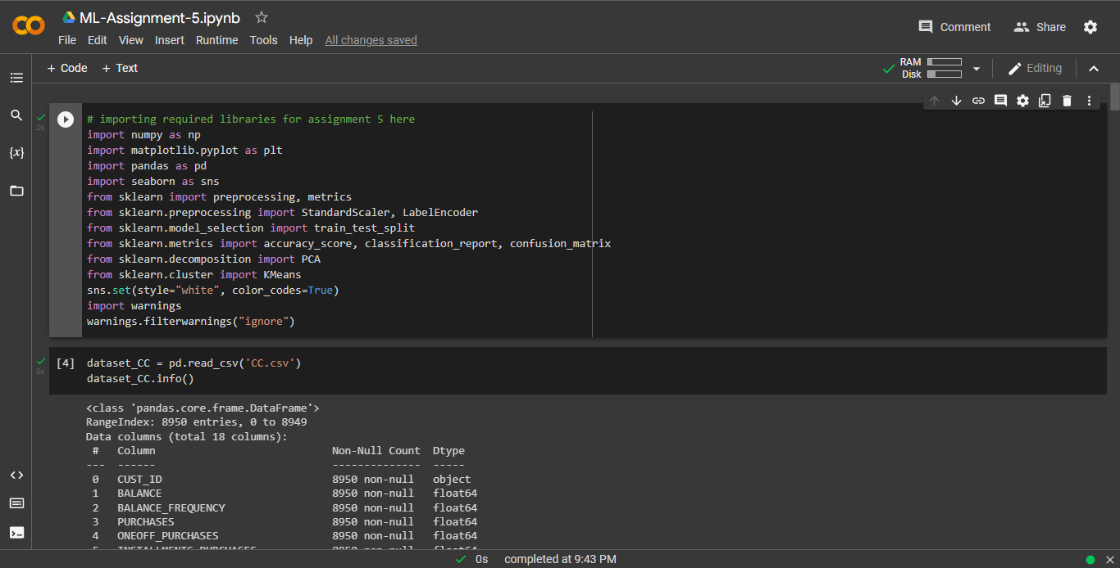

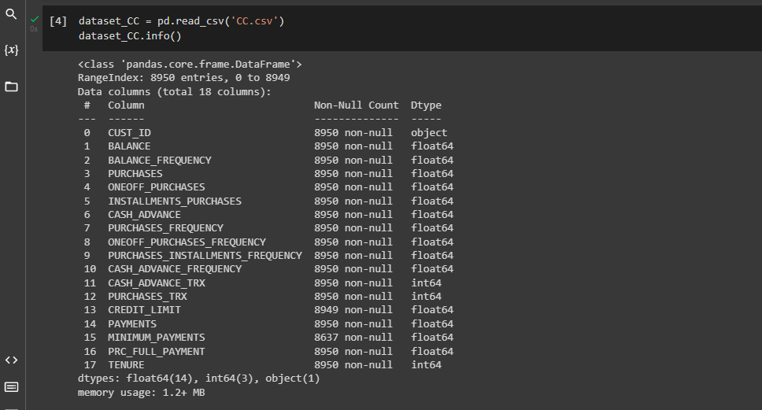

Applying PCA on CC Dataset.

Applying K means on PCA Result.

Predicting the cluster for each data point.

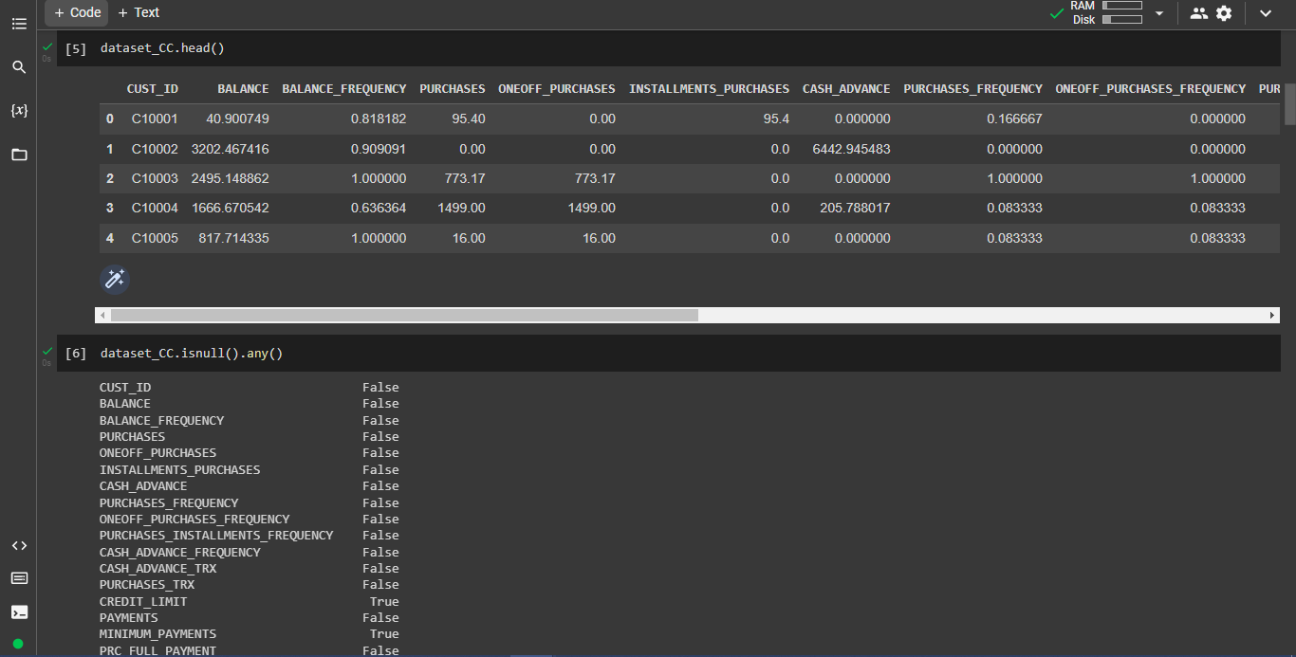

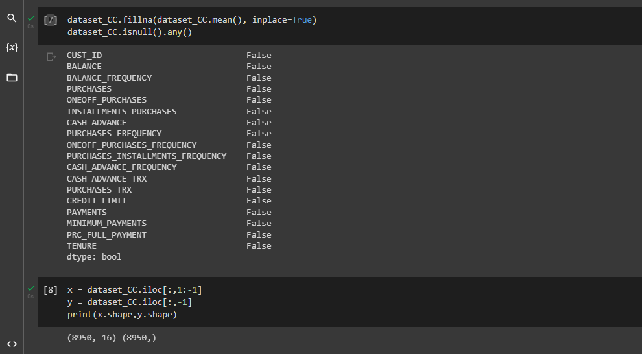

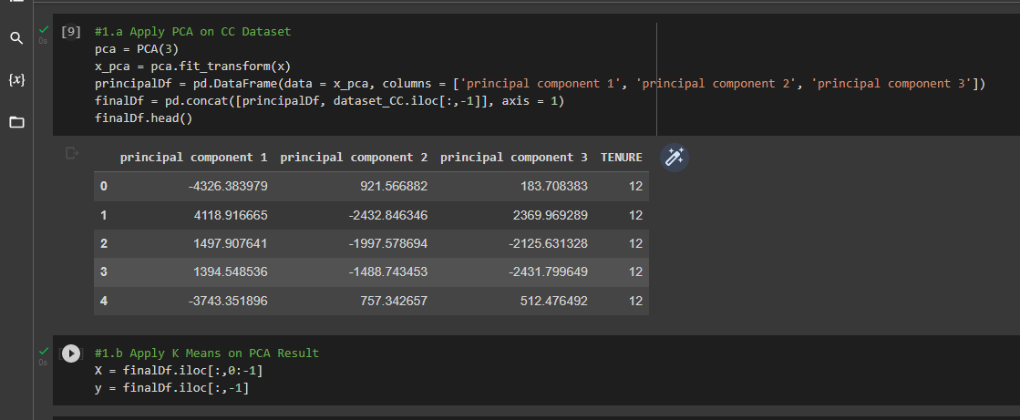

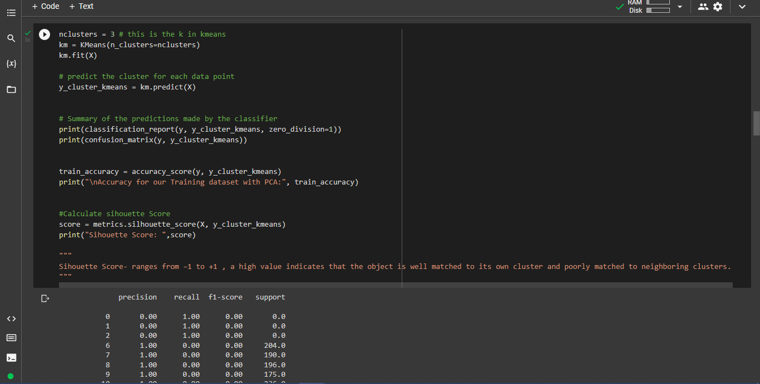

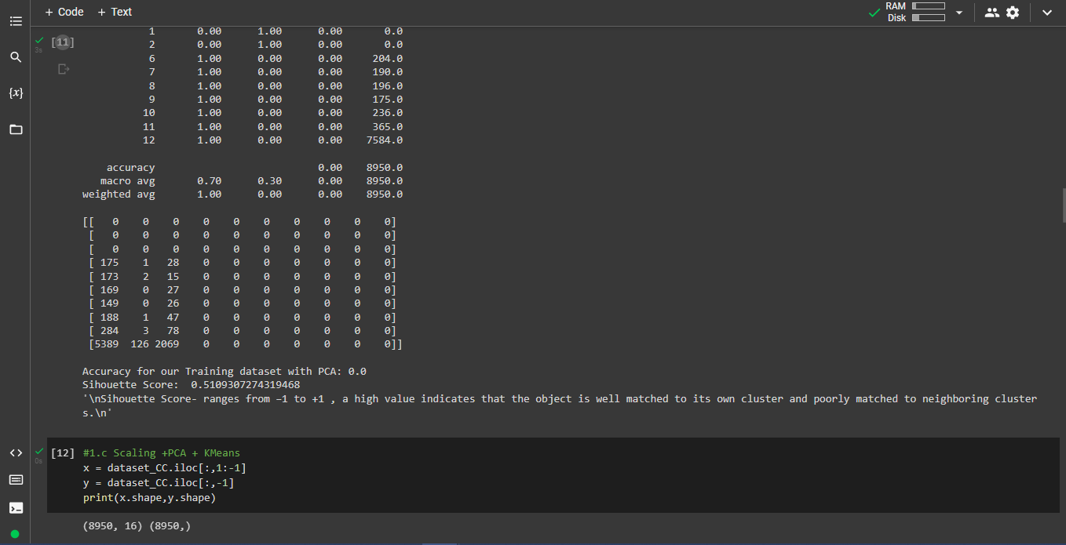

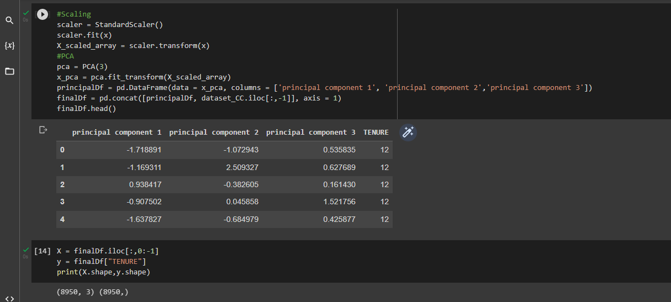

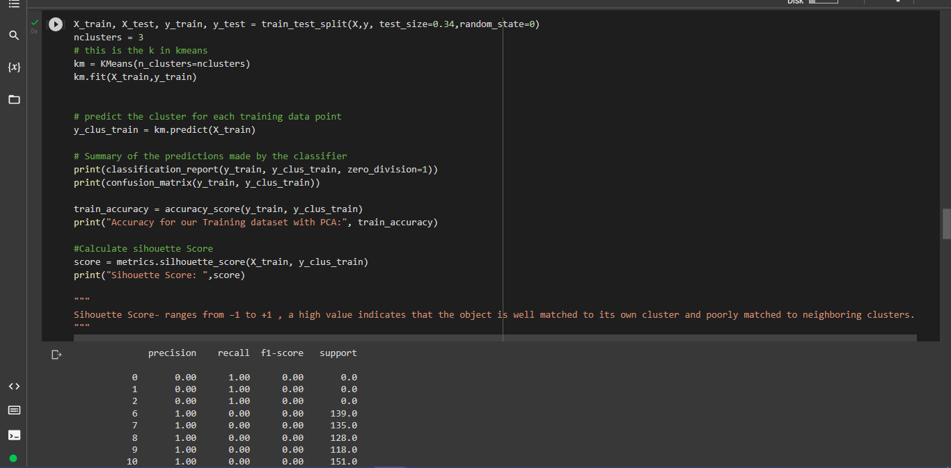

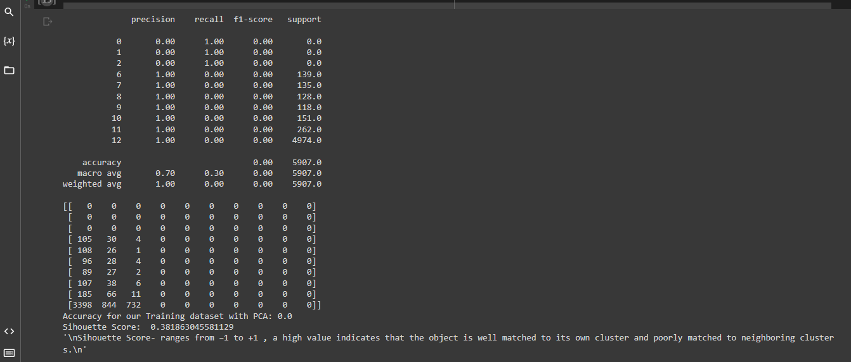

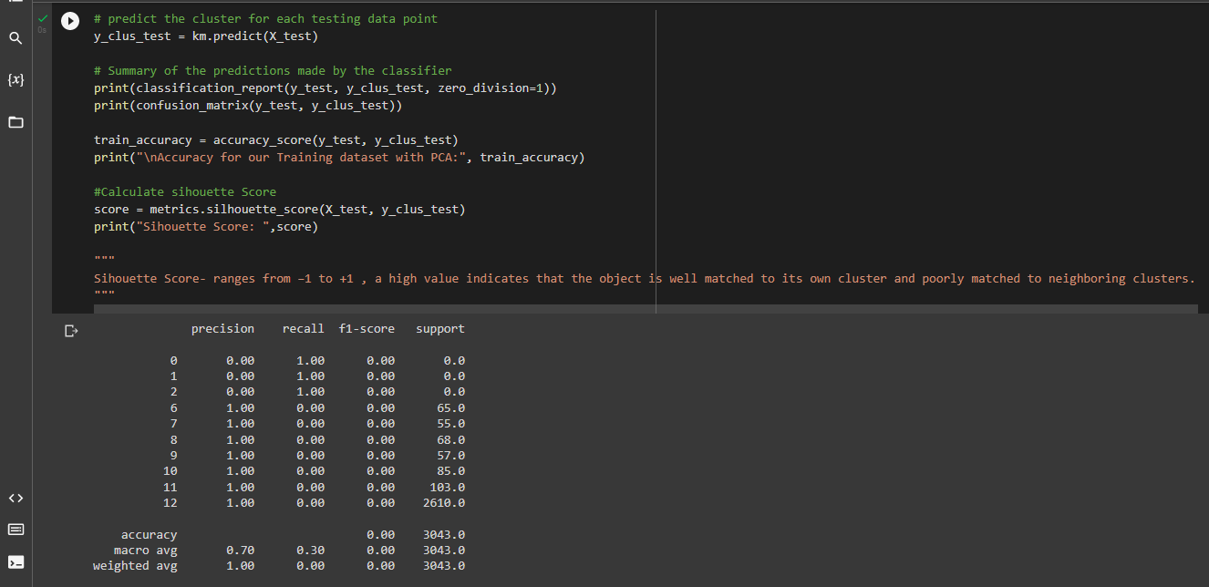

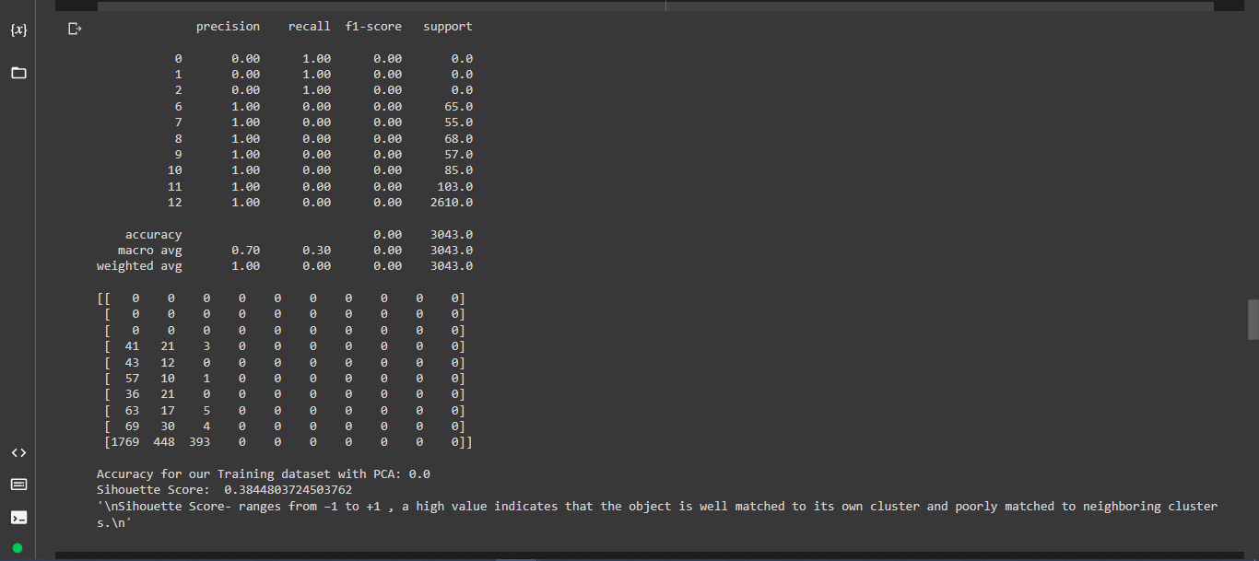

**#Question-2**

Used pd_speech_features.csv

a. performing scaling on the data.

b. Applying PCA (k=3)

c. Using SVM to report performance

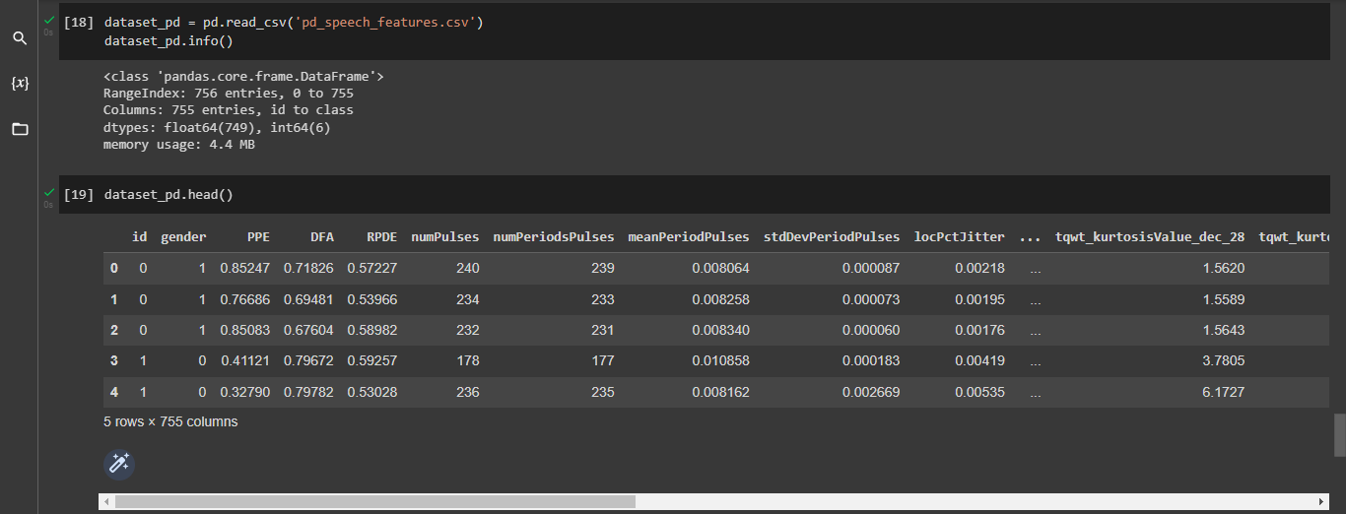

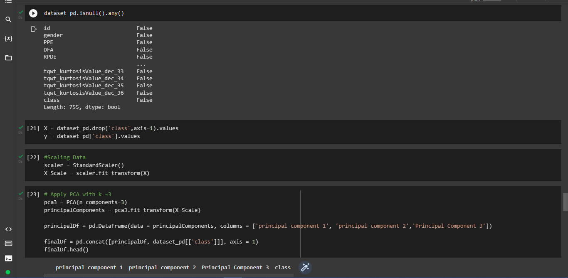

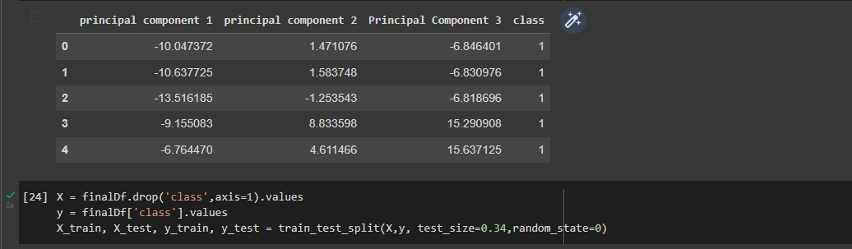

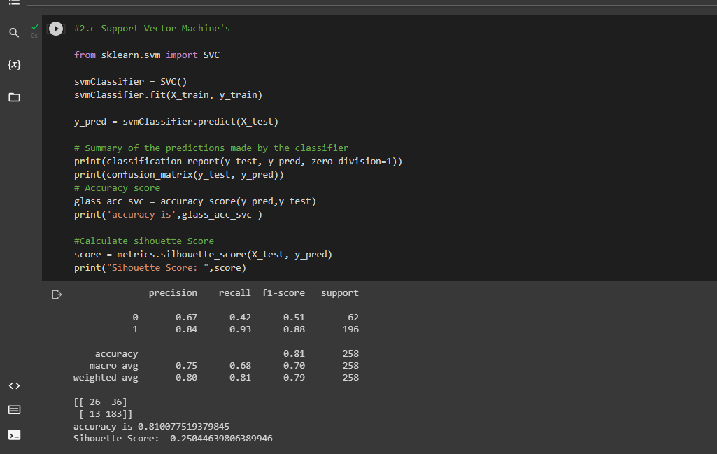

**#Question-3**

Applying Linear Discriminant Analysis (LDA) on Iris.csv dataset to reduce dimensionality of data to k=2.

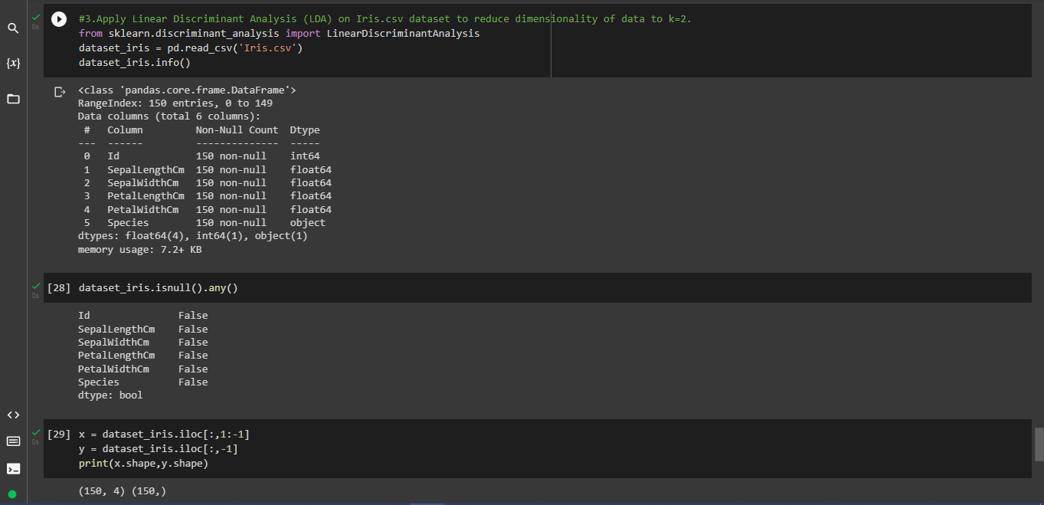

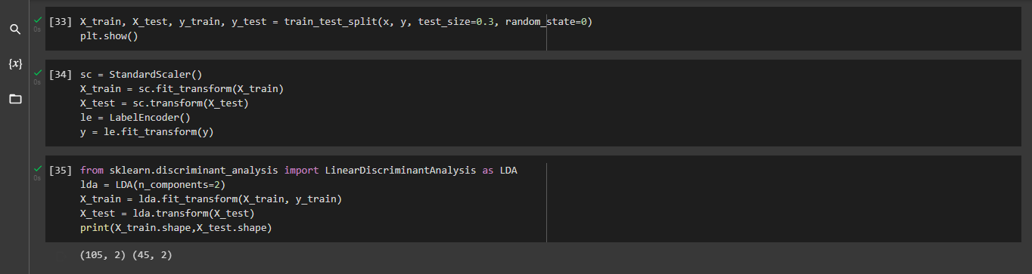

**#Question-4**

Difference between PCA & LDA:

1.Both LDA and PCA rely on linear transformations and aim to maximize the variance in a lower dimension. PCA is an unsupervised learning algorithm while LDA is a supervised learning algorithm. This means that PCA finds directions of maximum variance regardless of class labels while LDA finds directions of maximum class separability.

PCA: It reduces the features into a smaller subset of orthogonal variables, called principal components – linear combinations of the original variables. The first component captures the largest variability of the data, while the second captures the second largest, and so on.

LDA: LDA finds the linear discriminants in order to maximize the variance between the different categories while minimizing the variance within the class.