1. What exactly is []?

🡪 In python [ ] 🡪 is used for defining the list.

1. In a list of values stored in a variable called spam, how would you assign the value 'hello' as the third value? (Assume [2, 4, 6, 8, 10] are in spam.)

* 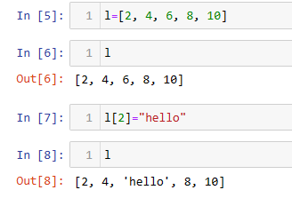

Let's pretend the spam includes the list ['a', 'b', 'c', 'd'] for the next three queries.

1. What is the value of spam[int(int('3' * 2) / 11)]?

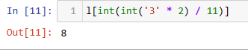

1. What is the value of spam[-1]?

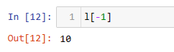

1. What is the value of spam[:2]?

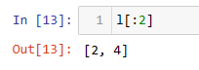

Let's pretend bacon has the list [3.14, 'cat,' 11, 'cat,' True] for the next three questions.

1. What is the value of bacon.index('cat')?

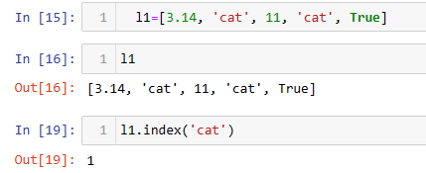

1. How does bacon.append(99) change the look of the list value in bacon?

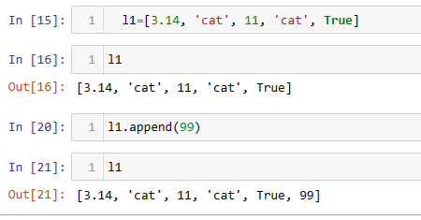

1. How does bacon.remove('cat') change the look of the list in bacon?

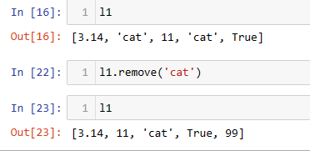

1. What are the list concatenation and list replication operators?

🡪 The operator for list concatenation is **+**, while the operator for replication **is \***

1. What is difference between the list methods append() and insert()?

* append() adds an item to the end of a list.

insert() inserts and item in a specified position in the list

1. What are the two methods for removing items from a list?

🡪 clear() , pop() , and remove() to remove elements from a list.

1. Describe how list values and string values are identical.

The differences between them are that firstly, Lists are mutable but Strings are immutable. Secondly, elements of a list can be of different types whereas a String only contains characters that are all of String type

1. What's the difference between tuples and lists?

* tuples are immutable as opposed to lists which are mutable.

it is possible to change a list but not a tuple.

The contents of a tuple cannot change once they have been created in Python due to the immutability of tuples.

1. How do you type a tuple value that only contains the integer 42?

🡪 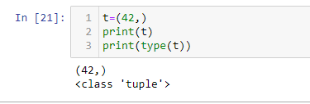

15. How do you get a list value's tuple form? How do you get a tuple value's list form?

🡪 tuple() built-in function and to convert a tuple into list in Python, call list() builtin function and pass the tuple as argument to the function.

16. Variables that "contain" list values are not necessarily lists themselves. Instead, what do they contain?

🡪 Variables will contain references to list values rather than list values themselves. But for strings and integer values, variables simply contain the string or integer value.

17. How do you distinguish between copy.copy() and copy.deepcopy()?

🡪 copy() create reference to original object. If you change copied object - you change the original object. . deepcopy() creates new object and does real copying of original object to new one.