1. What are escape characters, and how do you use them?

🡪 An escape character is a backslash \ followed by the character you want to insert.

e.g.--> txt = "We are the so-called \"Vikings\" from the north."

2. What do the escape characters n and t stand for?

🡪 \n 🡪 New line and \t 🡪 tab

1. What is the way to include backslash characters in a string?

🡪 txt = "This will insert one \\ (backslash)."

print(txt)

1. The string "Howl's Moving Castle" is a correct value. Why isn't the single quote character in the word Howl's not escaped a problem?

🡪 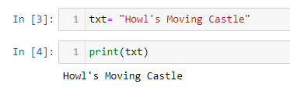

1. How do you write a string of newlines if you don't want to use the n character?

🡪 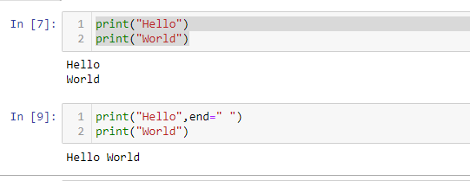

6. What are the values of the given expressions?

'Hello, world!'[1]

'Hello, world!'[0:5]

'Hello, world!'[:5]

'Hello, world!'[3:]

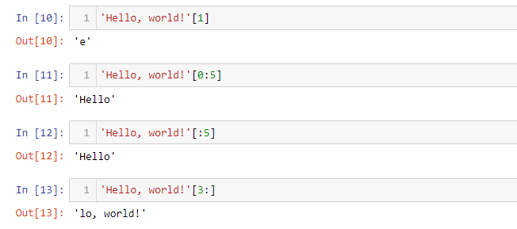

7. What are the values of the following expressions?

'Hello'.upper()

'Hello'.upper().isupper()

'Hello'.upper().lower()

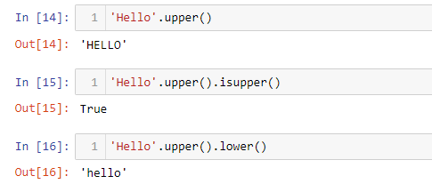

8. What are the values of the following expressions?

'Remember, remember, the fifth of July.'.split()

'-'.join('There can only one.'.split())

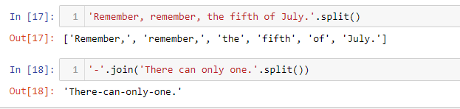

9. What are the methods for right-justifying, left-justifying, and centering a string?

🡪 Use the rjust() , center() , or ljust() methods to right-justify, center, or left-justify strings str in Python.

10. What is the best way to remove whitespace characters from the start or end?

🡪 .lstrip() method to remove whitespace and characters only from the beginning of a string. Use the .rstrip() method to remove whitespace and characters only from the end of a string.