Built in page locator
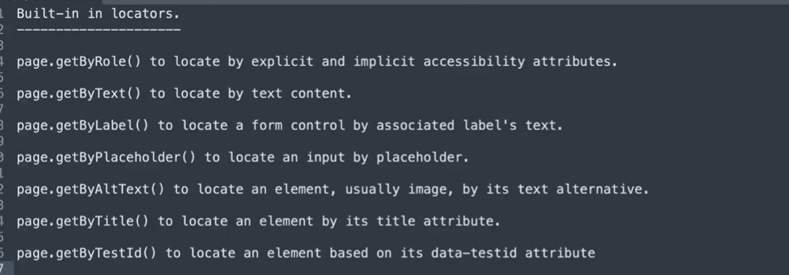
Npx playwright codegen - for automatic code generation

Npx playwright codegen -o tests/my_test.spec,js

Assertions:
What are Assertions in Playwright?
- Assertions are used to verify expected behavior in tests
- Playwright uses expect() function
- It automatically waits until condition is met (no need for manual waits)
- Makes tests stable and less flaky

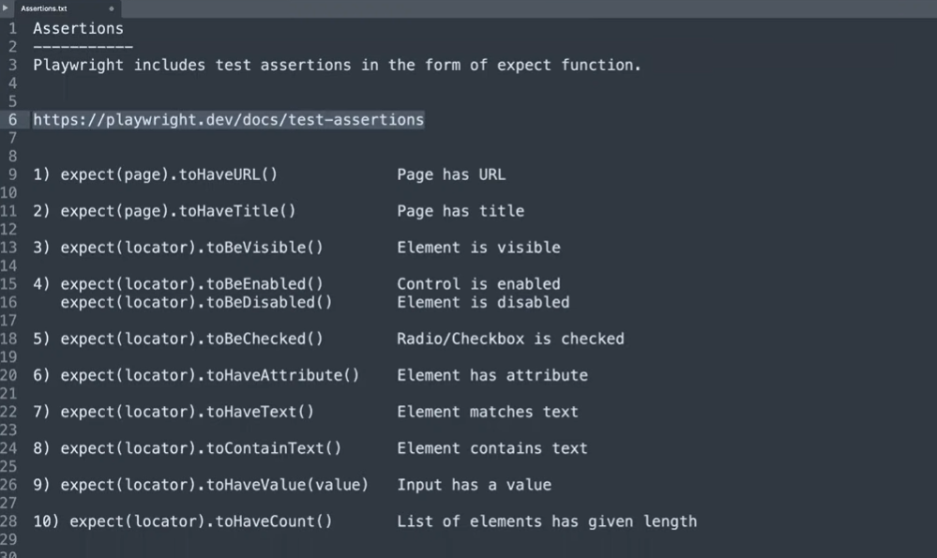
✅ Hard Assertions vs Soft Assertions (Playwright JS)
Feature | Hard Assertion | Soft Assertion
Behavior on Failure | Stops test execution immediately | Continues execution even after failure
Impact on Test Flow | Next steps are NOT executed | All steps are executed
Error Reporting | Shows first failure only | Shows all failures at the end

Hard Assertion
import { test, expect } from '@playwright/test';
test ('Hard Assertion Example', async ({ page }) => {
await page.goto('https://example.com');
await expect(page).toHaveTitle('Wrong Title'); // ❌ Test stops here
await expect(page.locator('#id')).toBeVisible(); // Not executed });

Soft Assertion
import { test, expect } from '@playwright/test';
test ('Soft Assertion Example', async ({ page }) => {
await page.goto('https://example.com');
await expect.soft(page).toHaveTitle('Wrong Title'); // ❌ but continues
await expect.soft(page.locator('#id')).toBeVisible(); // Executes });

