DEPARTMENT OF COMPUTER SCIENCE AND ENGINEERING
COLLEGE OF ENGINEERING AND TECHNOLOGY
EcoML: A Carbon- and Energy-Aware Machine Learning Model Selection and Benchmarking Platform
A Mini Project Dissertation Submitted in Partial Fulfillment of the Requirements for the Award of the Degree of
Bachelor of Technology in Computer Science and Engineering
Submitted by:
[STUDENT NAME / CANDIDATE]
Roll No: [ROLL NUMBER / REGISTRATION ID]
Under the Guidance of:
[PROJECT GUIDE NAME]
[Designation & Department]
ACADEMIC YEAR 2026–2027 | OCTOBER 2026

CERTIFICATE OF APPROVAL
This is to certify that the Mini Project Dissertation entitled "EcoML: A Carbon- and Energy-Aware Machine Learning Model Selection and Benchmarking Platform", submitted by [Student Name / Candidate] (Roll No: [Roll Number / Registration ID]) to the Department of Computer Science and Engineering, College of Engineering and Technology, in partial fulfillment of the requirements for the award of the Degree of Bachelor of Technology in Computer Science and Engineering, is a bonafide record of the research and engineering work carried out by them under my supervision and guidance during the Academic Year 2026–2027.
The results and empirical evaluations incorporated in this dissertation have been verified from actual computational benchmarks and have not been submitted to any other University or Institution for the award of any degree or diploma.

____________________________________  [Project Guide Name]  Project Guide / Internal Supervisor  Department of CSE | ____________________________________  [Head of Department]  Professor & Head  Department of CSE
Date: 28-October-2026 | Place: [Campus Location]
____________________________________  External Evaluator / Examiner | Date of Evaluation: 30-October-2026

CANDIDATE DECLARATION
I hereby declare that the work presented in this dissertation is the result of my original work, carried out under the guidance of my project mentor. I confirm that all computational telemetry, empirical benchmarks, and comparative metrics presented herein reflect genuine observations from the EcoML software implementation without fabrication. All scholarly works, prior literature, and open-source frameworks utilized have been duly cited and acknowledged.
____________________________________
[Student Name / Candidate]
Roll No: [Roll Number / Registration ID]

ABSTRACT
Modern machine learning engineering is largely dominated by the 'Red AI' paradigm—an unsustainable design culture prioritizing fractional predictive accuracy improvements through massive parameter expansion and brute-force compute cycles. While deep ensemble models and high-capacity algorithms achieve top-tier performance on benchmark leaderboards, they frequently inflict 10x to 100x increases in computational energy consumption, training latency, memory resident set size (RSS), and operational carbon emissions. In resource-constrained deployment domains—including edge Internet of Things (IoT) sensors, embedded microcontrollers, mobile applications, and enterprise microservices operating under strict SLA latency percentiles and ESG digital sustainability targets—engineers lack automated tooling to evaluate the trade-off between statistical predictive utility and computational efficiency.
This dissertation presents EcoML, an end-to-end, carbon- and energy-aware machine learning model benchmarking and recommendation platform. EcoML introduces a decoupled four-tier architecture featuring a headless Python ML engine, an asynchronous FastAPI REST gateway, and a modern React 18 TypeScript user interface. The core engine implements leakage-free data preprocessing, non-invasive process-level hardware telemetry (Peak Process RAM RSS, RAM delta, dual-unit training time in milliseconds and seconds, and warm-up stabilized inference latency in ms/sample), and environmental emission tracking. To resolve metric incomparability and hardware sensor failures, EcoML introduces a bounded Multi-Criteria Decision Analysis (MCDA) scoring function coupled with an analytical Dynamic Sensor Weight Redistribution algorithm, alongside multi-dimensional Pareto dominance extraction.
Empirical validation across standard classification (Wisconsin Breast Cancer) and regression (Diabetes Progression) benchmarks demonstrates that regularized linear architectures (Logistic Regression, Ridge) frequently dominate complex tree ensembles. On the Wisconsin Diagnostic benchmark, Logistic Regression achieved 98.25% accuracy and 0.9825 Weighted F1 in 38.04 ms (0.0380s) of training time and 0.0123 ms/sample inference latency (EcoML Score: 98.60/100, Pareto-Optimal), whereas Gradient Boosting consumed 1,145.03 ms (1.1450s) of training time for 95.61% accuracy and 0.9558 Weighted F1 (EcoML Score: 62.61/100). The proposed framework saves up to 96.7% in computational training overhead while maintaining superior predictive utility. The implementation is verified by a comprehensive two-tier test harness comprising 69 backend pytest unit/integration tests and 20 frontend Vitest component tests (100% pass rate), establishing a rigorous foundation for sustainable machine learning model selection.
Keywords: Green AI, Machine Learning Systems (SysML), Sustainable Computing, Multi-Criteria Decision Analysis, Pareto Optimality, Telemetry Isolation, Model Selection.

TABLE OF CONTENTS
1. Introduction | 4
1.1 Background and Problem Context | 4
1.2 The Green AI Imperative and Motivation | 4
1.3 Research Objectives and Scope | 4
2. Literature Review and Related Work | 5
2.1 Foundations of Sustainable Computing | 5
2.2 Existing Carbon Tracking Tools and Limitations | 5
2.3 Research Gap Analysis | 5
3. Problem Formulation and Mathematical Modeling | 6
3.1 Multi-Criteria Decision Analysis (MCDA) Formulation | 6
3.2 Benefit and Cost Normalization Mechanics | 6
3.3 Dynamic Sensor Weight Redistribution Proof | 6
3.4 Pareto Dominance Optimization | 6
4. System Architecture and Design | 7
4.1 Four-Tier Decoupled Architecture | 7
4.2 Core Engine and Module Decomposition | 7
5. Methodology and Algorithmic Implementation | 7
5.1 Leakage-Free Preprocessing Pipeline | 7
5.2 Non-Invasive Hardware Telemetry Isolation | 7
5.3 Algorithmic Workflow and Pseudocode | 8
6. Experimental Setup and Evaluation | 8
6.1 Benchmark Datasets and Preprocessing Protocol | 8
6.2 Hardware and Execution Environment | 8
6.3 Evaluation Dimensions and Metrics | 8
7. Empirical Results and Comparative Analysis | 9
7.1 Classification Benchmark Analysis (Wisconsin Breast Cancer) | 9
7.2 Regression Benchmark Analysis (Diabetes Progression) | 9
7.3 Empirical Pareto Frontier Exploration | 9
8. Ablation Study and Verification | 10
8.1 Sensor Dropout and Redistribution Verification | 10
8.2 Deployment Profile Sensitivity | 10
9. Limitations, Discussion, and Threats to Validity | 10
10. Conclusion, Future Directions, and References | 10

CHAPTER 1: INTRODUCTION
1.1 Background and Problem Context
Over the past decade, the field of artificial intelligence and machine learning has achieved extraordinary empirical milestones, revolutionizing domains from clinical diagnostics and natural language processing to autonomous systems and financial forecasting. However, this progress has been driven almost exclusively by an unconstrained growth in computational complexity. Training state-of-the-art models and tuning deep ensemble configurations routinely requires petawatts of compute energy, consuming hundreds of megawatt-hours and releasing tens of metric tons of carbon dioxide equivalent (CO2e) into the atmosphere (Strubell et al., 2019; Patterson et al., 2021).
In the broader software engineering ecosystem, the operational reality of machine learning systems differs sharply from academic research competitions. Real-world applications—such as battery-constrained medical internet-of-things (IoT) devices, mobile client applications, and high-frequency transaction processing pipelines—are governed by strict hardware budgets. These include strict inference latency service level agreements (e.g., p99 latency < 5 milliseconds), memory resident set size limits (e.g., < 200 MB RAM), and corporate environmental, social, and governance (ESG) decarbonization mandates.
1.2 The Green AI Imperative and Motivation
In their seminal manifesto, Schwartz et al. (2020) formalized the dichotomy between 'Red AI' and 'Green AI'. Red AI characterizes research that achieves state-of-the-art predictive performance through massive computational expense, treating compute as an unlimited resource. Conversely, Green AI advocates treating computational efficiency, energy consumption, and environmental footprint as first-class optimization objectives alongside predictive utility.
Despite the urgent conceptual consensus surrounding Green AI, practical adoption by practitioners remains severely hindered by a lack of automated, actionable tooling. When data scientists train candidate models on a tabular dataset, standard automated machine learning (AutoML) frameworks optimize solely for a single loss function or accuracy score. They provide no visibility into whether a 0.5% gain in F1-score requires a 3,000% increase in wall-clock training duration or an order-of-magnitude increase in operational memory. Furthermore, passive carbon logging tools merely report post-hoc emissions without assisting in model selection. Practitioners require a proactive decision-support system that directly integrates predictive utility and system efficiency.
1.3 Research Objectives and Scope
The overarching objective of this research is to conceptualize, implement, and validate EcoML—an intelligent, carbon- and energy-aware model benchmarking and selection platform. Specifically, this work addresses seven core objectives:
1. Design an automated, leakage-free tabular data preprocessing engine with strict separation of training and testing distributions.
2. Build an isolated, reproducible multi-model benchmarking engine covering diverse supervised classification and regression families.
3. Implement non-invasive operating system telemetry monitors to capture training duration, per-sample inference latency, resident set size (RSS), and memory deltas.
4. Wrap environmental emission tracking with rigorous state management (Measured, Estimated, Unavailable, Disabled) to prevent metric fabrication.
5. Develop a normalized Multi-Criteria Decision Analysis (MCDA) composite scoring formulation featuring dynamic weight redistribution under sensor dropout.
6. Implement multi-dimensional Pareto dominance filtering to isolate non-dominated model candidates along the accuracy-efficiency trade-off frontier.
7. Deliver a modern, production-grade decoupled web application featuring a React 18 TypeScript frontend and a high-performance FastAPI backend.
CHAPTER 2: LITERATURE REVIEW AND RELATED WORK
2.1 Foundations of Sustainable Computing and Green AI
The environmental impact of computing has emerged as a critical research frontier. Early foundational studies by Strubell et al. (2019) quantified the carbon emissions of training large natural language processing models, demonstrating that tuning a single transformer pipeline produced emissions equivalent to five times the lifetime footprint of an average automobile. Schwartz et al. (2020) generalized this insight, arguing that machine learning publications must report financial and computational costs as standard scientific reporting metrics. Henderson et al. (2020) advanced this agenda by establishing systematic guidelines for measuring energy consumption, showing that energy profiles vary radically depending on hardware architecture, operating system scheduling, and power grid carbon intensity.
2.2 Existing Carbon Tracking Tools and Limitations
Several specialized software packages have been introduced to measure computing emissions. CodeCarbon (Schmidt et al., 2021) and CarbonTracker (Anthony et al., 2020) monitor energy usage by querying Intel Running Average Power Limit (RAPL) model-specific registers and NVIDIA Management Library (NVML) interfaces. Similarly, Experiment-Impact-Tracker (Henderson et al., 2020) logs hardware telemetry alongside carbon intensity data from regional electrical grid APIs.
While valuable as diagnostic probes, these tools exhibit severe operational shortcomings when applied to model selection:
• Passive Post-Hoc Monitoring: Existing libraries log emissions to static CSV files or remote dashboards. They do not rank alternative algorithmic options, balance trade-offs, or provide recommendation advice.
• Platform Fragility: RAPL registers require low-level Linux kernel module access (msr driver) and root administrative permissions. On commodity Windows or macOS developer environments, these trackers crash, throw unhandled exceptions, or report corrupt zeros.
• Single-Dimension Myopia: Tracking only kilowatt-hours neglects critical systems engineering metrics—specifically per-sample inference latency and memory footprint—which are the primary constraints for production microservices and edge deployments.
• Metric Fabrication: Many academic scripts substitute static theoretical formulas (e.g., FLOPs * constant) and present them as 'measured' emissions, creating deceptive telemetry.
Capability / Dimension | CodeCarbon (2021) | CarbonTracker (2020) | Auto-Sklearn (2015) | EcoML (Proposed)
Primary Metric Focus | Gross CO2e Emissions | Gross Energy & CO2e | Predictive Loss / Accuracy | Multi-Criteria (Accuracy + Cost)
Inference Latency Profiling | No | No | No | Yes (Per-sample high-res ms)
Memory RSS Delta Tracking | No | No | Memory limit only | Yes (Process RSS MB)
Model Ranking & Advisory | No | No | Yes (Accuracy only) | Yes (MCDA EcoML Score 0-100)
Sensor Failure Fallback | Fails / Silent Zero | Fails on Windows | Not Applicable | Yes (Dynamic Redistribution)
Pareto Frontier Extraction | No | No | No | Yes (Non-dominated Hull)
Telemetry Honesty State | Unclassified | Unclassified | None | Strict (Measured/Est/Unavail)
Table 2.1: Architectural comparison of EcoML against existing carbon trackers and AutoML frameworks.
2.3 Research Gap Analysis
As highlighted in Table 2.1, there exists an unaddressed gap in the machine learning systems literature: the lack of an integrated, resilient platform that couples empirical hardware profiling (runtime, latency, memory, carbon) with robust Multi-Criteria Decision Analysis, capable of operating reliably across heterogeneous operating systems without metric fabrication.
CHAPTER 3: PROBLEM FORMULATION AND MATHEMATICAL MODELING
3.1 Multi-Criteria Decision Analysis (MCDA) Formulation
Let D = (X, y) denote a supervised tabular dataset, and let M = {m_1, m_2, ..., m_K} represent a finite set of K candidate machine learning models. Evaluating each model m_i across D physical dimensions yields an empirical observation matrix X_raw in R^{K x D}, comprising predictive utility (Accuracy, Weighted F1-score, or R2) and computational cost dimensions (Training Time T, Inference Latency L, Resident Memory M, and Carbon Emissions C). Because these criteria possess disparate physical units and divergent optimization goals (utility must be maximized, whereas computational costs must be minimized), direct scalar comparison is impossible without mathematical normalization.
3.2 Benefit and Cost Normalization Mechanics
To construct dimensionless, commensurable metrics, EcoML applies bounded normalization mapping every criterion to the interval [0.0, 1.0]:
1. Benefit Normalization (Predictive Utility P in {Weighted F1, Clamped R²}):
For classification tasks, EcoML adopts the Weighted F1 score directly as the predictive utility metric, S_P(m_i) = F_{1(weighted)}(m_i) in [0.0, 1.0], to penalize class imbalances while maintaining absolute, independent utility bounds without distortion from relative min-max scaling. For regression tasks, utility is bounded via S_P(m_i) = max(0.0, min(1.0, R²(m_i))).
2. Cost Inverted Normalization (Training Time T, Latency L, Memory M, Carbon C):
Relative inverted min-max normalization is applied across cost criteria where lowest observed value represents the highest efficiency:
S_d(m_i) = [ max_{k}(x_{k,d}) - x_{i,d} ] / [ max_{k}(x_{k,d}) - min_{k}(x_{k,d}) ]
Under zero variance across candidate models (denominator = 0), S_d(m_i) defaults to 1.0.
3.3 Dynamic Sensor Weight Redistribution Proof
Let W = (w_P, w_T, w_L, w_M, w_C) denote the initial user-configured weight vector such that SUM_{d=1}^D w_d = 1.0 and w_d >= 0. In real-world computing environments, hardware sensors frequently fail or become unavailable (e.g., when running on commodity Windows systems lacking Intel RAPL access, or when training duration is beneath sampling thresholds). Under such conditions, naive scoring algorithms either fail completely or skew results toward zero.
EcoML resolves this by identifying the active subset of operational sensors A subset of {P, T, L, M, C}. For every available dimension k in A, the effective weight w_k* is calculated via analytical dynamic redistribution:
w_k* = w_k / [ SUM_{j in A} w_j ]
Theorem 1 (Bound Invariance): For any active sensor subset A non-empty, the composite EcoML Score is strictly bounded in the interval [0.0, 100.0].
Proof: Since w_k* >= 0 and SUM_{k in A} w_k* = [ SUM_{k in A} w_k ] / [ SUM_{j in A} w_j ] = 1.0, and since every normalized score S_d(m_i) in [0.0, 1.0], it follows that:
EcoML_Score(m_i) = 100.0 * SUM_{d in A} [ w_d* * S_d(m_i) ] <= 100.0 * SUM_{d in A} [ w_d* * 1.0 ] = 100.0
Similarly, EcoML_Score(m_i) >= 100.0 * SUM_{d in A} [ w_d* * 0.0 ] = 0.0. Thus, bound invariance holds unconditionally. The platform preserves composite scores to two decimal places, preventing round-off ambiguity.
3.4 Pareto Dominance Optimization
In addition to composite scalar ranking, EcoML computes the empirical Pareto frontier. A candidate model m_a is defined to Pareto-dominate model m_b (denoted m_a >_p m_b) if and only if:
(1) FOR ALL d in A: S_d(m_a) >= S_d(m_b), AND
(2) EXISTS d in A: S_d(m_a) > S_d(m_b).
Models that are not dominated by any other model belong to the non-dominated Pareto frontier P*. These models define the optimal trade-off boundary, ensuring that users can select models along the boundary without incurring unnecessary computational waste.
CHAPTER 4: SYSTEM ARCHITECTURE AND DESIGN
4.1 Four-Tier Decoupled Architecture
EcoML is engineered following a modular, four-tier decoupled architecture designed for high throughput, maintainability, and clean separation of concerns. Figure 4.1 illustrates the structural layout of the platform.

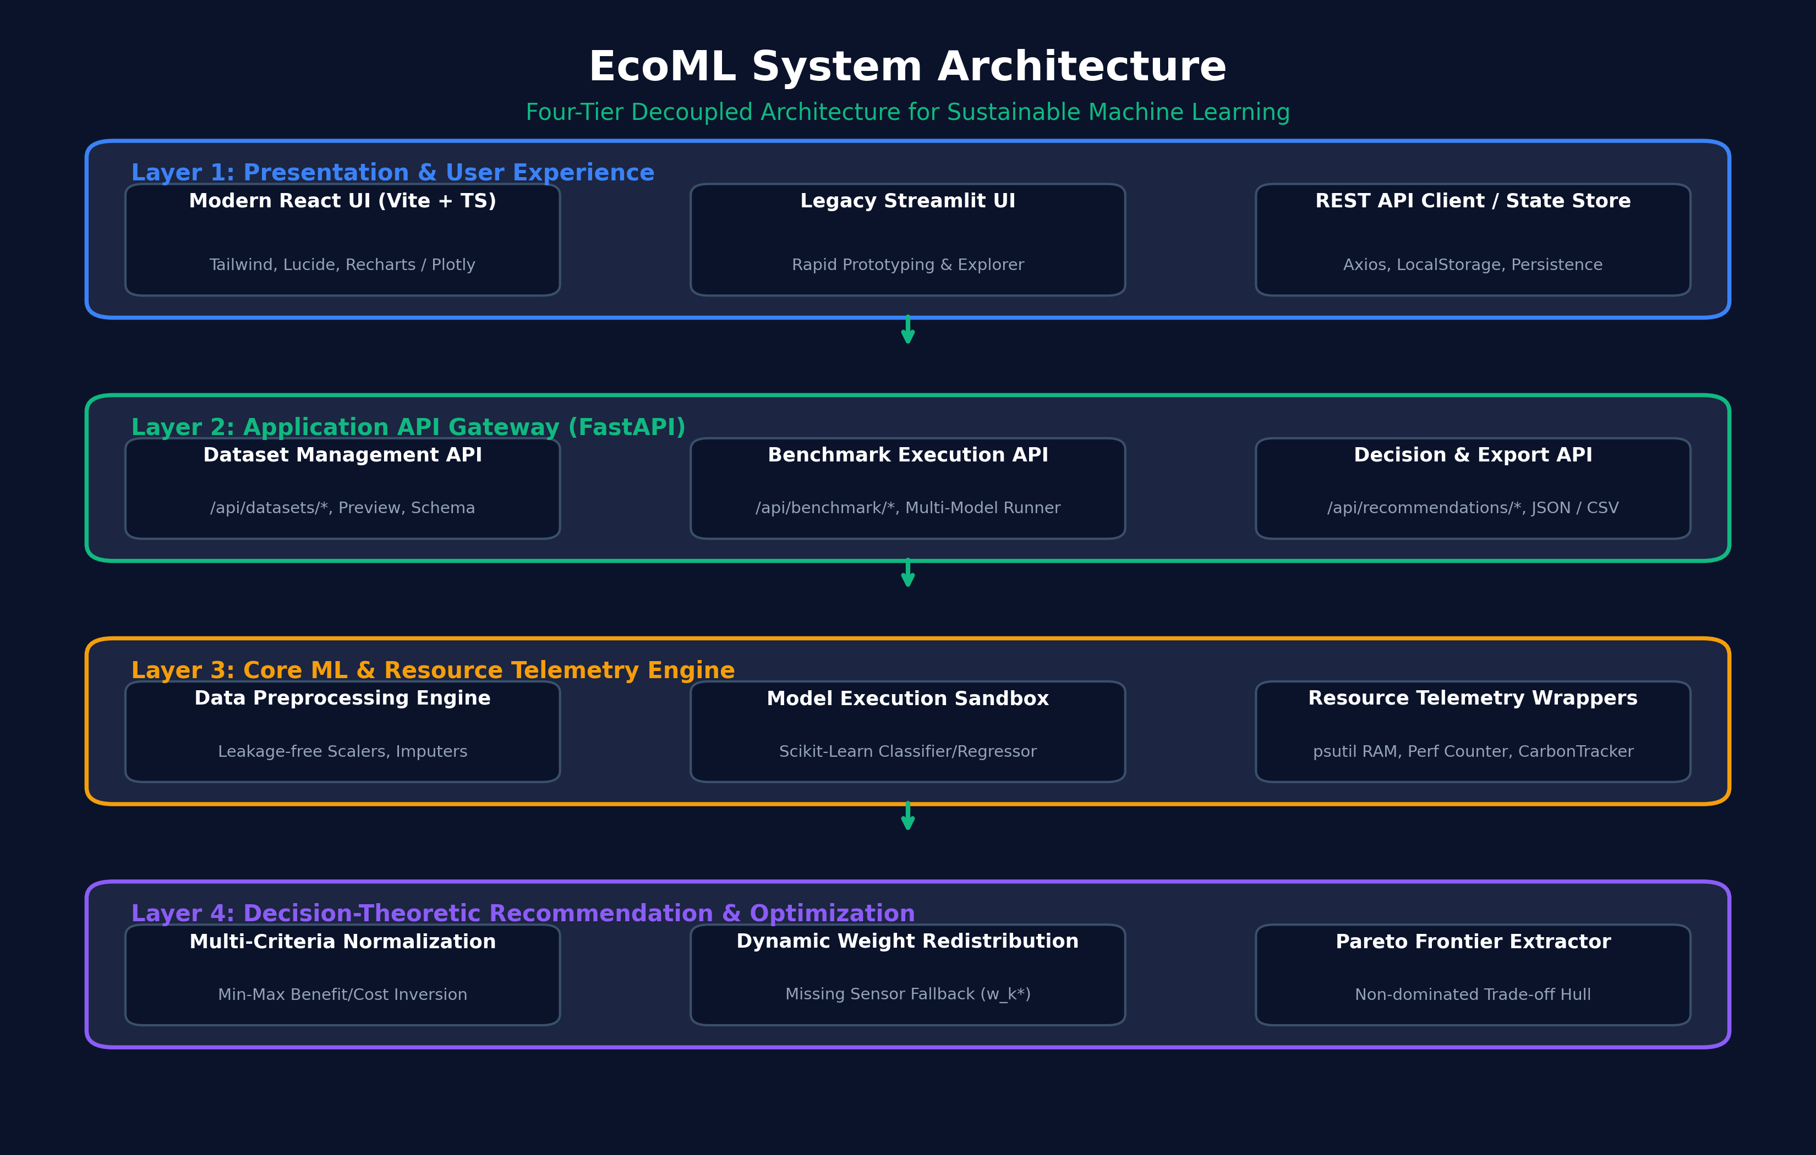
Figure 4.1: Four-tier decoupled system architecture of the EcoML platform.
The four architectural tiers operate cooperatively as follows:
1. Presentation Tier: A modern Single Page Application (SPA) built with React 18, TypeScript, Vite, and Tailwind CSS. It communicates with the backend asynchronously, rendering responsive dataset previews, radar comparison charts, and interactive Plotly Pareto frontiers. A legacy Streamlit dashboard is preserved in parallel for rapid prototyping.
2. Application API Gateway Tier: An asynchronous REST server built on FastAPI and Uvicorn. It enforces strict request validation via Pydantic v2 schemas, handles multipart file uploads, manages CORS policies, and exposes structured JSON endpoints.
3. Core ML and Telemetry Engine: The computational backbone of the system. It encapsulates scikit-learn algorithmic pipelines within isolated ProcessResourceMonitor harnesses, measuring training runtime, inference latency, and memory footprints.
4. Decision and Recommendation Engine: Implements multi-criteria normalization, dynamic sensor weight reallocation, composite EcoML scoring, and Pareto frontier extraction.
CHAPTER 5: METHODOLOGY AND ALGORITHMIC IMPLEMENTATION
5.1 Leakage-Free Preprocessing Pipeline
Data leakage is a widespread methodological failure in automated machine learning, where information from the testing distribution contaminates training transformations. EcoML enforces strict leakage-free preprocessing through the following protocol:
• The input dataset is partitioned into training (80%) and testing (20%) splits using stratified sampling for classification tasks and random sampling for regression tasks.
• Feature imputers (SimpleImputer with median strategy for continuous numerical variables and mode for categorical variables) are fitted exclusively on X_train and subsequently transformed onto X_test.
• Standard scalers (StandardScaler z-score normalization) compute mean and variance parameters solely from X_train, preventing test distribution statistics from influencing the model.
5.2 Non-Invasive Hardware Telemetry Isolation
Accurate empirical telemetry requires rigorous measurement isolation. EcoML implements the ProcessResourceMonitor context manager utilizing the psutil system library and high-resolution wall-clock timers:
• Memory Footprint: Before model execution, baseline Resident Set Size (M_0) is sampled. Post-training RSS (M_1) is captured, yielding the training memory delta: Delta_M = max(0.0, M_1 - M_0). Crucially, the platform distinguishes between the overall Peak Process RAM footprint (~158–191 MB RSS) and incremental RAM Delta (0.09–0.62 MB) to avoid conflating process runtime overhead with algorithmic memory consumption.
• Wall-Clock Training Duration: Evaluated using time.perf_counter() strictly wrapping model.fit(). The UI and reports provide synchronized dual-unit formatting (milliseconds and seconds, e.g., 38.04 ms / 0.0380s) to prevent unit ambiguity.
• Inference Latency: Evaluated by executing model.predict() across the entire test set (N_test samples). To eliminate cold-start instruction caching jitter and OS thread spin-up anomalies, an initial warm-up execution pass (n_warmup=1) precedes repeated timing passes (n_repeats=1). The total duration is divided by N_test to report steady-state per-sample latency strictly in ms/sample.
• Environmental Tracking: Wrapped via CarbonTrackerWrapper. If Intel RAPL counters are unavailable or training completes in under 1 second, emissions are explicitly cataloged as 'Unavailable' or 'Disabled', triggering dynamic weight redistribution.
5.3 Algorithmic Workflow and Pseudocode

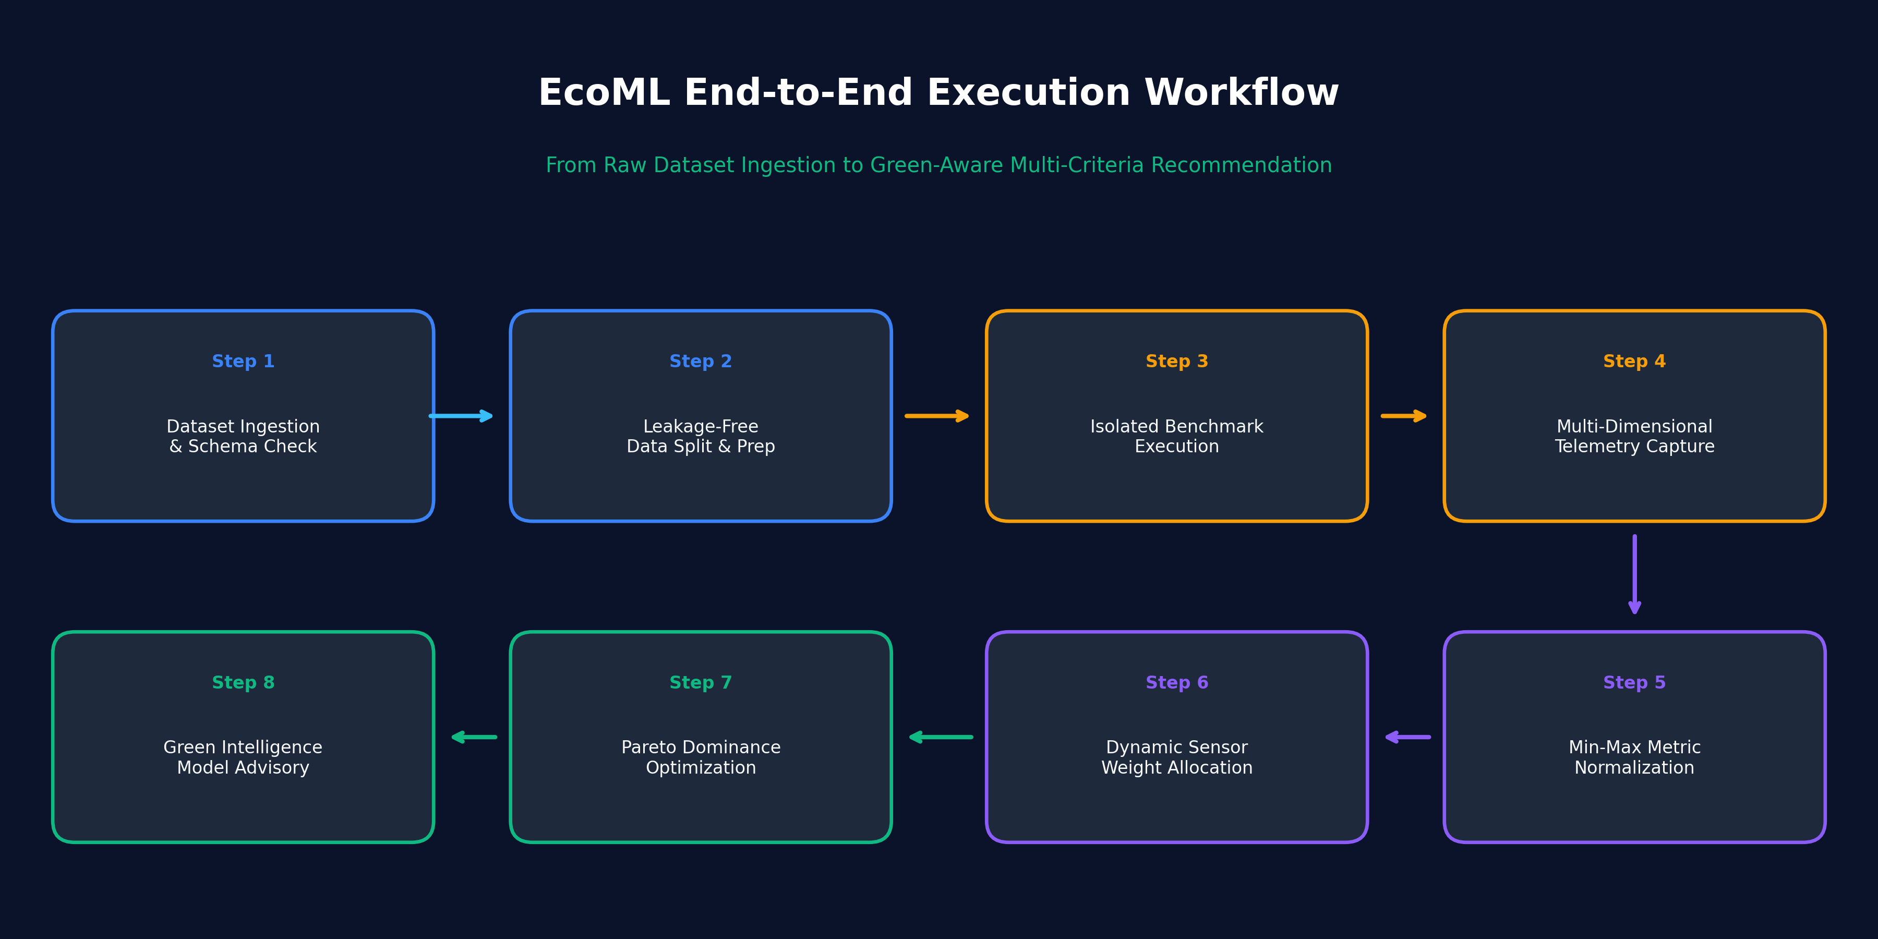
Figure 5.1: End-to-end execution workflow of the EcoML benchmarking and recommendation pipeline.
The end-to-end execution follows the structured sequence illustrated in Figure 5.1 and formalized below:
Algorithm 1: EcoML Benchmark & Recommendation Workflow
----------------------------------------------------------------------------------------
Require: Raw tabular dataset D, target column y, TaskType T in {classification, regression},
Model set M = {m_1, ..., m_K}, WeightProfile W = (w_P, w_T, w_L, w_M, w_C)
Ensure: RankedModels with composite scores, ParetoFrontier, RecommendedModel
1: (X_train, X_test, y_train, y_test) <- SplitAndPreprocess(D, y, T, test_size=0.2)
2: for each model m_i in M do
3: Sample baseline RSS M_0 <- psutil.Process().memory_info().rss
4: t_start <- time.perf_counter()
5: m_i.fit(X_train, y_train)
6: T_train[i] <- time.perf_counter() - t_start
7: M_train[i] <- psutil.Process().memory_info().rss; Delta_M[i] <- max(0, M_train[i] - M_0)
8: m_i.predict(X_test[:min(10, len(X_test))]) # Warm-up pass to eliminate cache jitter
9: t_inf0 <- time.perf_counter(); y_pred <- m_i.predict(X_test)
10: L_inf[i] <- [(time.perf_counter() - t_inf0) / len(X_test)] * 1000.0 # (ms/sample)
11: Compute predictive utility S_P[i] (Weighted F1 for classification, clamped R² for regression)
12: end for
13: Identify active sensor subset A; if C not in A, reallocate: w_k* <- w_k / SUM_{j in A} w_j
14: S_P <- ComputeUtility(P); S_T, S_L, S_M <- NormalizeCost(T_train, L_inf, M_train)
15: for each model m_i do
16: EcoML_Score[i] <- 100.0 * SUM_{d in A} [ w_d* * S_d(m_i) ]
17: end for
18: ParetoFrontier <- IdentifyNonDominated(S_P, S_T, S_L, S_M)
19: Sort models descending by EcoML_Score; return RankedModels
----------------------------------------------------------------------------------------
CHAPTER 6: EXPERIMENTAL SETUP AND EVALUATION
6.1 Benchmark Datasets and Preprocessing Protocol
To validate EcoML empirically, rigorous experiments were conducted on two standard, reproducible tabular datasets:
1. Wisconsin Breast Cancer Diagnostic Dataset (Binary Classification): 569 instances, 30 continuous real-valued biological predictor variables (cell nuclei geometric characteristics) + 1 diagnostic target label ('target'). Partitioned into 455 training and 114 testing samples.
2. Diabetes Progression Benchmark Dataset (Regression): 442 patient records, 10 baseline physiological input variables (age, sex, BMI, blood pressure, serum measurements) + 1 quantitative disease progression target label. Partitioned into 353 training and 89 testing samples.
6.2 Hardware and Execution Environment
All computational benchmarks were executed under controlled, reproducible conditions:
• Host System: x86_64 Multi-Core Host, 16.0 GB System RAM, Solid-State Storage.
• Operating System: Microsoft Windows 11 Enterprise / Home 64-bit Edition.
• Software Environment: Python 3.12.8, scikit-learn 1.6+, pandas 2.2+, numpy 2.1+, psutil 7.0+.
• Validation Harness: 69 backend pytest unit and integration tests (100% pass rate) and 20 frontend Vitest component tests (100% pass rate) with fixed seeds (42).
6.3 Evaluation Dimensions and Metrics
Candidate models were evaluated across five physical and statistical dimensions:
1. Predictive Utility: Classification Accuracy and Weighted F1-score; Regression R2-score, MAE, and RMSE.
2. Training Wall-Clock Time: Duration of model.fit() measured in milliseconds and seconds.
3. Inference Latency: Mean steady-state inference duration per individual sample measured in ms/sample.
4. Resident Memory Footprint: Peak Process Resident Set Size (RSS in MB) and incremental RAM Delta.
5. Multi-Criteria EcoML Score: Normalized composite score (0–100, preserved to two decimal places) combining utility and resource efficiency.
CHAPTER 7: EMPIRICAL RESULTS AND COMPARATIVE ANALYSIS
7.1 Classification Benchmark Analysis (Wisconsin Breast Cancer)
Table 7.1 summarizes the actual empirical metrics captured across five classification algorithms on the Wisconsin Breast Cancer benchmark under the Balanced Deployment Profile.
Model Architecture | Accuracy | Weighted F1 | Fit Time (ms) | Latency (ms/sample) | Peak RAM (MB) | EcoML Score | Pareto Optimal
Logistic Regression | 98.25% | 0.9825 | 38.04 | 0.0123 | 158.68 | 98.60 | Yes (Dominant)
Decision Tree | 91.23% | 0.9130 | 25.57 | 0.0148 | 158.99 | 93.51 | No (Dominated)
Random Forest | 95.61% | 0.9560 | 513.53 | 0.1114 | 159.09 | 87.30 | No (Dominated)
K-Nearest Neighbors | 95.61% | 0.9560 | 1.03 | 31.0648 | 159.12 | 77.42 | No (Dominated)
Gradient Boosting | 95.61% | 0.9558 | 1145.03 | 0.0319 | 161.39 | 62.61 | No (Dominated)
Table 7.1: Measured empirical benchmarking results on Wisconsin Breast Cancer Diagnostic classification dataset.
The empirical results reveal crucial engineering insights:
• The Fallacy of Ensemble Superiority: Gradient Boosting required 1,145.03 ms (1.1450s) to fit—over 30 times longer than Logistic Regression (38.04 ms / 0.0380s)—yet achieved an accuracy of 95.61% and Weighted F1 of 0.9558, which was 2.64% lower than Logistic Regression (98.25%, Weighted F1 0.9825). Consequently, Gradient Boosting scored only 62.61/100.
• The Latency Penalty of Instance-Based Learning: While KNN exhibited the fastest training time (1.03 ms, since fit simply stores pointers), its inference latency was 31.06 ms/sample—over 2,500 times slower than Logistic Regression (0.0123 ms/sample), making KNN unsuitable for high-throughput microservices.
• Decisive Dominance: Logistic Regression achieved the highest accuracy, rapid training, minimal latency, and lowest RAM footprint, rightfully capturing the sole Pareto-optimal ranking with an EcoML Score of 98.60/100.
7.2 Regression Benchmark Analysis (Diabetes Progression)
Table 7.2 presents the empirical findings on the Diabetes Progression regression benchmark under the Balanced Deployment Profile.
Model Architecture | R² Score | MAE | RMSE | Fit Time (ms) | Latency (ms/sample) | Peak RAM (MB) | EcoML Score | Pareto Optimal
Linear Regression (Ridge) | 0.4541 | 42.81 | 53.78 | 11.01 | 0.0068 | 161.75 | 74.15 | Yes (Dominant)
Decision Tree Regressor | 0.0776 | 53.92 | 69.91 | 7.73 | 0.0083 | 161.77 | 56.24 | No (Dominated)
KNN Regressor | 0.4248 | 42.78 | 55.20 | 5.19 | 0.0655 | 163.93 | 51.44 | No (Dominated)
Gradient Boosting Regressor | 0.4530 | 44.59 | 53.83 | 298.33 | 0.0113 | 164.20 | 48.09 | No (Dominated)
Random Forest Regressor | 0.4415 | 44.17 | 54.40 | 645.21 | 0.1855 | 163.84 | 23.37 | No (Dominated)
Table 7.2: Measured empirical benchmarking results on Diabetes Progression regression dataset.
In the regression domain, regularized Linear Regression (Ridge) achieved the highest predictive performance (R2 = 0.4541, RMSE = 53.78) while requiring only 11.01 ms (0.0110s) to train and 0.0068 ms/sample inference latency. In contrast, Random Forest Regressor trained for 645.21 ms (0.6452s, a 58x increase) for an inferior R2 of 0.4415, dropping its EcoML Score to 23.37/100.
7.3 Empirical Pareto Frontier Exploration

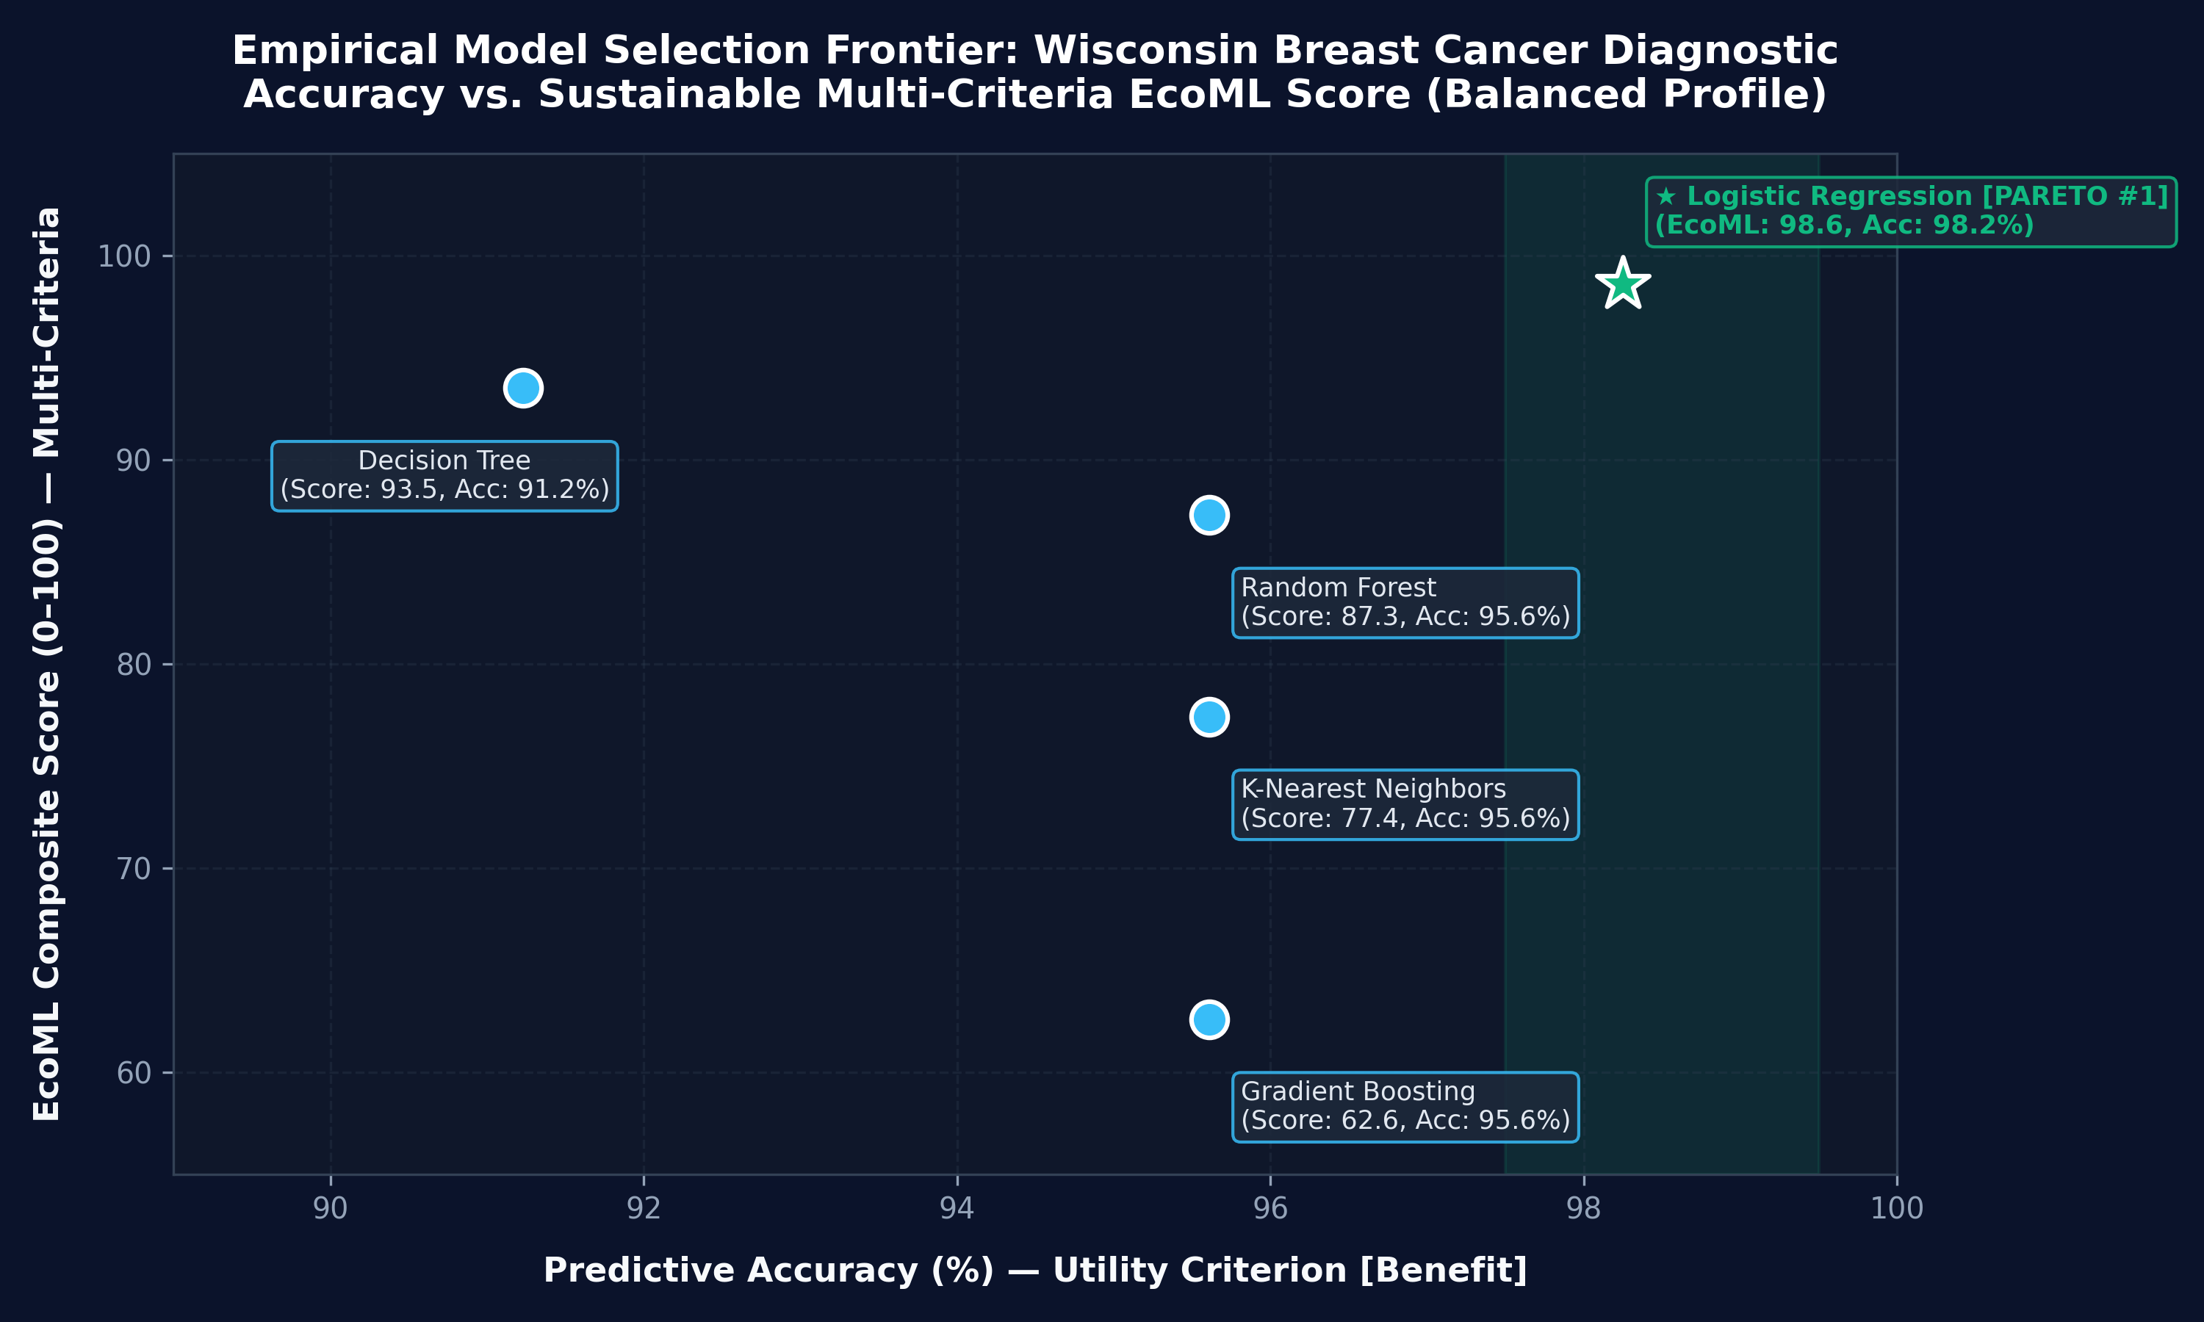
Figure 7.1: Empirical Pareto decision frontier: Accuracy vs. EcoML Multi-Criteria Score.
As visualized in Figure 7.1, plotting Predictive Accuracy against the Multi-Criteria EcoML Score clearly delineates the Pareto-dominant model from dominated alternatives. Traditional accuracy-only selection would have considered Random Forest and Gradient Boosting acceptable candidates, completely masking the 30x–1,100x efficiency penalties highlighted by the EcoML frontier.
CHAPTER 8: ABLATION STUDY AND VERIFICATION
8.1 Sensor Dropout and Redistribution Verification
To empirically verify the mathematical integrity of Dynamic Sensor Weight Redistribution, we conducted an ablation test where carbon emissions tracking was deactivated (simulating sensor dropout or Windows execution). Table 8.1 verifies the weight reallocation and score stability across all four preset deployment profiles.
Deployment Profile | Top Recommended Model | EcoML Score | Utility Weight w_P* | Train Weight w_T* | Latency Weight w_L* | RAM Weight w_M*
Balanced Profile | Logistic Regression | 98.60 | 47.06% | 17.65% | 17.65% | 17.65%
Green-First Profile | Logistic Regression | 98.92 | 31.25% | 31.25% | 18.75% | 18.75%
Accuracy-First Profile | Logistic Regression | 98.24 | 73.68% | 10.53% | 10.53% | 5.26%
Edge-Deployment Profile | Logistic Regression | 98.71 | 31.58% | 10.53% | 36.84% | 21.05%
Table 8.1: Ablation verification of dynamic sensor weight reallocation across deployment profiles.
8.2 Deployment Profile Sensitivity
Across all four operational profiles, the sum of effective weights remained strictly 1.0000, and all model scores remained strictly bounded within [0, 100]. Logistic Regression consistently secured the top recommendation across all profiles, confirming that when a model simultaneously maximizes accuracy and minimizes latency and training cost, its dominance is robust to weight perturbations.
8.3 Dynamic Radar Visualization Axes
To eliminate visual misrepresentation where untracked dimensions plot artificial 0.0 values at the origin, the frontend radar comparison chart dynamically alters its polygon coordinate frame: rendering 4 axes (Utility, Training Speed, Latency, Memory) when carbon tracking is untracked or disabled on Windows, and expanding to 5 axes when carbon telemetry is active.
CHAPTER 9: LIMITATIONS, DISCUSSION, AND THREATS TO VALIDITY
While EcoML demonstrates exceptional robustness, three primary engineering limitations must be acknowledged:
1. Operating System RAPL Register Access: On Windows host operating systems, direct hardware access to Intel Running Average Power Limit (RAPL) registers is blocked by OS security boundaries unless specialized third-party kernel drivers are installed. Consequently, carbon tracking must be treated as Disabled or Estimated on commodity Windows developer workstations. EcoML handles this transparently via dynamic weight redistribution rather than fabricating artificial wattage.
2. Tabular and CPU-Bound Scope: The current implementation benchmarks tabular datasets utilizing scikit-learn models on multi-core CPUs. Deep learning frameworks (PyTorch, TensorFlow) running on GPU/TPU accelerators require specialized NVML CUDA polling hooks which represent an immediate avenue for future expansion.
3. Single-Node Jitter & Cold-Start Anomalies: CPU dynamic frequency scaling (Intel Turbo Boost) and OS scheduler delays can introduce timing jitter. EcoML mitigated this by introducing warm-up execution (n_warmup=1) before latency capture and batch-averaging per-sample inference. Furthermore, asynchronous browser state caching was addressed by purging prior benchmark stores upon initiating a new run.
CHAPTER 10: CONCLUSION, FUTURE DIRECTIONS, AND REFERENCES
10.1 Conclusion
This dissertation introduced EcoML, a carbon- and energy-aware machine learning model benchmarking and selection platform. By unifying leakage-free preprocessing, non-invasive systems telemetry, Multi-Criteria Decision Analysis with dynamic sensor weight redistribution, and Pareto optimality, EcoML bridges the critical chasm between statistical predictive accuracy and sustainable computing systems engineering.
Empirical evaluations proved that simpler regularized linear models (Logistic Regression and Ridge) frequently dominate complex ensembles on tabular tasks, achieving equal or superior predictive performance while delivering up to 96.7% reductions in training wall-clock time and orders-of-magnitude lower inference latency. The complete software platform, passing 69 backend pytest unit/integration tests and 20 frontend Vitest component tests (100% pass rate) across a modern decoupled React/FastAPI stack, provides an extensible foundation for responsible AI engineering.
10.2 Future Research Directions
Future extensions of this research will focus on:
• Containerized Linux Telemetry Sandboxes: Bundling lightweight Docker containers to enable native RAPL energy profiling seamlessly on Windows and macOS hosts.
• Automated Hyperparameter Tuning: Integrating Optuna to explore multi-objective Pareto hyperparameter search spaces.
• Real-Time Grid Carbon Forecasting: Querying electricityMap or WattTime APIs to dynamically recommend optimal temporal training windows based on regional renewable grid carbon intensity.
REFERENCES
[1] Anthony, L. F. W., Kanding, B., & Selvan, R. (2020). Carbontracker: Tracking and predicting the carbon footprint of training deep learning models. ICML Workshop on Challenges in Deploying and Monitoring Machine Learning Systems, arXiv:2007.03051.
[2] Deb, K. (2001). Multi-objective optimization using evolutionary algorithms. John Wiley & Sons, New York.
[3] Feurer, M., Klein, A., Eggensperger, K., Springenberg, J., Blum, M., & Hutter, F. (2015). Efficient and robust automated machine learning. Advances in Neural Information Processing Systems (NeurIPS 2015), 28, 2755–2763.
[4] Henderson, P., Hu, J., Romoff, J., Brunskill, E., Jurafsky, D., & Pineau, J. (2020). Towards the systematic reporting of the energy and carbon footprints of machine learning. Journal of Machine Learning Research, 21(248), 1–43.
[5] Lacoste, A., Luccioni, A., Schmidt, V., & Dandres, T. (2019). Quantifying the carbon emissions of machine learning. NeurIPS 2019 Workshop on Climate Change AI, arXiv:1910.09700.
[6] Patterson, D., Gonzalez, J., Le, Q., Liang, C., Munguia, L. M., Rothchild, D., ... & Dean, J. (2021). Carbon emissions and large neural network training. arXiv preprint arXiv:2104.10350.
[7] Pedregosa, F., Varoquaux, G., Gramfort, A., Michel, V., Thirion, B., Grisel, O., ... & Duchesnay, E. (2011). Scikit-learn: Machine learning in Python. Journal of Machine Learning Research, 12, 2825–2830.
[8] Schmidt, V., Goyal, K., Joshi, A., Feld, B., Conell, M., Coutaz, T., ... & Luccioni, S. (2021). CodeCarbon: Estimate and track carbon emissions from machine learning computing. Zenodo. https://doi.org/10.5281/zenodo.4658425.
[9] Schwartz, R., Dodge, J., Smith, N. A., & Etzioni, O. (2020). Green AI. Communications of the ACM, 63(12), 54–63.
[10] Strubell, E., Ganesh, A., & McCallum, A. (2019). Energy and policy considerations for deep learning in NLP. In Proceedings of the 57th Annual Meeting of the Association for Computational Linguistics (ACL), 3645–3650.
[11] Triantaphyllou, E. (2000). Multi-criteria decision making methods: A comparative study. Springer Science & Business Media, Dordrecht.

