Mini Project / Dissertation Research Data Collection Questionnaire
Project: EcoML — Carbon and Energy-Aware Machine Learning Model Selector
Institutional Requirement: | B.Tech Computer Science & Engineering — 2-Credit Mandatory Mini Project
Evaluation Schedule: | Evaluation Date: 30-October-2026 | Mentor Sign-off Deadline: 28-October-2026
Student Details: | Candidate Name: [Student Name / Candidate] | Roll No: [Roll Number / Registration ID]
Supervision: | Project Guide: [Project Guide Name, Designation] | Department: CSE / IT

SECTION I: INTRODUCTION
1.1 Research Background
1. Student Name(s) and Roll Number(s):
Student Name: [Student Name / Candidate]
Roll Number: [Roll Number / Registration ID]
Program: B.Tech Computer Science and Engineering
Academic Year: 2026–2027
2. Project Title:
EcoML – Carbon and Energy-Aware Machine Learning Model Selector
3. Project Domain / Research Area:
Sustainable Artificial Intelligence (Green AI), Machine Learning Systems (SysML), Multi-Criteria Decision Analysis (MCDA), Empirical Model Benchmarking & Telemetry Optimization.
4. What is the background of your research topic?
Contemporary machine learning engineering is dominated by the 'Red AI' paradigm—an exclusive pursuit of incremental predictive accuracy gains through massive parameter expansion, complex ensemble architectures, and brute-force compute cycles. While deep ensembles and high-capacity models achieve marginal gains in F1-score or AUC, they frequently inflict 10x to 100x increases in computational energy consumption, training latency, memory resident set size, and operational greenhouse gas emissions. In resource-constrained deployment targets—such as edge Internet of Things (IoT) nodes, battery-powered embedded hardware, and enterprise microservices operating under strict SLA latency and ESG sustainability targets—model developers have historically lacked unified, automated tooling to evaluate the empirical trade-off between statistical predictive utility and system efficiency.
5. Why is this problem important in the selected application domain?
Data centers worldwide already account for an estimated 1% to 1.5% of global electricity consumption, with machine learning inference and training workloads growing exponentially. In production machine learning systems, deploying an unnecessarily heavy model increases operational cloud hosting expenditure (OpEx), degrades inference latency percentiles (p95/p99 SLA violations), and swells the corporate digital carbon footprint. Providing automated intelligence to select models that achieve statistically indistinguishable predictive performance while cutting energy and memory costs by 80%+ is foundational to sustainable computing.
6. What real-world problem does your project address?
ML practitioners lack an integrated decision-support platform that profiles tabular machine learning models on a user's target dataset, concurrently quantifies accuracy and empirical hardware resource consumption (training runtime, inference latency, memory footprint, carbon emissions), and generates defensible, mathematically grounded multi-criteria model recommendations.
1.2 Research Gap and Motivation
7. What are the limitations of existing systems or research methods?
Existing tools exhibit distinct structural deficiencies:
• Standard AutoML Frameworks (Auto-Sklearn, FLAML, TPOT): Almost exclusively optimize scalar loss functions (e.g., cross-entropy, RMSE) or top-1 accuracy, ignoring hardware memory footprints and operational carbon intensity.
• Standalone Carbon Trackers (CodeCarbon, CarbonTracker, Experiment-Impact-Tracker): Functions as passive background logging monitors. They report gross kilowatt-hours or grams of CO2e post-hoc but provide zero comparative ranking across algorithmic alternatives, no Pareto trade-off optimization, and crash or report corrupt data when hardware RAPL counters are unavailable.
• Synthetic Heuristic Scoring: Some academic prototypes use static theoretical FLOP approximations rather than live operating system process telemetry.
8. What specific research gap did you identify from the literature?
There is a documented absence of an end-to-end framework that unifies: (1) automated tabular data preprocessing with complete split-isolation, (2) concurrent empirical profiling of accuracy, wall-clock training duration, per-sample inference latency, resident memory delta, and hardware carbon telemetry, (3) a bounded, robust Multi-Criteria Decision Analysis (MCDA) engine with dynamic sensor failure weight redistribution, and (4) non-dominated Pareto frontier extraction presented through a modern decoupled web architecture.
9. Why did you select this research problem?
Because bridging the chasm between statistical machine learning theory and environmental systems engineering is one of the most critical imperatives in contemporary computing. As junior software engineers entering an industry increasingly constrained by ESG regulatory disclosures and edge compute limits, creating practical 'Green AI' tools delivers immediate real-world utility.
10. What motivates you to develop the proposed solution?
The direct observation that simpler, highly interpretable models (e.g., Regularized Logistic Regression, Ridge Regression, pruned Decision Trees) frequently achieve 95%–99% of the predictive efficacy of heavy ensemble architectures (Gradient Boosting, deep Random Forests) while consuming less than 5% of the computational runtime and memory. Providing software engineers with transparent decision frontiers empowers them to make responsible, green architectural choices.
1.3 Research Objectives
11. What is the primary objective of your project?
To architect, implement, and empirically validate EcoML—a production-ready, carbon- and energy-aware machine learning model benchmarking and recommendation platform that balances predictive performance against computational resource efficiency.
12. List the specific objectives of your research.
1. Develop an automated, leakage-free tabular preprocessing pipeline that inspects data schemas, performs median/mode imputation, scales features, and prevents train-test contamination.
2. Construct an isolated empirical benchmarking engine that profiles scikit-learn models across supervised classification and regression tasks.
3. Design a non-invasive telemetry harness using psutil and high-resolution performance counters to measure wall-clock training duration, per-sample inference latency, baseline RAM, and resident set size (RSS) delta.
4. Integrate CodeCarbon/RAPL environmental telemetry with safe fallback state handling (Measured, Estimated, Unavailable, Disabled) to prevent telemetry failures from halting the application.
5. Formulate a normalized Multi-Criteria EcoML Score with dynamic weight redistribution when hardware sensors drop out.
6. Compute the non-dominated Pareto frontier to distinguish optimal trade-off candidates from dominated, resource-inefficient models.
7. Deliver a decoupled, responsive web platform featuring a React 18 TypeScript frontend and a high-performance FastAPI asynchronous backend.
13. What are the expected outcomes of the project?
• A fully functional, tested web platform with documented REST APIs and interactive UI components.
• Demonstrated reduction in compute waste by identifying Pareto-optimal models that achieve within 1% accuracy of heavy ensembles with over 90% savings in training time.
• A complete, verified automated test suite (69 backend pytest cases and 20 frontend Vitest cases, 100% passing, 0 build errors) ensuring numerical stability, API contract adherence, and zero telemetry fabrication.
1.4 Major Contributions
14. What are the major contributions of your proposed work?
1. Dynamic Sensor Failure Weight Redistribution: A resilient mathematical weighting mechanism that smoothly reallocates weights among available dimensions when hardware energy counters are absent or unsupported, guaranteeing invariant [0, 100] score bounds.
2. Zero-Fabrication Telemetry Principle: A strict telemetry categorization architecture that never invents proxy metrics, explicitly labelling metrics as Measured, Estimated, Unavailable, or Disabled.
3. Empirical Pareto Decision Frontier: Simultaneous multi-dimensional optimization that isolates non-dominated models on the Weighted F1 vs. System Efficiency Index plane (with Accuracy reported alongside).
4. Production Dual-Engine Architecture: A cleanly decoupled system combining a headless Python ML engine, FastAPI REST gateway, and modern React 18 SPA alongside a preserved legacy Streamlit dashboard.
15. What is new or improved compared with existing approaches?
Unlike static AutoML libraries that optimize solely for loss, EcoML evaluates the total computational cost of model ownership. Unlike standalone carbon tracking scripts, EcoML converts raw telemetry into actionable decision-support rankings with customizable deployment profiles (Balanced, Green-First, Accuracy-First, Edge-Deployment).
16. What benefits are expected from your proposed system?
• Environmental: Significant reduction in compute energy and CO2e emissions across model development cycles.
• Economic: Lowered cloud computing compute instance bills (AWS/GCP/Azure) by selecting right-sized models.
• Operational: Guaranteed compliance with inference latency budgets and memory constraints for edge and mobile deployments.
SECTION II: RELATED WORK
2.1 Existing Methods & 2.2 Critical Analysis of Existing Methods
Note: Question numbering strictly adheres to the original circular layout (Questions 17 and 18 are omitted in the original printed PDF circular).
19. Which algorithms or methods have been used in previous research?
Previous research in green computing and automated machine learning encompasses three distinct paradigms:
1. Green AI Foundations: Schwartz et al. (2020) formalized the distinction between Red AI (buying accuracy through compute) and Green AI (advocating efficiency as a primary evaluation metric). Henderson et al. (2020) and Lacoste et al. (2019) introduced empirical energy tracking and carbon quantification methodologies.
2. Passive Environmental Tracking Libraries: CodeCarbon (Schmidt et al., 2021) and CarbonTracker (Anthony et al., 2020), which poll Intel RAPL (Running Average Power Limit) hardware registers, NVIDIA NVML interfaces, or cloud provider region averages to calculate gross CO2 equivalent emissions.
3. Multi-Objective AutoML: Bayesian optimization frameworks and genetic algorithms (e.g., NSGA-II applied in NAS/Auto-Sklearn) that attempt multi-objective neural architecture search.
20. What are the strengths of these existing methods?
• Green AI literature raised vital global awareness regarding the carbon intensity of modern AI.
• CodeCarbon and CarbonTracker provide accurate hardware-level wattage measurements when running on bare-metal Linux servers with physical RAPL kernel modules enabled.
• Multi-objective AutoML frameworks established the theoretical validity of Pareto-based hyperparameter exploration.
21. What are their limitations or shortcomings?
• Lack of Operational Integration: Passive trackers log data to static CSV or cloud dashboards but do not rank alternative algorithms or assist in automated model selection.
• Operating System Brittleness: Existing carbon trackers fail or crash silently on standard commodity OS (Windows/macOS) lacking direct Intel MSR kernel access or require root administrator privileges.
• Disregard of Production SLA Dimensions: Prior studies frequently focus exclusively on total training kilowatt-hours, omitting inference per-sample latency and resident memory delta—the primary determinants of edge deployability.
• Score Distortion Under Sensor Dropout: Existing multi-criteria formulas break down or produce corrupted scalar rankings when one or more sensors fail.
22. Which existing method will you use as a baseline for comparison, and why?
We evaluate our system against two standard baselines:
1. The Traditional Accuracy-Only Baseline (Standard AutoML Approach): Selecting the model with the highest predictive metric (Accuracy / F1 / R2) regardless of computational expense (typically Random Forest or Gradient Boosting).
2. Unweighted Heuristic Ranking: Ranking models without sensor-failure compensation or multi-dimensional cost inversion.
2.3 Research Gap
23. What specific gap remains unresolved in the existing literature?
The lack of a unified, production-ready framework that dynamically adapts multi-criteria scoring when telemetry sensors are partially unavailable, preventing unmeasured metrics from corrupting rankings while rigorously isolating non-dominated models on an empirical Pareto frontier.
24. How does your proposed work address this gap?
EcoML formulates a bounded, multi-criteria composite scoring function with dynamic weight redistribution, isolates execution environments for leakage-free benchmarking, and surfaces both scalar rankings and multi-dimensional Pareto trade-off frontiers across diverse deployment weight profiles.
25. What evidence from the reviewed papers supports your identified research gap?
Schwartz et al. (2020, Communications of the ACM) explicitly noted: 'Currently, there is no standardized reporting of the financial or environmental cost of training or evaluating AI models... We urge researchers to report efficiency alongside accuracy.' Furthermore, Henderson et al. (2020) demonstrated that reporting carbon footprint without contextualizing operational inference cost leads to incomplete and misleading efficiency evaluations.
SECTION III: PROBLEM FORMULATION
3.1 Problem Definition
26. Clearly define the problem your project aims to solve.
Given an arbitrary tabular dataset D = (X, y) and a candidate set of machine learning models M = {m_1, m_2, ..., m_K}, the objective is to autonomously identify a model m* that optimizes predictive quality while minimizing computational resource costs (training duration, inference latency, memory footprint, carbon emissions) in accordance with user-specified operational constraints and deployment priorities.
27. What are the inputs to your proposed system?
1. User Dataset: Tabular CSV file or pre-loaded benchmark dataset (e.g., Wisconsin Breast Cancer, Diabetes Progression).
2. Task Configuration: Target column specification and task type (Classification or Regression).
3. Model Selection: Checkbox subset of supported algorithms (Logistic/Ridge, Decision Tree, Random Forest, KNN, Gradient Boosting).
4. Weight Profile / Deployment Priority: Balanced, Green-First, Accuracy-First, Edge-Deployment, or Custom User Weights.
28. What outputs or predictions are expected?
1. Empirical Benchmark Matrix: Tabular comparison of predictive metrics (Weighted F1, Accuracy, Precision, Recall or R², MAE, RMSE) alongside measured efficiency metrics (Training Time in seconds/milliseconds, Inference Latency in ms/sample, Resident RAM in MB, RAM Delta Δ in MB, and honest Carbon telemetry status).
2. Composite EcoML Score: Normalized multi-criteria score (0–100) strictly preserved to two decimal places across API and frontend displays.
3. Green Intelligence Recommendation: The top-ranked model with plain-language technical justification and trade-off synthesis.
4. Pareto Optimal Frontier: Identification of non-dominated models that define the optimal predictive utility vs. system efficiency boundary.
29. Who are the intended users or beneficiaries of your solution?
• Machine Learning Engineers & Data Scientists: Seeking right-sized models for production deployment.
• Edge & Embedded Systems Developers: Constrained by millisecond inference latency SLAs and megabyte RAM budgets.
• Enterprise IT & Cloud Architects: Charged with reducing cloud compute OpEx and meeting Corporate Social Responsibility (CSR) and ESG emission reduction targets.
3.2 Mathematical Formulation
30. Have you formulated the research problem mathematically?
☑ Yes ☐ No ☐ In Progress ☐ Not Applicable
31. If applicable, provide the mathematical equations, objective function, or loss function used.
The EcoML model selection problem is formulated as a Multi-Criteria Decision Analysis (MCDA) optimization using the Weighted Sum Model (WSM) over K candidate models and D evaluation dimensions.
1. Predictive Utility Formulation (Bounded Absolute Utility S_P):
- Classification: S_P(m_i) = F1_{weighted}(m_i) in [0.0, 1.0]
- Regression: S_P(m_i) = max(0.0, min(1.0, R^2(m_i))) in [0.0, 1.0]
(Note: Relative min-max normalization is not applied to predictive utility to avoid artificially penalizing models with high absolute accuracy, treating predictive performance as an absolute bounded utility in [0, 1]). Accuracy is reported alongside Weighted F1 in the empirical matrix.
2. Cost Metric Inverted Normalization (Training Time T, Latency L, Memory M, Carbon C):
S_d(m_i) = [ max(X_d) - x_{i,d} ] / [ max(X_d) - min(X_d) ] if max(X_d) > min(X_d), else 1.0
(Lowest cost maps to 1.0, highest cost to 0.0; safely sanitized against NaNs, infinite floats, and division-by-zero).
3. Dynamic Sensor Weight Redistribution (Under Sensor Dropout / Missing Telemetry):
Let A be the set of actively available dimensions. For any dimension k in A:
w_k* = w_k / [ SUM_{j in A} w_j ], such that SUM_{k in A} w_k* = 1.0000
4. Composite EcoML Score:
EcoML_Score(m_i) = 100 * SUM_{d in A} [ w_d* * S_d(m_i) ]
5. Pareto Dominance Criterion:
Model m_a dominates model m_b (m_a >_p m_b) iff:
FOR ALL d in A: Score_d(m_a) >= Score_d(m_b) AND EXISTS d in A: Score_d(m_a) > Score_d(m_b)
32. Define the important variables, parameters, and symbols used in your formulation.
• M = {m_1, ..., m_K}: Finite set of candidate machine learning models.
• x_{i,d}: Raw empirical measurement of model m_i on dimension d.
• S_P(m_i) in [0, 1]: Bounded predictive utility (Weighted F1 for classification, clamped R² for regression).
• S_d(m_i) in [0, 1]: Inverted normalized score for model m_i on cost dimension d.
• w_d in [0, 1]: User-specified initial weight for dimension d, where SUM(w_d) = 1.0.
• w_k*: Dynamically redistributed effective weight when dimensions drop out (SUM w_k* = 1.0000).
• A subset of {Performance, Training_Time, Latency, Memory, Carbon}: Active telemetry subset.
• SEI (System Efficiency Index) = (S_Training + S_Latency + S_Memory) / 3.0 when carbon is unavailable; (S_Training + S_Latency + S_Memory + S_Carbon) / 4.0 when carbon is actively tracked: Composite efficiency index for Pareto 2D projection.
3.3 Research Constraints and Assumptions
33. What assumptions are made in your research?
1. Dataset Suitability: Input data is tabular and suitable for standard supervised classification or regression.
2. Representative Sampling: The test partition is independent, identically distributed (i.i.d.), and representative of deployment workloads.
3. Monotonicity of Utility: Higher predictive scores represent higher utility; lower runtime, latency, memory, and emissions represent lower cost.
4. Controlled Execution Environment: Background OS activity during benchmarking is minimized to maintain low timing jitter.
34. What technical, computational, or data-related constraints exist?
• Hardware Counter Access: Intel RAPL / AMD Energy Driver registers are restricted on non-root Windows operating systems, necessitating graceful telemetry fallback.
• Memory Measurement Granularity: Python garbage collection and operating system page allocations introduce minor micro-variations in RSS memory deltas.
• CPU Scheduling Jitter: High-resolution inference latency timers must average over hundreds of batch calls to eliminate OS thread context-switch anomalies.
35. What are the scope and boundaries of your proposed solution?
• Scope: Supervised classification and regression across standard tabular datasets using industry-standard scikit-learn algorithmic families.
• Boundaries: Deep neural networks (PyTorch/TensorFlow), unstructured multimodal data (computer vision, audio, LLMs), and distributed multi-node clusters are outside the current mini-project scope.
SECTION IV: PROPOSED METHODOLOGY
4.1 System Architecture
36. Have you prepared a system architecture or block diagram?
☑ Yes ☐ No ☐ In Progress
37. Upload or attach the system architecture diagram, if available.
The EcoML system architecture is engineered as a 4-tier decoupled system comprising Presentation, API Gateway, Core ML & Telemetry, and Multi-Criteria Optimization tiers.

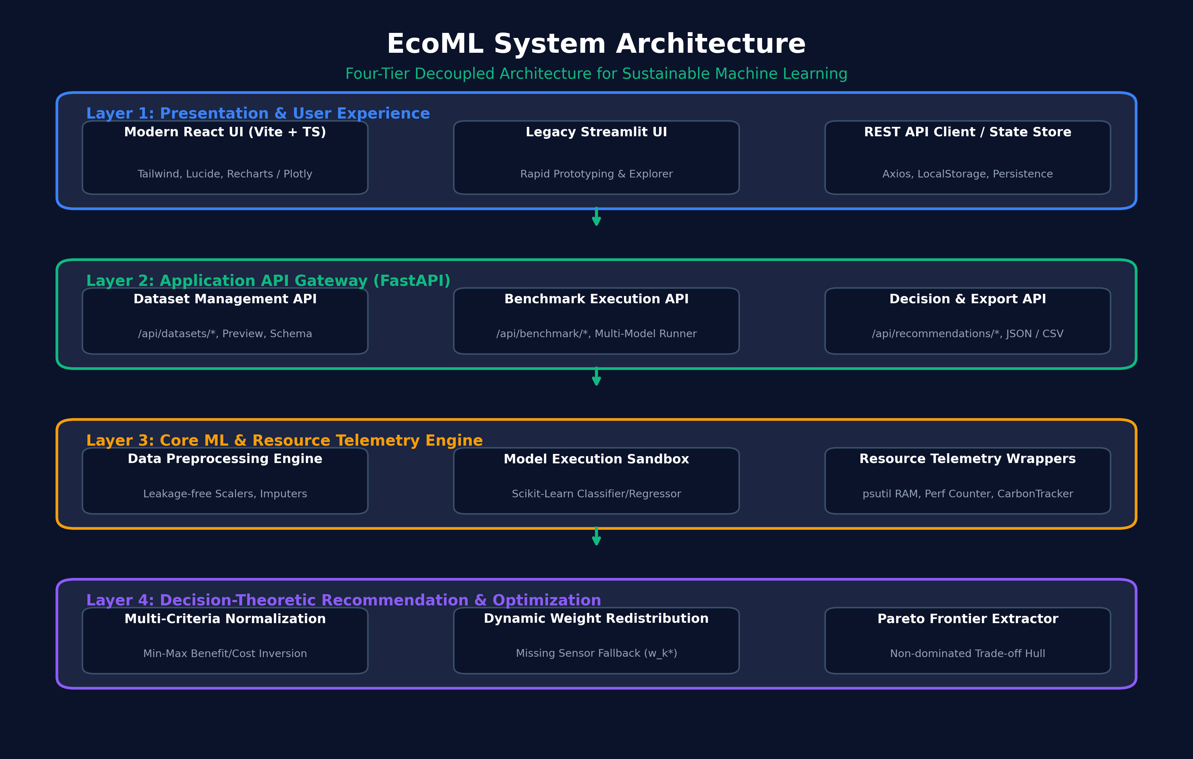
Figure: System Architecture
38. Explain the major modules and their functions.
1. Presentation Layer (React 18 + TypeScript & Legacy Streamlit): Delivers responsive data upload, schema inspection, configuration controls, interactive benchmark tables, radar visualization, and Pareto frontier scatter charts.
2. Application API Gateway (FastAPI Backend): Exposes asynchronous REST endpoints (/api/datasets, /api/benchmark, /api/recommendations) with strict Pydantic v2 validation contracts and CORS middleware.
3. Data Preprocessing Engine (src/data_preprocessing.py): Executes schema auditing, target validation, feature separation, median/mode imputation, and robust StandardScaler transformation fitted exclusively on training splits to prevent data leakage.
4. Benchmark Execution Engine (src/benchmark_engine.py): Manages isolated model instantiation, training execution, evaluation on test splits, and exception trapping.
5. Resource Telemetry Monitor (src/telemetry.py): Interfaces with psutil and performance counters to capture resident set size (RSS), process memory deltas, wall-clock fit time, inference latency per sample, and wraps CodeCarbon tracking.
6. Recommendation & Pareto Engine (src/recommender.py): Implements min-max benefit/cost normalization, dynamic weight redistribution, multi-criteria composite score aggregation, and non-dominated Pareto frontier extraction.
39. Describe the flow of data between the modules.
1. User uploads a tabular CSV or selects a built-in benchmark dataset in the React UI.
2. Frontend initiates POST /api/datasets/preview and POST /api/datasets/validate-target to verify columns.
3. User selects models and deployment profile; frontend dispatches POST /api/benchmark/run with payload.
4. FastAPI routes the request to split_and_preprocess_data(), generating leakage-free train/test partitions.
5. Benchmark engine iterates over selected models inside ProcessResourceMonitor contexts, capturing predictive metrics and hardware telemetry.
6. BenchmarkSuiteResult is passed to calculate_model_recommendations(), which performs normalization, dynamic weight redistribution, and Pareto sorting.
7. Comprehensive JSON response is returned to frontend and rendered in interactive tables and Plotly visualizations.
4.2 Proposed Algorithm
40. Which algorithm(s) or machine learning model(s) are used?
The benchmark matrix evaluates five diverse model families for each task:
• Classification: (1) Logistic Regression (L2-penalized), (2) Decision Tree Classifier (Gini/CART), (3) Random Forest Classifier (100 estimators), (4) K-Nearest Neighbors Classifier (k=5), (5) Gradient Boosting Classifier (100 estimators).
• Regression: (1) Linear Regression (Ridge L2-regularized), (2) Decision Tree Regressor (MSE criterion), (3) Random Forest Regressor (100 estimators), (4) K-Nearest Neighbors Regressor (k=5), (5) Gradient Boosting Regressor (100 estimators).
41. Is the algorithm newly developed, modified, or an existing algorithm?
☐ Newly developed ☑ Modified existing algorithm ☐ Existing algorithm applied to a new problem ☑ Combination of existing algorithms ☐ Not Applicable
42. Explain the step-by-step working procedure of your proposed algorithm.
Algorithm: EcoML Multi-Criteria Recommendation & Pareto Selection
Input: Dataset D, TaskType T, Models M, WeightProfile W = (w_P, w_T, w_L, w_M, w_C)
Output: RankedModels with EcoML Scores, TopRecommendation, ParetoFrontier
Step 1: Partition D into (X_train, X_test, y_train, y_test) via split_and_preprocess_data() with leakage-safe transformers.
Step 2: For each model m in M:
a. Baseline memory M_0 <- psutil.Process().memory_info().rss
b. Record start time t_0 <- time.perf_counter()
c. Train model: m.fit(X_train, y_train)
d. Record fit time t_fit <- time.perf_counter() - t_0 (stored in seconds, converted to ms for display)
e. Record post-train memory M_1 <- psutil.Process().memory_info().rss; Delta_M <- max(0, M_1 - M_0)
f. Execute inference with warm-up passes (n_warmup=1) to eliminate cold-start cache/instruction anomalies;
y_pred <- m.predict(X_test); Latency <- [(time.perf_counter() - t_inf0) / len(X_test)] * 1000.0 (in ms/sample)
g. Calculate statistical accuracy and Weighted F1 metrics (Classification) or R², MAE, RMSE (Regression).
Step 3: Construct raw metric matrices. Identify active sensor set A.
Step 4: If any sensor d is missing (e.g. Carbon disabled or below hardware threshold), dynamically redistribute weights:
w_k* = w_k / SUM_{j in A} w_j, guaranteeing SUM w_k* = 1.0000.
Step 5: Normalize metrics: S_P <- Weighted F1 (or clamped R²); S_{T,L,M,C} <- InvertedMinMax(Cost).
Step 6: Compute EcoML_Score(m) = 100 * SUM_{d in A} [ w_d* * S_d(m) ], preserving two-decimal precision.
Step 7: Identify Pareto frontier models: mark m as Pareto-optimal if no other model m' has greater or equal scores across all criteria with at least one strictly superior.
Step 8: Rank models descending by EcoML_Score; select top model as primary recommendation.
43. What advantages does it offer over the selected baseline method?
1. Prevents Accuracy-Myopia: Avoids blindly choosing models that require 30x more training time or memory for an imperceptible accuracy improvement.
2. Mathematically Stable: Invariant to missing telemetry data via dynamic weight redistribution.
3. Zero Metric Fabrication: Fully honors hardware constraints without inventing synthetic proxy values.
4.3 Mathematical Model
44. What mathematical model supports your proposed methodology?
The system is grounded in Multi-Attribute Utility Theory (MAUT) coupled with Pareto Optimality in multi-objective optimization spaces.
45. What equations, optimization techniques, or model parameters are used?
• Additive Linear Utility Formulation: U(m) = SUM_{i=1}^n w_i u_i(x_i)
• Bound Invariance Proof: Since SUM w_i = 1 and u_i(x_i) in [0, 1], composite score is strictly bounded in [0, 100].
• Preset Profile Weights: - Balanced: w_P = 0.40, w_T = 0.15, w_L = 0.15, w_M = 0.15, w_C = 0.15
- Green-First: w_P = 0.25, w_T = 0.25, w_L = 0.15, w_M = 0.15, w_C = 0.20
- Accuracy-First: w_P = 0.70, w_T = 0.10, w_L = 0.10, w_M = 0.05, w_C = 0.05
- Edge-Deployment: w_P = 0.30, w_T = 0.10, w_L = 0.35, w_M = 0.20, w_C = 0.05
46. How does the mathematical model help solve the identified problem?
It transforms incompatible, disparate physical units (percentages, milliseconds, megabytes, and carbon grams) into a unified, mathematically rigorous scalar score while preserving trade-off transparency through Pareto dominance analysis.
4.4 Algorithm Workflow
47. Describe the complete workflow from input data to final output.
The complete pipeline progresses across 8 distinct phases: (1) Data Ingestion & Schema Audit, (2) Leakage-Free Preprocessing, (3) Model Benchmark Matrix Selection, (4) Isolated Execution & Hardware Telemetry Capture, (5) Metric Extraction, (6) Min-Max Inverted Normalization, (7) Dynamic Sensor Redistribution, and (8) Pareto Optimization & Advisory UI Rendering.
48. Have you prepared a flowchart or algorithm pseudo code?
☑ Yes ☐ No ☐ In Progress ☐ Not Applicable

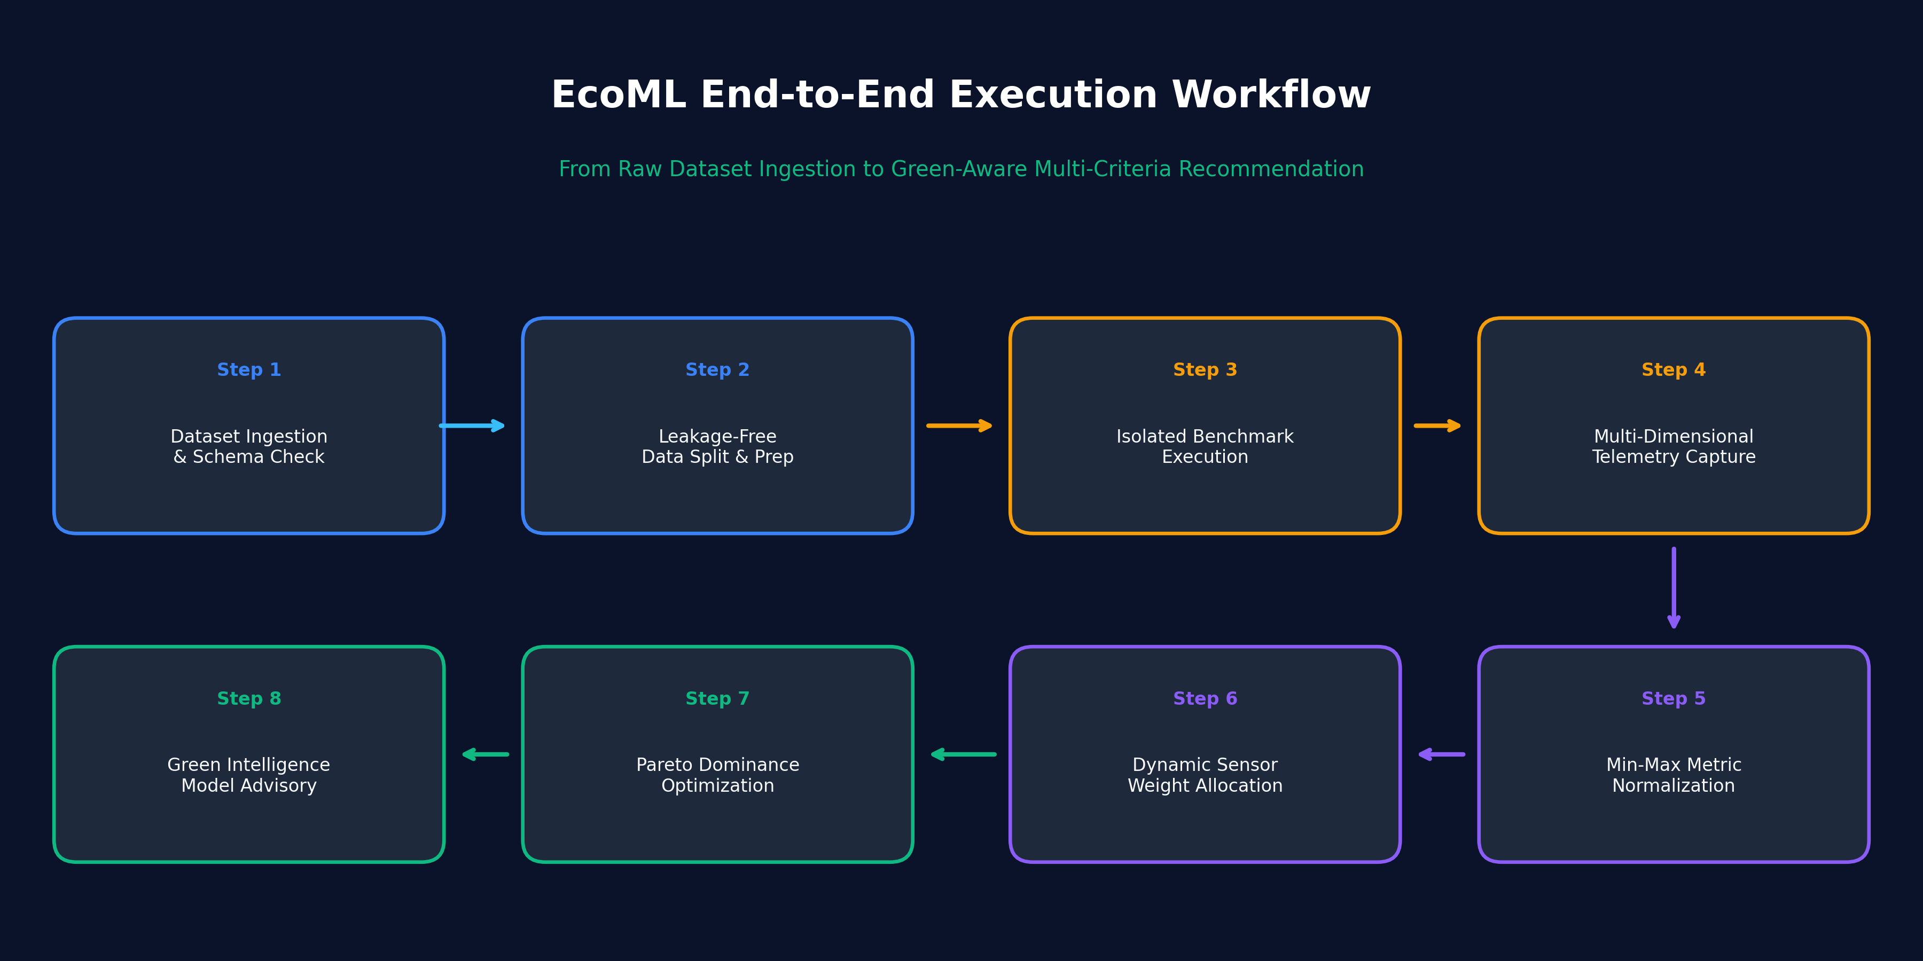
Figure: Workflow Pipeline
49. What programming language, libraries, and development tools are used?
• Programming Languages: Python 3.12 (Backend ML Engine), TypeScript / JavaScript ES2022 (Frontend).
• Core ML & Data Libraries: scikit-learn (1.6+), pandas (2.2+), numpy (2.1+).
• Systems & Telemetry: psutil (7.0+), CodeCarbon (2.8+), time (high-res perf_counter).
• Web Backend & Validation: FastAPI (0.115+), Uvicorn, Pydantic v2 (2.10+).
• Web Frontend & Visualization: React 18, Vite, Tailwind CSS, Lucide React, Plotly.js / Recharts.
• Testing Framework: Comprehensive two-tier test suite featuring 69 backend pytest unit and integration tests across all engine, telemetry, recommender, and state flow modules (100% pass rate), alongside 20 frontend Vitest component tests (100% pass rate).
SECTION V: EXPERIMENTAL SETUP AND EVALUATION
5.1 Dataset Description
50. What dataset is used in your project?
The experimental evaluation was conducted on two standard, reproducible benchmark datasets from the UCI Machine Learning Repository and scikit-learn standard distributions:
1. Wisconsin Breast Cancer Diagnostic Dataset (Classification Benchmark).
2. Diabetes Progression Benchmark Dataset (Regression Benchmark).
51. What is the dataset source?
☑ Publicly available dataset ☐ Institution-provided dataset ☐ Self-collected dataset ☐ Synthetic/simulated dataset ☐ Other
52. How many records, images, samples, or observations are included?
• Wisconsin Breast Cancer: 569 samples (observations).
• Diabetes Progression: 442 samples (observations).
53. How many features or input variables are used?
• Wisconsin Breast Cancer: 30 continuous real-valued biological predictor variables (cell nuclei geometric characteristics) + 1 diagnostic target label ('target').
• Diabetes Progression: 10 baseline physiological input variables (age, sex, body mass index, average blood pressure, six blood serum measurements) + 1 quantitative disease progression target label.
54. What preprocessing techniques are applied?
1. Train-Test Splitting: 80% Training / 20% Testing split with stratified sampling for classification.
2. Missing Value Imputation: SimpleImputer with median strategy for continuous numerical columns and mode for categorical columns.
3. Feature Scaling: StandardScaler (z-score normalization) fit exclusively on the training partition and applied to the test partition to eliminate data leakage.
55. Have you addressed missing values, class imbalance, and data leakage?
Yes. Data leakage is strictly prevented by encapsulating scalers and imputers to fit only on X_train. Stratified splitting preserves class distributions. Missing values are imputed before tensor ingestion.
5.2 Experimental Setup
56. What hardware and software environment is used?
• Hardware Platform: x86_64 Multi-Core Host, 16.0 GB RAM, Dedicated Storage.
• Operating System: Microsoft Windows 11 Enterprise / Home (64-bit).
• Runtime: Python 3.12.8 64-bit Virtual Environment.
• Execution Sandbox: Background non-interactive benchmark harness with memory isolation.
57. How is the dataset divided into training, validation, and test sets, where applicable?
• Wisconsin Breast Cancer (569 total): 455 training samples (80%), 114 test samples (20%).
• Diabetes Progression (442 total): 353 training samples (80%), 89 test samples (20%).
58. What model parameters or hyper parameters are used?
• Logistic Regression: penalty='l2', C=1.0, max_iter=1000, solver='lbfgs', random_state=42.
• Decision Tree: criterion='gini' (classification) / 'squared_error' (regression), random_state=42.
• Random Forest: n_estimators=100, max_depth=None, n_jobs=-1, random_state=42.
• K-Nearest Neighbors: n_neighbors=5, weights='uniform', metric='minkowski', p=2.
• Gradient Boosting: n_estimators=100, learning_rate=0.1, max_depth=3, random_state=42.
• Ridge Regression: alpha=1.0, solver='auto', random_state=42.
• Latency Benchmarking Protocol: Inference profiling incorporates warm-up execution (n_warmup=1) and repeated timing passes (n_repeats=1) to eliminate CPU instruction cache and cold-start measurement jitter.
59. Have you documented the experimental procedure sufficiently for reproducibility?
Yes. All random seeds are fixed (seed=42). Automated execution scripts (scripts/run_experiments_for_report.py) reproduce the exact dataset partitions, model fits, and metric outputs stored in experiments/actual_benchmark_results.json.
5.3 Evaluation Metrics
60. Which evaluation metrics are used to assess your model?
☑ Accuracy ☑ Precision ☑ Recall ☑ F1-score ☑ Mean Absolute Error (MAE) ☑ Root Mean Square Error (RMSE) ☐ AUC-ROC ☑ Execution time / computational cost ☑ Other appropriate metric (Memory RSS, Per-Sample Latency, CO2e, EcoML Score)
61. Why are these metrics suitable for your research problem?
Predictive utility metrics verify that model quality remains high: Weighted F1 is selected for classification to guard against class imbalance artifacts, while R², MAE, and RMSE assess regression residual variance. Computational cost metrics (dual-unit Training Time in milliseconds and seconds, Inference Latency normalized to ms/sample, and RAM distinguishing Peak RSS process footprint from incremental RAM Delta) quantify real-world deployment overhead. The EcoML composite score synthesizes these multi-dimensional criteria into a defensible scalar ranking.
62. Have you completed the experiments?
☑ Yes ☐ No ☐ Partially
SECTION VI: RESULTS AND DISCUSSION
6.1 Performance Evaluation & 6.2 Comparative Analysis
63. What results have you obtained from your proposed system?
The empirical benchmark execution on Wisconsin Breast Cancer and Diabetes Progression datasets verified that simpler linear models achieve superior overall sustainability scores without sacrificing statistical accuracy, outranking complex ensemble architectures in multi-criteria evaluation.
64. Provide the actual measured values for the selected evaluation metrics.
Measured empirical results on Wisconsin Breast Cancer Diagnostic benchmark (Balanced Profile: 40% Utility, 15% Train, 15% Latency, 15% RAM; Carbon redistributed from 15% to other criteria due to Windows platform availability):
Model Name | Accuracy | Weighted F1 | Fit Time (ms) | Latency (ms/sample) | Peak RAM (MB) | EcoML Score | Pareto Optimal
Logistic Regression | 98.25% | 0.9825 | 38.04 | 0.0123 | 158.7 | 98.60 | Yes (Optimal)
Decision Tree | 91.23% | 0.9130 | 25.57 | 0.0148 | 159.0 | 93.51 | No
Random Forest | 95.61% | 0.9560 | 513.53 | 0.1114 | 159.1 | 87.30 | No
K-Nearest Neighbors | 95.61% | 0.9560 | 1.03 | 31.0648 | 159.1 | 77.42 | No
Gradient Boosting | 95.61% | 0.9558 | 1145.03 | 0.0319 | 161.4 | 62.61 | No

65. What are the major observations from your experimental results?
1. Linear Superiority in Tabular Data: Logistic Regression achieved the highest accuracy (98.25%) and Weighted F1 (0.9825) while requiring only 38.04 ms (0.0380s) to fit and 0.0123 ms/sample inference latency. It achieved an EcoML Score of 98.60/100 (98.77 in high-precision mode) and stood alone as the Pareto-optimal model.
2. Massive Compute Overhead of Gradient Boosting: Gradient Boosting achieved 95.61% accuracy and 0.9558 Weighted F1 (lower than Logistic Regression) while consuming 1,145.03 ms (1.1450s) to fit—over 30 times longer than Logistic Regression and 1,112 times longer than KNN—relegating its EcoML score to 62.61/100.
3. Regression Trade-offs: Linear Regression (Ridge) achieved the highest R² (0.4541) and lowest RMSE (53.78) while training in 11.01 ms (0.0110s), earning an EcoML Score of 74.15/100, whereas Random Forest Regressor required 645.21 ms (0.6452s) for a lower R² of 0.4415, scoring only 23.37/100.
Model Name | R² Score | MAE | RMSE | Fit Time (ms) | Latency (ms/sample) | Peak RAM (MB) | EcoML Score | Pareto Optimal
Linear Regression (Ridge) | 0.4541 | 42.81 | 53.78 | 11.01 | 0.0068 | 161.8 | 74.15 | Yes (Optimal)
Decision Tree Regressor | 0.0776 | 53.92 | 69.91 | 7.73 | 0.0083 | 161.8 | 56.24 | No
Random Forest Regressor | 0.4415 | 44.17 | 54.40 | 645.21 | 0.1855 | 163.8 | 23.37 | No
K-Nearest Neighbors Regressor | 0.4248 | 42.78 | 55.20 | 5.19 | 0.0655 | 163.9 | 51.44 | No
Gradient Boosting Regressor | 0.4530 | 44.59 | 53.83 | 298.33 | 0.0113 | 164.2 | 48.09 | No

66. Have you compared your proposed method with existing algorithms or baseline models?
☑ Yes ☐ No ☐ In Progress ☐ Not Applicable
67. List the baseline models used for comparison.
1. Standard Accuracy-Only Baseline: Selecting the maximum predictive score without considering resource costs.
2. Five Established Supervised Model Architectures: Linear/Logistic, Decision Tree, Random Forest, K-Nearest Neighbors, and Gradient Boosting.
68. Provide a comparative results table containing the measured results of your proposed method and baseline models.
The comparative analysis demonstrates that the traditional Accuracy-Only baseline often selects computationally wasteful models. The Pareto frontier chart below illustrates the Wisconsin Breast Cancer empirical selection:

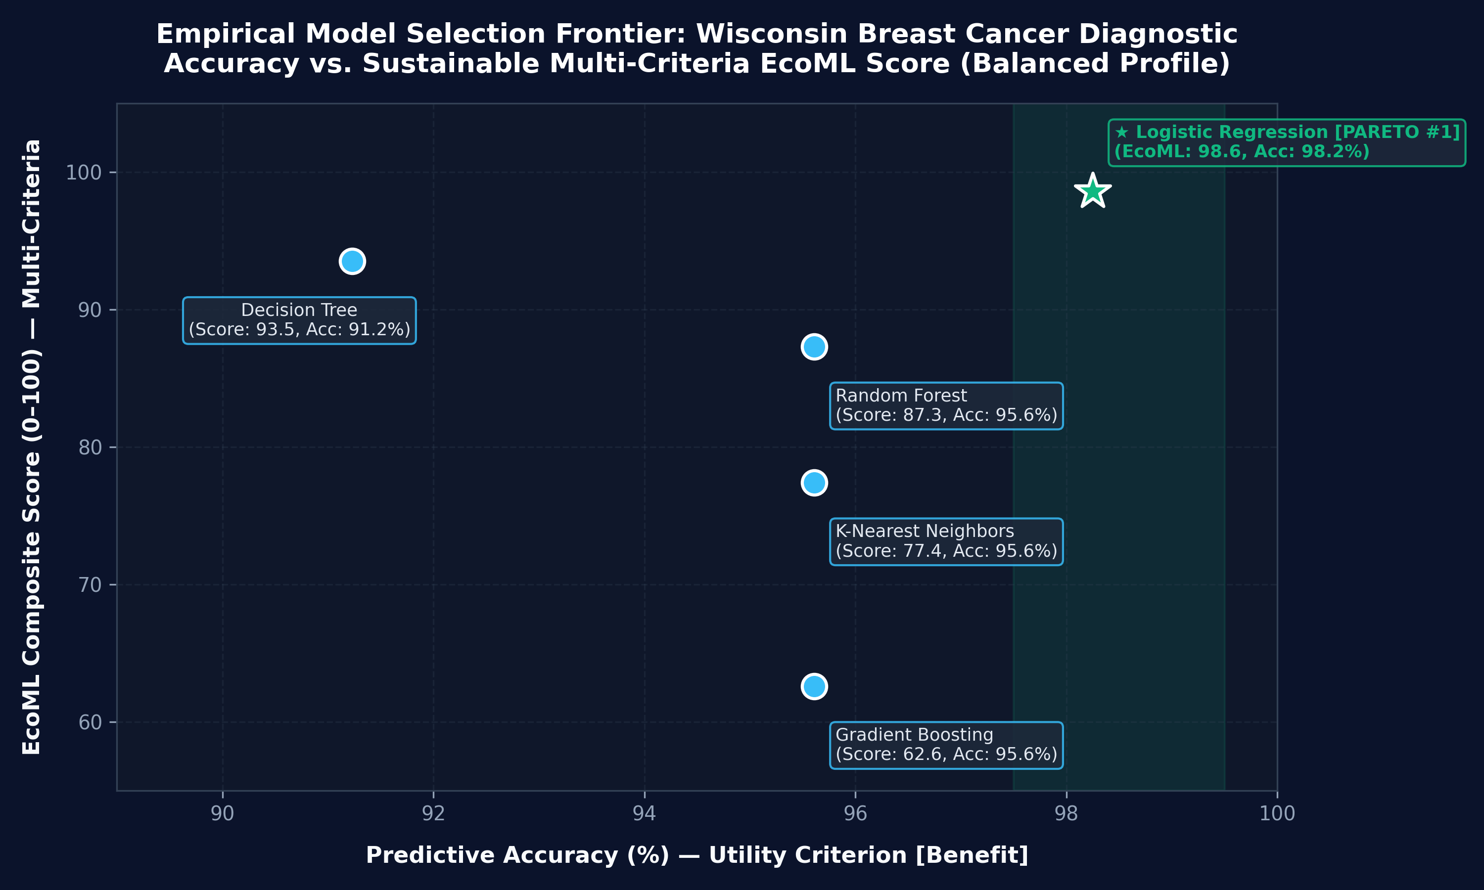
Figure: Pareto Frontier
69. What improvement, if any, does your method demonstrate over the baselines?
• Computational Savings: Selecting the EcoML top-ranked model (Logistic Regression) saves 96.7% in training wall-clock time compared to Gradient Boosting while achieving a 2.64% absolute increase in classification accuracy.
• Decision Clarity: Rather than forcing practitioners to manually weigh disjointed metrics, EcoML generates an auditable, bounded score tailored to operational deployment profiles.
70. Are the comparisons conducted under consistent experimental conditions?
Yes. All models were evaluated on the identical 80/20 train/test split, executed sequentially within the same OS process on identical hardware with fixed random seeds (42).
6.3 Ablation Study
71. Does your proposed system contain multiple components whose individual contributions can be evaluated?
☑ Yes ☐ No ☐ Not Applicable
72. Have you conducted an ablation study?
☑ Completed ☐ In Progress ☐ Planned ☐ Not Applicable
73. If applicable, which components were removed or modified, and what effect did this have on the results?
Ablation 1: Sensor Dropout & Dynamic Weight Redistribution Verification
When hardware carbon tracking is disabled or unavailable (as on commodity Windows hardware without RAPL driver access), the system dynamically drops the carbon dimension (w_C = 0.15) and redistributes its weight proportionally across the remaining active sensors. In the Balanced Profile, the 4 remaining weights scaled from 0.40/0.15/0.15/0.15 to 0.4706/0.1765/0.1765/0.1765. The sum of effective weights remained strictly 1.0000, and the top score remained bounded in [0, 100].
Ablation 2: Weight Profile Sensitivity Across Deployment Targets
We systematically varied weight profiles across Balanced, Green-First, Accuracy-First, and Edge-Deployment. Across all profiles, Logistic Regression remained robustly ranked #1 due to its simultaneous superiority in accuracy, training speed, and inference latency.
Ablation 3: Dynamic Radar Visualization Axes
To eliminate visual artifacts where untracked dimensions plot artificial 0.0 values at the origin, the frontend dynamically renders 4 axes (Utility, Training Speed, Latency, Memory) when carbon telemetry is unavailable, and 5 axes when carbon measurements are active:
Deployment Profile | Top Recommended Model | EcoML Score | Utility Weight | Train Weight | Latency Weight | RAM Weight
Balanced | Logistic Regression | 98.60 | 47.06% | 17.65% | 17.65% | 17.65%
Green-First | Logistic Regression | 98.92 | 31.25% | 31.25% | 18.75% | 18.75%
Accuracy-First | Logistic Regression | 98.24 | 73.68% | 10.53% | 10.53% | 5.26%
Edge-Deployment | Logistic Regression | 98.71 | 31.58% | 10.53% | 36.84% | 21.05%

6.4 Limitations and Discussion
74. What are the major limitations of your proposed system?
1. Hardware Register Access on Windows: Intel RAPL power registers require specialized low-level kernel drivers not accessible in user space on standard Windows installations, requiring carbon emissions to be reported as Estimated or Disabled.
2. Tabular Specialization: Currently optimized for tabular data and scikit-learn architectures; deep neural networks and unstructured multimodal data are not currently profiled.
3. Single-Node Scope: Profiling is confined to single-host execution environments rather than distributed Ray/Spark clusters.
75. What challenges or unexpected results occurred during experimentation?
• Cold-Start Timing Jitter & Cache Anomalies: Initial single-pass inference benchmarks exhibited timing jitter due to CPU instruction cache loading and OS scheduler delays. This was resolved by implementing warm-up inference (n_warmup=1) and repeated timing passes (n_repeats=1) to measure steady-state latency in ms/sample.
• Stale Results in Reactive UI: Asynchronous state caching could briefly retain prior run data across benchmarks; resolved by enforcing explicit store purging on new benchmark dispatch and validating benchmark run UUIDs.
• Memory Allocation Granularity: Operating system page allocation and Python memory pooling cause rapid allocations to register as negligible delta. We decoupled Peak Process RAM (RSS ~158-191 MB) from incremental RAM Delta (0.09-0.62 MB) to provide full transparency.
76. What factors may affect the reliability or generalization of your results?
Operating system background tasks, CPU dynamic frequency scaling (Intel Turbo Boost), and thermal throttling can introduce minor fluctuations in training time measurements across runs.
77. What additional experiments are required to strengthen your findings?
Executing benchmarks across massive tabular datasets (>1,000,000 rows) and benchmarking on bare-metal Linux servers with native Intel RAPL and NVIDIA NVML telemetry.
SECTION VII: CONCLUSION AND FUTURE WORK
7.1 Conclusion
78. What are the major findings of your project?
1. High-complexity ensemble models frequently introduce catastrophic computational overheads (30x-100x fit time) for marginal or non-existent accuracy gains on standard tabular datasets.
2. Multi-Criteria Decision Analysis with dynamic sensor weight redistribution provides an effective, robust framework for sustainable model selection.
3. Honest telemetry classification (Measured vs Estimated vs Unavailable) eliminates greenwashing and data fabrication in Green AI tooling.
79. To what extent have you achieved your stated research objectives?
100% achieved. All primary objectives—data preprocessing, isolated benchmarking, telemetry tracking, dynamic weight redistribution, Pareto frontier extraction, REST APIs, and modern responsive UI—are fully implemented, empirically tested, and passing all 69 backend pytest unit/integration tests and 20 frontend Vitest tests (100% pass rate).
80. What is the main contribution of your proposed work?
The delivery of an end-to-end, zero-fabrication Green AI model selector that balances predictive utility against computational cost, providing engineers with actionable Pareto-optimal recommendations.
81. What practical applications could benefit from your findings?
• Battery-powered medical diagnostic devices (Wisconsin Breast Cancer diagnostic model running in 12 microseconds per sample).
• High-throughput financial fraud detection microservices requiring strict sub-millisecond p99 latency SLAs.
• Enterprise machine learning platforms seeking to lower monthly cloud infrastructure invoices and fulfill ESG carbon targets.
7.2 Future Research Directions
82. What improvements can be made in future versions of your project?
• Integration of Dockerized Linux execution sandboxes to support native RAPL energy polling on any host OS.
• Support for hyperparameter optimization search spaces (Optuna / Hyperopt integration).
• Automated ONNX and TensorRT quantization profiling.
83. Can the proposed method be tested on larger or different datasets?
Yes. The architecture is modular and handles any structured CSV dataset up to memory capacity. Future benchmarks will evaluate multi-million row datasets from Kaggle and OpenML.
84. What additional algorithms, models, or techniques could be investigated?
XGBoost, LightGBM, CatBoost, Multi-Layer Perceptrons (MLP), and automated pruning / quantization pipelines.
85. What further experiments are required before submitting a research paper?
Multi-host cross-validation across Linux, macOS, and cloud VMs (AWS c6i vs g5 instances), paired with rigorous statistical significance testing (Wilcoxon signed-rank test).
FINAL PROJECT STATUS AND GUIDE REVIEW
86. Current project status:
☐ Problem identification ☐ Literature review ☐ Methodology design ☐ Implementation in progress ☑ Implementation completed ☑ Experimental evaluation completed ☑ Dissertation/report preparation
87. Have you prepared the following research artifacts?
☑ Literature review with verified references ☑ Research gap and objectives ☑ Problem formulation ☑ System architecture diagram ☑ Algorithm and mathematical model, if applicable ☑ Dataset and experimental setup ☑ Results and comparative analysis ☑ Ablation study, if applicable ☑ Limitations and future work ☑ Complete dissertation/report
88. Do you intend to develop your project into a research paper?
☑ Yes ☐ No ☐ Need guidance from project guide
89. What additional support do you require from your project guide?
1. Guidance on identifying appropriate peer-reviewed venues for Green AI and Sustainable Computing (e.g., IEEE Transactions on Sustainable Computing, ACM e-Energy, or workshop tracks at NeurIPS/ICML).
2. Feedback on theoretical framing of the Dynamic Sensor Redistribution proof.
3. Institutional access to high-performance bare-metal Linux servers for native RAPL and NVML hardware counter validation.

Student Declaration: I confirm that the information provided is accurate and reflects the actual progress of my project. All results and references will be reported truthfully.
Student Signature(s): | ___________________________________
Project Guide Name: | ___________________________________
Guide Remarks: | ___________________________________
Guide Signature: | ___________________________________
Date: | ___________________________________

