**Assignment – 5**

**Name: PAVANI KATKURI**

**Username: PXK26490**

**Student ID: 700732649**

**GITHUB:** [**https://github.com/pavanir2530/ML_ASS_5**](https://github.com/pavanir2530/ML_ASS_5)

**VIDEO LINK:** [**https://drive.google.com/file/d/1wNnF6u6x1tAQZtvcIo93V-jlgofBshYr/view?usp=sharing**](https://drive.google.com/file/d/1wNnF6u6x1tAQZtvcIo93V-jlgofBshYr/view?usp=sharing)

**Question – 1:**

Adding the screenshots of the code and output for Question -1

Code:

**Question – 2:**

Adding the screenshots of the code and output for Question -2

Code:

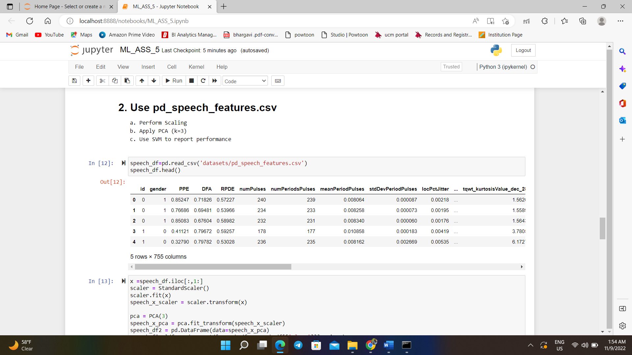

**Question – 3:**

Adding the screenshots of the code and output for Question -3

Code:

