**CS 5710**

**MACHINE LEARNING**

**Name:** katkuri pavani

**Student Id:** 700732649

**E-mail:** pxk26490@ucmo.edu

**Course:** CS 5710

**Assignment:** Assignment #6

**Semester:** Fall 2022

**GitHub Link:** [pavanir2530/ML_ass_6 (github.com)](https://github.com/pavanir2530/ML_ass_6/)

**Video Demo Link:**

<https://drive.google.com/file/d/1xVIHr2X8HBrfZ0hFy2s_OSDrl1POx1h9/view?usp=sharing>

**1) (Provide only mathematical solutions for this question)**

**Six points with the following attributes are given, calculate and find out clustering representations and dendrogram using Single, complete, and average link proximity function in hierarchical clustering technique.**

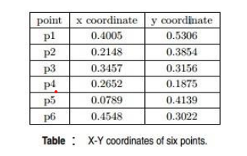

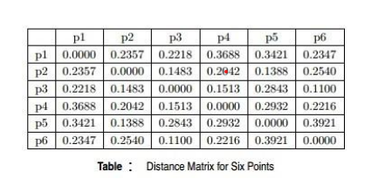

**Solution,Code&Output:**

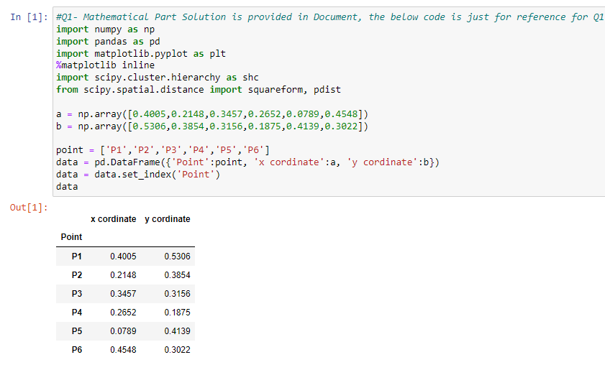

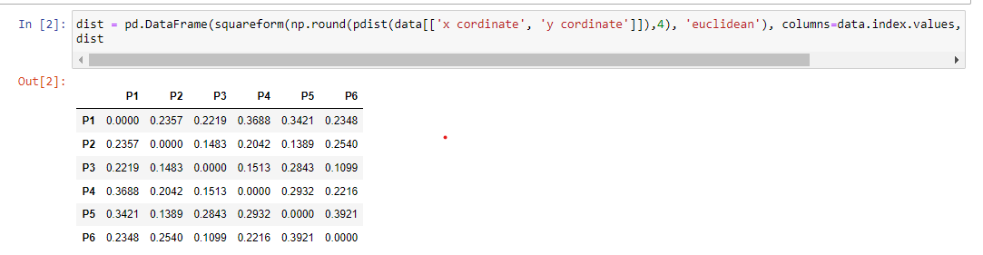

**Single Link Proximity:**

* In **Single Linkage,**the distance between two clusters is the minimum distance between members of the two clusters

|  |  |  |  |  |  |  |  |  |  |  |  |
| --- | --- | --- | --- | --- | --- | --- | --- | --- | --- | --- | --- |
|  | | **p1** | | **p2** | | **p3** | | **p4** | | **p5** | **p6** |
| **p1** | | 0 | | 0.2357 | | 0.2218 | | 0.3688 | | 0.3421 | 0.2347 |
| **p2** | | 0.2357 | | 0 | | 0.1483 | | 0.2042 | | 0.1388 | 0.254 |
| **p3** | | 0.2218 | | 0.1483 | | 0 | | 0.1513 | | 0.2843 | 0.11 |
| **p4** | | 0.3688 | | 0.2042 | | 0.1513 | | 0 | | 0.2932 | 0.2216 |
| **p5** | | 0.3421 | | 0.1388 | | 0.2843 | | 0.2932 | | 0 | 0.3921 |
| **p6** | | 0.2347 | | 0.254 | | 0.11 | | 0.2216 | | 0.3921 | 0 |
|  | |  | |  | |  | |  | |  |  |
| smallest distance from above data is | | | | | | | | | | 0.11 |  |
| so p3 and p6 forms first cluster | | | | | | | | | | |
|  | **p1** | | **p2** | | **p36** | | **p4** | | **p5** | |
| **p1** | 0 | | 0.2357 | | 0.2218 | | 0.3688 | | 0.3421 | |
| **p2** | 0.2357 | | 0 | | 0.1483 | | 0.2042 | | 0.1388 | |
| **p36** | 0.2218 | | 0.1483 | | 0 | | 0.1513 | | 0.2843 | |
| **p4** | 0.3688 | | 0.2042 | | 0.1513 | | 0 | | 0.2932 | |
| **p5** | 0.3421 | | 0.1388 | | 0.2843 | | 0.2932 | | 0 | |
|  |  | |  | |  | |  | |  | |
| smallest distance from above data is | | | | | | | | | 0.1388 | |

|  |  |  |  |  |  |
| --- | --- | --- | --- | --- | --- |
| so p2 and p5 forms 2nd cluster | | | | | |
|  | **p1** | **p25** | **p36** | **p4** |  |
| **p1** | 0 | 0.2357 | 0.2218 | 0.3688 |  |
| **p25** | 0.2357 | 0 | 0.1483 | 0.2042 |  |
| **p36** | 0.2218 | 0.1483 | 0 | 0.1513 |  |
| **p4** | 0.3688 | 0.2042 | 0.1513 | 0 |  |
|  |  |  |  |  |  |
| smallest distance from above data is | | | | | 0.1483 |
| so p25 and p36 forms 3rdcluster | | | | | |
|  |  |  |  |  |  |
|  | **p1** | **p(25)(36)** | **p4** |  |  |
| **p1** | 0 | 0.2218 | 0.3688 |  |  |
| **p(25)(36)** | 0.2218 | 0 | 0.1513 |  |  |
| **p4** | 0.3688 | 0.1513 | 0 |  |  |
|  |  |  |  |  |  |
| smallest distance from above data is | | | | | 0.153 |
| so p(25)(36)and p4 forms 4thcluster | | | | | |
|  | **p1** | **p4(25)(36)** |  |  |  |
| **p1** | 0 | 0.2218 |  |  |  |
| **p4(25)(36)** | 0.2218 | 0 |  |  |  |

**1 4 2 5 3 6**

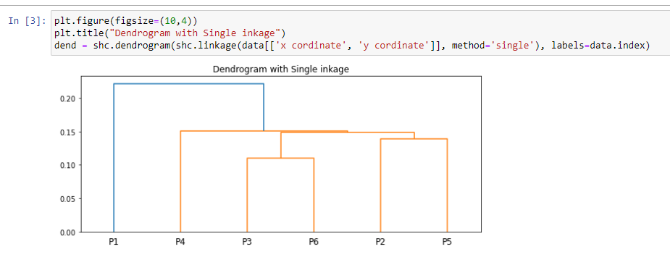

**Complete Link Proximity:**

* In **Complete Linkage,**the distance between two clusters is the maximum distance between members of the two clusters

|  |  |  |  |  |  |  |
| --- | --- | --- | --- | --- | --- | --- |
|  | **p1** | **p2** | **p3** | **p4** | **p5** | **p6** |
| **p1** | 0 | 0.2357 | 0.2218 | 0.3688 | 0.3421 | 0.2347 |
|  |  |  |  |  |  |  |
|  |  |  |  |  |  |  |
| **p2** | 0.2357 | 0 | 0.1483 | 0.2042 | 0.1388 | 0.254 |
| **p3** | 0.2218 | 0.1483 | 0 | 0.1513 | 0.2843 | 0.11 |
| **p4** | 0.3688 | 0.2042 | 0.1513 | 0 | 0.2932 | 0.2216 |
| **p5** | 0.3421 | 0.1388 | 0.2843 | 0.2932 | 0 | 0.3921 |
| **p6** | 0.2347 | 0.254 | 0.11 | 0.2216 | 0.3921 | 0 |
|  |  |  |  |  |  |  |
| smallest distance from above data is | | | | | 0.11 |  |
| so p3 and p6 forms first cluster | | | | | |  |
|  | **p1** | **p2** | **p36** | **p4** | **p5** |  |
| **p1** | 0 | 0.2357 | 0.2347 | 0.3688 | 0.3421 |  |
| **p2** | 0.2357 | 0 | 0.254 | 0.2042 | 0.1388 |  |
| **p36** | 0.2347 | 0.254 | 0 | 0.2216 | 0.3921 |  |
| **p4** | 0.3688 | 0.2042 | 0.2216 | 0 | 0.2932 |  |
| **p5** | 0.3421 | 0.1388 | 0.3921 | 0.2932 | 0 |  |
|  |  |  |  |  |  |  |
| smallest distance from above data is | | | | | 0.1388 |  |
| so p2 and p5 forms 2nd cluster | | | | | |  |
|  | **p1** | **p25** | **p36** | **p4** |  |  |
| **p1** | 0 | 0.3421 | 0.2347 | 0.3688 |  |  |
| **p25** | 0.3421 | 0 | 0.3921 | 0.2932 |  |  |
| **p36** | 0.2347 | 0.3921 | 0 | 0.2216 |  |  |
| **p4** | 0.3688 | 0.2932 | 0.2216 | 0 |  |  |
|  |  |  |  |  |  |  |
| smallest distance from above data is | | | | | 0.2216 |  |
| so p25 and p36 forms 3rdcluster | | | | | |  |
|  | **p1** | **p(25)(36)** | **p4** |  |  |  |
| **p1** | 0 | 0.3421 | 0.3688 |  |  |  |
| **p(25)(36)** | 0.3421 | 0 | 0.2932 |  |  |  |
| **p4** | 0.3688 | 0.2932 | 0 |  |  |  |
|  |  |  |  |  |  |  |
| smallest distance from above data is | | | | | 0.2932 |  |
| so p(25)(36)and p1 forms 4thcluster | | | | | |  |
|  | **p1(25)(36)** | **p4** |  |  |  |  |
| **p1(25)(36)** | 0 | 0.1483 |  |  |  |  |
| **p4** | 0.3688 | 0 |  |  |  |  |

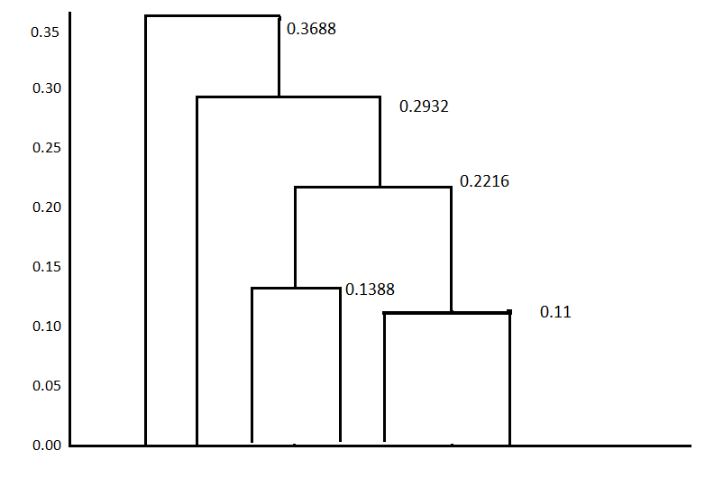

**4 1 2 5 3 6**

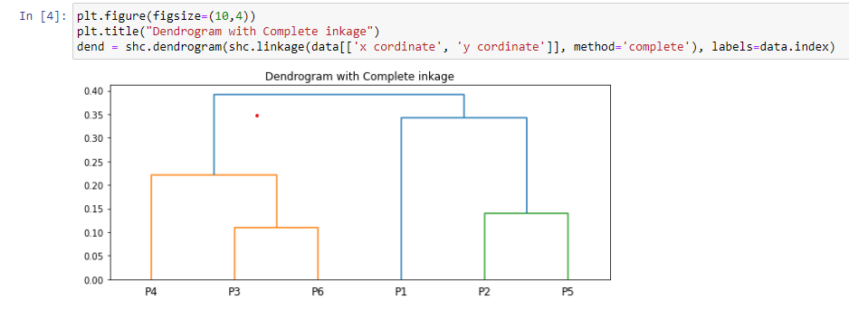

**Average Link Proximity:**

In **Average Linkage,**the distance between two clusters is the average of all distances between members of the two clusters

|  |  |  |  |  |  |  |
| --- | --- | --- | --- | --- | --- | --- |
|  | **p1** | **p2** | **p3** | **p4** | **p5** | **p6** |
| **p1** | 0 | 0.2357 | 0.2218 | 0.3688 | 0.3421 | 0.2347 |
| **p2** | 0.2357 | 0 | 0.1483 | 0.2042 | 0.1388 | 0.254 |
| **p3** | 0.2218 | 0.1483 | 0 | 0.1513 | 0.2843 | 0.11 |
| **p4** | 0.3688 | 0.2042 | 0.1513 | 0 | 0.2932 | 0.2216 |
| **p5** | 0.3421 | 0.1388 | 0.2843 | 0.2932 | 0 | 0.3921 |
| **p6** | 0.2347 | 0.254 | 0.11 | 0.2216 | 0.3921 | 0 |
|  |  |  |  |  |  |  |
| smallest distance from above data is | | | | | 0.11 |  |
| so p3 and p6 forms first cluster | | | | | |  |
|  | **p1** | **p2** | **p36** | **p4** | **p5** |  |
| **p1** | 0 | 0.2357 | 0.22825 | 0.3688 | 0.3421 |  |
| **p2** | 0.2357 | 0 | 0.20115 | 0.2042 | 0.1388 |  |
| **p36** | 0.22825 | 0.20115 | 0 | 0.18645 | 0.3382 |  |
| **p4** | 0.3688 | 0.2042 | 0.18645 | 0 | 0.2932 |  |
| **p5** | 0.3421 | 0.1388 | 0.3382 | 0.2932 | 0 |  |
|  |  |  |  |  |  |  |
| smallest distance from above data is | | | | | 0.1388 |  |
| so p2 and p5 forms 2nd cluster | | | | | |  |
|  | **p1** | **p25** | **p36** | **p4** |  |  |
| **p1** | 0 | 0.2889 | 0.2347 | 0.3688 |  |  |
| **p25** | 0.2889 | 0 | 0.269675 | 0.2487 |  |  |
| **p36** | 0.2347 | 0.269675 | 0 | 0.18645 |  |  |
| **p4** | 0.3688 | 0.2487 | 0.18645 | 0 |  |  |
|  |  |  |  |  |  |  |
| smallest distance from above data is | | | | | 0.18645 |  |
| so p25 and p36 forms 3rdcluster | | | | | |  |
|  | **p1** | **p(25)(36)** | **p4** |  |  |  |
| **p1** | 0 | 0.2618 | 0.3688 |  |  |  |
| **p(25)(36)** | 0.2618 | 0 | 0.217575 |  |  |  |
| **p4** | 0.3688 | 0.217575 | 0 |  |  |  |
|  |  |  |  |  |  |  |
| smallest distance from above data is | | | | | 0.217575 |  |
| so p(25)(36)and p1 forms 4thcluster | | | | | |  |
|  | **p1(25)(36)** | **p4** |  |  |  |  |
| **p1(25)(36)** | 0 | 0.3153 |  |  |  |  |
| **p4** | 0.3153 | 0 |  |  |  |  |

**4 1 2 5 3 6**

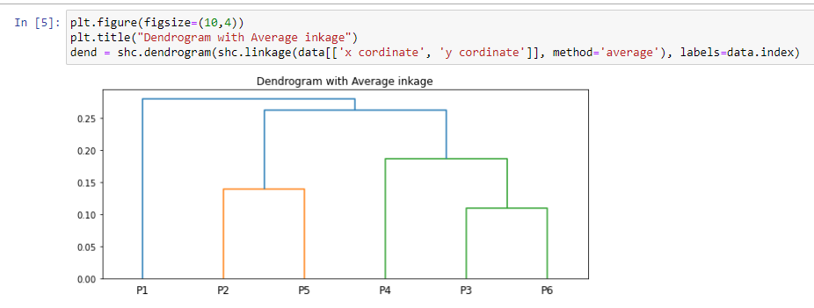

**----------------*******----------------**

**2) Use CC_GENERAL.csv given in the folder and apply:**

**a) Preprocess the data by removing the categorical column and filling the missing values.**

**b) Apply StandardScaler() and normalize() functions to scale and normalize raw input data.**

**c) Use PCA with K=2 to reduce the input dimensions to two features.**

**d) Apply Agglomerative Clustering with k=2,3,4 and 5 on reduced features and visualize the result for each k value using scatter plot.**

**e) Evaluate different variations using Silhouette Scores and Visualize results with a bar chart.**

**Source Code&Output:**

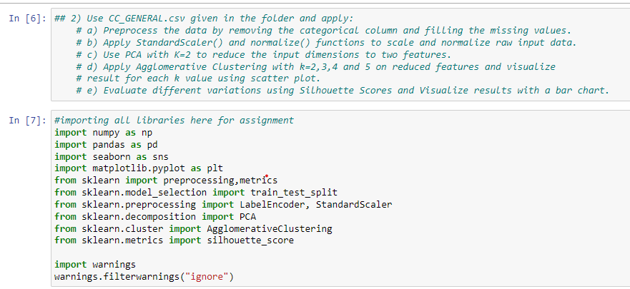

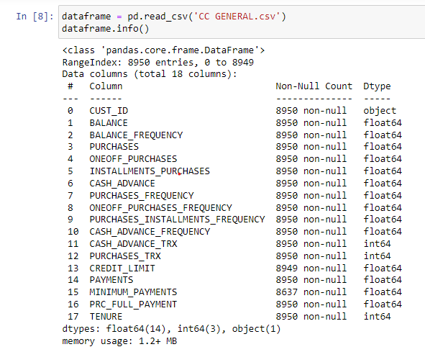

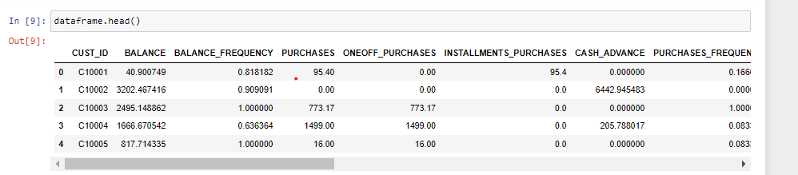

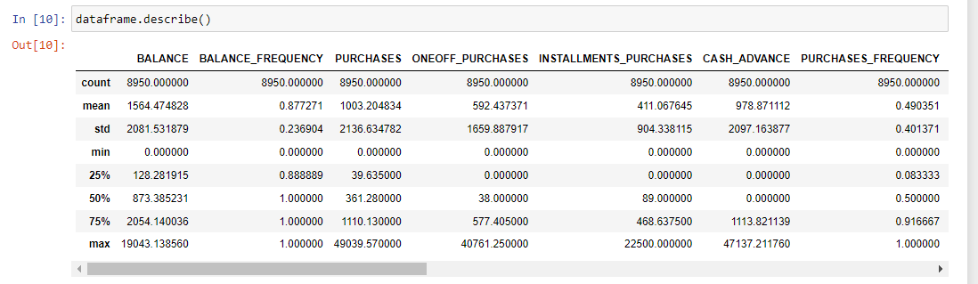

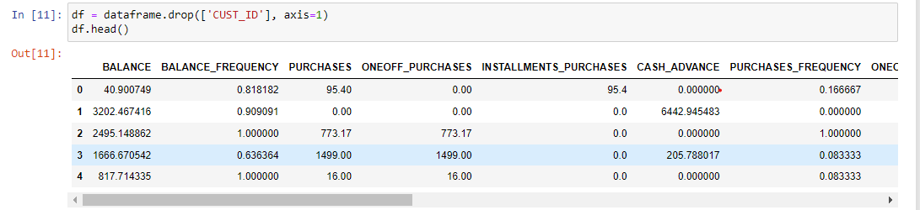

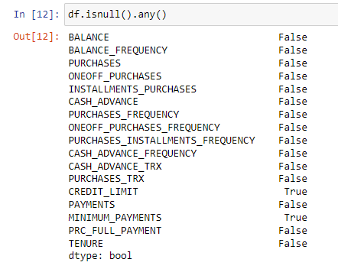

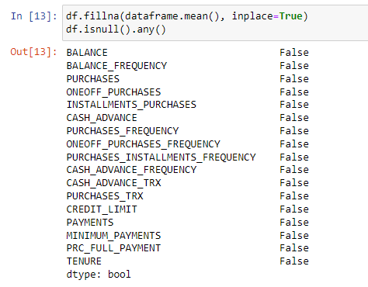

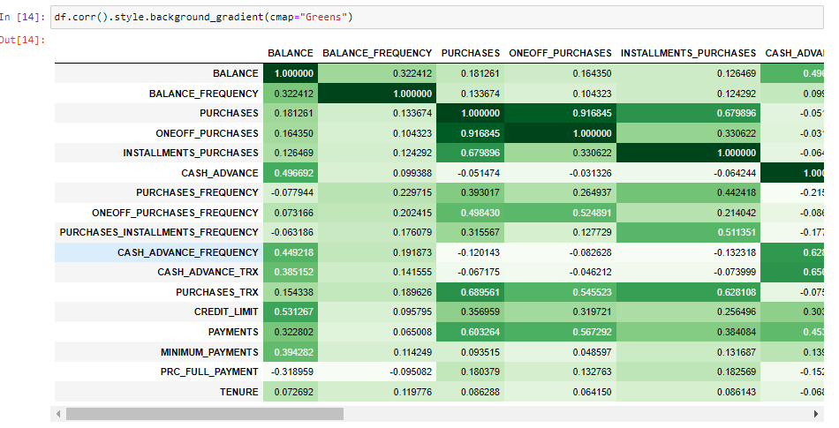

Read the csv file and removed the categorical column cust_id then checked for null values and the replaced the null values with the mean

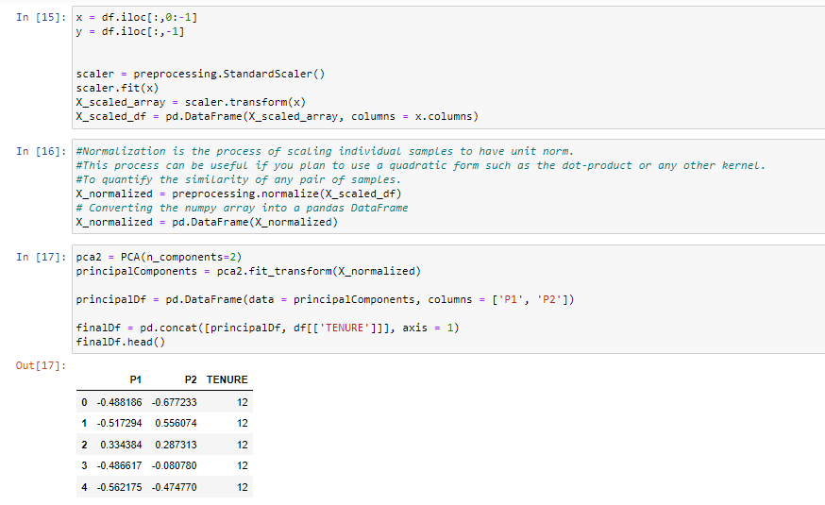

Applied StandardScalar and normalized the data using StandardScaler() and normalize() function.

Normalization is the process of scaling individual samples to have unit norm.This process can be useful if you plan to use a quadratic form such as the dot-product or any other kernel to quantify the similarity of any pair of samples.

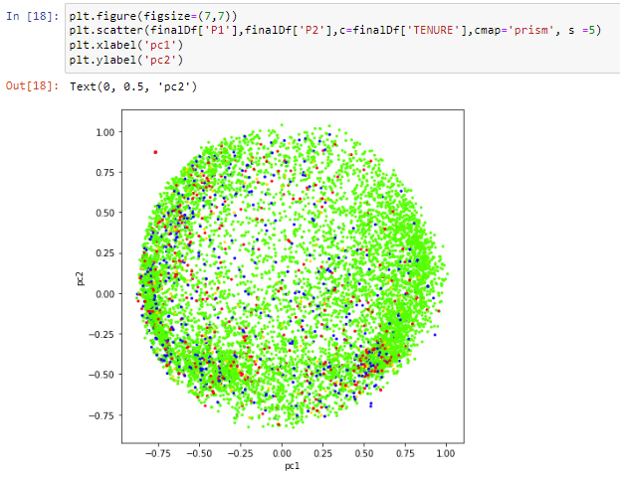

With k=2 applying principal component analysis and then reduced the principal components to 2

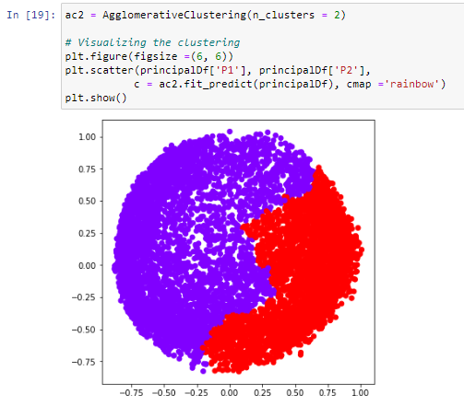

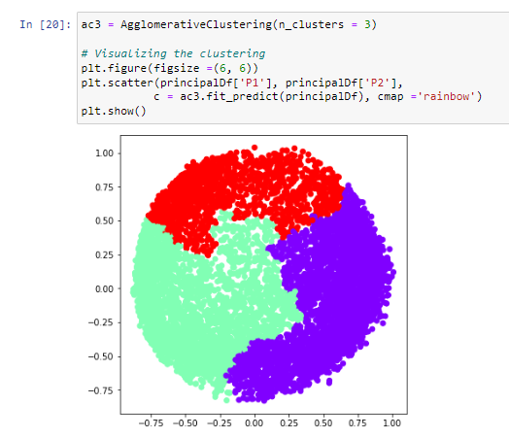

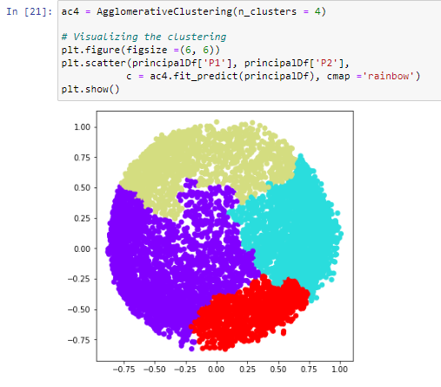

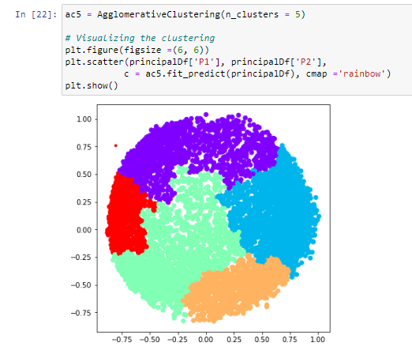

Visualized the features with k=2,3,4 and 5 by applying Agglomerative Clustering with the function AgglomerativeClustering(clusters).

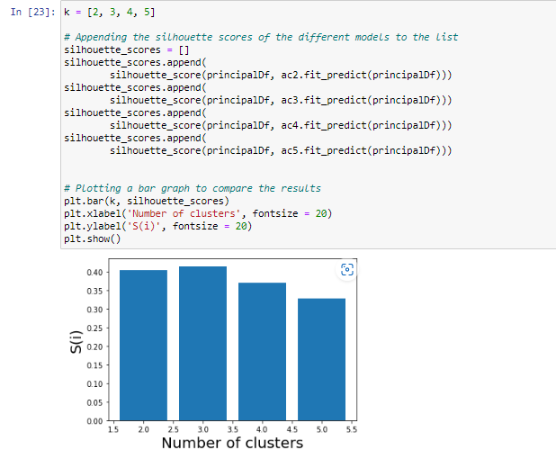

Appended the Silhouette score for all the different models with k values as 2,3,4,5 and visualized the plot as bar graph using plt.bar() function.

**----------------*******----------------**