DIGITAL LIBRARY
WEB PAGE 01 — WEBSITE DOCUMENTATION

1. Description of the Website
The Digital Library is a simple and user-friendly website designed to display books in an organized way. It presents different book categories such as Technology, Science, Fiction and History. The Popular Books section displays book images, titles, author names and availability status. This layout helps students and other readers quickly identify books and check whether a book is available.
The webpage is developed using HTML to create the content and structure, and CSS to control the appearance, spacing, alignment, colours and responsive layout.

2. HTML Code
HTML (HyperText Markup Language) is used to create the structure of the Digital Library webpage. The code below uses basic HTML elements to organize the page into book categories and popular book cards.
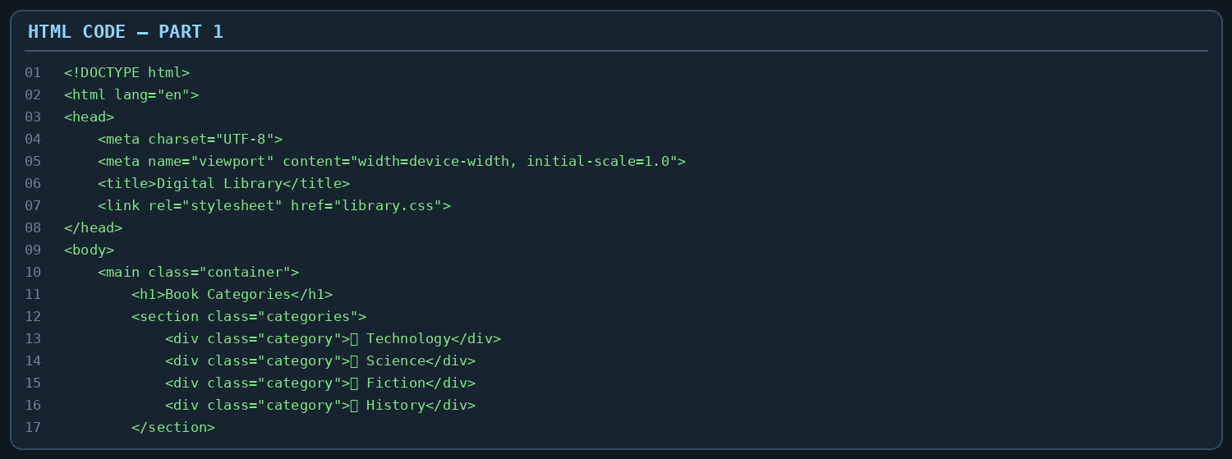
In Part 1, the <!DOCTYPE html> declaration identifies the document as HTML5. The html, head and body elements form the basic page structure. The title element sets the browser-tab title, while the link element connects the external CSS file. The main, section and div elements group the page content. Heading elements display the Book Categories title, and category blocks show the four categories.
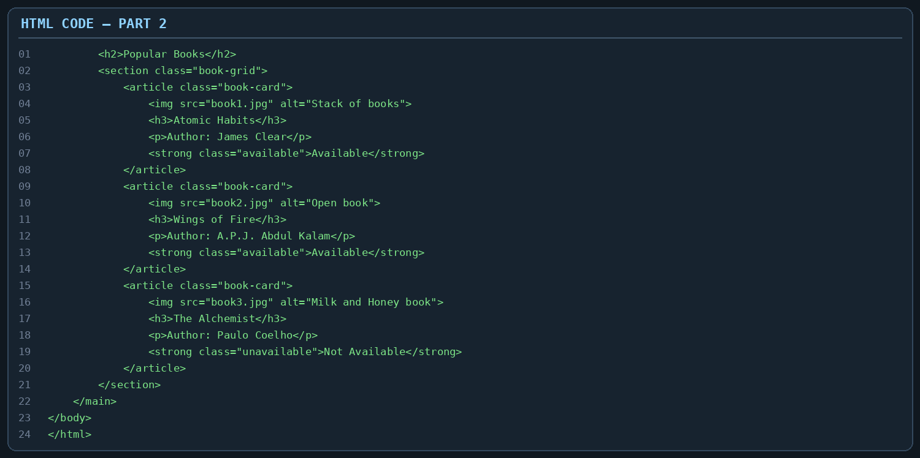
In Part 2, the h2 element introduces the Popular Books section. The section and article elements organize the book cards. Each card contains an img element for the book image, an h3 element for the book title, a p element for the author's name and a strong element for the availability status. The class attributes allow CSS to style available and unavailable labels differently. The alt attributes provide alternative text for images.

3. CSS Code
CSS (Cascading Style Sheets) is used to improve the visual appearance of the webpage. It controls the background colour, text style, spacing, card design, image size and arrangement of content.
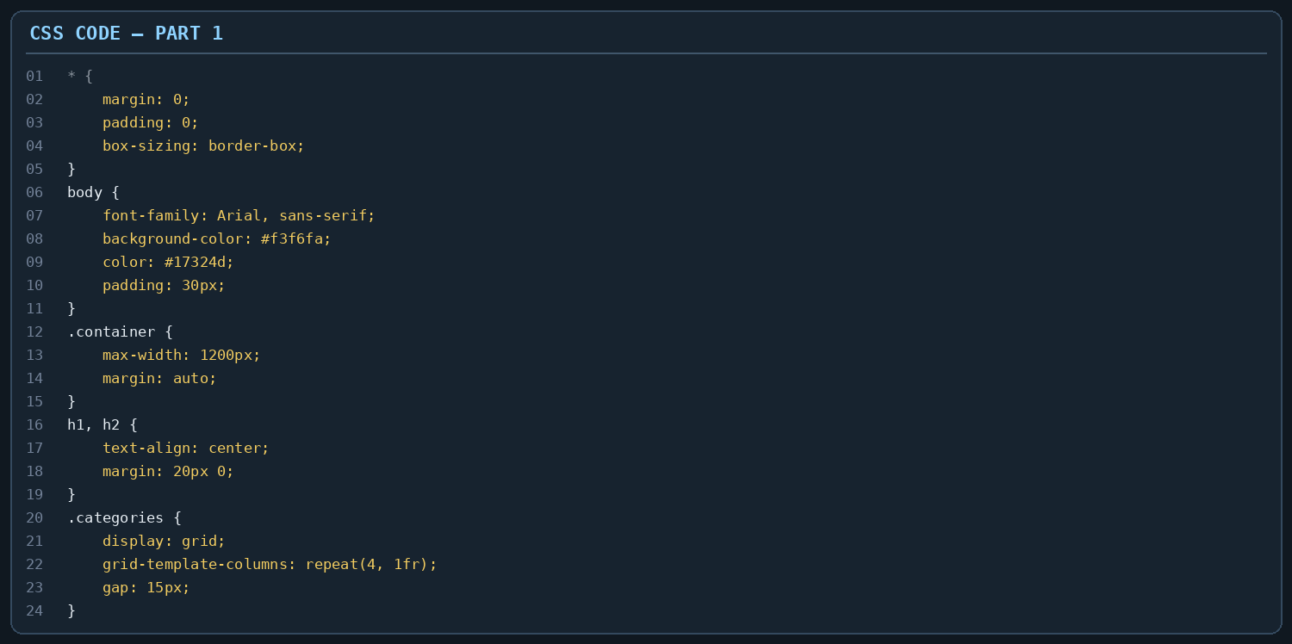
In Part 1, the universal selector (*) removes default margin and padding and applies border-box sizing. The body selector sets the font, background colour, text colour and outer spacing. The container class keeps the content centered with a maximum width. The heading rules center the section titles. CSS Grid with repeat(4, 1fr) arranges the four book categories in four equal columns, while gap adds space between them.
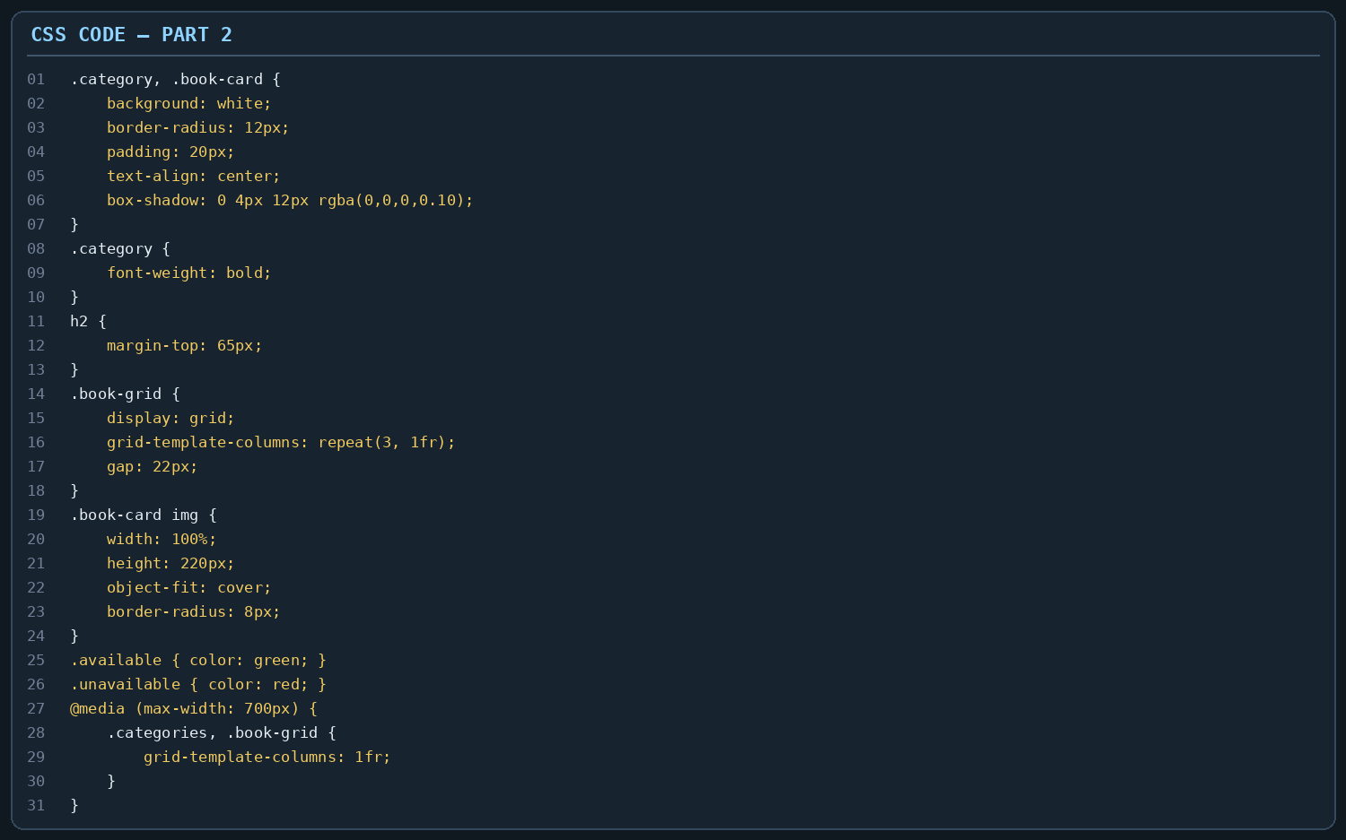
In Part 2, white backgrounds, rounded corners, padding and box shadows create card-style panels. The book-grid uses CSS Grid to arrange three book cards in equal columns. The img rules make book images fill their cards with a fixed height, and object-fit: cover keeps the images neatly cropped. Green and red text distinguish available and unavailable books. The media query changes the grids to one column on smaller screens, making the page easier to view on mobile devices.

4. Output
The following screenshot shows the Digital Library webpage displayed in the browser. It includes four book-category panels at the top and a Popular Books section below. Three book cards are visible, each with a book image, title and author. The first two books are marked Available in green, while The Alchemist is marked Not Available in red. The light background, white cards, rounded corners and shadows make the webpage clear and easy to read.
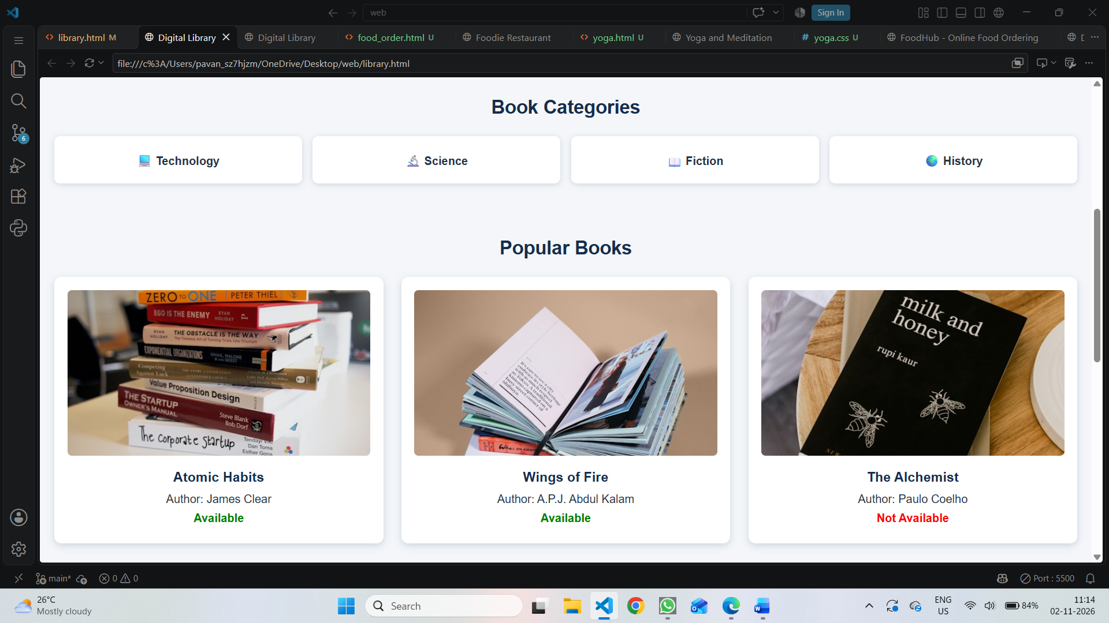
Overall, the output demonstrates how HTML provides the webpage structure and CSS creates its design. The Digital Library interface presents book information in a clean, organized and responsive format.

