ONLINE FOOD ORDERING WEBSITE DESIGN
WEB PAGE DOCUMENTATION

1. Description of the Website
The Online Food Ordering Website is a simple and attractive webpage designed to display food items in an organized manner. It shows four food categories: Pizza, Burgers, Pasta and Desserts. The Popular Menu section presents food images, item names, short descriptions and prices. Each food card also includes an Order Now button to represent the ordering option.
The webpage is structured using HTML and styled using CSS. HTML organizes the categories and menu items, while CSS controls the colours, spacing, card layout, typography and responsive appearance.

2. HTML Code
HTML (HyperText Markup Language) is used to create the structure and content of the webpage. The following code is divided into two parts for easy reading.
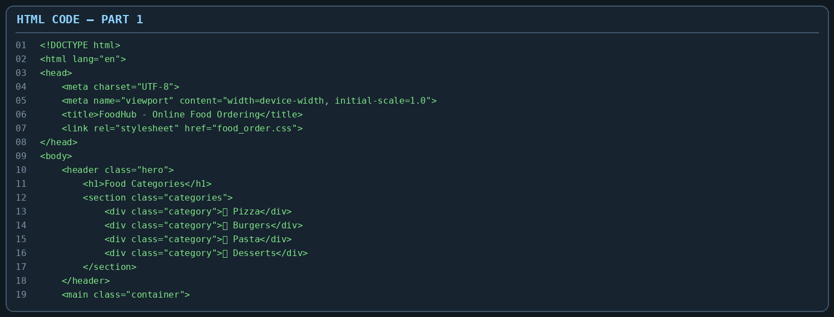
Part 1 contains the HTML5 document declaration and the basic html, head and body structure. The meta tags provide character encoding and viewport settings. The title element sets the browser tab title, and the link element connects the external CSS file. The header, h1, section and div elements create the Food Categories heading and the four category panels.
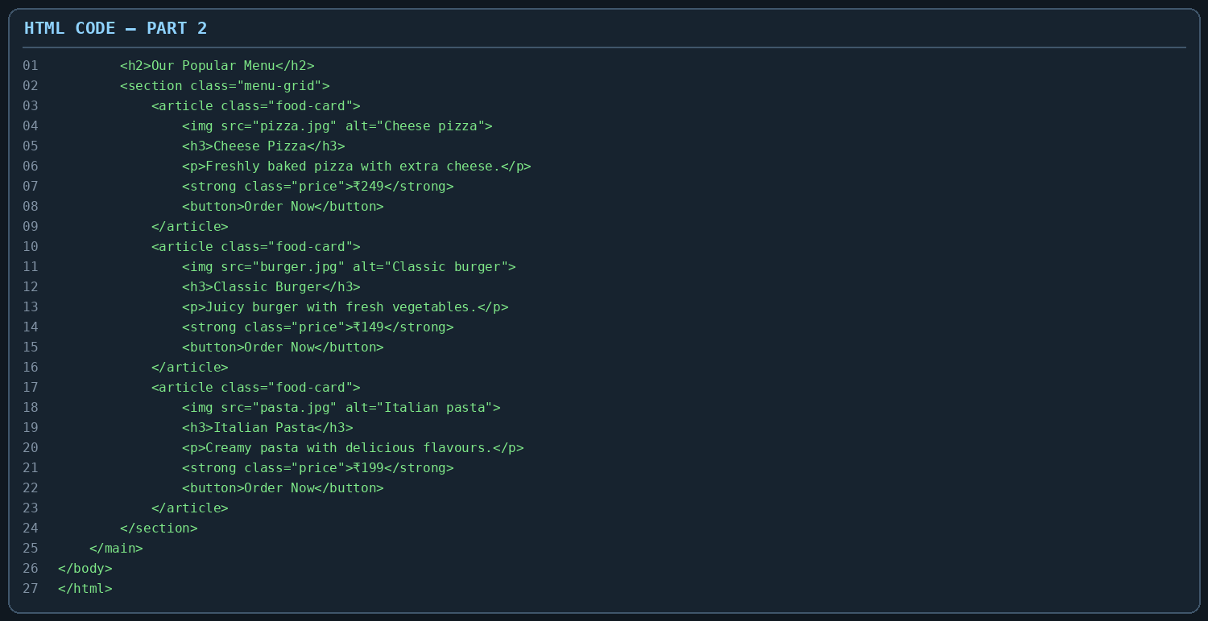
Part 2 creates the Our Popular Menu section. The article element groups each food item into a card. The img element displays food photographs and its alt attribute provides alternative text. The h3 element displays the food name, p provides a short description, strong highlights the price, and button displays the Order Now option. Class attributes connect these elements to their CSS styles.

3. CSS Code
CSS (Cascading Style Sheets) is used to design the webpage and make the content visually attractive. It controls the background, text colours, card appearance, spacing, image dimensions and layout.
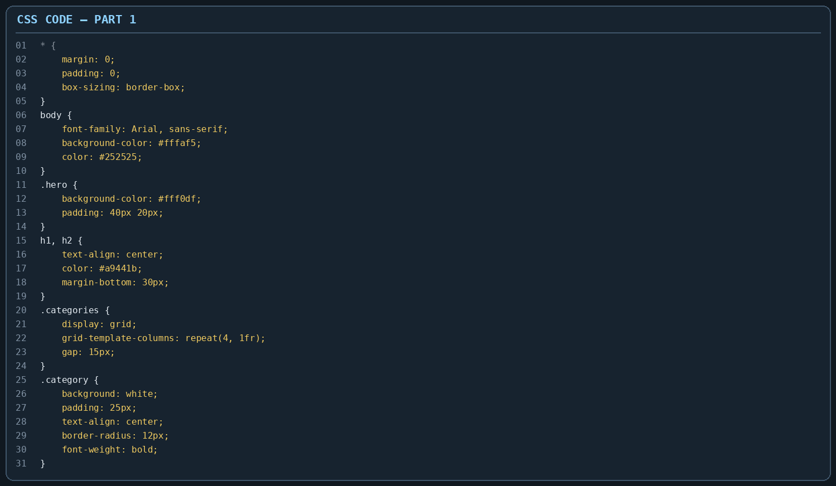
Part 1 uses the universal selector (*) to reset default margin and padding and apply border-box sizing. The body rule sets the font and page background. The hero class creates the light peach category area with padding. The heading rules center the titles and apply a dark orange colour. CSS Grid with repeat(4, 1fr) arranges the four food categories in equal columns. The category rule styles each category as a white rounded panel.
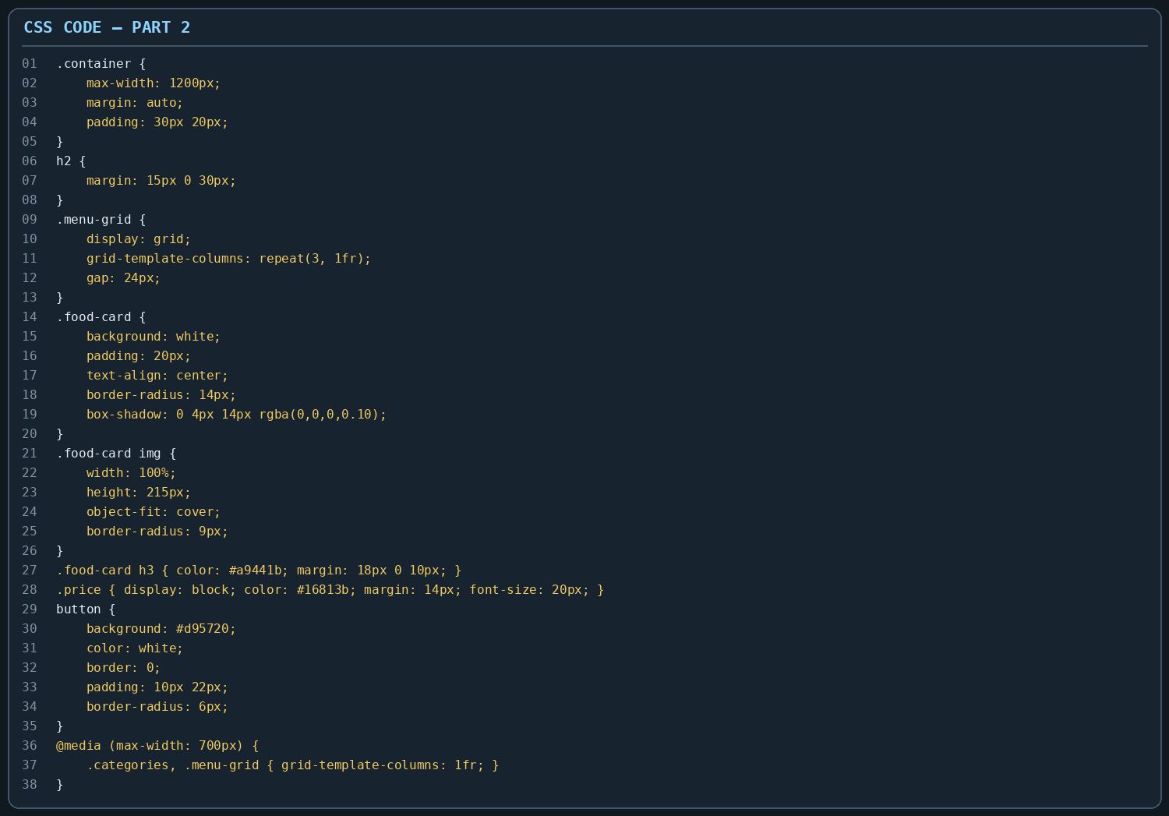
Part 2 styles the main content area and food cards. The menu-grid uses CSS Grid to display three cards in columns with even spacing. The food-card rule adds a white background, rounded corners, padding and a soft box shadow. The image rules set the image width and height, while object-fit: cover keeps images neatly fitted. The price and button rules give important details clear colours. The media query changes the grids to one column on narrow screens, improving mobile viewing.

4. Output
The screenshot below shows the Online Food Ordering webpage in the browser. The upper section displays the four food categories in separate white panels on a light peach background. Below it, the Our Popular Menu heading introduces three food cards: Cheese Pizza, Classic Burger and Italian Pasta. Each card contains a food image, a short description and its price. The orange-brown headings and green prices help distinguish the information, while the white cards and soft shadows create a clean layout.
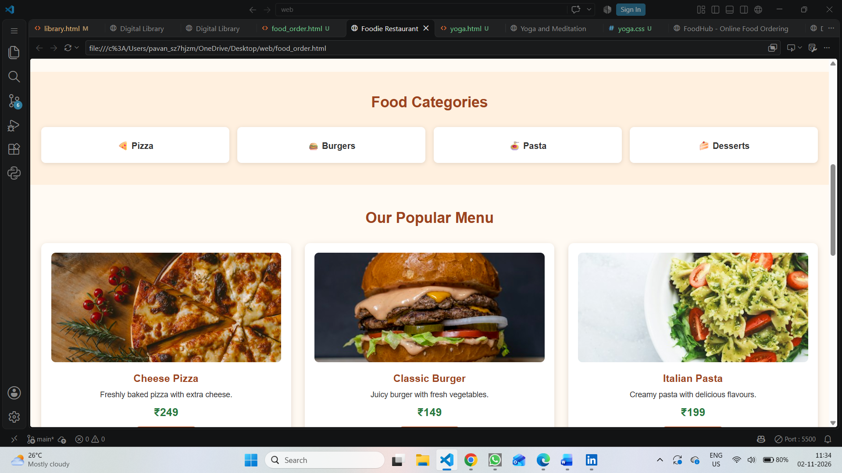
Overall, the output demonstrates the use of HTML for organizing food information and CSS for creating a neat, attractive and responsive menu interface. The Order Now buttons visually indicate where a user could begin an order; actual order processing would require additional programming.

