YOGA AND MEDITATION WEBSITE DESIGN
WEB PAGE DOCUMENTATION

1. Description of the Website
The Yoga and Meditation website is designed to introduce visitors to yoga practices and the benefits of meditation. The page highlights key benefits such as reducing stress, improving health, increasing flexibility, improving focus and encouraging a positive mindset. It also presents a Popular Yoga Poses section with images, pose names and short descriptions. A Meditation Techniques section is included to guide visitors towards learning more about meditation.
HTML is used to organize the website content into sections, navigation links and pose cards. CSS is used to create the calm visual theme, arrange the content in grids, style the cards and make the layout adapt to different screen sizes.

2. HTML Code
HTML (HyperText Markup Language) provides the structure of the webpage. The code is divided into two parts so that the main sections and their elements are easy to understand.
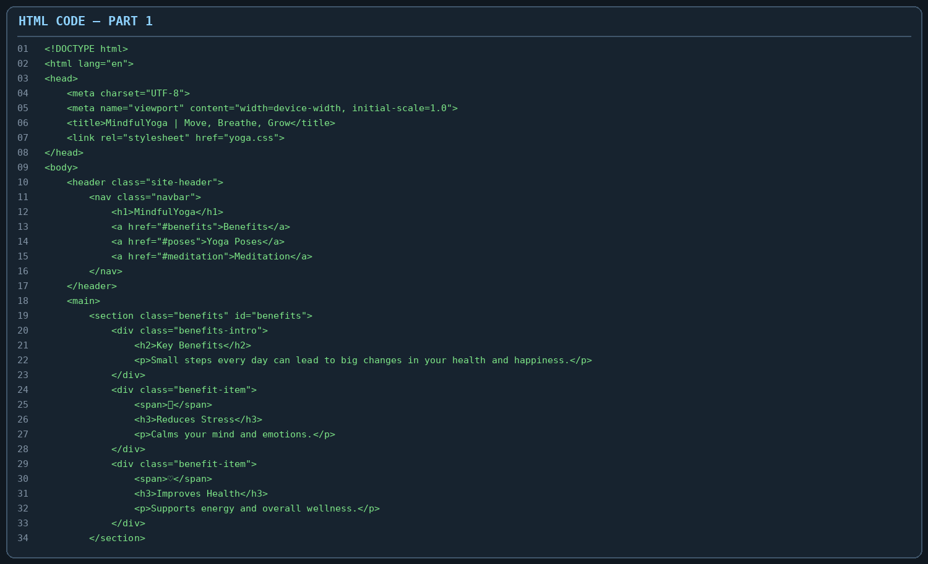
Part 1 includes the HTML5 declaration and the basic html, head and body elements. The meta tags set character encoding and responsive viewport settings. The title element defines the browser-tab title, and the link element connects the external CSS file. The header and nav elements create the site header and navigation area. The benefits section groups information about the positive effects of yoga, while div, span, h2, h3 and p elements organize icons, headings and descriptions.
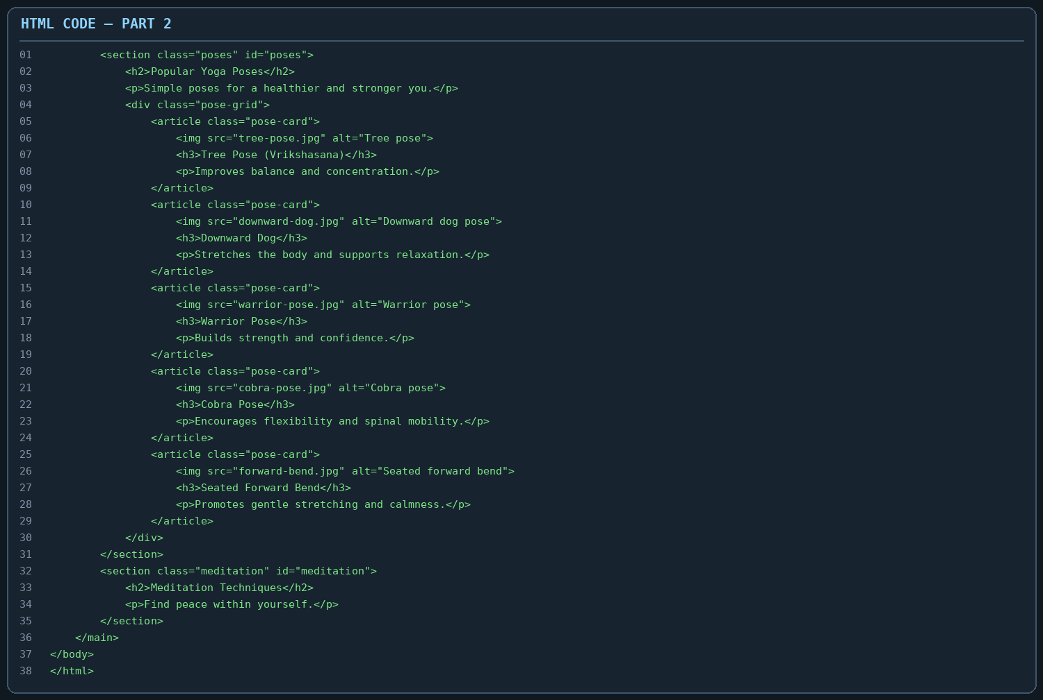
Part 2 creates the Popular Yoga Poses and Meditation Techniques sections. The section element groups related content, and the id attributes provide targets for navigation links. The div element with the pose-grid class groups the cards. Each article represents one yoga pose and contains an img element, a heading and a paragraph. The alt attribute gives alternative text for each image. These semantic elements make the webpage content organized and understandable.

3. CSS Code
CSS (Cascading Style Sheets) controls the appearance of the website. It is used to set the colour theme, font, spacing, grid layout, image size, card design and responsive behaviour.
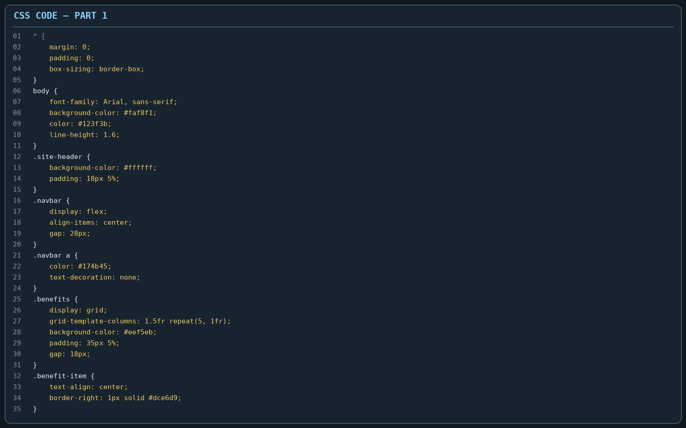
Part 1 uses the universal selector (*) to remove default margins and padding and apply border-box sizing. The body rule sets the font, background colour, text colour and line spacing. The site-header and navbar rules style the top navigation area using Flexbox. The benefits section uses CSS Grid to arrange the introductory text and benefit items in columns. The benefit-item rule centers its content and adds a subtle divider between items.
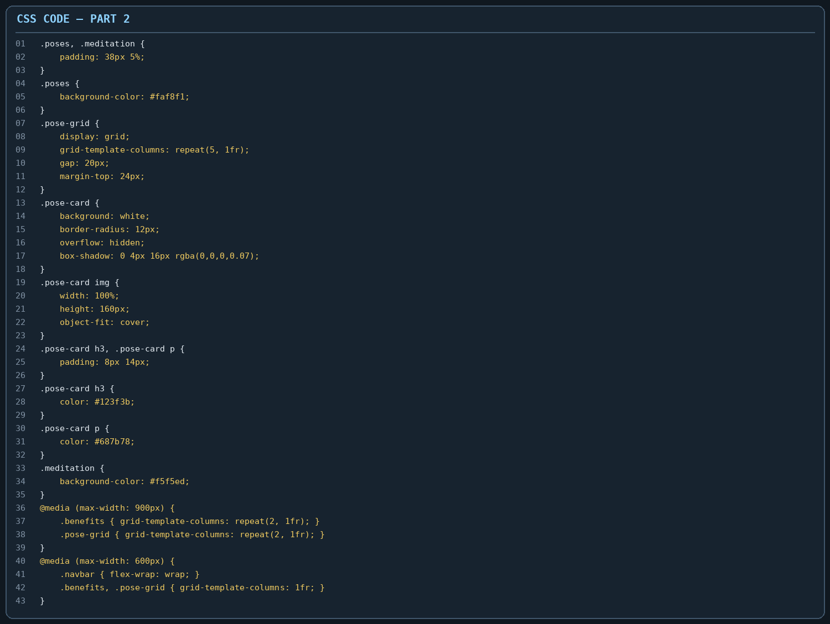
Part 2 styles the yoga pose and meditation sections. The pose-grid uses CSS Grid to arrange five pose cards in a row on wider screens. Each pose-card has a white background, rounded corners, hidden overflow and a soft shadow. The image rules set a consistent image height and use object-fit: cover to fit images neatly. The media queries adjust the number of columns on medium and small screens, helping the webpage remain readable on tablets and mobile devices.

4. Output
The screenshot shows the Yoga and Meditation webpage in a browser. The visible Key Benefits area presents five benefits in a horizontal layout. The Popular Yoga Poses section displays five cards: Tree Pose, Downward Dog, Warrior Pose, Cobra Pose and Seated Forward Bend. Each card includes a photograph, pose name and a short explanation. The beginning of the Meditation Techniques section is visible below. The soft green, cream and dark teal colours create a calm appearance suitable for a yoga and meditation website.
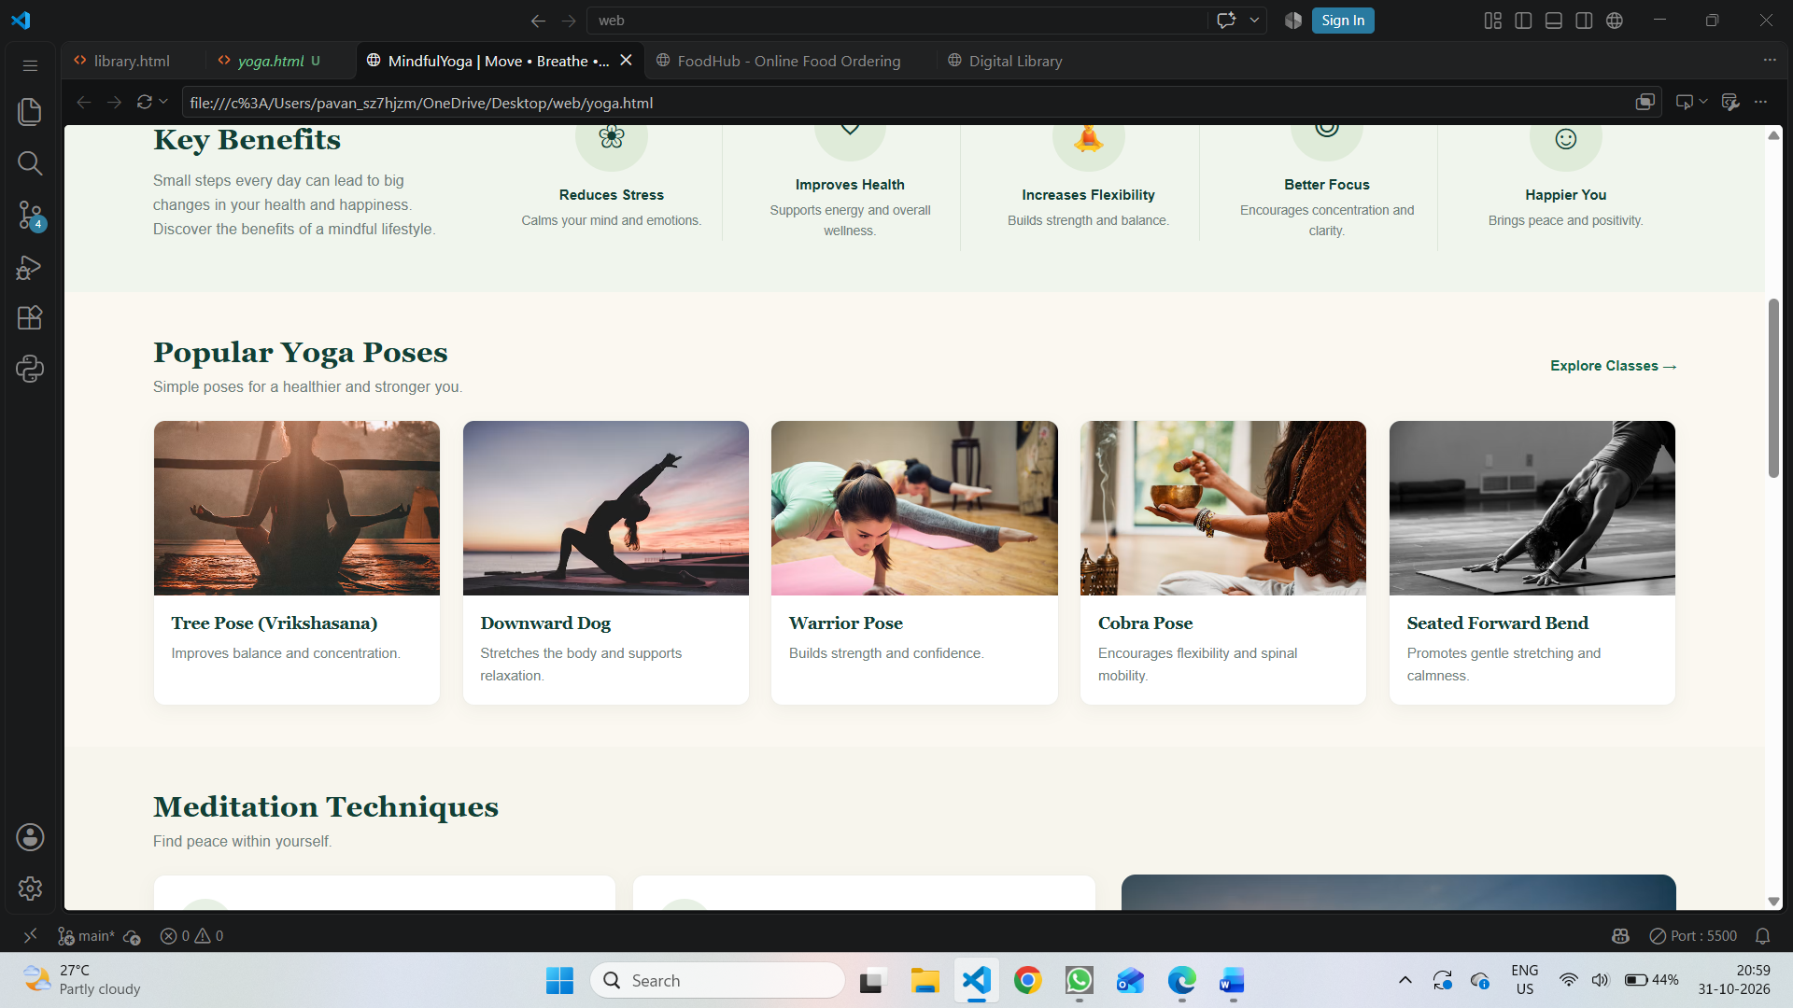
Overall, the output demonstrates how HTML structures the website and CSS creates its visual design. The page presents yoga benefits and pose information in a clean card-based layout. The responsive CSS rules help the content adjust to smaller screens. The screenshot represents the visible portion of the webpage at the time it was captured.

