AI-BASED IMAGE CAPTIONING SYSTEM
CodSoft Artificial Intelligence Internship — Task 3
Project Report
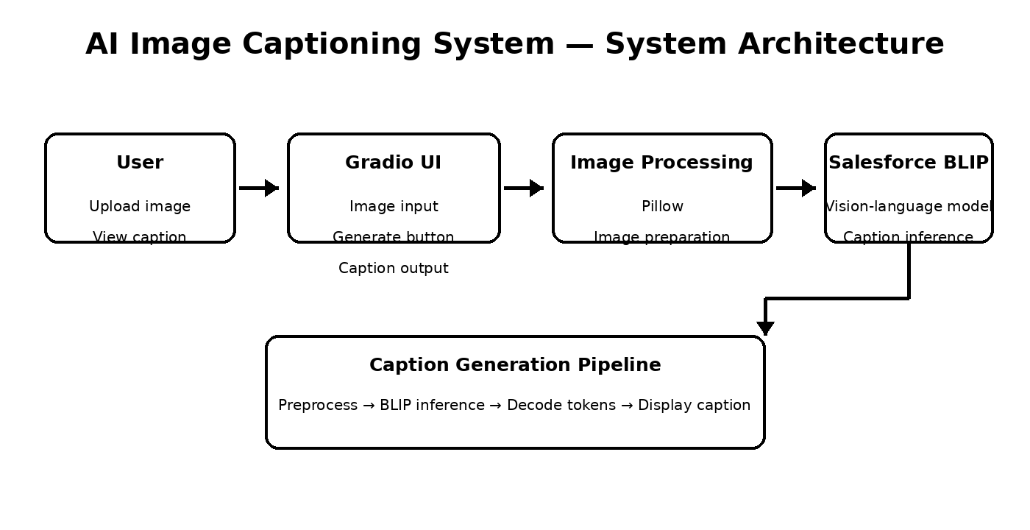

1. Introduction
Image captioning is a computer vision and natural-language processing task in which an artificial intelligence system analyzes an image and produces a textual description. This project implements a practical image captioning application using a pretrained vision-language model.

2. Objective
The objective is to build an easy-to-use application that converts visual information from an uploaded image into a meaningful natural-language caption while demonstrating image processing, deep learning inference, and an interactive web interface.

3. Problem Statement
Images contain rich visual information, but computers require machine-learning techniques to interpret that information in human-readable form. The project addresses the problem of automatically generating a concise textual description from an input image.

4. Proposed Solution
The system uses Pillow for image handling, a pretrained Salesforce BLIP image-captioning model through Hugging Face Transformers, PyTorch for inference, and Gradio for the interactive interface. The model is used for inference rather than custom training.

5. System Architecture
The architecture follows the pipeline: user input → Gradio interface → image processing → Salesforce BLIP → caption generation → result display.


6. Technologies Used
Technology | Purpose
Python 3.12 | Application development and execution
PyTorch | Deep learning inference framework
Hugging Face Transformers | Pretrained model integration
Salesforce BLIP | Image caption generation
Pillow | Image loading and preprocessing
Gradio | Interactive web user interface

7. System Requirements
Software: Python 3.12, virtual environment, PyTorch, Hugging Face Transformers, Pillow, Gradio, and a supported operating system.
Hardware: A modern CPU is sufficient for demonstration; adequate RAM and disk space are required for the pretrained model; GPU is optional and can improve speed.

8. Methodology / Workflow
1. User uploads an image through the Gradio interface.
2. The image is loaded and prepared using Pillow.
3. The processed image is passed to the pretrained Salesforce BLIP model.
4. BLIP performs vision-language inference and generates caption tokens.
5. The generated tokens are decoded into natural-language text.
6. The caption is displayed to the user.

9. AI Model — Salesforce BLIP
The application uses Salesforce BLIP through Hugging Face Transformers. BLIP is a pretrained vision-language model used here to connect visual information with natural-language caption generation. The model is loaded locally and performs inference on uploaded images.

10. Image Processing
Pillow is used to load and prepare images before model inference. The application interface supports JPG, JPEG, PNG and WEBP images.

11. Application Implementation
File / Folder | Role
app.py | Main Gradio application and UI
caption_generator.py | Model loading and caption generation
image_processor.py | Image preparation and preprocessing
utils.py | Reusable helper functionality
test_caption.py | Model/application testing
requirements.txt | Python dependencies
assets/ | Test and sample images
screenshots/ | Application screenshots
models/ | Reserved model resource directory
app.py launches the Gradio application and connects the image input to the caption-generation pipeline. The interface includes image upload, Generate Caption, caption output, and Clear functionality.

12. User Interface
The Gradio interface provides a straightforward workflow: upload an image, generate a caption, and view the AI-generated description. The UI also presents model and technology information.

13. Testing
Test | Expected Result | Observed Result
JPG/JPEG upload | Image accepted | Successful
PNG/WEBP upload | Image accepted | Supported
Generate caption | Caption displayed | Successful
Bridge/temple image | Scene described | Successful
Portrait image | Subject/background described | Successful
Model initialization | Model loads | Successful on CPU

14. Sample Results
For the bridge-and-temple test image, the model generated:
“a woman standing on a bridge in front of a temple”
For a portrait-style test image, the system generated a caption describing a woman standing in front of a white backdrop. These tests demonstrate scene and subject description capability.

15. Results
The completed system successfully loads the pretrained model, accepts image input, performs image-captioning inference on the CPU, and displays generated captions through the Gradio interface.

16. Advantages
- Simple upload-and-generate workflow.
- Uses a pretrained vision-language model instead of training from scratch.
- Runs locally through a Gradio interface.
- Supports JPG, JPEG, PNG and WEBP images.
- Produces human-readable descriptions of major visual content.

17. Limitations
- Caption quality depends on the pretrained model and image quality.
- CPU inference can be slower than GPU execution.
- The model may miss fine-grained or ambiguous scene details.
- The initial pretrained-model download requires substantial disk space and setup time.

18. Future Enhancements
- Add GPU acceleration and inference optimization.
- Allow beam-search or generation-parameter configuration.
- Support multilingual caption generation.
- Add caption history and export options.
- Deploy the application as a hosted web service.
- Evaluate caption quality on benchmark datasets using standard metrics.

19. Conclusion
The AI-Based Image Captioning System demonstrates an end-to-end application of artificial intelligence for converting visual content into natural-language descriptions. By combining Pillow, PyTorch, Hugging Face Transformers, Salesforce BLIP, and Gradio, the project demonstrates practical concepts in computer vision, vision-language models, preprocessing, inference, and AI application development.

20. References
- Hugging Face Transformers documentation and model ecosystem.
- Salesforce BLIP image-captioning pretrained model: Salesforce/blip-image-captioning-base.
- PyTorch documentation.
- Pillow documentation.
- Gradio documentation.
CodSoft Artificial Intelligence Internship — Task 3

