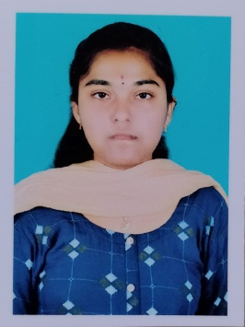**UMAMAHESWARI VENNAPUSA**

8688399357

vennapusaumamaheswari146@gmail.com

Address:1/104-A,Kammavaripalli,Chintakommadinne,

kadapa,Andhrapradesh,516002

**CAREER OBJECTIVE**

* I seek challenging opportunities where I can fully use my skills for the success of the organization

**PERSONAL DETAILS**

* Nationality: Indian
* Languages: English, Telugu
* Date of birth: 06 December 2003
* Gender: Female
* Marital Status: Single

**EDUCATIONAL QUALIFICATIONS**

* B-TECH: ANNAMACHARYA INSTITUTE OF TECHNOLOGY & SCIENCES

✓ Dept : Computer Science and Engineering

✓ CGPA: 9.01 (Y.O.P:2025)

* INTERMEDIATE:SRI CHAITANYA JUNIOR COLLEGE
* MPC
* GPA:9.75(Y.O.P:2021)
* SSC: Vikas English Medium High School
* GPA:10.0(2019)

**TECHNICAL SKILLS**

* C
* JAVA
* PYTHON
* HTML
* CSS

**STRENGTHS**

* **Communication skills**: Fluent in **English,**and **Telugu**, enabling cross-cultural collaboration.
* Good communication skills
* Ability to work 24/7 environment

**Interests&Hobbies**

* Cooking
* Listening to Music
* Meditating

**CERTIFICATES**

* Recived certificate in industrial IOT 4.0
* Recived certificate in Social Networks
* Programming languages and Machine learning certificate from Pantech E learning
* Machine learning certificate from SkillDzire
* Certificate on IoT Workshop

**REFERENCES:**

* M.SUBBARAO

HOD of computer science engineering, AITS, Rajampet

9704321971

* shaik Mohammed Rafi

Assistant Professor of Computer Science and Engineering, AITS, Rajampet

9441200741

**DECLARATION**

* I do here by declare the authenticity of all the information in my resume.

**V. Umamaheswari**