Assignment-LMS Authentication System for a Role-Based Platform
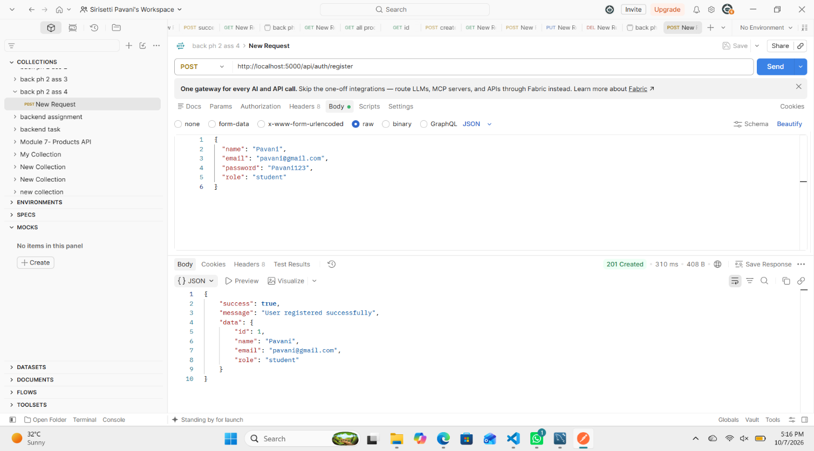

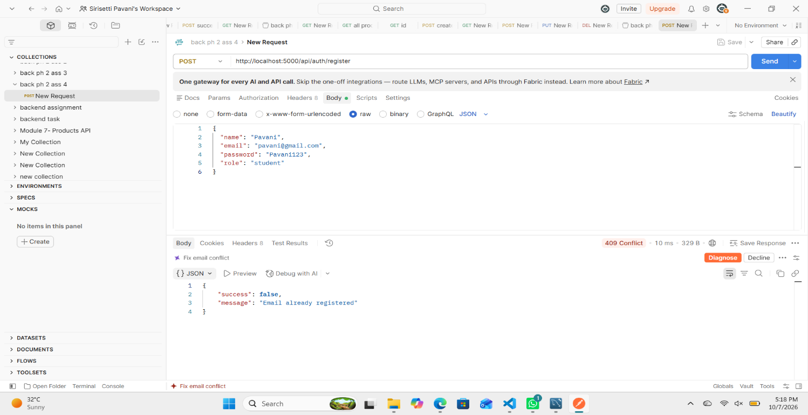
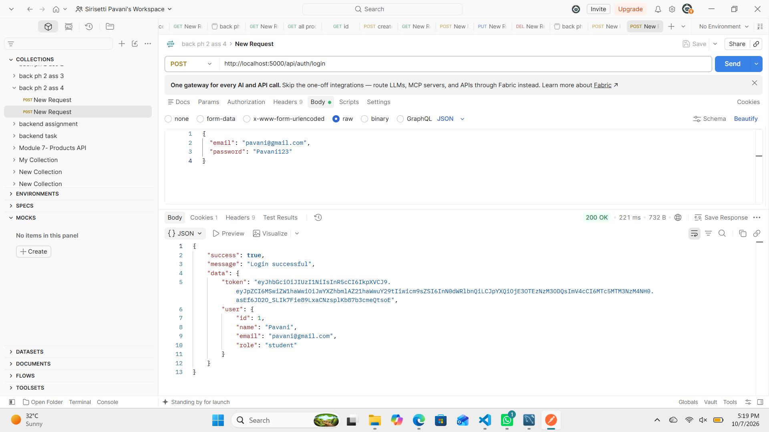

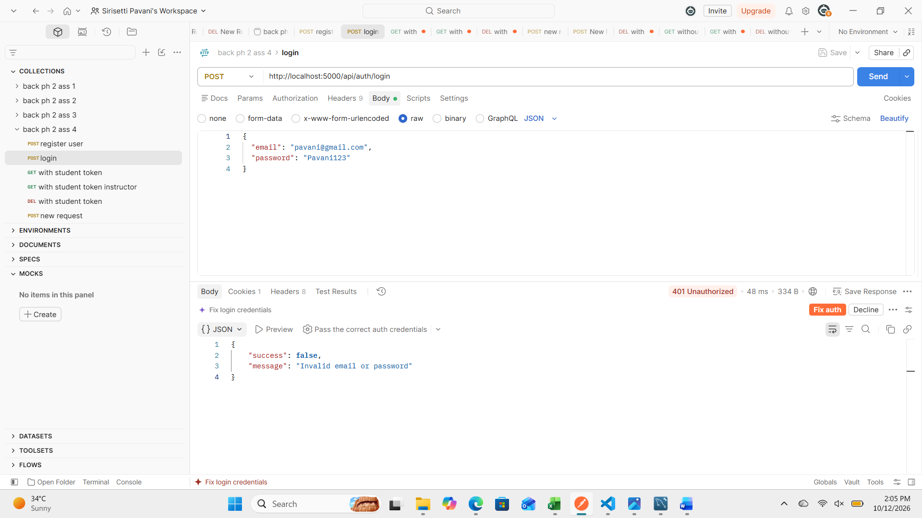
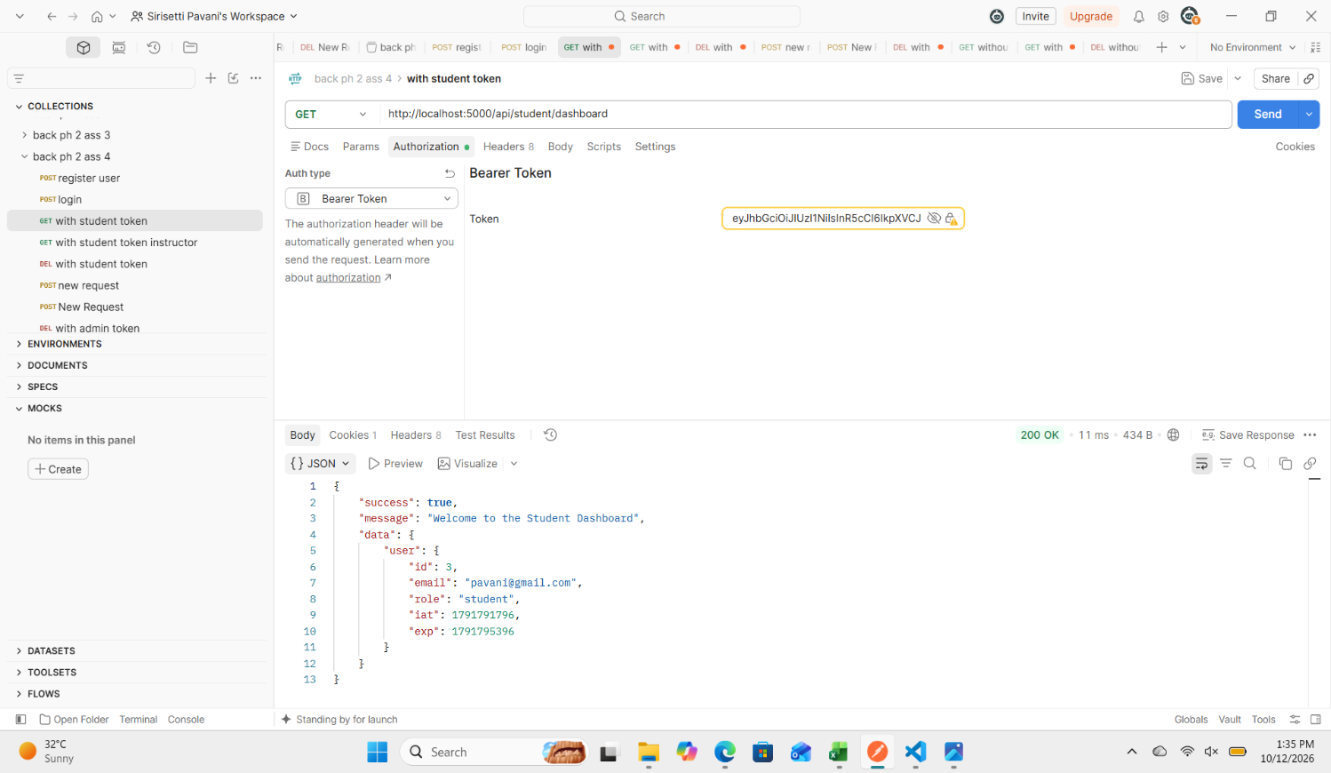

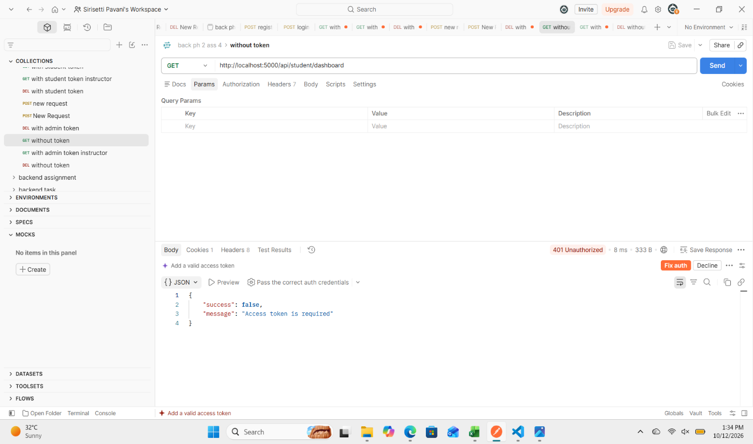
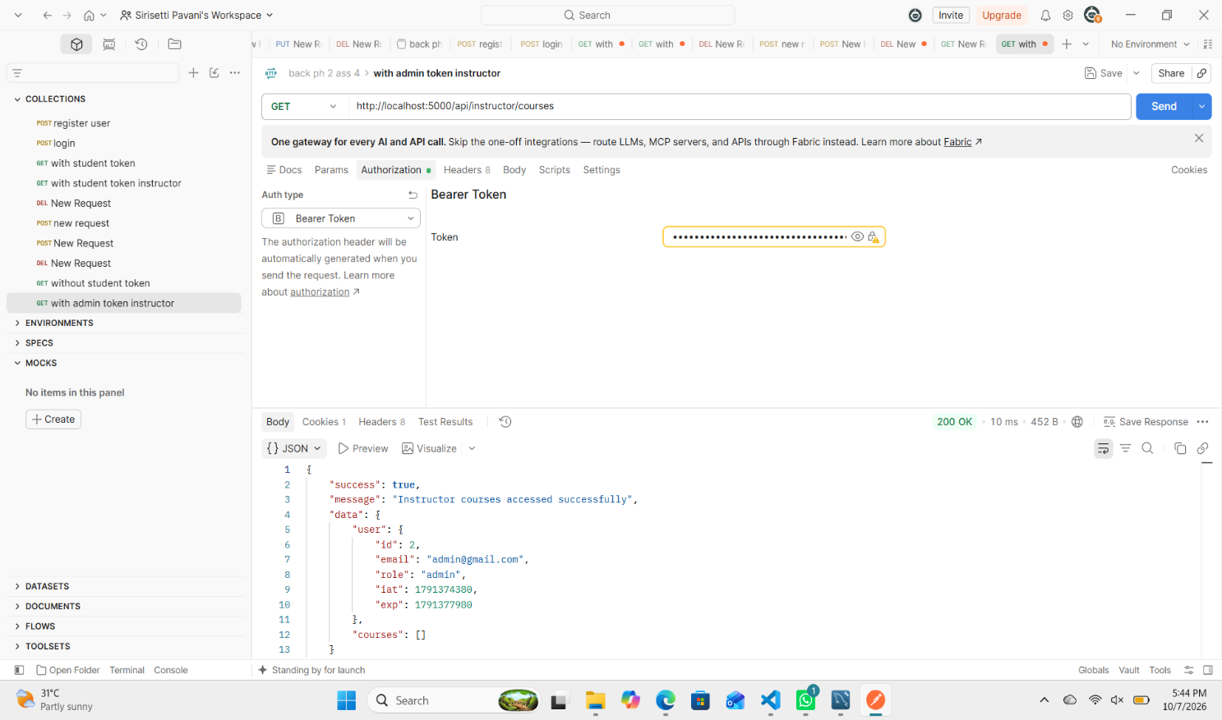

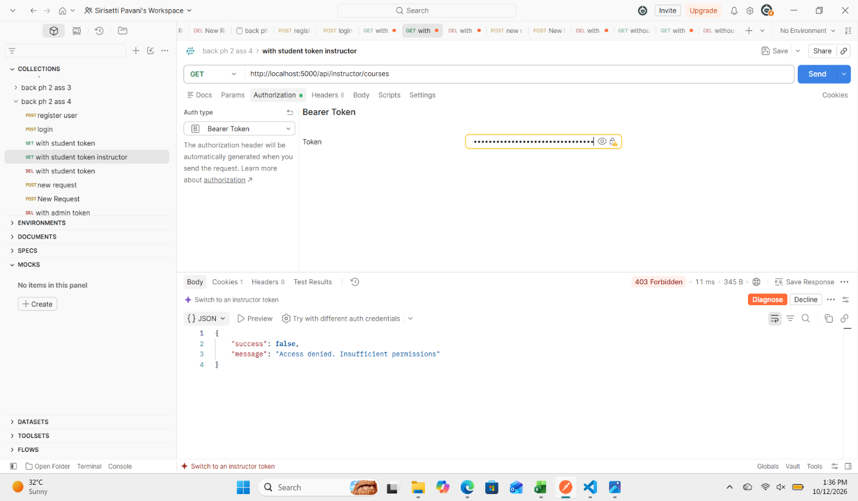
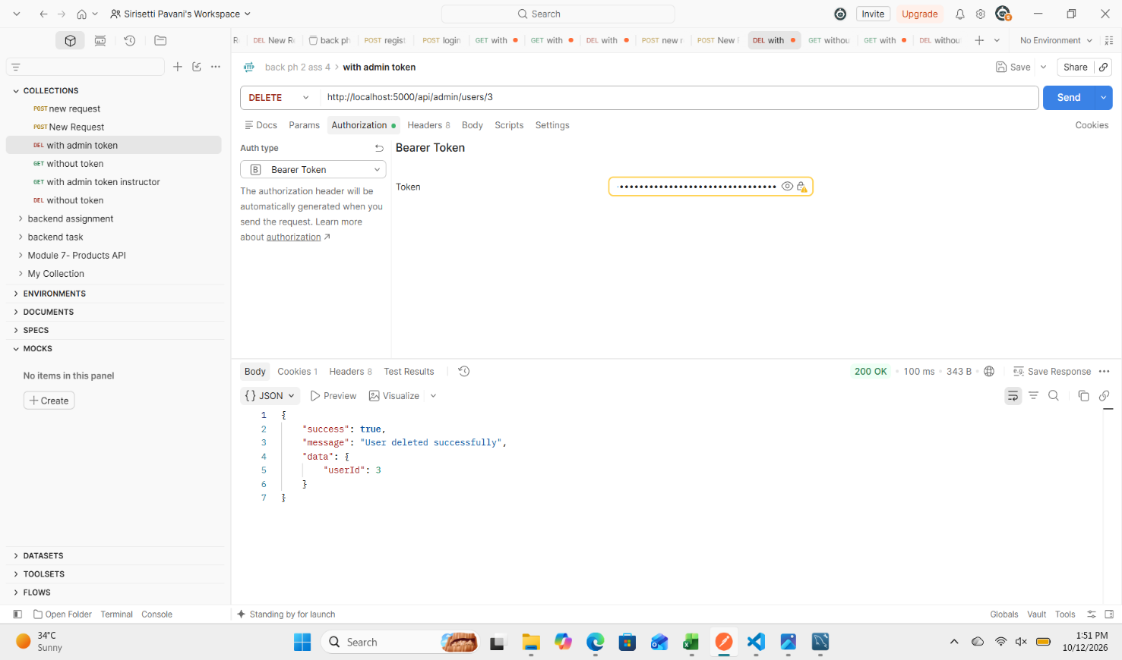

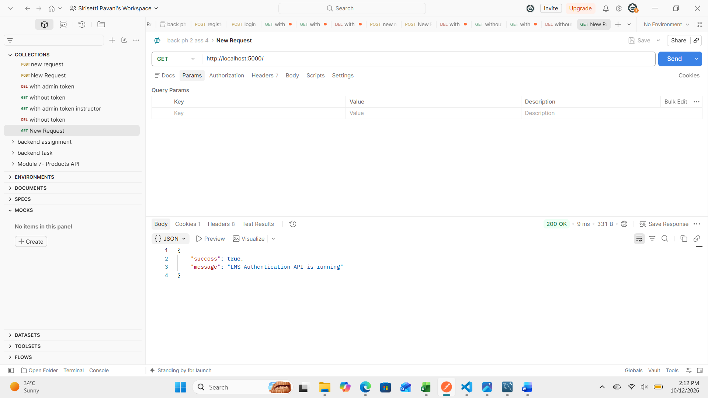

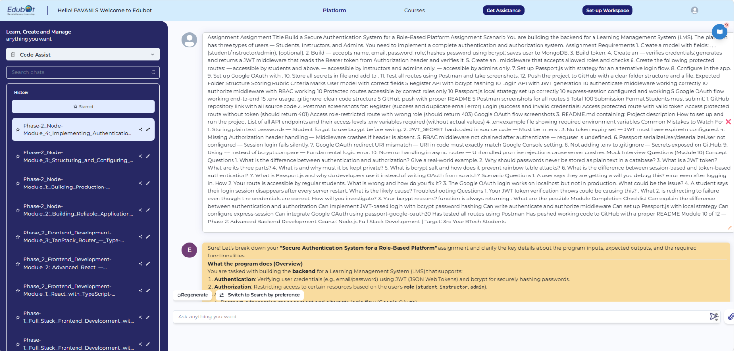

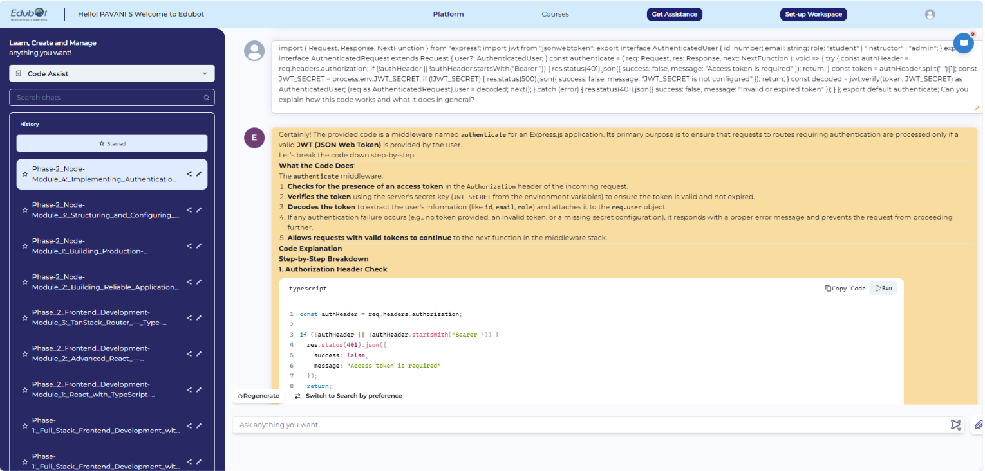

LMS Authentication System for a Role-Based Platform
1. Main Explanation
The LMS Authentication System is a backend application developed to provide secure authentication and role-based access control. It supports three types of users: Students, Instructors, and Admins. The system uses JWT tokens to authenticate users and middleware to control access to protected resources.
2. Description
This project provides REST APIs for user registration, login, and role-based access. User details are stored in a MySQL database, and passwords are hashed using bcryptjs. After successful login, a JWT token is generated. The token is verified before users can access protected routes. Postman is used to test the API functionality and responses.
3. Tools Used
- Node.js: Runs the backend application.
- TypeScript: Provides type checking and maintainable code.
- Express.js: Creates REST API endpoints.
- MySQL: Stores user information.
- bcryptjs: Hashes passwords.
- JWT: Generates and verifies authentication tokens.
- Passport.js: Supports local authentication.
- express-session: Manages user sessions.
- Postman: Tests API requests and responses.
- Visual Studio Code: Used for coding and development.
- Git and GitHub: Manage version control and project submission.
4. Features
- User registration and login.
- Secure password hashing.
- JWT-based authentication.
- Role-based authorization for students, instructors, and admins.
- Protected student dashboard and instructor courses endpoints.
- Admin-only user deletion.
- Session management using Passport.js and express-session.
- Error handling for invalid credentials, missing tokens, and insufficient permissions.
- API testing using Postman.

5. Benefits
- Protects passwords through hashing.
- Prevents unauthorized access to protected routes.
- Provides different permissions for different user roles.
- Stores user information in a structured database.
- Makes authentication reusable across multiple endpoints.
- Helps verify API functionality through testing.
6. Advantages
- Security: Uses password hashing and JWT verification.
- Modularity: Separates authentication and authorization logic.
- Maintainability: TypeScript helps identify coding errors.
- Access Control: Restricts resources according to user roles.
- Extensibility: Supports adding more routes and features in the future.
7. Disadvantages
- The application depends on MySQL database availability.
- Stolen JWT tokens may be misused before they expire or are invalidated.
- Incorrect role configuration can cause security problems.
- Sessions require proper configuration for production use.
- Additional features such as password recovery and email verification require further development.
8. Conclusion
The LMS Authentication System demonstrates secure user registration, login, JWT authentication, and role-based authorization using TypeScript, Express.js, MySQL, and Passport.js. It provides separate API endpoints for students, instructors, and admins, ensuring that access is controlled according to user roles. This project serves as a foundation for a secure LMS backend and can be improved with additional authentication and security features in the future.
Add a concise API endpoint sectionClarify the role permissions

