Online Examination System
Project Documentation
Module 5: AWT, Event Handling, JDBC, Servlet and JSP

1. Introduction
The Online Examination System is a small Java application that lets a student take a multiple-choice test on a computer. The student types a name, answers the questions, and gets the score at the end. The score is saved in a database, so it can be seen later.
The project is built with the topics from Module 5 of the syllabus. It has a desktop version made with Java AWT and a web version made with Servlets and JSP. Both versions use the same MySQL database through JDBC.

2. Application Details

2.1 Purpose
The purpose of this project is to show how a real application can be built by joining the Module 5 topics together. The application replaces a paper test with a simple on-screen test. It also marks the answers automatically, so no one has to check the papers by hand.

2.2 Features
- The student enters a name and agrees to the exam rules before starting.
- The exam time is fixed at 10 minutes, and a timer counts down on the screen.
- Only one question is shown at a time, with four options.
- The student can move between questions with the Next and Previous buttons.
- The keyboard also works: keys 1 to 4 choose an option, N goes to the next question, and P goes to the previous one.
- A confirmation box warns the student about unanswered questions before submitting.
- The exam is submitted automatically when the time is over.
- The score is calculated and saved in the database.
- A results list shows the scores of all students.
- An admin screen lets a teacher add new questions.
- A web version lets students take the same exam in a browser.

2.3 Technologies Used
Part | Technology
Language | Java (JDK 11 or newer)
Desktop screen | AWT (Abstract Window Toolkit)
Database | MySQL
Database connection | JDBC with MySQL Connector/J (Type-4 driver)
Web part | Servlet and JSP on Apache Tomcat 10 or newer

2.4 How the Application Works
Desktop version (ExamApp)
- The start screen asks for the student's name. The student ticks the rules box and clicks Start Exam.
- The program reads all questions from the database using JDBC.
- The exam screen shows the first question. The timer starts counting down from 10 minutes.
- Each time the student picks an option, the answer is stored in memory.
- When the student submits, or the time ends, the program compares each answer with the correct answer and counts the score.
- The score is saved in the result table, and the result screen shows the score and the list of past results.
Web version (ExamServlet and JSP pages)
- The student opens index.jsp and enters a name.
- ExamServlet reads the questions from the database and sends them to exam.jsp.
- The student answers all questions on one page and clicks Submit.
- ExamServlet marks the answers, saves the result, and shows result.jsp.
- results.jsp shows all saved results in a table.
The web version follows the MVC pattern. The servlet is the controller, the JSP pages are the view, and the DAO class with JDBC is the model.

2.5 Database Design
The database is named examdb and has two tables.
question table
Column | Type | Meaning
id | INT, primary key | Question number
text | VARCHAR(300) | The question
opt1 to opt4 | VARCHAR(100) | The four options
correct | INT | The correct option (1 to 4)

result table
Column | Type | Meaning
id | INT, primary key | Result number
student | VARCHAR(50) | Student name
score | INT | Marks scored
total | INT | Total questions
taken_on | TIMESTAMP | Date and time of the exam

2.6 Syllabus Topics Covered
Syllabus topic | Where it is used
AWT class hierarchy | ExamApp extends Frame (Component, Container, Window, Frame)
Label, Button, TextField, TextArea | Login, exam and admin screens
Checkbox, CheckboxGroup, Choice, List, Scrollbar | Rules box, answer options, correct-answer dropdown, results list, duration bar
Panel, ScrollPane, Dialog, MenuBar | Screen sections, scrolling exam body, message boxes, top menu
Flow, Border, Grid and Card layouts | All four are used. CardLayout switches between the screens
Events, sources and listeners | Action, Item, Adjustment and Window listeners
Mouse and keyboard events | Hover hints in the status bar, keys 1-4, N, P and Enter
JDBC, drivers and architecture | DBConnection and ExamDAO
Servlet API, life cycle, types | ExamServlet (init, doGet, doPost, destroy)
JSP, life cycle, architecture | index.jsp, exam.jsp, result.jsp, results.jsp

2.7 How to Run the Desktop Application
- Install the JDK and MySQL.
- Run schema.sql in MySQL Workbench to create the database and the sample questions.
- Put your MySQL password in DBConnection.java.
- Open a terminal in the project folder and compile the program:
mkdir out
javac -d out DBConnection.java ExamDAO.java Question.java Result.java ExamApp.java
Then run the program with the MySQL connector jar:
java -cp "out;mysql-connector-j-26.7.0.jar" gui.ExamApp

3. Source Code

3.1 schema.sql
CREATE DATABASE IF NOT EXISTS examdb;
USE examdb;

CREATE TABLE IF NOT EXISTS question (
id INT AUTO_INCREMENT PRIMARY KEY,
text VARCHAR(300) NOT NULL,
opt1 VARCHAR(100) NOT NULL,
opt2 VARCHAR(100) NOT NULL,
opt3 VARCHAR(100) NOT NULL,
opt4 VARCHAR(100) NOT NULL,
correct INT NOT NULL -- 1..4
);

CREATE TABLE IF NOT EXISTS result (
id INT AUTO_INCREMENT PRIMARY KEY,
student VARCHAR(50) NOT NULL,
score INT NOT NULL,
total INT NOT NULL,
taken_on TIMESTAMP DEFAULT CURRENT_TIMESTAMP
);

INSERT INTO question(text,opt1,opt2,opt3,opt4,correct) VALUES
('Which AWT class is the top-level window with a title bar and menu bar?','Panel','Frame','Canvas','Label',2),
('Which layout manager shows only one component at a time?','FlowLayout','GridLayout','CardLayout','BorderLayout',3),
('Which JDBC driver type is written purely in Java?','Type 1','Type 2','Type 3','Type 4',4),
('Which method is called only once in a servlet life cycle?','doGet()','service()','init()','doPost()',3),
('A JSP page is translated into a:','Applet','Servlet','Frame','Class file only',2),
('Which interface handles mouse button clicks in AWT?','KeyListener','MouseListener','ItemListener','TextListener',2);

3.2 Question.java
package db;

public class Question {
public int id, correct; // correct = 1..4
public String text;
public String[] options = new String[4];

public Question(int id, String text, String o1, String o2, String o3, String o4, int correct) {
this.id = id; this.text = text; this.correct = correct;
options[0] = o1; options[1] = o2; options[2] = o3; options[3] = o4;
}
public int getId() { return id; }
public String getText() { return text; }
public String[] getOptions() { return options; }
public int getCorrect() { return correct; }
}

3.3 Result.java
package db;

public class Result {
public String student, takenOn;
public int score, total;

public Result(String student, int score, int total, String takenOn) {
this.student = student; this.score = score; this.total = total; this.takenOn = takenOn;
}
public String getStudent() { return student; }
public int getScore() { return score; }
public int getTotal() { return total; }
public String getTakenOn() { return takenOn; }

@Override public String toString() {
return student + " - " + score + "/" + total + " (" + takenOn + ")";
}
}

3.4 DBConnection.java
package db;

import java.sql.Connection;
import java.sql.DriverManager;
import java.sql.SQLException;

/** JDBC steps: load driver -> get Connection -> create Statement -> execute -> process ResultSet -> close. */
public class DBConnection {
private static final String URL = "jdbc:mysql://localhost:3306/examdb";
private static final String USER = "root";
private static final String PASS = "your_password"; // <-- change this

public static Connection getConnection() throws SQLException {
try {
Class.forName("com.mysql.cj.jdbc.Driver"); // Type-4 (pure Java) driver
} catch (ClassNotFoundException e) {
throw new SQLException("MySQL driver not found. Add mysql-connector-j.jar to the classpath.", e);
}
return DriverManager.getConnection(URL, USER, PASS);
}
}

3.5 ExamDAO.java
package db;

import java.sql.*;
import java.util.ArrayList;
import java.util.List;

/** All SQL lives here; shared by the AWT client and the Servlet/JSP web client. */
public class ExamDAO {

public List<Question> getQuestions() throws SQLException {
List<Question> list = new ArrayList<>();
try (Connection con = DBConnection.getConnection();
Statement st = con.createStatement();
ResultSet rs = st.executeQuery("SELECT * FROM question ORDER BY id")) {
while (rs.next()) {
list.add(new Question(rs.getInt("id"), rs.getString("text"),
rs.getString("opt1"), rs.getString("opt2"),
rs.getString("opt3"), rs.getString("opt4"), rs.getInt("correct")));
}
}
return list;
}

public void addQuestion(Question q) throws SQLException {
String sql = "INSERT INTO question(text,opt1,opt2,opt3,opt4,correct) VALUES(?,?,?,?,?,?)";
try (Connection con = DBConnection.getConnection();
PreparedStatement ps = con.prepareStatement(sql)) {
ps.setString(1, q.text);
for (int i = 0; i < 4; i++) ps.setString(i + 2, q.options[i]);
ps.setInt(6, q.correct);
ps.executeUpdate();
}
}

public void saveResult(String student, int score, int total) throws SQLException {
try (Connection con = DBConnection.getConnection();
PreparedStatement ps = con.prepareStatement(
"INSERT INTO result(student,score,total) VALUES(?,?,?)")) {
ps.setString(1, student);
ps.setInt(2, score);
ps.setInt(3, total);
ps.executeUpdate();
}
}

public List<Result> getResults() throws SQLException {
List<Result> list = new ArrayList<>();
try (Connection con = DBConnection.getConnection();
Statement st = con.createStatement();
ResultSet rs = st.executeQuery("SELECT * FROM result ORDER BY id DESC")) {
while (rs.next()) {
list.add(new Result(rs.getString("student"), rs.getInt("score"),
rs.getInt("total"), rs.getString("taken_on")));
}
}
return list;
}
}

3.6 ExamApp.java (desktop application)
package gui;

import db.ExamDAO;
import db.Question;
import db.Result;

import java.awt.*;
import java.awt.event.*;
import java.util.List;
import java.util.Timer;
import java.util.TimerTask;

/**
* AWT desktop exam client.
* Components : Frame, MenuBar/Menu/MenuItem, Label, Button, TextField, TextArea, Checkbox,
* CheckboxGroup, Choice, List, Scrollbar, Panel, ScrollPane, Dialog.
* Layouts : CardLayout (4 screens), BorderLayout, GridLayout, FlowLayout.
* Events : ActionListener, ItemListener, AdjustmentListener, MouseListener, KeyListener,
* WindowListener.
*/
public class ExamApp extends Frame
implements ActionListener, ItemListener, AdjustmentListener, MouseListener, KeyListener {

private final ExamDAO dao = new ExamDAO();
private final CardLayout cards = new CardLayout();
private final Panel cardPanel = new Panel(cards);
private final Label status = new Label("Welcome");

// ---- login card ----
private final TextField tfStudent = new TextField(20);
private final Scrollbar sbMinutes = new Scrollbar(Scrollbar.HORIZONTAL, 10, 1, 1, 31); // 1..30
private final Label lblMinutes = new Label("Duration: 10 minutes (fixed)");
private final Checkbox cbRules = new Checkbox("I agree to the exam rules");
private final Button btnStart = new Button("Start Exam");

// ---- exam card ----
private final Label lblTimer = new Label("Time left: --:--", Label.RIGHT);
private final Label lblProgress = new Label("Question 0 of 0");
private final TextArea taQuestion = new TextArea("", 4, 40, TextArea.SCROLLBARS_VERTICAL_ONLY);
private final CheckboxGroup group = new CheckboxGroup();
private final Checkbox[] opts = new Checkbox[4];
private final Button btnPrev = new Button("< Previous");
private final Button btnNext = new Button("Next >");
private final Button btnSubmit = new Button("Submit Exam");

// ---- result card ----
private final Label lblScore = new Label("", Label.CENTER);
private final java.awt.List listResults = new java.awt.List(8);
private final Button btnHome = new Button("Back to Start");

// ---- admin card ----
private final TextArea taNewQ = new TextArea(3, 30);
private final TextField[] tfOpt = new TextField[4];
private final Choice chCorrect = new Choice();
private final Button btnAddQ = new Button("Add Question");

// ---- exam state ----
private List<Question> questions;
private int[] answers;
private int idx;
private String student;
private int secondsLeft;
private Timer timer;

public ExamApp() {
super("Online Examination System");
setLayout(new BorderLayout(5, 5));
setMenuBar(buildMenu());

Label title = new Label("Online Examination System", Label.CENTER);
title.setFont(new Font("SansSerif", Font.BOLD, 18));
add(title, BorderLayout.NORTH);

cardPanel.add(buildLoginCard(), "login");
cardPanel.add(buildExamCard(), "exam");
cardPanel.add(buildResultCard(), "result");
cardPanel.add(buildAdminCard(), "admin");
add(cardPanel, BorderLayout.CENTER);
add(status, BorderLayout.SOUTH);

for (Button b : new Button[]{btnStart, btnPrev, btnNext, btnSubmit, btnHome, btnAddQ})
b.addActionListener(this);
for (Checkbox c : opts) { c.addItemListener(this); c.addMouseListener(this); c.addKeyListener(this); }
sbMinutes.addAdjustmentListener(this);
btnStart.addMouseListener(this);
btnSubmit.addMouseListener(this);
addKeyListener(this);
tfStudent.addKeyListener(this);

addWindowListener(new WindowAdapter() {
@Override public void windowClosing(WindowEvent e) { stopTimer(); dispose(); System.exit(0); }
});

sbMinutes.setEnabled(false);
applyTheme();
setSize(560, 460);
setLocationRelativeTo(null);
setVisible(true);
}

// =============== UI builders ===============
private MenuBar buildMenu() {
MenuBar mb = new MenuBar();
Menu exam = new Menu("Exam");
Menu admin = new Menu("Admin");
Menu help = new Menu("Help");
exam.add(new MenuItem("Start Page"));
exam.add(new MenuItem("View Results"));
exam.addSeparator();
exam.add(new MenuItem("Exit"));
admin.add(new MenuItem("Add Question"));
help.add(new MenuItem("About"));
for (Menu m : new Menu[]{exam, admin, help}) {
for (int i = 0; i < m.getItemCount(); i++)
if (!(m.getItem(i).getLabel().equals("-"))) m.getItem(i).addActionListener(this);
mb.add(m);
}
return mb;
}

private Panel buildLoginCard() {
Panel grid = new Panel(new GridLayout(0, 2, 8, 14));
grid.add(new Label("Student name:")); grid.add(tfStudent);
grid.add(lblMinutes); grid.add(sbMinutes);
grid.add(new Label("Rules:")); grid.add(cbRules);

Panel flow = new Panel(new FlowLayout());
flow.add(btnStart);

Panel p = new Panel(new BorderLayout(10, 20));
p.add(new Label("Enter your details to begin", Label.CENTER), BorderLayout.NORTH);
sbMinutes.setPreferredSize(new Dimension(200, 18));
Panel wrap = new Panel(new FlowLayout(FlowLayout.CENTER, 0, 20));
wrap.add(grid);
p.add(wrap, BorderLayout.CENTER);
p.add(flow, BorderLayout.SOUTH);
return p;
}

private Panel buildExamCard() {
taQuestion.setEditable(false);
Panel top = new Panel(new GridLayout(1, 2));
top.add(lblProgress);
top.add(lblTimer);

Panel optPanel = new Panel(new GridLayout(4, 1));
for (int i = 0; i < 4; i++) {
opts[i] = new Checkbox("", group, false);
optPanel.add(opts[i]);
}
ScrollPane sp = new ScrollPane(); // long questions/options can scroll
Panel body = new Panel(new BorderLayout(5, 5));
body.add(taQuestion, BorderLayout.NORTH);
body.add(optPanel, BorderLayout.CENTER);
sp.add(body);

Panel nav = new Panel(new FlowLayout());
nav.add(btnPrev); nav.add(btnNext); nav.add(btnSubmit);

Panel p = new Panel(new BorderLayout(5, 5));
p.add(top, BorderLayout.NORTH);
p.add(sp, BorderLayout.CENTER);
p.add(nav, BorderLayout.SOUTH);
return p;
}

private Panel buildResultCard() {
lblScore.setFont(new Font("SansSerif", Font.BOLD, 16));
Panel p = new Panel(new BorderLayout(5, 5));
p.add(lblScore, BorderLayout.NORTH);
p.add(listResults, BorderLayout.CENTER);
Panel f = new Panel(new FlowLayout());
f.add(btnHome);
p.add(f, BorderLayout.SOUTH);
return p;
}

private Panel buildAdminCard() {
for (int i = 1; i <= 4; i++) { tfOpt[i - 1] = new TextField(25); chCorrect.add("Option " + i); }
Panel grid = new Panel(new GridLayout(0, 2, 6, 8));
grid.add(new Label("Question:")); grid.add(taNewQ);
for (int i = 0; i < 4; i++) { grid.add(new Label("Option " + (i + 1) + ":")); grid.add(tfOpt[i]); }
grid.add(new Label("Correct answer:")); grid.add(chCorrect);
Panel f = new Panel(new FlowLayout());
f.add(btnAddQ);
Panel p = new Panel(new BorderLayout(5, 5));
p.add(new Label("Add a new question (admin)", Label.CENTER), BorderLayout.NORTH);
p.add(grid, BorderLayout.CENTER);
p.add(f, BorderLayout.SOUTH);
return p;
}

// =============== Event handling ===============
@Override public void actionPerformed(ActionEvent e) {
Object src = e.getSource();
String cmd = e.getActionCommand();

if (src == btnStart) startExam();
else if (src == btnNext) { if (idx < questions.size() - 1) showQuestion(idx + 1); }
else if (src == btnPrev) { if (idx > 0) showQuestion(idx - 1); }
else if (src == btnSubmit) confirmSubmit();
else if (src == btnHome) cards.show(cardPanel, "login");
else if (src == btnAddQ) addQuestion();
else if ("Start Page".equals(cmd)) cards.show(cardPanel, "login");
else if ("View Results".equals(cmd)) { loadResults(); cards.show(cardPanel, "result"); }
else if ("Add Question".equals(cmd)) cards.show(cardPanel, "admin");
else if ("About".equals(cmd)) message("About", "Online Examination System - AWT + JDBC");
else if ("Exit".equals(cmd)) { stopTimer(); dispose(); System.exit(0); }
}

/** Fired when a radio option is chosen: remember the answer. */
@Override public void itemStateChanged(ItemEvent e) {
if (questions == null || e.getStateChange() != ItemEvent.SELECTED) return;
for (int i = 0; i < 4; i++) if (e.getSource() == opts[i]) answers[idx] = i + 1;
status.setText("Answer saved for question " + (idx + 1));
}

@Override public void adjustmentValueChanged(AdjustmentEvent e) {
lblMinutes.setText("Duration: " + sbMinutes.getValue() + " minutes");
}

// Mouse events
@Override public void mouseEntered(MouseEvent e) {
Object s = e.getSource();
if (s == btnStart) status.setText("Fill in your name and accept the rules to start");
else if (s == btnSubmit) status.setText("Submit ends the exam and shows your score");
else status.setText("Click to choose this option (or press 1-4)");
}
@Override public void mouseExited(MouseEvent e) { status.setText("Ready"); }
@Override public void mouseClicked(MouseEvent e) { }
@Override public void mousePressed(MouseEvent e) { }
@Override public void mouseReleased(MouseEvent e) { }

// Keyboard events: 1-4 pick an option, N / P navigate, Enter starts exam from the name box
@Override public void keyPressed(KeyEvent e) {
if (e.getSource() == tfStudent) {
if (e.getKeyCode() == KeyEvent.VK_ENTER) startExam();
return;
}
if (questions == null) return;
int k = e.getKeyCode();
if (k >= KeyEvent.VK_1 && k <= KeyEvent.VK_4) {
opts[k - KeyEvent.VK_1].setState(true);
answers[idx] = k - KeyEvent.VK_1 + 1;
} else if (k == KeyEvent.VK_N && idx < questions.size() - 1) showQuestion(idx + 1);
else if (k == KeyEvent.VK_P && idx > 0) showQuestion(idx - 1);
}
@Override public void keyTyped(KeyEvent e) { }
@Override public void keyReleased(KeyEvent e) { }

// =============== Actions ===============
private void startExam() {
student = tfStudent.getText().trim();
if (student.isEmpty()) { message("Error", "Please enter your name"); return; }
if (!cbRules.getState()) { message("Error", "You must agree to the rules"); return; }
try {
questions = dao.getQuestions();
} catch (Exception ex) { message("Database error", String.valueOf(ex.getMessage())); return; }
if (questions.isEmpty()) { message("Info", "No questions in the database"); return; }

answers = new int[questions.size()]; // 0 = unanswered
secondsLeft = sbMinutes.getValue() * 60;
cards.show(cardPanel, "exam");
showQuestion(0);
startTimer();
requestFocus();
}

private void showQuestion(int i) {
idx = i;
Question q = questions.get(i);
lblProgress.setText("Question " + (i + 1) + " of " + questions.size());
taQuestion.setText(q.text);
for (int k = 0; k < 4; k++) opts[k].setLabel((k + 1) + ". " + q.options[k]);
if (answers[i] == 0) group.setSelectedCheckbox(null);
else group.setSelectedCheckbox(opts[answers[i] - 1]);
btnPrev.setEnabled(i > 0);
btnNext.setEnabled(i < questions.size() - 1);
}

private void startTimer() {
stopTimer();
timer = new Timer(true);
timer.scheduleAtFixedRate(new TimerTask() {
@Override public void run() {
secondsLeft--;
EventQueue.invokeLater(() -> {
lblTimer.setText(String.format("Time left: %02d:%02d", secondsLeft / 60, secondsLeft % 60));
if (secondsLeft <= 0) finishExam();
});
}
}, 0, 1000);
}

private void stopTimer() { if (timer != null) { timer.cancel(); timer = null; } }

/** Modal confirm dialog before submitting. */
private void confirmSubmit() {
int unanswered = 0;
for (int a : answers) if (a == 0) unanswered++;
final Dialog d = new Dialog(this, "Confirm Submit", true);
d.setLayout(new BorderLayout(10, 10));
d.add(new Label("You have " + unanswered + " unanswered question(s). Submit now?", Label.CENTER),
BorderLayout.CENTER);
Panel p = new Panel(new FlowLayout());
Button yes = new Button("Yes, submit");
Button no = new Button("Go back");
yes.addActionListener(ev -> { d.dispose(); finishExam(); });
no.addActionListener(ev -> d.dispose());
p.add(yes); p.add(no);
d.add(p, BorderLayout.SOUTH);
d.addWindowListener(new WindowAdapter() {
@Override public void windowClosing(WindowEvent e) { d.dispose(); }
});
d.setSize(380, 130);
d.setLocationRelativeTo(this);
d.setVisible(true);
}

private void finishExam() {
if (timer == null) return; // already finished
stopTimer();
int score = 0;
for (int i = 0; i < questions.size(); i++)
if (answers[i] == questions.get(i).correct) score++;
try {
dao.saveResult(student, score, questions.size());
} catch (Exception ex) { message("Database error", String.valueOf(ex.getMessage())); }
lblScore.setText(student + ", your score: " + score + " / " + questions.size());
loadResults();
cards.show(cardPanel, "result");
}

private void loadResults() {
try {
listResults.removeAll();
for (Result r : dao.getResults()) listResults.add(r.toString());
} catch (Exception ex) { message("Database error", String.valueOf(ex.getMessage())); }
}

private void addQuestion() {
String text = taNewQ.getText().trim();
for (TextField t : tfOpt) if (t.getText().trim().isEmpty()) { message("Error", "Fill all four options"); return; }
if (text.isEmpty()) { message("Error", "Question text is required"); return; }
try {
dao.addQuestion(new Question(0, text, tfOpt[0].getText().trim(), tfOpt[1].getText().trim(),
tfOpt[2].getText().trim(), tfOpt[3].getText().trim(), chCorrect.getSelectedIndex() + 1));
taNewQ.setText("");
for (TextField t : tfOpt) t.setText("");
status.setText("Question added");
} catch (Exception ex) { message("Database error", String.valueOf(ex.getMessage())); }
}

private void message(String title, String msg) {
final Dialog d = new Dialog(this, title, true);
d.setLayout(new BorderLayout(10, 10));
d.add(new Label(msg, Label.CENTER), BorderLayout.CENTER);
Button ok = new Button("OK");
ok.addActionListener(ev -> d.dispose());
Panel p = new Panel();
p.add(ok);
d.add(p, BorderLayout.SOUTH);
d.addWindowListener(new WindowAdapter() {
@Override public void windowClosing(WindowEvent e) { d.dispose(); }
});
d.setSize(380, 130);
d.setLocationRelativeTo(this);
d.setVisible(true);
}

// =============== Theme (soft green, light mode) ===============
private void applyTheme() {
Color bg = new Color(240, 249, 242); // very light green background
Color primary = new Color(34, 139, 94); // green buttons and headings
Font normal = new Font("SansSerif", Font.PLAIN, 14);

setBackground(bg);
paintAll(this, bg, normal);

for (Button b : new Button[]{btnStart, btnPrev, btnNext, btnSubmit, btnHome, btnAddQ}) {
b.setBackground(primary);
b.setForeground(Color.WHITE);
b.setFont(new Font("SansSerif", Font.BOLD, 14));
}
lblTimer.setForeground(new Color(200, 50, 40));
lblScore.setForeground(primary);
lblProgress.setForeground(primary);
status.setForeground(Color.DARK_GRAY);
}

private void paintAll(Container c, Color bg, Font f) {
for (Component k : c.getComponents()) {
if (k instanceof Panel || k instanceof Label || k instanceof Checkbox) k.setBackground(bg);
Font cur = k.getFont();
if (!(k instanceof Button) && (cur == null || !cur.isBold())) k.setFont(f);
if (k instanceof Container) paintAll((Container) k, bg, f);
}
}

public static void main(String[] args) { new ExamApp(); }
}

3.7 ExamServlet.java (web controller)
package web;

import db.ExamDAO;
import db.Question;
import jakarta.servlet.ServletException;
import jakarta.servlet.annotation.WebServlet;
import jakarta.servlet.http.*;

import java.io.IOException;
import java.util.List;

/**
* Controller servlet (HttpServlet = protocol-specific servlet; GenericServlet is the
* protocol-independent parent).
* Life cycle: init() once -> service() -> doGet()/doPost() per request -> destroy() once.
* Uses jakarta.* (Tomcat 10+). For Tomcat 9 or older, change to javax.*
*
* GET /exam -> show login page (index.jsp is the welcome page)
* POST /exam?action=start -> store name in session, load questions, forward to exam.jsp
* POST /exam?action=submit-> evaluate answers, save result, forward to result.jsp
* GET /exam?action=results -> list previous results
*/
@WebServlet("/exam")
public class ExamServlet extends HttpServlet {
private ExamDAO dao;

@Override public void init() throws ServletException {
dao = new ExamDAO();
log("ExamServlet initialised");
}

@Override protected void doGet(HttpServletRequest req, HttpServletResponse resp)
throws ServletException, IOException {
try {
if ("results".equals(req.getParameter("action"))) {
req.setAttribute("results", dao.getResults());
req.getRequestDispatcher("/results.jsp").forward(req, resp);
} else {
resp.sendRedirect("index.jsp");
}
} catch (Exception e) { throw new ServletException(e); }
}

@Override protected void doPost(HttpServletRequest req, HttpServletResponse resp)
throws ServletException, IOException {
try {
HttpSession session = req.getSession();
String action = req.getParameter("action");

if ("start".equals(action)) {
session.setAttribute("student", req.getParameter("student"));
req.setAttribute("questions", dao.getQuestions());
req.getRequestDispatcher("/exam.jsp").forward(req, resp);

} else if ("submit".equals(action)) {
List<Question> qs = dao.getQuestions();
int score = 0;
for (Question q : qs) {
String a = req.getParameter("q" + q.getId()); // radio group name: q<id>
if (a != null && Integer.parseInt(a) == q.getCorrect()) score++;
}
String student = (String) session.getAttribute("student");
dao.saveResult(student, score, qs.size());
req.setAttribute("score", score);
req.setAttribute("total", qs.size());
req.getRequestDispatcher("/result.jsp").forward(req, resp);
} else {
resp.sendRedirect("index.jsp");
}
} catch (Exception e) { throw new ServletException(e); }
}

@Override public void destroy() { log("ExamServlet destroyed"); }
}

3.8 index.jsp
<%@ page contentType="text/html; charset=UTF-8" %>
<!DOCTYPE html>
<html><head><title>Online Examination</title><link rel="stylesheet" href="style.css"></head>
<body>
<h2>Online Examination System</h2>
<form method="post" action="exam">
<input type="hidden" name="action" value="start">
<p><label>Student name: <input name="student" required></label></p>
<p><button type="submit">Start Exam</button></p>
</form>
<p><a href="exam?action=results">View previous results</a></p>
<%-- JSP implicit object: 'application' (ServletContext), 'session', 'request', 'out' ... --%>
<p>Server time: <%= new java.util.Date() %></p>
</body></html>

3.9 exam.jsp
<%@ page contentType="text/html; charset=UTF-8" import="java.util.*, db.Question" %>
<!DOCTYPE html>
<html><head><title>Exam</title><link rel="stylesheet" href="style.css"></head>
<body>
<h2>Exam - <%= session.getAttribute("student") %></h2>
<form method="post" action="exam">
<input type="hidden" name="action" value="submit">
<%
List<Question> questions = (List<Question>) request.getAttribute("questions");
int n = 1;
if (questions != null) for (Question q : questions) { // scriptlet
%>
<fieldset>
<legend>Q<%= n++ %>. <%= q.getText() %></legend>
<% for (int i = 0; i < 4; i++) { %>
<label><input type="radio" name="q<%= q.getId() %>" value="<%= i + 1 %>">
<%= q.getOptions()[i] %></label><br>
<% } %>
</fieldset>
<% } %>
<button type="submit">Submit Exam</button>
</form>
</body></html>

3.10 result.jsp
<%@ page contentType="text/html; charset=UTF-8" %>
<!DOCTYPE html>
<html><head><title>Result</title><link rel="stylesheet" href="style.css"></head>
<body>
<h2>Result</h2>
<p><b><%= session.getAttribute("student") %></b>, you scored
<b><%= request.getAttribute("score") %> / <%= request.getAttribute("total") %></b>.</p>
<p><a href="exam?action=results">All results</a> | <a href="index.jsp">Home</a></p>
</body></html>

3.11 results.jsp
<%@ page contentType="text/html; charset=UTF-8" import="java.util.*, db.Result" %>
<!DOCTYPE html>
<html><head><title>All Results</title><link rel="stylesheet" href="style.css"></head>
<body>
<h2>All Results</h2>
<table>
<tr><th>Student</th><th>Score</th><th>Date</th></tr>
<% List<Result> list = (List<Result>) request.getAttribute("results");
if (list != null) for (Result r : list) { %>
<tr><td><%= r.getStudent() %></td><td><%= r.getScore() %> / <%= r.getTotal() %></td>
<td><%= r.getTakenOn() %></td></tr>
<% } %>
</table>
<p><a href="index.jsp">Home</a></p>
</body></html>

3.12 style.css
body{font-family:sans-serif;max-width:720px;margin:30px auto;padding:0 12px;background:#f0f9f2;color:#1d2b24}
h2{color:#228b5e}
fieldset{margin-bottom:14px;border:1px solid #9fd3b5;background:#fff;border-radius:6px}
table{border-collapse:collapse;width:100%;background:#fff} th,td{border:1px solid #9fd3b5;padding:6px;text-align:left}
th{background:#d6efdf}
button{padding:7px 16px;background:#228b5e;color:#fff;border:0;border-radius:4px;cursor:pointer}
button:hover{background:#1b724d}
a{color:#228b5e}

4. Output Screenshots
The following screenshots show the desktop application in use.

4.1 Start screen
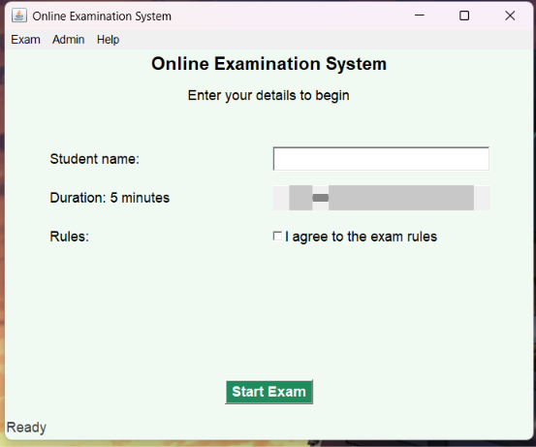
Start screen showing the five-minute duration, name field, and rules agreement.

4.2 Exam screen
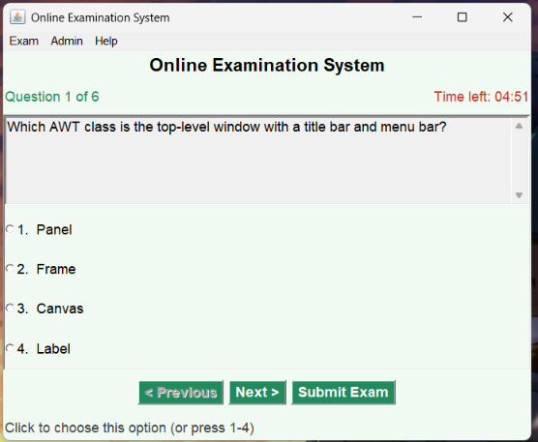
Exam screen showing question 1 of 6 and the remaining time.
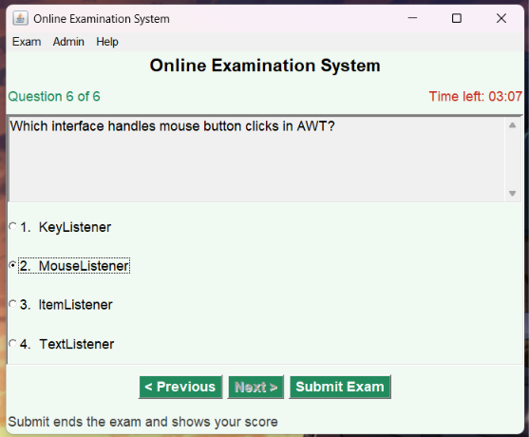
Exam screen showing question 6 of 6 and a selected answer.

4.3 Submit confirmation
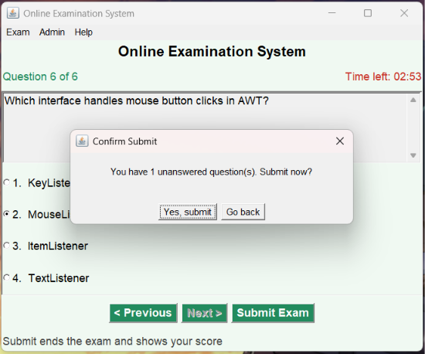
Submit confirmation showing one unanswered question.

4.4 Result screen
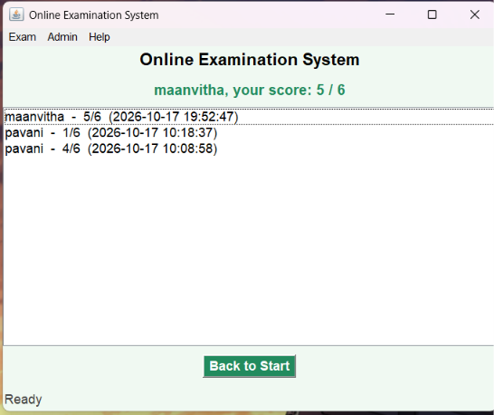
Result screen showing a score of 5 out of 6 and previous results.

4.5 Admin screen
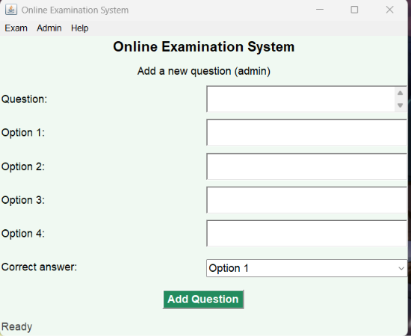
Admin screen for adding a question and its answer options.

4.6 Database tables
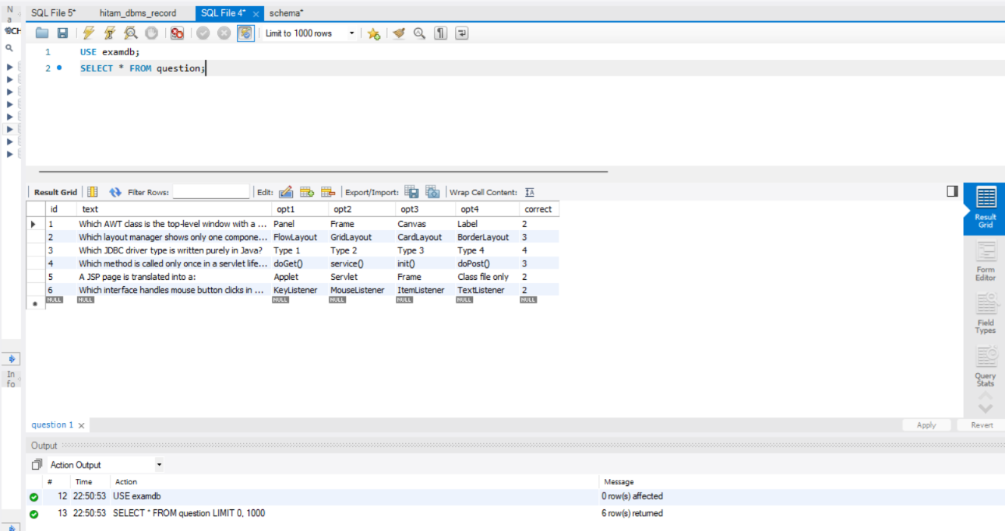
Question table showing the six sample questions and answer choices.
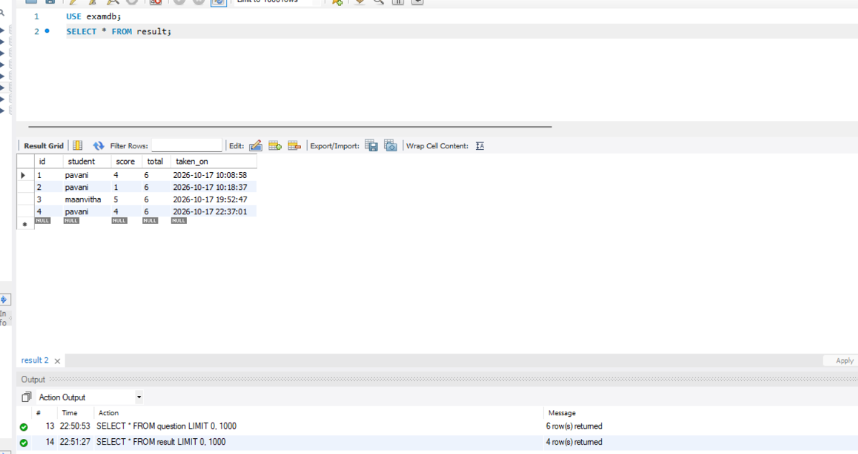
Result table showing saved student scores and exam dates.

4.7 Web pages (if you run Tomcat)
The supplied Chrome screenshots show the web exam and result pages.
4.7.1 Web start page
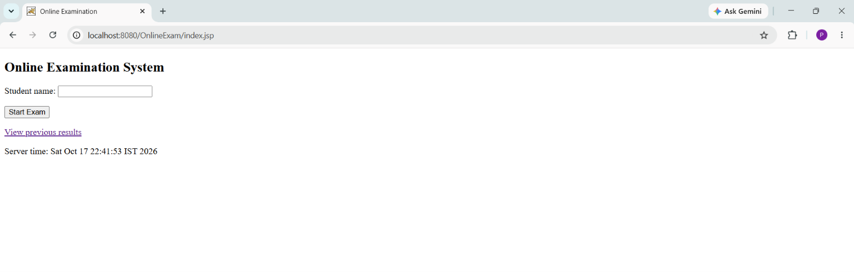
Web start page showing the student name field and Start Exam button.
4.7.2 Web exam page
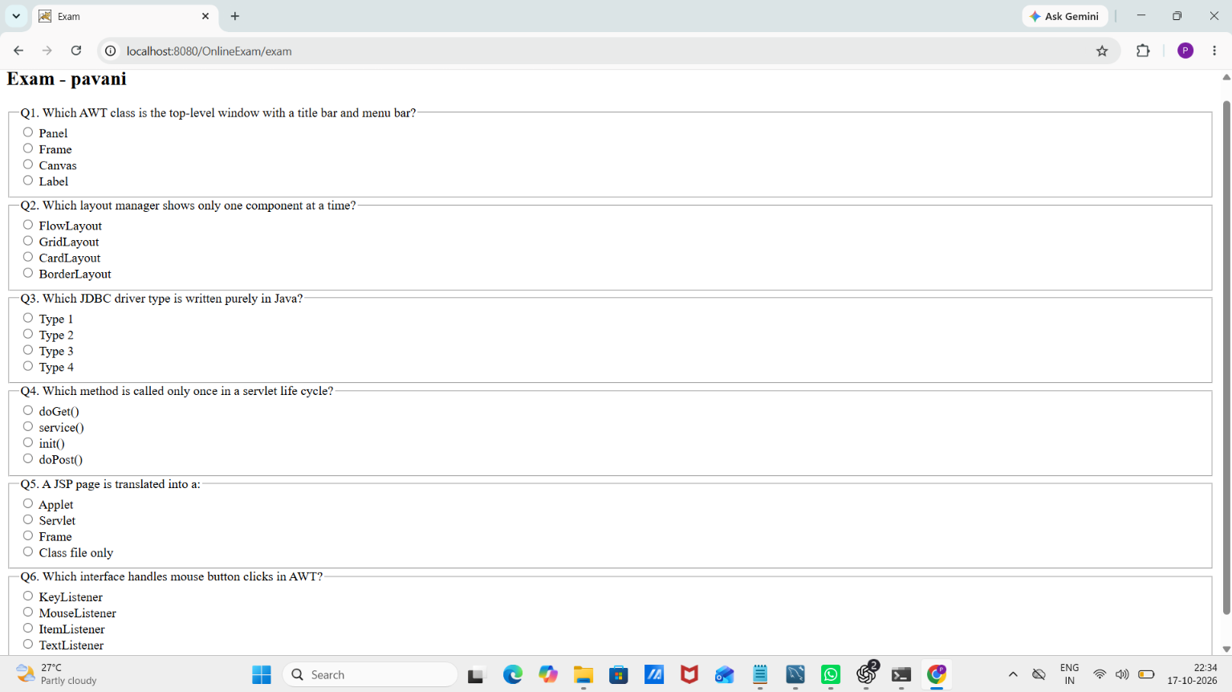
Web exam page showing the exam title and questions.
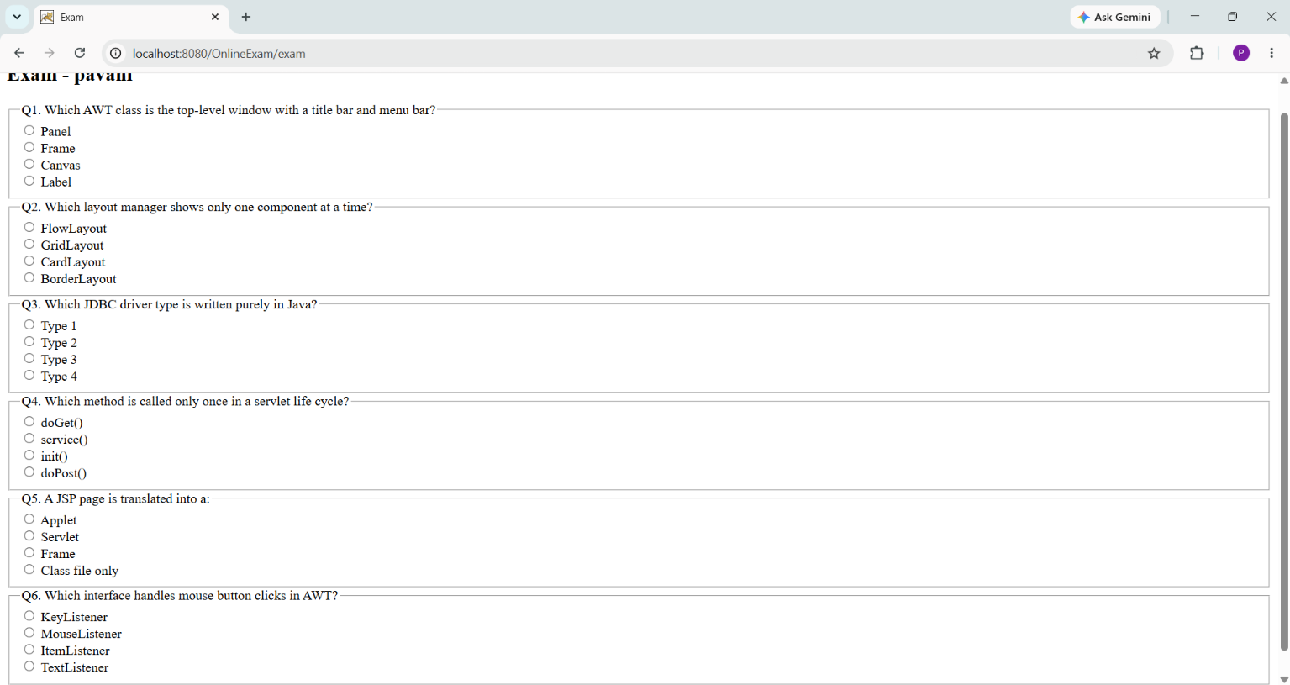
Web exam page showing the questions and answer choices in a scrolled view.
4.7.3 Web result page
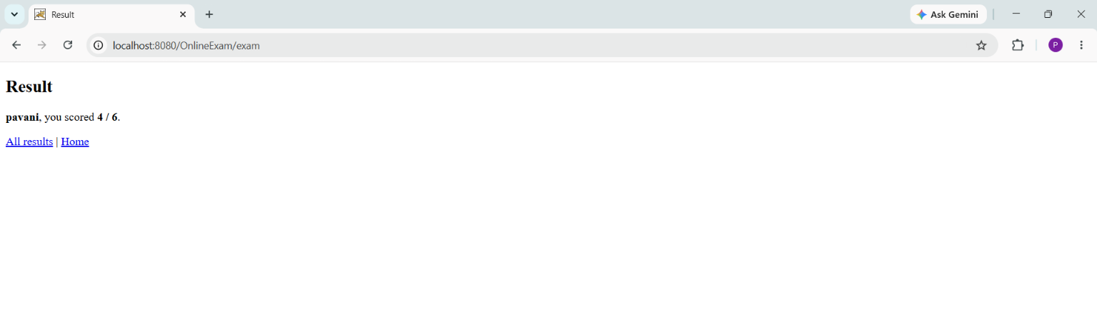
Web result page showing a score of 4 out of 6.
4.7.4 Web results page
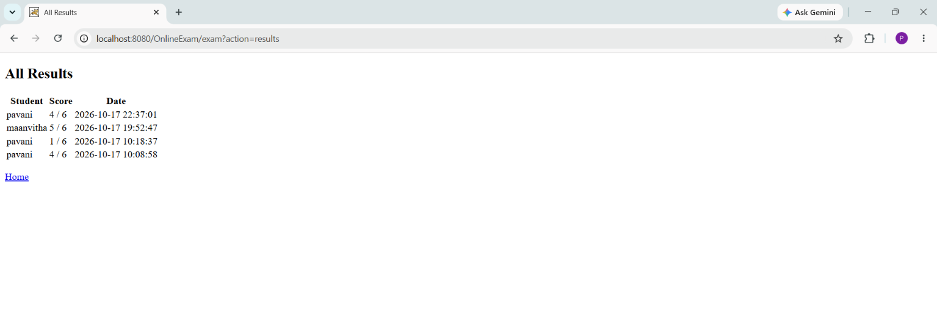
Web results page showing student scores and exam dates.

5. GitHub Link
Repository: [Paste your GitHub repository link here]
The repository should contain the src folder, the webapp folder, schema.sql and a README file.

6. Conclusion
This project joins the main ideas of Module 5 in one working application. The AWT screens show how windows, layouts and events work. JDBC connects the program to a real database. The Servlet and JSP pages show how the same exam can run in a web browser. The project can be improved later with an admin login, random question order, and a result chart.

