

Students’ Placement Office, IIT Kanpur
Title of the Project | Development of Optimized E-Commerce Experience
Commencement Date | 01-11-2023
Completion Date | Ongoing
Project Supervisor | Yasin Shah
Organization/Institution where the Project was accomplished | Technocolabs Softwares
Project Description (You can use extra A4 sheets in case you run out of space however the extra sheets should also have the seal & signature of the Project Supervisor or the relevant authority )
The aim of this project is to enhance the user experience of an e-commerce website through the implementation of key features. The frontend will be developed using HTML, CSS, JavaScript, and React, providing a seamless and responsive interface. On the backend, Node.js will be employed along with MongoDB for efficient data management.

The project scope includes the integration of email notifications to keep users informed about their actions, ensuring a smooth communication channel. Real-time messaging or notifications will be set up for timely updates on job statuses, providing users with instant feedback. Additionally, push notifications will be implemented where necessary, enhancing the overall engagement and user interaction.

Furthermore, the another project involves the development of a robust order management system and a user-friendly shopping cart. These components will be intricately connected to the backend, ensuring a secure and efficient transaction process. The synergy between frontend and backend technologies will result in an optimized e-commerce platform that seamlessly translates user requirements into a functional and visually appealing interface.
Project Verification Form
By appending your signatures to this form you acknowledge and agree that:
- This form along with the certificate would serve as the official document between the project supervisor and Students Placement Office, IIT Kanpur regarding verification of the student’s project work
- The student will provide additional information and documentation relevant to his/her project upon request by the Students’ Placement Office
- The student has clearly defined his/her individual role in projects done in cooperation with other students, faculty, groups or company personnel.
- Incorrectly over-stating the reach, impact and/or quantitative/qualitative results of a project is unethical.
- In case of violation of any of the above rules, Students’ Placement Office, IIT Kanpur reserves the right to take necessary action including de-registering the student from the placement season and reporting the misconduct to the Institute Authorities.
Submitted by:- | Project Supervisor Details:-
Name: Pavan Kumar C | Name:
Roll No: 208170680 | Designation:
Signature: 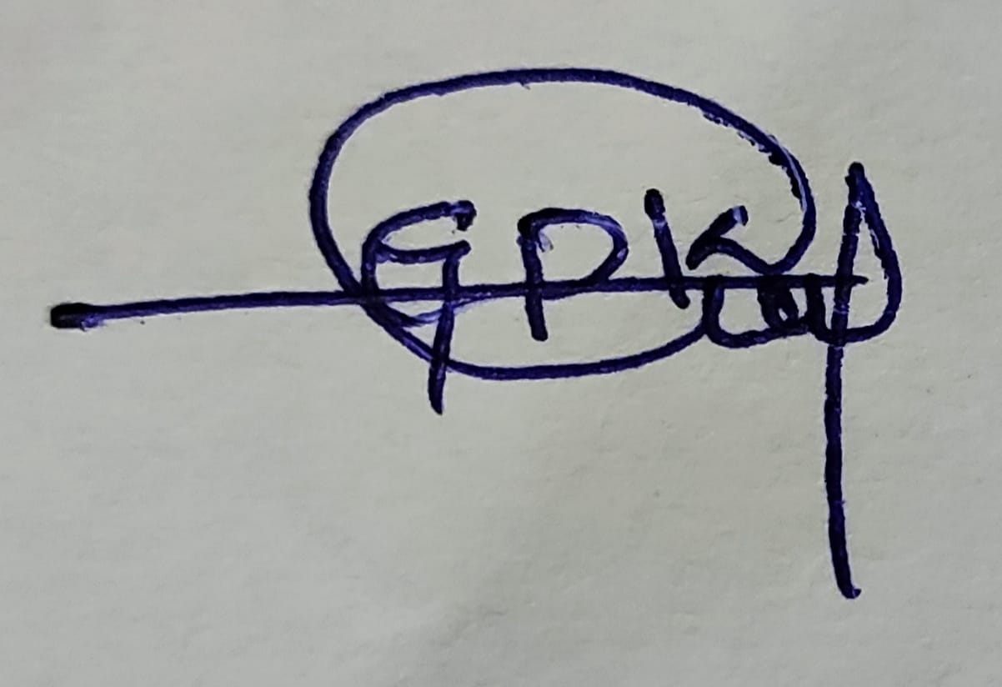 |   Signature:

