**UIPath Anchor base Activity:**

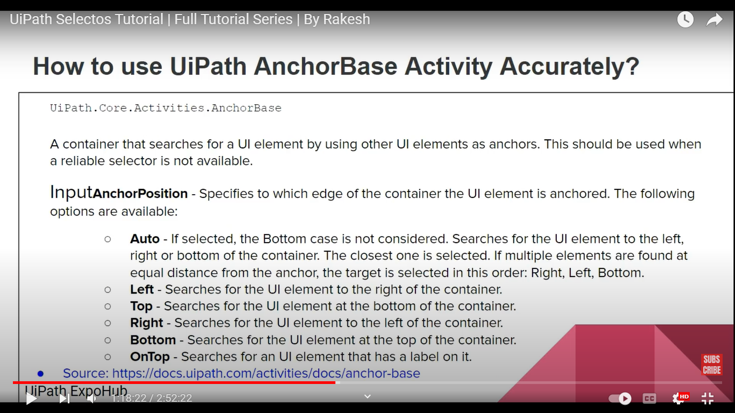

* **Auto** - If anchor position is at bottum it willnot take/consider the activity, it only takes when the Anchor position is at top,right and left(riht,left,bottum(chec k flow))

