MACHINE LEARNING

ASSIGNMENT - 6

**NAME: PAVAN KUMAR NARAGA  
 ID: 700733572**

**GIT HUB LINK:**

[**https://github.com/pavank234/Assignment---6--ML--**](https://github.com/pavank234/Assignment---6--ML--)

[**https://youtu.be/qtvegvcGKZw**](https://youtu.be/qtvegvcGKZw)

question 2:

OUTPUTS:

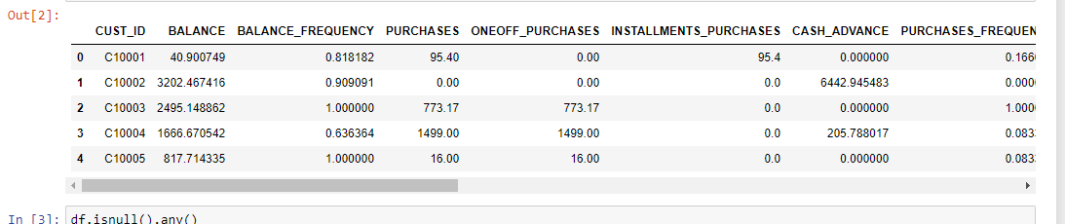

For k=2 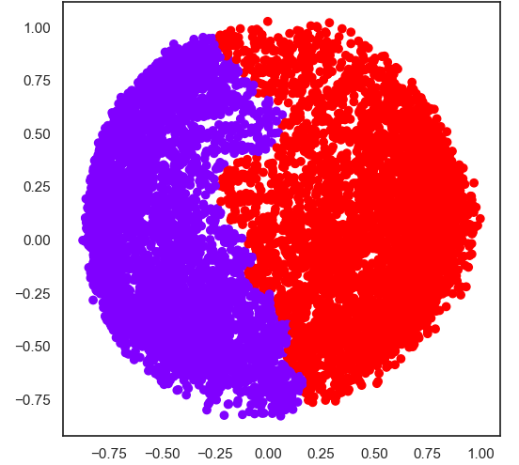

For k=3

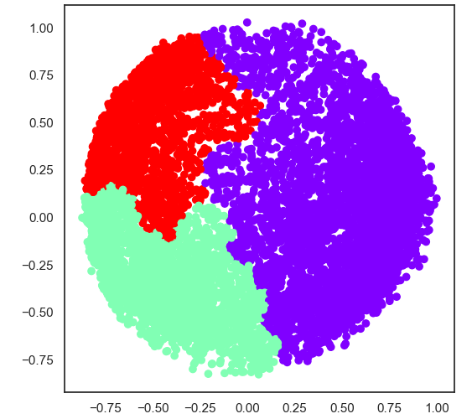

For k=4

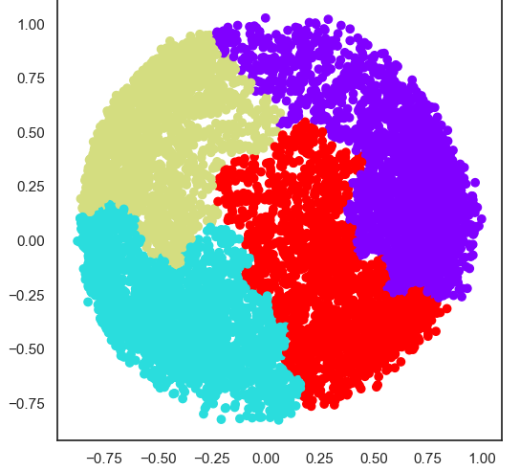

For k = 5

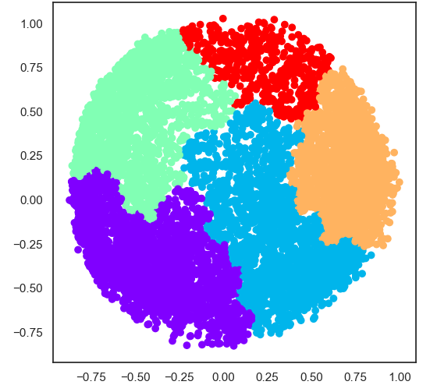

All together final graph

