EHIC European Health Insurance Card Issuance process
In French, CEAM (carte europeenee d’assurance maladie)
Time taken: 5 minutes.
- Home screen post login into ameli.fr
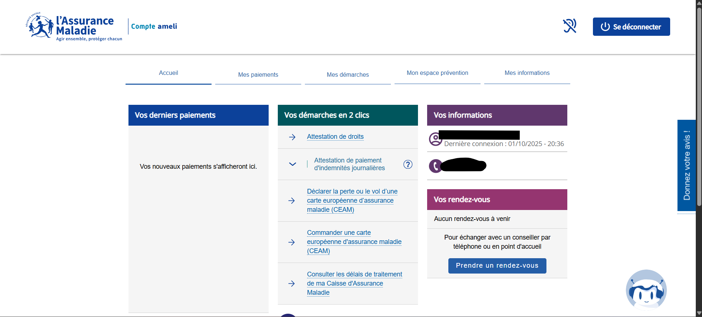
- Under the option “Mes demarches” (“my steps” in English), click on “Commander une carte europeene d’assurance maladie” (CEAM). For those using translation it will be EHIC.

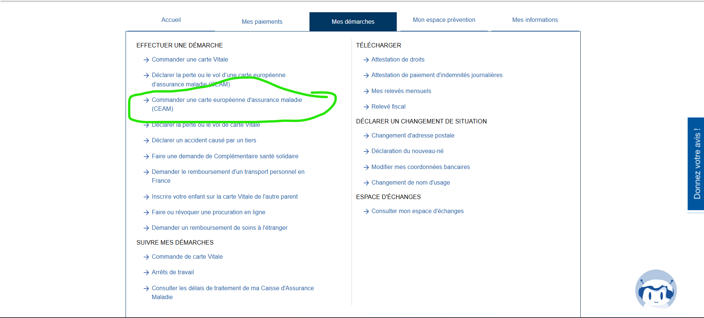
- Click Commander (“Order”)
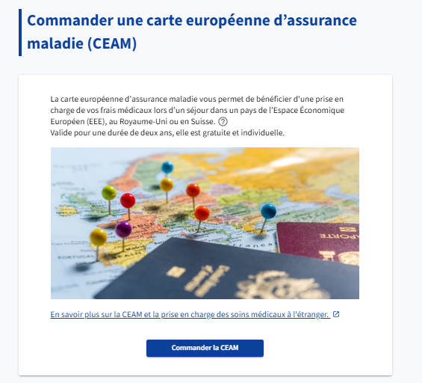
- As seen in screen below, verify details in each of the 5 steps. Very straightforward. In one of the steps, you’ll be asked to choose the countries you would like coverage for. EU, Swiss, UK. It’s free so choose all

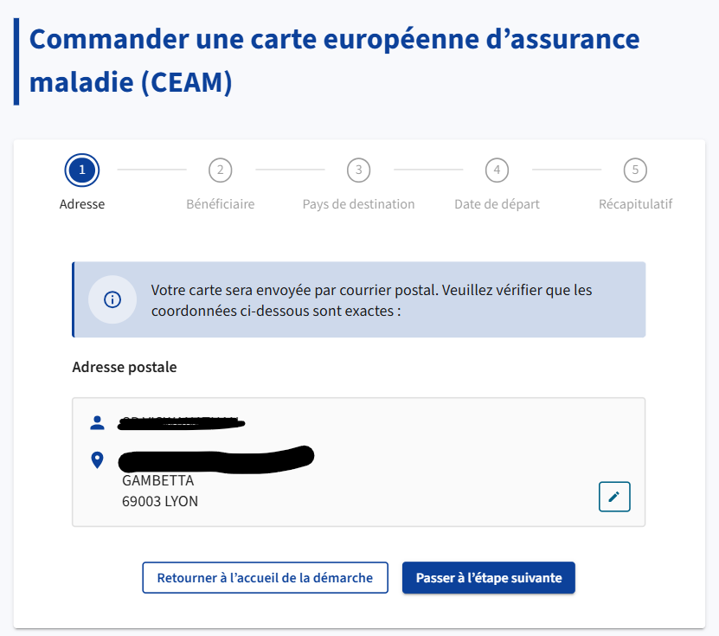
- Step 4 – Date de depart is for Assurance Maladie (organization responsible for Public Health and Carte Vitale) to know if you are departing within 15-20 days or if you have sometime before you travel. If your travel outside France is under 15 days, you have an option of instantly receiving your CEAM/EHIC account information in a PDF. If there is no hurry, you will eventually receive a physical card. Honestly, I don’t know why this matters, cuz either way, the PDF is shared right after you do the 5 steps.
- Enjoy your travel.

