

SOP – 005

PROCEDURE FOR SENSACORE INSTRUMENT

TABLE OF CONTENTS

TABLE OF CONTENTS 2
APPROVAL AUTHORITY 3
RECORD OF AMENDMENTS 4
DISTRIBUTION LIST 5
LIST OF ABBREVIATIONS 6
1. Objective 7
2. Scope 7
3. Responsibilities 7
4. Type of Sample 7
5. Requirements 7
6. Description 8
7. Specimen Collection 8
8. Start Up Process 8
9. Calibration Procedure 8
10. Analyze Sample 12
11. Maintenance 15
12. Biological Reference Interval 15
13. Performance Characteristics 16
14. References 16
Flowchart – 1: Sensacore ST200 Start Up Procedure 17
Flowchart – 2: Sensacore ST200 Shut Down Procedure 18

APPROVAL AUTHORITY

Prepared by: | Head of Department | Dr. K. Anusha  Name | Date: 14/11/2024

Signature
Reviewed & Approved by: | Laboratory Head | Dr. Abdul Aleem  Name | Date: 14/11/2024

Signature
Issued by: | BME Manager | Pallavi Elisetty  Name | Date: 14/11/2024

Signature

RECORD OF AMENDMENTS

S. No. | Ver. No. | Ver. Date | Rev. No. | Rev. Date | Description of Changes

Document Copy No. | Name / Designation of the holder of the document copy | Type of Copy | Version No. | Revision No.
01/10 | Managing Director | Controlled Copy | 01 | 00
02/10
03/10
04/10
05/10
06/10
07/10
08/10
09/10
10/10

DISTRIBUTION LIST

LIST OF ABBREVIATIONS
S. No. | Abbreviations | Expansion
1 | BC | Biochemistry
2 | CSF | Cerebral Spinal Fluid
3 | EDTA | Ethylenediaminetetraacetic Acid
4 | EQAS | External Quality Assurance Scheme
5 | QC | Quality Control
6 | QM | Quality Manager
7 | TDPL | TRUSTlab Diagnostics Private Limited

- Objective
  - This document describes the procedure for use, calibration and maintenance of the SENSACORE ST-200 aQua Electrolyte Analyzer used at TRUSTlab Diagnostics.
- Scope
  - This procedure applies to all staff of the Biochemistry Department tasked with the duty of performing tests on this instrument.
- Responsibilities
  - The concerned technicians are responsible for the operation, calibration and maintenance of the SENSACORE ST-200 aQua Electrolyte Analyzer.
  - The Head of Department shall ensure proper implementation of this SOP.
  - The Quality Manager shall monitor for compliance with this SOP.
- Type of Sample
Lithium heparin or Sodium heparin whole blood samples from syringes, open tubes, and capillary tubes can be used on the ST-200 aQua Electrolyte Analyzer. The minimum sample size for analysis is 100 μl.
- Requirements
  - Instrument-related Requirements
      - ANALYZER
      - Accessories – Power Adapter, Power cord, Paper rolls
      - Power supply with power cord
      - Quality Control material
      - ST-200 aQua Reagent Pack
      - Thermal printer paper rolls
      - Reference Electrode Kit
      - Trouble Shooting Kit
    - Environmental Requirements
      - Working area around the system should be free of dirt, corrosive fumes, vibration and excessive temperature changes.
      - Location: Indoors
      - Operating Temperature: 5 – 40C
      - Operating at Humidity: < 85%
- Description
The ST-200 aQua Electrolyte Analyzer is intended for invitro diagnostics use in the quantitative determination of Sodium, Potassium, Ionized Calcium, Lithium, pH, Chloride in Whole Blood, Electrolytes in Serum/Plasma/CSF and Diluted Urine. Measurements obtained by this device are used for the diagnosis, monitoring, and treatment of diseases involving electrolyte imbalance.
- Specimen Collection
  - Lithium heparin and Sodium heparin are acceptable anticoagulants.
  - EDTA, Citrate, Oxalate and Sodium fluoride are not acceptable for use.
- Start Up Process
  - After completing the whole path connections from reagent pack to the waste outlet via reference housing, perform Reagent pack option which does reagent priming.
  - The way to prime the reagents is as follows:
      - Go to Menu > Diagnostics > Flow > Reagent priming
      - Select Prime Cal A for priming Cal A reagent.
      - Select Prime Cal B for priming Cal B reagent.
      - Select Prime Cal C for priming Cal C reagent.
      - Select Prime All for priming all reagents.
      - Press Exit to exit the present screen.
- Calibration Procedure
  - The instrument has to be calibrated when it is switched ON or it automatically calibrates in set calibrated frequency after 6 hours or 12 hours as per set frequency.
  - The Calibration procedure is as depicted below:
First, Switch ON the Instrument
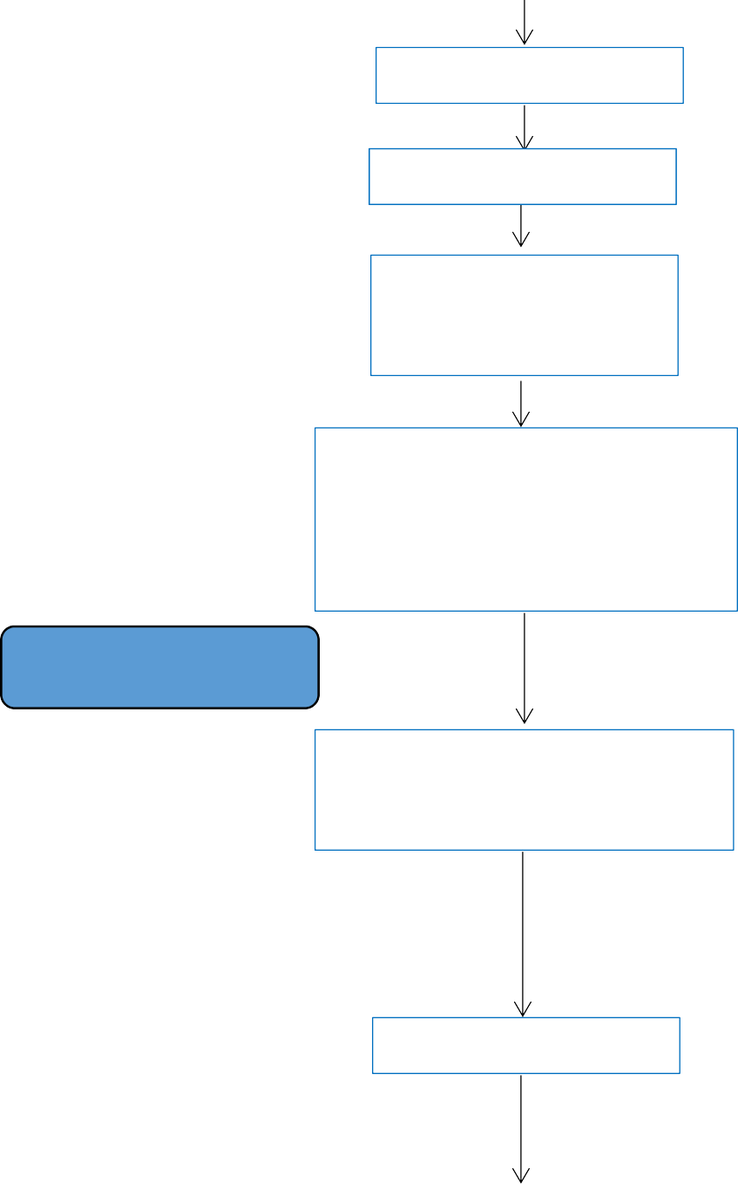
INITIALIZING
SELF CHECK
ACQUIRING RANGES

Please wait…
ST-200 aQua
--------------------
System Uncalibrated Please Calibrate…
Na * K * iCa * Li * pH * Cl
Press CALIBRATE key
CALIBRATE
Y --> Continue
N--> Exit
Press Y

Displays PUMP CALIBRATION STEPS
SEARCHING PACK
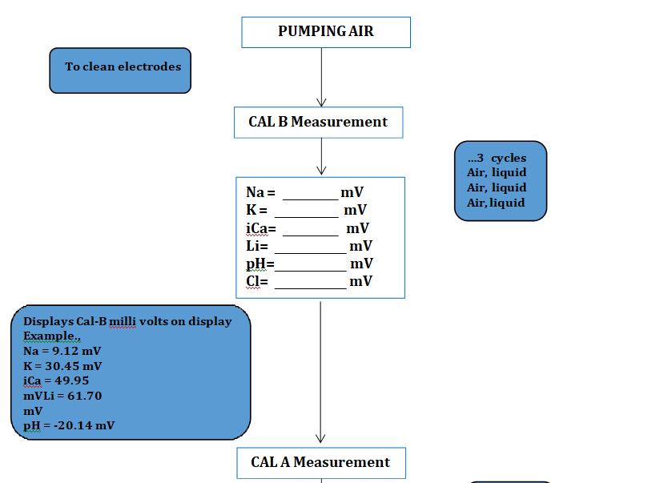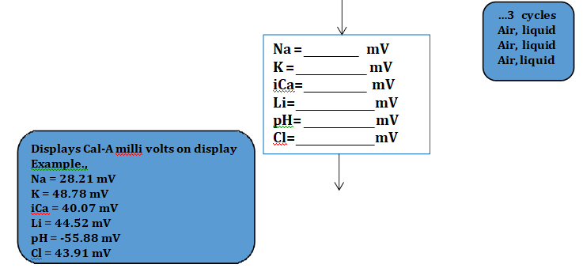
Finally, the instrument displays calibration slope and is ready for analysis
Na = __________
K = ____________
iCa= ___________
Li= _____________
pH= ____________
Cl= _____________
Displays Calibration Slope on display. Example.,
Na = 64.02
K = 63.07
iCa = 34.24
Li = 84.55
pH = 63.51
Cl = 62.14

If any electrode is Uncalibrated, then it will show (*) besides that parameter in the display screen. So that we can clearly see the status of the instrument.
Sensacore

-----------------------
Na K* iCa Li pH Cl*
The above figure shows, the K & Cl are Uncalibrated and Na, iCa, Li, pH are Calibrated.

- Analyze Sample
  - To obtain a patient’s sample, follow the procedure the precautions described under sample handling and collection. Quality Control materials should be run prior to patient sample analysis.
  - Firstly, select the Sample Type before setting to analyze the sample
ANALYZE
STANDBY
MENU
CALIBRATE
DIAGNOSTICS
PARAMETER
SELECT iCa UNIT
USER MENU
SETUP MENU

SETUP MENU
ANALYZE TYPE
SERUM/PLASMA/CSF
URINE
WHOLE BLOOD
QUALITY CONROL
MICRO MODE

Note: Select the sample type which you want to measure and Press N --> Press N --> Press -->. The home screen is on display now.
Now, select “ANALYZE” option.
Here, e.g. WHOLE BLOOD taken as SAMPLE TYPE for Analyze
ANALYZE SAMPLE

Y --> Continue N--> Exit
Please Lift Sampler

Displays Sample milli volts on display
Example.,
Na = 27.82 mV K = 53.92 mV iCa = 49.50 mV Li = 53.22 mV pH = -52.18 mV Cl = 47.79 mV
Insert the Sample at the Sample Probe and Select “Y”
Probe in Sample?
Y --> Continue
N--> Exit
Please wait…
Please remove sample &
Close the Sampler
Positioning Sample
Sample Measurement
Na = mV
K = mV
iCa= mV
Li= mV
pH= mV
Cl= mV
Processing…
Na = mV
K = mV
iCa= mV
Li= mV
pH= mV
Cl= mV
Now, the Analyze Sample results will be displayed on the Display Screen.
ANALYZE SAMPLE
Na = 141.6 mmol/L
K = 4.01 mmol/L
iCa = 1.13 mmol/L
Li = 1.36 mmol/L
pH = 7.450
Cl = 101.1 mmol/L
Apart from the above results the below-mentioned calculated parameters are printed on the paper.
CALCULATED PARAMETERS
nCa = 1.027 mmol/L
TCa = 2.054 mmol/L
Where,
            - nCa = Normalized Calcium
Formula used to calculate nCa is given below:
nCa = (iCa Result) x 10^(- 0.24 x (7.40 - pH Result))
            - TCa = Total Calcium
Formula used to calculate TCa is given below:
TCa = nCa x 2
The results outside the measurement range as follows will not be reported for WHOLE BLOOD, SERUM, PLASMA & CSF
Na+: 20.0 - 250 mmol/L
K+: 0.2 - 40.0 mmol/L
iCa++: 0 - 10.0 mmol/L
Li+: 0 - 5 mmol/L
pH: 5.0 - 9.0
Cl-: 20.0 - 200.0 mmol/L

- Maintenance
The operator must activate maintenance mode before switching off the instrument.
  - Sensors
Sensors option is used to check mV of the electrodes for each reagent separately.
SENSORS ----------------
1. SENSOR CAL A-mV
2. SENSOR CAL B-mV N --> E
  - Daily Cleaning
Daily cleaning is an important aspect in maintenance procedures. During daily cleaning the Cleaning Solution is aspirated through the probe cleaner and then cleaning is done by pumping the solution through Cal A and Cal B, which finally displays the calibration slope. The instrument is then ready for analysis.
  - Flow
It will be used when inserting a new reagent pack or troubleshooting flow issues in the instrument by priming CAL A, CAL B, WASH & ALL.
Reagent priming, Pump calibration and Valve test are the important steps in FLOW.
  - Hardware
This is an important aspect in the process of maintenance. Sample Detector, Pump module and Software version are crucial steps involved in Hardware.
    - Sample Detector test is used in the pumping of air and liquid.
    - Pump Module test is used in checking the pumping speed - fast and slow.
    - Software Version shows the version number and date.
  - Reagent Pack
Reagent pack contains the information of reagent pack like consumption, reagent pack lot number, pack volume and other information like about Cal A and Cal B concentration.
- Biological Reference Interval
N/A.
- Performance Characteristics
N/A.
- References
SENSACORE Operator Manual
Name of the instrument | SENSACORE | Remarks
Date of installation | 23-05-2022
Description | The ST-200 aQua Electrolyte Analyzer is intended for in-vitro diagnostics use in the quantitative determination of Sodium, Potassium, Ionized Calcium, Lithium, pH, Chloride in Whole Blood, Electrolytes in Serum/Plasma/CSF and Diluted Urine. Measurements obtained by this device are used for the diagnosis, monitoring, and treatment of diseases involving electrolyte imbalance
Start Up and Shut down procedures | Refer flow chart-1 & 2
Maintenance | Daily Maintenance
Calibration details | Once a year  Calibration Done date :23-05-2022  Calibration Due date :22-05-2023
Safety measures | Do not put hands on the instrument.  Always close the sample analyze lid.
Precautions if any |  | NA
Decontamination procedures |  | NA
Any other (taking out of service, breakdown and repairs) |  | NA

Flowchart – 1: Sensacore ST200 Start Up Procedure
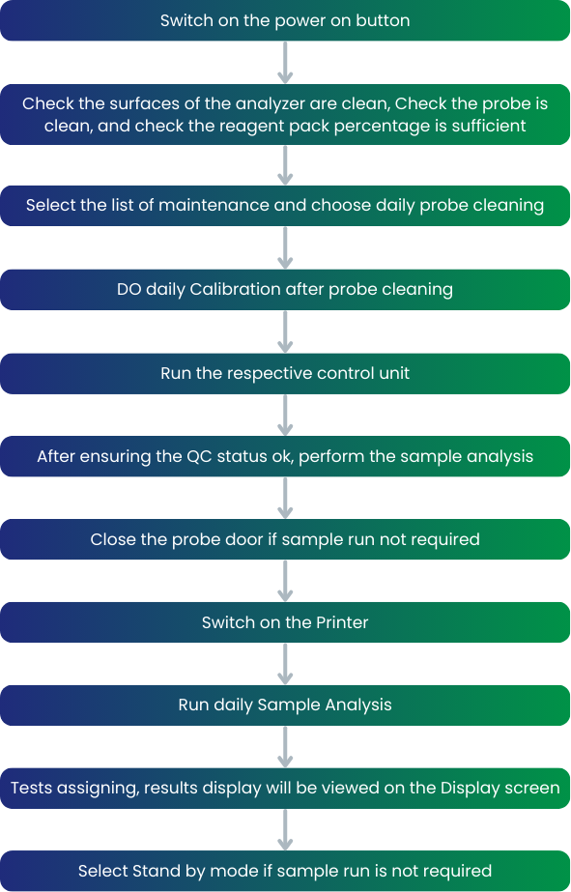

Flowchart – 2: Sensacore ST200 Shut Down Procedure
