AIR TICKET BOOKING SYSTEM

**A Project Submitted during 1st Year 1st Semester in Nov’2018 using C at :**

**Vidya Jyothi Institute of Technology**



**Submitted by :**

1. **PRAHARSHA – 18911A0515**
2. **PAVAN KALYAN –18911A0547**
3. **MALIK BASHA – 18911A0548**
4. **AJAY SAGAR –18911A0539**

**Subject : Programming and Problem Solving – I (PPS – I)**

**Developed under the guidance of :**

**Dr. Siddhartha Ghosh**

**Content**

**Page no**

1. Introduction - 3
2. Functions Used - 4
3. Use case - 5
4. The Code - 6-12
5. Output Screens - 13-15
6. Conclusion - 16

**Introduction:**

World has seen the most technological boom in the last fifty years , with the innovations in every field made possible now for making the human life easier and more comfortable. Airlines industry has evolved into one of the most sophisticated and fascinating industries of today. Airlines industry has made the dream of flying of the humans into a reality in less than a century;. Today, millions of people fly every day. This has strengthened not only the economies of places but also connected people and cultures. The advancement of technology has led to big progress in the system of flight ticket booking over the years.

Tickets are the documents that confirm purchase and guarantee a seat on the airplane for the chosen journey. Tickets are required as a proof to get the boarding pass at the airport, which is needed in order to board the aircraft.

In this thesis, the system behind online ticket booking especially used by airlines is going to be explained along with a demonstration of a working application to show sample online booking. Various sources such as e-books, online articles and websites have been referred to gather the materials for the thesis. The thesis has been completed with the co-operation with the supervisor to take in his valuable ideas and suggestions for the improvement of the work.

Hence, this project deals with a simple C- Language program for booking an Air Ticket in online .It includes switch cases, loops, print and scan functions.

**The functions used:**

1.info() : This function is used to show the information about the mentioned AIR LINES in INDIA to user.

2. Booking () : This function helps the user to choose

1.ROUTES.

2.CLASS and

3.TO BOOK TICKETS(accordingly)

3.exit() : This function gives an option for user to quit.

The use case diagram :

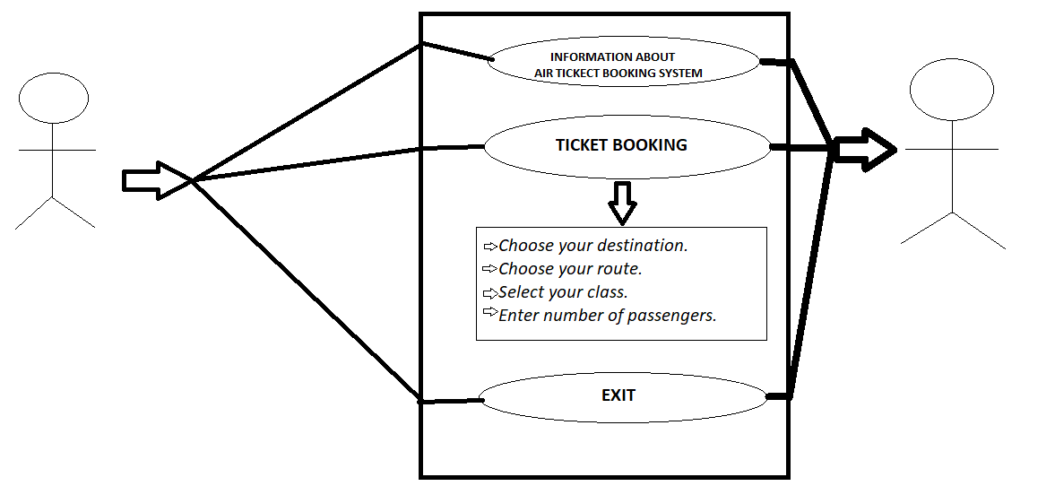

**The Code:**

// AIR-TICKET-BOOKING

#include<stdio.h>

#include<stdlib.h>

void info();

void booking ();

void main()

{

int option;

printf("\n\t\t\t\t\t WELCOME TO AIR TICKECT BOOKING SYSTEM");

printf("\n 1.INFORMATION \n 2.BOOKING\n 3.EXIT\n\n");

scanf("%d",&option);

switch(option)

{

case 1:

info();

main();

break;

case 2:

booking();

main();

break;

case 3:

exit(0);

default:

printf("\n ENTER A VALID OPTION \n");

main();

}

}

void info()

{

printf("\t\t\t\t\t\t*INFORMATION*\nTHIS IS A LIST OF AIRLINES OF INDIA OPERATING IN THE AREA OF CIVIL AVIATION..\n\n1.JET AIRWAYS(The Jet Airways is the second largest airline in India with a market share of 15.4 percent. It was established on 1st April, 1992 and started operations on 5th May, 1993. Chhatrapati Shivaji International Airport, Mumbai is the main hub of Jet Airways.)\n\n2.AIR INDIA(Air India is one of the oldest airline companies in India with presence in all the major as well as small cities of India. It was founded in July, 1930 as the Tata Airlines and started operations on 15th October, 1932. The airline was founded by one of the great industrialists JRD Tata.)\n\n3.SPICEJET(The SpiceJet Airlines serves in key cities of India such as Pune, Chennai, Ahmedabad, Goa and so on. Previously, it was owned by the NRI group and it was acquired by the media king Kalanithi Maran. However, Maran sold his shares back to Ajay Singh in 2015.)\n\n4.GOAIR(GoAir is the one of the most popular budget airlines in India. GoAir is promoted by the Wadia Group. It was founded in 2005 and started operations in November, 2005. The fleet size of the GoAir is 38 aircraft and serves in more than 23 destinations. The GoAir is headquartered in Worli, Mumbai, Maharashtra with the slogan of “Fly Smart”.)\n");

return;

}

void booking()

{

int option1,option2,passengers,price,class,d=002;

char route;

printf("\t\t\t\t\t**CHOOSE YOUR ROUTE* \n");

printf("A.INTERNATIONAL \nOR\nB.NATIONAL\n");

scanf(" %c",&route);

if(route==65||route==97)

{

OPTION:

printf("\t\t\t\t\t*INTERNATIONAL ROUTES* \n1.AUSTRALIA\n2.USA\n3.CANNADA\n4.SWITZERLAND\n\n");

scanf("%d",&option1);

if (option1<=4)

{

clas:

printf("\t\t\t\t\t*CHOOSE YOUR CLASS*\n1.1ST CLASS\n2.2ND CLASS\n3.3RD CLASS\n");

scanf("%d",&class);

{

switch(class)

{

case 1:

class =5000;

printf("------------YOU HAVE CHOOSEN CLASS 1-----------\n");

break;

case 2:

class =3000;

printf("------------YOU HAVE CHOOSEN CLASS 2----------\n");

break;

case 3:

class =2000;

printf("------------YOU HAVE CHOOSEN CLASS 3-----------\n");

break;

default:

printf("CHOOSE YOUR CLASS AGAIN\n");

goto clas;

}

{

printf("\t\t**ENTER NUMBER OF PASSENGERS**\n");

scanf("%d",&passengers);

}

switch(option1)

{

case 1:

price=passengers*(10000+class);

printf("YOU HAVE CHOSEN TICKET FROM INDIA TO AUSTRALIA\n");

printf("THE COST OF THIS TICKET IS 10000\n ");

printf("THE TICKET PRICE FOR %d MEMBERS IS %d\n",passengers,price);

break;

case 2:

price=passengers*(15000+class);

printf("YOU HAVE CHOSEN TICKET FROM INDIA TO USA \n");

printf("THE COST OF THIS TICKET IS 15000 \n");

printf("THE TICKET PRICE FOR %d MEMBERS IS %d\n",passengers,price);

break;

case 3:

price=passengers*(15000+class);

printf("YOU HAVE CHOSEN TICKET FROM INDIA TO CANNADA\n");

printf("THE COST OF THIS TICKET IS 15000 \n");

printf("THE TICKET PRICE FOR %d MEMBERS IS %d\n",passengers,price);

break;

case 4:

price=passengers*(20000+class);

printf("YOU HAVE CHOSEN TICKET FROM INDIA TO SWITZERLAND\n");

printf("THE COST OF THIS TICKET IS 20000\n ");

printf("THE TICKET PRICE FOR %d MEMBERS IS %d\n",passengers,price);

break;

default:

printf("PLEASE RE-CHOOSE YOUR OPTIONS\n");

}

}

}

else

{

printf("PLEASE RE CHOOSE YOUR OPTIONS\n");

goto OPTION;

}

}

else if (route==66||route==98)

{

nat:

{

printf("\t\t\t\t\t\t*NATIONAL ROUTES** \n1.HYDERABAD TO BENGALURU\n2.HYDERABAD TO CHENNAI\n3.HYDERABAD TO DELHI\n4.HYDERABAD TO VIZAG/VISHAKAPATNAM\n5.HYDERABAD TO GOA\n");

scanf("%d",&option2);

if (option2<=5)

{

classs :

printf("\t\t\t\t\t*CHOOSE YOUR CLASS*\n1.1ST CLASS\n2.2ND CLASS\n3.3RD CLASS\n");

scanf("%d",&class);

switch(class)

{

case 1:

class =5000;

printf("YOU HAVE CHOOSEN CLASS 1\n");

break;

case 2:

class =3000;

printf("YOU HAVE CHOOSEN CLASS 2\n");

break;

case 3:

class =2000;

printf("YOU HAVE CHOOSEN CLASS 3\n");

break;

default:

printf("CHOOSE YOUR CLASS AGAIN\n");

goto classs;

}

{

printf("\t\t**ENTER NUMBER OF PASSENGERS**\n");

scanf("%d",&passengers);

}

switch(option2)

{

case 1:

price = passengers*(4000+class);

printf("YOU HAVE CHOSEN TICKET FROM HYDERABAD TO BENGALURU\n");

printf("THE COST OF THIS TICKET IS 4000 \n");

printf("THE TOTAL TICKET PRICE FOR HYDERABAD TO BENGALURU FOR %d MEMBERS IS %d \n",passengers,price);

break;

case 2:

price = passengers*(5000+class);

printf("YOU HAVE CHOSEN TICKET FROM HYDERABAD TO CHENNAI\n");

printf("THE COST OF THIS TICKET IS 5000\n ");

printf("THE TOTAL TICKET PRICE FOR HYDERABAD TO CHENNAI FOR %d MEMBERS IS %d\n",passengers,price);

break;

case 3:

price = passengers * (6000+class);

printf("YOU HAVE CHOSEN TICKET FROM HYDERABAD TO DELHI\n");

printf("THE COST OF THIS TICKET IS 6000 \n");

printf("THE TOTAL TICKET PRICE FOR HYDERABAD TO DELHI FOR %d MEMBERS IS %d \n",passengers,price);

break;

case 4:

price = passengers * (3000+class);

printf("YOU HAVE CHOSEN TICKET FROM HYDERABAD TO VIZAG/VISHAKAPATNAM\n");

printf("THE COST OF THIS TICKET IS 3000 \n");

printf("THE TOTAL TICKET PRICE FOR HYDERABAD TO VIZAG/VISHAKAPATNAM FOR %d MEMBERS IS %d \n",passengers,price);

break;

case 5:

price = passengers * (4000+class);

printf("YOU HAVE CHOSEN TICKET FROM HYDERABAD TO GOA\n");

printf("THE COST OF THIS TICKET IS 4000 \n");

printf("THE TOTAL TICKET PRICE FOR HYDERABAD TO GOA FOR %d MEMBERS IS %d \n",passengers,price);

break;

default:

printf("PLEASE RE-ENTER YOUR OPTION \n");

}

}

else

{

printf("PLEASE CHOOSE YOUR OPTIONS\n");

goto nat;

}

}

}

else

{

printf("PLEASE CHOOSE YOUR ROUTE\n");

booking();

return;

}

// printf("\t\t\t\t\t\t * THANK YOU \t\t\t\t\t\t\n \t\t\t\t\t\t*VISIT AGAIN\t\t\t\t\t\t ");

}

**Output Screens**:

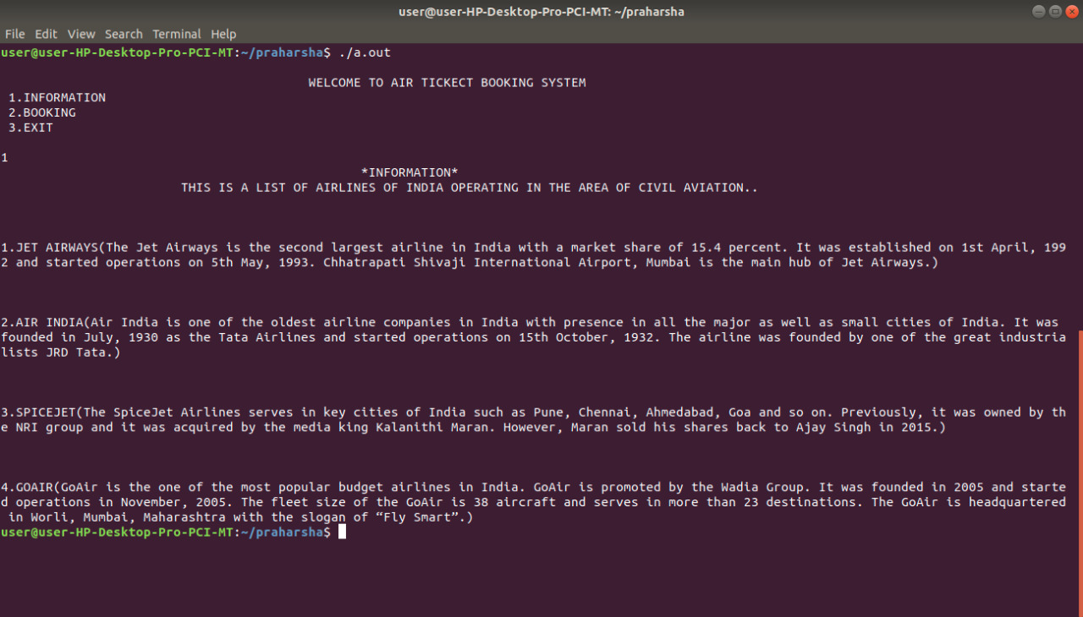

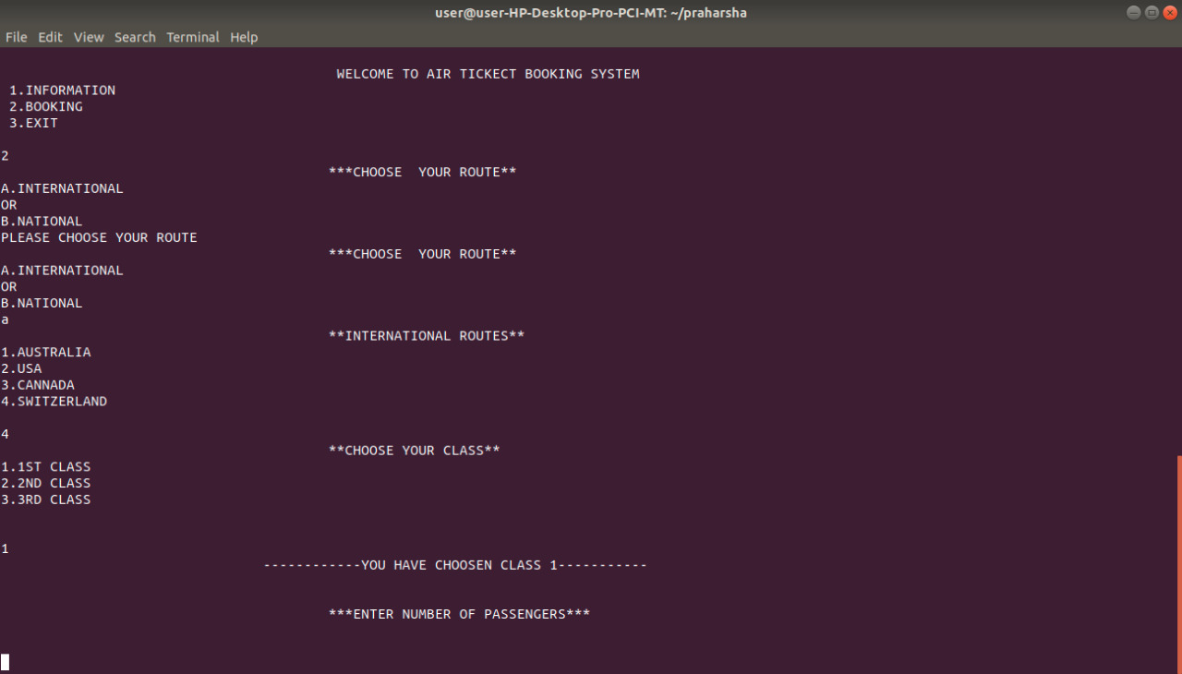

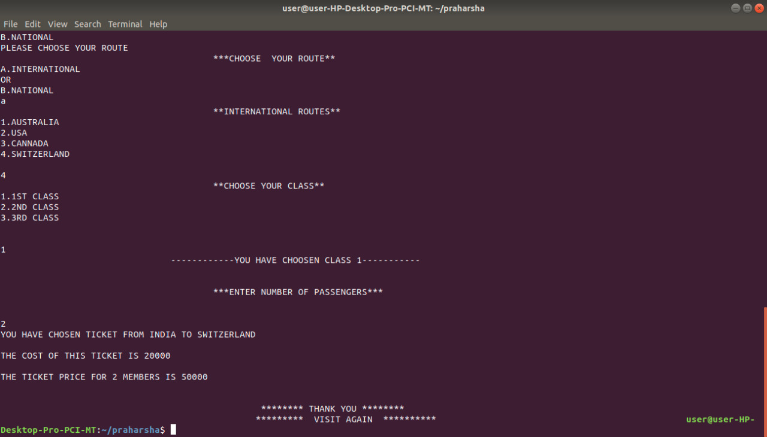

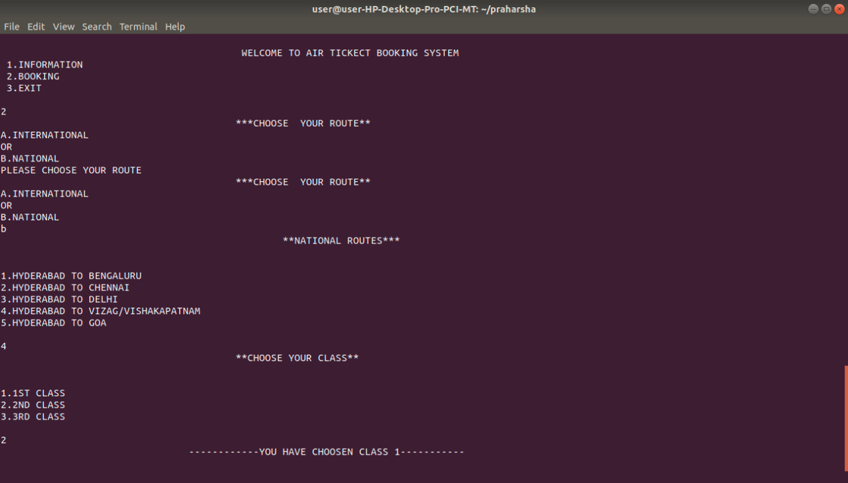

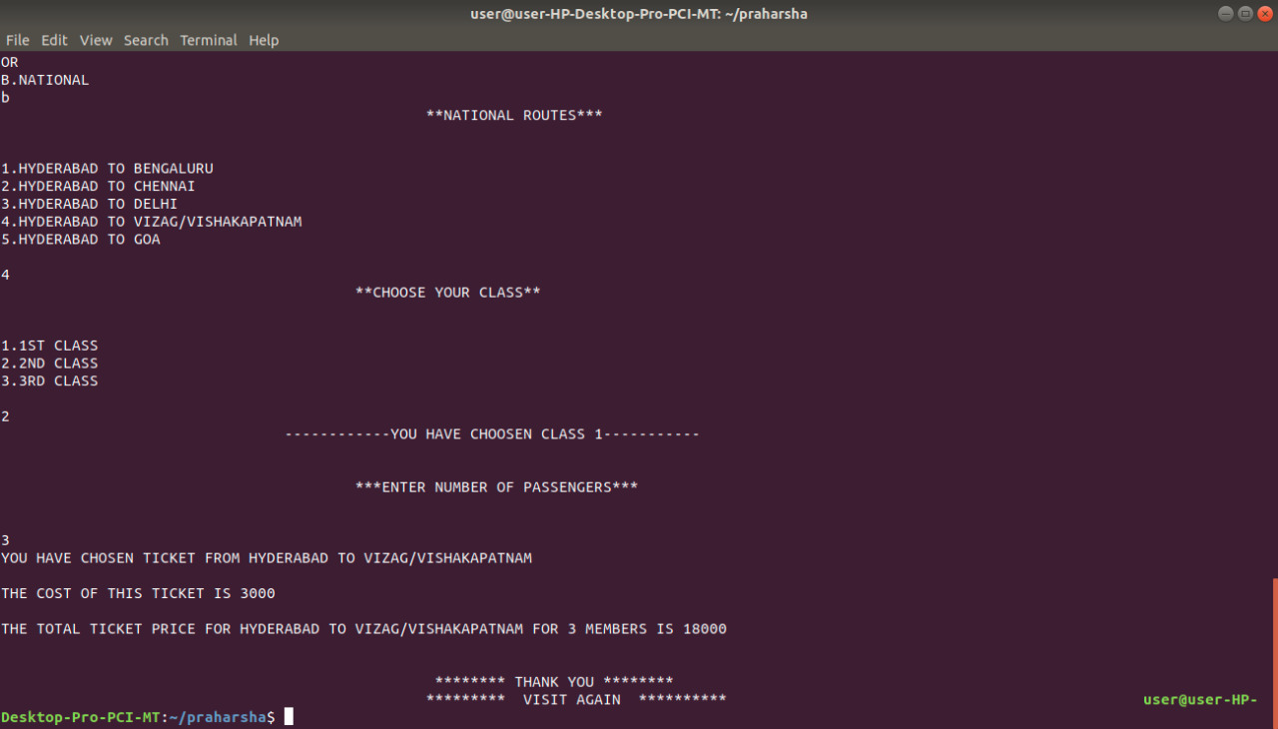

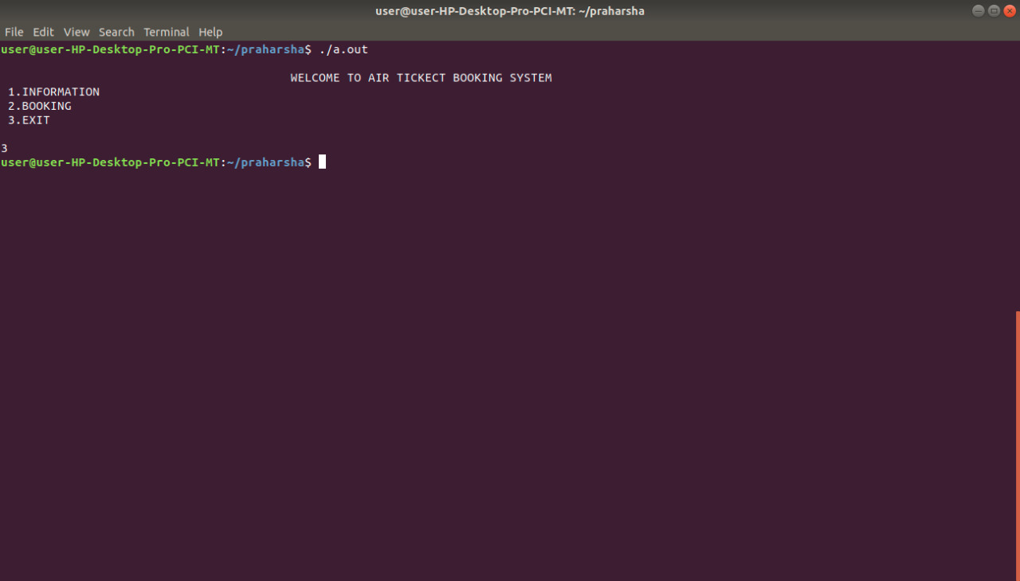

**Conclusion:**

The program we computed on AIR TICKET BOOKING helped us to learn what is behind the doors and how much of programming is needed to get small things done. It was exciting programming, learnt something new.

THANKS FOR THE OPPORTUNITY.