**CS3530 – Computer Networks**

**Assignment**

MS17BTECH11013  
 P. Pavan Kalyan

**Question 1:**

Integrate gedaddrinfo() as part of client

Sending the hostname of the server (localhost) for port 9898 with msg as “HI”.

From client code, executing the command.

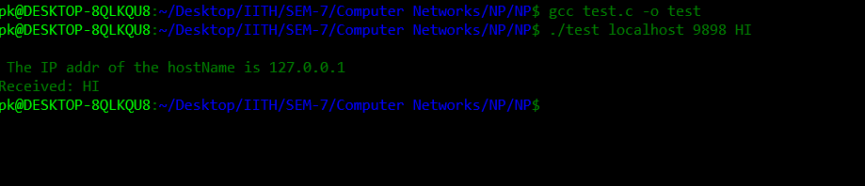

Client code successfully find the IP address for the hostname and prints the IP address.

Server code successfully received the message from the client code

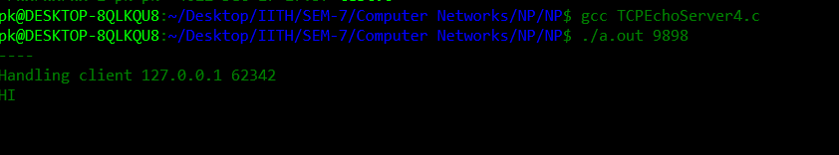

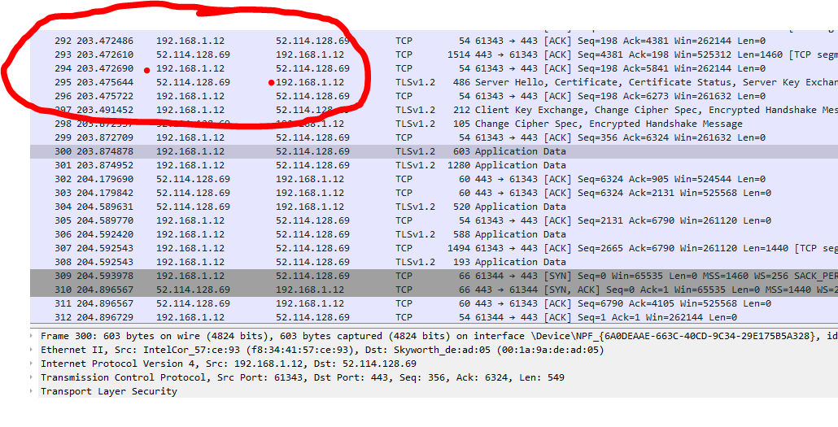

**Question 2:**

**Feature 1:**

I added the feature of **timestamp**.

The message delivered from the client is the timestamp at which it is delivered.

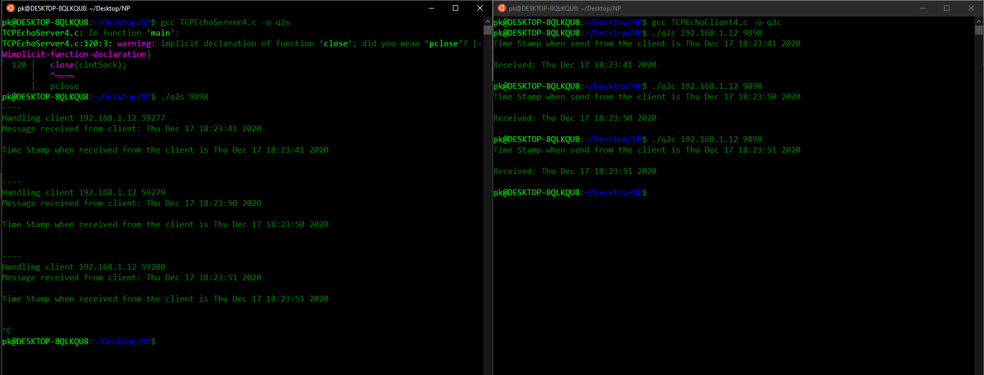

**Feature 2:**

I added the feature of **file sharing** between client and server.

From client:

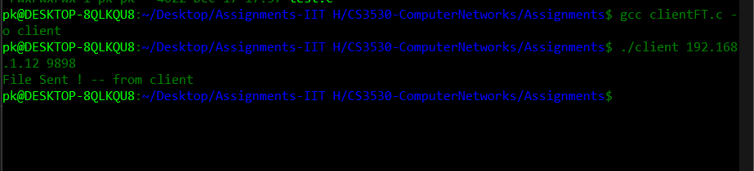

From server:

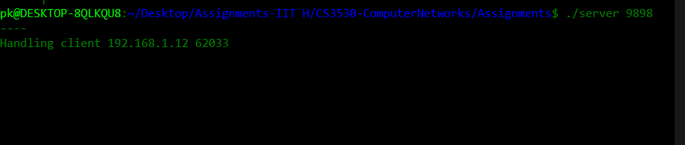

**References:**

<https://en.wikipedia.org/wiki/C_date_and_time_functions>

<https://www.youtube.com/watch?v=9g_nMNJhRVk>