**Tables:**

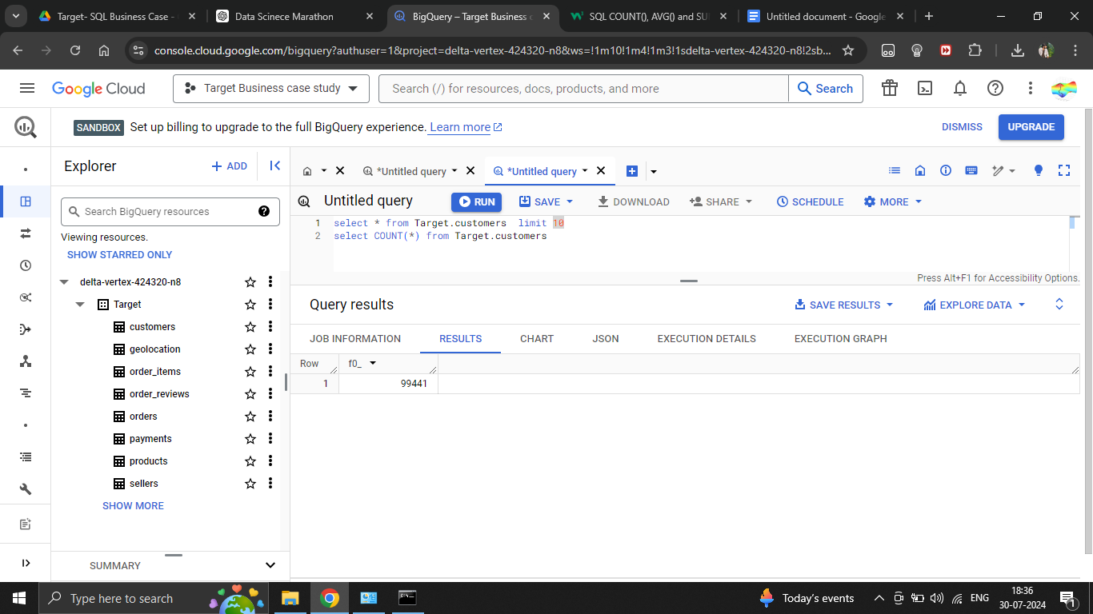

**Glimps of the tables:**

| **SL. No** | **Table Name** | **Screenshot** |
| --- | --- | --- |
| **1** | **Customers** |  |
| **2** | **geolocation** |  |
| **3** | **order_items** |  |
| **4** | **order_reviews** |  |
| **5** | **orders** |  |
| **6** | **payments** |  |
| **7** | **products** |  |
| **8** | **sellers** |  |

**Here how you can get the no. of rows of the tables.**

| **Table Name** | **Screenshot** |
| --- | --- |
| **Customers** |  |
| **geolocation** |  |
| **order_items** |  |
| **order_reviews** |  |
| **orders** |  |
| **payments** |  |
| **products** |  |
| **sellers** |  |