### Yearly Trend Analysis

#### Overview

This section examines the year-over-year trends in order volumes and revenues from 2016 to 2018, providing insights into the growth or variability in consumer purchasing behavior at Target in Brazil.

#### Findings

**- 2016:** The year started with 346 orders totaling a revenue of $59,836.24. This initial figure sets a baseline for comparison with subsequent years.

**- 2017:** There was a significant increase in orders and revenue, with a total of 47,525 orders generating $7,294,676.73. This indicates a robust growth, suggesting successful marketing strategies or expansion.

**- 2018:** The growth continued with even more orders and revenue; 56,015 orders brought in $8,969,763.05. The consistent increase suggests a strong market presence and possibly an expanding customer base.

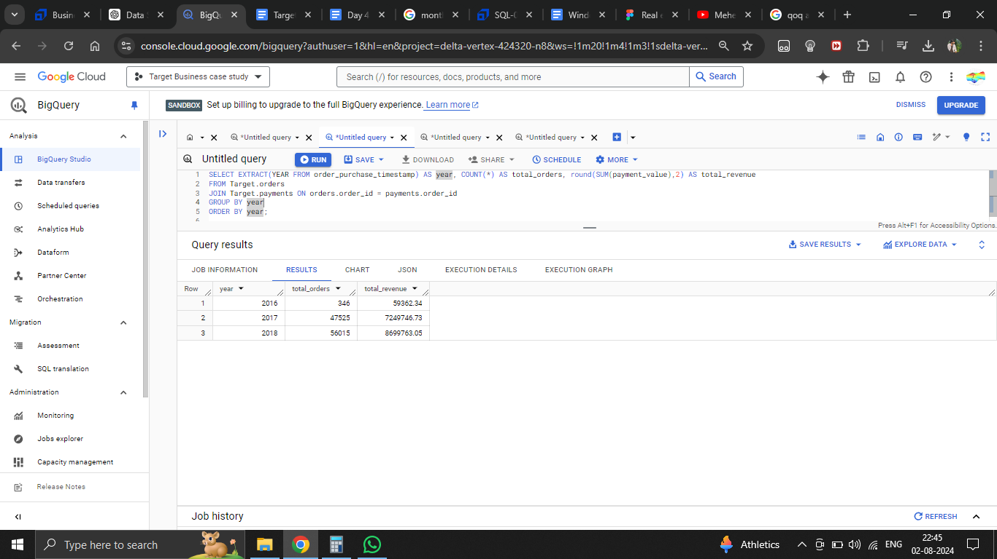

### Monthly Seasonality Analysis

#### Overview

This analysis focuses on the monthly distribution of orders throughout a typical year, aiming to identify peak sales periods and potential seasonal impacts on purchasing patterns.

#### Findings

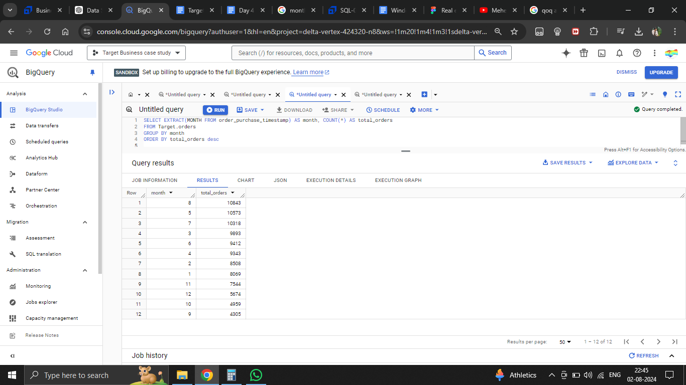

- The data shows a clear peak in order volume during August, with 10,843 orders, making it the busiest month for Target in Brazil. This could correlate with specific marketing campaigns, seasonal promotions, or holiday sales events.

- Following August, July and May also show high activity, with more than 10,000 orders each, which might be influenced by seasonal shopping habits or promotional activities.

- February has the fewest orders, with 8,508, which may be due to the shorter month or a lull after the holiday season.

- The least busy months, aside from February, include September and October, which see a noticeable dip in order volumes.

### Discussion

The year-over-year increase in both order volumes and revenues from 2016 to 2018 illustrates a positive growth trajectory for Target in Brazil, indicative of effective market penetration and possibly expanded inventory and service offerings. The monthly data adds another layer of insight, showing significant seasonality with a peak in the middle of the year and a notable drop towards the end. This seasonality could guide inventory management, staffing, and marketing efforts.

### Implications

**- Marketing Strategy:** Tailor marketing campaigns to leverage peak buying times, particularly in mid-year months. Consider targeted promotions during slower months to increase customer engagement.

**- Inventory Management:** Align inventory with expected seasonal demands, ensuring stock availability during peak months and optimized stock levels during slower periods.

**- Customer Engagement:** Develop loyalty programs or promotions that encourage purchases during off-peak months, smoothing out the variability in sales.

### Conclusion

The analysis clearly outlines the growth trend and seasonal patterns in Target's operations in Brazil. Understanding these patterns allows for strategic planning in marketing, inventory management, and customer engagement initiatives to capitalize on known peaks and augment troughs in sales.