SmartSure Insurance Management System
Low-Level Design (LLD) Document
Backend: ASP.NET Core 10 Microservices | Frontend: Angular 21
Version 1.0 | April 2026 | Complete and Authoritative

1. System Overview
SmartSure is a full-stack insurance management platform composed of four ASP.NET Core 10 microservices behind an Ocelot API Gateway, with an Angular 21 SPA as the client. Each service owns its own SQL Server 2022 database. Asynchronous inter-service communication uses RabbitMQ for email notifications. Authentication is JWT HS256 validated independently in every service.
1.1 Architecture Summary
Component | Technology | Port | Responsibility
Angular SPA | Angular 21 / TypeScript | 4200 | Customer and Admin UI; standalone components, reactive forms, functional guards and interceptors
API Gateway | Ocelot + SwaggerForOcelot | 5000 | Single entry-point: routing, CORS, JWT enforcement, aggregated Swagger UI
Identity Service | ASP.NET Core 10 | 5265 | Authentication, JWT (HS256), OTP email verification, BCrypt passwords, user management
Policy Service | ASP.NET Core 10 | 5145 | Policy types, premium calculation, policy creation, renewal, payment recording
Claims Service | ASP.NET Core 10 | 5084 | Claims lifecycle, document uploads, status state machine, claim statistics
Admin Service | ASP.NET Core 10 | 5073 | Dashboard aggregation, audit logs, report generation, user and claim management
RabbitMQ | rabbitmq:3-management (Docker) | 5672 / 15672 | Async message bus for claim status email notifications
SQL Server | mcr.microsoft.com/mssql/server:2022 | 1433 | 4 isolated databases, one per microservice, auto-migrated on startup

1.2 Cross-Cutting Concerns
- Authentication: JWT Bearer (HS256). Token issued by Identity Service; all other services validate using shared SecretKey, Issuer, and Audience from appsettings / environment variables.
- Token Expiry: 8 hours. Configured via JwtSettings:ExpiryHours in appsettings.json.
- Logging: Serilog console logging enabled in all four services and the API Gateway.
- Error Handling: GlobalExceptionMiddleware in each service's API/Middlewares folder maps typed domain exceptions to structured JSON responses. Domain exceptions carry an int StatusCode property. The middleware logs domain exceptions as Warning and unexpected exceptions as Error.
- Repository Pattern: All services use repository interfaces (IAuthRepository, IPolicyRepository, IClaimRepository, IAdminRepository) with EF Core implementations. AdminService additionally uses IHttpClientFactory for downstream HTTP calls.
- Auto-Migration: All four services call db.Database.Migrate() on startup, creating and updating their databases automatically.
- Environment Config: Services read connection strings and JWT settings from environment variables injected by Docker Compose (ConnectionStrings__DefaultConnection, JwtSettings__SecretKey, etc.).
1.3 Clean Architecture Layers (per service)
Layer | Project Suffix | Responsibility
API | *.API | Controllers, middleware, Program.cs, Swagger configuration
Application | *.Application | DTOs, service interfaces, service implementations, custom exceptions
Domain | *.Domain | Entities, enums, repository interfaces
Infrastructure | *.Infrastructure | EF Core DbContext, migrations, repository implementations, external services (email, RabbitMQ)

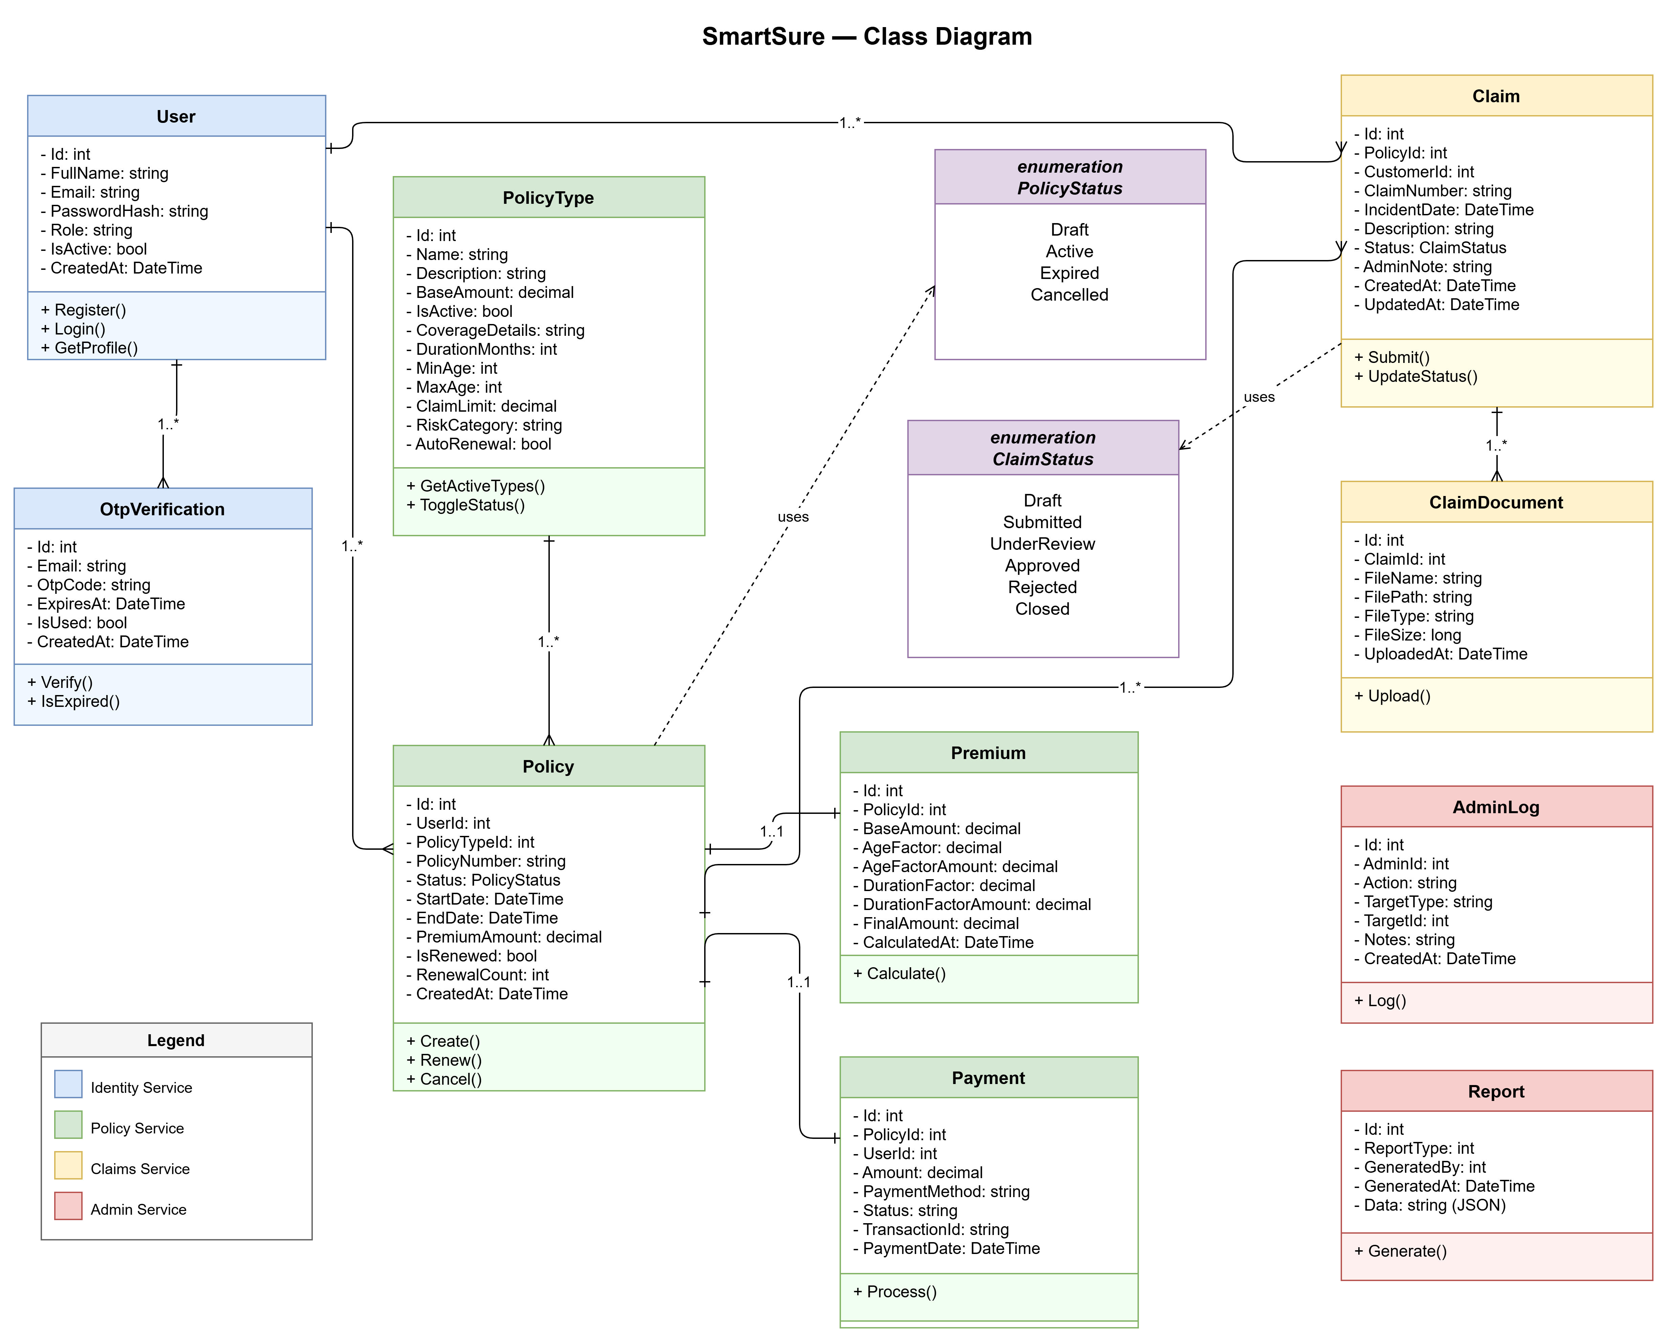

2. Work Breakdown Structure (WBS)
The following WBS decomposes the SmartSure project into hierarchical deliverables and work packages, organized by major development phases.

2.1 Project Planning & Design
• 1.1 Requirements Analysis: Gather functional and non-functional requirements from stakeholders
• 1.2 System Architecture Design: Define microservices architecture, API Gateway, and communication patterns
• 1.3 Database Schema Design: Design normalized schemas for Identity, Policy, Claims, and Admin databases
• 1.4 Technology Stack Selection: Finalize ASP.NET Core 10, Angular 21, SQL Server 2022, RabbitMQ, Docker
• 1.5 Security Design: Define JWT authentication, BCrypt password hashing, OTP verification flow

2.2 Backend Development - Identity Service
• 2.1 User Entity & Repository: Implement User model, IAuthRepository interface, EF Core DbContext
• 2.2 Registration & OTP Verification: Build send-otp, verify-register, resend-otp endpoints with 15-min expiry
• 2.3 Login & JWT Generation: Implement BCrypt verification, JWT token generation with HS256
• 2.4 Password Reset Flow: Build forgot-password/send-otp and forgot-password/reset endpoints
• 2.5 Admin User Management: Implement get-all-users, get-user-by-id, update-user-status endpoints
• 2.6 RabbitMQ Consumer: Build ClaimNotificationConsumer for claim status email notifications
• 2.7 Email Service Integration: Integrate MailKit with Gmail SMTP for OTP and notification emails

2.3 Backend Development - Policy Service
• 3.1 PolicyType Entity & CRUD: Implement PolicyType model with coverage details, admin CRUD endpoints
• 3.2 Premium Calculation Engine: Build age factor (18-25, 26-40, 41-55, 56+) and duration factor logic
• 3.3 Policy Creation: Implement POST /policies with Premium and Payment record creation
• 3.4 Policy Renewal: Build renewal logic with 1-year extension, fixed durationFactor=0.10
• 3.5 Payment Recording: Implement Payment entity with TransactionId generation (TXN-{ticks}, TXN-RENEW-{ms})
• 3.6 My Policies Endpoint: Build GET /policies/my for customer policy listing
• 3.7 Admin Policy Management: Implement policy status update and statistics endpoints

2.4 Backend Development - Claims Service
• 4.1 Claim Entity & State Machine: Implement Claim model with status enum (Draft, Submitted, UnderReview, Approved, Rejected, Closed)
• 4.2 Claim Creation & Submission: Build POST /claims (Draft) and POST /claims/{id}/submit (Submitted)
• 4.3 Document Upload: Implement multipart/form-data upload to wwwroot/uploads/{claimId}/
• 4.4 Document Deletion: Build DELETE /claims/{claimId}/documents/{docId} with Draft-only restriction
• 4.5 Status Transition Validation: Enforce state machine rules (e.g., Draft → Submitted → UnderReview → Approved)
• 4.6 My Claims Endpoint: Build GET /claims/my for customer claim listing with documents
• 4.7 Admin Claims Statistics: Implement GET /claims/admin/stats with counts by status

2.5 Backend Development - Admin Service
• 5.1 Dashboard Aggregation: Build parallel HTTP calls to Identity, Policy, Claims services for summary
• 5.2 Claims Review: Implement GET /admin/claims and PUT /admin/claims/status with AdminLog creation
• 5.3 User Management: Build GET /admin/users and PUT /admin/users/{id}/status endpoints
• 5.4 Report Generation: Implement GET /admin/reports/generate with JSON serialization to AdminDB
• 5.5 Audit Logging: Create AdminLog entity with action, targetType, targetId, notes, createdAt
• 5.6 RabbitMQ Publisher: Build NotificationPublisher for fire-and-forget claim status notifications
• 5.7 Background Task: Implement Task.Run with IHttpClientFactory for customer email fetch

2.6 API Gateway Configuration
• 6.1 Ocelot Route Configuration: Define upstream/downstream routes for all four services
• 6.2 JWT Validation Middleware: Configure shared JWT validation with SecretKey, Issuer, Audience
• 6.3 CORS Policy: Set up AllowAngular policy for http://localhost:4200
• 6.4 Swagger Aggregation: Integrate SwaggerForOcelot to aggregate all service Swagger UIs
• 6.5 Environment-Specific Config: Create ocelot.json (Development) and ocelot.Docker.json (Docker)

2.7 Frontend Development - Customer Portal
• 7.1 Authentication Module: Build login, register, OTP verification, forgot-password components
• 7.2 Policy Purchase Flow: Create 3-step wizard (select type, calculate premium, Razorpay payment)
• 7.3 My Policies Page: Build policy listing with status badges, renewal button, payment history
• 7.4 Claims Management: Create claim form, document upload, submission, and status tracking
• 7.5 Dashboard: Build customer dashboard with active policies, pending claims, recent payments
• 7.6 Auth Interceptor: Implement JWT token attachment to all HTTP requests
• 7.7 Route Guards: Build can Activate guards for CUSTOMER and ADMIN role-based routing

2.8 Frontend Development - Admin Portal
• 8.1 Admin Dashboard: Build aggregated statistics cards (users, policies, claims, revenue)
• 8.2 Claims Review Panel: Create slide-in panel with claim details, documents, status update form
• 8.3 User Management: Build user listing table with activate/deactivate toggle
• 8.4 Policy Type Management: Create CRUD interface for PolicyType with coverage details
• 8.5 Reports Generation: Build report type selector and download functionality
• 8.6 Audit Logs Viewer: Create AdminLog listing with filters by action, targetType, date range

2.9 Integration & Messaging
• 9.1 RabbitMQ Setup: Configure rabbitmq:3-management Docker container with durable queues
• 9.2 Claim Status Notification Flow: Integrate AdminService publisher → IdentityService consumer
• 9.3 Email Template Design: Create HTML email templates with color-coded status badges
• 9.4 Connection Resilience: Implement auto-reconnect logic with 5-second retry delay
• 9.5 Message Persistence: Configure persistent messages and durable queues for reliability

2.10 Testing
• 10.1 Identity Service Tests: Write 31 NUnit tests covering OTP flow, login, password reset (98% coverage)
• 10.2 Policy Service Tests: Write 34 NUnit tests covering premium calculation, renewal, payments (97% coverage)
• 10.3 Claims Service Tests: Write 30 NUnit tests covering state machine, documents, access control (95% coverage)
• 10.4 Admin Service Tests: Write 22 NUnit tests covering aggregation, status updates, audit logs (90% coverage)
• 10.5 Integration Testing: Test end-to-end flows (registration → policy purchase → claim submission → admin review)
• 10.6 API Gateway Testing: Verify routing, JWT validation, CORS, Swagger aggregation

2.11 Infrastructure & Deployment
• 11.1 Docker Compose Configuration: Define 8 services (SQL Server, RabbitMQ, 4 microservices, Gateway, Frontend)
• 11.2 Database Migration: Implement auto-migration on startup (db.Database.Migrate()) for all services
• 11.3 Environment Variables: Configure connection strings, JWT settings, RabbitMQ credentials via docker-compose.yml
• 11.4 Health Checks: Add SQL Server and RabbitMQ health checks with depends_on conditions
• 11.5 Nginx Configuration: Set up Nginx reverse proxy for Angular SPA with /gateway/ API routing
• 11.6 Production Deployment: Deploy to cloud (Azure/AWS) with managed SQL, RabbitMQ, container orchestration

2.12 Documentation
• 12.1 Low-Level Design (LLD): Create comprehensive LLD document with architecture, APIs, data models, flows
• 12.2 API Documentation: Generate Swagger/OpenAPI specs for all four microservices
• 12.3 Sequence Diagrams: Create diagrams for key flows (registration, policy purchase, claim review, renewal)
• 12.4 ER Diagram: Design entity-relationship diagram showing all 10 entities across 4 databases
• 12.5 Deployment Guide: Write Docker setup instructions, environment configuration, troubleshooting
• 12.6 User Manual: Create end-user documentation for customer and admin portal features.

3. API Gateway (Ocelot)
Port: 5000 | Technology: Ocelot 24.1.0 + SwaggerForOcelot
Single entry-point for the Angular SPA. Handles routing, CORS, JWT validation, and aggregated Swagger UI. Loads ocelot.json in Development and ocelot.Docker.json in Docker environments.
3.1 Route Table
Upstream Path (Client calls) | Downstream Path | Service Port | Auth Required
POST /gateway/auth/register | /api/auth/register | Identity 5265 | No
POST /gateway/auth/login | /api/auth/login | Identity 5265 | No
POST /gateway/auth/send-otp | /api/auth/send-otp | Identity 5265 | No
POST /gateway/auth/verify-register | /api/auth/verify-register | Identity 5265 | No
POST /gateway/auth/resend-otp | /api/auth/resend-otp | Identity 5265 | No
POST /gateway/auth/forgot-password/send-otp | /api/auth/forgot-password/send-otp | Identity 5265 | No
POST /gateway/auth/forgot-password/reset | /api/auth/forgot-password/reset | Identity 5265 | No
GET|POST|PUT|DELETE /gateway/auth/{everything} | /api/auth/{everything} | Identity 5265 | Bearer JWT
POST /gateway/policies/{id}/renew | /api/policies/{id}/renew | Policy 5145 | Bearer JWT
GET|POST|PUT|DELETE /gateway/policies/{everything} | /api/policies/{everything} | Policy 5145 | Bearer JWT
GET|POST|PUT|DELETE /gateway/claims/{everything} | /api/claims/{everything} | Claims 5084 | Bearer JWT
GET|POST|PUT|DELETE /gateway/admin/{everything} | /api/admin/{everything} | Admin 5073 | Bearer JWT

3.2 CORS Policy
Policy name: AllowAngular. Permits all HTTP methods and headers from http://localhost:4200 (local development). In Docker, the Angular frontend is served by Nginx which proxies /gateway/ calls to the api-gateway container on the internal Docker network.
3.3 Swagger Aggregation
SwaggerForOcelot aggregates Swagger JSON from all four downstream services and presents a unified API explorer at /swagger on the gateway. Swagger endpoints:
- Identity Service: http://localhost:5265/swagger/v1/swagger.json
- Policy Service: http://localhost:5145/swagger/v1/swagger.json
- Claims Service: http://localhost:5084/swagger/v1/swagger.json
- Admin Service: http://localhost:5073/swagger/v1/swagger.json
4. Identity Service
Port: 5265 | Database: SmartSure_IdentityDB | Route prefix: /api/auth
4.1 Data Models
User (Primary Entity)
Property | Type | Notes
Id | int (PK) | Auto-increment primary key
FullName | string | Required; stored in Title Case
Email | string | Required; stored lowercase; unique
PasswordHash | string | BCrypt hash of the user password
Role | string | CUSTOMER or ADMIN
IsActive | bool | Default true; set false by admin to deactivate account
CreatedAt | DateTime (UTC) | Auto-set at account creation

OtpVerification (Supporting Entity)
Property | Type | Notes
Id | int (PK) | Auto-increment primary key
Email | string | Email address the OTP was sent to
OtpCode | string | 6-digit numeric code
ExpiresAt | DateTime (UTC) | 15 minutes from creation
IsUsed | bool | Set true after successful verification; prevents reuse

4.2 API Endpoints
Verb | Path | Auth | Description
POST | /api/auth/register | None | Triggers OTP send; returns 202 Accepted with requiresOtpVerification=true
POST | /api/auth/send-otp | None | Sends 6-digit OTP to email; upserts OtpVerification record with 15-min expiry
POST | /api/auth/verify-register | None | Validates OTP; creates User account; returns JWT token
POST | /api/auth/resend-otp | None | Regenerates and resends OTP for the given email
POST | /api/auth/login | None | Validates BCrypt hash; checks IsActive; returns JWT token
POST | /api/auth/forgot-password/send-otp | None | Sends password reset OTP to registered email
POST | /api/auth/forgot-password/reset | None | Validates OTP; updates BCrypt password hash
GET | /api/auth/profile | [Authorize] | Returns authenticated user profile from JWT NameIdentifier claim
GET | /api/auth/admin/users | [ADMIN] | Returns all users with Id, FullName, Email, Role, IsActive, CreatedAt
GET | /api/auth/admin/users/{userId} | [ADMIN] | Returns profile for a specific user by ID
GET | /api/auth/admin/users/count | [ADMIN] | Returns totalUsers, activeUsers, inactiveUsers counts
PUT | /api/auth/admin/users/{userId}/status | [ADMIN] | Sets IsActive flag for a user (activate or deactivate)

4.3 Service Layer — AuthService
- SendRegistrationOtpAsync: Checks email uniqueness (throws EmailAlreadyRegisteredException if exists). Generates 6-digit OTP via RandomNumberGenerator.GetInt32. Calls IAuthRepository.UpsertOtpAsync to store with 15-minute expiry. Calls IEmailService.SendOtpEmailAsync.
- VerifyRegistrationOtpAsync: Checks email uniqueness again. Retrieves latest OTP record. Throws OtpNotFoundException if null or IsUsed=true. Throws OtpExpiredException if ExpiresAt < UtcNow. Throws InvalidOtpException if code mismatch (ordinal comparison). Creates User with BCrypt-hashed password and role CUSTOMER. Marks OTP as used.
- LoginAsync: Retrieves user by email. Throws InvalidCredentialsException if null or BCrypt.Verify fails. Throws AccountDeactivatedException if IsActive=false. Returns AuthResponseDto (token generated by JwtHelper in controller).
- SendPasswordResetOtpAsync: Looks up user by email. Throws UserNotFoundException if not found. Generates OTP, upserts record, sends email.
- ResetPasswordAsync: Validates OTP (same checks as registration). Hashes new password with BCrypt. Calls UpdatePasswordAsync. Marks OTP as used.
- GetAllUsersAsync / GetProfileAsync / UpdateUserStatusAsync: Admin operations delegating to IAuthRepository.
4.4 JWT Token Generation (JwtHelper)
- Algorithm: HS256 (HMAC-SHA256)
- Claims: ClaimTypes.NameIdentifier (user Id as string), ClaimTypes.Email, ClaimTypes.Role
- Expiry: Configured via JwtSettings:ExpiryHours (default 8 hours)
- Signing key: UTF-8 bytes of JwtSettings:SecretKey
- Issuer / Audience: JwtSettings:Issuer and JwtSettings:Audience (shared across all services)
4.5 RabbitMQ Consumer — ClaimNotificationConsumer
- Type: BackgroundService (IHostedService)
- Queue: claim.status.notification (durable, persistent messages)
- On message received: Deserialises ClaimStatusNotificationDto. Resolves scoped IEmailService via IServiceScopeFactory. Calls SendClaimStatusEmailAsync with colour-coded HTML template.
- Reconnection: Auto-reconnects on RabbitMQ disconnect with 5-second retry delay.
- Email colours: Approved=green, Rejected=red, UnderReview=purple, Closed=grey
4.6 Custom Exceptions
Exception Class | HTTP Status | Thrown When
EmailAlreadyRegisteredException | 409 Conflict | Registration attempted with an already-registered email
UserNotFoundException | 404 Not Found | Password reset OTP requested for non-existent email
InvalidCredentialsException | 401 Unauthorized | Login with wrong email or wrong password
AccountDeactivatedException | 401 Unauthorized | Login attempted on a deactivated account
OtpNotFoundException | 400 Bad Request | OTP verification attempted with no active OTP record
OtpExpiredException | 400 Bad Request | OTP submitted after the 15-minute expiry window
InvalidOtpException | 400 Bad Request | OTP code submitted does not match the stored code

5. Policy Service
Port: 5145 | Database: SmartSure_PolicyDB | Route prefix: /api/policies
5.1 Data Models
PolicyType (Configuration Entity)
Property | Type | Notes
Id | int (PK) | Auto-increment primary key
Name | string | e.g. Health Insurance, Auto Insurance
Description | string | Short description shown to customers
BaseAmount | decimal | Base premium amount before age/duration factors
IsActive | bool | Only active types shown on buy-policy page
CoverageDetails | string | What is covered (shown in buy-policy UI)
Exclusions | string | What is not covered (shown in buy-policy UI)
ClaimLimit | decimal | Maximum claim payout amount
MinAge / MaxAge | int | Eligible age range for this policy type
DurationMonths | int | Standard policy duration in months
RiskCategory | string | Low, Medium, or High
AutoRenewal | bool | Whether the policy supports auto-renewal
GracePeriodDays | int | Grace period after expiry before cancellation

Policy (Core Entity)
Property | Type | Notes
Id | int (PK) | Auto-increment primary key
UserId | int | References Identity user (no cross-service FK constraint)
PolicyTypeId | int (FK) | References PolicyType
PolicyNumber | string | Unique identifier: POL-{DateTime.UtcNow.Ticks}
Status | PolicyStatus enum | Active, Expired, Cancelled, Draft
StartDate / EndDate | DateTime (UTC) | Coverage period
PremiumAmount | decimal | Final calculated premium
IsRenewed | bool | True if this policy has been renewed at least once
RenewalCount | int | Number of times this policy has been renewed
CreatedAt | DateTime (UTC) | Auto-set at creation
Premium | Navigation | One-to-one: stores BaseAmount, AgeFactor, DurationFactor, FinalAmount

Payment (Supporting Entity)
Property | Type | Notes
Id | int (PK) | Auto-increment primary key
PolicyId | int (FK) | References Policy
UserId | int | References Identity user
Amount | decimal | Payment amount
PaymentMethod | string | Online (Razorpay)
Status | string | Success, Failed, Pending
TransactionId | string | TXN-{ticks} for new policies; TXN-RENEW-{ms} for renewals
PaymentDate | DateTime (UTC) | Auto-set at creation

5.2 API Endpoints
Verb | Path | Auth | Description
GET | /api/policies/types | None (public) | List all active policy types with full coverage details
GET | /api/policies/types/{id} | None (public) | Get a specific policy type by ID
POST | /api/policies/calculate-premium | [Authorize] | Calculate premium breakdown; no database write
POST | /api/policies | [Authorize] | Create policy with Active status; record payment
GET | /api/policies/my | [Authorize] | Get all policies for the authenticated user
GET | /api/policies/{id} | [Authorize] | Get a specific policy by ID
GET | /api/policies/{id}/payment | [Authorize] | Get payment record for a policy
GET | /api/policies/my/payments | [CUSTOMER] | Get all payment records for the authenticated user
POST | /api/policies/{id}/renew | [Authorize] | Renew an Active or Expired policy for 1 year
PUT | /api/policies/{id}/status | [ADMIN] | Update policy status (Admin only)
GET | /api/policies/admin/count | [ADMIN] | Returns totalPolicies and totalRevenue
GET | /api/policies/admin/types | [ADMIN] | List all policy types including inactive ones with enrolled count
POST | /api/policies/admin/types | [ADMIN] | Create a new policy type
PUT | /api/policies/admin/types/{id} | [ADMIN] | Update an existing policy type
PUT | /api/policies/admin/types/{id}/toggle | [ADMIN] | Toggle IsActive status of a policy type
DELETE | /api/policies/admin/types/{id} | [ADMIN] | Delete a policy type
GET | /api/policies/admin/types/{id}/stats | [ADMIN] | Get total policies, active policies, and total premium for a type

5.3 Premium Calculation Logic
Implemented in PolicyAppService.CalculatePremiumAsync. The formula is additive:
Final Premium = Base Amount + Age Factor Amount + Duration Factor Amount
Parameter | Rule
Age Factor — 18 to 25 years | +10% of Base Amount
Age Factor — 26 to 40 years | +0% (no surcharge)
Age Factor — 41 to 55 years | +20% of Base Amount
Age Factor — 56 years and above | +50% of Base Amount
Duration Factor — 1 Year | +(1-1)+0.10 = 0.10 = +10% of Base Amount
Duration Factor — 2 Years | +(2-1)+0.10 = 1.10 = +110% of Base Amount
Duration Factor — 3 Years | +(3-1)+0.10 = 2.10 = +210% of Base Amount
Duration Factor — N Years | +(N-1)+0.10 = +(N-0.9)*100% of Base Amount
Duration Calculation | Math.Ceiling(totalDays / 365.0) — partial years round up
Renewal Duration Factor | Always fixed at 0.10 (1-year rate) regardless of original duration

5.4 Service Layer — PolicyAppService
- GetAllPolicyTypesAsync: Returns all active policy types with full coverage details mapped to PolicyTypeResponseDto.
- CalculatePremiumAsync: Looks up PolicyType. Calculates years = Ceiling(days/365). Applies age and duration factors. Returns PremiumResponseDto with BaseAmount, AgeFactor, AgeFactorAmount, DurationFactor, DurationFactorAmount, DurationYears, FinalAmount, AgeGroup, FormulaExplanation.
- CreatePolicyAsync: Calls CalculatePremiumAsync. Creates Policy with status Active and PolicyNumber=POL-{ticks}. Creates Premium record. Creates Payment record with TransactionId=TXN-{ticks}.
- RenewPolicyAsync: Validates ownership (throws PolicyAccessDeniedException if UserId mismatch). Validates status is Active or Expired (throws PolicyNotRenewableException otherwise). Calculates renewal premium with fixed durationFactor=0.10. Updates Policy dates, status, IsRenewed=true, RenewalCount+=1. Creates Payment with TransactionId=TXN-RENEW-{ms}.
- UpdatePolicyStatusAsync: Parses status string to PolicyStatus enum (throws InvalidPolicyStatusException if invalid). Updates policy status.
5.5 Custom Exceptions
Exception Class | HTTP Status | Thrown When
PolicyTypeNotFoundException | 404 Not Found | Policy type ID not found in database
PolicyNotFoundException | 404 Not Found | Policy ID not found in database
PaymentNotFoundException | 404 Not Found | No payment record found for the given policy ID
PolicyAccessDeniedException | 403 Forbidden | Renewal attempted on a policy owned by a different user
PolicyNotRenewableException | 400 Bad Request | Renewal attempted on a policy in Draft or Cancelled status
InvalidPolicyStatusException | 400 Bad Request | Admin submits an unrecognised status string

6. Claims Service
Port: 5084 | Database: SmartSure_ClaimsDB | Route prefix: /api/claims
6.1 Data Models
Claim (Core Entity)
Property | Type | Notes
Id | int (PK) | Auto-increment primary key
PolicyId | int | References Policy Service (no cross-service FK constraint)
CustomerId | int | References Identity user
ClaimNumber | string | Unique identifier: CLM-{DateTime.UtcNow.Ticks}
IncidentDate | DateTime | Date the incident occurred
Description | string | Required; trimmed on creation
Status | ClaimStatus enum | Draft, Submitted, UnderReview, Approved, Rejected, Closed
AdminNote | string? | Optional note added by admin on status update
CreatedAt / UpdatedAt | DateTime (UTC) | Audit timestamps; UpdatedAt refreshed on every change
ClaimDocuments | Navigation | Collection of ClaimDocument records

ClaimDocument (Supporting Entity)
Property | Type | Notes
Id | int (PK) | Auto-increment primary key
ClaimId | int (FK) | References Claim
FileName | string | Original file name
FilePath | string | Server path under wwwroot/uploads/{claimId}/
FileType | string | MIME type (e.g. application/pdf, image/jpeg)
FileSize | long | File size in bytes
UploadedAt | DateTime (UTC) | Auto-set at upload

6.2 Claim Status Lifecycle
Status | Triggered By | Allowed Next Statuses | Notes
Draft | Customer creates claim | Submitted | Starting state; documents can be uploaded and deleted
Submitted | Customer submits claim | UnderReview | No edits allowed; RabbitMQ event published
UnderReview | Admin sets review | Approved, Rejected | Admin is actively reviewing the claim
Approved | Admin approves | Closed | Admin note recorded; email notification sent to customer
Rejected | Admin rejects | Closed | Admin note recorded; email notification sent to customer
Closed | Admin closes | None (terminal) | Final state; no further transitions allowed

6.3 API Endpoints
Verb | Path | Auth | Description
POST | /api/claims | [CUSTOMER] | Create claim in Draft status
POST | /api/claims/{id}/submit | [CUSTOMER] | Transition Draft to Submitted; publish RabbitMQ event
POST | /api/claims/{id}/documents | [CUSTOMER] | Upload document (multipart/form-data); save to wwwroot/uploads/{id}/
DELETE | /api/claims/{claimId}/documents/{docId} | [CUSTOMER] | Delete document (only allowed on Draft claims)
GET | /api/claims/my | [CUSTOMER] | Get all claims for the authenticated customer
GET | /api/claims/{id} | [Authorize] | Get a specific claim with documents
GET | /api/claims | [ADMIN] | Get all claims across all customers
PUT | /api/claims/{id}/status | [ADMIN] | Update claim status with admin note; enforces state machine
GET | /api/claims/admin/stats | [ADMIN] | Returns counts by status: total, draft, submitted, underReview, approved, rejected, closed

6.4 Service Layer — ClaimAppService
- CreateClaimAsync: Creates Claim with status Draft, ClaimNumber=CLM-{ticks}, trimmed Description.
- SubmitClaimAsync: Validates claim exists (ClaimNotFoundException). Validates ownership (ClaimAccessDeniedException). Validates status is Draft (ClaimAlreadySubmittedException). Transitions to Submitted.
- UpdateClaimStatusAsync: Validates claim exists. Parses status string to ClaimStatus enum (InvalidClaimStatusException if invalid). Enforces state machine via switch expression (InvalidClaimStatusTransitionException if invalid transition). Updates status and AdminNote.
- AddDocumentAsync: Validates claim exists. Saves file via FileStorageService to wwwroot/uploads/{claimId}/. Creates ClaimDocument record. Returns FileUrl with wwwroot prefix stripped.
- DeleteDocumentAsync: Validates claim exists and ownership. Validates status is Draft (ClaimNotEditableException). Validates document exists (ClaimDocumentNotFoundException). Validates document belongs to claim (DocumentClaimMismatchException). Deletes physical file if it exists. Deletes ClaimDocument record.
- GetClaimsStatsAsync: Returns anonymous object with counts for each ClaimStatus value.
6.5 Custom Exceptions
Exception Class | HTTP Status | Thrown When
ClaimNotFoundException | 404 Not Found | Claim ID not found in database
ClaimDocumentNotFoundException | 404 Not Found | Document ID not found in database
ClaimAccessDeniedException | 403 Forbidden | Customer attempts to act on a claim they do not own
ClaimAlreadySubmittedException | 400 Bad Request | Submit attempted on a claim not in Draft status
InvalidClaimStatusException | 400 Bad Request | Admin submits an unrecognised status string
InvalidClaimStatusTransitionException | 400 Bad Request | Status transition violates the state machine rules
ClaimNotEditableException | 400 Bad Request | Document operation attempted on a non-Draft claim
DocumentClaimMismatchException | 400 Bad Request | Document ID does not belong to the specified claim

7. Admin Service
Port: 5073 | Database: SmartSure_AdminDB | Route prefix: /api/admin
The Admin Service is an orchestrator, not a data owner. It aggregates data from the three domain services via direct HTTP calls (forwarding the JWT Bearer token) and maintains its own AdminDB for audit logs and reports.
7.1 Data Models
AdminLog (Audit Entity)
Property | Type | Notes
Id | int (PK) | Auto-increment primary key
AdminId | int | ID of the admin who performed the action
Action | string | UpdateClaimStatus, UpdateUserStatus, GenerateReport
TargetType | string | Claim, User, Report
TargetId | int | ID of the entity acted upon
Notes | string? | Optional notes (e.g. admin note on claim, new IsActive value)
CreatedAt | DateTime (UTC) | Timestamp of the action

Report (Reporting Entity)
Property | Type | Notes
Id | int (PK) | Auto-increment primary key
ReportType | ReportType enum | ClaimsSummary, UserSummary, PolicySummary, RevenueSummary
GeneratedBy | int | Admin user ID
GeneratedAt | DateTime (UTC) | Timestamp of generation
Data | string | Serialised JSON of the DashboardSummaryDto at time of generation

7.2 API Endpoints
Verb | Path | Auth | Description
GET | /api/admin/dashboard | [ADMIN] | Aggregates totalUsers, activeUsers, totalPolicies, totalRevenue, totalClaims, pendingClaims, approvedClaims, rejectedClaims, closedClaims
GET | /api/admin/claims | [ADMIN] | Proxies GET /api/claims to ClaimsService; returns all claims
GET | /api/admin/claims/pending | [ADMIN] | Returns claims with status Submitted or UnderReview
PUT | /api/admin/claims/status | [ADMIN] | Updates claim status in ClaimsService; logs action; fires RabbitMQ notification
GET | /api/admin/users | [ADMIN] | Proxies GET /api/auth/admin/users to IdentityService
PUT | /api/admin/users/{userId}/status | [ADMIN] | Proxies PUT to IdentityService; logs action in AdminLog
GET | /api/admin/reports/generate | [ADMIN] | Generates and persists a report; logs action
GET | /api/admin/logs | [ADMIN] | Returns all AdminLog records

7.3 Service Layer — AdminAppService
- GetDashboardSummaryAsync: Fires three parallel HTTP calls using Task.WhenAll. Calls IdentityService /api/auth/admin/users/count, PolicyService /api/policies/admin/count, ClaimsService /api/claims/admin/stats. Aggregates into DashboardSummaryDto. If any downstream call fails, logs a Warning and returns partial data.
- UpdateClaimStatusAsync: Pre-fetches claim details (claimNumber, customerId, oldStatus) from ClaimsService. Sends PUT to ClaimsService /api/claims/{id}/status. Creates AdminLog entry. Fires fire-and-forget background task: fetches customer email from IdentityService using IHttpClientFactory (scope-independent), publishes ClaimStatusNotificationDto to RabbitMQ queue claim.status.notification.
- UpdateUserStatusAsync: Sends PUT to IdentityService /api/auth/admin/users/{userId}/status. Creates AdminLog entry.
- GenerateReportAsync: Calls GetDashboardSummaryAsync. Parses reportType to ReportType enum (defaults to ClaimsSummary if unrecognised). Creates Report record with serialised JSON data. Creates AdminLog entry.
- GetAdminLogsAsync: Returns all AdminLog records from AdminDB.
7.4 Fire-and-Forget Notification Pattern
The RabbitMQ notification is published as a fire-and-forget background task to ensure the API response is never blocked by email delivery:
- Admin calls PUT /api/admin/claims/status.
- AdminService pre-fetches claim details from ClaimsService.
- AdminService sends the status update to ClaimsService.
- AdminService creates an AdminLog entry.
- AdminService captures the JWT token from the current HttpContext (before the scope is disposed).
- AdminService starts a background Task using IHttpClientFactory.CreateClient() with its own 25-second timeout and a separate CancellationTokenSource(30s).
- Background task fetches customer email from IdentityService.
- Background task publishes ClaimStatusNotificationDto to the claim.status.notification RabbitMQ queue.
- IdentityService ClaimNotificationConsumer receives the message and sends the HTML email.
- If RabbitMQ is unavailable, the failure is logged as a Warning and the API response is unaffected.
7.5 Custom Exceptions
Exception Class | HTTP Status | Thrown When
AdminUserNotFoundException | 404 Not Found | User ID cannot be resolved from IdentityService
AdminClaimNotFoundException | 404 Not Found | Claim ID cannot be resolved from ClaimsService
DownstreamServiceException | 502 Bad Gateway | Required downstream HTTP call fails
InvalidReportTypeException | 400 Bad Request | Unrecognised report type string submitted

8. Frontend (Angular 21 SPA)
Port: 4200 (local) / 80 via Nginx (Docker) | Technology: Angular 21 / TypeScript
A standalone Angular 21 application. All components use standalone: true. Angular Router handles client-side navigation. Functional HTTP interceptors inject JWT. Functional route guards enforce access control. All API calls target the gateway at http://localhost:5000/gateway.
8.1 Route Table
Route Path | Component | Guard | Notes
/ | LandingComponent | None | Public landing page with insurance showcase and CTAs
/home | LandingComponent | None | Alias for landing page
/auth/login | LoginComponent | None | Email/password login with animated left panel
/auth/register | RegisterComponent | None | Two-step OTP registration flow
/auth/forgot-password | ForgotPasswordComponent | None | Three-step password reset flow
/customer | CustomerLayoutComponent | authGuard | Parent route; requires valid JWT
/customer/dashboard | CustomerDashboardComponent | authGuard | Customer overview
/customer/policies | PolicyListComponent | authGuard | List of customer policies
/customer/policies/:id | PolicyDetailComponent | authGuard | Individual policy details
/customer/claims | ClaimListComponent | authGuard | List of customer claims
/customer/claims/:id | ClaimDetailComponent | authGuard | Individual claim details with documents
/customer/buy-policy | BuyPolicyComponent | authGuard | 3-step wizard: details, premium, confirm+pay
/customer/initiate-claim | InitiateClaimComponent | authGuard | Create new claim form
/admin | AdminLayoutComponent | adminGuard | Parent route; requires ADMIN role
/admin/dashboard | AdminDashboardComponent | adminGuard | Aggregated KPI dashboard
/admin/claims | AdminClaimsComponent | adminGuard | All claims with status update panel
/admin/users | AdminUsersComponent | adminGuard | All users with activate/deactivate toggle
/admin/reports | AdminReportsComponent | adminGuard | Report generation and audit logs
/admin/policies | AdminPolicyManagementComponent | adminGuard | Policy type CRUD management

8.2 Route Guards
- authGuard: Checks if JWT token exists in localStorage via TokenService.isLoggedIn(). If missing, redirects to /auth/login.
- adminGuard: Checks token exists, then validates role is ADMIN via TokenService.isAdmin(). No token redirects to /auth/login. Non-admin role redirects to /customer/dashboard.
8.3 HTTP Interceptor — AuthInterceptor
- Attaches JWT Bearer token to all outgoing HTTP requests.
- Injects TokenService.getToken(). If a token exists, clones the request and adds Authorization: Bearer {token} header.
- Applied globally via provideHttpClient(withInterceptors([authInterceptor])) in app.config.ts.
8.4 Core Services
AuthService
- sendOtp(data): POST /gateway/auth/send-otp
- verifyOtpAndRegister(data): POST /gateway/auth/verify-register — stores JWT token via TokenService on success
- resendOtp(email): POST /gateway/auth/resend-otp
- login(data): POST /gateway/auth/login — stores JWT token via TokenService on success
- forgotPasswordSendOtp(email): POST /gateway/auth/forgot-password/send-otp
- forgotPasswordReset(data): POST /gateway/auth/forgot-password/reset
- logout(): Removes token via TokenService; navigates to /auth/login
- getProfile(): GET /gateway/auth/profile
PolicyService
- getPolicyTypes(): GET /gateway/policies/types — public, no auth required
- calculatePremium(data): POST /gateway/policies/calculate-premium
- createPolicy(data): POST /gateway/policies
- getMyPolicies(): GET /gateway/policies/my
- getPolicyById(id): GET /gateway/policies/{id}
- renewPolicy(policyId, age): POST /gateway/policies/{policyId}/renew
- getAdminPolicyTypes(): GET /gateway/policies/admin/types
- createPolicyType / updatePolicyType / deletePolicyType / togglePolicyTypeStatus: Admin CRUD operations
ClaimService
- createClaim(data): POST /gateway/claims
- submitClaim(id): POST /gateway/claims/{id}/submit
- uploadDocument(id, file): POST /gateway/claims/{id}/documents (multipart/form-data)
- deleteDocument(claimId, documentId): DELETE /gateway/claims/{claimId}/documents/{documentId}
- getMyClaims(): GET /gateway/claims/my
- getClaimById(id): GET /gateway/claims/{id}
- updateClaimStatus(claimId, status, adminNote): PUT /gateway/claims/{claimId}/status
AdminService
- getDashboard(): GET /gateway/admin/dashboard — cached in _dashboardCache
- getAllClaims(): GET /gateway/admin/claims — cached in _claimsCache
- updateClaimStatus(claimId, status, adminNote): PUT /gateway/admin/claims/status — clears caches
- getAllUsers(): GET /gateway/admin/users — cached in _usersCache
- updateUserStatus(userId, isActive): PUT /gateway/admin/users/{userId}/status — clears user cache
- generateReport(reportType): GET /gateway/admin/reports/generate
- getAdminLogs(): GET /gateway/admin/logs
8.5 TokenService
- Stores JWT in localStorage under key smartsure_token.
- Decodes JWT payload using atob() to extract userId, email, fullName, role, and expiry.
- isLoggedIn(): Returns true if token exists and is not expired.
- isAdmin(): Returns true if decoded role claim equals ADMIN.
- getUserId() / getUserName() / getEmail(): Accessors for decoded JWT claims.
8.6 Buy Policy Wizard (3-Step Flow)
- Step 1 — Details: Customer selects policy type (dropdown shows full coverage details on selection), enters age, start date, and end date. Clicks Calculate Premium.
- Step 2 — Premium Breakdown: System displays base amount, age factor amount, duration factor amount, total premium, age factor rules table, and duration factor rules table. Customer clicks Proceed to Confirm.
- Step 3 — Confirm and Pay: Summary of policy details and total premium. Customer clicks Pay with Razorpay. Razorpay checkout modal opens. On successful payment, frontend receives razorpay_payment_id and calls POST /gateway/policies to create the policy. Customer is redirected to My Policies.

9. Key Data Flows
9.1 User Registration and OTP Verification
- User fills Register form. Angular calls POST /gateway/auth/send-otp.
- Identity Service: checks email uniqueness (throws EmailAlreadyRegisteredException if exists). Generates 6-digit OTP via RandomNumberGenerator.GetInt32(100000, 1000000). Calls IAuthRepository.UpsertOtpAsync to store with 15-minute expiry. Calls IEmailService.SendOtpEmailAsync via SMTP (Gmail).
- Angular navigates to OTP verification screen. User enters OTP code.
- Angular calls POST /gateway/auth/verify-register with {email, otpCode, fullName, password}.
- Identity Service: validates OTP (checks IsUsed, ExpiresAt, and code match). Creates User with BCrypt-hashed password and role CUSTOMER. Marks OTP as used. JwtHelper generates JWT token.
- Response: {token, fullName, email, role, expiresAt}. AuthService stores token via TokenService. User is redirected to Customer Dashboard.

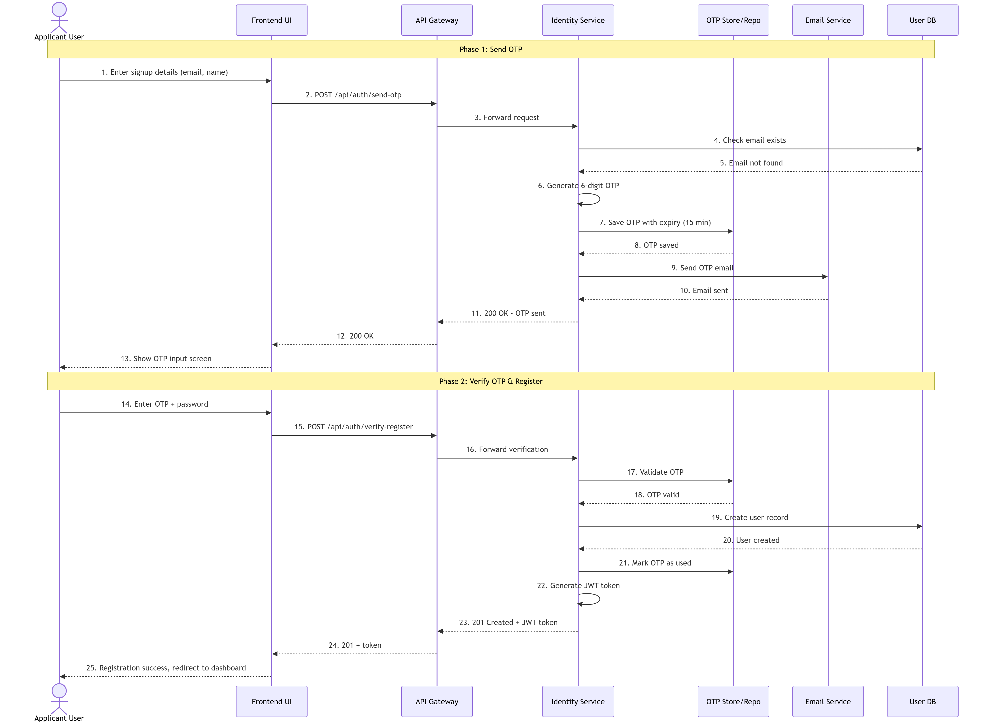

9.2 Login and JWT Token Flow
- Angular calls POST /gateway/auth/login with {email, password}.
- Identity Service: retrieves user by email. Verifies BCrypt hash. Checks IsActive. JwtHelper generates JWT with claims: NameIdentifier (userId), Email, Role.
- Response: {token, fullName, email, role, expiresAt}. AuthService stores token via TokenService.
- AuthInterceptor attaches Bearer token to all subsequent requests automatically.
- Route guards read role from TokenService to enforce route-level access control.

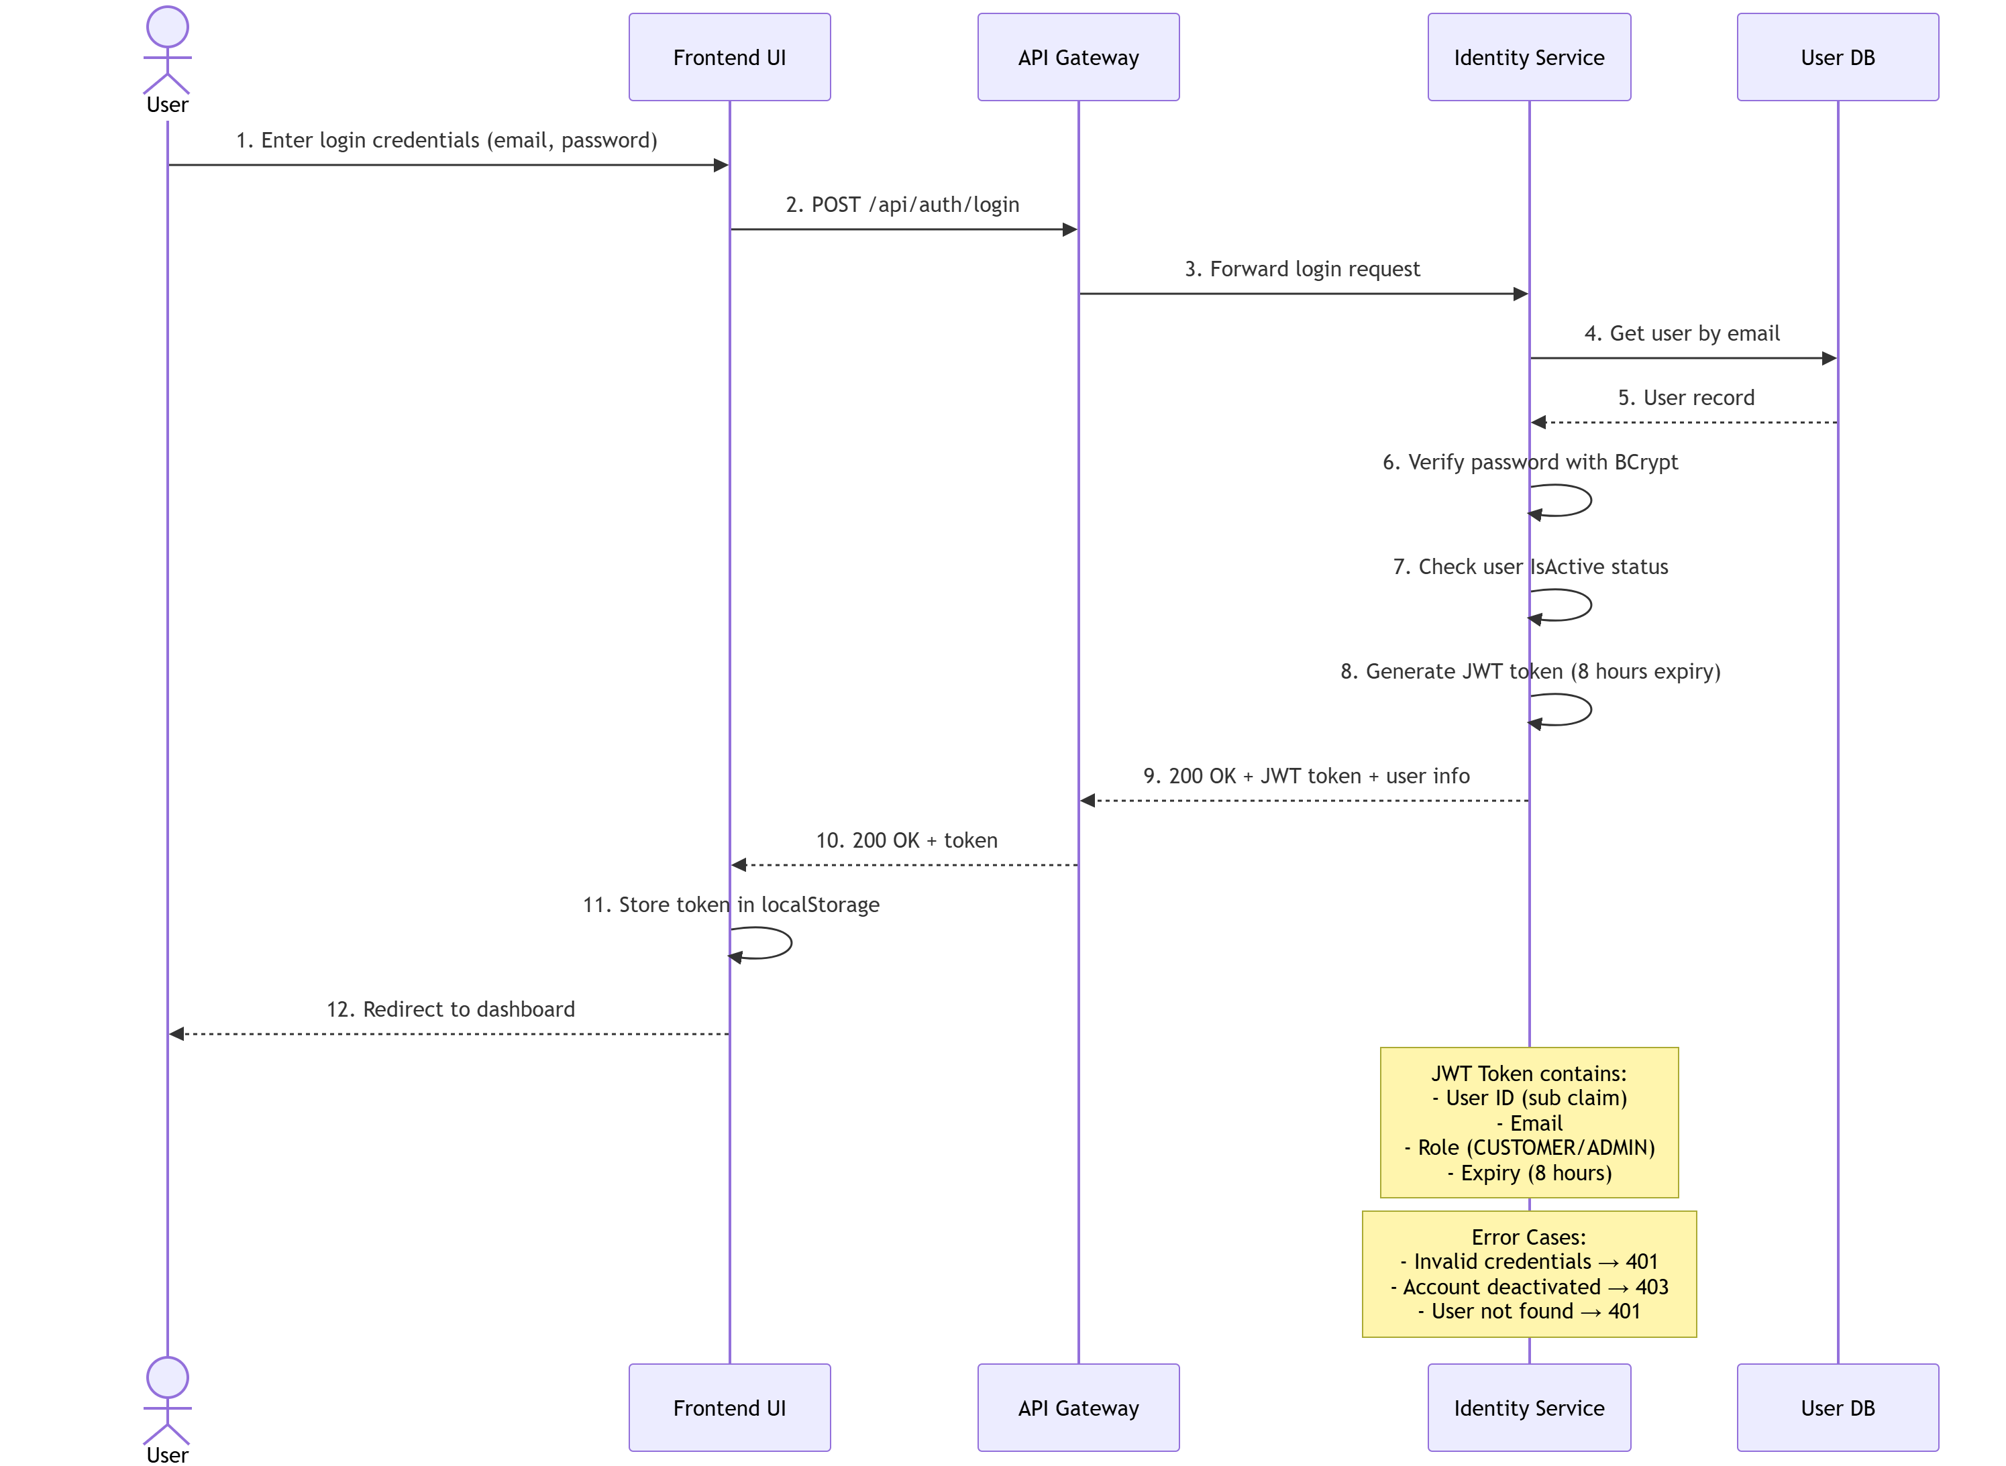

9.3 Policy Purchase Flow
- Customer selects policy type. Angular calls GET /gateway/policies/types to populate dropdown with full coverage details.
- Customer enters age, start date, end date. Angular calls POST /gateway/policies/calculate-premium. Policy Service returns PremiumResponseDto with full breakdown.
- Customer reviews breakdown and proceeds to Step 3.
- Customer clicks Pay with Razorpay. Razorpay checkout modal opens in browser.
- On successful payment, frontend receives razorpay_payment_id. Angular calls POST /gateway/policies with {policyTypeId, startDate, endDate, age}.
- Policy Service: calculates premium, creates Policy with status Active and PolicyNumber=POL-{ticks}, creates Premium record, creates Payment record with TransactionId=TXN-{ticks}.
- Customer is redirected to My Policies.

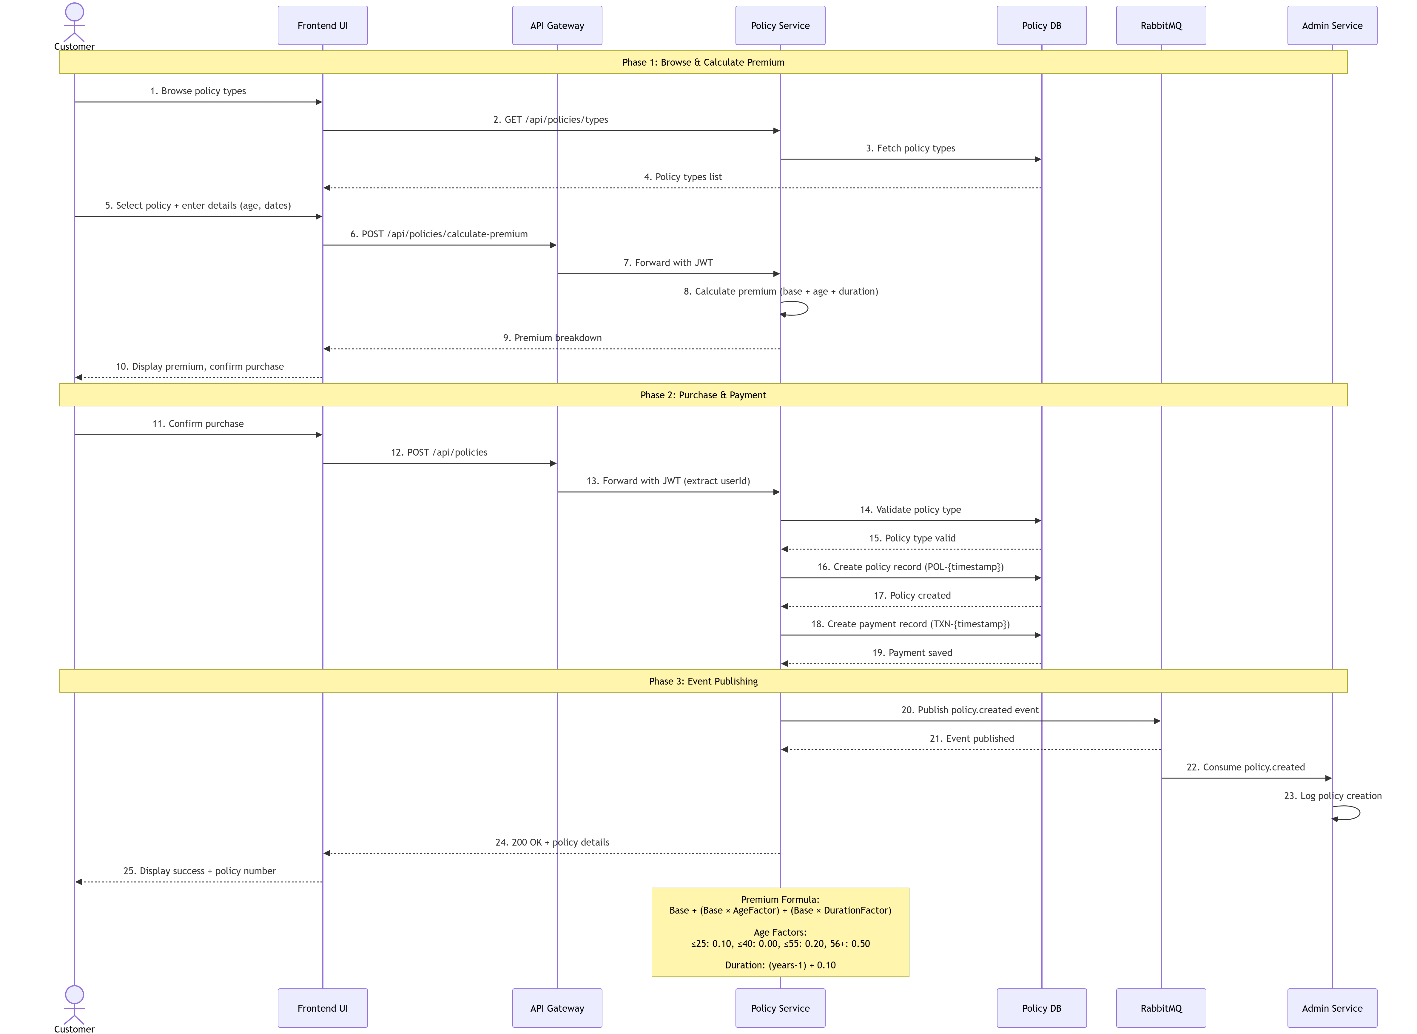

9.4 Claim Lifecycle Flow
- Customer fills claim form. Angular calls POST /gateway/claims. Claims Service creates Claim in Draft status with ClaimNumber=CLM-{ticks}.
- Customer uploads documents. Angular calls POST /gateway/claims/{id}/documents (multipart/form-data). FileStorageService saves file to wwwroot/uploads/{claimId}/. ClaimDocument record created.
- Customer submits claim. Angular calls POST /gateway/claims/{id}/submit. Claims Service transitions Draft to Submitted. RabbitMQ ClaimSubmitted event published.
- Admin views claim in Admin Portal (GET /gateway/admin/claims). Admin opens review panel.
- Admin selects new status and enters note. Angular calls PUT /gateway/admin/claims/status.
- AdminService pre-fetches claim details. Sends PUT to ClaimsService /api/claims/{id}/status. ClaimsService enforces state machine. Creates AdminLog entry.
- AdminService fires background task: fetches customer email from IdentityService. Publishes ClaimStatusNotificationDto to claim.status.notification RabbitMQ queue.
- IdentityService ClaimNotificationConsumer receives message. Sends colour-coded HTML email to customer.

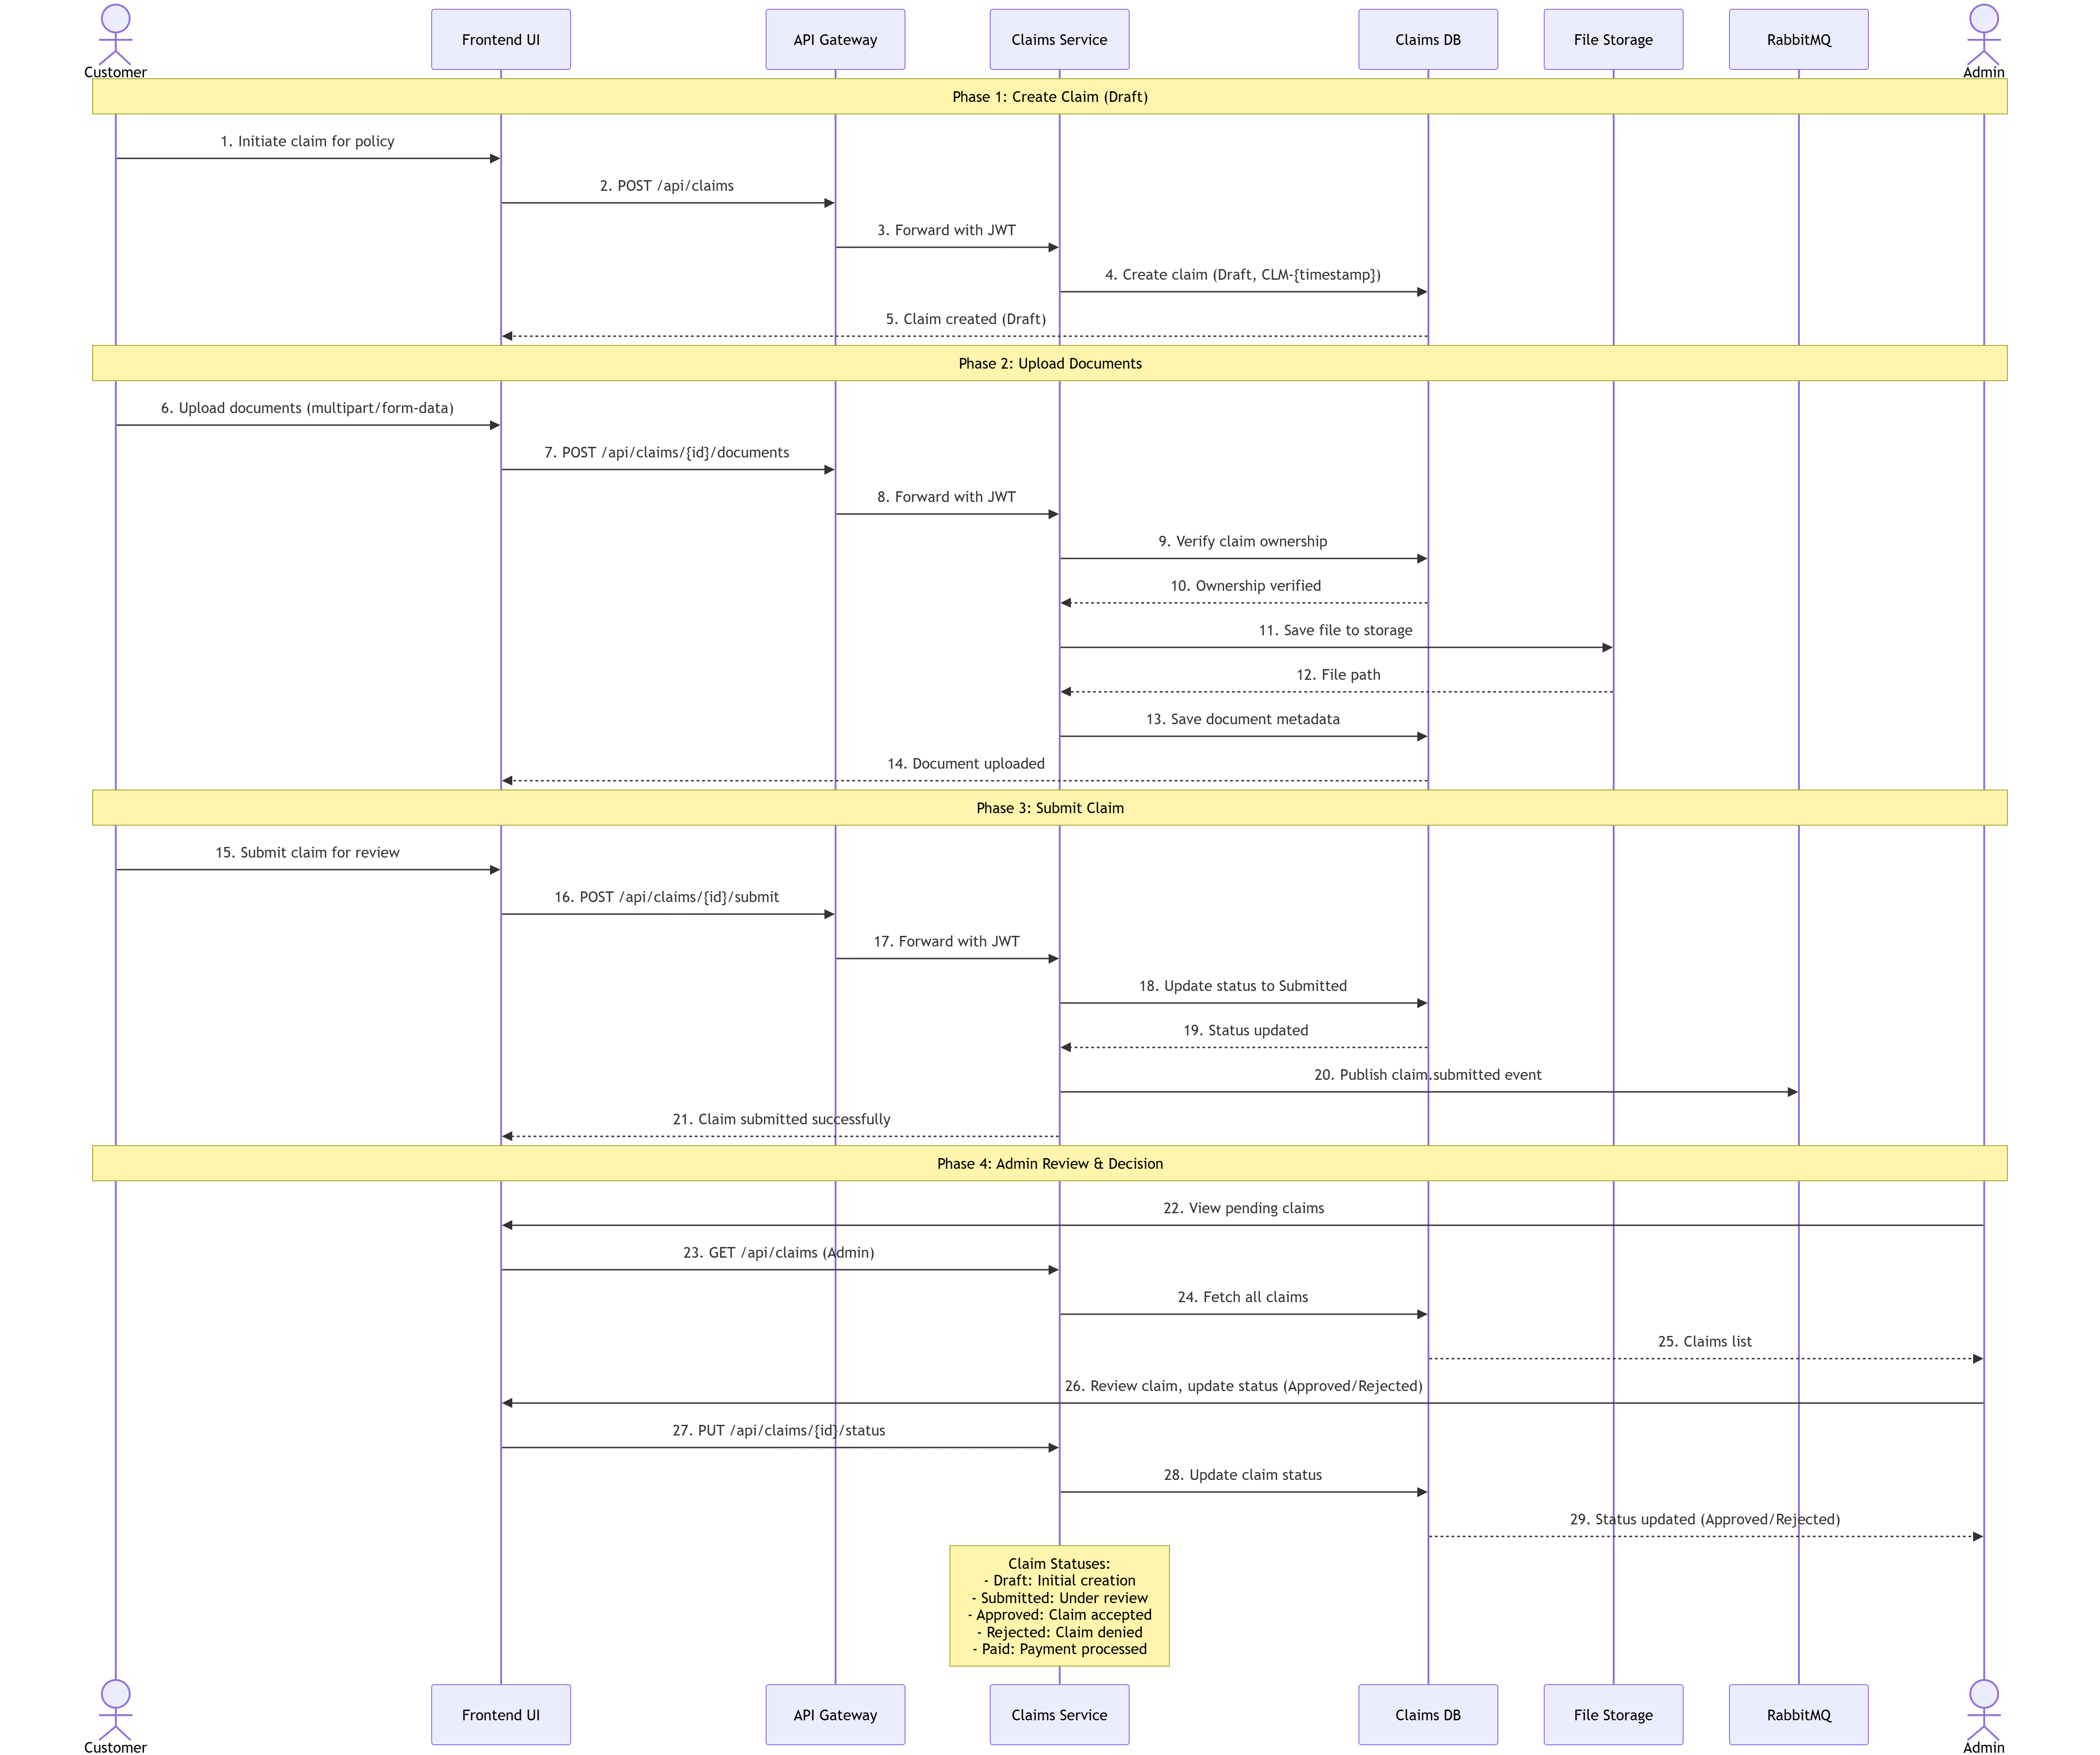

9.5 Policy Renewal Flow
- Customer clicks Renew on an Active or Expired policy in My Policies.
- Angular calls POST /gateway/policies/{id}/renew with {age}.
- Policy Service: validates ownership (PolicyAccessDeniedException if mismatch). Validates status is Active or Expired (PolicyNotRenewableException otherwise). Calculates renewal premium with fixed durationFactor=0.10.
- New start date: today if policy is expired, or current EndDate if still active. New end date: +1 year.
- Policy updated: new dates, status=Active, IsRenewed=true, RenewalCount+=1. Payment created with TransactionId=TXN-RENEW-{ms}.
- Customer is redirected to My Policies with updated policy visible.

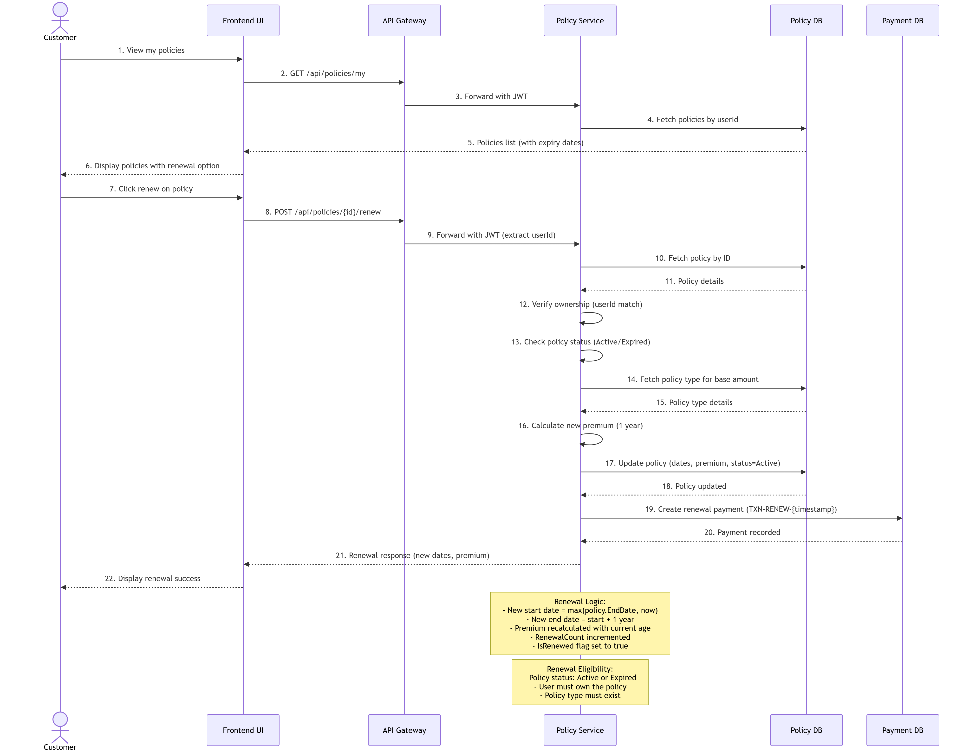

9.6 Claim Review and RabbitMQ Email Notification
- Admin navigates to Claims Management. Angular calls GET /gateway/admin/claims. AdminService fetches claims from ClaimsService. Angular displays claims table with status badges.
- Admin clicks Review on Submitted claim. Slide-in panel opens showing claim details, documents, status history. Admin writes review note and selects Approved or Rejected.
- Admin clicks Approve/Reject. Angular calls PUT /gateway/admin/claims/status. API Gateway validates JWT + ADMIN role, forwards to AdminService.
- AdminService pre-fetches claim details (claimNumber, customerId, oldStatus) from ClaimsService. Calls PUT /api/claims/{id}/status. ClaimsService updates status in ClaimsDB.
- AdminService creates AdminLog entry for audit trail. Returns 200 OK to Angular. Angular updates status badge in UI. API response completes BEFORE email notification.
- Background task starts (fire-and-forget). Captures JWT token. Creates independent HttpClient via IHttpClientFactory. Calls IdentityService to fetch customer email.
- AdminService builds ClaimStatusNotificationDto. Publishes to RabbitMQ queue claim.status.notification (durable, persistent). If RabbitMQ down, warning logged only.
- IdentityService ClaimNotificationConsumer receives message. Creates scoped IEmailService. Builds HTML email with color-coded status badge (Approved=green, Rejected=red).
- Email sent via MailKit to Gmail SMTP. Consumer ACKs message on success, NACKs on failure. Auto-reconnects to RabbitMQ every 5s if connection lost.

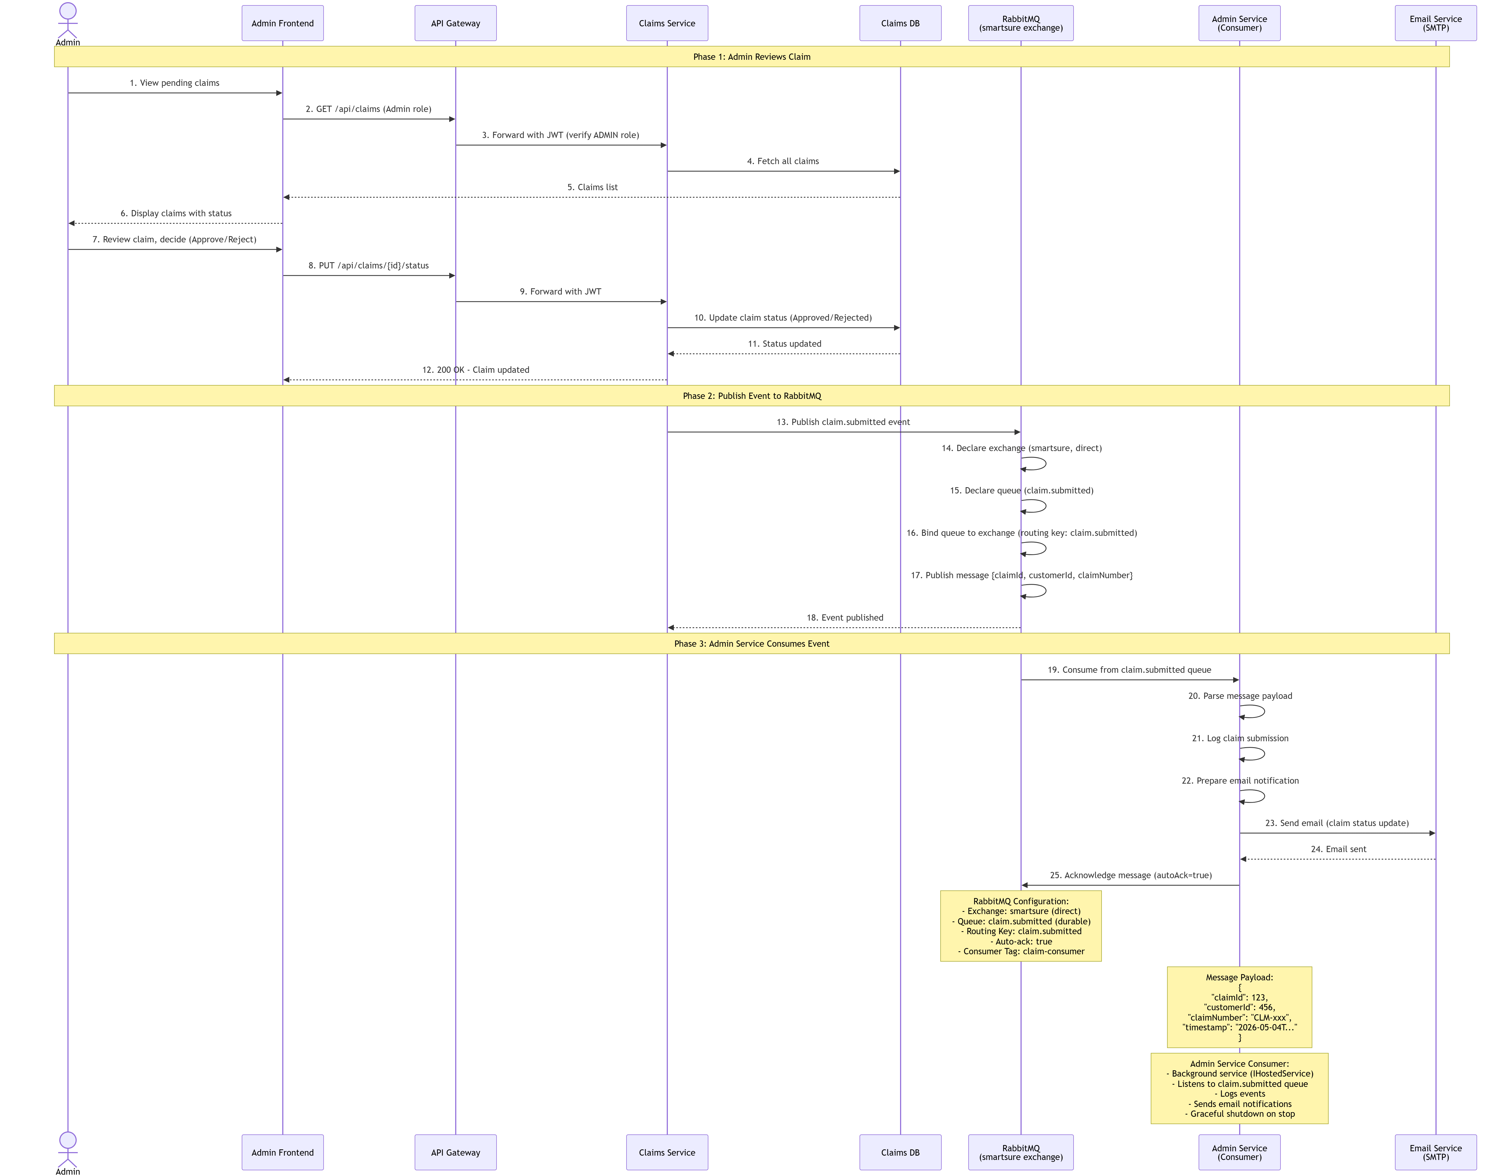

10. Infrastructure and Configuration
10.1 Docker Compose Services
Container | Image | Port(s) | Depends On
smartsure-sqlserver | mcr.microsoft.com/mssql/server:2022-latest | 1433 | —
smartsure-rabbitmq | rabbitmq:3-management | 5672, 15672 | —
smartsure-identity | Custom build (IdentityService) | 5265 | sqlserver (healthy)
smartsure-policy | Custom build (PolicyService) | 5145 | sqlserver (healthy), rabbitmq (healthy)
smartsure-claims | Custom build (ClaimsService) | 5084 | sqlserver (healthy), rabbitmq (healthy)
smartsure-admin | Custom build (AdminService) | 5073 | sqlserver, rabbitmq, identity, policy, claims
smartsure-gateway | Custom build (ApiGateway) | 5000 | identity, policy, claims, admin
smartsure-frontend | Custom build (Nginx + Angular) | 4200 (→80) | api-gateway

10.2 Database Configuration per Service
Service | Database Name | DbContext Class | Key Tables
Identity Service | SmartSure_IdentityDB | AppDbContext | Users, OtpVerifications
Policy Service | SmartSure_PolicyDB | PolicyDbContext | PolicyTypes, Policies, Premiums, Payments
Claims Service | SmartSure_ClaimsDB | ClaimDbContext | Claims, ClaimDocuments
Admin Service | SmartSure_AdminDB | AdminDbContext | AdminLogs, Reports

10.3 JWT Configuration (Shared Across All Services)
- JwtSettings:SecretKey — HS256 signing secret. Must be identical across all services.
- JwtSettings:Issuer — Token issuer identifier (SmartSure).
- JwtSettings:Audience — Token audience identifier (SmartSureClients).
- JwtSettings:ExpiryHours — Token lifetime in hours (default 8).
- Identity Service generates tokens. All other services validate them using the same parameters.
- Token claims: ClaimTypes.NameIdentifier (userId as string), ClaimTypes.Email, ClaimTypes.Role.
10.4 RabbitMQ Configuration
- All services connect to RabbitMQ on host rabbitmq (Docker) or localhost (local development).
- Credentials: smartsure / smartsure123 (Docker); guest / guest (local).
- Queue: claim.status.notification — durable, persistent messages.
- Publisher: AdminService.Infrastructure.Services.NotificationPublisher — uses RabbitMQ.Client directly.
- Consumer: IdentityService.Infrastructure.Messaging.ClaimNotificationConsumer — BackgroundService with auto-reconnect.

10.5 Email Configuration (IdentityService)
- Provider: Gmail SMTP (smtp.gmail.com:587) with STARTTLS.
- Settings: EmailSettings:SmtpHost, SmtpPort, FromEmail, AppPassword, FromName, UseAuthentication, UseStartTls.
- Library: MailKit / MimeKit.
- Emails sent: OTP for registration, OTP for password reset, claim status change notifications.
11. Unit Test Projects
Test Project | Framework | Tests | Coverage | Key Areas Covered
IdentityService.Tests | NUnit 4 + Moq + FluentAssertions | 31 | ~98% line / 100% branch | Registration OTP flow, login, password reset, account deactivation, OTP expiry/reuse
PolicyService.Tests | NUnit 4 + Moq + FluentAssertions | 34 | ~97% line / 100% branch | Premium calculation (all age/duration brackets), policy creation, renewal (active/expired/cancelled/wrong user), payment recording
ClaimsService.Tests | NUnit 4 + Moq + FluentAssertions | 30 | ~95% line / ~78% branch | Claim creation, submission, status transitions, document upload/delete, access control
AdminService.Tests | NUnit 4 + Moq + FluentAssertions | 22 | ~90% line | Dashboard aggregation, claim status update, user status update, report generation, audit logging

11.1 Testing Approach
- Repository interfaces are mocked with MockBehavior.Strict — any unexpected call fails the test immediately.
- Service-level mocks use MockBehavior.Loose.
- FluentAssertions used for all assertions: .Should().Be(), .Should().ThrowAsync<T>(), .WithMessage().
- Custom exception types are asserted directly (e.g. ThrowAsync<PolicyNotFoundException>()) — not the old generic InvalidOperationException.
- Premium calculation tests cover all six age/duration combinations from the README examples.
- Renewal tests cover: active policy (extends from EndDate), expired policy (starts from today), cancelled policy (throws PolicyNotRenewableException), wrong user (throws PolicyAccessDeniedException), renewal count increment, 1-year duration factor enforcement.
12. Security Considerations
- Password Storage: Passwords are hashed using BCrypt.Net.BCrypt.HashPassword() and stored in the PasswordHash column of the Users table. The hash cannot be reversed.
- JWT Validation: Each service independently validates JWT tokens using the shared signing key. The API Gateway also validates tokens before forwarding to protected routes.
- OTP Security: OTPs are 6-digit numeric strings generated via RandomNumberGenerator.GetInt32(100000, 1000000). Expiry is 15 minutes. OtpRecord.IsUsed is set to true after successful verification, preventing reuse.
- CORS: Restricted to http://localhost:4200 in the gateway. In Docker, the Angular Nginx container proxies API calls internally.
- Authorization: All sensitive endpoints use [Authorize] attribute. Admin-only endpoints use [Authorize(Roles = 'ADMIN')]. Route guards provide an additional client-side layer.
- File Upload: Documents are saved to the server filesystem under wwwroot/uploads/{claimId}/. Only the relative URL path is stored in ClaimDocument.FilePath. The wwwroot prefix is stripped from the returned FileUrl.
- Global Exception Handling: GlobalExceptionMiddleware in each service catches all unhandled exceptions. Domain exceptions (typed, expected) are logged as Warning. Unexpected exceptions are logged as Error. Stack traces are only included in the response body in the Development environment.
- Downstream HTTP Calls: AdminService uses IHttpClientFactory.CreateClient() for background tasks to avoid using a disposed HttpClient after the request scope ends.

SmartSure — Confidential Technical Document | April 2026

