1.Funny Train in terminal
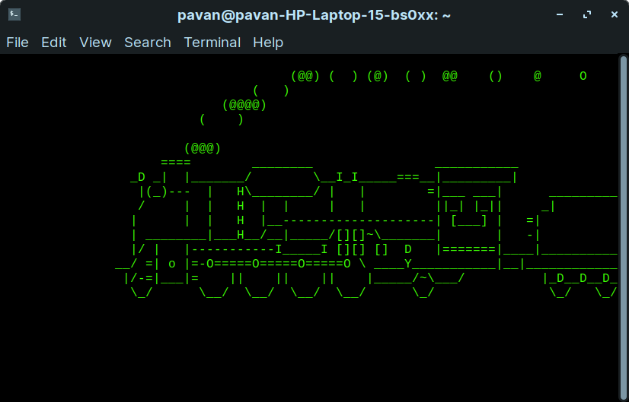
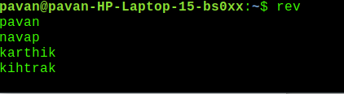
2.Rev Command in Linux

3.Factor Command In Linux
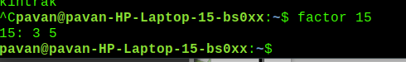

4.Health Report:

Code:
top -b -d 1 -n 5 >>health.txt
echo " "
echo "Free Memory"
free -m >> health.txt
echo ""
echo "Network "
netstat >> health.txt
echo"cpu load and vmstat"
vmstat -s >> health.txt

Output:
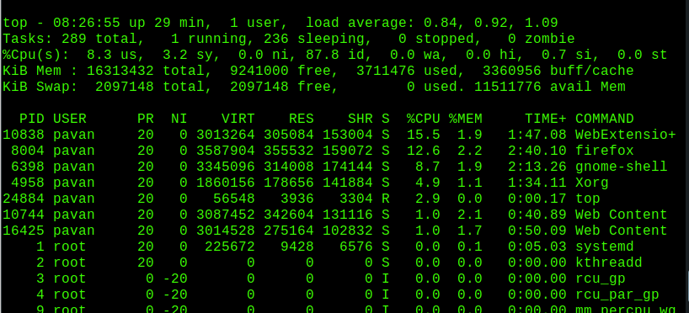

Additional Questions:

Code for writer process:
#include <iostream>
#include <sys/ipc.h>
#include <sys/shm.h>
#include <stdio.h>
using namespace std;

int main()
{
// ftok to generate unique key
key_t key = ftok("bhaveshfile",65);

// shmget returns an identifier in shmid
int shmid = shmget(key,1024,0666|IPC_CREAT);

// shmat to attach to shared memory
char *str = (char*) shmat(shmid,(void*)0,0);

cout<<"Write Data : ";
gets(str);

printf("Data written in memory: %s\n",str);

//detach from shared memory
shmdt(str);

return 0;
}

Code For Reader Process:

#include <iostream>
#include <sys/ipc.h>
#include <sys/shm.h>
#include <stdio.h>
using namespace std;

int main()
{
// ftok to generate unique key
key_t key = ftok("bhaveshfile",65);

// shmget returns an identifier in shmid
int shmid = shmget(key,1024,0666|IPC_CREAT);

// shmat to attach to shared memory
char *str = (char*) shmat(shmid,(void*)0,0);

printf("Data read from memory: %s\n",str);

//detach from shared memory
shmdt(str);

// destroy the shared memory
shmctl(shmid,IPC_RMID,NULL);

return 0;
}

