# eLOCUTOR

Imagine your life where you can use only one finger for work or speaking or writing. Its difficult some say its impossible , but the famous person who is known as the professor of space and science who is affected by the ALS([amyotrophic lateral sclerosis](https://en.wikipedia.org/wiki/Amyotrophic_lateral_sclerosis)) disease but had written more than 20 books on TIME made the impossible possible. He is Stephen Hawking. We may think what is the relation between elocutor and professor? Did he make the device?

Stephen Hawking had a rare early-onset slow-progressing form of [motor neuron disease](https://en.wikipedia.org/wiki/Motor_neuron_disease) (MND; also known as [amyotrophic lateral sclerosis](https://en.wikipedia.org/wiki/Amyotrophic_lateral_sclerosis) (ALS), or [Lou Gehrig](https://en.wikipedia.org/wiki/Lou_Gehrig)'s disease), a fatal neurodegenerative disease that results in the death of motor neurons in the brain and spinal cord, which gradually paralyzed him over decades. This incident changed the world because hawking was the only person who strictly believed in the quantum world and black hole but due to this incident he couldn’t speak or write. This incident brought a great development to engineers.

## How could Hawking disability brought development to engineers?

Two famous Indian engineers Arun Mehta(INDIAN software developer and a disability activist) and Vikram Krishna developed a device which works on just one click which is named eLOCUTOR. At the request of Hawking arun developed free and open source software which does the basic works of Hawking.

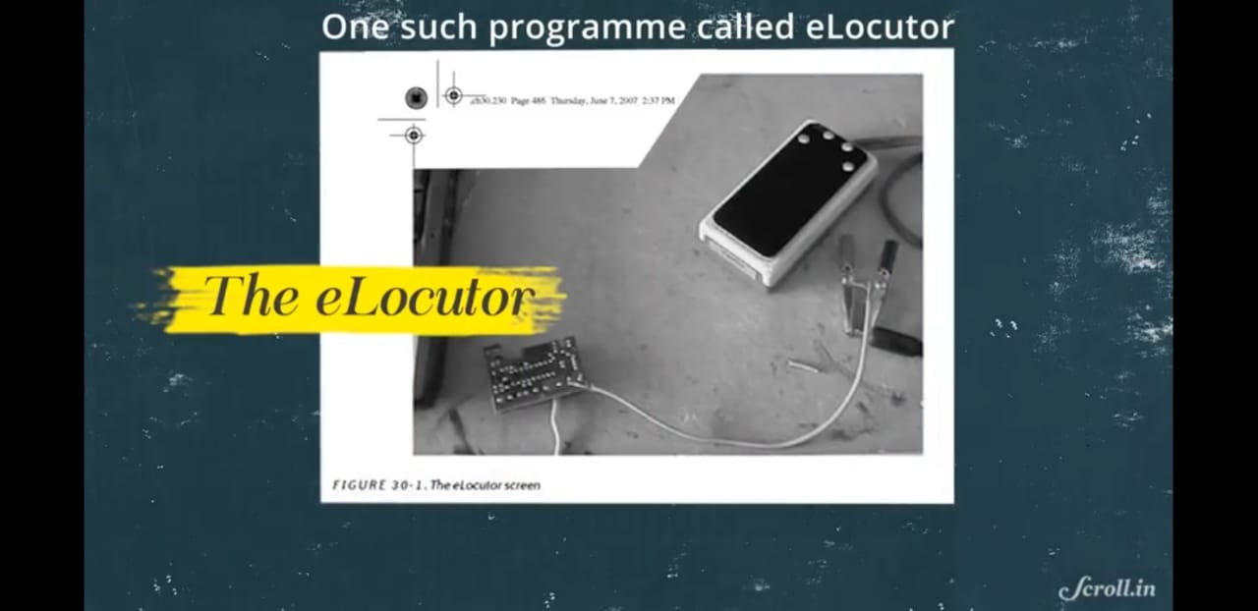

## 

## How Hawking know Arun Mehta ?

During a tour to India in 2001, [Stephen Hawking](https://en.wikipedia.org/wiki/Stephen_Hawking) delivered lecture in an international physics conference dedicated to [String theory](https://en.wikipedia.org/wiki/String_theory) held at [Tata Institute of Fundamental Research](https://en.wikipedia.org/wiki/Tata_Institute_of_Fundamental_Research), [Mumbai](https://en.wikipedia.org/wiki/Mumbai). It was during this time, Hawking, suffering from [amyotrophic lateral sclerosis](https://en.wikipedia.org/wiki/Amyotrophic_lateral_sclerosis), contacted Mehta and Crishnaalong with several other software companies to write the replacement for the software he was using for the computerised machine fixed to his wheelchair, to communicate with others.Mehta and Krishna developed eLocutor, a free and open source single-button typing and speaking software.

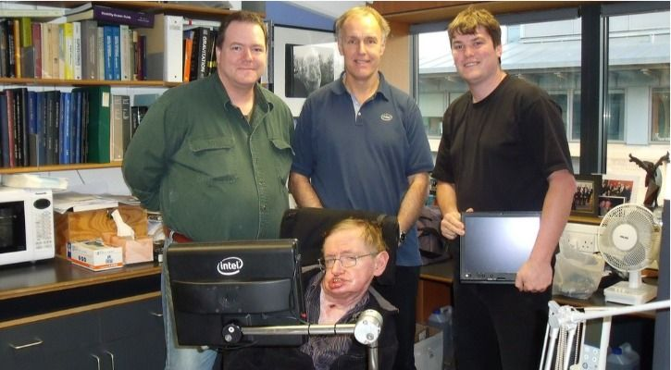

Arun and Crishna faced the first difficulty on clearing the acknowledgment of device. They had three goals in their minds on how the device should work they are

* It should predict the words
* It should make a clear statement or pronunciation
* It should save the frequently used sentences.

Arun faced the challenge that Hawking loved to make jokes so where the eLocutor should also pronounce in a funny way. The basic idea is taken from the mouse where the complete work of computer can be controlled by one click which later changed. eLocutor has three steps they are

* Sense a click
* Sense lack of a click
* Sense the length of a click

Using the above three aspects the statements are made easier and fast. The eLocutor software has the predefined words and statements which made Hawking easy to speak. The basic knowledge of eLocutor is text to speech where eLocutor could nearly 2 statements in a minute.

Arun is a software developer where he used Visual Studio 6 for the software development. This software is the background source of the world famous book “A BRIEF HISTORY OF TIME”. The complete book is written using eLocutor. After this development many engineers developed different devices and software for the disabled person. During the year 2011 Hawking chair was the most developed and attractive due to the latest technology which uses just the movement of the nerve under eye and tells the statement. This work of Mehta made all the engineers to work on problem solving methods. Many engineers worked on Hawking chair where in the final which is after the death of Stephen Hawking the chair was kept in a museum where it costs in millions.

