Family Expenditure Project using ServiceNow - Documentation

# Introduction

The Family Expenditure Project is implemented on the ServiceNow platform to record, track, and calculate family expenses in a structured manner. The project involves creating custom tables, forms, update sets, relationships, and business rules to automate financial management for a household.

# Project Steps Summary

## 1. ServiceNow Instance Setup

1. Sign up for a developer account at https://developer.servicenow.com.  
2. Request a Personal Developer Instance.  
3. Log in with the provided credentials.

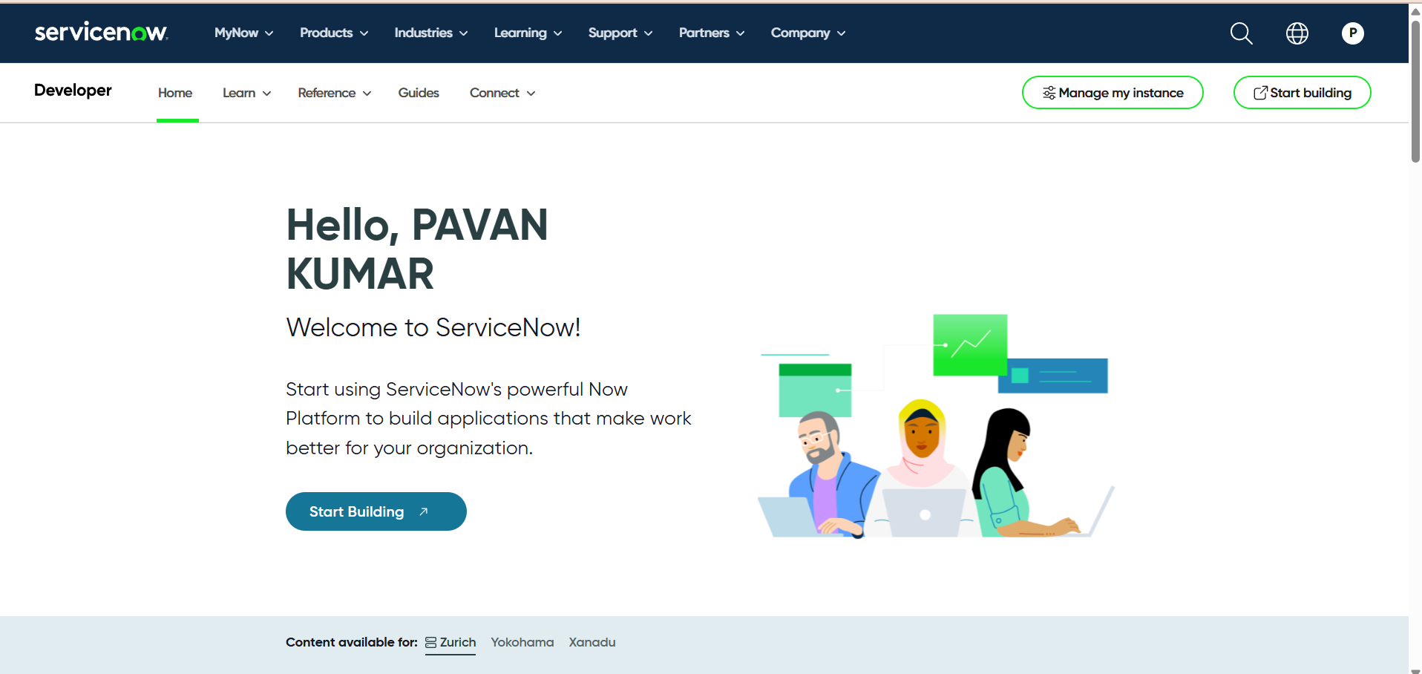

## 2. Creation of Update Set

1. Navigate to Local Update Set > New.  
2. Enter Name: Family Expenses.  
3. Submit and Make Current.

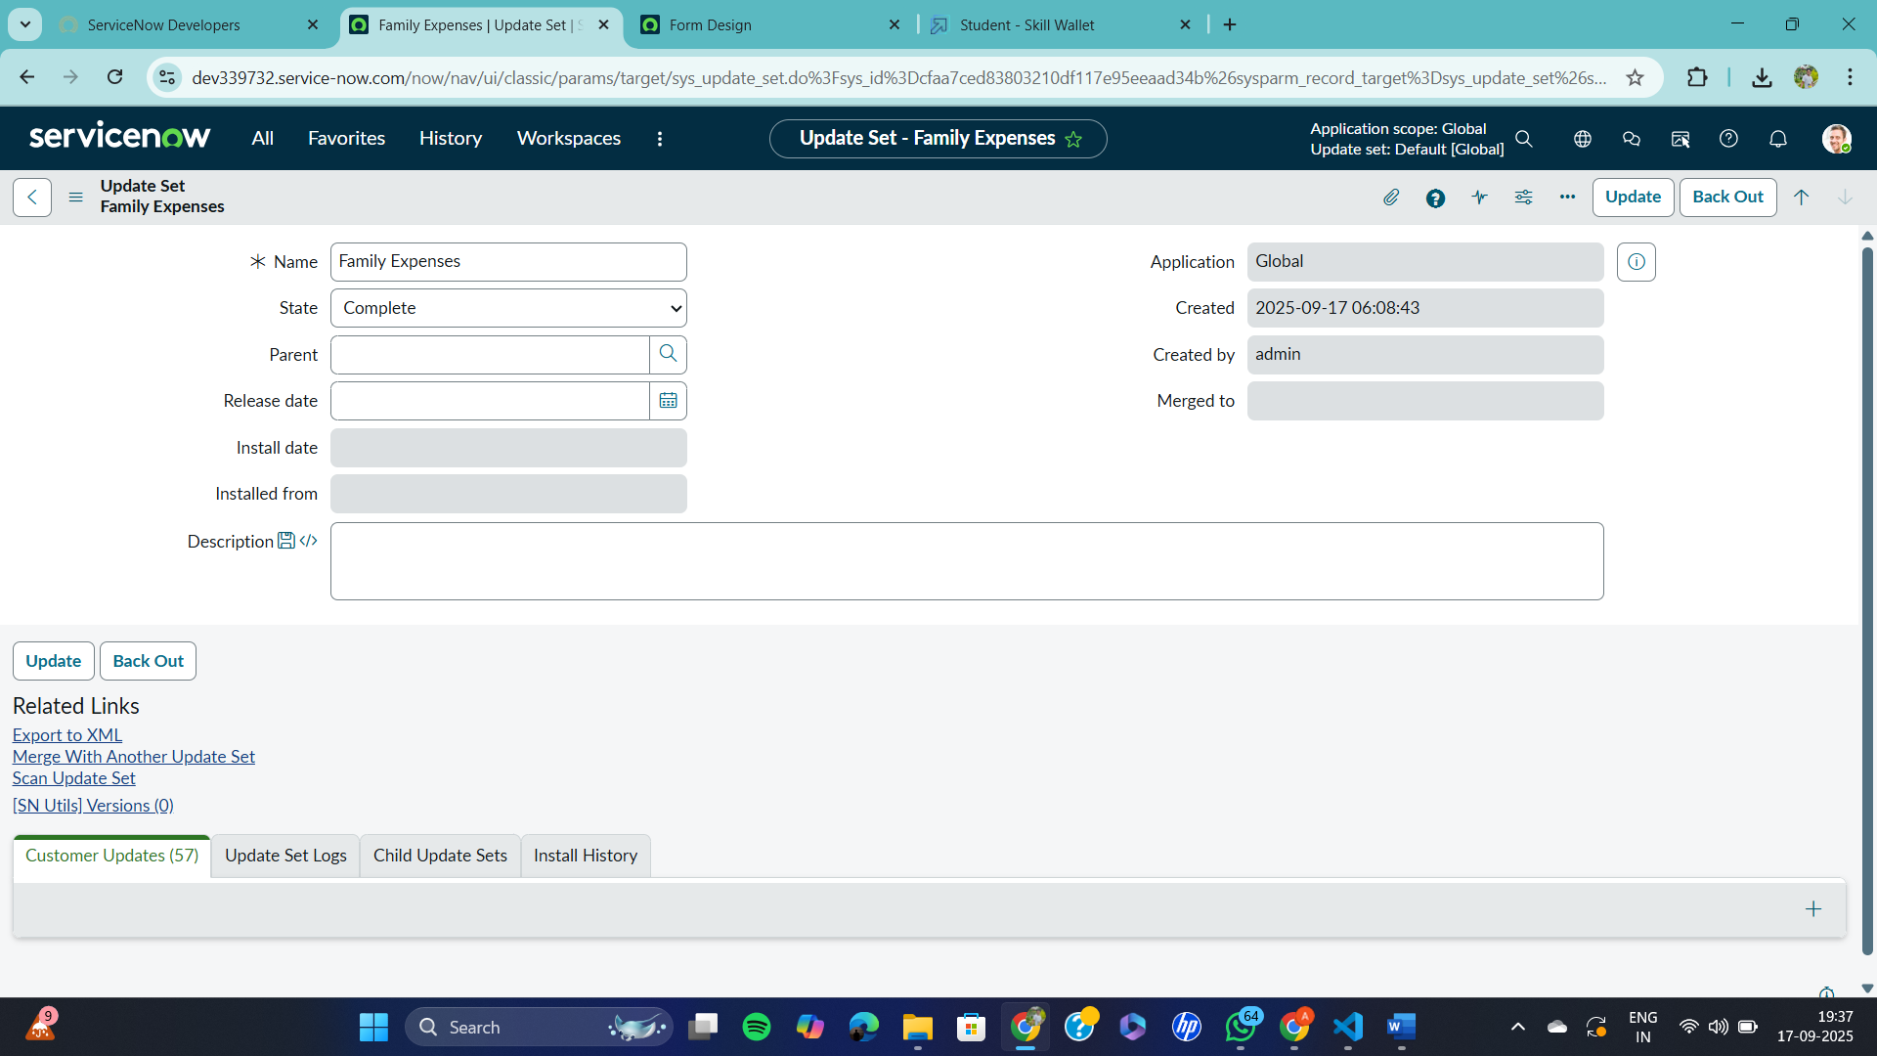

## 3. Creation of Family Expenses Table

1. Navigate to Tables > New.  
2. Label: Family Expenses | New menu name: Family Expenditure.  
3. Create fields:  
- Number (String)  
- Date (Date)  
- Amount (Integer)  
- Expense Details (String, Max length: 800)  
4. Configure Auto-Number for 'Number' field with prefix MFE.  
5. Configure Form: Make Number Read-only, Date & Amount Mandatory.

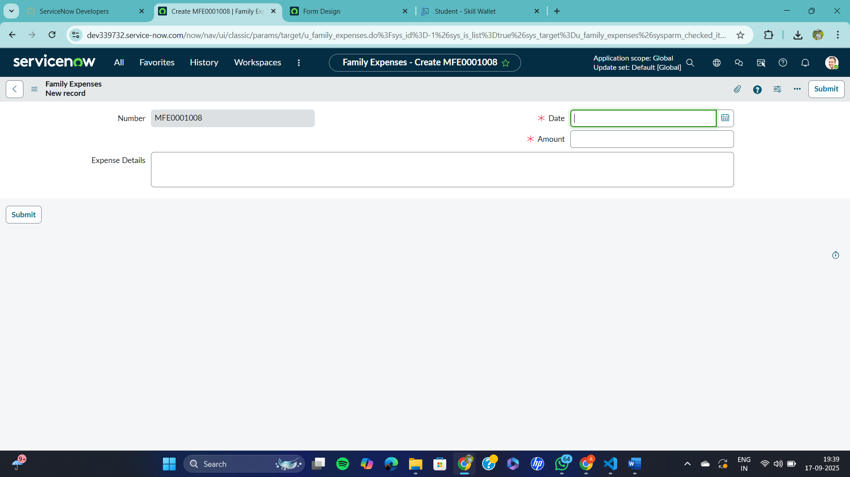

## 4. Creation of Daily Expenses Table

1. Navigate to Tables > New.  
2. Label: Daily Expenses | Add module to Family Expenditure menu.  
3. Create fields:  
- Number (String)  
- Date (Date)  
- Expense (Integer)  
- Family Member Name (Reference)  
- Comments (String, Max length: 800)  
4. Configure Auto-Number for 'Number' field with prefix MFE.  
5. Configure Form: Make Number Read-only, Date & Family Member Name Mandatory.

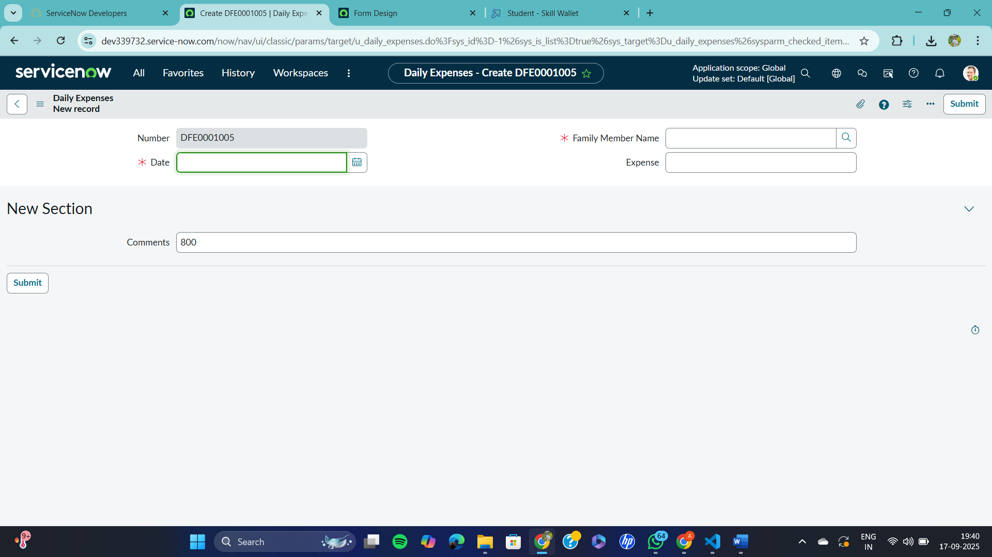

## 5. Creation of Relationship

1. Navigate to Relationships > New.  
2. Name: Daily Expenses | Applies to table: Family Expenses | Related: Daily Expenses.  
3. Add Daily Expenses to Related List in Family Expenses form.

## 6. Business Rules

1. Navigate to Business Rules > New.  
2. Name: Family Expenses BR | Table: Daily Expenses | Check Insert & Update.  
3. Advanced Script:  
  
(function executeRule(current, previous) {  
 var FamilyExpenses = new GlideRecord('u_family_expenses');  
 FamilyExpenses.addQuery('u_date', current.u_date);  
 FamilyExpenses.query();  
 if(FamilyExpenses.next()) {  
 FamilyExpenses.u_amount += current.u_expense;  
 FamilyExpenses.u_expense_details += '>' + current.u_comments + ': Rs.' + current.u_expense + '/-';  
 FamilyExpenses.update();  
 } else {  
 var NewFamilyExpenses = new GlideRecord('u_family_expenses');  
 NewFamilyExpenses.u_date = current.u_date;  
 NewFamilyExpenses.u_amount = current.u_expense;  
 NewFamilyExpenses.u_expense_details += '>' + current.u_comments + ': Rs.' + current.u_expense + '/-';  
 NewFamilyExpenses.insert();  
 }  
})(current, previous);

## 7. Configure Relationship Query

Refine query to match Daily Expenses with Family Expenses by date:  
  
(function refineQuery(current, parent) {  
 current.addQuery('u_date', parent.u_date);  
 current.query();  
})(current, parent);

# Conclusion

The Family Expenditure project in ServiceNow centralizes and automates expense management. By leveraging custom tables, relationships, and business rules, it simplifies household financial tracking, provides accurate insights, and improves overall expense management.