10 - Partitions & Mount Points

-Partitioning

-Designing filesystem Layouts

-Swap Space 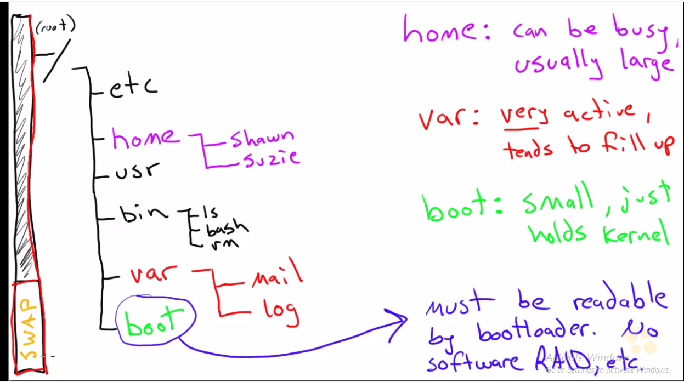

/var 🡪 Better have a separate partition other wise it fills up entire hdd with logs and all.

EX:

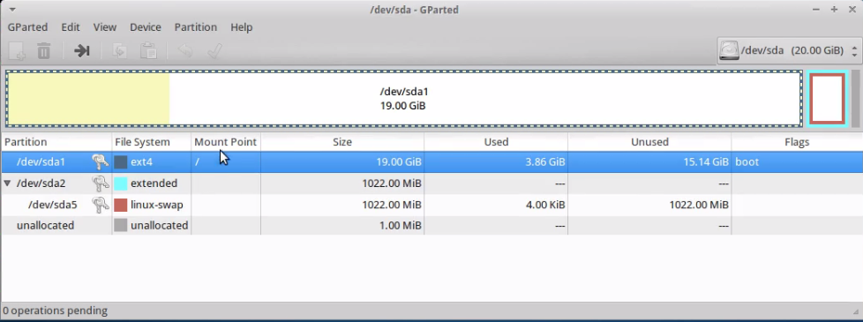

11 - RAID vs – LVM

What is RAID?

What is LVM?

Which is Better?

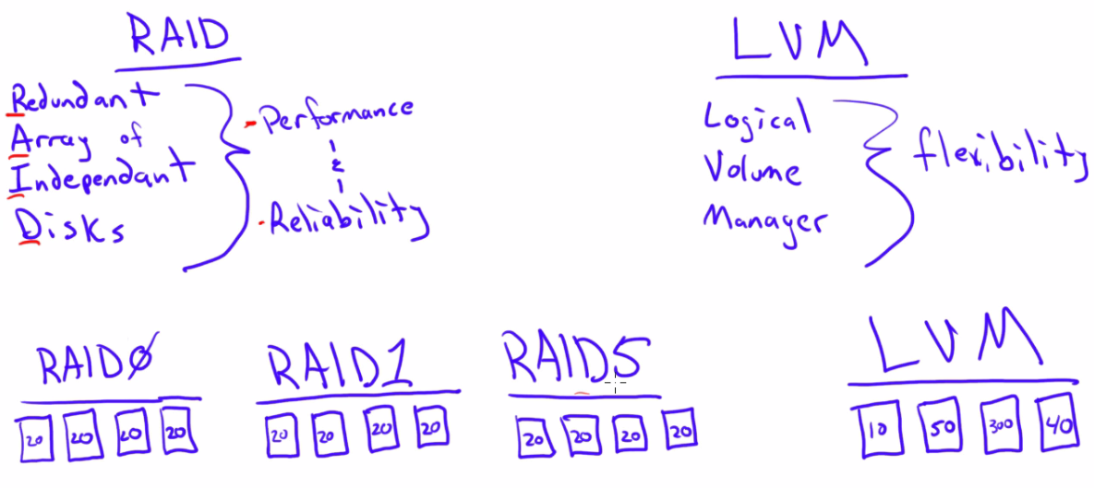

RAID0 🡪 Stripped (Maximum storage, Fast Access. It gives performance)

RAID1 🡪 Mirroring (It gives Reliability)

RAID5 🡪 Parity