

### COMPSOFT TECHNOLOGIES

#### AN INTERNSHI REPORT

ON

“WEBSITE FOR STOREMYRESULT”

**Bachelor of Engineering**

**In**

**Electronics and Communication Engineering**

**Submitted by: VUNNAM PAVAN KRISHNA(1AT19EC169)**



Atria Institute of Technology

**2021**

### ABOUT THE COMPANY

We are a digital service provider that aims to provide software, designing and marketing solutions to individuals and businesses, we believe that service and quality is the key to success

We provide all kinds of technological and designing solutions from Billing Software to Web Designs or any custom demand that you may have. Experience the service like none other!

Some of our services include:

Development - We develop responsive, functional and super-fast websites.

We keep User Experience in mind while creating websites. A website should load quickly and should be accessible even on a small view-port and slow internet connection.

Mobile Application - We offer a wide range of professional Android, iOS & Hybrid app development services for our global clients, from a start up to a large enterprise.

Design - We offer professional Graphic design, Brochure design & Logo design. We are experts in crafting visual content to convey the right message to the customers.

Consultancy - We are here to provide you with expert advice on your design and development requirement.

Videos - We create a polished professional video that impresses your audience.

**TABLE OF CONTENTS**

#### Table of contents i

Overview of the Project 1

Key details of storemyresult 2

Storemyresult tmodules 3

Tools Used 4

Implementation 5

Snapshots 21

Bibliography 25

### OVERVIEW OF THE PROJECT

**Project Name:** Tribute to **S**toremyresult

**Team Members:** VUNNAM PAVAN KRISHNA (1AT19EC169) MANASA MARIGOLI (1MJ18EC075) DIVYASHREE K S (1MS18TE018) JAYANTH HEGDE H R (1KG17EC098)

This project is based on Web Development And its Applications. The main objective of this project is to learn the implementation of HTML, CSS, JavaScript, MySQL, PHP. The basic webpage of this project is created using HTML and styling of the webpage is done using CSS.

This webpage is about the Storemyresult .

It deals with the complete details of academic details of the student. It comprises of the student Roll no, Name, Marks Obtained, Total, Average, Attendance Percent etc. It can be accessed by the teacher or the faculty who alone can change or update the marks of the students,

**ABOUT STOREMYRESULT**

Engineering Students Nowadays do not have the habit of remembering their marks of the previous semester or the work rating of the last project in the company, this can actually cause a huge problem to students in their final year of Engg/if switching companies is taking place, in order to solve this, we here at storemyresults.com would love to provide a platform to students/Graduates to store their results of the previous/current semester thereby making it comfortable to access results and marks accessible whenever required, fun fact, Majority of students don’t even remember the marks of their current semester and the sophisticated design of result websites make it a little difficult to access the same.

# Key details of storemyresult

The most important part of making this site is the user experience, which results in specific university websites do not focus on design as functionality outweighs design in these specific websites, which can further ruin the user experience, here the focus lies on functionality and design. The Working Process is pretty simple here we ask students to create an account with us and we tend to store the data that they enter, the data might include USN, NAME and SUBJECT NAMES with their finalized marks, once that is done we keep a submit option wherein the users/Students can submit their responses, the content of the web page at the time of submission should be downloadable in pdf form for their reference, the data of the user should be completely secured and (s)he has to make an account and set their password to access their account at any point in time. This will make it easier for the students to retrieve their results or marks of any subject of any semester anytime.

**STORE MY RESULT MODULES:**

1. LOGIN MODULE

This feature used by the user to login into system. There will be two option admin login and student login. Only admin can manage and have access to all data. Admin will be like super use having control over each and everything which make application more secure and with single security control. Students are required to enter user id and password before they are allowed to enter the system.The user id and password will be verified and if invalid id is there user is allowed to not enter the system. The system must only allow user with valid id and password to enter the system .The system performs authorization process which decides what user level can acess to. The user must be able to logout after they finished using system.

1. DASHBOARD

This feature is used to manage or add classes, students and result. In dashboard user has 3 options: classes, students, Results. There user can find their class and marks obtained in respective class. User can even alter / edit the data.

1. LOGOUT MODULE

This feature is used by the user to logout the system. Before logging out user can save the result in pdf format. Print out option will also be there if they want to have hard copy of result. The use must logout after they finished using the system for the security.

**TOOLS USED**

**Software Requirements**

* + Visual Studio Code 2019.
  + Google Chrome or Microsoft Edge of latest version.
  + Front End: HTML, CSS, JS (optional)
  + Linux 7.1 or Windows XP/7/8/10 OS or Mac OS

**Hardware Requirements**

* + Pentium 200-MHz computer with a minimum of 64 MB of RAM (128 MB of RAM recommended).
  + Monitor with a refresh rate of at least 40Hz for a smooth GUI experience (optional).

**IMPLEMENTATION**

**Source Code : HTML:**

<!DOCTYPE html>

<html lang="en">

<head>

<meta charset="UTF-8">

<meta name="viewport" content="width=device-width, initial-scale=1.0">

<link href="https://fonts.googleapis.com/css?family=Roboto" rel="stylesheet">

<link rel="stylesheet" href="./css/homepage.css">

<link rel="stylesheet" href="./css/font-awesome-4.7.0/css/font-awesome.css">

<title>Homepage</title>

</head>

<body>

<div class="container">

<div class="title">

<span class="heading">Store My Results</span>

</div>

<div class="nav">

<ul>

<li>

<a href="login.php">Admin Login</a>

</li>

</ul>

</div>

<div class="slider">

<img src="images/home3.png" class="slider-image" alt="img">

</div>

<div class="main">

<span>About the University</span>

<p>VTU is one of the largest Technological Universities in India with 20 years of Tradition of Engineering & Technical Education, Research and Innovations. It came into existence in the year 1998 to cater the needs of Indian industries for trained technical manpower with excellence in practical experience and sound theoretical knowledge. University has very successfully achieved the tremendous

task of bringing various colleges affiliated earlier to different Universities, with different syllabi, different procedures and different traditions under one umbrella.

219

Affiliated Colleges

1

Constituent College

</p>

<div class="info">

<div>

<span>Courses</span> <hr>

<p>Still deciding what you want to study at university? Browse the full range of options with our course guides, a detailed information about types of program, specializations and career prospects.</p>

</div>

<div>

<span>Admissions</span> <hr>

<p>Whether your new to campus or are looking for more information on campus activities you can find information about admissions and financial aid here</p>

</div>

<div>

<span>Library</span> <hr>

<p>Be the first to know. Stay informed and up to date with the upcoming technology. Get varied knowledge right from social events to newest research topics by clicking the link</p>

</div>

<div>

<span>Campus Region</span> <hr>

<p>Welcome to Campus, a multipurpose WordPress theme. Go ahead and click around, there is a ton of new stuff to check out. For more information</p>

</div>

</div>

</div>

</div>

</body>

</html>

**CSS:**

**Login :**

body{



input[type=submit]{ background-color: #1eb851; color: whitesmoke; border: none;

transition-duration: 0.4s; cursor: pointer;

font-size: 16px;

}

input[type=submit]:hover{ background-color: #193faa; color: whitesmoke

}

fieldset{

font-size: 20px; border-radius: 10px; border-width: 5px; border-style: solid;

}

margin: 0;

background-color: #38c91b; color: whitesmoke;

font-family: 'Roboto', sans-serif;

}

.title{

font-size: 3em; text-align: center; margin-top: 10px;

}

.main{

display: grid;

grid-template-rows: 80vh;

grid-template-columns: 1fr 1fr; align-items: center;

}

.login,.search{ padding: 20px;

}

/* form */ input,select{

width: 100%; padding: 12px 20px; margin: 10px 0;

box-sizing: border-box; display: block;

}

input[type=text],input[type=password],select{ background-color: #182fb4;

color: whitesmoke; border: none; font-size: 100%;

letter-spacing: 0.2em;

}

**Home page :**

body {

font-size: 16px;

font-family: 'Roboto', sans-serif; background-color:lemonchiffon; color: whitesmoke;

margin: 0;}

hr {

border-top: 1px solid whitesmoke;}

.container {

padding: 0 5%;}

.title {

display: flex; font-size: 3em;

justify-content: center; align-items: center; height: 80px;}

.main {

}

.main span {

font-size: 20px;

}

.main p {

font-size: 16px; line-height: 2;

}

.info {

display: grid; grid-gap: 2%;

grid-template-columns: 1fr 1fr 1fr 1fr;

}

.info span {

color: #86c232; font-size: 20px;

}

.footer {

display: grid;

grid-template-columns: 1fr 1fr; line-height: 2;

margin-top: 100px;

}

.footer a{

color: whitesmoke; display: block;}

.footer span {

font-size: 20px;}

ul{

list-style-type: none; margin: 30px 0;

padding: 0; display: flex; overflow: hidden;

justify-content: space-evenly; border-style: solid;

border-width: 1px 0 1px 0;} li a,.dropbtn{

display: inline-block; text-decoration: none; color: whitesmoke; height: 40px; display: flex;

align-items: center; padding: 5px 50px;}

li a:hover, .dropdown:hover { background-color: #61892f}

li.dropdown {

display: inline-block;}

.dropdown-content{ display: none; position: absolute;

background-color: #462fc9;}

.dropdown-content a { color: whitesmoke; text-decoration: none; display: flex;

align-items: center;}

.dropdown:hover .dropdown-content { display: block;}

.slider {

text-align: center;}

.slider img {

width: 50%;

}

## Student:

body{

margin: 0;

font-family: 'Roboto', sans-serif;

}

.container {

margin: 5% 10%;

}

.title {

font-size: 50px; text-align: center;}

.details{

font-size: 20px;

letter-spacing: 0.1em;}

.main{

font-size: 18px; display: grid;

grid-template-columns: 1fr 1fr; padding: 20px 25%;

}

.button{

text-align: center;

}

.main p{

text-align: center;

}

.main p:nth-child(1) { font-weight: bold;

}

.result p{

font-size: 20px;

}

.error {

color: red;

margin: 30px 0 0 30vh;

}

@media print {

.button {

display: none;

}

}

**PHP:**

**Dashboard:**

<?php

include("init.php");

$no_of_classes=mysqli_fetch_array(mysqli_query($conn,"SELECT COUNT(*) FROM `class`"));

$no_of_students=mysqli_fetch_array(mysqli_query($conn,"SELECT COUNT(*) FROM `students`"));

$no_of_result=mysqli_fetch_array(mysqli_query($conn,"SELECT COUNT(*) FROM `result`"));

?>

<!DOCTYPE html>

<html lang="en">

<head>

<meta charset="UTF-8">

<meta name="viewport" content="width=device-width, initial-scale=1.0">

<link rel="stylesheet" href="./css/home.css">

<link href="https://fonts.googleapis.com/css?family=Roboto" rel="stylesheet">

<link rel="stylesheet" href="./css/font-awesome-4.7.0/css/font-awesome.css">

<link rel="stylesheet" href="normalize.css">

<title>Dashboard</title>

<style>

.main{

border-radius: 10px; border-width: 5px; border-style: solid; padding: 20px;

margin: 7% 20% 0 20%; }

</style>

</head>

<body>

<div class="title">

<a href="dashboard.php"><img src="./images/logo1.png" alt="" class="logo"></a>

<span class="heading">Dashboard</span>

<a href="logout.php" style="color: white"><span class="fa fa-sign-out fa-2x">Logout</span></a>

</div>

<div class="nav">

<ul>

<li class="dropdown" onclick="toggleDisplay('1')">

<a href="" class="dropbtn">Classes &nbsp

<span class="fa fa-angle-down"></span>

</a>

<div class="dropdown-content" id="1">

<a href="add_classes.php">Add Class</a>

<a href="manage_classes.php">Manage Class</a>

</div>

</li>

<li class="dropdown" onclick="toggleDisplay('2')">

<a href="#" class="dropbtn">Students &nbsp

<span class="fa fa-angle-down"></span>

</a>

<div class="dropdown-content" id="2">

<a href="add_students.php">Add Students</a>

<a href="manage_students.php">Manage Students</a>

</div>

</li>

<li class="dropdown" onclick="toggleDisplay('3')">

<a href="#" class="dropbtn">Results &nbsp

<span class="fa fa-angle-down"></span>

</a>

<div class="dropdown-content" id="3">

<a href="add_results.php">Add Results</a>

<a href="manage_results.php">Manage Results</a>

</div>

</li>

</ul>

</div>

<div class="main">

<?php

echo '<p>Number of classes:'.$no_of_classes[0].'</p>'; echo '<p>Number of students:'.$no_of_students[0].'</p>'; echo '<p>Number of results:'.$no_of_result[0].'</p>';

?>

</div>

<div class="footer">

</div>

</body>

</html>

<?php

include('session.php');

?>

## Database: (SQL)

**CREATE TABLE `admin_login` (**

**`userid` varchar(30) NOT NULL,**

**`password` varchar(30) NOT NULL**

**) ENGINE=InnoDB DEFAULT CHARSET=latin1 ROW_FORMAT=COMPACT;**

**--**

**-- Dumping data for table `admin_login`**

**--**

**INSERT INTO `admin_login` (`userid`, `password`) VALUES ('TIE', '123');**

**-- --------------------------------------------------------**

**--**

**-- Table structure for table `class`**

**--**

**CREATE TABLE `class` (**

**`name` varchar(30) NOT NULL,**

**`id` varchar(30) NOT NULL**

**) ENGINE=InnoDB DEFAULT CHARSET=latin1;**

**-- --------------------------------------------------------**

**--**

**-- Table structure for table `result`**

**--**

**CREATE TABLE `result` (**

**`name` varchar(30) NOT NULL,**

**`rno` varchar(30) NOT NULL,**

**`class` varchar(30) NOT NULL,**

**`p1` int(3) NOT NULL,**

**`p2` int(3) NOT NULL,**

**`p3` int(3) NOT NULL,**

**`p4` int(3) NOT NULL,**

**`p5` int(3) NOT NULL,**

**`p6` int(3) NOT NULL,**

**`marks` int(3) NOT NULL,**

**`percentage` float NOT NULL**

**) ENGINE=InnoDB DEFAULT CHARSET=latin1;**

**-- --------------------------------------------------------**

**--**

**-- Table structure for table `students`**

**--**

**CREATE TABLE `students` (**

**`name` varchar(30) NOT NULL,**

**`rno` varchar(30) NOT NULL,**

**`class_name` varchar(30) NOT NULL**

**) ENGINE=InnoDB DEFAULT CHARSET=latin1;**

**--**

**-- Indexes for dumped tables**

**--**

**--**

**-- Indexes for table `admin_login`**

**--**

**ALTER TABLE `admin_login` ADD PRIMARY KEY (`userid`);**

**--**

**-- Indexes for table `class`**

**--**

**ALTER TABLE `class`**

**ADD PRIMARY KEY (`name`),**

**ADD UNIQUE KEY `id` (`id`);**

**--**

**-- Indexes for table `result`**

**--**

**ALTER TABLE `result` ADD KEY `class` (`class`),**

**ADD KEY `name` (`name`,`rno`);**

**--**

**-- Indexes for table `students`**

**--**

**ALTER TABLE `students`**

**ADD PRIMARY KEY (`name`,`rno`), ADD KEY `class_name` (`class_name`);**

**--**

**-- Constraints for dumped tables**

**--**

**--**

**-- Constraints for table `result`**

**--**

**ALTER TABLE `result`**

**ADD CONSTRAINT `result_ibfk_1` FOREIGN KEY (`class`) REFERENCES `class` (`name`),**

**ADD CONSTRAINT `result_ibfk_2` FOREIGN KEY (`name`,`rno`) REFERENCES `students` (`name`, `rno`);**

**--**

**-- Constraints for table `students`**

**--**

**ALTER TABLE `students`**

**ADD CONSTRAINT `students_ibfk_1` FOREIGN KEY (`class_name`) REFERENCES `class` (`name`); COMMIT;**

**/*!40101 SET CHARACTER_SET_CLIENT=@OLD_CHARACTER_SET_CLIENT */;**

**/*!40101 SET CHARACTER_SET_RESULTS=@OLD_CHARACTER_SET_RESULTS */;**

**/*!40101 SET COLLATION_CONNECTION=@OLD_COLLATION_CONNECTION */;**

**IMPLEMENTATION**

Snapshots:

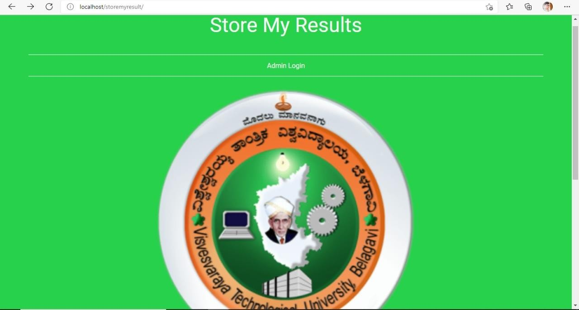

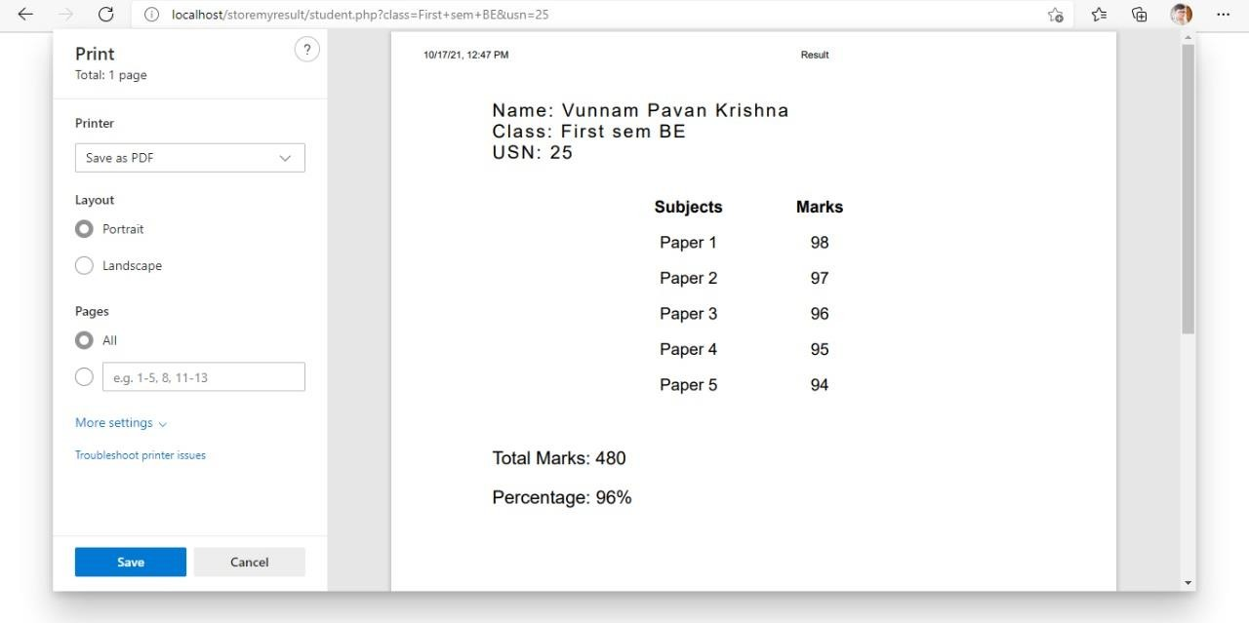

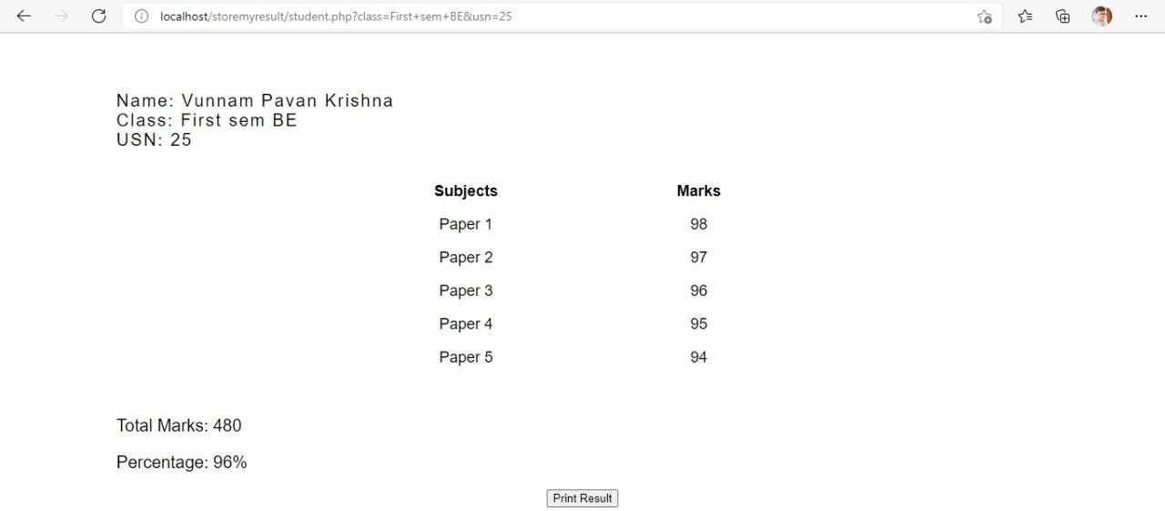

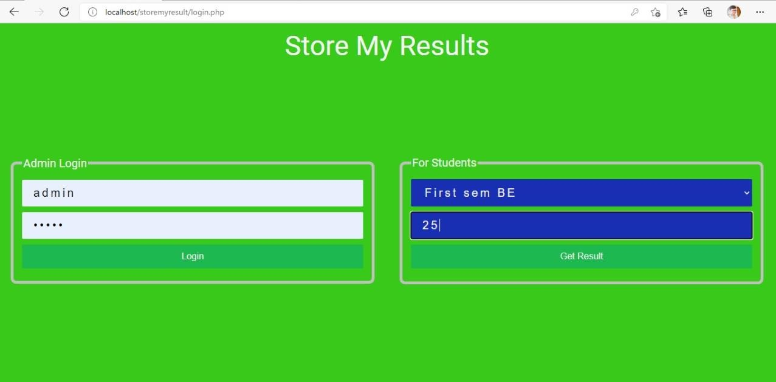

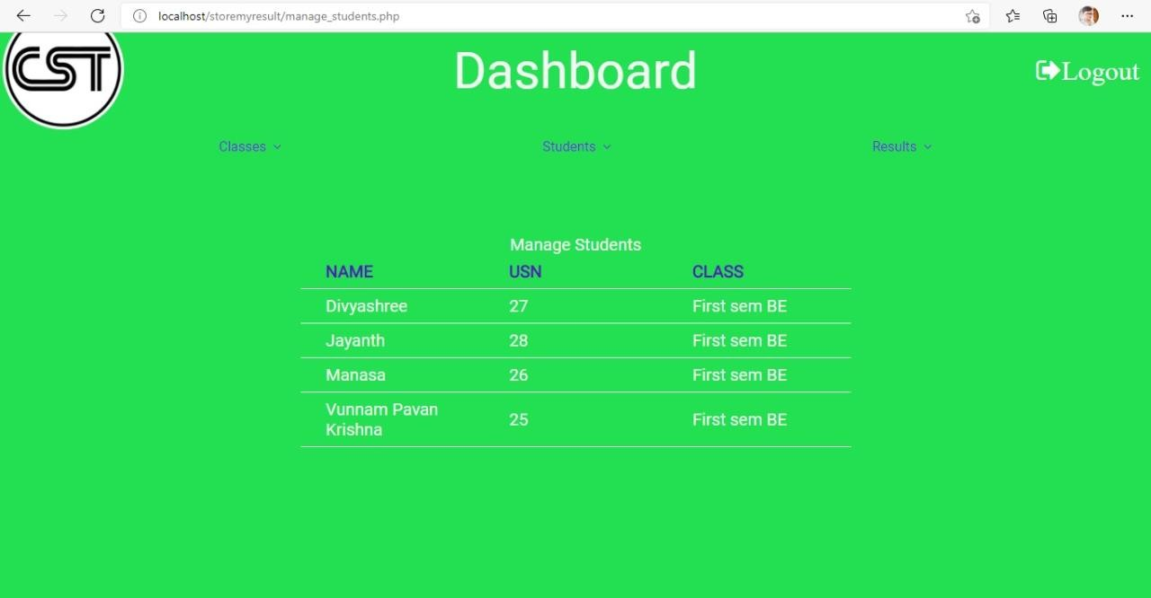

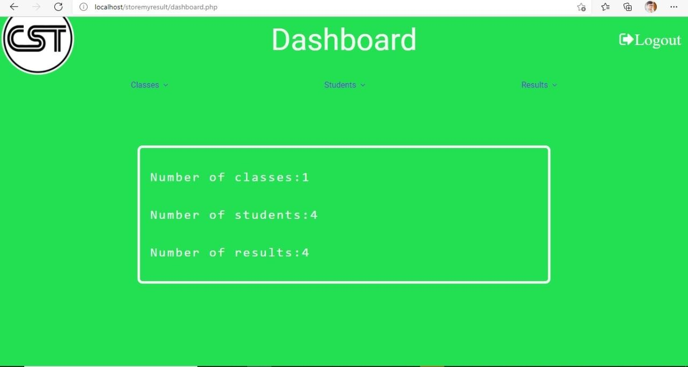

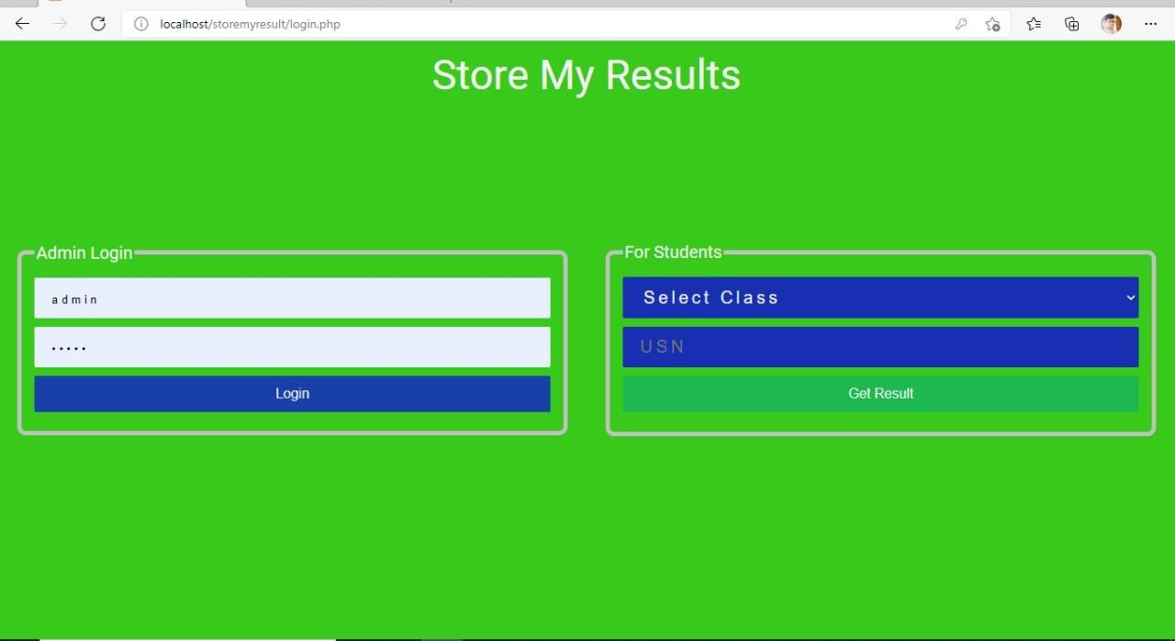

# BIBLIOGRAPHY

* https://[www.w3schools.com](http://www.w3schools.com/)
* https://[www.geeksforgeeks.org](http://www.geeksforgeeks.org/)
* https://freefrontend.com

**About my TEAM**

* + Vunnam Pavan Krishna – Worked on the code
  + Manasa Marigoli – Prepared the report of the project.
  + Divyashree K S – Helped in write the code
  + Jayanth Hegde H R – Helped in write the code