**ATM – Withdrawals**

**Version 1.0**

**K Pavan Kumar Reddy**

**10/05/2021**

**DOCUMENT CONTROL**

|  |  |  |  |
| --- | --- | --- | --- |
| Document Name: | ATM Withdrawals | Version: | 1.0 |
| Template Owner | Information Technology | Prepared By: | Pavan Kumar |
| Date | 10/05/2021 | Approved By: |  |

**VERSION HISTORY**

|  |  |  |  |  |
| --- | --- | --- | --- | --- |
| **Version** | **Description of Change** | **Author** | **Date** | **Reviewed by** |
| **1.0** | Initial version | Pavan Kumar | 10/05/2021 |  |
|  |  |  |  |  |

**Contents**

1 Introduction 5

1.1 Purpose 5

3.1 Preconditions 5

1.4 Basic flow : 5

2 API Detail Design: 5

2.1 Overview: 5

3 USE-CASE – Read card 6

3.2 Key Scenarios: 6

3.2.1 Success Scenarios: 6

3.2.2 Failure Scenarios : 6

3.2.3 Sequence Diagram : 7

3.2.4 API Contract : 7

4 USE-CASE – Authenticate user and Display amounts 8

4.1 Key Scenarios: 8

4.1.1 Successful Scenarios : 8

4.1.2 Failure : 9

4.2 Sequence Diagram: 9

4.3 API Contract : 9

5 USE-CASE - Withdraw and Remove card 11

5.1 Key Scenarios 11

5.1.1 Successful Scenarios: 11

5.1.2 Failure Scenarios: 11

5.2 Sequence Diagram : 11

5.3 API Contract : 12

6 Error Handling : 15

6.1 Error Cases: 16

6.2 Sample Error codes: 16

Error Payload: 17

7 Post Conditions: 17

8 ATM Withdraw Sequence diagram 18

# Introduction

## Purpose

The purpose of the document is to provide the technical details that are required to integrate with Bank`s API to withdraw cash in ATM .

## 1.2 Preconditions

* ATM System should not be in out of services
* The bank customer must posses a bank card to be acceptable by the ATM
* The network connection to the bank must be active
* The cash withdrawal service must be active

## 1.4 Basic flow :

* + - 1. Insert card
      2. Read card
      3. Authenticate customer
      4. Select Withdrawal
      5. Select amount
      6. Confirm Withdrawal
      7. Eject card
      8. Dispense cash

# API Detail Design:

## Overview:

This section elaborates functional and technical design of each use case which ATM interact with Core Bank API. Each use case will elaborate the API contract and control flow.

This document is developed based on assumption that ATM interacts with Switch and switch communicate with core banking server using secure and encrypted vpn tunnel through private leased lines.

High-level Design

Core Banking Server

ATM

ATM Switch

Bank API`s are developed using Open API 3.0 standards. In the intial stage four API for cash withdraw in ATM.

Each request having X-Request-id which is unique UUID and Idempotency-Key in headers. An idempotency key is a unique value generated by the client which the server uses to recongnize subsequent retries of same request.

Please refer below use cases

# USE-CASE – Read card

## Key Scenarios:

### Success Scenarios:

* The use case begins when the actor Customer inserts their bank card into the card reader on the ATM.
* The system allocates an ATM session identifier to enable errors to be tracked and synchronized between the ATM and the Bank System.
* The system reads the bank card information from the card.

### Failure Scenarios :

Fail due to invalid card :

* if card is damazed not able to read
* if card validity is expired
* if the System doesnt support the bank card financial insistute

### Sequence Diagram :

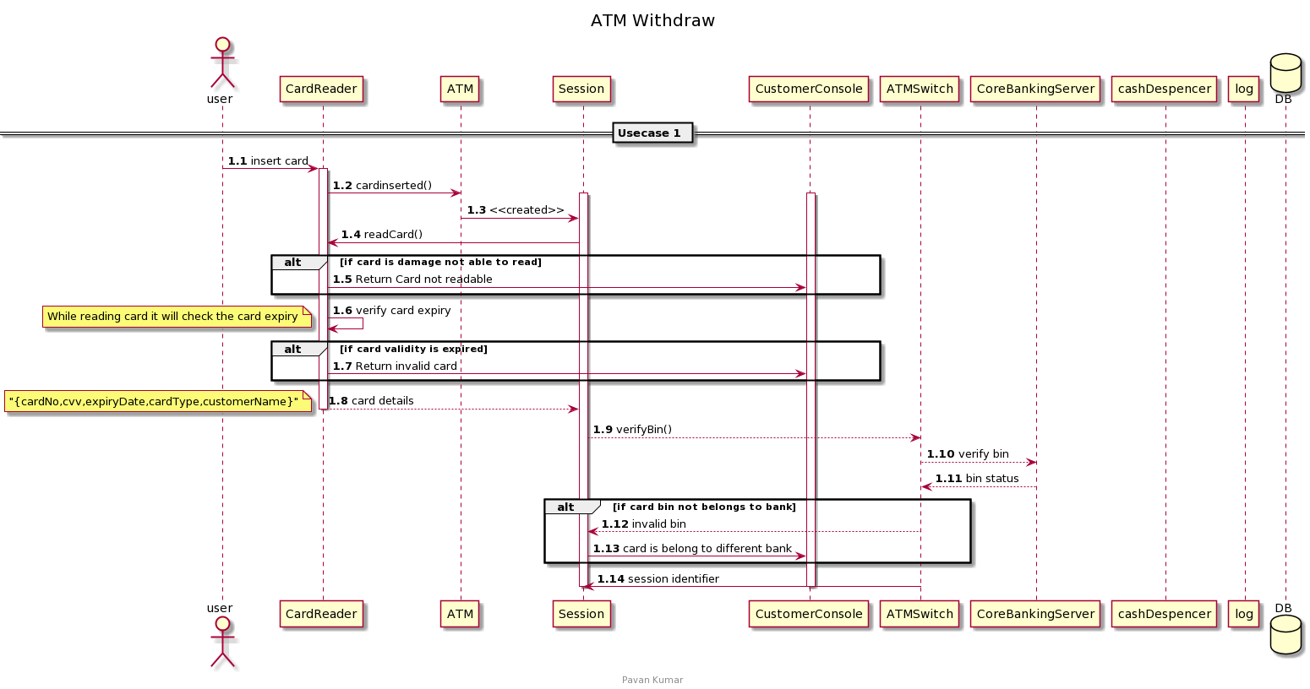

### API Contract :

This endpoint is to verify the card is belongs to issuing bank or not. It will check the bin of card , based on bin validation it will set the status in response.

|  |  |
| --- | --- |
| Title | Verify Card |
| URL | /bincheck |
| Headers | Content-type : application/json  X-Request-ID , Idempotency-Key |
| Method | POST |
| Data Params | {  "cardSequence": 45116787  } |
| Success Response | {  "binStatus": "VALID"  } |

**BinCheckRequest**

|  |  |
| --- | --- |
| cardSequence | **number *minLength: 6*** |
| atmID | **string *example: ATM123456*** |
| sessionIdentifier | **string *example: gytyy67gbbhhb88788*** |
|  |  |

**BinCheckResponse**

|  |  |
| --- | --- |
| binStatus | **string *example: VALID*Enum: [ VALID, INVALID ]** |
|  |  |

# USE-CASE – Authenticate user and Display amounts

# Key Scenarios:

# 4.1.1 Successful Scenarios :

* On card read successful, system prompts to enter the pin

**Validate Customer Identity and Card Information :**

* + - Once customer enter the pin , system sends the bank card information to the Bank System to confirm that the bank card and its associated account are active, that the card has not been reported stolen and that the bank card information (including the PIN) read from the bank card is valid.
    - The system also sends the ATM ID and the ATM session identifier to the Bank System along with the bank card information.
    - The Bank System acknowledges that the bank card information is valid and that the card can be used and account details with account balance.

### 4.1.2 Failure Scenarios :

* Customer not entered the correct PIN .
* Bank System reports card associated account is inactive.

### 4.2 Sequence Diagram:

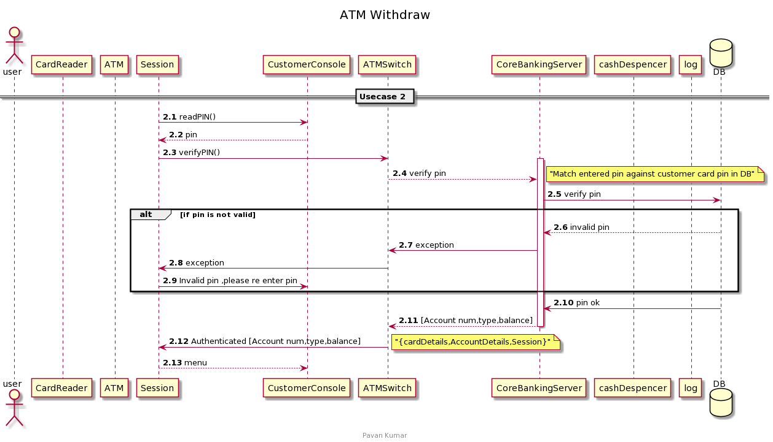

## 4.3 API Contract :

This endpoint has to use to validate the card information by verifying the pin .

|  |  |
| --- | --- |
| Title | Validate card information |
| URL | /verifyPin |
| Method | POST |
| Data Params | CardNuumber : number (16 digit number)  cardPIn : number (min 4 digit)  atmID : string  atmSessionIdentifier : string  example:  {  "cardNuumber": "4618765432889",  "cardPin": 3322,  “atmID”: “ATM123”,  “atmSessionIdentifier”:”wwwdwwfwef3223”  } |
| Success Response | {  "pin_status": "VALID",  "accountDetails": {  "accountName": "Payroll Account",  "currency": "INR",  "customerType": "PERSON",  "accountType": "string",  "accountStatus": "ENABLED",  "accountOwnership": "SOLE",  "postingsRestriction": "DEBITCREDIT"  },  "accountBalance": 500  } |

**VerifyPinRequest**

|  |  |
| --- | --- |
| cardNuumber | **string *minLength: 16 example: 4618765432889*** |
| cardPin | **number *minLength: 4 example: 3322*** |
| atmID | **string *example: ATM123456*** |
| sessionIdentifier | **string *example: gytyy67gbbhhb88788*** |
|  |  |

# USE-CASE - Withdraw and Remove card

# Key Scenarios

### 5.1.1 Successful Scenarios:

Conduct Withdrawal:

* On card authentication Successful ,customer choose to withdraw the amount.
* Customer has to enter the standard amount and with in ATM withdraw limit.

Validate Withdrawal:

* The System determines whether it has sufficient funds on hand to dispense the requested amount. System will checks to see the amount requested is greater than the amount in hand.
* The system supplies the Bank system with the card information, the amount of requested withdrawal, the ATM Session identifier
* On validation Bank System responds with a withdrawal acceptance to approve the withdrawal

On Withdraw approval ,system dispense the cash . After collecting cash ,customer terminate the system . System will eject the bank card.

### 5.1.2 Failure Scenarios:

* If the Bank System rejected the withdrawal because there were not sufficient fund in the account.
* If customer not responded with in 30 sec , system will terminate the session.
* If requested amount is greater than amount held in ATM , system will terminate the session.

### 5.2 Sequence Diagram :

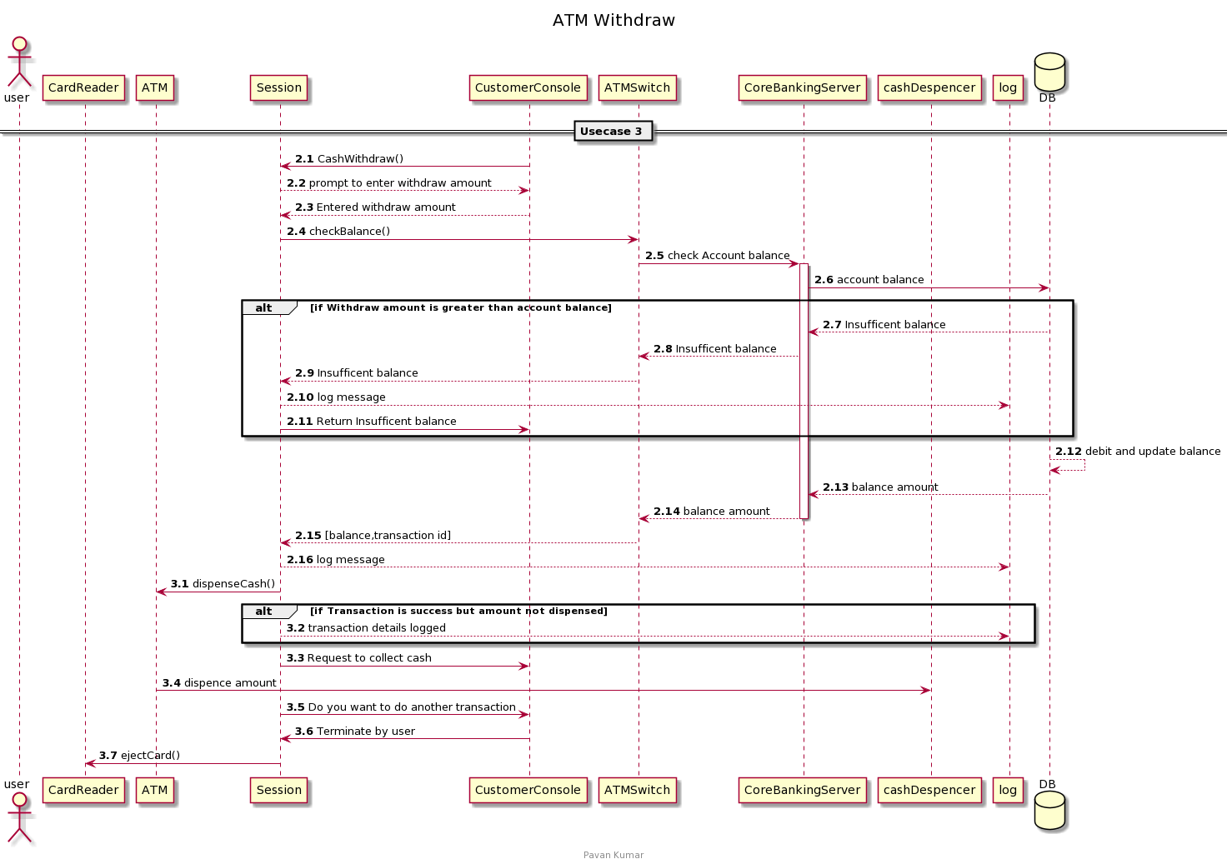

### 5.3 API Contract :

a) This endpoint has to use to check the account balance.

|  |  |
| --- | --- |
| Title | Balance Check |
| URL | /balance |
| Method | POST |
| Data Params | {  "accountNum": "9876543210",  "channelID": "ATM",  "dateTimeTransmission": "2021-05-10",  “atmID”:”ATM123”,  “sessionIdentifier”:”XXXdddss”  } |
| Success Response | {  "accountLedgerBalance": 50,  "accountAvailableBalance": 50,  "accountAvailableBalanceWithoutCredit": 10  } |

**BalanceEnquiryRequest**

|  |  |
| --- | --- |
| accountNum | **string *minimum: 10 example: 9876543210*** |
| channelID | **string *example: ATM*** |
| atmID | **string *example: ATM123456*** |
| sessionIdentifier | **string *example: gytyy67gbbhhb88788*** |
| dateTimeTransmission | **string($date-time)** |
|  |  |

**BalanceEnquiryResponse**

|  |  |
| --- | --- |
| **description:** | Balance Enquiry Response |
| **accountLedgerBalance\*** | **number($double) *example: 50 minimum: 1***  **Account Running Balance (Ledger Balance). BigDecimal(24,6) indicating 18 digits before and 6 after decimal** |
| **accountAvailableBalance\*** | **number($double) *example: 50 minimum: 1***  **Available balance including OD/Limits. BigDecimal(24,6) indicating 18 digits before and 6 after decimal** |
| **accountAvailableBalanceWithoutCredit\*** | **number($double) *example: 10 minimum: 1***  **Available balance excluding OD/Limits. BigDecimal(24,6) indicating 18 digits before and 6 after decimal** |
|  |  |

b) This endpoint is used to withdraw cash.

|  |  |
| --- | --- |
| Title | Cash Withdraw |
| URL | /withdraw |
| Method | POST |
| Data Params | {  "channelID": "ATM",  "terminalID": "ATM123",  "accountType": "SAVING",  "accountNumber": "456111189899",  "amountToBeWithdraw": 300,  "atmID": "ATM123456",  "sessionIdentifier": "gytyy67gbbhhb88788",  "dateTimeTransmission": "2021-05-09T08:02:10.996Z"  } |
| Success Response | {  "transactionStatus": "S",  "accountAvailableBalance": 5000,  "transactionID": "TNS1234456"  } |

**WithdrawRequest**

|  |  |
| --- | --- |
| **description:** | Cash Withdrawal Request |
| channelID | **string *example: ATM*** |
| terminalID | **string *example: ATM123*** |
| accountType | **stringEnum: [ SAVING, CURRENT, PENSION ]** |
| **accountNumber\*** | **string** |
| atmPin | **string *minimum: 4 example: 3456*** |
| **amountToBeWithdraw\*** | **number *example: 300*** |
| **atmID\*** | **string *example: ATM123456*** |
| **sessionIdentifier\*** | **string *example: gytyy67gbbhhb88788*** |
| dateTimeTransmission | **string($date-time)**  **Indicates the message transmission date and time from the channel** |
|  |  |

**WithdrawAmountResponse**

|  |  |
| --- | --- |
| **transactionStatus\*** | **string *example: S minLength: 1 maxLength: 1***  **Status of the ATM cash withdrawal transaction. S for Success F for Failure**  **Enum: Array [ 2 ]** |
| **accountAvailableBalance\*** | **number($double) *example: 5000 minimum: 1***  **Available balance , BigDecimal(24,6) indicating 18 digits before and 6 after decimal** |
| transactionID | **string *example: TNS1234456*** |
|  |  |

# Error Handling :

In all error conditions system creates a event log includes bank card information (excluding the PIN) and details of the cause. System shares this event log to Bank System

## 6.1 Error Cases:

Card Authentication Failure:

* If bank card not authenticated then the system ejects the customer bank card.
* If customer entered more than the 3 times wrong ping, system confiscates the card.

Bank not approve the withdrawal:

* If the bank systems not approval the withdrawal because of insufficient funds in customer account.

Customer quitting the Session:

* At any time ,if the customer elects to quit the session.
* If the customer quits after a withdrawal has been authorized but before cash dispensed.

ATM Running out of cash:

* If ATM machine is running out of cash , system will disable the withdraw option

Cash Dispensing Errors:

* If withdrawal is approved but cash is not dispensed (might be stuck at counting machine etc)

a) system disables the withdraw -cash option

b) system will inform to bank system for transaction adjustment

Customer not responding:

* At any point of time ,if the customer is not responding more than 30 secs. System will terminate the session

Bank System not responding:

* If Bank System is not responding after repeated times, System will terminate the session

## 6.2 Sample Error codes:

|  |  |  |
| --- | --- | --- |
| **Error Codes** | **Error Message** | **Http Status Code** |
| 050 | Unauthorized Usage | 401 |
| 053 | Incorrect PIN | 401 |
| 058 | Insufficient Funds | 400 |
| 062 | Pin Tries exeeds | 400 |
| 064 | Acct Not Connected to ATM Card | 400 |

### Error Payload:

{

"type": "https://api.banking.com/validation-error",

"title": "The request is invalid",

"status": 400,

"detail": "The account does not exist",

"causes": [

{

"code": "x068",

"message": "The account '1234567890' is dormant",

"severity": "ERROR",

"comment": "Ensure the account is active for the request",

"field": "account",

"fieldValue": "1234567890"

}

]

}

# Post Conditions:

* The ATM has returned the card and may or may not dispense the cash to the customer
* The ATM has returned the card to the Customer and no withdrawal done by customer
* The ATM has kept the card, no withdrawal has registered on the Customer’s account and the Customer
* has been notified where to contact for more information

# ATM Withdraw Sequence diagram

