**1 Introduction to mechanical engineering domain**

Mechanical engineering is a branch of applied science that deals with design, manufacturing, maintenance and analysis of machines and their interconnected components (involving force, motion etc.) that perform specific task.

**Role of mechanical engineering in industry and society**

**Role in Industry**

**Design and Innovation**

Mechanical engineers develop innovative (new or improved) products, machines, and systems, processes ranging from small components like sensors to large systems like power plants and manufacturing lines.

They contribute to innovations in industries for advancing efficiency, sustainability, and performance.

They design i.e. determine optimum (eg. not too strong or too weak) size of systems as per the requirment in industry.

**Manufacturing and Production**

They optimize manufacturing and management processes to produce goods efficiently (with minimum possible resources) and sustainably (low energy, low water, low waste).

Mechanical engineers work with automation, robotics, and additive manufacturing (3D printing) to improve quality, precision and reduce costs of manufacturing.

**Maintenance and Safety**

Engineers ensure the reliability and safety of machinery and systems, minimizing downtime (a period when production stops for maintenance or breakdown) and enhancing productivity (output).

They develop equipments (gloves, helmets, shoes, safety glasses, fall safety equipment) and guidelines for workplace safety in industrial operations.

**Research and Development (R&D)**

Mechanical engineers work on cutting-edge technologies like artificial intelligence (AI), nanotechnology, and advanced materials, contributing to research (discover new information) and gain competitive advantage in global markets.

**Role in Society**

**Infrastructure Development**

They design and maintain critical infrastructure, such as transportation systems (road, railway, air transport, and ocean transport), Heating, Ventilation, and Air Conditioning systems (of buildings, supermarkets, hospitals) and water supply networks in cities, improving public services and living conditions.

**Healthcare Advancements**

Mechanical engineering contributes to medical devices (pacemaker, robotic surgery, surgical and dental equipment) prosthetics (artificial limbs), and equipment like MRI machines, improving healthcare availability and products.

**Sustainability and Environment**

Engineers develop solutions to combat climate change by improving energy efficiency (from using supercritical power plants to home appliances like inverter ACs), reducing emissions, and advancing green technologies like electric vehicles and waste recycling systems.

**Improving Quality of Life**

From household appliances (vacuum cleaners, washing machines, fridges and ACs) to modern transportation (scooters and cars), mechanical engineers design systems that enhance daily convenience and comfort.

**Disaster Mitigation**

They play a role in designing resilient structures and systems to withstand disasters (base isolators to reduce damage during earthquake, flood barriers, life jackets, inflatable boats, fire extinguishing equipments), ensuring safety and reducing loss.

**Application of Mechanical Engineering in various domains such as Automobile, Aerospace, Energy, Manufacturing etc**

**Automobile Industry**

Mechanical engineers are at the core of vehicle design, development, and production.

**Vehicle Design:** Designing engines, chassis (support structure), suspension systems (with springs and dampers), and transmission.

**Thermal Management:** Developing cooling systems (eg. Radiator, fins) to manage engine heat to reduce thermal stresses and improve volumetric efficiency.

**Manufacturing Processes:** Utilizing advanced techniques like robotic welding, die-casting, and CNC machining.

**Electric Vehicles (EVs):** Designing battery systems, electric motors, and powertrain components for EVs.

**Safety Systems:** Developing airbags, crash-resistant structures, and advanced braking systems.

**Aerospace Industry**

Mechanical engineering drives advancements in aviation and space exploration.

**Aircraft Design:** Developing lightweight and aerodynamic structures for airplanes and helicopters.

**Propulsion Systems:** Designing engines, such as jet turbines and rocket engines.

**Material Science:** Creating durable, lightweight materials for extreme conditions.

**Thermal Management:** Ensuring proper cooling in spacecraft and satellites.

**Simulation and Testing:** Conducting stress analysis, wind tunnel testing, and fatigue testing for safety and performance.

**Energy Sector**

Mechanical engineering is vital in both traditional and renewable energy systems.

**Power Plants:** Designing turbines, boilers, and heat exchangers for coal, nuclear, and natural gas plants.

**Renewable Energy:** Developing wind turbines, solar panels, and geothermal systems.

**Energy Efficiency:** Optimizing energy use in industrial and residential systems.

**Hydropower:** Designing components like water turbines and dam systems.

**Manufacturing and Production**

Mechanical engineering revolutionizes production processes and industrial efficiency.

**Automation:** Developing robotic systems and automated assembly lines.

**CNC Machining:** Programming precision tools for high-quality production.

**Additive Manufacturing:** Innovating with 3D printing for rapid prototyping and custom parts.

**Lean Manufacturing:** Enhancing productivity by minimizing waste and optimizing processes.

**Quality Control:** Utilizing tools like coordinate measuring machines (CMMs) for accuracy

**2 Fundamentals of Mechanical Engineering**

**Concept of prime mover**

Prime movers transform energy from natural sources (thermal, chemical, hydraulic, etc.) into mechanical energy

The mechanical energy generated by a prime mover is used to drive other machines or systems, such as generators, pumps, or compressors.

Prime movers are designed for consistent and sustained operation to meet industrial or utility demands.

**Types of Prime Movers**

**Heat Engines** (Thermal Energy Conversion):  
These use thermal energy from fuel combustion or other heat sources.

**Internal Combustion Engines (IC Engines):** <https://www.youtube.com/watch?v=ZSkB3zrU8T4&t=383s>

Found in cars and motorcycles; convert the chemical energy of fuel into mechanical work. Used in vehicles due to better low speed efficiency, rapid response and compact compared to steam engines. Uses costly fuel, significant noise and lower efficiency so not used in large power generation but better for small power generation as diesel generators because of better fuel efficiency at wider

**Steam Turbines:** <https://www.youtube.com/watch?v=SPg7hOxFItI&t=250s>

Used in power plants; convert thermal energy from steam into rotational motion. Suitable in power generation due to low cost fuel such as coal. They add significant weight and bulk to the vehicle so not used in road vehicles and air crafts. Steam turbines operate at high pressures in the boiler so safety concerns are there. Star up time is high, considerable noise generation, costly maintenance so not used instead of diesel generators.

**Gas Turbines:** <https://www.youtube.com/watch?v=LDotzmLwTcw>

Used in jet engines and power plants; convert high-temperature, high-pressure gas into mechanical energy. Preferred than I C engines in aircrafts because low power to weight ratio (at larger power I C engines would become heavier), good high speed (supersonic effects at propeller tips in I C engines creating shock waves increasing drag significantly) and high altitude performance (low density air means supercharged engine will be required), not used in road vehicles because low efficiency and low torque at low speeds, high cost and complexity, slow response etc. Not suitable for power plants instead of steam turbine as alone because of fuel costs (natural gas), poor low load efficiency. How ever can be used in combination with steam turbine as a combined cycle (gas turbine exhaust generates steam) or peak load plant due to fast start up.

**Hydraulic Machines** (Fluid Energy Conversion):

**Water Turbines:** <https://www.youtube.com/watch?v=Lx6UfiEU3Q0>

Used in hydropower plants; convert the energy of dam water into mechanical energy.

**Hydraulic Motors:** <https://www.youtube.com/watch?v=sTrEGXXSLSA>

Driven by pressurized oil in systems. Due to compact and light in weight compared to electric motors, used in heavy duty applications such as construction equipment, mining, industrial presses. It is easily used as integral component of hydraulic system instead of separate electric motor to perform the functions. Maintenance is costly, complex design makes them unsuitable for many applications.

**Wind Machines** (Kinetic Energy Conversion):

**Wind Turbines:** <https://www.youtube.com/watch?v=qSWm_nprfqE>

Convert the kinetic energy of wind into mechanical energy, often used to generate electricity.

**Electric Motors** (Electrical Energy Conversion): <https://www.youtube.com/watch?v=1AaUK6pT_cE>

Though they are powered by electricity, electric motors act as prime movers in many applications by converting electrical energy into mechanical energy. They are used in electric vehicles, automation, consumer products due to high efficiency, easy maintenance, precise control, quieter operation.

**Human and Animal Power:** [**https://www.youtube.com/watch?v=0zL-PYsL25Y**](https://www.youtube.com/watch?v=0zL-PYsL25Y)  
In earlier mechanical systems, human or animal effort served as the prime mover. Examples include treadmills and manual cranks.

**Pneumatic motors:** <https://www.youtube.com/watch?v=cQnvWUpWmYg>

Driven by pressurized air in systems. Compressed air systems are inefficient to operate and motors generate noise so not common. Due to high power to weight ratio so used in portable handled tools. No generation of debris or electric spark so used in oil and gas industry environments and clean room environment in pharma and semiconductor industries

**Applications of Prime Movers**

**Power Generation:** Driving generators in power plants (steam turbines, gas turbines, hydro turbines).

**Transportation:** Propelling vehicles, ships, and aircraft (IC engines, jet engines).

**Industrial Machines:** Powering machinery in factories and plants.

**Agriculture:** Driving pumps, tractors, and other agricultural equipment.

**Characteristics of a Good Prime Mover**

**Efficiency:** High energy conversion efficiency.

**Reliability:** Minimal breakdowns and consistent performance.

**Adaptability:** Suitability for various energy sources and operating conditions.

**Compactness:** Space-saving design for easier integration.

**Sustainability:** Low environmental impact and use of renewable energy sources where possible.

**Sources of energy**

Mechanical engineering deals with the design, construction, and operation of machines and systems that use energy. Therefore, understanding various energy sources is fundamental to the field.

**Conventional (Non-Renewable) Energy Sources**

These are traditional energy sources derived from finite natural resources.

**Fossil Fuels**

**Coal:** Used in thermal power plants for electricity generation and industrial processes.

**Petroleum:** Powers internal combustion engines in vehicles and is used for heating and industrial applications.

**Natural Gas:** Used in gas turbines for electricity and as a fuel for heating and cooking.

**Nuclear Energy**

**Uranium and Thorium:** Used in nuclear reactors to generate electricity through fission processes. Safety Concerns and Accidents specially during natural disasters. Nuclear Waste Disposal is another problem.

**Renewable Energy Sources**

These sources are sustainable and replenished naturally at faster rate.

**Solar Energy**

**Photovoltaic Systems:** Convert sunlight into electricity for powering systems. Intermittency is the problem. It has become cost-competitive. Not used widely till today due to no availablity at night and cloudy sky, requirement of significant land area, fear of fast growing technology and high capital cost of technology.

**Solar Thermal Systems:** Use solar energy for heating and powering steam turbines. Plants generally have higher capital costs compared to solar PV plants. Due to same reasons are not preferred over other sources of energy.

**Wind Energy**

Wind turbines convert the kinetic energy of wind into mechanical energy, often used to generate electricity. It has become cost-competitive now a days, however intermittency is the problem. Limited to specific locations.

**Hydropower**

Water turbines in dams convert the potential energy of stored water into mechanical energy for power generation. Mature technology hence efficient, cost effective and reliable, lower capital costs compared to ocean energy and lower operating costs than coal thermal power station.

**Geothermal Energy**

Heat from the Earth's interior is used to generate steam, driving turbines for electricity or direct heating applications. Limited to specific locations. significant capital investment in exploration, drilling and construction comparable with hydropower.

**Biomass**

Organic materials (wood, agricultural waste) are burned or processed to release chemical energy.

**Biofuels:** Biogas, ethanol and biodiesel are renewable alternatives for traditional fuels. Growing crops for biofuels can compete with land used for food production and forests, potentially leading to food shortages and environmental concerns.

**Emerging and Alternative Energy Sources**

**Hydrogen Energy**

Green hydrogen is used as a clean fuel in fuel cells and combustion engines, producing only water as a byproduct. Green hydrogen requires significant electricity and electrolysers have high capital costs.

**Ocean Energy** Harsh marine environment can cause wear and tear on ocean energy devices increasing maintenance and reducing durability so it is not popular. Also there is a possibility of disruption of marine ecosystem and technology is not mature.

**Tidal Energy:** The kinetic and potential energy of tides drives turbines. High capital costs and intermittency are problems.

**Wave Energy:** Energy from surface waves powers mechanical systems. Capital intensive is the problem.

**Ocean Thermal Energy Conversion (OTEC):** Exploits temperature differences in ocean layers to generate electricity. Low efficiency and high capital costs are the problems.

**Waste-to-Energy**

Converts municipal and industrial waste into usable energy through combustion or other processes. Emkission of dioxins, heavy metals, high cost involved in maintenance and specialised equipments are the problems

**Fusion Energy**

Still in experimental stages, fusion reactions promise immense energy output with minimal environmental impact. Extremely expensive so not yet used. No fusion experiment has yet achieved sustained net energy gain.

**Human and Animal Power**

Historically used for driving mechanical systems like water lifting wheels and hand-operated tools like drill, and still relevant in remote or resource-constrained areas.

|  |  |  |
| --- | --- | --- |
| **Feature** | **Renewable Energy Sources** | **Non-Renewable Energy Sources** |
| Source | Naturally replenished on a human timescale (e.g., sunlight, wind, water) | Finite resources that cannot be easily replenished (e.g., fossil fuels, uranium) |
| Availability | Abundant and widely distributed (though geographically variable) | Limited and concentrated in specific locations |
| Environmental Impact (General) | Generally lower greenhouse gas emissions during operation; some impacts from manufacturing and installation | Generally higher greenhouse gas emissions; significant environmental impacts from extraction, processing, and combustion |
| Air Pollution | Minimal air pollution during operation | Significant air pollution (particulates, NOx, SOx) |
| Waste Products | Minimal waste; some waste from manufacturing and end-of-life disposal | Significant waste products (e.g., ash from coal, spent nuclear fuel) |
| Land Use | Can require large land areas (e.g., solar farms, wind farms), but often compatible with other land uses | Extraction (mining, drilling) can disrupt large areas; infrastructure (pipelines, refineries) also requires land |
| Water Use | Can require water for some technologies (e.g., hydropower, some CSP), but generally less than fossil fuels | Significant water use for extraction, processing, and cooling |
| Cost (General) | Decreasing costs; becoming increasingly competitive with fossil fuels | Costs can fluctuate significantly depending on market conditions and extraction costs |
| Technology Maturity | Varying levels of maturity; some are well-established (hydropower), others are still developing (wave, OTEC) | Well-established technologies with existing infrastructure |
| Energy Security | Improves energy security by reducing reliance on imported fossil fuels | Can lead to geopolitical tensions and price volatility due to concentrated resources |
| Examples | Solar, wind, hydro, geothermal, tidal, wave, OTEC, biomass | Coal, oil, natural gas, nuclear |

Sources of energy can also be classified as follows

**By Origin:**

**Primary Energy Sources:** These are found in nature in their raw form.

Sunlight (solar), Wind, Moving water (hydropower), Geothermal heat, Fossil fuels, Nuclear fuels

**Secondary Energy Sources:** These are produced from the conversion of primary energy sources. Electricity (can be generated from various primary sources), Hydrogen (can be produced from natural gas, water, or biomass)

**By Commercial Use:**

**Commercial Energy Sources:** These are traded in the market and are used for industrial and commercial purposes. Fossil fuels, Electricity, Nuclear energy

**Non-Commercial Energy Sources:** These are typically used for self-consumption or in traditional settings. Firewood, Animal dung, Agricultural waste

**Force and mass**

Force and mass are fundamental concepts in mechanical engineering, closely related and essential for understanding how objects move and interact. Understanding force and mass is essential for mechanical engineers to design and analyze systems that are safe, efficient, and reliable.

**Mass**

**Definition:** Mass is nothing but the amount of matter in an object. It's an intrinsic property. It remains constant irrespective of place (not like weight, which changes with gravity).

**Units:** The SI unit of mass is the kilogram (kg).

**Inertia:** Mass is a measure of inertia, which is the resistance to change in motion. The greater the mass, the greater the inertia.

**Force**

**Definition:** Force is an external influence that can cause an object to accelerate (change its velocity), change direction, or deform.

**Units:** The SI unit of force is the Newton (N) (1 N = 1 kg⋅m/s²).

**Types of Forces:** Mechanical engineering deals with various types of forces, including:

**Gravitational Force:** The force of attraction between objects with mass (e.g., weight).

**Applied Force:** A force directly applied to an object (e.g., pushing or pulling).

**Frictional Force:** A force that opposes motion between surfaces in contact.

**Tension Force:** The force transmitted through a rope, string, or wire when it is pulled tight.

**Compressive force:** The force transmitted on the bar due to pushing from both sides

**Internal Forces**: Forces that act within an object, such as due to stress and strain.

**Relationship between Force and Mass**

**Newton's Second Law of Motion:** This law is the relationship between force, mass, and acceleration:

**Force (F) = Mass (m) × Acceleration (a)**

This relation says that the force acting on an object is equal to the product of mass of the object and acceleration of the object.

**Application of concept of force in Crane’s hoisting Mechanism, a mechanical system :** [**https://www.youtube.com/watch?v=29uQKTJjSXM&t=122s**](https://www.youtube.com/watch?v=29uQKTJjSXM&t=122s)

**Force Applied (Input Force):** A force is applied to the rope or cable to lift the load.

**Mechanical Advantage:** By using pulleys, the force required to lift the load can be reduced.

For example, in a simple block-and-tackle system with n pulleys, the required force (Fin) is reduced to: Fin=Fload/n​​

where Fload is the weight of the load= mass to be lifted m x gravitational acceleration g.

**Force Output:** The applied force is transmitted through the rope and pulleys to lift the load, overcoming the force of gravity.

**Example:**

A crane uses a block-and-tackle system with 4 pulleys to lift a load weighing 1000 N:

Without pulleys, the required force is Fin=1000 N.

With 4 pulleys, the required force becomes: Fin=1000/4=250 N.

**Importance in Mechanical Engineering**

The concepts of force and mass are crucial in various areas of mechanical engineering:

Statics: Analyzing forces on objects at rest to ensure structural stability.

Dynamics: Analyzing forces on objects in motion to predict their behavior.

Strength of Materials: Determining how materials respond to applied forces and designing structures that can withstand those forces.

Machine Design: Designing machines and mechanisms that can transmit and transform forces to perform desired tasks.

Vibrations: Analyzing the effects of dynamic forces on structures and machines to prevent unwanted vibrations and failures.

**Pressure**

Pressure is defined as the force applied by the fluid per unit area.

**Units of Pressure**

**SI Unit:**

Pascal 1Pa=1N/m2.

**Other Common Units:**

Bar (1 bar=105 Pa)

Atmosphere (1 atm=101,325 Pa)

Pounds per square inch (psi)

Torr or mmHg (1 Torr=133.322 Pa)

**Types of Pressure**

**Atmospheric Pressure:**

The pressure exerted by the atmosphere air.

Standard atmospheric pressure is 101,325Pa (1 atm).

**Gauge Pressure:**

The pressure measured relative to atmospheric pressure.

Positive gauge pressure indicates pressure above atmospheric pressure, while negative values indicate a vacuum.

**Absolute Pressure:**

Total pressure measured from absolute zero pressure (vacuum).

P absolute=P gauge+ P atmospheric​

**Differential Pressure:**

The difference between two pressure readings, used in flow and process control systems.

**Hydrostatic Pressure:**

Pressure due to the weight of a fluid on a surface: P=ρ⋅g⋅h, ρ is the density, g is acceleration due to gravity, h is the height of the fluid column.

**Devices for Measuring Pressure**

**Manometers:**

Measure differential pressure using liquid columns.

For pressure drop and flow rate measurement,

**Pressure Gauges:**

Used in tanks, pipelines, and machines to display gauge pressure.

Measure pressure using the deformation of a coiled tube.

**Pressure Transducers:**

Convert pressure into an electrical signal for digital systems

These are strain guage type, piezoelectric capacitive

**Barometers:**

Measure atmospheric pressure

**Application of concept of pressure in the Hydraulic Press, a mechanical system:** [**https://www.youtube.com/watch?v=JxJUPD-Ajnc**](https://www.youtube.com/watch?v=JxJUPD-Ajnc)

A hydraulic press operates based on **Pascal's principle**, which states that pressure applied to a confined fluid is transmitted uniformly in all directions.

**System Description:**

**Force Applied:** A small force (F1​) is applied to a small piston with area (A1​).

**Pressure Transmission:** The pressure (P) generated is transmitted through a hydraulic fluid to a larger piston with area (A2).

Pressure: P=F1/A1​​

**Force Output:** At the larger piston, this pressure generates a larger force (F2​):

F2=P x A2​=F1/A1 x A2

**Amplification of Force:** By designing the pistons such that A2>A1​, the hydraulic press magnifies the applied force. A small input force can lift or compress a much heavier load.

**Uses:** Hydraulic presses are widely used in metal forming, forging, and car repair shops for lifting vehicles.

**Example:**

Suppose F1=100N, A1=0.01 m2 and A2=1 m2

Pressure generated: P=100/.01​=10,000Pa

Output force: F2=P⋅A2=10,000N

Thus, the hydraulic press uses the concept of pressure to magnify small input forces into much larger output forces, demonstrating its utility in mechanical systems.

**Work**

Work is a product of force F acting on the body and the distance travelled by the body S in the direction of force. For a rotating body it is product of the torque acting on the body T and the angular distance ϴ travelled by the body.

W= F.S

W= T.ϴ

**Units of Work**

**SI Unit:**

Joule where 1 J=1 N⋅m

**Application of concept of work in mechanical engineering (work done on screw jack for lifting load)**

[**https://www.youtube.com/watch?v=RM9zTq7sSZ0&t=8s**](https://www.youtube.com/watch?v=RM9zTq7sSZ0&t=8s)

A screw jack uses a helical thread to lift heavy loads. Work is done by rotating the screw, which translates into vertical linear motion of the load.

**Work Input (Rotation) = Work Output (Lifting)**

**Torque (τ) x Angle of Rotation (θ) = Force (F) x Distance (d)**

Where:

Torque (τ) is the force applied tangentially to the screw handle.

Angle of Rotation (θ) is the angle through which the handle is rotated.

Force (F) is the weight of the load being lifted.

Distance (d) is the vertical distance the load is raised.

**Example:**

Let's assume:

Torque (τ) = 50 Nm

Angle of Rotation (θ) = 2π radians (one full rotation)

Load weight (F) = 1000 N

Calculate the distance lifted:

**d = (τ x θ) / F**

d = (50 Nm x 2π radians) / 1000 N = 0.314 meters

**Importance in Mechanical Engineering**

The concept of work is fundamental in many areas of mechanical engineering:

Thermodynamics: Work is a key concept in thermodynamics, where it is used to analyze energy transfer in systems such as engines and heat pumps.

Mechanics: Work is used to analyze the motion of objects and the forces acting on them.

Machine Design: Engineers consider work when designing machines to ensure they can perform their intended tasks efficiently.

Material Testing: Measuring work done during deformation helps evaluate material strength and ductility.

**Power**

Power, in mechanical engineering, is the rate at which work is done or energy is transferred. It tells us how quickly work can be performed.

Power is defined mathematically as:

P=W/t

Where:

P: Power (in Watts)

W: Work done or energy transferred (in Joules)

t: Time taken (in seconds)

Alternatively, for systems where force and velocity are involved:

P=F⋅v

Where:

F: Force applied (in Newtons, N)

V: Velocity of the object (in m/s)

For rotational systems:

P=τ⋅ω

Where:

τ: Torque (in N)

ω: Angular velocity (in radians per second)

**Units of Power**

**SI Unit:**

Watt 1 W=1 J/s

**Other Units:**

Horsepower (hp): Commonly used in automotive and mechanical systems.

1 hp=746 W

Kilowatt: 1 kW=1000 W

**Application of concept of power in mechanical engineering (Engine Power Required for a Car to Maintain Constant Speed):**

Mass of the car: m=1200 kg, m = 1200 kg

Speed of the car: v=20 m/s (approximately 72 km/h)

Coefficient of rolling resistance: Cr=0.01

Gravitational acceleration: g=9.81 m/s2

Efficiency of the vehicle transmission system from engine to wheels: η=90%.

We have to calculate the power required by the car's engine to maintain a constant speed.

**Calculating the Force Due to Rolling Resistance**

The rolling resistance force is given by:

Frr=Cr×m×g

Where:

Cr is the coefficient of rolling resistance

m is the mass of the car

g is the acceleration due to gravity

Substituting the given values:

Frr=0.01×1200 kg×9.81 m/s2=117.72

**Calculating the Power to Overcome Rolling Resistance**

The power required to overcome the rolling resistance is calculated by multiplying the force Frr by the speed v of the car:

Prr=Frr×vr=117.72 N×20 m/s=2354.4 W=2.354 kW

So, the power required to overcome rolling resistance is **2.354 kW**.

**Adjusting for vehicle transmission Efficiency**

Since the vehicle transmission efficiency only 90% efficient, we need to calculate the total input power to be supplied by the engine. The input power Pin​ can be calculated as:

Pin=Pout/η​​=2354.4 W/0.9=2.616kW

Where:

Pin is the input power (in watts)

Pout​ is the output power (in watts)

η is the efficiency

For a car weighing 1200 kg and traveling at 20 m/s, with a rolling resistance coefficient of 0.01 and an engine efficiency of 90%, the engine needs to supply 2.616 kW of power to overcome rolling resistance and transmission losses. If there are no efficiency losses, the engine needs to provide power of approximately 2.354 kW to maintain this speed.

**Importance in Mechanical Engineering**

Power is a crucial concept in various areas of mechanical engineering:

Machine Design: Engineers consider power requirements when designing machines to ensure they can perform their intended tasks at the desired speed.

Engine Performance: Power is a key performance indicator for engines, determining their ability to accelerate vehicles or drive machinery.

Fluid Systems: Power is important in designing pumps, turbines, and other fluid systems to ensure they can move fluids at the required flow rates.

Energy Systems: Power is a critical factor in the design and analysis of power plants and other energy systems.

**Energy**

In mechanical engineering, energy is a fundamental concept that describes the capacity of a physical system to do work. It's the ability to cause change or perform actions like moving objects, generating heat, or producing light.

**Units of Energy**

**SI Unit:**

Joule, where 1 J=1 N m.

**Other Units:**

Kilowatt-hour (kWh), commonly used in power and energy consumption.

Calorie =4.184 J, used in thermodynamics and food energy.

British Thermal Unit (BTU), used in heating and cooling systems.

**Forms of Energy in Mechanical Engineering**

**Mechanical Energy:** This is the energy associated with the motion and position of an object. It has two components:

**Kinetic Energy:** The energy of motion. Any object in motion has kinetic energy. It depends on the object's mass and velocity.

Formula: KE = (1/2)mv² (where m is mass and v is velocity)

**Potential Energy:** The energy stored in an object due to its position or condition. There are several types:

**Gravitational Potential Energy:** Energy stored due to an object's height above a reference point.

Formula: PE = mgh (where m is mass, g is acceleration due to gravity, and h is height)

**Elastic Potential Energy:** Energy stored in a deformed elastic object, like a spring.

Formula: PE = (1/2)kx² (where k is the spring constant and x is the displacement from the equilibrium position)

**Thermal Energy (Heat):** The energy associated with the random motion of atoms and molecules within a substance. Heat transfer is a crucial aspect of thermodynamics.

**Chemical Energy:** The energy stored in the bonds of chemical compounds. This is released during chemical reactions, such as combustion in engines.

**Electrical Energy:** The energy associated with the flow of electric charge. Electrical energy is used to power various devices and systems in mechanical engineering.

**Law of Conservation of Energy**: Energy can neither be created nor be destroyed, it can only be converted from one form to another form.

**Application of concept of energy in mechanical engineering (Heat energy to be dissipated from braking system):**

Consider the following parameters for a vehicle:

Mass of the vehicle m=1000 kg

Initial velocity of the vehicle v=25 m/s (about 90 km/h)

Distance over which the vehicle is stopped dbrake=50 m

**Calculating the initial kinetic energy of the vehicle.**

KEvehicle=1/2mv2=1/2×1000×(25)2=312,500 J

**Work done by the brake system.**

Assuming that the brakes apply a constant force to stop the vehicle, the work done by the brakes is equal to the kinetic energy of the vehicle:

Wbrake=KEvehicle=312,500 J

This work is done by the brake pads over a distance of dbrake=50 m

**Heat generated by the brake system.**

Since all of the kinetic energy is converted into heat (ideal case), the thermal energy Q generated is:

Q=KEvehicle=312,500 J

This needs to be dissipated in braking systems to prevent overheating

**Importance in Mechanical Engineering**

Energy is a central concept in many areas of mechanical engineering:

Thermodynamics: The study of energy transfer and transformations between heat and other forms of energy.

Fluid Mechanics: Analyzing the energy of fluids in motion, including kinetic energy, potential energy, and pressure energy.

Heat Transfer: Studying the transfer of thermal energy between systems.

Machine Design: Designing machines to efficiently convert and utilize energy to perform desired tasks.

Energy Systems: Designing and analyzing power plants, renewable energy systems, and other systems that generate, distribute, and utilize energy

Power Generation: Conversion of thermal, chemical, or kinetic energy into electrical energy.

Engine Design: Analysis of energy transformations in internal combustion engines, turbines, and other machinery.

HVAC Systems: Designing heating, ventilation, and air conditioning systems to manage thermal energy.

**Temperature**

A measure of the average kinetic energy of the particles in a substance. It indicates how hot or cold a substance is. Temperature quantifies the thermal state of a system, determining the direction of heat transfer between two objects.

**Units**

**Celsius (°C)**: The commonly used temperature scale in everyday applications.

**Kelvin (K)**: The absolute temperature scale, used in scientific and engineering applications.

T(K)=T(oC)+273.15

**Fahrenheit (°F)**: Used in some countries, particularly in the United States.

T(oF)=T(oC). 9/5​+32

**Temperature Measurement**

**Thermometers**:

Instruments calibrated to measure temperature using materials that change properties with temperature, such as mercury or alcohol.

**Thermocouples**:

Devices that measure temperature based on the voltage generated at the junction of two dissimilar metals.

**Infrared Sensors**:

Measure temperature by detecting emitted infrared radiation.

**Resistance Temperature Detectors (RTDs)**:

Measure temperature by monitoring the resistance of materials like platinum, which changes predictably with temperature.

**Application of concept of temperature in mechanical engineering (ideal refrigeration system):**

For the ideal refrigeration, the COP (energy efficiency heat absorbed per unit of electricity consumed) can be written in terms of the temperatures

COPideal=TL/(TH−TL)​​

Where:

TL = Temperature of the cold reservoir to be cooled (temperature, in Kelvin)

TH = Temperature of the reservoir where heat is dissipated (temperature, in Kelvin)

Let’s assume

Temperature TL=275 K (2°C)

Temperature TH=300 K(27°C)

COPideal=TL/(TH−TL)=275/(300−275)=11

**Interpretation:**

This means that for every unit of electricity supplied to the refrigerator, it is able to absorb 11 units of heat from the space to be cooled. This is the maximum possible ideal performance. In real-world applications, the COP would be lower due to losses and non-ideal behaviors. A larger temperature difference between the space to be cooled and atmosphere reduces the COP and lowers the system’s efficiency.

**Importance in Mechanical Engineering**

Temperature is a critical factor in numerous areas of mechanical engineering:

Thermodynamics: Temperature is a fundamental thermodynamic property used to define the state of a system and analyze energy transfer as heat.

Heat Transfer: Understanding temperature differences is essential for analyzing heat transfer processes like conduction, convection, and radiation.

Material Properties: Temperature affects various material properties, such as:

Strength: Materials generally lose strength at high temperatures.

Ductility: The ability of a material to deform plastically can change with temperature.

Thermal Expansion: Materials expand or contract with changes in temperature, which must be considered in design.

Fluid Mechanics: Temperature affects fluid properties like viscosity and density, influencing fluid flow behavior.

Manufacturing Processes: Temperature control is crucial in many manufacturing processes, such as heat treatment, welding, and casting.

Engine Performance: Engine efficiency and emissions are strongly influenced by operating temperatures.

HVAC Systems: Heating, ventilation, and air conditioning (HVAC) systems rely on temperature control to maintain comfortable indoor environments.

**Heat**

Heat is the transfer of thermal energy between systems due to a temperature difference. It always flows from a region of higher temperature to a region of lower temperature. Heat is energy in transit. It's not something that is "contained" within an object; rather, it's the process of energy moving from one object to another. A temperature difference is required for heat transfer to occur. If two objects are at the same temperature, there is no net heat transfer between them.

**Mechanisms of Heat Transfer:** Heat can be transferred through three primary mechanisms:

**Conduction:** Heat transfer through direct contact between substances. Energy is transferred by molecular collisions. **Fourier's Law of Conduction**: Q = -k * A * (dT/dx) (heat transfer rate = thermal conductivity * area * temperature gradient)

**Convection:** Heat transfer through the movement of fluids (liquids or gases). Warm fluids rise, and cooler fluids sink, creating currents that transfer heat. **Newton's Law of Cooling**: Q = h * A * (T1 - T2) (heat transfer rate = convective heat transfer coefficient * area * temperature difference

**Radiation:** Heat transfer through electromagnetic waves. This does not require a medium and can occur through a vacuum. **Stefan-Boltzmann Law**: Q = ε * σ * A * (T1^4 - T2^4) (heat transfer rate = emissivity * Stefan-Boltzmann constant * area * temperature difference)

**Units of Heat**

**SI Unit:**

Joule  
1 J=1 N m

**Other Units:**

Calorie  
1 cal=4.186J

British Thermal Unit   
1 BTU=1055 J

**Application of concept of heat in mechanical engineering (heat transfer rate through wall):**

The rate of heat transfer (Q) through a solid material wall is given by the equation:

Q=−kAΔT/L ​

Where:

Q = Rate of heat transfer (in watts, W)

k= Thermal conductivity of the material (in watts per meter-kelvin, W/m·K)

A= Cross-sectional area of the material through which heat flows (in square meters, m²)

ΔT = Temperature difference between the two sides of the material (in Kelvin or °C)

L = Thickness of the wall material through which heat flows (in meters, m)

Consider a scenario where heat is transferred through a wall (such as in the walls of a building).

The thermal conductivity of the wall material, k=50 W/mK

The temperature difference between the inside and outside surfaces of the wall, ΔT=20 K

The thickness of the wall, L=0.1 m

The cross-sectional area of the wall through which heat is flowing, A=10 m2

To calculate the rate of heat transfer through the wall. Using Fourier's law:

Q=−50×10×20/0.1=−100,000W

The negative sign indicates the direction of heat flow (from high temperature to low temperature), but the magnitude is what matters for the rate of heat transfer.

So, the rate of heat transfer through the wall is:

Q=100,000 W or 100 kW

This result means that 100 kW of heat is transferred through the wall due to the temperature difference of 20 K across the wall. In practical applications, understanding this heat transfer rate is crucial for designing systems where insulation or temperature control is needed to minimize or control heat loss or gain. This can be used in improving the insulation (e.g., reducing L or using materials with lower k) that can help reduce the heat transfer rate.

**Importance in Mechanical Engineering**

Heat is a crucial concept in many areas of mechanical engineering:

Thermodynamics: The study of heat and its relationship to other forms of energy. The laws of thermodynamics govern energy transfer and transformations in various systems.

Heat Transfer: Analyzing the rate and mechanisms of heat transfer in different situations. This is essential for designing heat exchangers, cooling systems, and insulation.

Engine Design: Understanding heat transfer is critical for designing efficient and reliable engines, as heat generation and dissipation affect performance and durability.

HVAC Systems: Heating, ventilation, and air conditioning (HVAC) systems are designed to control heat transfer to maintain comfortable indoor environments.

Manufacturing Processes: Heat is involved in many manufacturing processes, such as heat treatment, welding, and casting.

**Basic concepts in thermodynamics**

**Definition of thermodynamics**

**Thermodynamics** is a branch of physics that deals with the study of heat, work, other forms of energy. It focuses on understanding the principles governing the conversion of energy from one form to another and the effects of these on physical properties.

**Microscopic and macroscopic approach in thermodynamics**

**Microscopic Approach**

The microscopic approach analyses the behaviour of individual particles (atoms or molecules) within the system. It uses the principles of statistical mechanics to connect microscopic particle behavior to macroscopic properties.

**Characteristics of the Microscopic Approach:**

**Detailed Behavior**: Examines individual particles and their interactions, velocities, and energies.

**Statistical Analysis**: Uses probability and statistics to determine macroscopic properties from the behavior of a large number of particles.

**Complexity**: Requires advanced mathematical tools and a detailed understanding of molecular dynamics.

**Molecular Interpretation**: Explains concepts like temperature as the average kinetic energy of particles and pressure as the result of molecular collisions with container walls.

**Applications:**

Used in research to study molecular-level phenomena, such as gas diffusion, chemical reactions, and quantum thermodynamics.

Critical in advanced fields like nanotechnology, molecular simulations, and computational physics.

Calculating the temperature of a gas based on the average kinetic energy of its molecules; determining the entropy of a system based on the number of possible microscopic arrangements of its molecules.

**Macroscopic Approach**

The macroscopic approach focuses on the system as a whole, considering its bulk properties like pressure, temperature, and volume. It does not delve into the behavior of individual particles.

**Characteristics of the Macroscopic Approach:**

**Average Behavior**: Considers the average behavior of a large number of particles, rather than individual molecules or atoms.

**Observable Properties**: Relies on measurable quantities like pressure (P), temperature (T), and volume (V).

**Simplicity**: Easier to analyze since it avoids dealing with the complexity of individual particle interactions.

**Thermodynamic Laws**: Directly applies the laws of thermodynamics, such as the first and second laws.

**Applications:**

Used in engineering to design and analyze systems like engines, power plants, and refrigeration units.

Ideal for large-scale systems where only overall properties matter.

|  | **Microscopic Approach** | **Macroscopic Approach** |
| --- | --- | --- |
| **Focus** | Individual particles | System as a whole |
| **Description** | Particle-level description | System-level description |
| **Analysis** | Statistical analysis | Classical thermodynamic analysis |
| **Applicability** | Research and theoretical analysis. | Engineering and practical thermodynamic systems. |
| **Complexity** | Computationally intensive | Simplified understanding |

**System, boundary and surroundings**

To analyse and understand the behaviour of a system, it is essential to define the system, its boundary, and its surroundings.

**System**

A **system** refers to a specific quantity of matter or a region in space chosen for analysis. It is the part of the universe under study, where energy interactions and processes are examined.

**Types of Systems:**

**Closed System** (Control Mass):

No mass enters or leaves the system, but energy (heat or work) can be exchanged with the surroundings.

Example: A piston-cylinder with no mass transfer but heat transfer allowed.

**Open System** (Control Volume):

Both mass and energy can cross the system's boundary.

Example: A steam turbine or a pump.

**Isolated System**:

Neither mass nor energy can cross the system's boundary.

Example: A thermos flask.

**Boundary**

A **boundary** is the interface or surface that separates the system from its surroundings. It defines the limits of the system.

**Characteristics of a Boundary:**

Can be real (e.g., the walls of a container) or imaginary (e.g., the boundary around a volume of air in the atmosphere).

Can be fixed or movable.

Facilitates energy and mass exchange in open or closed systems.

**Types of Boundaries:**

**Fixed Boundary**: Does not move, such as the walls of a rigid tank.

**Movable Boundary**: Changes its position, such as the piston in a cylinder.

**Surroundings**

The **surroundings** refer to everything outside the system that interacts with it. This includes the environment or other systems that exchange energy or matter with the system.

**System-Surroundings Relationship:**

Energy and matter exchange between the system and surroundings is analyzed to study thermodynamic processes.

The surroundings often act as a reservoir for heat or work transfer.

**Interaction Between System, Boundary, and Surroundings Examples**

**Closed System**:

A sealed pressure cooker: The boundary is the metal walls, and no mass enters or exits, but heat and work are exchanged with the surroundings.

**Open System**:

A boiler: Water enters, gets heated, and steam exits. Both mass and energy cross the boundary.

**Isolated System**:

A perfect thermos flask: No heat or mass exchange occurs.

**Thermodynamic properties**

Thermodynamic properties are measurable or calculable characteristics of a thermodynamic system that describe its current state. These properties are essential for understanding and analyzing energy transfer and transformations.

**Intensive and Extensive Properties**

**Intensive Properties**: Independent of the mass or size of the system.

Examples: Temperature (T), Pressure (P), Density (ρ), Specific volume (v). Specific Internal Energy (u)

**Extensive Properties**: Depend on the mass or size of the system.

Examples: Volume (V), Internal Energy (U), Enthalpy (H), Entropy (S).

**Primary and Secondary Properties**

**Primary Properties**: Directly measurable properties such as temperature, pressure, and volume.

**Secondary Properties**: Derived from primary properties, such as specific heat, enthalpy, and entropy.

**Pressure (P)**

Force exerted by a fluid per unit area.

SI Unit: Pascal (1Pa=1N/m2).

**Temperature (T)**

Measure of the thermal state or heat intensity of a system.

SI Unit: Kelvin (K).

**Volume (V)**

Total space occupied by the system.

SI Unit: Cubic meter (m3).

**Specific Volume (v)**

Volume per unit mass.

SI Unit: m3/kg

**Density (ρ)**

Mass per unit volume.

SI Unit: kg/m3.

**Internal Energy (U)**

Total energy contained within a system due to molecular kinetic and potential energy.

SI Unit: Joule (J).

**Enthalpy (H)**

Total heat content of the system, defined as: H=U+PV

SI Unit: Joule (J).

**Entropy (S)**

Measure of the disorder or randomness of a system.

SI Unit: Joule per Kelvin (J/K)

**Specific Heat (C)**

Amount of heat required to raise the temperature of a unit mass of a substance by one degree.

SI Units: J/(kg K).

**Gibbs Free Energy (G)**

Energy available to do useful work at constant pressure and temperature. It is a thermodynamic potential that can be used to predict the direction of chemical reactions and phase changes at constant pressure and temperature.

G = H – TS SI Unit: Joule

**Helmholtz Free Energy (F)**

Energy available to do work at constant volume and temperature. It is a thermodynamic potential that measures the useful work obtainable from a closed thermodynamic system at constant volume and temperature.

F=U−TS SI Unit: Joule .

**Zeroth law of thermodynamics**

The law states that, if two thermodynamic systems (A and B) are each in thermal equilibrium with a third thermodynamic system (C), then systems A and B are in thermal equilibrium with each other.

Two systems are said to be in thermal equilibrium when there is no net flow of heat between them when they are brought into thermal contact.

**Importance in mechanical engineering**

The Zeroth Law provides a logical basis for the concept of temperature as a measurable property.

A thermometer is brought into thermal contact with a system (system A), and when they reach equilibrium, the thermometer's reading indicates the temperature of the system. If we then use the same thermometer to measure another system (system B) and get the same reading, we know that systems A and B are at the same temperature.

The Zeroth Law is crucial in the design and analysis of various thermal systems, including:

Heat engines: Understanding heat transfer and thermal equilibrium is vital for analyzing the efficiency of engines.

Refrigeration and air conditioning systems: These systems rely on the principles of heat transfer and achieving desired temperature differences.

Heat exchangers: These devices are designed to efficiently transfer heat between two fluids, and their design is based on the principles of thermal equilibrium

**First law of thermodynamics**

The First Law of Thermodynamics states that energy cannot be created or destroyed, only transformed from one form to another. The total energy of an isolated system (the universe, system and the surrounding combined) remains constant.

If the system changes its state during a process from state 1 to state 2. The first law applied to the process undergone by a system is written as:

ΔE = Q – W

ΔE: Change in total energy of the system during the process

Q: Heat added to the system

W: Work done by the system

For the system performing cyclic process where the starting state is same as end state of the system

Sum of all heat transfer during all the process in the cycle ΣQ= Sum of all work transfer during all the processes in cycle ΣW

**Energy (**E**)**

The total energy of the system at given state: internal energy+ kinetic energy+ potential energy (+ flow energy only for open system)

**Heat (**Q**)**

The energy transferred to or from a system due to a temperature difference. Positive Q indicates heat added to the system, while negative Q indicates heat removed from the system.

**Work (**W**)**

The energy transferred due to mechanical actions such as compression or expansion of the system. Positive WW indicates work done by the system on its surroundings, while negative WW indicates work done on the system by its surroundings.

**Implications of the First Law**

**Perpetual Motion Machines (of the first kind):** The First Law rules out the possibility of perpetual motion machines of the first kind, which are hypothetical machines that can operate indefinitely without any energy input. Such machines would violate the conservation of energy.

**Energy Balance:** The First Law provides a basis for performing energy balances in thermodynamic systems, allowing engineers to track energy flows and transformations.

**Importance in Mechanical Engineering**

**Internal Combustion Engines:** In an engine, chemical energy from fuel is converted into thermal energy through combustion. Some of this thermal energy is then converted into mechanical work to move the pistons, while the rest is lost as heat to the surroundings. The First Law helps analyze the energy balance in this process.

**Power Plants:** Power plants convert various forms of energy (e.g., chemical energy from fossil fuels, nuclear energy, or potential energy of water) into electrical energy. The First Law is crucial for analyzing the efficiency of these energy conversion processes.

**Refrigeration Systems:** Refrigerators transfer heat from a cold space to a warmer space. This requires work input, and the First Law governs the energy balance in the refrigeration cycle.

**Internal Energy**

It is the energy of the system encompassing all forms of energy associated with the microscopic constituents of the system, such as atoms and molecules.

It's impossible to determine the absolute value of internal energy. However, in thermodynamics, we are usually concerned with *changes* in internal energy (ΔU), which can be measured or calculated.

For a process undergone by a closed system with no kinetic and potential energy changes

Q-W= ΔU………first law of thermodynamics

If the closed system is an ideal gas changing the temperature (ΔT) then

ΔU= Cv ΔT………where Cv is specific heat of ideal gas at constant volume

Internal energy consists of several components:

**Kinetic Energy:** This includes the translational, rotational, and vibrational kinetic energies of the molecules.

**Translational:** Energy due to the movement of molecules from one place to another.

**Rotational:** Energy due to the rotation of molecules around their center of mass.

**Vibrational:** Energy due to the vibration of atoms within molecules.

**Potential Energy:** This includes the potential energy associated with intermolecular forces (attraction and repulsion between molecules) and intramolecular forces (chemical bonds within molecules).

**Key Points about Internal Energy**

**State Function:** Internal energy is a state function. This means that the change in internal energy (ΔU) depends only on the initial and final states of the system, not on the path taken to reach those states.

**Absolute Value is Difficult to Determine:** It's often difficult or impossible to determine the absolute value of internal energy. However, in thermodynamics, we are usually concerned with *changes* in internal energy (ΔU), which can be measured or calculated.

**Factors Affecting Internal Energy**

The internal energy of a system can change due to:

**Heat Transfer:** Adding heat to a system increases its internal energy (Q > 0), while removing heat decreases it (Q < 0).

**Work Done:** Doing work on a system (compressing a gas, for example) increases its internal energy (W < 0), while the system doing work on its surroundings (expanding a gas) decreases its internal energy (W > 0).

**Phase Changes:** Changes in the phase of a substance (solid, liquid, gas) involve changes in internal energy due to changes in intermolecular forces.

**Chemical Reactions:** Chemical reactions involve changes in internal energy due to the breaking and forming of chemical bonds

**Application of concept of internal energy in mechanical engineering application (compressing the air in ideal air compressor without considering the work of suction and discharge)**

Initial temperature of air=300K

Final temperature of air after compression=475K

The change in internal energy (ΔU) for an ideal gas is given by:

ΔU = m * Cv * ΔT

Where:

m is the mass of air.

Cv is the specific heat at constant volume.

ΔT is the change in temperature (T2 - T1).

If we don't have the mass of air, we can express the change in internal energy per unit mass:

Δu = Cv * ΔT , Δu = Cv * (T2 - T1)

Assuming Cv for air is approximately 718 J/kg.K:

Δu = 718 (475 - 300) ≈ 125,650 J/kg

**Work Done:**

In an adiabatic process, the work done (W) on the system is equal to the change in internal energy:

Q-W = ΔU

Q=0 in adiabatic process

-W= ΔU

Therefore, the work done per unit mass is:

w = Δu ≈ -125,650 J/kg

**Explanation:**

Negative sign indicates work is done on the air. The work done by the compressor on the air is entirely converted into an increase in the internal energy of the air. This increase in internal energy is observed as a rise in temperature.

**Importance in mechanical engineering:**

Internal Combustion Engines: The efficiency and performance of engines are directly related to the changes in internal energy of the working fluid.

Power Plants: In power plants, the conversion of thermal energy to mechanical work is governed by the principles of thermodynamics, which involve internal energy.

HVAC Systems: Heating, ventilation, and air conditioning systems rely on the principles of heat transfer and changes in internal energy to maintain comfortable indoor environments.

**Enthalpy**

Enthalpy (H) is a thermodynamic property that represents the total heat content of a system, a sum of its internal energy (U) and the energy associated with the pressure and volume of the system.

Enthalpy is defined as:

H = U + PV

Where:

H is the enthalpy of the system

U is the internal energy of the system

P is the pressure of the system

V is the volume of the system

In case of process of open system with negligible change in kinetic and potential energy at inlet and outlet

Q-W= ΔH………first law of thermodynamics

ΔH=Cp ΔT………for an ideal gas

**Importance in Mechanical Engineering and Chemistry**

Enthalpy is widely used in:

**Chemical Reactions:** In chemistry, enthalpy changes (ΔH) are used to determine whether a reaction is exothermic (releases heat, ΔH < 0) or endothermic (absorbs heat, ΔH > 0).

**Thermodynamic Cycles:** Enthalpy is used in the analysis of thermodynamic cycles, such as those in power plants, engines, and refrigeration systems.

**Fluid Mechanics:** Enthalpy is used in the analysis of compressible flows and other fluid systems.

**Application of concept of enthalpy in mechanical engineering application (work done by ideal gas turbine):**

**Inlet conditions :**

Temperature (T1) = 1000 K

Specific heat (Cp​) for air is constant (approximately 1.005 kJ/kg·K).

**Outlet conditions (state 2):**

Temperature (T2​) = 500 K

The expansion process is assumed adiabatic Q=0

Q-W​=h2​−h1​….first law

W=h1-h2= Cp​⋅(T1-T2)=1.005x(1000-500)=502.5kJ/kg

**Entropy**

Entropy (S) is a property of the thermodynamic system that is described as a measure of disorder or randomness within a system.

It provides a quantitative description of the energy in a system that is unavailable to perform useful work

For a process the change in the entropy is given by

ΔS = Q / T + Sgen

ΔS is the change in entropy of the system

Q is the heat transferred to or from the system

T is the temperature at which the heat transfer occurs

Sgen is the entropy generation in universe that is 0 for reversible process and positive for irreversible process.

ΔS = m.cp.​ln(T2/​T1​​)−m.R.ln(P2/​P1​​)= m.cv.​ln(T2/​T1​​)+m,R.ln(V2​/V1​​)

In statistical mechanics, entropy is related to the number of microscopic states (Ω\Omega) corresponding to a macroscopic state, given by the Boltzmann equation:

S=klnΩ

Where k is the Boltzmann constant and ln is the natural logarithm

The Second Law of Thermodynamics states:

In any natural process, the total entropy of the universe (system + surroundings) always increases or remains constant.

For irreversible processes: ΔSuniverse​ or Sgen > 0.

For reversible processes: ΔSuniverse or Sgen = 0

This law highlights that processes naturally proceed in a direction that increases the overall entropy, making entropy generation a measure of the irreversibility of a process

**Application of concept of entropy in a mechanical engineering application (hot water getting cooled in a automobile radiator at constant pressure):**

Water flows through a radiator, cooling from Tin=90∘C=363 K to Tout=60∘C=333 K, while losing heat to the surroundings at Tsur=300 K. The water flow rate is 1 kg/s, and the specific heat of water is cp=4.18 kJ/kg.

The entropy change of water (ΔSwater​) during cooling is given by:

ΔSwater=m.cp.ln(Tout/Tin)

Substitute the values:

ΔSwater​=1 x 4.18 x ln(333/363​) ΔSwater=4.18⋅(−0.0841)=−0.3516 kJ/K.

The negative sign indicates a decrease in entropy as water loses heat.

Calculating Q/T

The heat lost by water rate of heat transfer (Q) can be calculated as:

Q=m.cp.(Tin−Tout))

Substitute the values:

Q=1x 4.18x (363−333)=125.4 kJ/s.

substitute Q=125.4 kJ/s and Tsur=300

Q/T=125.4/300 = 0.418 kJ/K

Calculating Sgen:

ΔSwater=Q/T+Sgen

Sgen= −0.3516+0.418=0.0664kJ/K.

The positive entropy generation reflects the irreversibilities in the heat transfer process, primarily due to the finite temperature difference between the water and the surroundings. Higher entropy generation implies greater irreversibilities, reducing the radiator's effectiveness in heat transfer.

**Importance of entropy in mechanical engineering:**

Design and Analysis of Thermal Systems:

Heat Engines and Refrigerators: Understanding entropy is crucial for analyzing the performance of heat engines, refrigerators, and heat pumps. Engineers strive to minimize entropy generation in these devices to improve their efficiency.

Heat Exchangers: In heat exchangers, entropy generation due to heat transfer and fluid friction needs to be considered to optimize their design and performance.

Fluid Flow: Entropy is also relevant in fluid mechanics, where it helps analyze losses due to friction and turbulence in fluid flow.

**4.Gas power cycles**

**Definition of thermodynamic cycle**

A **thermodynamic cycle** is a sequence of thermodynamic processes that involve the transfer of heat and work into and out of a system, eventually returning the system to its initial state.

The primary goal of a thermodynamic cycle is to convert energy, often in the form of heat, into useful work or to transfer heat from one reservoir to another.

These cycles are fundamental in understanding how engines, refrigerators, and other systems convert energy into work or transfer heat.

Thermodynamic cycles are often represented graphically on diagrams, such as:

**Pressure-Volume (P-V) Diagrams:** These diagrams show the changes in pressure and volume of the system during the cycle. The area enclosed by the cycle on a P-V diagram represents the net work done during the cycle.

**Temperature-Entropy (T-S) Diagrams:** These diagrams show the changes in temperature and entropy of the system. The area under a curve on a T-S diagram represents the heat transferred during the process

**Air standard cycles**, also known as **gas power cycles**, are idealized thermodynamic cycles used to analyze and model the performance of internal combustion engines and gas turbines.

Airstandard cycles assume that the working fluid is air, which behaves as an ideal gas throughout the cycle with constant specific heats.

Air standard cycles simplify real-world processes and help understand engine performance and efficiency.

Examples are: Carnot cycle, Otto cycle, Diesel cycle, Dual combustion cycle, Atkinson cycle, Brayton cycle etc.

**Air standard efficiency**

The air standard efficiency of a thermodynamic cycle is a theoretical measure of how effectively the cycle converts the heat energy supplied into useful work, under idealized assumptions.

The air standard efficiency provides an upper limit for the efficiency of real-world cycles and helps engineers compare and analyze different thermodynamic air standard cycles.

The air standard efficiency is useful in the design and optimization of engines and turbines by setting ideal targets.

The air standard efficiency (ηair) is defined as the ratio of the net work output (Wnet​) to the heat input (Qin​) in a given air standard cycle.

**Carnot cycle**

[**https://www.youtube.com/watch?v=aSdVwo8CkiY**](https://www.youtube.com/watch?v=aSdVwo8CkiY)

Carnot cycle comprise of four processes it is not followed in any real life systems but used as a maximum performance limit any system can achieve operating in cycle.

Reversible adiabatic (isentropic) compression of gas inside a system (1 to 2). Here the work is added to the gas system. (Wc)

Reversible isothermal heat addition in gas from a high temperature reservoir (2 to 3) (Qa)

Reversible adiabatic (isentropic) expansion of gas (3 to 4). Here the work is done or produced by the system. (We)

Reversible isothermal heat rejection by gas to a low temperature reservoir (4 to 1) generally at atmospheric temperature (Qr)

Following are the P-V and T-S diagrams of the cycle

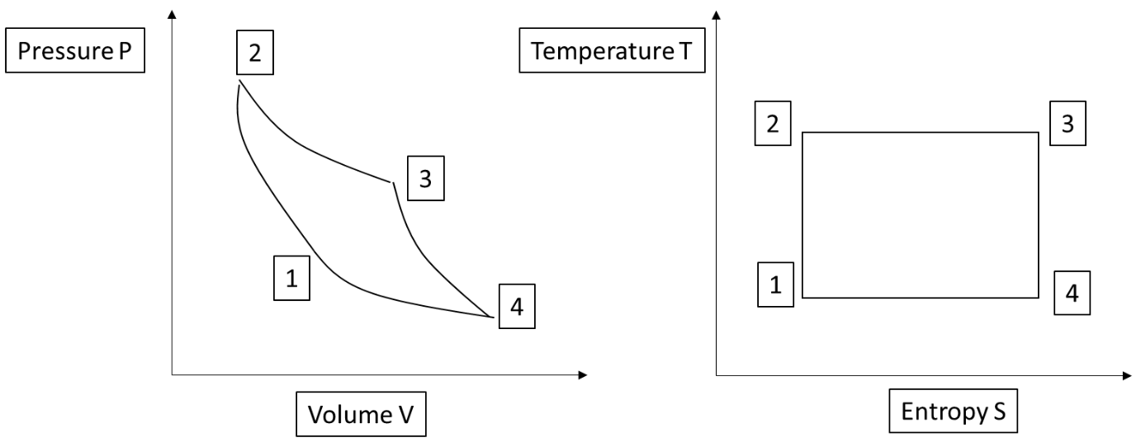

Air standard efficiency of the cycle:

$η=\frac{W_{net}}{Q_{a}}=\frac{W_{e}-W_{c}}{Q_{a}}=\frac{Q_{a}-Q_{r}}{Q_{a}}$………… Since ΣQ= ΣW for first law applied to cyclic process i.e.

We-Wc=Qa-Qr (Work of compression is negative and heat rejected is negative)

$η=1-\frac{Q_{r}}{Q_{a}}=1-\frac{T_{1}\left(S_{4-}S_{1}\right)}{T_{2}\left(S_{3-}S_{2}\right)}$………..Q=TΔS for reversible process i.e. Qr= T1(S4-S1) and Qa= T2(S3-S2)

………… S1=S2 and S3=S4 for isentropic processes 1-2 and 3-4 therefore (S4-S1) = (S3-S2)

It can be observed that the efficiency of Carnot cycle engine increases with either decreasing the temperature T1 at which the heat is rejected or Increasing the temperature T2 at which heat is added.

**Otto cycle**

[**https://www.youtube.com/watch?v=hk4oFsjfnPc**](https://www.youtube.com/watch?v=hk4oFsjfnPc)

Otto cycle contain of four processes and is followed in petrol (spark ignition) engines

Reversible adiabatic (isentropic) compression of gas inside a system (1 to 2), Here the work is added to the gas system. (Wc)

Reversible constant volume (isochoric) heat addition in gas from a high temperature reservoir (2 to 3) (Qa)

Reversible adiabatic (isentropic) expansion of gas (3 to 4) Here the work is done or produced by the system. (We)

Reversible constant volume (isochoric) heat rejection by gas to a low temperature reservoir (4 to 1) generally at atmospheric temperature (Qr)

Following are the P-V and T-S diagrams of the cycle

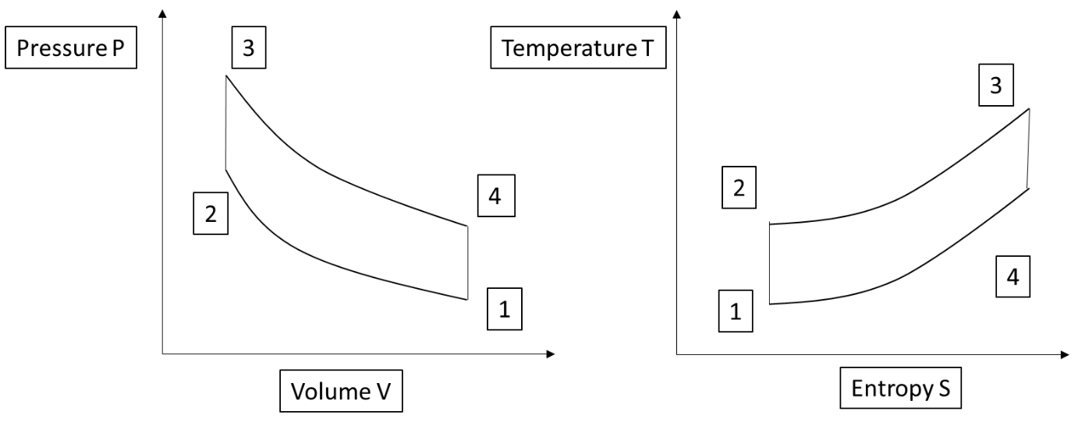

Air standard efficiency of cycle

$$η=\frac{W_{net}}{Q_{a}}=\frac{W_{e}-W_{c}}{Q_{a}}=\frac{Q_{a}-Q_{r}}{Q_{a}}=1-\frac{Q_{r}}{Q_{a}}$$

$η=1-\frac{{mC}_{v}\left(T_{4}-T_{1}\right)}{{mC}_{v}\left(T_{3}-T_{2}\right)}$……..first law applied to constant volume process Q=ΔU=mCvΔT (m is the mass of air)

$η=1-\frac{\left(T_{4}-T_{1}\right)}{\left(T_{3}-T_{2}\right)}$……..**Eqn of efficiency for Otto cycle in terms of temperatures**

It can be shown that the efficiency can also be written as follows

$$η=1-\frac{1}{{R_{c}}^{γ-1}}$$

In otto cycle it could be observed that the efficiency increases with increase in compression ratio Rc=V2/V1 (ratio of total volume of gas in the cylinder to the volume of gas at the end of compression i.e. clearance volume) however the compression ratio above 12:1 produces high intensity pressure fluctuations inside the cylinder, called knocking, in actual practice, that can damage the engine components setting a limit to increasing the efficiency.

It could also be observed that the engine efficiency working on otto cycle increases with increase in specific heat ratio ϒ=Cp/Cv. In actual engines the specific heat ratio is lesser than that of air which has specific heat ratio 1.4. This specific heat ratio can be increased by lean burning of petrol (i.e. by increasing the air in the air fuel mixture) but petrol in petrol engines can only be properly burnt if the air fuel ratio in the mixture is near chemically correct 14.5:1. This limits the increase in efficiency.

**Diesel cycle**

[**https://www.youtube.com/watch?v=t3HEk38MnJU&t=88s**](https://www.youtube.com/watch?v=t3HEk38MnJU&t=88s)

Diesel cycle has four processes and is followed in Diesel (compression ignition) engines

Reversible adiabatic (isentropic) compression of gas inside a system (1 to 2). Here the work is added to the gas system. (Wc)

Reversible constant pressure (isobaric) heat addition in gas from a high temperature reservoir (2 to 3) (Qa)

Reversible adiabatic (isentropic) expansion of gas (3 to 4). Here the work is done or produced by the system. (We)

Reversible constant volume (isochoric) heat rejection by gas to a low temperature reservoir (4 to 1) generally at atmospheric temperature (Qr)

Following are the P-V and T-S diagrams of the cycle

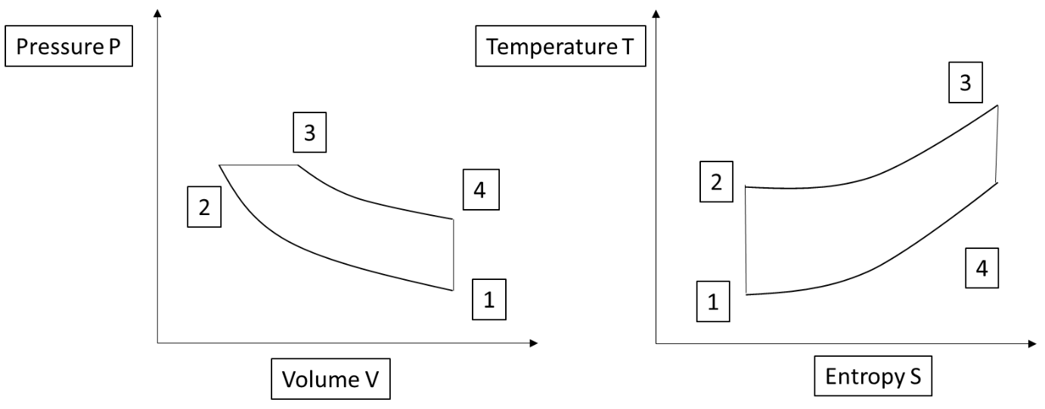

Air standard efficiency of cycle

….…..first law applied to constant volume process Qr=ΔU=mCvΔT (m is the mass of air) and constant pressure process Qa=ΔH=mCpΔT

$η=1-\frac{\left(T_{4}-T_{1}\right)}{γ\left(T_{3}-T_{2}\right)}$………..**Eqn of efficiency for Diesel cycle in terms of temperatures**

It can be shown that the efficiency can also be written as follows

$$η=1-\frac{1}{{{γR}_{c}}^{γ-1}}\left(\frac{ρ^{γ}-1}{ρ-1}\right)$$

It can be obsereved that the efficiency of the engine working on diesel cycle can be increased by increasing the compression ratio Rc=V2/V1. In actual practice it is limited to 22:1. This is because the efficiency increases by lesser magnitude and increase in cost and weight of stronger engine components, due to high pressures and temperatures at high compression ratio, is not justified.

Decrease in cut off ratio ρ=V4/V3 increases efficiency.

Increase in specific heat ratio ϒ=Cp/Cv increases efficiency. Diesel engines are lean burn engines so specific heat ratio is higher compared to petrol engines.

Due to higher compression ratio and higher specific heat ratio diesel engines are more efficient than petrol engines.

**Dual combustion cycle**

[**https://www.youtube.com/watch?v=Ycc0wkgVJj8**](https://www.youtube.com/watch?v=Ycc0wkgVJj8)

Dual combustion cycle has of five processes and is followed in modern high speed Diesel (compression ignition) engines

Reversible adiabatic (isentropic) compression of gas inside a system (1 to 2). Here the work is added to the gas system. (Wc)

Reversible constant volume (isochoric) heat addition in gas from a high temperature reservoir (2 to 3) (Qav)

Reversible constant pressure (isobaric) heat addition in gas from a high temperature reservoir (2 to 3) (Qap)

Reversible adiabatic (isentropic) expansion of gas (3 to 4). Here the work is done or produced by the system. (We)

Reversible constant volume (isochoric) heat rejection by gas to a low temperature reservoir (4 to 1) generally at atmospheric temperature (Qr)

Following are the P-V and T-S diagrams of the cycle

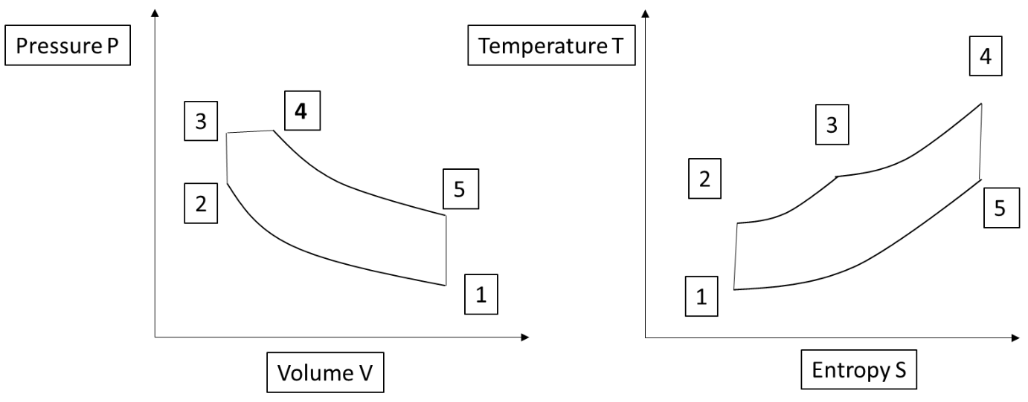

Air standard efficiency of cycle

………..….…..first law applied to constant volume process Qr=ΔU=mCvΔT (m is the mass of air) and constant pressure process Qa=ΔH=mCpΔT

$η=1-\frac{\left(T_{5}-T_{1}\right)}{\left(T_{3}-T_{2}\right)+γ\left(T_{4}-T_{3}\right)}$………….. **Eqn of efficiency for Dual combustion cycle in terms of temperatures**

It can be shown that the efficiency can also be written as follows

$$η=1-\frac{1}{{R_{c}}^{γ-1}}\left[\frac{{αρ}^{γ}-1}{\left(α-1\right)+αγ\left(ρ-1\right)} \right]$$

It can be observed from the expression for efficiency that the increase in compression ratio Rc=V2/V1 increases efficiency.

Increase in specific heat ratio ϒ=Cp/Cv increases efficiency.

Decrease in cut off ratio ρ=V4/V3 increases efficiency.

Increase in explosion ratio α=P3/P2 increases efficiency

**Atkinson cycle**

[**https://www.youtube.com/watch?v=CNsJOsnuIMA**](https://www.youtube.com/watch?v=CNsJOsnuIMA)

Atkinson cycle contain of four processes and is followed in petrol (spark ignition) engines with variable valve timing

Reversible adiabatic (isentropic) compression of gas inside a system (1 to 2), Here the work is added to the gas system. (Wc)

Reversible constant volume (isochoric) heat addition in gas from a high temperature reservoir (2 to 3) (Qa)

Reversible adiabatic (isentropic) expansion of gas (3 to 4) Here the work is done or produced by the system. (We)

Reversible constant pressure (isobaric) heat rejection by gas to a low temperature reservoir (4 to 1) generally at atmospheric temperature (Qr)

Following are the P-V and T-S diagrams of the cycle

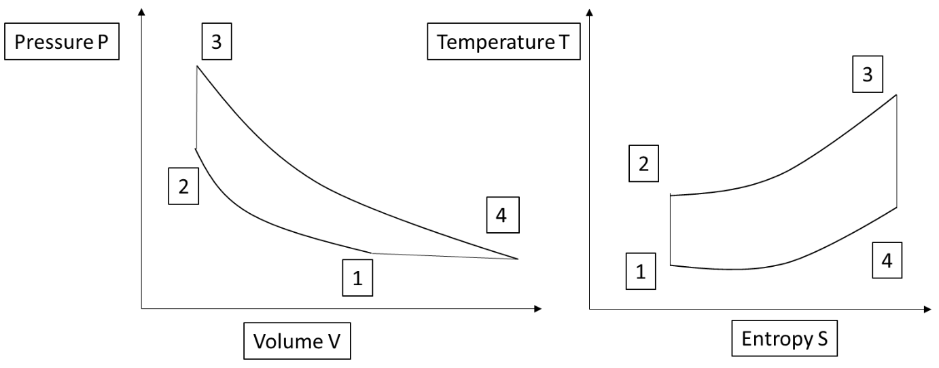

Air standard efficiency of cycle

…….. first law applied to constant volume process Qr=ΔU=mCvΔT (m is the mass of air) and constant pressure process Qa=ΔH=mCpΔT

η $=1-\frac{ϒ\left(T_{4}-T_{1}\right)}{\left(T_{3}-T_{2}\right)}$………. **Eqn of efficiency for Atkinson cycle in terms of temperatures**

It can be shown that the efficiency can also be written as follows

$$η=1-\frac{γ\left(R_{e}-R_{c}\right)}{{{{(R}_{e}^{γ}-R}_{c}}^{γ})}$$

Increase in the specific heat ratio ϒ=Cp/Cv increases the efficiency. Increase in compression ratio Rc=V2/V1 and expansion ratio Re=V4/V3 increases efficiency.

**Brayton cycle**

[**https://www.youtube.com/watch?v=Mw4Ri5x_uQ0**](https://www.youtube.com/watch?v=Mw4Ri5x_uQ0)

Brayton cycle contain of four processes and is followed in gas turbines (jet engines)

Reversible adiabatic (isentropic) compression of gas inside a system (1 to 2), Here the work is added to the gas system. (Wc)

Reversible constant pressure (isobaric) heat addition in gas from a high temperature reservoir (2 to 3) (Qa)

Reversible adiabatic (isentropic) expansion of gas (3 to 4) Here the work is done or produced by the system. (We)

Reversible constant pressure (isobaric) heat rejection by gas to a low temperature reservoir (4 to 1) generally at atmospheric temperature (Qr)

Following are the P-V and T-S diagrams of the cycle

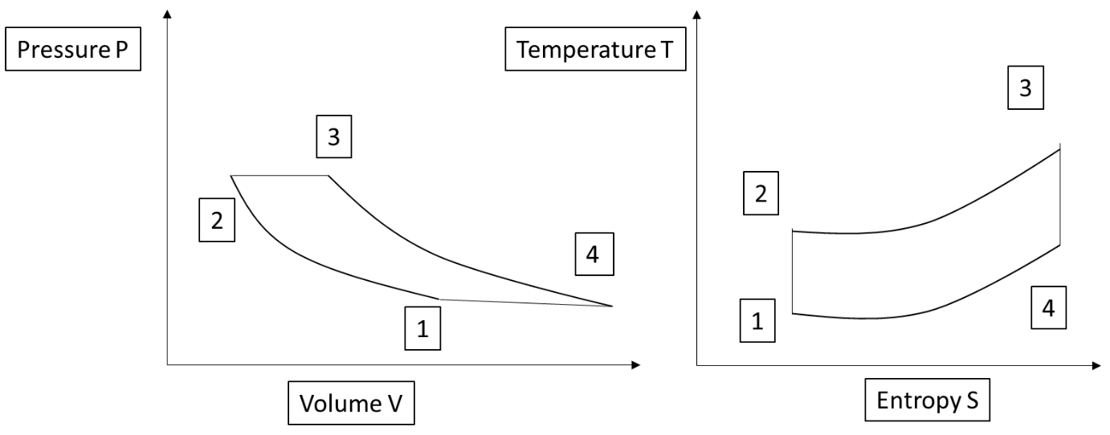

Air standard efficiency of cycle

$$η=\frac{W_{net}}{Q_{a}}=\frac{W_{e}-W_{c}}{Q_{a}}=\frac{Q_{a}-Q_{r}}{Q_{a}}=1-\frac{Q_{r}}{Q_{a}}$$

$η=1-\frac{{mC}_{p}\left(T_{4}-T_{1}\right)}{{mC}_{p}\left(T_{3}-T_{2}\right)}$……..first law applied to constant pressure process Q=ΔH=mCpΔT (m is the mass of air)

$η=1-\frac{\left(T_{4}-T_{1}\right)}{\left(T_{3}-T_{2}\right)}$……..**Eqn of efficiency for Brayton cycle in terms of temperatures**

Expression for efficiency can also be written as follows

$$η=1-\frac{1}{{R_{p}}^{\frac{γ-1}{γ}}}$$

It can be observed that the efficiency of cycle increases with pressure ratio Rp=P2/P1 and ϒ=Cp/Cv specific heat ratio.

The gas turbines are lean burnt so the specific heat ratio is high. The increase in pressure ratio is limited by the maximum temperature attained in the cycle which can lead to failure of material of expansion turbine. To increase the efficiency, modifications in gas turbine such as intercooling, reheating and regeneration are used.

**Internal combustion engines**

**Heat engine**

A heat engine is a device or a machine which transforms the chemical energy of a fuel into thermal energy and uses this thermal energy to produce mechanical work.

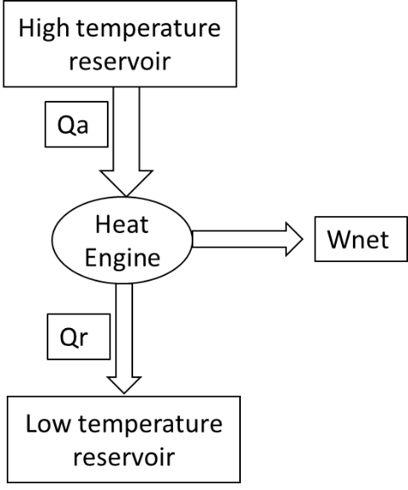A heat engine uses a working substance (typically a gas or vapor) that undergoes a series of thermodynamic processes.

These processes involve changes in the working substance's pressure, temperature, and volume.

The working substance undergoes a cyclic process, meaning it returns to its initial state after a series of transformations.

This cycle involves heat addition, heat rejection, and work done by or on the working substance. In all it takes in heat from a thermal reservoir producing a net work output and rejects heat to low temperature thermal reservoir.

**Types of Heat Engines**

Heat engines can be classified into two main categories:

**External Combustion Engines:** The combustion of fuel occurs outside the working substance. Examples include steam engines.

**Internal Combustion Engines:** The combustion of fuel occurs within the working substance. Examples include gasoline and diesel engines

**Classification of I C Engines**

**Based on the Type of Fuel Used**

**Petrol (Gasoline) Engine**:

Uses petrol as fuel.

Example: Spark-ignition engines in cars and motorcycles.

**Diesel Engine**:

Uses diesel as fuel.

Example: Compression-ignition engines in trucks, buses, and industrial applications.

**Gas Engine**:

Uses gaseous fuels like CNG (Compressed Natural Gas), LPG (Liquefied Petroleum Gas), or biogas.

Example: Industrial gas engines.

**Dual-Fuel Engine**:

Operates on two types of fuel, typically diesel and a gaseous fuel like natural gas.

**Based on the Cycle of Operation**

**Two-Stroke Engine**:

Completes a power cycle (intake, compression, power, exhaust) in two strokes of the piston (one revolution of the crankshaft).

Example: Small motorcycles, outboard motors.

**Four-Stroke Engine**:

Completes a power cycle in four strokes of the piston (two revolutions of the crankshaft).

Example: Most cars, trucks, and generators.

**Based on the Method of Ignition**

**Spark-Ignition (SI) Engine**:

Ignites the air-fuel mixture using a spark plug.

Example: Petrol engines in cars.

**Compression-Ignition (CI) Engine**:

Compresses air to a high temperature, causing the injected fuel to ignite automatically.

Example: Diesel engines in trucks and buses.

**Based on the Number of Cylinders**

**Single-Cylinder Engine**:

Has only one cylinder.

Example: Small motorcycles, lawnmowers.

**Multi-Cylinder Engine**:

Has multiple cylinders (e.g., 2, 3, 4, 6, 8, 12 cylinders) for higher power output and smoother operation.

Example: Cars, trucks, and heavy machinery.

**Based on the Arrangement of Cylinders** [**https://www.youtube.com/watch?v=90uUdwJBEu4**](https://www.youtube.com/watch?v=90uUdwJBEu4)

**In-Line Engine**:

Cylinders are arranged in a single straight line.

Example: Small cars, bikes.

**V-Engine**:

Cylinders are arranged in two banks forming a "V" shape.

Example: High-performance cars and trucks (e.g., V6, V8 engines).

**Opposed (Flat) Engine**:

Cylinders are horizontally opposed.

Example: Subaru cars, aircraft engines.

**Radial Engine**:

Cylinders are arranged radially around a central crankshaft.

Example: Aircraft engines.

**Based on the Cooling System**

**Air-Cooled Engine**:

Uses air to dissipate heat from the engine.

Example: Small motorcycles, scooters.

**Water-Cooled Engine**:

Uses water or coolant to remove heat.

Example: Cars, heavy vehicles.

**Based on the Speed of the Engine**

**Slow-Speed Engine**:

Operates at speeds less than 250 RPM.

Example: Large marine engines.

**Medium-Speed Engine**:

Operates between 250 and 1000 RPM.

Example: Industrial engines.

**High-Speed Engine**:

Operates at speeds above 1000 RPM.

Example: Automotive engines.

**Based on the Applications**

**Automotive Engines**:

Used in cars, motorcycles, and trucks.

**Stationary Engines**:

Used for power generation or pumping applications.

**Marine Engines**:

Used in ships and submarines.

**Aviation Engines**:

Used in aircraft for propulsion.

**Agricultural Engines**:

Used in tractors, harvesters, and other agricultural machinery.

**Based on the Type of Fuel System**

**Carbureted Engine**:

Uses a carburetor to mix air and fuel.

Example: Older petrol engines.

**Fuel-Injected Engine**:

Uses fuel injectors to supply fuel directly into the cylinder or intake manifold.

Example: Modern petrol and diesel engines.

**Based on the Stroke Cycle**

**Positive Displacement Engine**:

Uses pistons to create pressure and generate power.

Example: Most I.C. engines.

**Rotary Engine (Wankel Engine)**:

Uses a rotating triangular rotor instead of pistons.

Example: Mazda RX-series engines.

**Based on air intake**

**Naturally Aspirated Engine**:

Relies on atmospheric pressure to draw in air.

Example: Standard petrol engines.

**Turbocharged Engine**:

Uses a exhaust operated turbine to force more air into the engine for higher power.

Example: Modern high-performance vehicles.

**Supercharged Engine**:

Uses a compressor driven by the engine's crankshaft to force air into the engine.

Example: High-performance sports cars.

**Based on Fuel Combustion Process**

**Homogeneous Combustion Engine**:

Air-fuel mixture is uniform before combustion.

Example: Spark ignition engines.

**Heterogeneous Combustion Engine**:

Fuel is injected directly into the combustion chamber, resulting in localized combustion.

Example: Diesel engines.

**Engines can also be classified as Square, over-square (short stroke) and under-square (long stroke) engines**

**Components of I C Engine**

There are five main components of any reciprocating type internal combustion engine-

1.cylinder

2.piston

3.connecting rod

4.crankshaft

flywheel

and eight subsystems

1.starting system

2.air intake system

3.fuel supply system

automated valve/port operating system

5.ignition system

6.exhaust system

7.cooling system

8.lubrication system.

Ignition system does not exist in diesel engines and automated valve opening-closing system does not exist in 2 stroke engines.

**Cylinder**

Cylinder Block

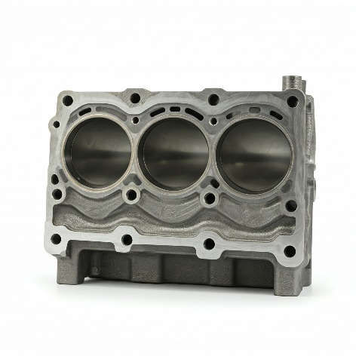

Function: The main structural component of the engine. It contains the cylinders, coolant passages, and oil passages.

Material: Typically made of cast iron or aluminum alloy. Due to vibration damping ability and low cost. Also intricate shapes can be cast easily.

Cylinder Head

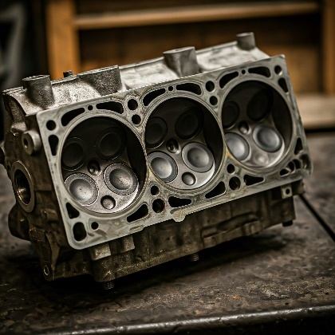

Function: Covers the top of the cylinders and houses the valves, spark plugs (in SI engines), or fuel injectors (in CI engines).

Material: Typically made of cast iron or aluminum alloy

Cylinder liner

It's a cylindrical metal sleeve inserted into the engine block to create the cylinder bore.

The liner provides a durable, wear-resistant surface for the piston to move within, protecting the engine block from damage. Liners can be replaced, allowing for engine rebuilding without replacing the entire block.

Cylinder liners are typically made from cast iron due to its excellent wear resistance.

**Piston**

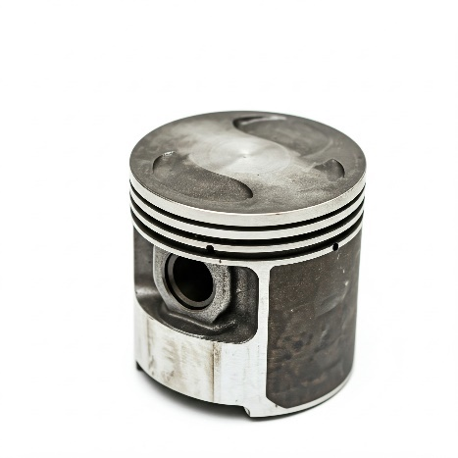

Piston

Function: A cylindrical component that moves up and down inside the cylinder, driven by the force of combustion. It transfers this force to the connecting rod.

Material: Typically made of aluminum alloy.

Piston Rings

Function: Fit into grooves on the piston and provide a seal between the piston and the cylinder wall, preventing leakage of combustion gases and oil.

Material: Typically made of cast iron or steel.

Piston pin

Function: The piston pin acts as a pivotal joint between the piston and the connecting rod. It allows the connecting rod to pivot or oscillate as the piston moves up and down in the cylinder

Material: Forged alloy steel due to high fatigue resistance.

**Connecting Rod**

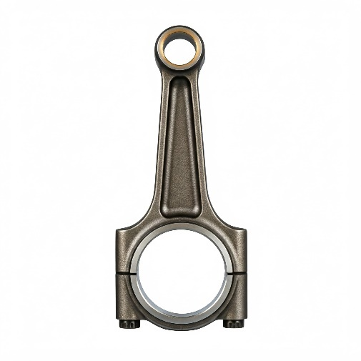

Function: Connects the piston to the crankshaft, converting the linear motion of the piston into rotary motion of the crankshaft.

Material: Typically made of steel or forged aluminum. So that the fatigue strength is high under continuous compressive and tensile stresses.

**Crankshaft**

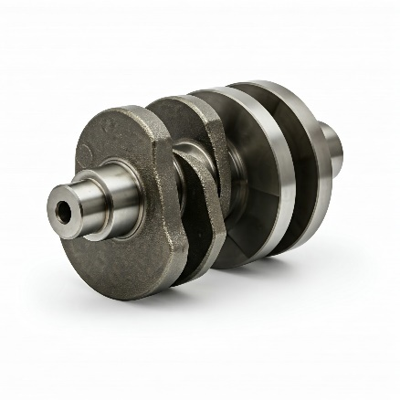

Function: Converts the linear motion of the pistons into rotary motion, which is then transmitted to the transmission and ultimately to the wheels.

Material: Typically made of forged steel to get high fatigue strength

**Flywheel**

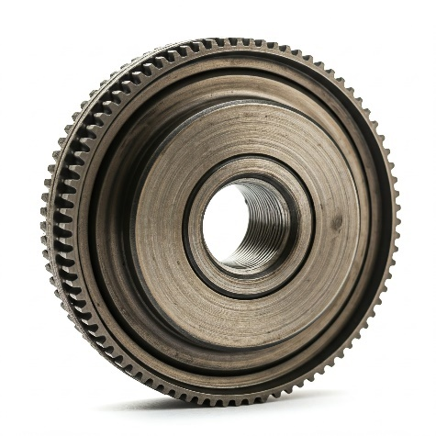

Function: Stores rotational energy and helps smooth out the engine's power output

Material: Cast iron due to low cost

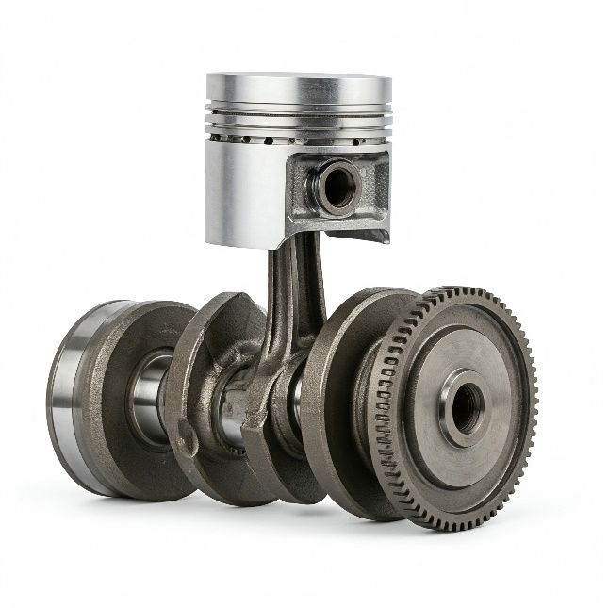

**Starting system**

Starter Motor

Provides the initial power to start the engine by turning the crankshaft.

Alternator

Generates electrical power to charge the battery and power the vehicle's electrical systems.

Battery

Provides the electrical power needed to start the engine and run electrical accessories when the engine is off.

**Air intake system**

Air Filter

Cleans incoming air by removing dust and debris.

Intake Manifold

Distributes air (or air-fuel mixture) to the cylinders

**Fuel supply system**

Fuel Tank

Stores fuel.

Fuel Pump

Transfers fuel from the tank to the carburetor or fuel injectors.

Fuel Filter

Removes impurities from the fuel.

Fuel Lines

Pipes through which fuel flows.

Fuel Injector / Carburetor

Delivers fuel into the combustion chamber in modern engines (fuel injector) or mixes air and fuel in older engines (carburetor).

**Valve operating system**

Camshaft

Operates the engine's valves by converting rotational motion into linear motion. It is driven by the crankshaft via a timing belt or chain.

Valves

Regulate the intake of the air-fuel mixture (intake valve) and the exhaust of combustion gases (exhaust valve).

**Ignition system**

Spark Plug

Ignites the air-fuel mixture in the combustion chamber of a spark-ignition engine

Battery

Supplies electrical power to the ignition system, especially during the starting of the engine

Ignition Coil

A transformer that converts the low-voltage from the battery to a high voltage needed to create a spark at the spark plug.

Ignition Module/Control Unit

Controls the timing and sequence of the ignition system. It can be a mechanical system (in older vehicles) or an electronic control unit (ECU) in modern vehicles.

**Exhaust system**

Exhaust Manifold

Collects exhaust gases from the engine's cylinders and directs them into the exhaust pipe. It is often made of cast iron or stainless steel.

Catalytic Converter

Converts harmful pollutants in the exhaust gases (such as carbon monoxide, hydrocarbons, and nitrogen oxides) into less harmful substances (such as carbon dioxide, water vapor, and nitrogen) using a catalyst.

Muffler (Silencer)

Reduces the noise produced by the exhaust gases as they exit the engine. It uses a series of chambers and perforated tubes to dampen the sound.

**Cooling system**

Radiator

Transfers heat from the coolant to the outside air. It consists of a series of tubes and fins to dissipate heat efficiently.

Water Pump

Circulates the coolant through the engine and the radiator. It is usually driven by the engine via a belt.

Coolant (Antifreeze)

A liquid mixture, typically of water and antifreeze, that absorbs and transfers heat from the engine to the radiator. The antifreeze also prevents the coolant from freezing in cold weather and boiling in hot weather.

Cooling Fan

Helps to cool the radiator by drawing air through it. The fan can be mechanical (driven by the engine) or electric (controlled by the engine's electronic control unit).

**Lubrication system**

Oil Pan (Sump)

A reservoir that holds the engine oil. It is located at the bottom of the engine.

Oil Pump

Circulates oil from the oil pan through the engine's lubrication system. It is usually driven by the crankshaft or camshaft.

Oil Filter

Removes contaminants and debris from the oil to ensure it is clean before circulating through the engine.

**Terms associated with I C engine**

**Cylinder bore** (d): The inner diameter of the cylinder.

**Piston area** (A): The area of cylinder bore.

**Top Dead Center** (TDC): The location of the piston at the top of the cylinder. In horizontal engines it is known as the outer dead center (ODC).

**Bottom Dead Center** (BDC): The location of the piston at the bottom of the cylinder. In horizontal engine it is known as the Inner Dead Center (IDC).

**Stroke** (L): The distance between TDC and BDC or length of piston travel, is called the stroke length and is equal to double the crank radius.

**Swept volume or displacement volume** (Vs): The volume swept through by the piston in moving between TDC and BDC. For multicylinder engine Vs x k is called engine capacity or cubic capacity. (k is number of cylinders)

**Clearance volume** (Vc): The space above the piston top when it is at the TDC.

Therefore volume of the cylinder: V = Vc + Vs

**Compression ratio** (R): The ratio of the total volume of the cylinder to the clearance volume. R=(Vc+Vs)/Vc

**Mean Piston speed**: Vp=2LN m/min

**Mean effective pressure**: Dividing the work per cycle by the cylinder volume displaced per cycle we get mean effective pressure. We can also describe MEP as the average pressure that acts on piston, while making one complete stroke. It implies how efficiently the swept volume of the engine is utilized while designing

**Indicator diagram**An indicator diagram is graph of cylinder pressure vs volume (P-V diagram) or cylinder pressure vs piston position.

A pressure gauge used to measure cylinder pressure with respect to position of piston is called indicator.

Indicator diagram area represents the work done in one engine cycle of a single cylinder. This is an actual P-V diagram of an engine.

In modern engines two transducers, one pressure transducer in the combustion space and other transducer on the shaft, are used whose outputs are given to computer to get indicator diagram and work done per cycle of all cylinders.

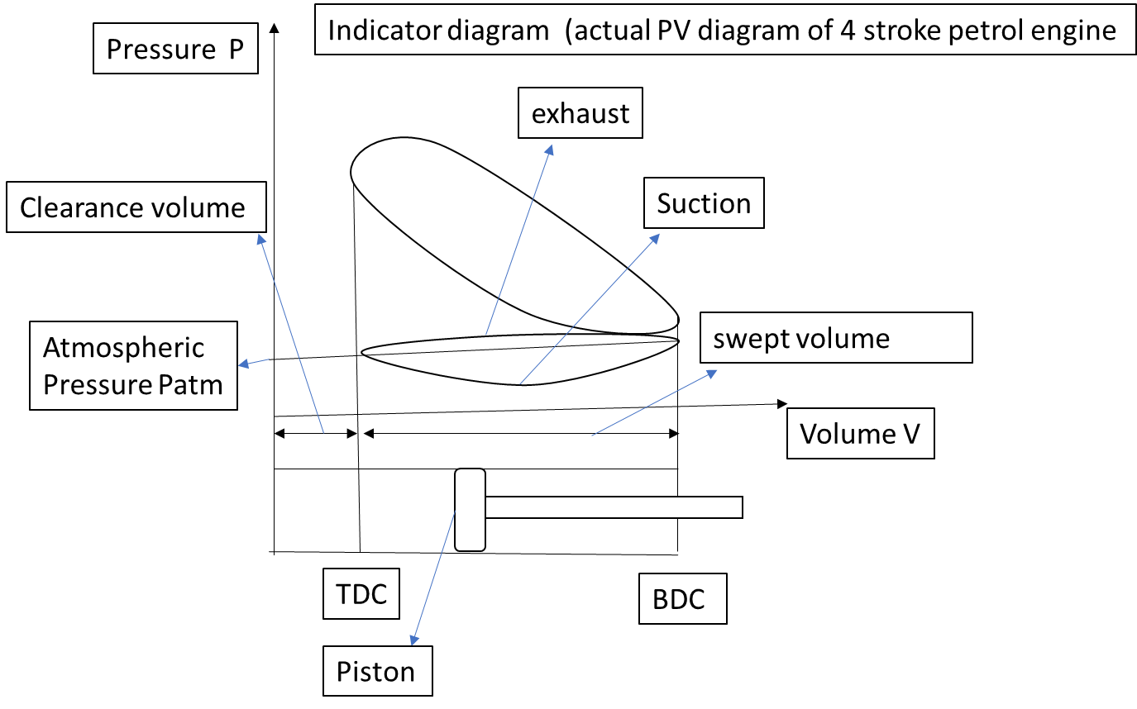

**Indicated power**: Indicated power (IP) is the theoretical power developed within the cylinders of an IC engine due to the combustion of the fuel-air mixture. It represents the total power generated by the expanding gases pushing on the pistons

**Brake Power (BP):** This is the actual power available at the engine's crankshaft or flywheel after accounting for frictional losses. It's the power used to drive the vehicle or other machinery.

Indicated Power (IP) is always higher than Brake Power (BP). The difference between the two is the power lost to friction (Friction Power, FP):

**IP = BP + FP**

**Mechanical efficiency**: (ηm) is the ratio of the actual power delivered by the engine (brake power) to the power developed within the engine's cylinders (indicated power).

**Indicated thermal efficiency**: (ηith) quantifies the proportion of heat energy released from burning fuel that is converted into indicated work

ηith = (Indicated Power / Heat Supplied) * 100%

**Brake thermal efficiency:** It quantifies the proportion of heat energy released from burning fuel that is converted into brake power (the power available at the crankshaft)

ηbth = (Brake Power / Heat Supplied) * 100%

**Two stroke cycle engine**

[**https://www.youtube.com/watch?v=xNLE8G3pC0k&t=7s**](https://www.youtube.com/watch?v=xNLE8G3pC0k&t=7s)

Working of this engine can be explained as follows

**Upward Stroke (Compression and Intake)**

As the piston moves upwards, it performs two crucial functions simultaneously:

**Compression:** The upward movement of the piston compresses the air-fuel mixture (in a gasoline engine) or just air (in a diesel engine) in the combustion chamber above the piston.

**Intake:** At the same time, a partial vacuum is created in the crankcase (the space below the piston). This draws in a fresh air-fuel mixture (in a gasoline engine) through the intake port. In some designs, a reed valve or rotary valve controls this intake process.

**Downward Stroke (Power and Exhaust)**

When the piston is at TDC, the compressed mixture is ignited (by a spark plug in a gasoline engine or by the heat of compression in a diesel engine). This initiates the:

**Power Stroke:** The combustion of the fuel rapidly increases the temperature and pressure in the cylinder, forcing the piston downwards. This downward movement is what produces the engine's power.

**Exhaust and Transfer:** As the piston moves downwards, it first uncovers the exhaust port, allowing the burnt gases to escape the cylinder. Shortly after, it uncovers the transfer port. The compressed air-fuel mixture in the crankcase is then forced through the transfer port into the cylinder, helping to scavenge (push out) the remaining exhaust gases and prepare for the next cycle.

**Key Features and Differences from Four-Stroke Engines**

**No Valves (Usually):** Two-stroke engines typically use ports in the cylinder walls, opened and closed by the piston's movement, instead of mechanical valves. This simplifies the engine's design.

**Lubrication:** In many two-stroke engines, oil is mixed with the fuel to lubricate the piston, cylinder, and crankshaft. This results in some oil being burned during combustion, contributing to higher emissions.

**Power Output:** For a given engine size, a two-stroke engine generally produces more power than a four-stroke engine because it has a power stroke every revolution instead of every two revolutions.

**Efficiency and Emissions:** Two-stroke engines are generally less fuel-efficient and produce more emissions than four-stroke engines due to the scavenging process, where some of the fresh air-fuel mixture can escape out the exhaust port.

**Applications**

Two-stroke engines are commonly used in:

Small motorcycles and scooters

Lawnmowers and other garden equipment

Chainsaws and other handheld power tools

Outboard motors for boats

**Four stroke cycle engine**

[**https://www.youtube.com/watch?v=0SPn5AxVx3k**](https://www.youtube.com/watch?v=0SPn5AxVx3k)

Working of this engines can be explained as follows

**Induction stroke** (suction): During this piston moves from TDC to BDC and inlet valve is open to suck the fresh charge (air-fuel mixture in case of SI engines and air in case of CI engines) in the cylinder. The Exhaust valve is closed during this stroke.

**Compression stroke**: During this the piston moves From BDC to TDC, inlet valve and exhaust valve are in closed condition. The compression of fresh charge starts and completes when piston reaches TDC.

**Power (expansion) stroke**: During this the piston moves from TDC to BDC, both inlet and exhaust valves are in closed condition. Fuel is injected in case of CI Engines and spark is ignited in case of SI engines when the piston is at TDC. The combustion of charge takes place and the heat is released expanding the gas and pushing the piston towards BDC.

**Exhaust stroke**: During this the piston moves from BDC to TDC, exhaust valve is kept open and the combustion products are expelled out. Again when piston is at TDC inlet valve opens and suction process starts thus completing the working cycle.

The valves as explained above are not made to open or close instantaneously when the piston is exactly at TDC or BDC due to some reasons in actual practice

**Key Features of Four-Stroke Engines**

**Valves:** Four-stroke engines use mechanically operated valves (typically poppet valves) to control the intake and exhaust processes. These valves are precisely timed by the camshaft.

**Lubrication:** Four-stroke engines have a dedicated lubrication system that keeps the moving parts lubricated with oil. This is more efficient and results in less oil consumption and cleaner emissions compared to two-stroke engines.

**Efficiency and Emissions:** Four-stroke engines are generally more fuel-efficient and produce fewer emissions than two-stroke engines due to better control of the combustion process and less scavenging losses.

**Applications**

Four-stroke engines are the dominant type of engine used in:

Cars and trucks

Motorcycles (most modern ones)

Generators

**Comparison between SI and CI engines**

|  |  |  |
| --- | --- | --- |
| **Feature** | **Spark Ignition (SI) Engine** | **Compression Ignition (CI) Engine** |
| Ignition Method | Spark plug ignites pre-mixed air-fuel mixture | Fuel auto-ignites due to high temperature and pressure from compression |
| Fuel | Gasoline (petrol), high octane number fuels | Diesel fuel, high cetane number fuels |
| Fuel Delivery | Carburetor or fuel injection (port or direct) | Fuel injection (direct injection into the cylinder) |
| Air-Fuel Mixture | Premixed before entering the cylinder (homogeneous) | Fuel injected into highly compressed air (heterogeneous) |
| Compression Ratio | Lower (typically 8:1 to 12:1) | Higher (typically 14:1 to 25:1) |
| Operating Cycle | Otto cycle (idealized) | Diesel cycle (idealized) |
| Efficiency | Lower thermal efficiency due to low compression ratio | Higher thermal efficiency due to high compression ratio |
| Emissions | Generally higher CO emissions, lower NOx and particulate matter | Generally lower CO emissions, higher NOx and particulate matter (though modern systems with exhaust aftertreatment significantly reduce these) |
| Weight | Lighter engine weight | Heavier engine weight due to stronger components due to higher compression ratio |
| Cost | Lower initial cost due to light weight | Higher initial cost due to larger weight |
| Noise and Vibration | Quieter operation, less vibration | Noisier operation, more vibration because of combustion process |
| Applications | Passenger cars, motorcycles, small engines where quick acceleration, smooth operation, and lower emissions are prioritized | Trucks, buses, heavy machinery, power generation where high torque, fuel efficiency are crucial, |

**Mechanical power transmission**

Mechanical power transmission involves transferring energy from one part of a machine to another to perform useful work. This process typically converts the energy generated by a power source (such as an engine or motor) into a form suitable for driving a load (like wheels, conveyor belts, or machinery) which may require different torque and/or speed compared to power source torque/speed.

**Belt drives**

Arrangements of belt drive: <https://www.youtube.com/watch?v=sHtcCvaFtSQ&t=5s>

Belt drives are a common method of mechanical power transmission, using belts and pulleys to transfer rotational motion and power between shafts.

**Working:**

A **driving pulley** is connected to the power source (e.g., an engine or motor). As the power source rotates, it imparts motion to the driving pulley.

The belt, wrapped around the driving pulley, makes contact with the pulley surface. Friction between the belt and pulley surface ensures that the belt moves with the pulley without slipping.

Proper belt tension is maintained using tensioners or adjustable pulley positions. One side of the belt (called the **tight side**) experiences greater tension, while the other side (the **slack side**) experiences less tension.

As the driving pulley rotates, it pulls the belt along its surface. The moving belt then causes the **driven pulley** to rotate, transferring power to the load.

The driven pulley is connected to the load (e.g., machinery, conveyor, or fan), which receives rotational motion and torque to perform work

The process continues as long as the power source rotates, maintaining a constant transfer of motion and energy.

**Features:**

**Simplicity and Low Cost:** Belt drives are relatively simple and inexpensive compared to other power transmission methods like gears.

**Smooth and Quiet Operation:** They operate smoothly and quietly, with minimal vibration. Belts can absorb shocks and vibrations, protecting the driving and driven components.

**Flexibility in Shaft Distance:** They can be used to transmit power between shafts that are relatively far apart.

**Overload Protection:** Belts can slip under excessive load, providing a form of overload protection for the machinery.

**Slippage:** Some slippage is inherent in belt drives, which can reduce efficiency and affect speed ratios.

**Limited Power Transmission Capacity:** Compared to gears and chains, belts have a lower power transmission capacity.

**Belt Wear and Maintenance:** Belts are subject to wear and tear and require periodic replacement and tension adjustment.

**Environmental Sensitivity:** Belts can be affected by temperature, humidity, and chemicals.

**Components of belt drive**

**Belt**

Function: The flexible medium that transmits motion and power by friction or direct engagement.

Material: Commonly made of rubber, leather, synthetic materials, or composite fabrics, depending on the application.

Types:

Flat Belt: For long-distance, low-power applications.

V-Belt: For high-speed, high-power applications.

Timing Belt: For applications requiring precise motion and no slippage.

Round Belt: Used for light-duty applications like small machinery.

**Driving Pulley (Driver)**

Function: The pulley attached to the power source (e.g., motor or engine) that transmits motion to the belt.

Material: Typically made of cast iron, steel, or aluminum.

Design: Can have a flat surface (for flat belts), grooves (for V-belts), or teeth (for timing belts).

**Driven Pulley (Follower)**

Function: The pulley connected to the load that receives motion and transmits it to the machine or system.

Material: Similar to the driving pulley, made of durable metals or alloys.

Design: Matches the type of belt used (flat, grooved, or toothed).

Diameter: The diameter of the pulleys determines the speed ratio between the driving and driven shafts

**Tensioning Device**

Function**:** Ensures the belt maintains the correct tension for effective power transmission and reduces slippage**.**

**Belt Guard**

Function: A protective enclosure that covers the belt and pulleys to prevent accidents and contamination.

Material: Made of metal or plastic.

**Types of belt drive**

**Flat Belts**

**Cross-section:** Rectangular, with a width much larger than its thickness.

**Pulley Groove:** Flat or slightly crowned pulleys. When the belt starts to drift off-center, the crowned shape automatically guides it back to the middle.

**Contact Area:** Only one surface of the belt contacts the pulley.

**Friction:** Relies on friction between the flat belt surface and the pulley surface.

**Slippage:** More prone to slippage, especially under heavy loads or sudden changes in speed.

**Efficiency:** Generally high efficiency when properly tensioned and aligned, but slippage can reduce it.

**Speed Ratio:** Suitable for lower speed ratios (typically up to 4:1).

**Power Transmission:** Lower power transmission capacity compared to V-belts.

**Center Distance:** Can be used for long center distances between shafts. The minimum center distance is usually recommended to be at least 3.5 times the diameter of the larger pulley to avoid excessive belt bending.

**Noise:** Can be noisier than V-belts, especially with joined belts.

**Applications:** Older machinery, agricultural equipment, conveyors, and some textile machines.

**V-Belts**

**Cross-section:** Trapezoidal (V-shaped), fitting into matching V-grooves on the pulleys.

**Pulley Groove:** V-shaped grooves with specific angles to match the belt.

**Contact Area:** Two inclined surfaces of the belt contact the pulley, creating a wedging action.

**Friction:** Increased friction due to the wedging action, reducing slippage.

**Slippage:** Less prone to slippage, providing more positive power transmission.

**Efficiency:** Slightly lower efficiency than flat belts due to internal friction, but the reduced slippage often results in better overall performance.

**Speed Ratio:** Suitable for higher speed ratios (up to 7:1 or more).

**Power Transmission:** Higher power transmission capacity compared to flat belts due to increased friction.

**Center Distance:** Typically used for shorter to medium center distances not used for long distances due to weight and cost. V-belts are most effective when the center distance is roughly between 1 and 3 times the diameter of the larger pulley.

**Noise:** Operate more quietly than flat belts.

**Applications:** Modern machinery, automotive accessories (alternators, power steering pumps), industrial equipment, HVAC systems

**Applications of belt drives**

**Automotive**

**Engine Accessories:** V-belts or ribbed belts drive essential engine components like alternators (generating electricity), power steering pumps, water pumps (coolant circulation), and air conditioning compressors.

**Timing Belts:** Synchronous belts are used to precisely synchronize the rotation of the engine's camshaft(s) and crankshaft, controlling valve timing.

**Industrial Machinery**

**Conveyors:** Belt drives power conveyor belts in various industries, from manufacturing and warehousing to mining and agriculture.

**Fans and Blowers:** Belt drives are used to rotate fan blades for ventilation, cooling, and air circulation in industrial processes and HVAC systems.

**Pumps:** Many pumps, such as centrifugal pumps used for water and fluid transfer, are driven by belt drives.

**Manufacturing Equipment:** Belt drives are found in various machines used in manufacturing, such as lathes, milling machines, and drill presses.

**Agricultural Equipment**

**Tractors and Harvesters:** Belt drives power various components in agricultural machinery, such as threshers, balers, and mowers.

**Irrigation Systems:** Belt drives can be used to power pumps for irrigation.

**HVAC (Heating, Ventilation, and Air Conditioning)**

**Air Handlers and Furnaces:** Belt drives are used to drive blower fans that circulate air in HVAC systems.

**Cooling Towers:** Belt drives power fans that help cool water in cooling towers.

**Household Appliances**

**Washing Machines and Dryers:** Belt drives are used to rotate the drums in washing machines and dryers.

**Vacuum Cleaners:** Belt drives power the rotating brushes in some vacuum cleaner models.

**Sewing Machines:** Belt drives transmit power from the motor to the needle and other mechanisms.

**Other Applications**

**Exercise Equipment:** Treadmills, stationary bikes, and other exercise machines often use belt drives.

**Printing Presses:** Synchronous belts are used for precise timing and registration in printing processes.

**Textile Machinery:** Belt drives are used in various textile machines for spinning, weaving, and other processes.

**Types of velocity ratio**

The **velocity ratio** in belt drives refers to the ratio of the rotational speed of the driven pulley to the rotational speed of the driving pulley. It is a key parameter in designing belt drive systems

**Ideal Velocity Ratio (Considering Pulley Diameters)**

This is the most basic calculation. It's based solely on the diameters of the pulleys. In a **crossed belt drive**, the driver and driven pulleys rotate in opposite directions. The formula remains the same:

Velocity Ratio (VR) = N₂ / N₁ = D₁ / D₂

Where: N₁ = Rotational speed of the driving pulley (e.g., in RPM)   N₂ = Rotational speed of the driven pulley (e.g., in RPM)   D₁ = Diameter of the driving pulley D₂ = Diameter of the driven pulley

If D₂ is larger than D₁, then N₂ will be smaller than N₁, meaning the driven pulley rotates slower than the driving pulley (speed reduction).

If D₂ is smaller than D₁, then N₂ will be larger than N₁, meaning the driven pulley rotates faster than the driving pulley (speed increase).

**Velocity Ratio Considering Belt Thickness**

This calculation adds a bit more accuracy by accounting for the thickness of the belt:

VR = N₂ / N₁ = (D₁ + t) / (D₂ + t)

Where: t = Thickness of the belt

The effective diameter of the pulley is slightly increased by the belt's thickness, so this formula provides a more precise velocity ratio, especially when the belt thickness is significant compared to the pulley diameters.

**Velocity Ratio Considering Slip**

In reality, some degree of slip is always present in belt drives. This means the driven pulley doesn't rotate at the exact speed predicted by the ideal velocity ratio. To account for this:

VR = (D₁ / D₂) * (1 - (s/100))

Where: s = Percentage of slip

Slip reduces the actual speed of the driven pulley. For example, if there's 2% slip, the driven pulley rotates at 98% of the speed it would have without slip

**Compound Belt Drive Velocity Ratio**

In a **compound belt drive**, power is transmitted through multiple pulleys. The overall velocity ratio is the product of the velocity ratios of individual stages:

VR = (D₁ / D₂) (D3 / D4)

Where D3and D4 are the diameters of intermediate pulley

**Concept of chain drive**

A chain drive is a method of transmitting mechanical power from one place to another using a chain and sprockets. It's a positive drive system, meaning there's no slippage (unlike belt drives), making it suitable for applications requiring precise speed ratios and high torque transmission. <https://www.youtube.com/watch?v=PAalcNqS84w&t=3s>

**Key Components of a Chain Drive**

**Chains:** These are the power-transmitting elements. They consist of a series of interconnected links, typically made of metal.

**Sprockets:** These are toothed wheels that the chain engages with. They are mounted on shafts and rotate with them.

**Driving Sprocket:** Connected to the power source (e.g., motor or engine).

**Driven Sprocket:** Connected to the machinery or equipment being powered.

**Types of Chains**

**Roller Chains:** The most common type, consisting of inner and outer links connected by pins and rollers. They offer good strength, efficiency, and wear resistance.

**Silent Chains (Inverted Tooth Chains):** Have teeth that mesh with corresponding grooves on the sprockets, providing smoother and quieter operation compared to roller chains.

**Leaf Chains:** Made of multiple layers of flat plates (leaves) connected by pins. They are used for high-load applications, such as lifting and hoisting.

**Hoisting chain:** These are used in hoist for lifting the loads.

**How Chain Drives Work**

The driving sprocket, connected to the power source, rotates and engages with the chain. The chain's links fit precisely into the sprocket teeth, transferring the rotational motion to the chain. The chain, in turn, engages with the driven sprocket, causing it to rotate and power the connected machinery.

**Features**

**Positive Drive:** No slippage, providing precise speed ratios and consistent power transmission.

**High Torque Transmission:** Can transmit high levels of torque, making them suitable for heavy-duty applications.

**Durability:** Chains are generally durable and can withstand harsh operating conditions.

**Efficiency:** High efficiency in power transmission, especially at lower speeds.

**Multiple Drives from One Sprocket:** A single driving sprocket can drive multiple driven sprockets, distributing power to different parts of a system.

**Noise:** Can be noisier than belt drives, especially at higher speeds.

**Lubrication:** Requires regular lubrication to reduce wear and maintain efficiency.

**Maintenance:** Requires periodic inspection and maintenance, including tension adjustment and replacement of worn components.

**Speed Limitations:** Not suitable for very high speeds due to noise, vibration, and wear.

**Applications of Chain Drives**

**Bicycles and Motorcycles:** For transmitting power from the pedals or engine to the wheels.

**Automotive:** Used in some vehicles for timing chains (synchronizing engine components) and transfer cases (in four-wheel-drive vehicles).

**Industrial Machinery:** Used in various machines, such as conveyors, machine tools, agricultural equipment, and construction machinery.

**Material Handling Equipment:** Used in forklifts, cranes, and other material handling equipment.

**Gear drives**

A gear drive is a method of transmitting power and motion between machine parts using gears. Gears are toothed wheels that mesh together, transferring rotational motion and modifying torque and speed. Gear drives are known for their high efficiency, precision, and ability to transmit large amounts of power.

<https://www.youtube.com/watch?v=49IOAHJ-V4I>

<https://www.youtube.com/watch?v=yZlynzaPTwc&t=2s>

**How Gear Drives Work:**

When one gear (the driving gear) rotates, its teeth mesh with the teeth of another gear (the driven gear), causing it to rotate as well. The relative sizes of the gears determine the speed and torque changes:

**Gear Ratio:** The ratio of the number of teeth on the driven gear to the number of teeth on the driving gear.

A gear ratio greater than 1 means speed reduction and torque increase.

A gear ratio less than 1 means speed increase and torque reduction.

**Features:**

**High Efficiency:** Minimal power loss due to friction.

**Positive Drive:** No slippage, ensuring precise speed ratios.

**High Torque Transmission:** Can transmit large amounts of torque.

**Compact Design:** Can achieve large speed reductions in a relatively small space.

**Reliability:** Durable and reliable when properly lubricated and maintained.

**Cost:** More expensive to manufacture than belt or chain drives.

**Noise:** Can generate noise, especially at high speeds.

**Lubrication:** Requires proper lubrication to reduce wear and heat.

**Complexity:** Design and manufacturing can be complex, especially for specialized gear types.

**Applications of Gear Drives:**

**Automotive:** Transmissions, differentials, and other drivetrain components.

**Industrial Machinery:** Machine tools, robotics, and various manufacturing equipment.

**Aerospace:** Aircraft engines and control systems.

**Wind Turbines:** Increasing the rotational speed of the generator.

**Watches and Clocks:** Precise timekeeping mechanisms.

**Types of gears**

**Spur Gears**

**Teeth:** Straight and parallel to the axis of rotation.

**Shaft Orientation:** Parallel shafts.

**Characteristics:** Simple design, efficient, but can be noisy at high speeds.

**Applications:** Simple machinery, gearboxes, and applications where noise is not a major concern.

**Helical Gears**

**Teeth:** Angled to the axis of rotation can be right hand or left hand. Screw gear (crossed helical) teeth are in the form of a helix with larger thickness of gear, while the teeth of simple helical gears are a segment of a helix with lesser thickness of gear.

**Shaft Orientation:** Parallel shafts for simple helical gears or nonparallel shafts for crossed helical gears

**Characteristics:** Smoother and quieter operation than spur gears, can handle higher loads, and produce axial thrust.

**Applications:** Automotive transmissions, high-speed machinery, and applications requiring smooth and quiet operation.

**Bevel Gears**

**Teeth:** Cut on conical surfaces.

**Shaft Orientation:** Intersecting shafts, typically at 90 degrees.

**Characteristics:** Used to change the direction of rotation.

**Types:**

**Straight Bevel Gears:** Straight teeth, similar to spur gears but on conical surfaces.

**Spiral Bevel Gears:** Curved teeth, providing smoother and quieter operation and higher load capacity.

**Miter Gears:** Bevel gears with a 1:1 gear ratio, used to transmit power between shafts at 90 degrees without changing the speed.

**Applications:** Automotive differentials, power tools, and machinery with intersecting shafts.

**Worm Gears**

**Components:** A screw-like gear (worm) meshes with a toothed wheel (worm wheel).

**Shaft Orientation:** Non-parallel and non-intersecting shafts, typically at 90 degrees.

**Characteristics:** Used for large speed reductions and high torque multiplication, self-locking in some configurations.

**Applications:** Elevators, hoists, and applications requiring large speed reductions.

**Rack and Pinion**

**Components:** A linear gear (rack) meshes with a circular gear (pinion).

**Motion Conversion:** Converts rotary motion to linear motion or vice versa.

**Applications:** Steering systems in vehicles, linear actuators, and measuring instruments.

**Internal Gears**

**Teeth:** Cut on the inside of a cylinder or ring.

**Shaft Orientation:** Parallel shafts.

**Characteristics:** Used in planetary gear systems and provide a compact design.

**Applications:** Automatic transmissions, planetary gearboxes.

**Herringbone Gears**

Teeth

Double-helical gears with opposing helix angles to cancel out axial thrust.

Provide smooth and quiet operation.

**Applications**:

Heavy machinery and marine propulsion systems

**.8. Hypoid Gears**

**Teeth:** Similar to spiral bevel gears cut on hyperboloid surface but with the shafts offset.

**Shaft Orientation:** Non-intersecting shafts.

**Characteristics:** Operate more smoothly and quietly than spiral bevel gears, can handle higher loads, and allow for more compact designs.

**Applications:** Automotive differentials, especially in rear-wheel-drive vehicles

**Types of gears based on tooth profile**

**Cycloidal gears**

**Tooth Profile:** The tooth profile is generated by rolling a circle (called generating circle) on the inside of base circle (called pitch circle) for shape of lower part of tooth (hypocycloid) and outside (epicycloid) of the base circle for shape of upper portion of the tooth.

**Smooth Engagement:** The smooth rolling action between the teeth provides gentle engagement and minimal wear. **High Efficiency:** Efficient in transmitting power with reduced friction. **Low Noise:** Quiet operation due to the rolling contact between teeth. **Tooth strength** is higher compared to involute gears for the same size (pitch). **Complex manufacturing** process. Sensitive in terms of velocity ratio to slight changes in center distance**. No Interference:** Cycloidal gears do not experience interference, even with small numbers of teeth

Typically used in clock mechanisms and some precision instruments due to their smooth operation.

**Involute gears**

**Tooth Profile:** The whole tooth profile (upper as well as lower portion of tooth) is generated by unwinding a taut string from a base circle.

**Moderate efficiency. Nosier** under heavy loads**. More prone to friction and wear** compared to cycloidal gears**. Weaker Teeth:** Compared to cycloidal gears, involute gears may have slightly weaker teeth for the same pitch**. Easier to Manufacture:** The involute profile is easier to generate using cutting tools, making manufacturing more efficient. Less Sensitive to changes in **center distance. Potential for Interference:** Under certain conditions, involute gears can experience interference, where the tips of one gear's teeth contact the roots of the mating gear's teeth.

Widely used in automotive transmissions, industrial machinery, and various mechanical systems due to their adaptability to center distance variations and ease of manufacturing.

**Simple Gear Train**

In a **simple gear train**, each shaft carries only one gear. The driver gear transmits motion to the driven gear directly or through one or more intermediate gears.

**Features of Simple Gear Train**

**Single Gear Per Shaft**: Each shaft in the system supports only one gear.

**Direct or Indirect Transmission**: Gears are connected in sequence, with intermediate gears possibly altering direction but not affecting speed ratio.

Simple design.

Easy to manufacture and assemble.

Requires more space for larger gear systems.

Limited flexibility in achieving high-speed reduction or multiplication.

**Applications**

Clocks, toys, simple machines, and conveyors.

**Compound Gear Train**

In a **compound gear train**, at least one shaft carries more than one gear. These gears are rigidly mounted on the same shaft and rotate together. The motion is transmitted between the driver and driven gears through the compound gears.

**Features of Compound Gear Train**

**Multiple Gears Per Shaft**: Allows greater flexibility in design.

**Speed and Torque Adjustment**: Compound gears enable higher or lower speed ratios.

Achieves higher or lower velocity ratios within compact systems.

Suitable for transmitting power between distant shafts.

More complex design and assembly.

Increased cost due to additional gears.

**Applications**

Automotive gearboxes, machine tools, and heavy machinery.

**Velocity ratio**

**Basic Velocity Ratio (Simple Gear Train)**

In a simple gear train with two gears meshing:

**Formula:** Velocity Ratio (VR) = N₂ / N₁ = T₁ / T₂=D1/D2

Where:

N₁ = Rotational speed of the driving gear (e.g., in RPM)

N₂ = Rotational speed of the driven gear (e.g., in RPM)

T₁ = Number of teeth on the driving gear

T₂ = Number of teeth on the driven gear

**Interpretation:**

If T₂ is larger than T₁, then N₂ will be smaller than N₁, meaning the driven gear rotates slower than the driving gear (speed reduction, torque increase).

If T₂ is smaller than T₁, then N₂ will be larger than N₁, meaning the driven gear rotates faster than the driving gear (speed increase, torque reduction).

**Velocity Ratio in Compound Gear Trains**

A compound gear train has multiple gears on intermediate shafts. To calculate the overall velocity ratio:

Calculate the velocity ratio of each pair of meshing gears.

Multiply the individual velocity ratios together.

**Formula:** Overall VR = (T₁ / T₂) × (T₃ / T₄) × (T₅ / T₆) × ...

Where T₁, T₃, T₅... are the number of teeth on the driving gears in each stage.

Where T₂, T₄, T₆... are the number of teeth on the driven gears in each stage.

**5 Refrigeration and air conditoning**

Refrigeration is the process of removing heat from a space, substance, or system to lower its temperature and maintain it below the ambient temperature.

Air conditioning is the process of treating and controlling the temperature, humidity, air quality (purity and freshness) and distribution of air within an enclosed space.

COP is coefficient of performance of refrigeration system. It is heat absorption rate from the space to be cooled per the unit energy supply rate to the refrigeration system. Used to compare the energy efficiency of two refrigeration systems. It is amount of heat the refrigeration system absorbs from the space to be cooled per unit of electricity consumed in case of electrically operated refrigerator.

TR is Ton of Refrigeration. It is the unit of heat absorption rate of refrigeration system It is the capacity of refrigeration system. 1 TR=3.5 kW of heat absorption capacity. It is the heat absorption rate required to convert 1 American Ton of liquid water (907.18 kg) from 0oC to solid water ice at 0oC in a day of 24hrs.

**Applications of refigeration**

**Food Preservation and Processing:**

**Domestic Refrigerators and Freezers:** These are the most common applications, used to store food at low temperatures to slow down spoilage and maintain freshness.

**Commercial Refrigeration:** Supermarkets, restaurants, and food storage facilities use large-scale refrigeration systems to preserve perishable goods like meat, dairy, fruits, and vegetables.

**Food Processing:** Refrigeration is crucial in various food processing stages, such as chilling meat after slaughtering, cooling baked goods, making and storing icecrerams and freezing food products for long-term storage (frozen food)

**Transportation:** Refrigerated trucks, trains, and ships are used to transport perishable food over long distances, maintaining the cold chain from production to consumption.

**Air Conditioning and Comfort Cooling:**

**Residential and Commercial Buildings:** Air conditioners use refrigeration cycles to cool indoor spaces, providing thermal comfort for people in homes, offices, and public buildings.

**Automotive Air Conditioning:** Cars, buses, and other vehicles use air conditioning systems to cool the cabin, improving passenger comfort, especially in hot climates.

**Industrial Applications:**

**Chemical and Pharmaceutical Industries:** Refrigeration is used in various chemical processes, such as liquefying gases, separating substances, and controlling reaction temperatures. In the pharmaceutical industry, it is essential for storing and preserving temperature-sensitive drugs and vaccines.

**Manufacturing and Metalworking:** Refrigeration is used for cooling machinery and equipment to prevent overheating and ensure efficient operation. It is also used in metalworking processes like hardening and tempering.

**Cryogenics:** This branch of refrigeration deals with extremely low temperatures (below -150°C) and has applications in scientific research, medical treatments (cryosurgery), and the storage of biological materials.

**Other Applications:**

**Ice Production:** Refrigeration systems are used to produce ice for various purposes, including food preservation, cooling drinks, and recreational activities like ice skating.

**Data Centers:** Cooling is crucial in data centers to prevent overheating of servers and maintain optimal operating temperatures.

**Medical Applications:** Refrigeration is used in medical equipment like superconductors of MRI machines and for storing blood and organs.

**Heat Pumps**: Refrigeration systems are used in heat pumps to provide heating and cooling in energy-efficient ways.

**Desalination**: Some desalination methods use refrigeration principles to produce potable water from seawater.

Cooling of electronic components in aerospace and military equipment.

**Principle of refrigeration**

The principle of refrigeration is based on the transfer of heat from a lower-temperature region to a higher-temperature region using a refrigeration system, which operates on the principles of thermodynamics.

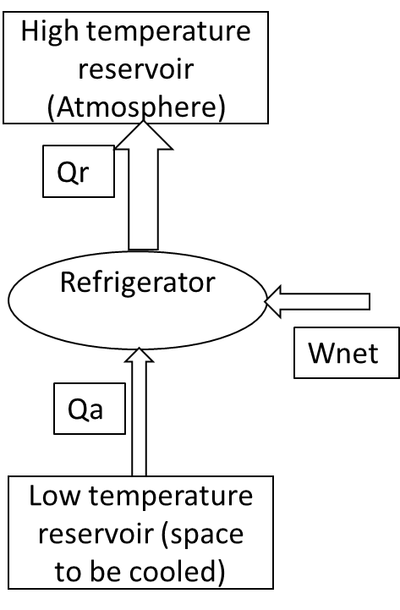

**Working Principle (Refrigeration Cycle)**

The refrigeration system typically operates on the **vapor-compression refrigeration cycle**, which involves the following steps:

**Compression**:

The refrigerant (working fluid), in gaseous form, is compressed to high pressure and temperature by the compressor.

**Condensation**:

The high-pressure gas passes through the condenser, releasing heat to the surroundings and condensing into a high-pressure liquid.

**Expansion**:

The high-pressure liquid refrigerant flows through the expansion valve, where its pressure and temperature drop.

**Evaporation**:

The low-pressure refrigerant enters the evaporator, absorbs heat from the refrigerated space, and evaporates into a gas. This cools the space or substance.

**Return to Compressor**:

The refrigerant gas returns to the compressor, and the cycle repeats.

**Refrigeration system**

Refrigerator: <https://www.youtube.com/watch?v=JUQ2Aw8W3BI&t=1s>

A **refrigeration system** is a mechanical system designed to transfer heat from a specific space or substance to the external environment, thereby lowering and maintaining the temperature of the space or substance below its surroundings.

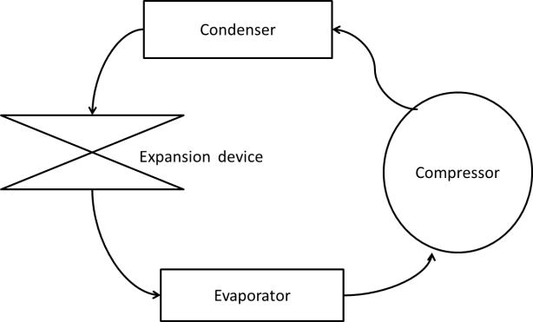

**Components of a Refrigeration System**

**Compressor**:

Compresses the refrigerant gas, raising its pressure and temperature.

Acts as the system's heart, driving the refrigeration cycle.

Types: Reciprocating type hermetically sealed (domestic refrigerators and car ACs because compact size, cost-effectiveness, high compression ability at small sizes (0.1 to 0.5 TR) hermaticaly sealed so as to eliminate leakages), Rotary type hermetically sealed (split ACs because compact & lightweight, better energy efficiency(1-5 Tons of Refrigeration (TR))) , Scroll type hermetically sealed (inverter ACs because works smoothly with variable speed operation) , Screw type (large commercial and industrial chillers for better energy efficiency at part load (50 TR - 2,000 TR)), and centrifugal type compressors (large systems, pharma industries because of no lube oil requirement, when system to be operated at full load for best energy efficiency (500 TR - 10,000+ TR))

**Condenser**:

Removes heat from the high-pressure refrigerant gas, causing it to condense into a high-pressure liquid.

Typically located outside the refrigerated space.

Types: Natural circulation air cooled (domestic refrigerators 0.1 TR to 0.5 TR, cost effective for low loads can not dissipate heat at the required rate in high capacity systems), forced circulation air cooled (coil less domestic refrigerators, split ACs, automobile ACs, supermarket refrigerators (more heat dissipation rate and compact in size for capacity of 1 to 10 TR, ) water cooled type either shell and tube type or shell and coil type (not used in smaller units due to need of cooling towers, these have highest heat dissipation rate due to water, usually used for the capacity more than 10 TR for better energy efficiency ice plants)

**Expansion device**:

Reduces the pressure and temperature of the refrigerant as it flows into the evaporator.

Controls the amount of refrigerant entering the evaporator.

Types: capillary tube (used in low capacity systems such as domestic refrigerators and split ACs due to low cost, low refrigerant gas flow rate requirement and no requirement of refrigerant flow control, no leakage problems), expansion valves (high capacity systems such as supermarkets, ice plants because of higher flow rate requirement, flow regulation as per changes in the load)

**Evaporator**:

Absorbs heat from the space or substance to be cooled, causing the refrigerant to evaporate and return to a gaseous state.

Located inside the refrigerated space.

Types: Bare Tube Evaporator or plate type (Used in domestic fridges because ease in cleaning and low cost in small capacity), Finned Tube Evaporator (Used in split ACs, automobile ACs because of compactness but requires fan with large air flow), Shell and Tube Evaporator (Used in chillers, ice plants, industrial cooling because tubes can be cleaned easily and replaced individually), Shell and Coil Evaporator (Used in larger systems where compact size is a must), flooded evaporator, dry expansion evaporator (used where capacity is low and compactness and low cost are important eg. fridge), flooded evaporators (used large systems more than 10 TR where entire tube bundle is submerged in refrigerant, ensuring better heat transfer rate improving energy efficiency ofrefrigeration system)

**Refrigerant**:

The working fluid that circulates through the system, absorbing and releasing heat as it undergoes phase changes (liquid to gas and vice versa).

Types: R12 (phased out due to Ozone depletion potential ODP 1 and high Global warming potential GWP 10900 times that of CO2, R134a, (zero ODP but being phased out due to higher GWP 1430) R600a (isobutane zero ODP, 3 GWP but highly flammable) in domestic refrigerators , R1234yf in refrigeration system of Automobile AC (high cost but due to GWP norms GWP less than 1 and ODP zero, not flammable), R22 (0.05 GWP 1810), R410a (zero ODP but 2088 GWP), (R32 zero ODP and 675 GWP) in refrigeration system of domestic ACs, R717 (ammonia zero ODP and zero GWP but toxic and attacks copper) in ice plants, 404a (zero ODP but 3922 GWP) , 449a (zero ODP 1282 ODP good energy efficiency and low cost at higher loads and lower temperatures) in supermarkets.

**Auxiliary Components**:

**Filter-Drier**: Removes moisture and contaminants from the refrigerant.

**Accumulator**: Protects the compressor by ensuring only gas enters it.

**Fans/Blowers**: Enhance heat exchange in the evaporator and condenser.

**Control Systems**: Thermostats and sensors regulate system operation.

**Cooling towers in refrigerators using water cooled condensers**: These are separate components preferred for more than 100TR refrigeration capacity. When water takes out the heat from condenser it can be cooled in cooling tower using evaporative cooling technique (similar to desert cooler used at home). This cooled water is again circulated in condenser to take away the heat from refrigerant.

**Air conditioning system:**

Split AC: <https://www.youtube.com/watch?v=nVTdukNJdtM&t=68s>

Central AC: <https://www.youtube.com/watch?v=THDGlVKrs5A>

Automobile AC: <https://www.youtube.com/watch?v=nm0vXRiLTqs>

**Types of air conditioning systems:**

Window AC, Split and cassette ACs, Portable AC, Automobile AC, Central AC.

**Components of central AC system:**

**AHU:**

**Components of an AHU**

**Housing/Casing**

Encloses all components and provides **insulation** to prevent energy loss and noise.

Made of **galvanized steel or aluminum panels** with thermal insulation.

**Filters**

Removes **dust, pollutants, and allergens** from the air.

Types of filters:

**Pre-Filters** – Captures large dust particles such as textile fibres, hair etc of size above 5 micrometer. For pre-filters, a MERV Minimum Efficiency Reporting Value rating of 1 to 8 is common.  Pre-filters are typically made from synthetic fibres, fiberglass, or aluminium metal mesh.

**Fine Filters (bag 1 micrometer or HEPA (High Efficiency Particulate Air) 0.3 micrometer)** – Bag MERV 9-16 and HEPA MERV 17-20 filters have almost same materials as prefilters with finer structure and multiple layers. Traps smaller particles and bacteria.

**Activated Carbon Filters** – Removes odors, smoke and gases. Activated carbon is made of exposing raw carbon (e.g., coconut shells, coal, wood) to high temperatures and chemicals to create a network of tiny pores. Activated carbon works through adsorption, a process where contaminants stick to the surface of carbon particles.

**Fans/Blowers**

Ensures proper air circulation through the system.

Types:

**Centrifugal Fans** – Common in large AHUs.

**Axial Fans** – Used for high-volume air movement.

**Backward/Forward Curved Fans** – Provide efficient airflow.

**Cooling Coil (Evaporator Coil)**

Uses **chilled water or refrigerant** to cool down the air.

Typically made of **copper tubes with aluminum fins** for heat exchange.

**Heating Coil**

Heats air using **hot water, steam, or electric resistance**.

Found in **winter HVAC systems**.

**Humidifier/Dehumidifier**

**Humidifier** adds moisture to dry air (used in winter).

**Dehumidifier** removes excess moisture (used in humid climates).

Types of humidifiers:

Steam Humidifier

Spray-Type Humidifier

Evaporative Pad Humidifier

**Mixing Box (Damper Section)**

**Mixes fresh outdoor air** with recirculated indoor air.

Uses **motorized dampers** to control airflow ratios.

**Heat Exchanger (Heat Recovery Unit)**

Transfers heat between incoming and outgoing air to improve **energy efficiency**.

Types:

**Plate Heat Exchanger** – Transfers heat using metal plates.

**Rotary Heat Exchanger** – Uses a rotating wheel to exchange heat.

**Additional Components**

**Sound Attenuators**

Reduces noise generated by fans and airflow turbulence. control noise inside the ducts by **reducing air turbulence and sound waves**.

**Control Panel & Sensors**

Includes **temperature, humidity, and pressure sensors**.

Manages **fan speed, damper position, and filter status**.

**Drain Pan**

Collects condensate water from the cooling coil and prevents water leakage.

**Vibration Isolators**

Absorbs mechanical vibrations to **reduce noise and wear**. stop noise at the source by **absorbing vibrations** before they transfer to the building.

**How an AHU Works**

**Air Intake:** Fresh outdoor air and recirculated indoor air enter through dampers.

**Filtration:** Air passes through filters to remove contaminants.

**Cooling/Heating:** The air is conditioned using cooling or heating coils.

**Humidification/Dehumidification:** The air's moisture level is adjusted.

**Air Circulation:** Fans push the treated air through ductwork into the building.

**Exhaust & Energy Recovery:** Stale air is exhausted, and heat recovery systems improve efficiency.

**Refrigeration system**

It comprises of compressor, condenser, expansion device, evaporator, primary/secondary refrigerants, auxiliary components and cooling towers (for water cooled condensers). It is used to produce chilled water to be circulated in cooling coils of AHU. Some times evaporator coils are directly inserted in AHU.

**Air Circulation system -** Distributes cooled or heated air in central AC systems.

**Components of a Ducting System**

**Supply Ducts**

Carries **cooled or heated air** from the **air handling unit (AHU)** or **central AC** to different rooms.

**Return Ducts**

Recirculates indoor air back to the **AHU or central AC** for filtering and reconditioning.

**Fresh Air Ducts**

Brings in **outside air** for ventilation and improves **air quality**.

**Exhaust Ducts**

Removes **stale air, smoke, or odors** from kitchens, bathrooms, and industrial areas.

**5.Dampers**

Controls airflow by opening or closing sections of the duct.

Types: **Manual, Motorized, Fire Dampers (for safety).**

**Grilles & Diffusers**

**Grilles**: Covers for duct openings, allowing air to enter/exit.

**Diffusers**: Evenly distributes air into a room.

**Insulation**

Reduces heat loss, noise, and condensation inside ducts.

**6 Automotive systems**

**Layout of Automotive systems (Clutch, Gearbox, Propeller shaft, Differential, Rear axle drives, wheels and tyre)**

Layouts of automobiles: <https://www.youtube.com/watch?v=EM1cd0901D4>

FWD front wheel drive , RWD rear wheel drive, AWD all wheel drive, 4WD 4wheel drive, front engine, mid engine, rear engine.

**Drivetrain Configurations**

These define how power is delivered to the wheels:

**Front-Wheel Drive (FWD)** – Compact, fuel-efficient, and cheaper to produce. Common in economy cars.

**Rear-Wheel Drive (RWD)** – Better balance and handling, especially for sports cars and trucks.

**All-Wheel Drive (AWD)** – Provides better traction in various road conditions for off-road use.

**Four-Wheel Drive (4WD)** – Designed for off-road use, common in SUVs and trucks.

**Engine Placements**

Engine position affects weight distribution, handling, and performance:

**Front-Engine** – Most common, offers good balance of cost, space, and cooling.

**Mid-Engine** – Used in sports and supercars for better weight distribution and handling.

**Rear-Engine** – Found in some sports cars for more traction under acceleration.

Components of automotive system layout.

**Clutch**

Located between the engine output shaft and the gearbox.

Engages and disengages the engine power from the power transmission system.

In vehicles, it allows the engine to run while the vehicle is stationary. It temporarily interrupts power flow to allow for smooth gear shifting in manual transmissions.

Common types: Single-plate (used in cars because a this clutch is cheap and occupies moderate space in cars for the torque they produce 100-400 Nm), multi-plate (used in motorcycles 5-150 Nm due to compactness, buses, trucks due to high torque transmission ability 600-2500 Nm ), and centrifugal clutches (used in scooters for smooth start and stop without manual intervention)

Working of a clutch: <https://www.youtube.com/watch?v=8Jr44ybyS7U>

**Gearbox (Transmission)**

Connected to the clutch output shaft.

Provides different gear ratios to adjust torque and speed.

Types: Manual (used in all type of vehicles due to low cost and driver control over power and efficiency), automatic (used in modern cars and luxury vehicles due to ease in driving and fuel efficiency), continuously variable transmission (CVT) (used hybrid cars and scooters for maximizing fuel efficiency, uses belt and pulley system) , and dual-clutch transmission (DCT) (Provides both manual control and automatic, used in sports cars)

Gear box working: <https://www.youtube.com/watch?v=wCu9W9xNwtI>

**Propeller Shaft (Drive Shaft)**

Transmits power from the gearbox (in rear-wheel-drive vehicles) to the differential.

Equipped with universal coupling to accommodate movement due to suspension travel.

Single piece (rear wheel drive vehicles with maximum 1.5 m distance between transmission and differential), two or three piece (rear wheel drive vehicles, long trucks, with more than 1.5 m distance between transmission and differential otherwise bending stresses on propeller shaft would increase), Slip joint (Has a telescopic mechanism to adjust length during suspension movement), constant velocity joint (used in front wheel drive vehicles, uses CV joint (45o angle motion transmission) instead of universal joint (30o angle coupling))

Propeller shaft working: <https://www.youtube.com/watch?v=y8QaD8NJLxM>

**Differential**

Receives power from the propeller shaft and distributes it to the drive wheels.

Allows wheels to rotate at different speeds during turns.

Types: Open (used in passenger cars and light duty trucks due to low cost), limited-slip   
(used in off vehicles operating on slippery roads, off road SUVs), locking (uased where both wheels on an axle get equal power even if one is in the air or on a slippery surface in military vehicles or tractors) and torque-vectoring differentials (used in sport cars and has electronic system and sensors)

Working of open differential: <https://www.youtube.com/watch?v=nC6fsNXdcMQ>

**Front and Rear Axle Drive**

**Front Axle (in FWD cars):** Connected directly to the differential, transmitting power to the front wheels.

**Rear Axle (in RWD cars):** Receives power from the differential and delivers it to the rear wheels.

Types: Live axle (solid axle) (transmits power to wheels, eg. Front axle in front wheel drive), dead axle (does not transmit power, eg. In front wheel drive rear axle is dead axle), independent axle (allows each wheel to move independently of the other while moving on bumps, used where comfort is important), dependant axle (wheels move as a unit when travelling on bumps, used where low cost, high strength are important, commercial vehicles, heavy duty trucks), floating axle (the housing carries the weight of vehicle through bearings and axle transmits only torque, used in buses and trucks), semi floating axle (the axle carries the weight of vehicle through bearings as well as transmits torque, used in cars)

Axle: <https://www.youtube.com/watch?v=N50igrkhOTs>

**Wheels and Tyres**

Types of wheels: <https://www.youtube.com/watch?v=HCiUZU09xkM&t=285s>

Typical tubeless tyre layers: <https://www.youtube.com/watch?v=PHdCezJ7Pyw>

Convert rotational motion into linear motion to move the vehicle.

**Tyres** provide traction, shock absorption, and stability.

Types: Radial tyres (modern tyres) (famous for flexibility, grip and fuel efficiency) and bias-ply tyres (famous for strength and resistance to punctures), tubeless tyres (deflate more slowly in case of a puncture providing better safety and control, expensive) and tube-type tyres (deflate rapidly during punctures, which can compromise safety, comparatively cheaper)

Tyre generally consists of 1. inner liner of rubber to retain the air in the (tubeless) tyre 2. Over the inner layer there are two body plies (layers) of the polyester fabric coated with rubber compound to stick together and with inner liner. Plies have cords (cords means the strong reinforcing fibers, often made of nylon, polyester, or steel, embedded within the plies). The fibres of two ply layers if are at cross with each other it is called bias-ply tyre and if run perpendicular to the direction of travel then radial tyre. 3. on top of plies there is wedge 4. on top of that there are two steel belts, means layers with cords, in cross direction. Function is to give impact resistance they are back bone to the tread. Inbetween these steel belts there is a rubber layer preventing steel belts rubbing each other 5. on top of steel belts there is nylon layer prevents flexing of tyre out from center 6. on top of that there is tyre tread made of silica based rubber reducing tread wear. It is the tread that actually is in contact with road surface while rolling. 7. one more component of tyre is bead means thick steel wires that hold the tyre on to the rim of wheel. 8. in addition to above in a tire, the sidewall also is there which refers to the section of the tire that bridges the tread and the bead.

Types of wheels: disc wheel (steel wheel, it has a disc and a rim, used in buses dyue to high load bearin capacity and budget cars due to inexpensive), wire wheel (spokes wheel, spokes extending from hub to rim), Alloy wheel (arms extending outward from the hub, the centre portion of wheel, to the rim the outer ring on which the tyre fits, used in modern cars due to light weight and better heat dissipation)

**Other systems that an automobile has are:**

Suspension (<https://www.youtube.com/watch?v=PDnyfrMy1iA&t=650s>)

braking system (<https://www.youtube.com/watch?v=bcnmgu8hzjI>)

Steering system, (<https://www.youtube.com/watch?v=ltufRS3xj30>)

Chassis (<https://www.youtube.com/watch?v=k_TkVZz9Vhs>)

Body (<https://www.youtube.com/watch?v=oQSFuHog6Yc>)

**Components of hybrid EV vehicle (car)**

how it works: <https://www.youtube.com/watch?v=SHRrhyGYbb8&t=5s>

An hybrid electric vehicle is a vehicle that uses both gasoline and electricity to run, and it charges its own battery while you drive and brake.

Hybrid Electric Vehicles (HEVs) combine a conventional internal combustion engine with an electric motor and battery. The key components are:

**Internal Combustion Engine (ICE)**

The ICE in HEVs is typically optimized for efficiency and works in conjunction with the electric motor. It can be gasoline, diesel, or alternative fuel-based.

**Electric Motor**

The electric motor assists the ICE during acceleration and can also act as a generator to charge the battery. Types include:

**Permanent Magnet Synchronous Motor**: Known for efficiency and compact size.

**Induction Motor**: Used for its reliability and efficiency.

**Battery**

The battery stores energy captured during regenerative braking and from the ICE. Common types include:

**Nickel-Metal Hydride (NiMH) Batteries**: Durable and cost-effective.

**Lithium-ion (Li-ion) Batteries**: Offer higher energy density and efficiency.

**Battery Management System (BMS)**

The BMS monitors and controls the battery's state of charge, health, and safety, ensuring optimal performance and longevity.

**Power Control Unit (PCU)**

The PCU manages the flow of electrical energy between the battery, electric motor, and ICE, optimizing efficiency and performance.

**Transmission**

HEVs often use specialized transmissions, such as:

**Continuously Variable Transmission (CVT)**: Allows for seamless gear ratio changes to optimize engine efficiency.

**Dual-Clutch Transmission**: Provides quick and efficient gear shifts.

**Regenerative Braking System**

Captures kinetic energy during braking and deceleration, converting it into electrical energy to recharge the battery.

**Start/Stop System**

Automatically shuts off the ICE when the vehicle is stationary (e.g., at traffic lights) and restarts it when needed, reducing fuel consumption and emissions.

**Electric-Only Mode**

Some HEVs can operate in electric-only mode at low speeds, reducing emissions and fuel consumption in urban environments.

**Control System**

The control system manages the interaction between the ICE, electric motor, and battery, optimizing fuel efficiency and performance based on driving conditions.

**Thermal Management System**

Maintains optimal temperatures for the battery, electric motor, and ICE, ensuring efficiency and longevity.

**Auxiliary Systems**

Includes:

**12V Battery**: Powers the vehicle's electrical systems.

**DC-DC Converter**: Steps down the high voltage from the hybrid battery to charge the 12V batter

**Components of EV (car)**

How it works: <https://www.youtube.com/watch?v=tJfERzrG-D8&t=460s>

The key components of an Electric Vehicle (EV) car are as follows:

**Electric Motor**

The electric motor is what converts electrical energy into mechanical energy to propel the vehicle. There are several types, including:

**AC Induction Motors**: Common in many EVs due to their efficiency and reliability.

**Permanent Magnet Motors**: Known for their high efficiency and power density.

**Brushless DC Motors**: Offer high efficiency and long lifespan.

**Battery**

The battery is essentially the heart of an EV, storing the energy needed to power the vehicle. Most EVs use:

**Lithium-ion Batteries**: Preferred for their high energy density, long cycle life, and relatively low self-discharge rate.

**Battery Management System (BMS)**: Ensures the battery operates within safe limits, balancing performance and longevity.

**Charging System**

The charging system allows the EV to replenish its battery. This includes:

**Onboard Charger**: Converts AC power from charging stations or home outlets to DC power for the battery.

**External Chargers**: Fast chargers that can charge the battery to 80% in 30 minutes.

**Power Electronics**

These components manage the flow of electrical energy within the vehicle:

**Inverters**: Convert DC power from the battery to AC power for the electric motor.

**DC-DC Converters**: Step down the high voltage from the battery to lower voltages for the vehicle's electrical systems.

**Transmission**

EVs often use simpler transmissions than internal combustion engine vehicles, such as:

**Single-Speed or Multi-Speed Gearboxes**: Designed to optimize the efficiency and performance of the electric motor.

**Regenerative Braking System**

This system captures kinetic energy during braking and deceleration, converting it into electrical energy to recharge the battery.

**Thermal Management System**

Maintains optimal temperatures for the battery, electric motor, and other components to ensure efficiency and longevity.

**Chassis and Body**

Lightweight materials are often used to maximize range and efficiency, including:

**Aluminum and Carbon Fiber**: These materials provide strength while reducing overall vehicle weight.

**Safety Features**

EVs include various safety features, such as:

**Battery Isolation**: Ensures the battery is safely disconnected in the event of a collision.

**Crash Structures**: Designed to protect occupants and the battery in the event of an impact.

**Infotainment and Navigation**

Modern EVs come equipped with advanced infotainment systems, including:

**Touchscreen Displays**: Provide access to navigation, climate control, and connectivity features.

**Connectivity Options**: Such as Bluetooth, Wi-Fi, and over-the-air updates for seamless connectivity and software updates.

**Auxiliary Systems**

These include:

**12V Battery**: Powers the vehicle's electrical systems, similar to a conventional car.

**HVAC System**: Provides heating, ventilation, and air conditioning, often with an electric compressor.

**Case Study Report: Tata Nexon EV**

**Introduction** The Tata Nexon EV is one of the most successful electric vehicles (EVs) in India, produced by Tata Motors. Launched in January 2020, it has played a significant role in accelerating the adoption of electric mobility in the country. This case study analyzes the key factors behind the success of the Tata Nexon EV, including its market impact, technological innovations, challenges, and future prospects.

**Background** Tata Motors, one of India’s largest automobile manufacturers, ventured into the electric vehicle segment as part of its sustainability and innovation strategy. The Nexon EV was designed to provide an affordable, reliable, and efficient EV solution for Indian consumers. It is based on the company’s Ziptron technology and has been well received due to its balance of affordability, performance, and features.

**Key components and features of Tata Nexon EV**

**Battery & Range**: The Nexon EV is powered by a 30 kWh lithium-ion (Lithium Ferro Phosphate) battery 320 volt (because normal 12 volt volt battery would increase current to provide the same power inducing losses due to heat, 320 volt to keep moderate cost and safety) and offering an Automotive Research Association of India (ARAI) certified range of approximately 300 km on a single charge.

**Performance**: The Permanent Magnet Synchronous Motor, an AC electric motor, delivers 129 PS ("PS" stands for "Pferdestärke", a unit of power, which is a German term for horsepower used in Europe and India) of power and 250 Nm of instant torque, enabling quick acceleration (0-100 km/h in under 10 seconds).

**Charging**: It supports DC fast charging, which can charge the battery from 0 to 80% in about 60 minutes, and standard AC home charging takes around 8 hours.

**Safety & Features**: It comes with a 5-star Global NCAP safety rating (NCAP safety rating refers to the New Car Assessment Program (NCAP), (NCAP which is a vehicle safety rating system used worldwide. As per crash test 5 star rating is highest), advanced connectivity features (eg, remote access to vehicle functions via a mobile app, Smartphone Integration) and regenerative braking.

**Inverter**: Uses Insulated Gate Bipolar Transistor based **3-phase inverter** to convert the DC power from the battery into AC power for the motor.

**Thermal management system**: The Tata Nexon EV uses a Liquid-Cooled Thermal Management System for its battery, motor, and power electronics. Uses coolant circulation to maintain optimal temperature of the battery pack, inverter, and electric motor. Ensures consistent performance, longer battery life, and safety. It uses Ethylene Glycol-based coolant a non-conductive, dielectric coolant. Coolant absorbs heat from the battery, inverter, and motor. The heated coolant flows to the radiator Airflow (via the front grille and radiator fan) cools down the liquid. The cooled liquid recirculates. Battery Management System (BMS) continuously monitors battery temperature and adjusts cooling accordingly

**Gearbox** **(transmission)**: Type: Single-Speed Automatic (Fixed Gear Ratio). Transmission Mode: Direct Drive (No Clutch, No Manual Gears). Power Flow: Electric motor directly drives the front wheels (FWD). Gear Ratio: Approx. 8:1 (Reduction Gear). Reverse Gear: Achieved via motor rotation reversal

**Differential:** It uses E differential. One wheel starts to spin faster (losing grip), brakes are applied to that wheel to control speed. This indirectly allows the other wheel to receive more effective power.

**Wheels and tyres (tires):** The Tata Nexon EV is equipped with tubeless tyres. It comes with generally steel wheels, while the some variants use alloy wheels.

**Drive:** It is a front wheel drive vehicle.

**DC DC converter and 12 V auxiliary battery:** The DC-DC converter steps down the high-voltage DC from the main battery to 12V DC, which then powers the 12V auxiliary battery and all the low-voltage electronics in the car. The car has many components that operate on 12V battery, such as headlights and cabin lights, horn, infotainment and display systems, power windows and locks, wipers, airbags and safety modules, ECU (Electronic Control Unit) etc. When the main high-voltage battery is disconnected (e.g., during servicing or an emergency), the 12V battery ensures that the car can still lock/unlock, emergency lights and hazard indicators work, safety systems remain operational.  
When you start the car, the 12V battery initializes all the essential electronics before the high-voltage battery is connected. If the high-voltage system fails temporarily, the 12V battery provides uninterrupted power to key systems, like brake assist or hazard lights.

**Air conditioning:** In the Nexon EV the AC compressor is electric and powered by the high-voltage battery. Refrigerant used by Nexon EV is still R134a which is an affordable refrigerant.

**Braking system:** Nexon EV uses a hydraulic oil pressure braking system, just like conventional cars, but it's combined with regenerative braking to enhance efficiency. Front wheels: Disc brakes, Rear wheels: Drum brakes. When applied light braking, the electric motor runs in reverse mode, acting like a generator charging the high-voltage battery. The car’s control unit seamlessly blends regenerative and mechanical braking based on speed, pedal pressure, and battery charge level.

**Axle**: Nexon EV uses semi floating axle.

Body type: SUV, Monocoque Chassis (Unibody Construction), Electric Power Assisted Steering (EPAS)

**Market Impact and Sales Performance** Since its launch, the Nexon EV has significantly contributed to the growth of the EV market in India. By 2023, it became the highest-selling electric car in India, capturing over 60% of the market share in the EV segment. The vehicle's success encouraged Tata Motors to expand its EV portfolio and invest further in electric mobility.

**Challenges Faced**

**Charging Infrastructure**: Limited EV charging stations in India approx 12,000 remain a challenge for wider adoption only 50000 cars sold over 500 cities till mid 2023. Only 8% of total Nexons sold.

**High Initial Cost**: Despite being more affordable than other EVs, the upfront cost is still higher than conventional petrol/diesel vehicles. The approximate cost of the Tata Nexon EV ranges from ₹15 lakh to ₹20 lakh (ex-showroom, India). 1.5 to 2 times higher than an internal combustion (IC) engine car of the same power basically due to the high cost of lithium-ion batteries.

**Battery Technology & Range Anxiety**: Consumer concerns over battery life and driving range continue to impact purchasing decisions. The Tata Nexon EV's lithium-ion battery is designed to last approximately 8-10 years or around 1,50,000 km, depending on usage and maintenance.

**Government Support and Policy Impact** The Indian government has played a crucial role in promoting EV adoption through incentives and policies:

**FAME II Scheme**: The **Faster Adoption and Manufacturing of Electric Vehicles (FAME II) Scheme** was introduced in 2019 as an extension of the FAME I Scheme. It aims to promote electric mobility through financial incentives for EV buyers, support for charging infrastructure development, and subsidies for electric two-wheelers, three-wheelers, and four-wheelers used in public and commercial transport.

**Tax Benefits**: GST on EVs reduced to 5%, and buyers of EVs can claim a deduction of up to ₹1.5 lakh on the interest paid on a loan taken to purchase the vehicle.

**State-Level Incentives**: Various states offer additional subsidies and incentives to promote EV adoption. In Maharashtra these are as follows.

**Purchase Subsidy:** A 15% subsidy on the purchase price of four-wheelers, capped at Rs 1 lakh per vehicle. This subsidy is transferred directly to the buyer's bank account within three months of purchase.

**Road Tax and Registration Fees:** All EVs sold in Maharashtra are exempt from road tax and registration fees, reducing the overall cost of ownership.

**Scrappage Incentive:** Owners scrapping old internal combustion engine vehicles receive additional incentives—up to Rs. 25,000 for four-wheelers when replacing them with EVs.

**Future Prospects and Expansion Plans** Tata Motors plans to expand its EV lineup with new models and improved battery technology. The company has also introduced the **Nexon EV Max**, an upgraded version with a larger battery (approx 40 kWh), which is suitable for urban and moderate long-distance travel, and an extended range of 450 km.

**Conclusion** The Tata Nexon EV has been a game-changer in India’s electric vehicle industry. Its affordability, minimal issues, and government-backed incentives have contributed to its success. While challenges like charging infrastructure persist, continuous advancements and increasing consumer awareness will likely drive further growth in the Indian EV market. Tata Motors’ strategic approach to sustainable mobility positions it as a key player in India's transition to electric transportation.

**Types of EVs**

**BEV (Battery Electric Vehicle)**:

Fully electric vehicles powered solely by a large battery and electric motor(s).

Has no internal combustion engine, meaning zero emissions during operation.

Must be recharged via an external power source (home charger, public charging station).

Examples: Tesla Model 3, Nissan Leaf, Ford Mustang Mach-E.

**PHEV (Plug-in Hybrid Electric Vehicle)**:

Combines an internal combustion engine (ICE) with an electric motor and a rechargeable battery.

The battery can be charged via an external power source (like a home outlet or charging station).

Operates on electric power for a certain range (typically 20–50 miles) before switching to the ICE for longer trips.

Examples: Toyota Prius Prime, Mitsubishi Outlander PHEV.

**EREV (Extended-Range Electric Vehicle)**:

A specialized type of PHEV designed to primarily use its electric motor for propulsion.

Has a small ICE that acts as a generator to recharge the battery when it depletes, extending the driving range.

Focuses on electric driving as the primary mode, with the ICE as a backup.

Example: Chevrolet Volt.

**Parallel Hybrid Electric Vehicle (Parallel HEV)**

**Powertrain Configuration**:

Both the **internal combustion engine (ICE)** and the **electric motor** are connected to the drivetrain and can propel the vehicle **independently or together**.

The battery is charged through **regenerative braking** and power from the engine.

**How It Works**:

At low speeds, the **electric motor** may drive the car alone.

During acceleration or high-speed driving, the **ICE and electric motor** work together for better power and efficiency.

The ICE may also charge the battery while driving.

**Advantages**:

More fuel-efficient than conventional gasoline vehicles.

No need to plug in for charging (self-charging through braking and engine).

**Series Hybrid Electric Vehicle (Series HEV)**

**Powertrain Configuration**:

The **ICE does not drive the wheels directly**.

Instead, the ICE acts as a **generator** to charge the battery, which then powers the **electric motor** that drives the wheels.

**How It Works**:

The vehicle **starts and runs on electric power**.

When the battery charge is low, the **ICE generates electricity** to keep the car running.

The ICE acts purely as a **range extender** rather than a primary propulsion source.

**Advantages**:

Smoother drive since the electric motor is the only one powering the wheels.

More efficient than traditional gasoline vehicles.

**Fuel Cell Electric Vehicle (FCEV)**

**Powertrain Configuration**:

Uses a **hydrogen fuel cell** to generate electricity, which then powers an electric motor.

**No internal combustion engine (ICE)**—only a fuel cell stack and electric drivetrain.

**How It Works**:

Hydrogen from the fuel tank reacts with **oxygen from the air** in the fuel cell to produce **electricity**.

This electricity drives the **electric motor**, and the only emission is **water vapor**.

**Advantages**:

Zero emissions (only water).

Faster refueling than battery electric vehicles (3–5 minutes vs. hours for BEVs).

Longer range compared to BEVs.

**Challenges**:

Expensive and limited **hydrogen fueling infrastructure**.

Hydrogen production is still not widely green (most hydrogen comes from fossil fuels).

**Mild Hybrid Electric Vehicle (MHEV)**

**Powertrain Configuration**:

Uses a **small electric motor and battery** to assist the internal combustion engine (ICE).

The **electric motor does not directly drive the wheels**—it only supports the ICE for efficiency and performance.

**How It Works**:

The **electric motor assists** with acceleration, stop-start functionality, and regenerative braking.

The **battery is recharged** via braking and the engine.

The car **cannot drive on electric power alone**—it always requires the ICE.

**Advantages**:

Slightly better **fuel efficiency** than conventional ICE vehicles.

Reduced **emissions and improved performance**.

Cheaper than full hybrids (HEVs) and plug-in hybrids (PHEVs).

Each type offers different advantages depending on your driving needs, charging availability, and environmental priorities.

**7. Emerging Technological applications in Mechanical Engg**

**Robotics in mechanical engineering:**  <https://www.youtube.com/watch?app=desktop&v=8gy6ZvIDtbU>

Robots do welding, bolting, and component placement (assembly) with high accuracy and speed, reducing cycle times and minimizing errors. This is crucial in industries like automotive, aerospace, etc.

Robots do picking, packing, palletizing, and transporting heavy or hazardous materials, improving workplace safety. This is especially valuable in foundries, warehouses etc.

Robots do cutting , like laser and plasma cutting, provide precise and intricate cuts on various materials.

Robots when integrated with CNC machines enable automated loading, unloading, and part transfer, increasing machine utilization

Robots equipped with sensors and vision systems perform automated inspections, ensuring product quality. This includes dimensional measurement, surface defect detection

Robots provide uniform and precise application of painting and coatings, reducing material waste and improving finish quality. This is commonly used in the automotive and aerospace industries.

Robots operate almost continuously reducing the labour costs required for the manufacturing

Robotic systems have very high upfront cost (money need to be paid right away at the start)

Integrating robots with existing manufacturing systems is complex and requires expertise

Robotic systems need skilled personnel for programming and troubleshooting.

Cobots, IOT, AI are future of robotics

Robotics is actually a part of automation

**Automation in mechanical engineering:**

<https://www.youtube.com/watch?app=desktop&v=tw-79FiRYKA>

It is nothing but use of technology to perform tasks with minimal human intervention.employing machines, software, and control systems to execute manufacturing processes

Purpose of automation is to Increase productivity (rate at which a company creates completed products), Enhance product quality and consistency., Reduce labor costs, Improve workplace safety, Optimize resource utilization may be using data gathered, to increase flexibility (ability of a system to adapt to changes in product design, production volume, or processes)

Key technologies in automation are robotics, CNC (automated machining), PLCs (controlling and monitoring of industrial processes for precise and reliable operation), . CAD/CAM softwares (Automated design and manufacturing processes, from product development to production), IOT (for Connecting machines, enabling data exchange and remote monitoring) etc.

Automation requires significant upfront costs

Integrating new automation technologies with existing systems is very complex

Operating and maintaining automated systems requires skilled personnel.

AI, Cobots, digital twins can be the future of automation

Automation helps achieving competitiveness in mechanical industry

Due to automation workers lose their jobs involuntarily Increasing unemployment which can negatively affect the overall economy.

**Augmented reality and virtual reality in mechanical engineering:**

What is AR and VR: <https://www.youtube.com/watch?v=NOKJDCqvvMk>

Augmented reality use in a warehouse: <https://www.youtube.com/watch?v=5E6qambiCo0>

Virtual reality for traning: <https://www.youtube.com/watch?v=T4kFBP_aUDw>

In VR, Users typically wear a headset that blocks out the real world, transporting them to a virtual one.

AR is often achieved through smartphones or AR glasses

VR (virtual reality) completely replaces the user's real-world environment with a simulated one and AR (augmented reality) overlays digital information onto the user's real-world view.

Smaller companies cannot afford AR VR easily. Prolonged use of VR causes motion sickness, eye strain, and headaches, AR distract users from their surroundings, potentially leading to safety hazards in industrial environments. AR/VR systems collect sensitive data about users and their surroundings, a data privacy problem.

Benefits of AR and VR are faster design cycles and reduced prototyping costs, Enhanced visualization and collaboration., Increased safety and efficiency, Reduced training costs., Reduced downtime and repair costs., Improved technician efficiency, More accurate inspections., More accurate inspections., reduction of errors.

Quality Control and Inspection: AR can overlay digital information onto physical products, enabling precise inspections and defect detection. VR can be used to simulate stress tests and other quality control procedures.

Maintenance and repair: AR can provide technicians with real-time access to digital manuals and schematics, streamlining troubleshooting and repair.. Remote experts can use AR to guide on-site technicians, reducing downtime and travel costs

Design and prototyping: AR can overlay digital designs onto physical prototypes, facilitating real-time comparisons and adjustmentsVR allows engineers to immerse themselves in 3D models, enabling detailed visualization and early detection of design flaws

Training: AR can overlay instructions and data onto real-world equipment, guiding technicians through maintenance and repair procedures. VR provides realistic simulations for training on complex machinery, reducing the risk of accidents and improving proficiency.

**Digital twin:** <https://www.youtube.com/watch?v=60eCpw0Toy4>

A digital twin is essentially a virtual representation of a physical object or system

It's designed to accurately reflect its real-world counterpart, allowing for simulation, analysis, and prediction

they are used to predict failures in mechanical systems beforehand

simulations in virtual wind tunnels and virtual race tracks are possible due to digital twining reducing the need for physical prototypes and speeding up development cycles.

Manufacturers can simulate production processes to identify inefficiencies and improve overall productivity.

Digital twins help in assessing the environmental impact of mechanical systems, aiding in the development of greener technologies.

benefits of digital twins are reduced down time, improved quality, reduced cost, enhanced innovations, increased productivity

drawbacks of digital twins are cybersecurity, data privacy, complexity in integration, high initial investment, skilled workforce with expertise in data analysis, modelling, and simulation.

**Autonomous vehicles** <https://www.youtube.com/watch?v=gEy91PGGLR0>

Autonomous vehicle is capable of sensing its environment and operating without human input.

Autonomous vehicle uses a combination of technologies, including sensors (like radar, lidar, and cameras), GPS, and sophisticated software

The Society of Automotive Engineers defines six levels of driving automation, ranging from Level 0 (no automation) to Level 5 (full automation).

Currently, most commercially available vehicles offer features within Level 1 or Level 2, providing driver assistance but requiring human oversight.

Lidar, radar, and cameras provide the vehicle with a 360-degree view of its surroundings detecting objects, pedestrians, and other vehicles, enabling the AV to navigate safely.

AI algorithms process the sensor data and make real-time decisions about steering, acceleration, and braking. Machine learning allows AVs to learn from experience and improve their performance.

Precise GPS (satellite-based radio navigation system owned by the United States government) and high-definition maps enable AVs to determine their location and plan routes.

Advantages of Autonomous vehicles are decreased accidents due to human error, elderly and disabled people can drive, solving traffic jams, low emissions through optimized driving

challenges of autonomous vehicles are cyber attacks, regulations for autonomous vehicle testing are not yet set