A Real-time Twitter Sentiment Analysis of
U.S. Presidential Candidates-2016

Lavanya Kumar Somu, Srikar Reddy Mallareddygari, Pavan Kumar Bollaram, Sashidhar Reddy Gowra, Rajasekhar Reddy Ogirala.
School of Computing and Engineering
University of Missouri-Kansas City
Missouri, United States of America

Abstract—This paper describes real-time analysis of public sentiment about 2016 U.S. presidential candidates on twitter, a micro blogging system. Twitter is most widely used blogging site to post public interest about politics, news and events. Emerging tweets are almost updated instantly on twitter which makes us analyze these emerging tweets and provide some good sentiment analysis on the public responses about presidential candidates of 2016.In contrast to traditional analysis, where we need many days and weeks to analyze public opinions here we can get twitter pulse about a particular candidate instantly and continuously. This sentiment analysis can be used as one of the factor in determining tweet pulse about a particular presidential candidate on twitter.

Introduction
The main objective of this project is to analyze the tweets which reflects the political content. Once we have this data we can classify the data using prediction classifiers so that a useful information can be extracted from the collected tweets. This data is further used for showing the end user about current trend and how the future trend going to take turn. This approach is inspired from the many available trends in the market. We have seen different data mining techniques and analyzing methods which shows user the popular tweets, most tweets from countries and popular images in Twitter and Facebook. So we thought of collecting the political data and using this data for predicting the sentiment of the people towards the presidential candidates-2016.
Political data is collected in real time from the twitter using standard twitter API. We have used Apache storm an open source distributed real time computation system to establish connection to twitter API and collected data using tuples and bolt supported by storm. This data can be related to anything which describes political systems and this was collected by supplying query parameters to twitter API. This raw data filtered again so that this collected data is further processed for sentiment analysis using different classifiers such as Naïve model, supporting vector machine, D-tree. This analyzed data is stored into Hbase database and which is collected using mobile interface. We have developed a mobile application based on android platform which collects the analyzed data stored into Hbase. This mobile interface establishes connection to Hbase server and follows http protocols to read the data .We have developed visualization code which inturn reads the collected data and visually represents to the end user using simple bar charts, pie charts.
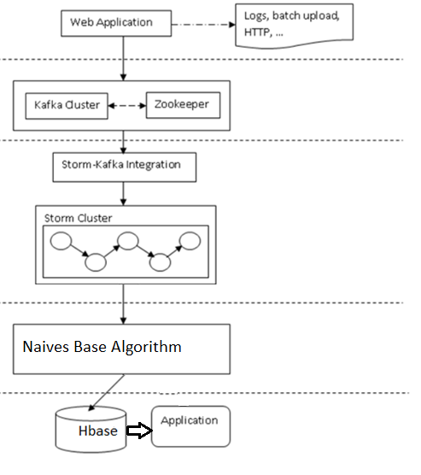
Fig 1: Flow Chart for Twitter Tweet Analysis

Firstly, the vernacular sentiment analysis system we used on twitter can differentiate between common tweets and political related tweets, some common tweets are almost related to politics and we have trained our sentiment analysis this peculiarity. Secondly, tweets in general purpose and political related purpose tweets are more ironic which are challenging to computer models. Here we focus on this paper presenting over all system, approach and visualization dashboards. In second section we will start with materials and methods then later on we will walk through results, discussions, conclusions and acknowledgements.

MATERIALS AND METHODS

2.1 Input/Data Source:

We selected twitter, micro-blogging service because it is major online portal to get comments, views and upcoming events about U.S. political system from public, TV channels and news papers, where they tweet and retweet to others messages. For example, twitter messages goes very high when republicans are making a speech at some point about republicans, at this time we saw twitter messages increase from hundreds to thousands in just few hours of time for all the candidates in republic party. Twitter's public API provides only very few percentage of its entire traffic which is completely insufficient for very accurate sentiment analysis of public tweet messages.
Since our analysis is about presidential candidates of 2016 U.S. presidential elections, we construct a set of rules manually like we will set some keywords to search or combination of keywords that used to retrieve particular tweets that are related to presidential candidates. These keywords must be about candidates, political parties (republic/ democratic). For example @Republicans, @Democratics, @2016President, @HillaryClinton. Our system mostly retrieve tweets about top four candidates in each political party.

2.2 Storm-Distributed and Fault-torrent real-time computation:

Storm amalgamates with any database system and any other queuing system. Spout in storm enables us easy to interrogate a new queuing system. This system include kafka, JMS, Kestrel. Storm will handle the partitioning, retrying on any failures if there is necessary and parallelization. Storm has a very simple way of using API’s. When we were doing programming in storm, we transform and manipulate streams of tuples. Tuples are list of values that are named, it can contain any type of object. We can register any new type of data without knowing anything about that object.
There are three notions in Storm, they are spouts, topologies and bolts. In a computation a source of stream can be called as spout. Spout can read from kafka stream broker or it can also read from Twitter streaming API. This implementations already exists in many famous systems. Any number of input streams are processed by bolt and it can produce any number of output streams. Bolts, such as functions, filters, talking to database, streaming joins and streaming aggregations and many more. Finally, topology is network that represents spouts and bolts in very structured manner. A topology can run indefinitely when it was deployed. Storm also has a local mode called storm cluster which can run all the processes locally.
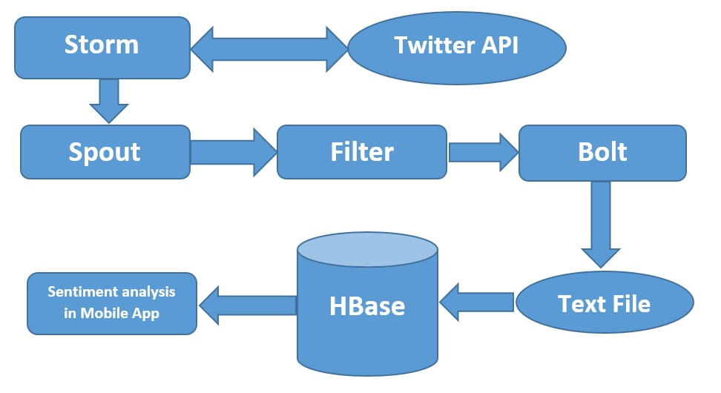
Fig-2 Storm abstractions architecture

Twitter API has token key and access key, they can be send through storm. In Storm we will go through a keyword search. This can be done through spout, it reads streaming tweets from twitter API and sent in form of tuples (it can be any object types. Here we installed a own filter where we can filter only text and image type objects only. For example, a twitter message can have many information like source ID, date, text, language, location and many more. In these data types we only take text and images as our filter output. This filtered data can be processed through csv bolt, where these input filtered tuples can be joined and formatted as single text file this file will sent to sentiment analysis (naive base analysis) to get sentiment processing of the public data. Finally, this analysis and text file will be uploaded to Hbase for viewing purpose.

III. IMPLEMENTATION

3.1 Sentiment analysis algorithms:
Weka Model and Naïve-Bayes algorithm:
The Standard approach for analyzing document classifier is to transform unstructured text format datasets into a predefined or semi structured to apply a standard propositional learning schema. The Model provides a Classification Job to analyze the unstructured data. Naïve Bayes is the one of such multinomial algorithm. We have used Naïve Bayes algorithm for analyzing the JSON twitter data for mood analysis.

This approach is supervised learning approach and system builds their own knowledge structure with capacity of learning something new. To do classification we have to do data preprocessing, feature extraction, training and testing.
Once the data is read from the file it will be preprocessed and feature extraction will be done on the data. In this approach we will find the part of the speech of the word and we do feature extraction using pre define feature word list which intern produces feature vector. The weight age of the tweet sentiment is evaluated based on the feature vector.

The Standard approach for analyzing document classifier to transform unstructured text format datasets into a predefined or semi structured to apply a standard propositional learning schema. This Model provides a Classification Job to analyze the unstructured data. Naïve Bayes is the one of such multinomial algorithm. We have used Naïve Bayes algorithm for analyzing the JSON twitter data for mood analysis.

We are capturing the sentiment or mood of the tweets with the use of Naïve Bayes analysis algorithm because of the simplest mathematics involved and it is very simpler to code using programming languages. This algorithm uses the simple probabilistic classifier with naïve independence assumption. This approach is supervised learning approach and system builds their own knowledge structure with capacity of learning something new

3.2 Data persistence to HBase:
We are using standard HTTP protocols in our application to store the data into HBase using java. We have created tables at http://134.193.136.114:8181 address to store the data from a file. These tables are accessed using mobile interface to retrieve the data which can be shown to the user.

3.3 Design of Mobile Client:
Mobile Application:
Developed a mobile application which reads the collected twitter dataset. User can check the content of the data set and at the same time after sentimental analysis user can check the each tweet and their respective analysis whether it reflects positive mood or negative mood. At the end we are displaying the report to user on click of button which included on mobile app.
Features:
- Reads the data from the Hbase by establishing the connection.
- Analyses mood of the data (tweets) retrieved from Hbase.
- Displays the data in pie-chart graphical view with the different colors.

Technologies for UI:
- Android SDK
- Achart Engine for graphical view
Technologies for Data Storage:
- Hbase.

Technologies for Real-Time Streaming with Twitter API
- Storm

GUI:
GUI is contains Text view, web view and buttons on screen. Used Pie chart for visualization of the analysis.

- Implemented logic to establish connection to Hbase and trying to fetch the real time data which is stored in Hbase.
- Once the data retrieved we are finding the sentiment of the mood by analyzing the data collected.
- The required data which is needed for graphical representation is passed to Achart Engine client.

Designed layout which includes buttons and text view and displaying the rendered output on screen using pie chart. Extracting a real time streaming data based on a keywords using storm distributed computation by taking twitter stream API data as input was developed. The filter was also developed in storm to filter the twitter messages using keywords provided by user. This twitter messages also filtered based on tuple object type (text and image). These text and images are processed through weka sentiment analysis algorithm to get sentiment analysis of the public responses over twitter micro-blogging site. Also, developed a mobile app to show automated process of android GUI and retrieved data from a centralized Hbase location.
IV. RESULTS

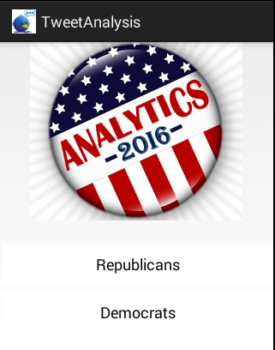

III. Results

This is the home page of our mobile application TweetAnalysis for US Presidential elections 2016. It has two buttons each for Republicans and Democrats which are major contesting parties of Presidential elections 2016. On the click of each button a list of probable contestants from each party will be displayed.
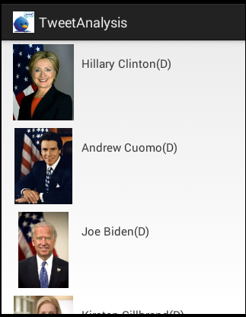

Here is the list of probable US Presidential Election Democratic Candidates.

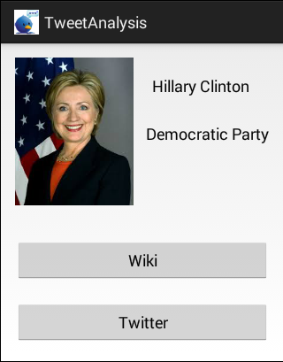
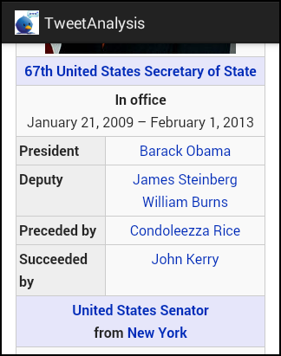
This screen shows the profile of each candidate and displays two buttons for their wiki page and tweet analysis. This screen shows wiki page of the candidate.

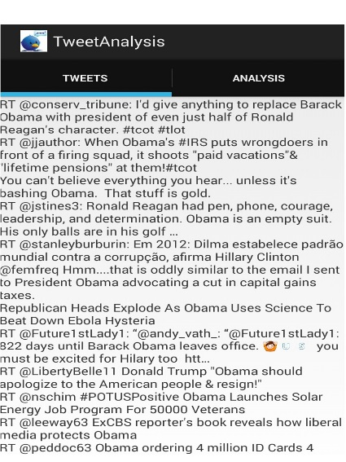

Tweets tab in this screen shows the list of real time tweets of a particular candidate.

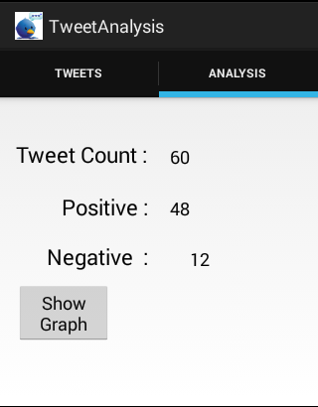

The Analysis Tab will classify the tweets into positive and negative along with total tweet count and also a button to view the graphical analysis.

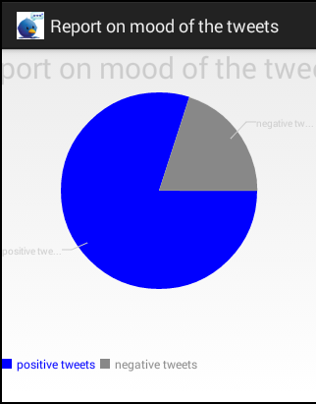

This screen presents the graphical analysis of tweets collected.

V.EVALUATION
To evaluate the accuracy levels of tweets analysed we have used some algorithms like Decision tree, Naïve-bayes algorithm,
Decision Tree: Tree is constructed in a top down recursive divide and conquer manner At start, all the training examples are at the root Attributes are categorical. Examples are partitioned recursively based on selected attributes.Test attributes are selected on the basis of a heuristic or statistical measure
Accuracy: 68.417%
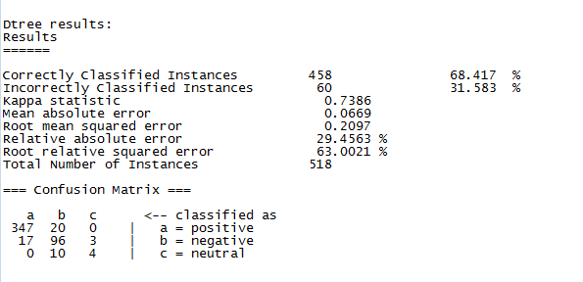
Naïve-bayes Classifiers:
Accuracy: 59.7648%
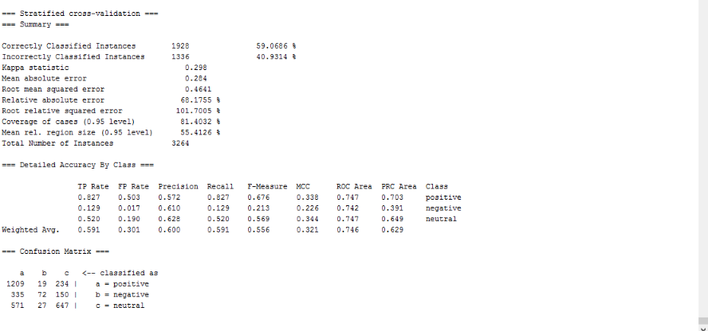

Graphical Classification of analysed tweets in Weka Tool:

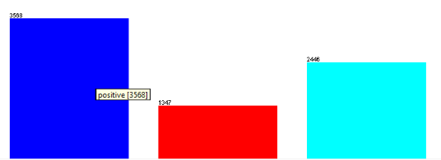

Positive Negative Neutral

VI. CONCLUSION

Extracted a real time twitter streaming data based on keywords from user using storm distributed computation for streaming data and a filter was also developed to process the touples from storm as text and image based csv files or text files. Developed a sentiment analysis to analyze the sentiment of the twitter messages using navie base analysis. Also, developed android GUI to retrieve the data from the centralized HBase. This design is more generic and can be adopted or extended to any environment with minimal changes.

VII. acknowledgements

We would like to thank Prof.Dr.Yugyung Lee for designing course curriculum in understanding the Real time big data challenges and we would like to extend our thanks to Feichen Shen, TA, CS590RA Course in letting us understand real time analysis of big data through class tutorials.

VIII. RELATED WORK

Opinion Mining and Sentiment Analysis. Foundations and Trends in Information Retrieval. (2011).
Bollen, J. M. (2011). Twitter mood predicts the stock market. Journal of Computational. 1-8.
DC.Pang, B. &. (2008). TweetMotif:Exploratory Search and Topic Summarization forTwitter. In Proceedings of the the Fourth International Twitter. In Proceedings of the the Fourth International. Washington.
González-Ibáñez, R. M. (2011). A sentiment analysis of Singapore Presidential Election using Twitter data with census correction.
IBM. (2012). Identifying Sarcasm in Twitter: A Closer Look.
Lassen, D. S. (2010). InfoSphere Streams. From http://www-01.ibm.com/software/data/infosphere/streams/
O'Connor, B. K. (2010). Twitter: TheElectoral Connection? Social Science Computer Review.
ShrutiWakade, C. S.-C. (n.d.). Text Mining for Sentiment Aanlysis of Twitter Data.
Symeon Papadopoulos, Y. (Vol. 47, no.5, pp. 84-87 May,2014). "Social Multimedia Crawling for Mining and Search," Computer.
Vergeer, M. H. (2012, Mar 18). What is Twitter Retrieved. From https://business.twitter.com/en/basics/what-istwitter/

